RESEARCH INFORMED TEACHING
DR ISMINI NAKOUTI & PROF GLYN HOBBS-SCHOOL OF PHARMACY AND BIOMOLECULAR SCIENCES

Antimicrobial Resistence (AMR): The invisible killer!
Bacteria have developed ‘smart’ mechanisms to fight commercially available drugs and resist their antimicrobial actions. One of their most prevalent characteristics is the formation of thick structures, called biofilms, that protect microorganisms from external threats and enable them to harbour antimicrobial resistance. Bacteria are also succeeding in their mission by communicating with their counterparts, broadcasting their ‘unique weapon’ through a specialised chemical vocabulary (auto-inducers) and eventually circulating their valuable gift of drug resistence in their community [1].
Antimicrobial resistance is acknowledged as one of the greatest threats to humanity and modern, evidence-based medicine. In 2014 the UK Government, led by PM David Cameron and the Wellcome Trust, commissioned the O’Neil Report on Antimicrobial Resistance. Lord Jim O’Neil reported that by 2050, unless action is taken, the death toll due to antimicrobial resistant strains could reach up to 10 million lives a year globally, equivalent to 1 person’s death every 3 seconds!
“If we fail to act, we are looking at an almost unthinkable scenario where antibiotics no longer work and we are cast back into the dark ages of medicine" David Cameron, former UK Prime Minister.
“We have reached a critical point and must act now on a global scale to slow down antimicrobial resistance” Professor Dame Sally Davies, UK Chief Medical Officer.
Prof Hobbs and Dr Nakouti have established collaborations on antimicrobial resistence, biofilms and diagnostics with industry and academia, both nationally and internationally, with a focus in UK, Thailand and India. Their current research interests include the detection of pathogenic bacteria using both molecular and phenotypic approaches. Prof Hobbs along with Dr Nakouti have been working in close collaboration with Prof Griangsak Eumkem and Dr Yothin Teethaisong, Suranaree University of Technology, Thailand in developing phenotypic tests to identify multi drug resistance in Enterobacteriaceae. Recently Dr Nakouti has established a close collaboration with Prof Chinnasamy Ragavendran, the Department of Conservative Dentistry and Endodontics, Saveetha Dental College and Hospital, in India investigating antibacterial/anti-inflammatory properties of new antimicrobials. In the past Prof Hobbs and Dr Nakouti have worked together on several projects funded by commercial partners including Unilever and Oxoid.

IMPACT ON CURRICULUM

The main aim of this curriculum development was the transfer of research knowledge within the classroom environment with the view to boosting the students’ conceptual learning about antimicrobial resistance. Specifically, the team’s focus was to facilitate students understanding of biofilms and bacterial behaviour. One of the main challenges was to create robust biofilms in vitro to mimic complex systems present in nature.

Consequently, a research-informed approach was developed in the teaching of level 4 students (BSc in Biomedical Sciences and BSc in Biochemistry) that included the concepts of biofilm creation/eradication and antimicrobial resistence/stewardship. One of the key focuses was the transfer of analytical skills linked to different types of imaging via microscopy (light, scanning electron, confocal and atomic force). These powerful visual tools enable students to appreciate the complex, multi-layered structures of biofilms that harbour antimicrobial resistance. Figure 1 is a 3-D confocal image that demonstrates the effect of an antimicrobial agent on the viability of the opportunistic pathogen Pseudomonas aeruginosa. The cells were stained with Invitrogen™ LIVE/DEAD™ BacLight™ Bacterial Viability stain. Live cells were stained green and cells with compromised membranes (dead) were stained red. Following examination, the students concluded that the pathogen resists the effect of the antimicrobial agent.

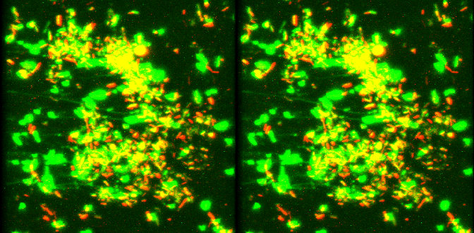

Figure 1. 3-D image of a Pseudomonas aeruginosa biofilm (a nosocomial opportunistic pathogen). Live cells are stained green and cells with compromised membranes (dead cells) are stained red.

Another very important aspect of this module was the analysis of new research developments conducted in high throughput screening technologies [2]. These tools are used in early, rapid diagnosis and are relevant to future work skill development and employment experience. This exercise enabled the students to develop practical skills associated with the assessment and interpretation of antimicrobial resistence, a discipline employed daily by clinical scientists working in the UK healthcare system (NHS and private medicine).

The students had the opportunity to view 3-D images of in vitro biofilms to recognize the advantages to the pathogen of living within a biofilm (Figure 2).

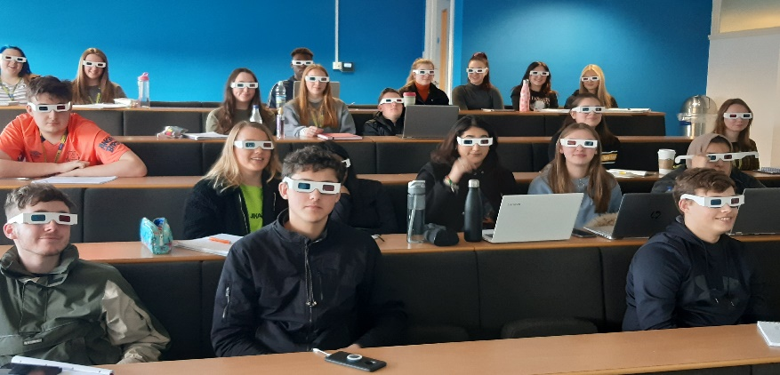
Figure 2. Undergraduate students viewing 3-D pictures of a Pseudomonas aeruginosa biofilm (nosocomial opportunistic pathogen).
Student evaluation has been very positive: “Dr Nakouti made the lecture fun and interesting and always leaves you with things to think about" Module Evaluation Report 2022-2023.

BROADER IMPACT of the RESEARCH INFORMED TEACHING APPROACH
- Undergraduate students realize that for healthcare professionals, clinical decision-making is underpinned by research-based evidence. Unpacking the complexity of scientific concepts and tasting genuine research during the students’ early learning experience supports, motivates and inspires these students. They develop their own research and professional skills as well as appreciate that health professions are constantly reshaped by research.
- Research informed curriculum design influences students’ professional career opportunities from a very early stage. This has the potential to boost their employment opportunities. Research based education at Level 4 helps them identify potential career identities and inspires their curiosity regarding prospects after their University life.

REFERENCES
- Wainwright J, Hobbs G, Nakouti I. 2021. Persister Cells: Formation, Resuscitation and Combative Therapies. Archives of Microbiology, 203:5899-5906.
- Almatrood W, Nakouti I, Hobbs G. 2022. Microtiter plate with built-in oxygen sensors: A novel approach to investigate the dynamics of Pseudomonas aeruginosa growth suppression in the presence of divalent cations. Archives of Microbiology. Archives of Microbiology, 204 (297).

