Research Informed Teaching
School of Nursing and Allied Health - Cardiovascular Care
General Context (100 words) what area of work is involved and which school, faculty, staff does this represent
The School of Nursing and Allied Health is a leading provider of healthcare programmes in the U.K. This statement is supported by high levels of student recruitment and the receipt of numerous national awards.
The school hosts the LJMU site of the Liverpool Centre for Cardiovascular Science (LCCS). LCSC is a collaborative multi-disciplinary venture in partnership with the University of Liverpool, and Liverpool Heart and Chest Hospital that is focussed on generating world leading research to reduce the global burden of cardiovascular disease. The LCCS Director is Professor Greg Lip, who is cross appointed from Liverpool Heart and Chest Hospital, and the LJMU lead is Professor Ian Jones.

Specific Project Work (200 words) one or more linked projects, which PGR students involved, other collaborators or partners
To develop a cadre of world leading researchers it is essential that we foster a dynamic research culture at all levels. This must be initially introduced at undergraduate level where students see real-world research and are able to play a role in the delivery of innovative studies that provide solutions to the problems, they witness in everyday practice.
Here we provide two such examples and the resultant impact of these initiatives.
- The SHOPS AF study investigated the uptake, feasibility and effectiveness of introducing heart rhythm sensors into the handles of supermarket trolleys to detect a potentially life-threatening heart rhythm (Fig 1) Nineteen of our second- and third-year undergraduate nursing and paramedic students were placed with experienced researchers at one of four supermarkets where they invited >3000 shoppers to participate in the study, reviewed the resulting heart tracing with the PI, and witnessed health promotion advice being given. They were then able to review and support the data analysis.

Fig 1 ECG taken from hands holding a shopping trolley.

- The Liverpool Cardiovascular Disease Screening study was undertaken in partnership with Liverpool Football Club Foundation. The aim of the study was to explore if sports branded health screening was feasible and effective compared to traditional methods. Twenty of our second- and third-year undergraduate nursing students were placed with experienced researchers and health promotion experts (Fig 2, 3) They were included in the study design, data collection and analysis. In addition, they were given responsibility for providing health promotion and cardiovascular disease risk advice under the supervision of the academic team. The students participated in the study as part of a student enhancement project which was undertaken outside the traditional curriculum.

Fig 2 Some our undergraduate students ready to complete the screening
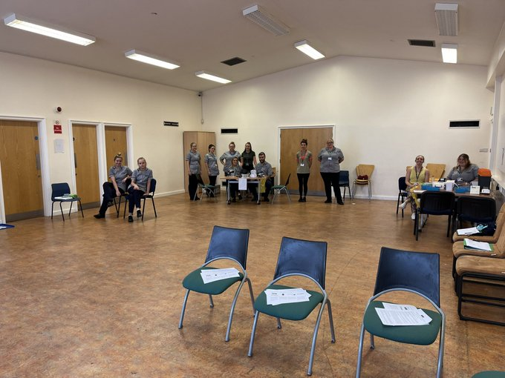

Fig 3 Liverpool Football Club Mascot, Mighty Red supporting our screening study
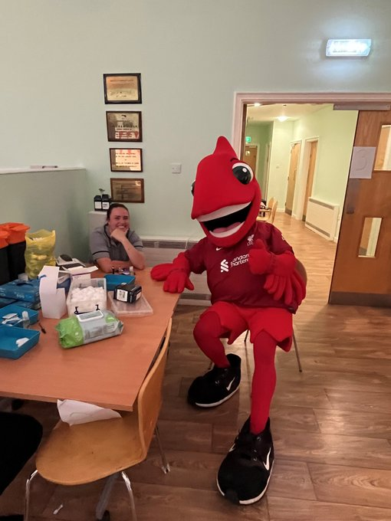
.
Impact on curriculum (300 words) which course or modules changed, what changes occurred, link to specific students (delivery) or content
In addition to the formal study review, Dr Nicola Morrell Scott, Emma Johnston Smith, Professor Ian Jones and Professor Debbie Roberts completed an evaluation of the student experience using a novel data collection method that encouraged the students to engage via drawings, paintings and narration. The use of visual methods is increasingly being used in healthcare research (Horne; Masley; Allison-Love, 2017). We chose to use this method to illicit the experiences of student nurses following their research placement. Adopting this approach also exposed the students to alternative ways in which data can be collected. Students reported positive experiences of participating in primary research (Fig 4), identifying changes in understanding and attitude towards research and highlighting changes in their clinical practice as a result. The evaluation concluded that healthcare students participating in primary research can positively influence understanding and attitudes towards research and should be embedded in nurse education. This is now being repeated with subsequent cohorts dramatically changing the student experience. The student evaluation was recently presented at the Royal College of Nursing’s Annual Scientific Conference by Emma Johnston Smith and has been submitted for publication to Nurse Education Today by Nicola Morrell Scott, Emma Johnston Smith, Ian Jones and Debbie Roberts. Five students also attended the British Association for Nursing in Cardiovascular Care annual conference where Professor Ian Jones presented their work and the ways in which the profession can grow future researchers.

Fig 4 Diagrammatic responses to programme evaluation impact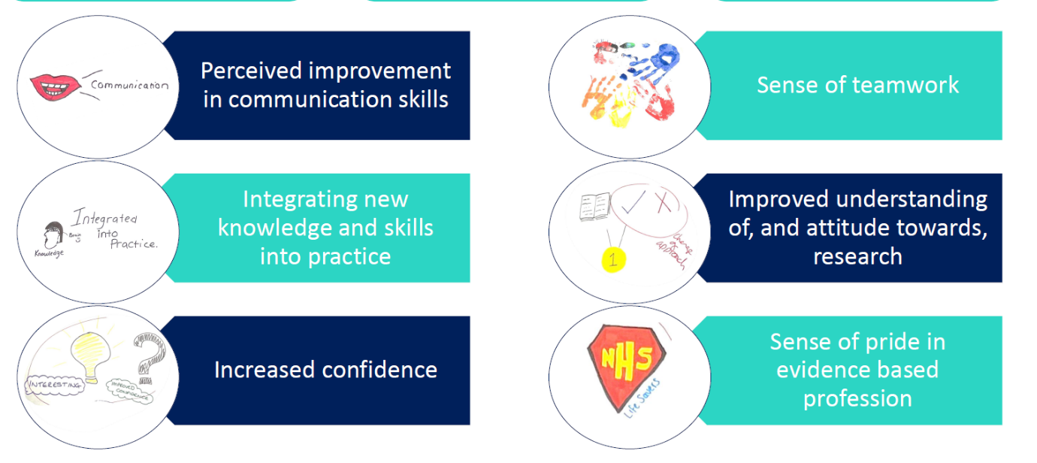

Broader Change (300 words) did curriculum impact lead to change in skills, career choice and employability, student evaluation, other impacts (advertising case studies, alumni lectures)
As has been stated above, those students who have been exposed to real-world research have benefitted greatly both in terms of their research and health promotion knowledge. Placing the students with active researchers whilst focussing on a nurse led study provides context to their classroom learning. Rather than receiving the results of a study they have been party to the discussions and decision making that is inherent within all study design. It is the ability to follow a study from conception to completion and witnessing the barriers and influencers that researchers must navigate which has helped them to understand some of the methodological choices that impact studies. In addition, the studies have enabled the students to observe nurse researchers in a patient facing habitat, consequently, broadening their views on future career options (see diagrams above)

This complementary approach to teaching research has been seized upon by several Higher Education Institutions who are now following suit. In addition, the National Institute for Health Research Clinical Research Network (NIHR CRN) are interested in exploring how they can provide clinical placements to enable students to broaden their experience of nursing research, an approach which is aligned to the National Nursing Research Strategy and the Clinical Academics Framework. Professor Jones is now working with this organisation to help to develop a roadmap to enhance nursing research in the U.K. Whilst the CRN have published the first version of this map (www.research-career-nwc.co.uk) additional work is underway to further advance this initiative

