Teaching Operations Management through Digital Pedagogy and Experiential Learning
Dr. Foteini Stavropoulou, Liverpool Business School
Gamification in Higher Education
Gamification is the application of gaming mechanisms in non-gaming contexts. In Higher Education gamification is used to enhance the student learning experience and engagement. As part of gamification, simulation games have been broadly adopted in Business Schools worldwide to teach a variety of subjects, such as Operations Management, Sustainability, Marketing, Strategic Management and Finance.
Since 2014, I have been using a web-based simulation game developed by Edumundo as part of the Operations and Technology Management core module in level 4. Usually, simulation games focus on specific Operations Management areas, such as the Beer Game that focuses on supply chain co-ordination or the Littlefield simulation that focuses on production management of a factory. The innovation in this case is that a simulation game is used in level 4 (most papers report that simulation games for teaching Operations Management are used in 2nd or 3rd year or in a Master’s level) and also this simulation does not focus on a specific Operations Management area, but it gives a more holistic overview to students, while they need to make Operations Management-related decisions, such as supplier selection, quality management, logistics, demand forecasting and inventory management (Stavropoulou et al., 2023).
This module was the first undergraduate module to use a simulation game within Liverpool Business School. Currently, a number of undergraduate modules, such as Strategic Management, Strategy and Leadership, Foundations of Marketing and Management Functions and Practice, across all levels and programmes, e.g., BSc (Hons) Business Management, BA (Hons) Marketing, BSc (Hons) Business with Marketing and BA (Hons) Human Resource Management, use simulation games provided by Edumundo as part of their curriculum.
Experiential learning
Research largely advocates the use of simulation games in Operations Management teaching as they promote both active and experiential learning (Miyaoka, 2005; Pasin & Giroux, 2011; Snider & Balakrishnan, 2013; Stavropoulou et al., 2023). Experiential learning focuses on the idea that people best learn by having experiences and knowledge is created by perceiving and processing/transforming experience. Based on Kolb’s experiential learning theory, this module’s didactic setting can be seen as an implementation of Kolb’s learning cycle (see Figure 1). This cycle has four stages: “concrete experience” refers to having an experience, “reflective observation” is reflecting on the experience, “abstract conceptualisation” refers to learning from the experience and “active experimentation” as applying what you have learnt. It should be highlighted that in this module I use an adapted version of the aforementioned model, as students start with the “active experimentation” stage and then move on to the other stages of the cycle (Kolb, 1984).
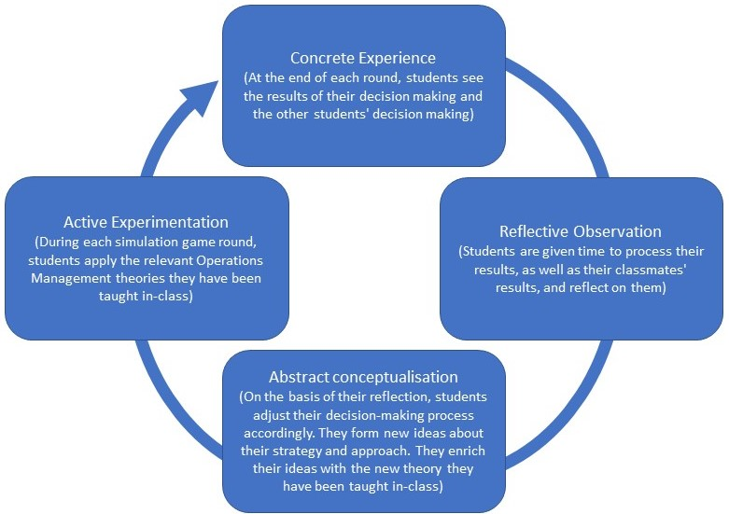
Figure 1 Adapted Kolb's experiential learning cycle
Impact on curriculum
The adoption of a simulation game for the Operations and Technology Management module was part of an overall curriculum review and redesign for this module in 2014. The utilisation of the game as a learning and assessment tool brought a number of changes in the curriculum design. First, it was important to align the module’s learning objectives with the simulation game’s learning objectives, so that students understand why they are playing this game. Research demonstrates that games in education are better used as a mechanism to apply existing learning of a topic rather than an assessment method (Pasin & Giroux, 2011). For this reason, students are not assessed on how well they perform in the simulation game but on a reflective presentation (this is also part of the “reflective observation” stage of the learning cycle) where they justify their decision-making by linking it to the Operations Management theory taught in-class. In addition, the simulation game is slotted later in the semester to allow students to familiarise with the Operations Management concept and theories. Prior to Covid19, the experiential learning aspect of this module was enhanced by combining the use of the simulation game with visits to car plants, factories, and distribution centres to witness first hand Operations Management in practice.
In terms of which research has informed teaching learning and assessment in this context, I have co-authored a paper that provides useful insights to educators based on my experience of using this simulation game as part of Operations Management teaching and assessment (Stavropoulou et al., 2023), and we are now working with two colleagues from a different programme within the Liverpool Business School to investigate the use of simulation games across different programmes and their role on student self-efficacy and ethical decision-making.

Broader change
Pedagogical research showcases that simulation game use brings about various positive outcomes, such as increasing student engagement and motivation. It also enhances student learning as it improves collaboration, communication, and decision-making skills, among others. Furthermore, it develops and reinforces students’ soft skills, like social interaction, team building, team working, self-efficacy, negotiating and planning. The aforementioned skills are transferable to the workplace, therefore, they enhance the students’ employability. Based on my experience, the simulation game adoption in my module has significantly contributed to the student learning experience. It has consistently led to increased student attendance – the student attendance has been higher in the simulation game sessions than the normal seminar sessions on average by 6,72%. In addition, student module evaluation has been positive, and students have been highlighting that one of the best aspects of this module is the use of the simulation game.
Emma Ainscough, a Level 4 BSc Business Management student commented on her experience: “The game is like a real-world application, so you learn things yourself and is more engaging than being taught in the usual in-class way.”
Zayneb Abbarah, another Level 4 BSc Business Management student said: “Everything that our lecturer has explained in the lectures, we can apply in practice. It makes it more memorable and logical.”
Max Bird, a Level 4 BSc Business Management student commented about the game: “I think the game is quite fun. The different options and variety of decisions is a quite cool feature and the stock exchange (i.e., where you can see all the groups’ progress) adds a competitive element. You feel more involved in the lessons, and you are more enthusiastic of applying things rather than just sitting and listening to theories.”
Hildana Demessie, another Level 4 BSc Business Management student, enjoyed the teamwork and the decision-making process: “I like that I am working in a group, where we can discuss and make decisions, and see how to make decisions in a company, especially if you want to set up your own company, you can see what it takes to make the right decisions.”
Finally, Ashton Carr, another Level 4 BSc Business Management student, commented on her experience: “It feels very realistic. I feel like I am actually involved in the business. It has helped me to use my initiative to make decisions, instead of looking for a right or wrong answer. I find the time flies when playing the game and I am more active. It’s groupwork and you feel more reliable to show up for your teammates; other people are depending on you, so we motivate each other. Plus, you get a reward (i.e., Amazon vouchers) if you do well, so that’s motivating too.”
All the above reiterate the positive impact of the simulation game use within the Operations and Technology Management module curriculum. Thus, I will continue using this as a learning and assessment tool, while looking to find ways to enrich the module’s experiential and active learning, e.g., via the use of virtual tours, virtual reality applications and/or educational escape rooms.

References
Kolb, D. A. (1984). Experiential learning: Experience as the source of learning and development (Vol. 1). Englewood Cliffs, NJ: Prentice-Hall.
Miyaoka, J. (2005) Making operations management fun: Littlefield technologies. INFORMS Transactions on Education, 5(2), pp. 80-83.
Pasin, F. & Giroux, H. (2011) The impact of a simulation game on operations management education. Computers & Education, 57, pp. 1240-1254.
Snider, B. & Balakrishnan, J. (2013) Lessons learned from implementing web-based simulations to teach operations management concepts. INFORMS Transactions on Education, 13(3), pp. 152-161.
Stavropoulou, F., PanjehFouladgaran, H.R. & Teimouri, M. (2023) Operations Management Curriculum Development under Uncertain Situations: Lessons learned from the pandemic (under review).

