Suicide and Self-Harm Research Group Newsletter May 2023

Suicide Prevention Strategy – Cheshire and Merseyside 2022-2027

The aim of the Cheshire and Merseyside Suicide Prevention Strategy is to build individual and community resilience to improve lives, prevent crisis and address risk factors for suicide. Key values for the strategy include addressing health and social inequalities, reducing stigma, using a ‘people-first’ approach, working collaboratively with partners and stakeholders and utilising local and real-time surveillance data.

As a research group, our work maps onto the key values and priority areas for action mapped out across Cheshire and Merseyside.

- Leadership and Governance
This priority area relates to effective collaborative suicide prevention partnership. At the SSHRG, we work collaboratively with local partners and stakeholders including Mersey Care and Cheshire & Wirral Partnership NHS Foundation Trust.

- Prevention
Prevention includes improving mental health and resilience in children and young people, men and older people by linking to local plans and wider strategies. We have a number of research projects addressing the prevention strategy including COPESS, James Place, MAPSS and menopause study.

- Intervention
Increasing suicide prevention training and safety planning in key groups and improving crisis care for all ages is a key component of the intervention priority. COPESS, James Place and MAPSS contribute work towards this strategy.

- Postvention
Postvention relates to improving effective bereavement support for all ages and ensuring effective postvention services across Cheshire and Merseyside. Within the SSHRG, we have a completed PhD specifically researching postvention services in England.

- Data, Intelligence, Evidence and Research
Improving data sets collated by real-time surveillance and using data to inform community response plans is a core aspect of the data, intelligence, evidence and research priority. As a group we have a number of projects examining data and intelligence; for example, emergency department attendacnes and coding practices for suicidal criiss, transformation change project, Alder Hey suicidal crisis attendances and the complex mental health study.

CWP REAL (Research, Effectiveness. Academia and Learning) Launch Event

Members of the Suicide and Self-Harm Research Group (SSHRG) were invited to present their collaborative work with Cheshire & Wirral Partnership NHS Foundation Trust (CWP) at the launch of their new research centre. The day centred around exploring the benefits that high quality research, usage and innovation can bring to patients.

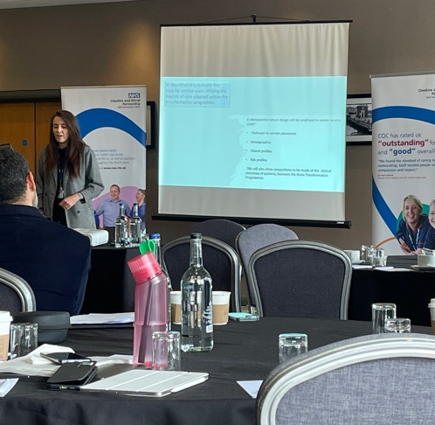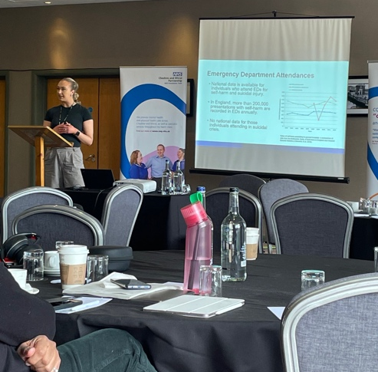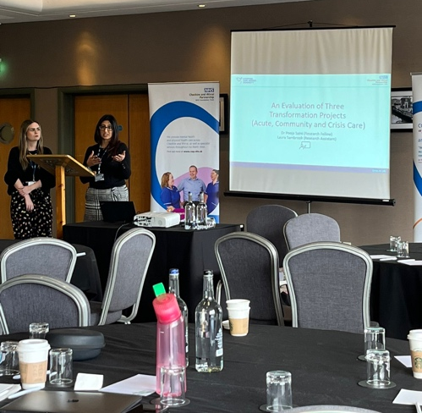

Hana Roks presented her PhD proposal exploring ‘a specialist mental health transformation change programme: a mixed method study to inform evidence-based service delivery models’. Molly McCarthy’s talk revolved around her PhD work into emergency department coding practices, clinical pathways and staff decision-making for people presenting in suicidal crisis. Finally, Dr Pooja Saini and Laura Sambrook presented work into the evaluation of three transformation change projects (Acute, Community and Crisis Care). The presentations and day were well received among clinical staff from CWP and highlighted the importance of utilising research to inform practice and improve patient experiences.

Upcoming Conference Presentations

- Liverpool John Moores University PGR Research Festival (May 2023)
Poster Presentations from Salma Shalaby, Rashmi Liyanage, Olivia Hendricks and Molly McCarthy.

- Suicide Cultures Conference, Edinburgh (June 2023)
Oral presentation from Molly McCarthy titled ‘staff perspectives of emergency department pathways for people in suicidal crisis: a qualitative study’.

- 7th Early and Mid-Career Research Forum, Glasgow (June 2023)
Oral presentation from Molly McCarthy on ‘Factors Influencing Emergency Department Staff Decision-Making for People Attending in Suicidal Crisis: A Systematic Review’ and poster presentation on 'Staff Perspectives of Emergency Department Pathways for People in Suicidal Crisis: A Qualitative Study’.

- SSHaRE NoW, Manchester (June 2023)
COPESS Oral Presentation – Dr Pooja Saini

Oral Presentation from PhD Students and Research Assistants:
'Staff Perspectives of Emergency Department Pathways for People in Suicidal Crisis: A Qualitative Study’ – Molly McCarthy

‘Carers for those at risk of suicide’ – Sunny Blaney

- Royal College of Psychiatry, Liverpool (July 2023)
Posters: 'Staff Perspectives of Emergency Department Pathways for People in Suicidal Crisis: A Qualitative Study’ and ‘Improve Coding Practices for Patients in Suicidal Crisis’ – Molly McCarthy
‘An examination of inpatient ward and secondary community care stay costs for individuals with complex mental health needs in the UK’ – Dr Pooja Saini
‘The Journey of Service Users with Complex Mental Health Needs: A Qualitative Study’ – Dr Pooja Saini

- BABCP (Jiuly 2023)
COPESS Oral Presentation – Dr Pooja Saini

- SAPC (July 2023)
COPESS Oral Presentation – Dr Pooja Saini

- IASP, Piran (September 2023)
Symposium:
- ‘Factors Influencing Emergency Department Staff Decision-Making for People Attending in Suicidal Crisis: A Systematic Review’ – Molly McCarthy
- James Place – Jane Boland
- The social validity of a suicide prevention intervention in UK schools – Dr Emma Ashworth
- MAPSS – Dr Pooja Saini

Oral Presentations:
- Improve Coding Practices for Patients in Suicidal Crisis – Molly McCarthy
- Cards Study - Claire Hanlon
- Postvention – Laura Abbate

- Entrapment – Dr Pooja Saini and Jane Boland
- Assessing the social validity of a multi-modal school-based suicide prevention intervention in the UK: A scoping study – Dr Emma Ashworth
- Clinical Decision-Making - Laura Sambrook

Poster Presentations:
- Children and young people presenting in Emergency Departments in England in suicidal crisis: A case series study – Dr Emma Ashworth
- ACES – Hana Roks
- Carers for those at risk of suicide – Sunny Blaney

- Harmless Conference September 2023
Workshop Presentation – Laura Abbate and Dr Pooja Saini

- PGR Conference Chester 2023
Postvention - Laura Abbate

- Salford University (October 2023)
Suicide Prevention – Dr Pooja Saini

- LJMU IHR SSHRG Conference November 2023

Recent Publications
Hanlon C, Ashworth E, Moore DJ, Donaghy B, Saini P. 2022. Autism should be considered in the assessment and delivery of mental health services for children and young people Disability and Society
Hanlon C, McIlroy D, Poole H, Chopra J, Saini P. 2022. Evaluating the role and effectiveness of co‐produced community‐based mental health interventions that aim to reduce suicide among adults: A systematic reviewHealth Expectations
McCarthy, M., McIntyre, J., Nathan, R., & Saini, P. (2023). Factors influencing emergency department staff decision-making for people attending in suicidal crisis: a systematic review. Archives of suicide research, 1-15.
McCarthy, M., Saini, P., Nathan, R., & McIntyre, J. (2023). Predictors of self-harm and emergency department attendance for self-harm in deprived communities. International journal of injury control and safety promotion, 1-7.
Mulholland H, Whittington R, Lane S, Haines-Delmont A, Nathan R, Saini P, Kullu C, Comerford T, Yameen F, Corcoran R. 2023. Longitudinal investigation of the presence of different trajectories and associated health and socio-economic determinants, for participants who report suicidal ideation within a community-based public health survey. BMJ open, 13 :e063699
Saini P, Chopra J, Hanlon C, Boland JE. 2022. The adaptation of a community-based suicide prevention intervention during the COVID19 pandemic: a mixed methods study. Cogent Psychology, 9
Saini P, Hunt A, Kirkby J, Chopra J, Ashworth E. 2023. A qualitative dyadic approach to explore the experiences and perceived impact of COVID-19 restrictions among adolescents and their parents Health Psychology and Behavioral Medicine, 11

Awards
LJMU Poster Competition Winner ‘Staff Perspectives of Emergency Department Pathways for People in Sucidal Crisis: A Qualitative Study’ – Molly McCarthy
ARC North West Coast Innovation Awards Molly McCarthy shortlisted for Researtch Student of the Year.
Winner of Cogent Psychology Research Spotlight Awards - The adaptation of a community-based suicide prevention intervention during the COVID19 pandemic: a mixed methods study.l

External Speakers
Professor Jessica Schwartzman, Assistant Professor Vanderbilt Univeristy, USA.
Rachael Gilbert
Dr Lindsay Dewa, Imperial College London.
Rachel Gilbert, Manager, Wirral Lived Expereince Network.
Dr Nicole Tang, Reader, Univeristy of Warwick.
Dr Anita Mottershead, Quality and Performance Analysis, East Cheshire CCG.
Dr Caroline Clements, Manchester Self-Harm Group, University of Manchester.
Sally Darwin, Practice Development Nurse, West London Forensic Services.

Next Quarterly Meeting: 15th June 2023 (link will be circulated).

