Newsletter July 2022

Project Updates:

James Place: Data ready for 3-year evaluation. London process evaluation drafted.

COPESS: Reached recruitment target of 52, closing recruitment window end of June.

COMPAT: Interviews with service users and carers complete. Clinician interviews underway. Patient journey report complete.

Ask, Listen, Act: In the process of sharing key findings with MPs and relevant government departments.

MAPSS: Three focus groups with CYP, 7 interviews with mental health practitioners, 4 with school staff, 3 with parents.

Self-Harm Kit: Completed report. Presented at Cheshire & Merseyside C&M Self-Harm Development Group.

OASIS Domestic Violence Service Evaluation: Completed report.

PhD Updates:

Laura Abbate – Postvention Services: Systematic review published.

Claire Hanlon – James Place: Qualitative analysis and car data complete.

Molly McCarthy – A&E Suicidal Crisis: Systematic review submitted and started interviews with staff.

Anna Hunt – A&E CYP Suicidal Crisis: Working on ethics application and PROSPERO registration for systematic review.

New Research:

Hana Roks PhD – Transformation Change
Olivia Hendriks PhD – Suicide risk and perimenopause.

Transformation Change Project: Crisis care, acute care and community care.

An evaluation of the Royal National Institute of Blind People (RNIB) Book Share Scheme.

6th Suicide and Self-Harm Early and Mid-Career Researchers Forum (EMCRF) – Glasgow 2022
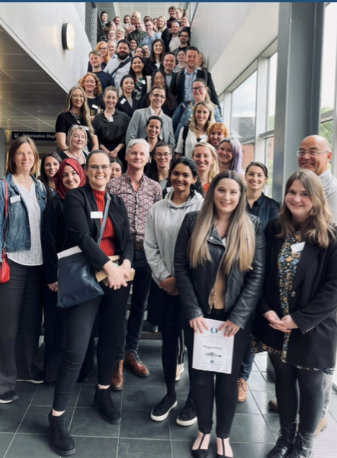
We at the team were thrilled to be given the privilege of presenting both oral and poster presentations at the EMCRF in Glasgow. Many researchers and presenters came from around the world, with attendees and presenters from the UK, Netherlands, Lithuanian, Australia and Switzerland. The forum connected researchers of all levels to share research, experiences and network. Keynote speakers including Dr Katrina Wit, Professor David Gunnell, Dr Mareike Ernst, Dave Sandford and Dr Katerina Kavalidou, shared their personal journey’s into research and promoted resilience, self-care and many other skills needed for a researcher's career journey. The forum displayed a range of methodologies such as network analysis and diary sampling to explore suicide and to bring together many pieces of the puzzle to aid in preventing suicide and self-harm (Peter Blaney).
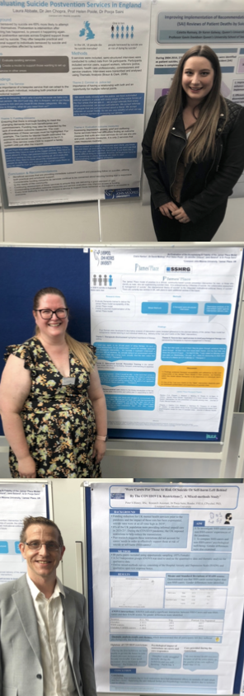

Laura Abbate
Winner of Poster Competition
‘Evaluating Suicide Postvention Services in England’.

Claire Hanlon
‘Acceptability and Fidelity of the James Place Model’.

Peter Blaney
‘Were carers for those at risk of suicide and self-harm left behind by the COVID-19 UK restrictions?’.

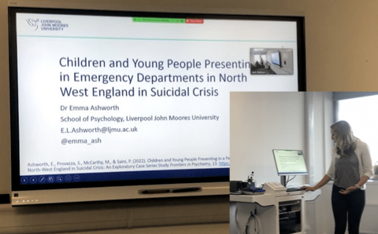
Dr Emma Ashworth
‘CYP presenting to a paediatric emergency department in England in suicidal crisis’.

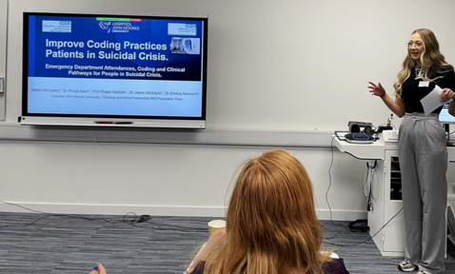

Molly McCarthy
‘Improve coding practices for patients in suicidal crisis’.

Conference Presentations

- Laura Abbate Three Minute Thesis and Dr Pooja Saini presented on Research Impact at the LJMU PGR Conference (May 2022).
- Dr Pooja Saini, Anna Hunt and Dr Jen Chopra presented at SSHaRE NoW Conference (June 2022).
- PhD students Claire Hanlon and Molly McCarthy presented 'Why PGRs need to think about impact' at the LJMU Students at the Heart Conference (June 2022).
- Dr Pooja Saini and Dr Dave Moore presented at the Royal College of Psychiatry Conference in Edinburgh (June 2022).
- Anna Hunt presenting at the Society of Academic Primary Care conference on COPESS (Community Outpatient Psychotherapy Engagement Service for Self-Harm (6th July).

Ask, Listen, Act

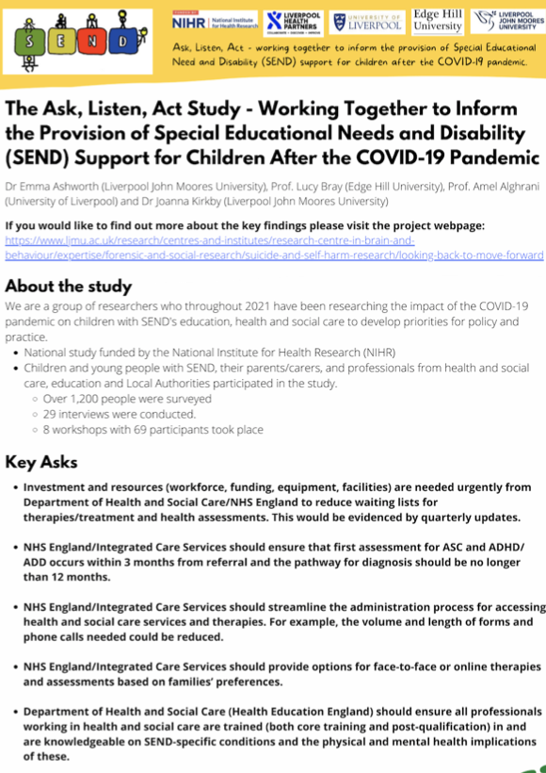

Following such a fantastic response to the study and the development of tightly focused priorities for policy and practice for children and young people with SEND linked to the COVID-19 pandemic, the team wanted to ensure that the participants' voices were heard and change enacted. The team sent bespoke evidence briefings to MP’s, and several MP’s expressed an interest in meeting the team to discuss the research findings and key asks. So far, the team have met with Rt Hon Dr Liam Fox MP, Margaret Greenwood MP, and Sally-Ann Hart MP (vice-chair of the SEND All-Party Parliamentary Group). The team asked the MP’s what they could do for us, and are currently following up on the MP’s suggestions, such as creating a more in-depth education evidence briefing for the minister of children and families.

For more information and the study findings please visit our website: https://www.ljmu.ac.uk/research/centres-and-institutes/research-centre-in-brain-and-behaviour/expertise/forensic-and-social-research/suicide-and-self-harm-research/looking-back-to-move-forward

SSHRG Publications

Abbate, L., Chopra, J., Poole, H., Saini, P. (2021). Systematic review protocol: a feasibility study of the effectiveness and acceptability of postvention liaison services for individuals bereaved by suicide. PROSPERO 2021 CRD42021239308

Ashworth E, Hunt A, Chopra J, et al. Adolescents’ Lockdown-Induced Coping Experiences (ALICE) Study: A Qualitative Exploration of Early Adolescents’ Experiences of Lockdown and Reintegration. The Journal of Early Adolescence. December 2021. doi:10.1177/02724316211052088

Ashworth E, Putwain D, McLoughlin S, Saini P, Chopra J, Rosser B, Eames C. 2021. Ordinary magic in extraordinary circumstances: Predictors of positive mental health outcomes for early adolescents during the COVID-19 pandemic. Research Square. Preprint. Submitted to Adversity and Resilience Science.

Ashworth, E., Provazza, S., McCarthy, M., & Saini, P. (2022). Children and young people presenting in a pediatric emergency department in North-West England in suicidal crisis: an exploratory case series study. Frontiers in psychiatry, 746.

Blaney, P and Saini, P (2021) ‘Informal families like ours seemed unaccounted for’. Psychologist. ISSN 0952-8229

Chopra, J., Hanlon, C.A., Boland, J., Timpson, H., Harrison, B., Saini, P. Case Series Study of an Innovative community-based brief psychological model for men in suicidal crisis. Submitted to Journal of Mental Health. (Resubmitted follower reviewer comments)

Hanlon, C., McIlroy, D., Poole, H., Boland, J., Saini, P. (2021). Exploring the role and effectiveness of co-produced community-based mental health interventions that aim to reduce suicide among adults. PROSPERO 2020 CRD42020221564

McCarthy M, Saini P, Nathan R, McIntyre J. Improve coding practices for patients in suicidal crisis. BMJ 2021; 375 :n2480 doi:10.1136/bmj.n2480.

McCarthy, M., Saini P., McIntyre, J., Nathan, R. (2022). Factors influencing clinical-decision making for patients attending A&E in suicidal crisis: A systematic review. PROSPERO 2022 CRD42022303429 Available from: https://www.crd.york.ac.uk/prospero/display_record.php?ID=CRD42022303429

Mughal F, Gorton HC, Michail M, Robinson J, Saini P. 2021. Suicide Prevention in Primary Care. Crisis, 42 :241-246

Saini P, Chopra J, Boland J, Hanlon C. 2021. A Case Series Study of Help-Seeking among Younger and Older Men in Suicidal Crisis. International Journal of Environmental Research and Public Health, 18

Saini P, Hunt A, Taylor P, Mills C, Clements C, Mulholland H, Kullu C, Hann M, Duarte R, Mattocks F, Guthrie E. Community Outpatient Psychotherapy Engagement Service for Self-harm (COPESS): A Feasibility Trial Protocol. Submitted to BMC Pilot and Feasibility Studies. (Resubmitted follower reviewer comments)

Saini P, Rajan N, Mark G, Clarissa G, Sean B, Carl O, Phil E, Pete W. 2021. Use of acute psychiatric hospitalisation: a study of the factors influencing decisions to arrange acute admission to inpatient mental health facilities. Frontiers in Psychiatry,

Saini P, Shaima H, Esmaeil K-M, Mark G, Clarissa G, Saiqa A, Anna P, Lesley H, Jane C, Jenny I, Mark G. 2021. The value of involving patients and members of the public in applied health services research and evaluation: a qualitative study. Research Involvement and Engagement.

Reports:

Ashworth, E., Provazza, S., McCarthy, M., & Saini, P. (2022). Children and Young People Attending Alder Hey A&E in Suicidal Crisis: 2019-2021. https://researchonline.ljmu.ac.uk/id/eprint/16481/1/Alder%20Hey%20Final%20Report.pdf

Chopra, J & Sambrook, L. Oasis Understanding Trauma Programme Evaluation Report.

Saini.P., McCarthy, M., & McIntyre, J. (2022). Crisis Line Evaluation: Cheshire & Wirral Partnership, Mersey Care and Mid-Mersey. Saini, P., & McCarthy, M. (2021). Imagining the Future: A Service Evaluation.

