Newsletter October 2022

Notice: We have not scheduled a quarterly SSHRG meeting as we will be discussing all of our current and upcoming projects at the SSHRG conference in December.

New Projects:

Transformation Change Project:
There are three transformation projects underway in Cheshire & Wirral Partnership NHS Foundation Trust (CWP): acute, community and crisis care. The aim of the project is to evaluate clinical and non-clinical outcomes across the three programmes and evaluate the pathways for individuals utilising the services.
- Ethical approval in progress.
- Finalised three proposals with teams.
- Two PPI members recruited.

Hana Roks PhD – A specialist mental health transformation change programme: A mixed methods study to inform service delivery models.
This PhD runs alongside the transformation change project above looking at patient pathways
- Ethical approval in progress.
- Protocol completed.

Olivia Hendriks PhD – Suicide Risk and Perimenopause.
Ethics has been submitted, and public advisory group is being formed. A webpage will also be developed in the upcoming months. A podcast episode was created to raise the profile of the PhD – it can be listened to here: Apple Music, Spotify

Recent Publications:

Ashworth, E., Molloy-Vickers, D. & Saini, P. A pilot evaluation of self-harm kits in Cheshire & Merseyside: 2021-2022. Project Report. Merseyside Health and Care Partnership. https://researchonline.ljmu.ac.uk/id/eprint/17462/

Balmer A, Sambrook L, Roks H, Tait J, Ashley-Mudie P, McIntyre J, Shetty A, Nathan R, Saini P. Patient profiles of service users with complex mental health needs: an in-depth case notes analysis:1-27.

Roks H, Balmer A, Sambrook L, Burton S, Tait J, Ashley-Mudie P, Shetty A, Nathan R, Saini P, McIntyre J. 2022. Descriptive analysis of complex mental health service users using routinely collected data.

Sambrook, L, Balmer, A, Roks, H, Tait, J, Ashley-Mudie, P, McIntyre, JC, Shetty, A, Nathan, T and Saini, P Patient Journey of Service Users with Complex Mental Health Needs: A Qualitative Study. Project Report. LJMU/CWP. https://researchonline.ljmu.ac.uk/id/eprint/17136/

Coproduction at its best!

Reflections from the COMPAT Study.

It is not an exaggeration to say that engaging with the COMPAT study team profoundly changed my life. I found myself working with a compassionate, thoughtful group of people who seemed genuinely committed to improving mental health provision for extremely vulnerable patients with complex needs. I met clinical and research leaders with the values and integrity needed to drive change in the system. The experience enabled me to overcome my distrust of mental health services; it gave me hope that the proposed transition to a new and better model of mental health care might just be possible. Huge changes are afoot in mental health provision. I'm really excited about the prospect of a system that helps meet the needs of vulnerable people for safe homes, decent food, freedom from abuse, and opportunities to live a full and thriving life. My experience as a member of the COMPAT research team has given me confidence that clinical and research leaders are committed to realising this dream, and that their leadership will transform the culture within mental health care to establish trauma-informed, compassionate and effective pathways to recovery. (Dr Jackie Tate - Public Advisor).

Leading the COMPAT study over the past two years has been a great experience, working so closely with Cheshire and Wirral Partnership (CWP) Trust from the design, planning, data collection, analysis and now disseminating. It has been one of the most collaborative projects I have led, and the most attended project by clinicians and experts by experience throughout. The coproduction element between academics, clinicians, CWP trust staff, community housing partners and most importantly the experts by experience has been excellent due to the shared decision making and mutual respect between group members. Due to the success of our working model, further research has been funded for this team to be involved in leading the evaluation of three transformation change projects with CWP. We are looking forward to sharing all of the findings of the COMPAT study with you all. (Dr Pooja Saini – Principal Investigator).

Over the space of 18 months, I have had the opportunity to write literature reviews, contribute to the writing of published articles, create posters and present findings at conferences, recruit participants, analyse data both qualitatively and quantitatively, and work closely with public and patient involvement volunteers to ensure our research is achieving its aims. The work has been incredibly varied, and it has been really exciting to be part of such a novel study that will directly impact (and hopefully improve) the care of individuals with complex mental health needs. As of July, I started working on the Transformation Change Project, whose aims and objectives were directly influenced by the COMPAT study. (Laura Sambrook - Research Assistant).

Working on the COMPAT project and speaking to clinicians about this population really opened my eyes to the complexity and skill involved in making difficult clinical decisions. It was also encouraging to see how a range of clinicians have all found ways to navigate through the complexity of the health and social care system in order to do right by their patients. This was the first job where research is formally part of the post and it has been an invaluable experience that has made me think more broadly as a practicing clinician. In particular, the close involvement of patient experts in the regular team meetings highlighted the importance of being careful with certain terminology around care and diagnosis. I find myself still asking whether I fall into the same clumsy behaviour and language around patients and their care. (Dr Christopher Bu - Core Trainee CWP).

Working on the COMPAT project has been one of the most enjoyable and insightful experiences of my career to date. The multi-disciplinary nature of the project, which included participants and researchers who had experienced mental health care from a range of different standpoints, helped me to understand mental health care provision more thoroughly. As an academic, this is really important as we can sometimes become detached from what is happening on the front-line of mental health care. Hearing about people’s mental health journeys from different perspectives has also helped me understand where my research efforts should be focused moving forward. Furthermore, as a data analyst, I found it fascinating to see the way data is captured and curated in NHS settings, which has helped me think about how we can use data to improve patient experiences and outcomes. (Dr Jason McIntyre - Co-Investigator and Statistician).

Working on the COMPAT study really opened my eyes to the complexities within mental health care, being able to see first-hand how people progress throughout their time as a mental health patient and being able to hear their experiences has been really interesting. Furthermore, hearing the experiences of clinicians and carers has provided much thought for future research. I also found it fascinating how many different clinical pathways patients take, which has led me to begin a PhD funded by CWP, which will allow me to look at this in much more detail. (Hana Roks - Research Assistant).

19th European Symposium on Suicide & Suicidal Behaviour – Copenhagen, Denmark.
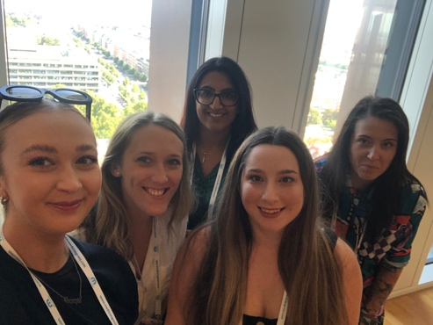
This August members of the SSHRG attended the 19th European Symposium on Suicide & Suicidal Behaviour in Copenhagen, Denmark. The conference involved presentations on suicide prevention, postvention and intervention. 25 world-leading Plenary Speakers and more than 350 Scientists share clinical innovations, treatment strategies and novel approaches for prevention of suicide. The group presented two oral presentations and nine poster presentations.
Poster Award: Community Outpatient Psychotherapy Engagement Service for Self-Harm (COPESS) Feasibility Trial.
Oral Presentations:
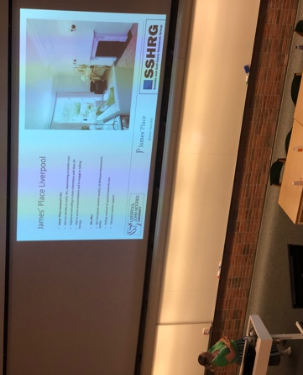
Jane Boland
‘Reducing entrapment and suicide risk through a community intervention’.
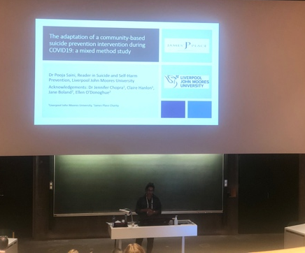
Dr Pooja Saini
‘Adaption of a community-based suicide prevention intervention during COVID-19’.

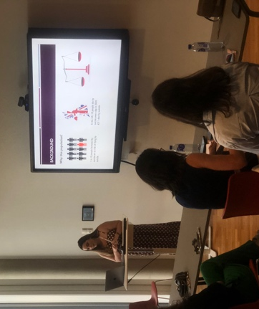
Laura Abbate
‘Suicide postvention services in the United Kingdom’.
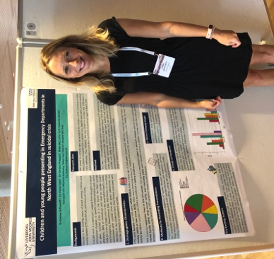
Dr Emma Ashworth
‘Children and Young People Presenting in Emergency Departments in North West England in Suicidal Crisis’.
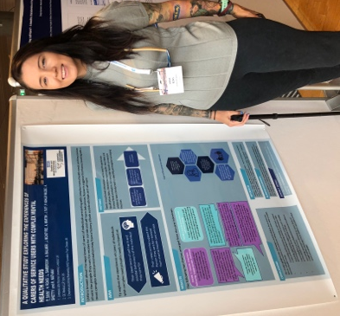
Hana Roks

‘A Qualitative Study Exploring the Experiences of Carers of Service Users with Complex Mental Health Needs’.

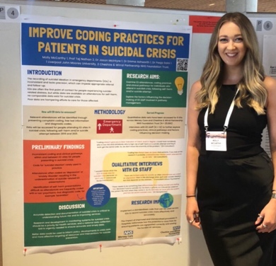
Molly McCarthy
‘Improve coding practices for patients in suicidal crisis’.
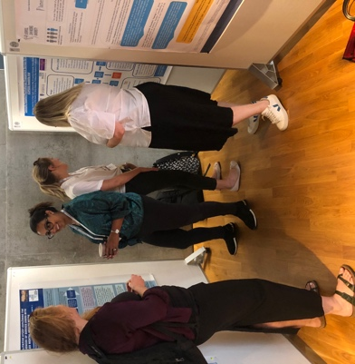
Dr Pooja Saini presenting numerous SSHRG projects:

- COPESS
- COMPAY
- COVID and Carers
- James Place

SSHRG Conference
Conference Details:

Date: 14th December 2022
Time: 10 am – 4 pm
Location: Liverpool Quaker Meeting House, 22 School Lane, L1 3BT.
The event has been designed as an opportunity to discuss current research in the field of suicide and self-harm prevention. The aim is for people from across different sectors to come together to share ideas, discuss future possibilities for research in this area and consider the impact of current events on suicide and self-harm.

From the event, you will be able to:
- Watch short presentations about our current and upcoming projects, including collaborative research with James' Place service, the Menopause Clinic, Postvention services for people bereaved by suicide, schools, emergency departments, and regional mental health trusts.
- Be involved in discussions about our public engagement work, safety planning and upcoming grants.
- Join us for a﻿ panel discussion about the impact of the current cost of living crisis on suicide and self-harm.

Agenda:

Introductions (10.00-10.10am)

Community Intervention Studies (10.15-10.55 am)
- An innovative community-based brief psychological model for men in suicidal crisis (Claire Hanlon).
- Community outpatient psychotherapy engagement service for self-harm (COPESS): A feasibility trial (Pooja Saini).
- A feasibility study of the effectiveness and acceptability of postvention liaison services for individuals bereaved by suicide (Laura Abbate).
- The feasibility and efficacy of the James’ Place brief psychological therapeutic model (Pooja Saini and/or Jen Chopra).
- Self-harm toolkit (Danielle Molloy-Vickers).

Cohort Studies (11.00-11.30 am)
- The impact of intimate partner abuse (Jennifer Chopra).
- Informal carers (Sunny Blaney).
- Suicide prevention in perimenopause (Liv Hendriks).
- Phoenix suicide study (Pooja Saini).

Coffee Break (11.30-11.45 am)

Young People Studies (11.50 am-12.20 pm)
- Crisis report – Alder Hey (Emma Ashworth).
- MAPSS (Emma Ashworth and/or Pooja Saini).
- Impact of COVID on teachers (Emma Ashworth and/or Pooja Saini).
- Parent/children dyad study (Emma Ashworth and/or Pooja Saini).

Hospital Studies (12.25-12.55 pm)
- COMplex mental health PAThways (COMPAT) study: a mixed methods study to inform an evidence-based service delivery model for people with complex needs (Jason McIntyre).
- An evaluation of three transformation projects (Laura Sambrook).
- A specialist mental health transformation change programme (Hana Roks).
- Experiences and decision-making of emergency department staff for people attending in suicidal crisis (Molly McCarthy).
- Crisis Line Evaluation: Alder Hey, Cheshire & Wirral Partnership, Mersey Care and Mid-Mersey (Molly McCarthy).

Lunch (1.00-2.00pm)

Feedback and Discussion (2.00-2.45pm)
Feedback from last year’s workshop. Discussion about safety planning (Claire Hanlon), public engagement and upcoming grants (Pooja Saini). Questions.

Break (2.45-3.00pm)

Panel Discussion (3.00-4.00pm) - Impact of the cost-of-living crisis on self-harm and suicide.
Scan here for Eventbrite link:
Limited spaces available.
Date: 14th December 2022
Time: 10 am – 4 pm
Location: Liverpool Quaker Meeting House, 22 School Lane, L1 3BT
For more updates follow our twitter account: @SSHRG_1

