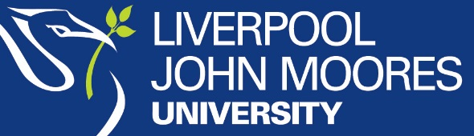
American loans request form
This form will be used to notify Liverpool John Moores University that you intend to borrow a Federal or Private Loan to cover the costs of attending your programme at the University during the 2022/23 academic year. Applications received will be processed from 1 July 2022 onwards.

Title (Miss/Mrs/Ms/Mr)

First Name |  | Middle  Initial |  | Surname

Date of Birth (MM/DD/YY)

LJMU Student ID
(Can be found on your offer letter but if not known leave blank)

Social Security Number

E-Mail
(Please use address you check regularly)

Once completed please scan this form and e-mail to studentadministration@ljmu.ac.uk.
If you need further details concerning US loans and the processes involved please see our website.

