

**The International Journal of**

**Pavement Engineering & Asphalt Technology**

**Volume 24 ISSN 1464-8164 March 2023**

**For:**

* **Roads,Highways, City Streets & Airports**
* **Production and Use of: Concrete & Asphalt Pavements and Bituminous Materials in Civil Engineering and Building Construction**
* **Design, Manufacturing, Specification, Management, Construction, Evaluation and Rehabilitation**
* **IT**

**in Pavement Engineering, Material Technology & Research Focus**

|  |  |  |  |
| --- | --- | --- | --- |
|  |  |  |  |

Editor-in-Chief: Professor Hassan Al Nageim

Editors:

Dr Michael Nunn

Assist. Prof Anmar Dulaimi

K. Karyono

Dr Yangming Gao

**The 20th Annual International Conference on Highways and Airport Pavement Engineering, Asphalt Technology, and Infrastructure**

**April 2022, Adaptive Learning Zone, Liverpool John Moores University, Liverpool, UK**

|  |
| --- |
|  |
|  |
|  |
|  |
|  |

|  |  |  |
| --- | --- | --- |
|  | **The International Journal of Pavement Engineering & Asphalt Technology, PEAT ISSN 1464-8164** |  |
| * **Roads, City Streets, Highways & Airports** * **Production and Use of: Concrete Pavement and Bituminous Materials in Civil Engineering and Building Construction** * **Design, Manufacturing, Specifications, Management, Construction, Evaluations, Rehabilitation,** * **IT in Pavement Engineering, Material Technology & Research Focus** | | |



**Call for Papers**

The *International Journal of Pavement Engineering & Asphalt Technology* has been established as a leading refereed forum. It reports on innovative research; design breakthroughs; construction practices; evaluation techniques; industrial applications; specification & analysis of asphalt binders & mixtures. Authors are invited to submit papers for inclusion in future editions. Theoretical papers should deal with innovation and, wherever possible, the implementation of new materials or techniques. Papers describing work in progress should discuss the long-term practical implications of the research undertaken. Contributions are especially welcome from designers and contractors dealing with new materials or construction / testing techniques (including destructive and non-destructive testing). Papers discussing IT, construction management, environmental maintenance and pavement material performance will also be considered.

*March 2024*

The **International Journal of Pavement Engineering & Asphalt Technology** (ISSN: 1464-8164) is published annually. All rights including translation reserved. The Editors and members of the Journal’s Editorial Review Board are from a range of organisations including academic institutions, oil and chemical producers, government institutions, consulting companies and equipment developers with a wide range of expertise.

Papers or other contributions and the statements made, or opinions expressed therein are published on the understanding that the author of the contribution is solely responsible for the opinion expressed in it and its publication does not imply that such statements and / or opinions are, or reflect the views or opinions of, the Editors, the Editorial Review Board or the Publisher. The views expressed in the Journal do not represent any of the organisations for which the Editors or members of the Editorial Review Board are associated.

No part of this publication may be reproduced, stored in a retrieval system, or transmitted in any form or by any means electrical, mechanical, photocopy, recording or otherwise, without the prior written permission of the Editor –in- Chief.

|  |  |  |
| --- | --- | --- |
|  | **The International Journal of Pavement Engineering & Asphalt Technology, PEAT ISSN 1464-8164** |  |
| **For**   * **Roads, City Streets & Airports** * **Production and Use of: Concrete Pavement and Bituminous Materials in Civil Engineering And Building Construction** * **Design, Manufacturing, Specification, Management, Construction, Evaluation, Rehabilitation,** * **IT in Pavement Engineering, Material Technology & Research Focus** | | |



|  |  |
| --- | --- |
| TABLE OF CONTENTS |  |
| Editors | 5 |
| Editorail Board | 6-7 |
| Editorail | 8 |
| TECHNICAL PAPERS | 9 |
| **EVALUATING THE STRENGTH AND DURABILITY CHARACTERISTICS OF GEOPOLYMER CONCRETE INCORPORATING RECLAIMED ASPHALT PAVEMENT MATERIALS IN ROAD CONSTRUCTION**  Ayana Ghosha\*, GD Ransinchung R.Nb  aPhD Scholar, Department of Civil Engineering, Indian Institute of Technology Roorkee, Uttarakhand, India-247667, a\_ghosh@ce.iitr.ac.in (Corresponding author)  bProfessor, Department of Civil Engineering, Indian Institute of Technology Roorkee, Uttarakhand, India-247667, g.n@ce.iitr.ac.in | 10-21 |
| **Comparison between Linear, Viscoelastic, and Non-Linear Analysis of the Flexible Pavement using KENLAYER Program**  Prof. Dr. Ayman A. Abdulmawjoud, Ass. Prof. Amina A. Shamam, Noor Y. Younis  College of Engineering-University of Mosul-Iraq | 22-42 |
| **INFLUENCE OF ELASTOMERIC POLYMER MODIFIED BITUMEN ON FATIGUE AND RUTTING PERFORMANCE OF BITUMINOUS PAVEMENT**  Gagandeep Singh1, Satish Pandey1, M.N.Nagabhusana2, P.K.Jain3  1Principal Scientist, CSIR- Central Road Research Institute, New Delhi, India  2Ex- Senior Principal Scientist, CSIR- Central Road Research Institute, New Delhi, India  3Ex-Chief Scientist, CSIR- Central Road Research Institute, New Delhi, India  Corresponding Email ID- singh1830@gmail.com, satishpandey.crri@nic.in | 43-56 |
| **IMPERATIVE ROLE OF WASTE JAROSITE ON RUTTING AND FATIGUE PROPERTIES OF ASPHALT MASTIC AND MIXES**  Sk Sohel Islama\*, GD Ransinchung R.Nb, Jayvant Choudharyc,  aPhD Scholar, Department of Civil Engineering, Indian Institute of Technology Roorkee, Uttarakhand, India-247667, ssohelislam@ce.iitr.ac.in (Corresponding author) \*  bProfessor, Department of Civil Engineering, Indian Institute of Technology Roorkee, Uttarakhand, India-247667, g.n@ce.iitr.ac.in  cAssistant Professor, Department of Civil Engineering, Madhav Institute of Technology & Science, Gwalior, India-474005, jayvant.chaudhary.civ13@itbhu.ac.in | 57-75 |
| **LARGE SCALE STATIC TESTING OF ASPHALT UNDERLAYS IN RAILWAY TRACK FOUNDATION**  Zelong Yu1\*, David Connolly2, Peter Woodward3, Omar Laghrouche4  1\* Lecturer, School of Civil Engineering and Built Environment, Liverpool John Moores University, L3 3AF. Email: Z.Yu@ljmu.ac.uk.  2 Associate Professor, School of Civil Engineering, University of Leeds, Leeds, LS2 9JT. Email: D.Connolly@leeds.ac.uk.  3 Professor, School of Civil Engineering, University of Leeds, Leeds, LS2 9JT. Email: P.K.Woodward@leeds.ac.uk.  4 Professor, Institute for Infrastructure and Environment, Heriot-Watt University, Edinburgh, EH14 4AS. Email: [o.laghrouche@hw.ac.uk](mailto:o.laghrouche@hw.ac.uk).  \* Corresponding author | 76-91 |
| Content of Previos Issues | 92-112 |
| Information for Prospective Authors | 113-114 |
| Subscription Form | 115 |
| Instruction to Make Online Payment for Subscription | 116 |



|  |  |  |
| --- | --- | --- |
|  | **The International Journal of Pavement Engineering & Asphalt Technology, PEAT ISSN 1464-8164** |  |
| **For**   * **Roads, City Streets & Airports** * **Production and Use of: Concrete Pavement and Bituminous Materials in Civil Engineering And Building Construction** * **Design, Manufacturing, Specification, Management, Construction, Evaluation, Rehabilitation,** * **IT in Pavement Engineering, Material Technology & Research Focus** | | |

EDITORS



**Professor Hassan Al Nageim**

Liverpool John Moores University, UK

Editor-in-Chief

**Dr. Michael Nunn**

Transport & Road Research Laboratory, UK

Editor

****



**Assist. Prof Anmar Dulaimi**

University of Warith Al-Anbiyaa, Iraq;

Liverpool John Moores University, UK, Editor

**Dr Yangming Gao**

Liverpool John Moores University, UK,

Editor

**K. Karyono**

Liverpool John Moores University, UK

Universitas Multimedia Nusantara, Indonesia, Editor

EDITORIAL BOARD

|  |  |  |
| --- | --- | --- |
| **Professor A. Woodside**, Emeritus Professor in Highway Engineering, Ulster University, UK |  | **Mr. I. Walsh**, Head of Laboratories,  Babtie Laboratory, UK |
| **Mr. F. Chaignon**, Department of Research & Development, Colas, France |  | **Dr. G. White**, University of the Sunshine Coast, Australia |
| **Mr. D. Day**, Nynas Bitumen, UK |  | **Dr. R. Douglas**, University of Canterbury, New Zealand |
| **Dr. Manar Hamzah Herez**  Department of Civil Engineering, Kufa University, Iraq |  | **Dr. Hassnen M. Jafer**  Civil Engineering Department, College of Engineering, University of Babylon, Iraq |
| **Dr. M.N.S. Hadi**, Faculty of Engineering, University of Wollongong, Australia |  | **Dr. L. Gaspar**, KTI, Hungary |
| **Dr. R. Hunter**, Consulting Civil Engineers, Hunter & Edgar, UK |  | **Professor E. Santagata**, Politecnico di Torino, Torino, Italy |
| **Dr. Hayder Kamil Shanbara**  Department of Civil Engineering, Al-Muthanna University, Iraq |  | **Dr. Abbas Al-Hdabi**  Civil Engineering Department, Faculty of Engineering, Kufa University, Iraq |
| **Dr. J.M. Reid,** Senior Technical Manager, TRL, UK |  | **Dr. I.L. Jamieson**, Ireland |
| **Dr. J.C. Nicholls**, UK |  | **Dr. R.J. Ellis**, Aggregate Industries UK Limited |
| **Assist. Prof. Basim Hassan Al-Humeidawi**  Roads and Transport Department, College of Engineering, University of Al-Qadisiyah, Iraq |  | **Dr. Tariq Al-Mansoori**  Department of Civil Engineering, Al-Muthanna University, Iraq |
| **Dr. S. Said,** Swedish National Road & Transport Research Institute, Sweden |  | **Professor A.F. Nikolaides**, Department of Civil Engineering, University of Thessaloniki, Greece |
| **Dr. W. Woodword**, Highway Engineering Research Group, Ulster University, UK |  | **Dr. R.A. Peden**, Tennants Tar Distillers, UK |
| **Assist. Prof. Dr. Jalal Al-Obaedi**  Roads and Transport Department, College of Engineering, University of Al-Qadisiyah, Iraq |  | **Dr. Mahdi Al-Naddaf**  Dept. of Civil Engineering, College of Engineering, the University of Karbala, Iraq**.** |
| **Professor M. Pasetto**, University of Padua, Italy |  | **Ms. E.S. Caballero**, R&D Investigator Acciona Infrastructures, Spain |
| **Dr. Hamid Athab Eedan Al-Jameel**  College of Engineering, University of Kufa, Iraq |  | **Dr. Alaa M Shaban**  Department of Civil Engineering, Engineering College, University of Kerbala, Iraq |
| **Dr. Anmar Dulaimi**  Department of Civil Engineering, University of Warith Alanbiyaa, Iraq; Department of Civil Engineering, Liverpool John Moores University, UK |  | **Assist. Prof. Dr. Shakir Al-Busaltan**  Department of Civil Engineering, University of Kerbala, Iraq |

EDITORIAL

*Liverpool Centre for Materials Technology*

***The 20th Annual International Conference on Highways and Airport Pavement Engineering, Asphalt Technology, and Infrastructure***

April 2022, Adaptive Learning Zone, Liverpool John Moores Univ., Liverpool, UK

**SPONSORED & SUPPORTED BY:**

**ASI Solutions♦ Colas Ltd♦ Total Energies♦ WDM ltd ♦ Velocity UK♦** **Highways England♦ The Chartered Institution of Highways and Transportation (CIHT)♦ The Institution of Asphalt Technology (IAT)♦The Institution of Civil Engineers (ICE), UK**

**LJMU 2022 Conference**

The Department of Civil Engineering at Liverpool John Moores University in association with ASI Solutions and Colas Ltd is hosting its 20th Annual International Conference addressing: Highways and Airport Pavement Engineering, Asphalt Technology, and Infrastructure International Conference.

**Conference theme**

Conference is aimed at stakeholders with specific interest in the; development, construction and management of asphalt technology, sustainable infrastructure, environmental protection and energy reduction, aggregate recycling initiatives, airport and highways design and maintenance. The conference will be of interest to; policy advisors, environmental regulators, infrastructure clients, specifiers, planners, designers, local authorities, highway related consultants and designers, materials suppliers, construction companies, contractors and educational institutions.

**WHO SHOULD ATTEND?**

The conference will be of interest to; policy advisors, environmental regulators, infrastructure clients, specifiers, planners, designers, local authorities, highway related consultants and designers, materials suppliers, construction companies, contractors and educational institutions.

**PUBLICATIONS**

The papers will be reviewed by the conference scientific and technical board and published in the conference proceedings. Selected papers will also be refereed and published in a special issue of the International Journal of Pavement Engineering and Asphalt Technology, ISBN 1464-184.

TECHNICAL PAPERS

**EVALUATING THE STRENGTH AND DURABILITY CHARACTERISTICS OF GEOPOLYMER CONCRETE INCORPORATING RECLAIMED ASPHALT PAVEMENT MATERIALS IN ROAD CONSTRUCTION**

Ayana Ghosh\*, GD Ransinchung R.Nb

aPhD Scholar, Department of Civil Engineering, Indian Institute of Technology Roorkee, Uttarakhand, India-247667, a\_ghosh@ce.iitr.ac.in (***Corresponding author***) \*

bProfessor, Department of Civil Engineering, Indian Institute of Technology Roorkee, Uttarakhand, India-247667, g.n@ce.iitr.ac.in

doi: 10.1515/ijpeat-2016-0051

**ABSTRACT**

Developing alternative binders in the construction industry by the utilization of different industrial wastes, aims to mitigate the augmenting demand for adopting sustainable approaches. The current study convenes on the efficacy of employing fly ash and ground granulated blast furnace slag as synthesizing source materials for geopolymer concrete. Reclaimed asphalt pavement materials (RAP) have been used to partially replace natural coarse aggregates varying over 20% to 50% and the performance of the designed binders was evaluated in terms of achieved strength, durability and microstructural properties. Experimental results accentuated that the developed RAP-FA blends at a fixed 14M concentration of Sodium Hydroxide (NaOH) fail to achieve the desired strength (40 MPa in compression for Pavement Quality Concrete) at room temperature. However, there is substantial strength improvement with the incorporation of GGBS for 28days ambient cured specimens. However, for RAP-FA blends, results depicted a decrement in compressive strength at increased RAP content compared to RAP-FA-GGBS blend. The latter exhibits maximum strength at 30% replacement percentage by RAP (52MPa) following which the strength radically decreases. Furthermore, a defined study for assessing durability property was also conducted by immersing the specimens in 5% sulphuric acid solution. Results portray that contrary to the general trend of compressive strength decrement on the inclusion of RAP aggregates, the sulphuric acid resistance showed significant improvement due to the presence of adhered asphalt. Analysing the compressive strength data using ANOVA exhibited statistical significance for all the considered parameters.

**Keywords:**

Reclaimed asphalt pavement, Geopolymer concrete, Durability, Fly Ash, Ground granulated blast furnace

**INTRODUCTION**

Sustainable construction practices are the need of the hour. Any initiative fostering the reduction of carbon foot-print contributing to global warming is of relevance. Concrete is the highest man-made material in terms of consumption world-wide and cement serves as the primary component of manufacturing concrete. This industry contributes to almost 10% of the cumulative global CO2 emission. 1 ton of production of OPC (Ordinary Portland Cement) releases an almost equal amount of carbon dioxide in the atmosphere which led the researchers to come up with alternative environmentally friendly solutions thereby leading to the production of greener concrete. Moreover, in developing economies like that of India and China, which primarily depends on thermal power subsequently produces a huge amount of Fly Ash as industrial by-product.

Geopolymers are primarily alumino-silicate materials that are activated using alkaline solutions. The term “Geopolymer” was first coined by Davidovits, a French Professor who is considered a pioneer in this field in the year 1978 representing broad range of materials characterized by networks of inorganic molecules (Davidovits, 1984; Davidovits 2008).

The geopolymerisation reaction mechanism is depicted in Equations (1.1) and (1.2) Activation and setting are the two stages of this reaction. The underlying principle governing this reaction mechanism that completely differentiates it in comparison to hydration reaction is that water does not take part in the reaction and primarily contributes towards the workability of the mix. Geopolymerisation basically involves a three-step mechanism commencing with the dissolution of silica and alumina from the source materials followed by coagulation and gelation of the dissolved materials which subsequently polymerizes to form 3-D networks of silica-aluminate structures. Thus, it may be inferred that the geopolymer concrete (GPC) is fundamentally re-utilizing the supplementary cementitious materials and takes a way forward towards sustainability and eco-friendliness (Saloma et al., 2017; Purwanto et al., 2018; Jindal et al., 2019; Hassan et al., 2020)

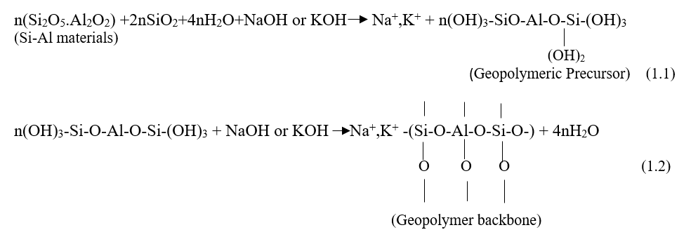

Additionally, in the current scenario where the natural resources are depleting, any construction initiatives must rely on alternate aggregate resources to prevent the environmental instability. In this dilemma of infrastructure development being environmentally friendly, the innovative alternative is utilization of recycled aggregates in construction of highways in place of natural aggregates. Reclaimed Asphalt Pavement aggregates are pavement materials that are removed and /or reprocessed containing asphalt (bitumen) and aggregates from bituminous pavements. Reclamation of materials could be done by milling, pavement demolition and full depth reclamation. From the existing literature review, it is evident that the RAP aggregates generated in a cleaner way usually consist of a soft-coated asphalt layer engulfing its periphery. Utilization of this type of RAP usually lowers its potential in cement concrete pavement mixes due to its high asphalt concentration, agglomerated particles, and gap-graded nature.

However, it may be contemplated that the stresses induced in concrete pavements are predominantly flexural. Therefore, designing mixes based on flexural strength criterion is considered for rigid pavements. The minimum characteristics flexural strength of concrete shall not be less than 4.5MPa unless otherwise specified (MoRTH 2013). Comprehensive studies have reported that GPC incorporating RAP can attain the desired strength when designed precisely. Furthermore, for pavements, consideration of durability is obligatory in predicting the service life since they are exposed outside, often in harsh environments. Athika et al., investigated the performance properties of high calcium Fly Ash (FA)-GPC and concluded that the existence of adhered asphalt surrounding the aggregates benefitted in terms of increased sulphate-acid resistance and surface abrasion although it resulted in decreased compressive strength. The thermal conductivity also showed improved results. Although the experimental results highlighted a decrement in compressive strength with 20% RAP incorporation, yet it was higher than the recommended value of 40MPa for Pavement Quality Concrete (PQC) (MoRTH 2013)

**SCOPE OF WORK**

This study highlights the potential utilisation of RAP aggregates in designing geopolymer mixes that may be applied in PQC layer of rigid pavements. RAP aggregates have been used to replace natural coarse aggregates varying over 20%-50% and the developed binders were subjected to compressive test and flexural test. Fly Ash (FA) and Ground Granulated Blast Furnace Slag (GGBS) were selected as geopolymer synthesising source materials. Experimental studies pertained to RAP-FA (designated as Mix A) and RAP-FA-GGBS (designated as Mix B) was conducted, and results analysed statistically. The control mixes were designed using natural virgin aggregates to understand the effectiveness of RAP incorporation.

**MATERIALS AND MIX DESIGN**

The primary silicate source material that was used for preparing the geopolymer specimens was low calcium Class F Fly Ash and it was collected from NTPC, Dadri, India conforming to Indian standard code (IS: 3812-2013) The GGBS were procured from Bhilai Steel Plant, Chattisgarh, India. The natural coarse and fine aggregates were obtained from a local quarry and the RAP aggregates were reclaimed from a 20-year-old flexible pavement, NH 334, Uttarakhand, India.

Sodium Hydroxide (NaOH) and Sodium Silicates were used as Alkaline activator Solutions (AAS) with a fixed ratio of Na2Sio3/ NaOH as 2.5 and AAS/binder ratio of 0.3. The experimental programme was designed keeping the concentration of NaOH fixed at 14M. The specimens were subjected to ambient curing and tested for compression at 7 and 28days. However, the flexural strength was reported at 28days of curing. Polycarboxylate Ether (PCE) was used as an admixture for achieving the desired level of workability. Table 1 represents the physical properties of natural coarse and fine aggregates. The RAP aggregates were sieved through 4.75mm IS sieve to separate out the coarser and finer aggregates. The retained fraction was used in this study having a specific gravity of 2.43, water absorption of 1.3% and bitumen content of 3.5%.

**SAMPLE PREPARATION**

The NaOH pellets were mixed with water as per the requisite molarity and were followed by the addition of Na2SiO3 after an interval of 4hrs. Since the reaction is exothermic, the activator solution was prepared 24hrs before casting. The aluminosilicate source materials along with the aggregates were mixed dry in a pan-type mixer for 3minsfollowed by the additionof alkaline solution and admixture. All the mixes were designed using a 2% PCE dosage for achieving the required strength with desirable workability. The mix was then cast in respective moulds as per relevant Standards for determining compressive strength, flexural strength, and split tensile strength.

**Table 1.** Properties of the coarse and fine aggregates

|  |  |  |  |  |
| --- | --- | --- | --- | --- |
| Coarse Aggregates | |  | Fine Aggregates | |
| Property | Value |  | Property | Value |
| Specific Gravity | 2.72 |  | Specific Gravity | 2.70 |
| Water Absorption (%) | 0.59 |  | Water Absorption (%) | 1.40 |
| Density (kg/lit) | 1.826 |  | Loose Bulk Density (kg/lit) | 1.58 |
| Percent Voids | 41 |  | Roller Bulk Density (kg/lit) | 1.9 |
| Aggregate Impact Value (%) | 18 |  | Percent Voids | 40 |
| Aggregate Crushing Value (%) | 22.30 |  |  |  |
| Los Angeles Abrasion Value (%) | 24 |  |  |  |

**EXPERIMENTAL PROGRAMME**

**Testing Methodology**

*Compressive strength*

For determining the compressive strength, concrete cubes of dimension 100mm x 100mm x 100mm were cast and tested for compression at 7 and 28 days of ambient curing as per relevant Indian Standard (IS 516-2004). The testing was performed in an Automatic Compression Testing Machine (CTM) having a capacity of 3000 KN with a gradual application of load @140 kg/cm2/minute. The maximum applied load was noted down and the corresponding compressive strength of the cubical specimen was calculated using Eq. (2).

Compressive strength=(Maximum load applied to the cubes)/(Cross-sectional area) (2)

Three specimens per mix per age were used for the compressive strength test and the average compressive strength in MPa is reported for all ages and curing conditions.

*Flexural strength*

Flexural strength is recognized as an indirect measure of the tensile strength of concrete. Evaluation of the flexural strength of concrete was determined using a prismatic beam specimen of 500mm x 100mm x 100mm size as per relevant standards (IS:516-1959; IS:10086-1982). For each mix proportion, three numbers of prisms were cast and tested at the age of 28 days. An automated flexural testing machine applying a four-point bending load on the prismatic specimens was used for conducting this test.

*Acid resistance test*

In order to identify the long-term performance of the studied geopolymer mixes, the ambient and oven-cured samples were exposed to sulphuric acid solution (H2SO4) having a pH 3 and tested for residual compressive strength at the end of 28days. During the entire period of soaking, a pH meter was used to monitor the pH of the solution. The samples were immersed in the aggressive media till the concrete specimens reached an age of additional 28days. The solution was renewed every two weeks to maintain the concentration throughout the study.

**RESULTS AND DISCUSSION**

**Characteristics of studied aluminosilicate wastes**

Scanning Electron Microscope (SEM) images of all studied wastes are presented in Figure 1. The microstructural image clearly exhibits the spherical shape of the FA which is considered to be the fundamental reason for enhancing workability in the mix when FA is used. The chemical properties of the studied wastes as obtained from X-Ray Fluorescence are presented in Table 2. The FA and GGBS exhibit 59.18 and 33.52% of silica respectively. The presence of high CaO (41.5%) establishes a significant calcium source for the geopolymer binder production. The presence of heavy metal oxides is also seen in traces providing a possibility of deeming non-hazardous on geopolymeric stabilization. The XRD images presented in Figure 2 show the distinct crystalline peaks present in FA with maximum Quartz phase. GGBS being amorphous in nature doesn’t exhibit strong peaks.

|  |  |
| --- | --- |
| **(a) Fly ash** | (b) Ground granulated blast furnace slag |
| (a) Fly ash | (b) Ground granulated blast furnace slag |
| **Figure 1.** SEM images of studied fillers | |

|  |  |
| --- | --- |
| (a) Fly ash |  |
| (a) Fly ash b) GGBS | |
| **Figure 2.** XRD images of studied wastes | |

**Table 2.** Chemical composition of the studied waste materials

|  |  |  |  |  |  |  |  |  |  |  |
| --- | --- | --- | --- | --- | --- | --- | --- | --- | --- | --- |
| Material | SiO2 | TiO2 | Al2O3 | Fe2O3 | MgO | Cao | Na2O | Cr2O3 | NiO | LOI |
| FA | 59.18 | 1.56 | 31.18 | 4.31 | 0.41 | 0.96 | 0.09 | 0.037 | 0.013 | 2.1 |
| GGBS | 33.52 | 0.51 | 14.10 | 0.66 | 6.53 | 41.51 | 0.15 | - | - | 10.77 |

**Compressive Strength**

The compressive strength of concrete is considered as an index to assess its overall quality. The compressive strength data for mix A and mix B are presented in Figure 3 and Figure 4 respectively. Results clearly portray that the presence of the asphalt layer adhered to the aggregate surface does influence the strength properties developed.

|  |  |
| --- | --- |
|  |  |
| **Figure 3.** Compressive strength for Mix A | **Figure 4**. Compressive strength for Mix B |

Maximum compressive strength of 52 MPa was obtained for the mix BRAP30, having 60% FA + 40% GGBS with a RAP content of 30% at 28 days of curing. It is interesting to note that for mixes designed with only FA as the binder, the maximum 28 days strength obtained was 20MPa which shortfalls the prerequisite 40MPa compressive strength for constructing PQC layer in rigid pavements. This highlights the fact that use of only FA as geopolymeric synthesizer at ambient curing is not feasible for designing PQC mixes. However, substantial strength improvement along with accelerated hardening was achieved on the incorporation of GGBS with FA. The probable reason may be the presence of higher calcium content in the mix due to GGBS which helps in formation of additional C-S-H along with geopolymer gel in the matrix thereby imparting strength (Yip et al., 2005; Yip et al., 2008). Studies have reported that the the hardening process is initiated by the precipitation of C-S-H/C-A-S-H, and rapid hardening continues on account of an accelerated geopolymerization (Puligilla and Mondal 2013). Although it may be understood that the incorporation of GGBS resulted in a stiffer mix with lesser workability that that of FA based mixes. Results show that the incorporation of RAP aggregates in place of natural coarse aggregates shows marginal increase for both 7 and 28days. For the samples tested for compression at 7 and 28days of curing, the mix ARAP20 consisting of 100% FA and 20% RAP developed 17.23MPa and 22.19MPa respectively. Results exhibit a decrease in compressive strength with RAP content of more than 20%. This may be due to the formation of weaker ITZ, reduced bulk modulus and decreased bonding between asphalt and geopolymer matrix. Past research has also reported increased porosity in ITZ resulting in strength decrement (Brand et al., 2016; Toledo et al., 2018). However, the underlying reason for best performance of mix BRAP30 may be attributed to the effect of the formation of addition gel in the geopolymer matrix due to excess calcium from GGBS dominates over the adverse effects of RAP inclusion. Overall, it may be inferred that inclusion of RAP aggregates although increases strength marginally at lower replacement percentages or decreases significantly at a higher percentage of replacement, yet its utilization is beneficial in fulfilling the minimum strength criteria for rigid pavement design. This study thus suggests using RAP in GPC for pavement application but at maximum replacement percentage of 30%.

**Flexural Strength**

For designing rigid pavements, importance is directed towards achieving the minimum flexural strength criteria of 4.5MPa. Variation of 28-days flexural strength of all the studied concrete mixes is presented in Table 3. For this study, the 28-days flexural strength data exhibited similarity with the performance of the studied specimens under compressive testing. Higher flexural strength could be achieved with GGBS incorporation and almost all the mixes fulfilled the minimum strength prerequisite except BRAP50. Similar to the compressive strength formation, results exhibit that using FA alone as the synthesising source could achieve a maximum strength of 3.6MPa at ambient curing thereby reinforcing its inadequacy to be used solely for PQC construction. Inputs from past literature on RAP-GPC mixes are very limited so authors try to understand the phenomenon by comparing it with convention RAP mixes. Results depict that there is marginal increase in flexural strength upto 30% RAP incorporation.

The reason might be the presence of aged-stiff asphalt layer around the RAP aggregates and its well-graded particle size distribution (Hossiney et al., 2010; Huang et al., 2006; Singh et al., 2018). Researchers have also reported enhanced prevention of crack propagation due to the presence of adhered asphalt exhibiting visco-elastic properties (Huang et al., 2005; Brand et al. 2015).

**Table 3.** 28 days flexural strength of studied mixes

|  |  |  |  |
| --- | --- | --- | --- |
| MIX ID | Material Proportion | | Flexural Strength (MPa) |
|  | Fly Ash (%) | GGBS (%) |  |
| ARAP0 | 100 | 0 | 3.56 |
| ARAP20 | 3.60 |
| ARAP30 | 3.41 |
| ARAP40 | 3.30 |
| ARAP50 | 2.84 |
| BRAP0 | 60 | 40 | 5.32 |
| BRAP0 | 5.36 |
| BRAP0 | 5.50 |
| BRAP0 | 4.70 |
| BRAP0 | 4.31 |

**Sulphuric Acid Exposure**

Assessment of durability is indispensable in predicting the service life of a structure. Apparently, like the compressive strength, the durability of concrete is not an inherent property and has to be ensured considering the various factors that may affect its long-term performance. Figure 5 represents the percentage reduction in compressive strength of ambient and oven-cured specimens when immersed in 5% H2SO4. Studies indicated that the dealumination and depolymerization of geopolymer gels are the primary reasons for the degradation of mechanical properties after the sulphuric acid attack (Zhang et al., 2016). Experimental results show that for both mix A and B, with increase in RAP content, reduction in strength loss due to exposure in aggressive environment decreases. Maximum strength deterioration has been observed for the control mixes having natural aggregates.



**Figure 5**. Reduction in compressive strength of all mixes on sulphuric acid exposure

However, results highlight a better trend for mixes incorporating GGBS where loss in strength was marginally lesser than that of FA-GPC. This may be due to increase in porosity which allows the transportation of sulphate ions in the specimen (Abraham and Ransinchung 2018 a,b ). Thus, it may be inferred that incorporation of RAP aggregates enhances the durability properties of the developed GPC binders.

**Statistical Analysis**

In statistics, analysis of variance (ANOVA) is an important technique to determine whether there is a significant difference between two or more sample means of populations. To statistically evaluate the effects of RAP proportions on the compressive and flexural strength of studied mixes, two-way ANOVA with a 95% confidence interval (𝛼 = 0.05) was carried out in this research and the results reported in Table 4 and Table 5. The independent variables are the curing time of 7 and 28 days respectively and the RAP content represented by Mix Type, whereas compressive strength of the RAP-GPC is the dependent variable. The obtained F value is less than F critical thereby rendering the relationship significant.

**Table 4.** Two Way ANOVA for compressive strength of Mix A

|  |  |  |  |  |  |  |
| --- | --- | --- | --- | --- | --- | --- |
| *Source of Variation* | *Sum of Square* | *df* | *Mean Square* | *F* | *P-value* | *F critical* |
| Mix type | 243.7966 | 4 | 60.94916 | 479.0972 | 1.51E-19 | 2.866081 |
| Curing time | 219.9979 | 1 | 219.9979 | 1729.317 | 6.76E-21 | 4.351244 |
| Interaction | 3.322713 | 4 | 0.830678 | 6.529634 | 0.001568 | 2.866081 |
| Within | 2.544333 | 20 | 0.127217 |  |  |  |
|  |  |  |  |  |  |  |
| Total | 469.6616 | 29 |  |  |  |  |

**Table 5.** Two Way ANOVA for compressive strength of Mix B

|  |  |  |  |  |  |  |
| --- | --- | --- | --- | --- | --- | --- |
| *Source of Variation* | *Sum of Square* | *df* | *Mean Square* | *F* | *P-value* | *F critical* |
| Mix type | 1397.47 | 4 | 349.3676 | 1269.028 | 9.5006E-24 | 2.866081 |
| Curing time | 557.1106 | 1 | 557.1106 | 2023.625 | 1.4264E-21 | 4.351244 |
| Interaction | 48.65275 | 4 | 12.16319 | 44.18104 | 1.1776E-09 | 2.866081 |
| Within | 5.506067 | 20 | 0.275303 |  |  |  |
|  |  |  |  |  |  |  |
| Total | 2008.74 | 29 |  |  |  |  |

**CONCLUSIONS**

From the current study the following conclusions may be arrived at-

1. Use of RAP aggregates in place of natural virgin aggregates is acceptable for the construction of PQC layer of geopolymer rigid pavements, however its use over 30% exhibits significant strength loss characteristics.
2. RAP-GPC exhibits enhanced durability when exposed to aggressive environment as compared to conventional GPC using natural aggregates.
3. Minimum strength criteria both in terms of compression and tension cannot be achieved using FA as the single source material when the specimens are cured under ambient conditions. Hence its use is discouraged in the construction of PQC layer.
4. Incorporation of GGBS has shown promising results in terms of both strength and durability performance, however it resulted in the formation of a stiffer mix as compared to FA-GPC.

**REFERENCES**

Abraham, S. M., Ransinchung, G.D.R.N., 2018a. “Strength and permeation characteristics of cement mortar with Reclaimed Asphalt Pavement Aggregates” Constr. Build. Mater. 167, 700–706, https://doi.org/10.1016/j.conbuildmat.2018.02.075.

Abraham, S. M., Ransinchung, G.D.R.N., 2018b. “Influence of RAP aggregates on strength, durability and porosity of cement mortar, Constr. Build. Mater. 189, 1105–1112, https://doi.org/10.1016/j.conbuildmat.2018.09.069.

Athika, W., Patcharapol, P., Apichit, K., Traitot, K., 2021. “Beneficial utilization of recycled asphaltic concrete aggregate in high calcium fly ash geopolymer concrete,” Case Studies in Cons. Mater. vol. 15, e00615,

Brand, A.S., Roesler, J.R., 2017. “Bonding in cementitious materials with asphalt-coated particles: part I-the interfacial transition zone”, *Constr. Build. Mater.* 130 171–181, doi: http://dx.doi.org/10.1016/j.conbuildmat.2016.10.019.

Brand, A. S., and Roesler, J. R. 2015. “Ternary concrete with fractionated reclaimed asphalt pavement.” *ACI Materials Journal*, 112(1), 155–163.

Davidovits, J. 1984. “Pyramids of Egypt Made of Man- Made Stone, Myth or Fact?” *Symposium on Archaeometry*. Smithsonian Institution, Washington, DC.

Davidovits, J. 2008. “Geopolymer Chemistry and Applications”. Institute Géopolymère, Saint-Quentin, France.

Hassan, A., Arif, M., Shariq, M., 2020, “Mechanical behaviour and microstructural investigation of geopolymer concrete after exposure to elevated temperatures.” *Arabian J. Sci. Eng*. 45 (5), 3843-3861

Hossiney, N., Tia, M., and Bergin, M. J. 2010. “Concrete containing RAP for use in concrete pavement.” *Int J. Pav Res and Tech*, 3(5), 251–258.

Huang, B., Shu, X., and Burdette, E. G. (2006). “Mechanical properties of concrete containing recycled asphalt pavements.” *Magazine of Concrete Research*, 58(5), 313–320.

Huang, B., Shu, X., and Li, G. (2005). “Laboratory investigation of portland cement concrete containing recycled asphalt pavements.” *Cement and Concrete Research*, 35(10), 2008–2013

IS:3812. 2013. Specification for Pulverized Fuel Ash, Part 1: For Use as Pozzolana in Cement, Cement Mortar and Concrete. Bur. Indian Stand. New Delhi, India

IS: 516. 2004. Standard methods of tests for strength of concrete. Bureau of Indian Standards, New Delhi, India

IS:10086. 2004. Standard specification for moulds for use in tests of cement and concrete. Bureau of Indian Standard, New Delhi, India

Jindal, B.B., 2019. “Investigations on the properties of geopolymer mortar and concrete with mineral admixtures: a review.” *Construct. Build. Mater*. 227

MoRTH, 2013. Specifications for Road and Bridge Works (Fifth Revision), Ministry of Road Transport and Highways. Indian Road Congress, New Delhi, India.

Pereira, D. S., Silva, F. J., Porto, A. B. R., Candido, V. S., Silva, A. C. R., Filho, F.D.C.G. Monteiro, S. N., 2018. “Comparative analysis between properties and microstructures of geopolymeric concrete and portland concrete”, *J. Mater. Res. Technol*. 7 606–611, doi: http://dx.doi.org/10.1016/j. jmrt.2018.08.008

Puligilla, S., Mondal, P., 2013. “Role of slag in microstructural development and hardening of fly ash-slag geopolymer”, *Cem. Con. Res.* 43, 70-80 https://doi.org/10.1016/j.cemconres.2012.10.004

Purwanto, Han, A.L., Nuroji, Jaya Ekaputri, J., 2018. “The influence of molarity variations to the mechanical behavior of geopolymer concrete”. *MATEC Web of Conferences.* 195.

Singh, S., Ransinchung, G. D., Debbarma, S., and Kumar, P. 2018. “Utilization of reclaimed asphalt pavement aggregates containing waste from Sugarcane Mill for production of concrete mixes.” *Journal of Cleaner Production*, 174, 42–52.

Saloma, Hanafiah, Elysandi, D.O., Meykan, D.G., 2017. “Effect of Na2SiO3/NaOH on mechanical properties and microstructure of geopolymer mortar using fly ash and rice husk ash as precursor”. *AIp Conf. Proceed.* 1903

Yip, C. K., Lukey, G. C., Van Deventer, J. S. J., 2005. “The coexistence of geopolymeric gel and calcium silicate hydrate at the early stage of alkaline activation”, *Cem. Concr. Res*. 35 (9) 1688–1697.

Yip, C. K., Lukey, G. C., Provis, J. L., Van Deventer, J. S. J., 2008. “Effect of calcium silicate sources on geopolymerisation” *Cem. Concr. Res*. 38 (4) 554–564.

Zhang, M., M. Zhao, G. Zhang, D. Mann, K. Lumsden, and M. Tao. 2016. “Durability of red mud-fly ash based geopolymer and leaching behavior of heavy metals in sulfuric acid solutions and deionized water”. *Constr. Build. Mater*. 124, 373-382.

**Comparison between Linear, Viscoelastic, and Non-Linear Analysis of the Flexible Pavement using KENLAYER Program**

Prof. Dr. Ayman A. Abdulmawjoud, Ass. Prof. Amina A. Shamam, Noor Y. Younis

College of Engineering-University of Mosul-Iraq

Corresponding author Email: aymanmawjoud@uomosul.edu.iq

doi: 10.1515/ijpeat-2016-0052

**Abstract**

Roads are one of the country's most significant infrastructures. Overloading vehicles on Iraqi roads is a major problem in the flexible pavement, which can lead to early asphalt road degradation. As a result, fatigue and rutting are two types of asphalt road failure that must be concerned. The goal of the study is to use the (KENLAYER) program to determine fatigue and rutting failures by assessing the performance of flexible pavement using the Mechanistic-Empirical Method (M-E). HMA layers act as viscoelastic material under real-world situations, assuming that the pavement structures form a linear multi-layer structure for flexible pavement, and their mechanical responses depend on temperature and loading, and the granular layers act as a nonlinear material. Axial load proportions were used of 50%, 100%, 150%, and 200% of the standard axle load according to Iraqi specifications. The results revealed that the highest tensile strain values among the layers occurred at asphalt stabilized base coarse of the single axle of (-1.5\*10-4) for the standard load, while the highest compressive strain values exist at the top of the subbase layer of the single axle with dual tires of (4.761\*10-4) for the standard load. The highest value of damage ratio in linear case was existing at the asphalt stabilized base course with a value of (0.04426) at standard load. It was also found that the design life decreases by 9 times when increasing the load twice the standard load, which in turn reduces the paving efficiency. It was shown that the highest values of tensile and compressive strain and the highest damage value were in the case of viscoelastic analysis (static vehicle) and that the pavement life in linear analysis decreases in the case of the static vehicle. While the pavement life increases in the case of vehicle movement due to the viscoelastic behavior.

*Keywords: damage ratio, distress, flexible pavement, KENLAYER, mechanistic-empirical method.*

1. **INTRODUCTION**

Flexible pavement design is one of the most important components in the sustainability of the road network infrastructure, which is closely related to civil activities such as commerce, industry, environment, and others, as well as its important role in road quality in terms of safety and reducing accidents [1]. The main purpose of pavement is the transfer of stresses arising from traffic on the road surface through other pavement layers until their effect reaches the soil layer. The validity of the pavement and its tolerance of these stresses depends in complex ways that are affected by the stress condition, its value, temperature, humidity, time, loading rate, and other factors. High levels and varying environmental conditions lead to more complications, so pavement design aims are to determine the appropriate thickness of the pavement layers above the soil so that it gives a good and flat surface under traffic without deterioration and collapse [2, 3]. Therefore, the aims of pavement layers are to resist traffic loads that in turn cause distress to the road, such as fatigue and rutting [4].

The repetition of traffic whose traffic loads exceed the permissible limits leads to the failure of rutting in the surface layer, which depends on the structural characteristics of the damaged bottom layers [5]. Perhaps the reason for the increase in the damage ratio and the decrease in the design life is the lack of application of the flexible pavement analysis. Furthermore, there is a lack of interest in identifying the basic components of the pavement that would achieve a balance between fatigue failures and rutting of the pavement layers.

There are two types of strains caused by traffic loads on the road; they are vertical compressive strain (εc) and horizontal tensile strain (εt). Kerkhoven & (Dormon) in 1953 first proposed the use of the vertical compressive strain on the surface of the subgrade layer [6]. While Pell in 1962 [7] recommended the use of horizontal tensile strain in the asphalt layer to reduce the fatigue failure cracks.

The need to develop improved pavement design and analysis methods is vitally essential [8] as a result of the situation of overloading and the optimization of material quality in flexible pavement design, which was not considered in the 1993 AASHTO designs. The Mechanistic-Empirical Method of flexible pavement design was implemented in this study, which contains distress to determine the fatigue and rutting failures, where these models are used to determine the design life of the pavement according to the program (KENLAYER) [9].

The analysis was adopted assuming that all layers are linear by choosing the appropriate parameters for the hot mix asphalt (HMA) layers, and the viscoelastic asphalt layers, where the properties of asphalt pavement materials vary substantially depending on the type of material, aging and temperature, while the soil layers can be described as linear elastic. The analysis was also adopted on the basis that the soil layers are non-linear with a resilient modulus that depends on the stress.

1. **MATERIAL CHARACTERIZATION**

In this work, aggregate, filler, and asphalt cement were used and described utilizing routine tests. Then, the consequence was compared with the Iraqi State Corporation for Roads and Bridges specifications [10].

**2.1 Asphalt Cement**

Asphalt cement of grade (40-50) from Al-Dora Refinery in Baghdad was used. The tests that was conducted on it showed that it conforms to the Iraqi specifications for roads and bridges [10] as shown in Table (1).

**2.2 Aggregate**

In this study, the local aggregate was employed, which came from Al-Khazar quarry in Mosul City and passed through a sieve of ¾ inch and the retained on sieve No. 200 for the surface layer, as well as for the binder layer that passed through a sieve of 1 inch and the retained on sieve No. 200. Physical tests were carried out on it as shown in the Table (2). The gradation curve for surface and binder are shown in Figure (1) and Figure (2).

**Table (1): Asphalt physical properties**

|  |  |  |  |
| --- | --- | --- | --- |
| **Tests** | **Units** | **Test Result** | **SCRB Specification [10]** |
| Penetration at 25°C, 100gm, 5sec (ASTM-D5) | 0.1 mm | 45 | 40-50 |
| Softening point R&B (ASTM-D36) | oC | 48 | ---- |
| Specific gravity at 25°C (ASTM-D70) | ---- | 1.04 | ---- |
| Flash point (ASTM-D92) | oC | 290 | 232 min |
| Ductility (ASTM-D113) | cm | 132 | 100 min |
| **Residue from thin film oven test D-1754** | | | |
| Retained penetration % of original D-5 | 0.1 mm | 59 | 55 min |
| Ductility at 25°C, 5cm/min, (cm) D-113 | cm | 90 | 25 in |

**Table (2): Aggregate physical properties**

|  |  |  |  |
| --- | --- | --- | --- |
| **Property** | **Value** | **ASTM designation No. [11]** | **SCRB Specification [10]** |
| **Coarse Aggregate** | | | |
| Bulk Specific gravity | 2.640 | C-127 | ----- |
| Apparent Specific gravity | 2.675 | C-127 | ----- |
| Water absorption % | 0.76 | C-127 | ----- |
| Wear % ( Los Angeles abrasion) | 19.55 | C-131 | 30 max |
| **Fine Aggregate** | | | |
| Bulk Specific gravity | 2.624 | C-128 | ----- |
| Apparent Specific gravity | 2.685 | C-128 | ----- |
| Water absorption % | 1.42 | C-128 | ----- |

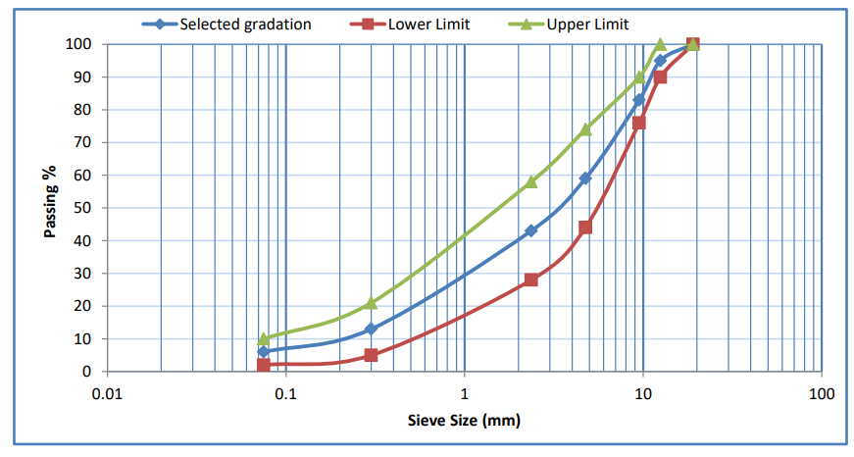

Figure (1): Surface gradation curve

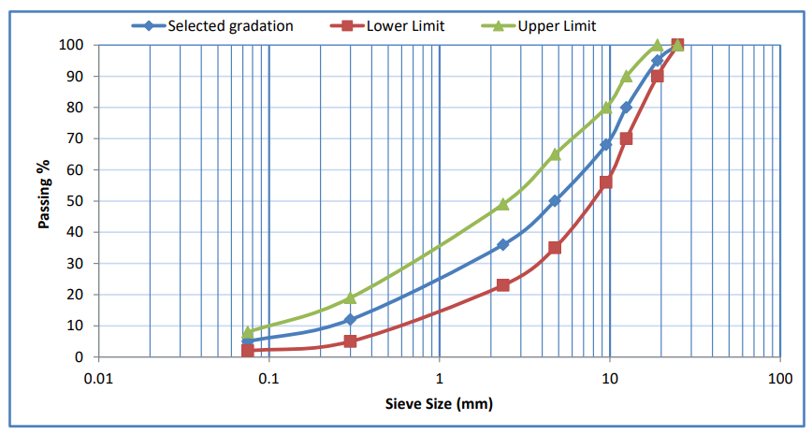

Figure (2): Binder gradation curve

**2.3 Filler**

The filler used in this study is ordinary Portland cement, and it was obtained from Badosh cement factory in Mosul City. Table (3) shows the properties of the filler.

**Table (3): Cement physical properties**

|  |  |
| --- | --- |
| **Property** | Value |
| Bulk Specific gravity | 3.15 |
| % Passing Sieve No.200 | 97 |

1. **METHODOLOGY OF THE STUDY**
   1. **Experimental Work**

The practical program was divided into several stages. These stages aim to obtain the results of the indirect tension repeated load test at (25°C) to obtain the values of the resilient modulus for the asphalt mixture. The optimum asphalt content of surface and binder layers was determined using five asphalt contents (4%, 4.5%, 5%, 5.5%, and 6%) by Marshall method. The indirect tension repeated load test was carried out on samples prepared using optimum asphalt content.

* + 1. **Marshall Mix Design**

The standard method of Marshall was conducted in this work to achieve the optimum asphalt content for the mixtures, according to (ASTM D-1559) standards [11]. The test specimen has a diameter of 4 inches (101.6 mm) and a height of 2.5 inches (63.5 mm). The average asphalt content that belongs to a maximum unit weight, maximum stability, and 4 % air void was considered to determine the optimum asphalt content [12].

* + 1. **Indirect Tension Repeated Load Test (ITRL)**

The uniaxial repeated loading tests for cylindrical samples were performed using the pneumatic repeated load system (see Figure 3). The tested samples had a diameter of 4 inches (101.6 mm) and a height of 2.5 inches (63.5 mm). A rectangular wave with a loading frequency of (1 Hz) was used to perform a repeating compressive loading with a stress level of 20 psi (0.1 sec load period and 0.9 sec rest period) [13]. As a result, the permanent axial deformation was computed at various loading repetitions, taking into account that the tests were conducted at temperature of 25°C. The permanent strain (Ɛp) was calculated using the following equation [14].

$Ɛp=\frac{Pd×{10}^{6} }{h}$ (1)

Where:

Ɛp: axial permanent micro-strain,

pd: axial permanent deformation, and

h: specimen height.

The resilient deflection is evaluated in this test at 50 to 100 load repetitions, and the resilient strain (Ɛr) and resilient modulus (MR) are computed as follows [14]:

$Ɛr=\frac{Δr }{h}$ (2)

$MR =\frac{σ }{Ɛr}$ (3)

Where:

εr: axial resilient micro strain,

Δr: $a$ xial resilient deflection,

h: specimen height,

σ: repeated axial stress, and

MR: resilient modulus.

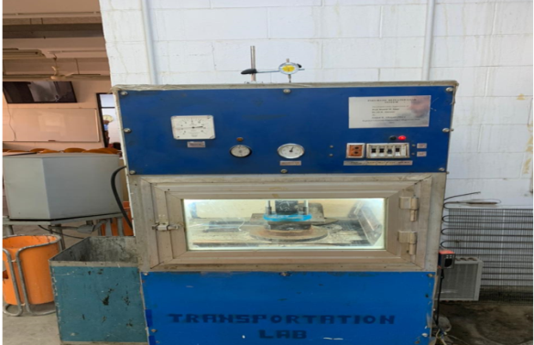

Figure (3): Pneumatic repeated load system

* 1. **Theoretical Work**

The method used in the theoretical work is the Mechanistic-Empirical (M-E) method, as a set of scenarios were used in the data analysis due to the variation in traffic loads and the properties of the materials used to determine the performance and design life of the pavement layers. To analyze distress models, the KENLAYER program is used. The analysis input consists of two main parts, which are traffic loading and material properties using the LAYERINP menu. The damages of fatigue and rutting were analyzed as well as the use of the analysis in calculating the design life [5].

* + 1. **Material Properties and Layers Thickness**

In this analysis, the characteristics of the Iraq Freeways No.1 were relied upon [15]. The thickness and characteristics of the pavement layers in the case of linear and viscoelastic analyses are shown in Table (4). Figure (4) shows the pavement layers. The average temperatures for the seasons of the year for the city of Mosul were depend on from the meteorological department’s statistics for twenty years as inputs to the program for the case of the viscoelastic analysis [16].

**Table (4): Material properties and layers thickness for linear and viscoelastic analysis**

|  |  |  |  |
| --- | --- | --- | --- |
| **Layers** | **Thickness (cm) [15]** | **Resilient Modulus (Mpa) [5,10]** | **Poisson’s Ratio [5]** |
| Wearing Course | 4 | 3000 | 0.4 |
| Binder Course | 8 | 2275 | 0.4 |
| Bituminous Base | 18 | 1585.7 | 0.35 |
| Subbase | 40 | 207 | 0.35 |
| Subgrade | ∞ | 41 | 0.45 |

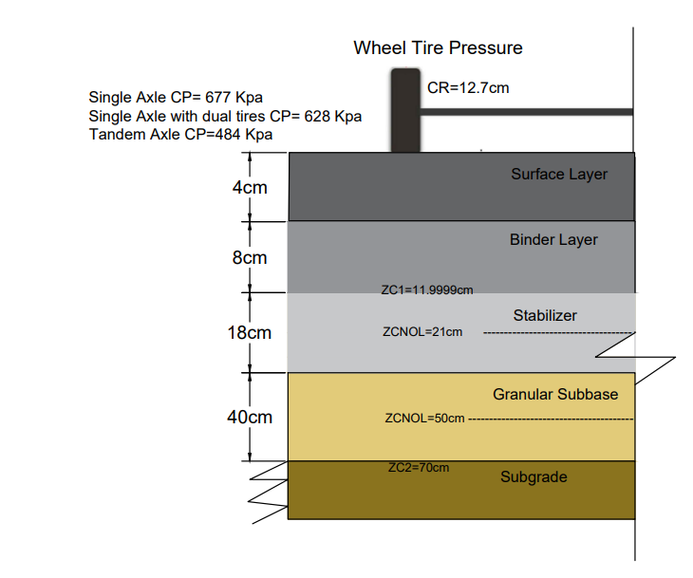

Figure (4): Flexible pavement layers in the linear and viscoelastic analysis used in the study

Thickness and properties of the layers used in the non-linear analysis for both dry and wet conditions are shown in Table (5).

**Table (5): Material properties and layers thickness for non-linear analysis**

|  |  |  |  |  |
| --- | --- | --- | --- | --- |
| **Layers** | **Thickness (cm) [15]** | **Resilient Modulus (Mpa) [5,10]** | **Poisson’s Ratio (Dry)** [**17**] | **Poisson’s Ratio (Wet) [17]** |
| Wearing Course | 4 | 3000 | 0.4 | 0.4 |
| Binder Course | 8 | 2275 | 0.4 | 0.4 |
| Granular Base | 18 | 150 | 0.3 | 0.5 |
| Granular Subbase | 40 | 207 | 0.3 | 0.5 |
| Subgrade | ∞ | 41 | 0.45 | 0.45 |

To improve the non-linear layer coefficients according to (AASHTO-93) [18], where the unit weight for HMA layers (22.8KN/m3) and the granular layers (21.2KN/m3) and for the natural ground layer (19.6KN/m3) was used [5]. The parameters K1 and K2 of the base layer and the subbase layer were also defined as variables. In Table (6), K0 represents the soil pressure at rest and was realized from the analysis. K1 is a non-linear modulus that varies with the moisture content of the granular layers. K2 is the non-linear exponent while; PHI is the internal friction angle for the granular layers. ZCNOL value is the depth of the resilient modulus calculation for non-linear layers, it is recommended to take it in the middle of the layer depth as shown in Figure (5).

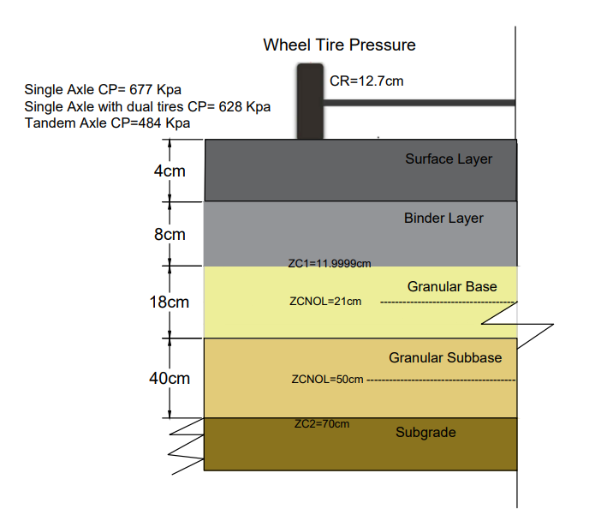

Figure (5): Flexible pavement layers in the non-linear analysis used in the study

**Table (6): Coefficients of non-linear layers**

|  |  |  |  |  |  |  |  |
| --- | --- | --- | --- | --- | --- | --- | --- |
| **Layers** | **K0** | **K1dry (Kpa)** | **K1wet (Kpa)** | **K2dry** | **K2wet** | **PHI** | **ZCNOL (cm)** |
| Base | 0.6 | 41369 | 13790 | 0.5 | 0.5 | 0 | 21 |
| Subbase | 0.6 | 41369 | 10343 | 0.5 | 0.5 | 0 | 50 |

Suggested values for K1 and K2 for granular layers are given in Tables (7) [5].

**Table (7): Values of K1 and K2 depending on the moisture content of the base and subbase layers [5]**

|  |  |  |  |  |
| --- | --- | --- | --- | --- |
|  | **Base Layer** | | **Subbase Layer** | |
| **Moisture Content** | **K1 (Kpa)** | **K2** | **K1 (Kpa)** | **K2** |
| Dry | 41369-68948 | 0.5-0.7 | 41369-55159 | 0.4-0.6 |
| Wet | 13790-27580 | 0.5-0.7 | 10343-27580 | 0.4-0.6 |

**3.2.2 Traffic Loading**

The traffic volume data for the main routes to Mosul city were taken from the Iraqi Transport Master Plan (ITMP) project [19], where total loading repetitions were as follows:

1. Single axles with single tires: 6035
2. Single axles with double tires: 15085
3. Tandem axles: 3017

The growth factor was considered using the following equation as mentioned in Asphalt Institute [2] and AASHTO Design Guide [20]. They suggested using the traffic during the entire design period to calculate the total growth factor. The growth rate (r) used in this study is 5% and the design period (Y) is 20 years [19].

$G=\frac{{\left(1+r\right)}^{n-1}}{r}$ (4)

Centering to the mid of the spacing between dual wheels along the Y axis (YW), this distance was taken for the single axle (0) and for the single axle with double tires as well as the tandem axle (30 cm) [5]. Also, centering to the mid of the spacing between two wheels for two different axes along X axis (XW), this distance was taken (150 cm) [21].

**3.2.3 Mechanistic-Empirical Method**

Since the past two decades, there has been a trend for road agencies to use the mechanistic-experimental method in designing flexible pavement layers, and perhaps this tendency prompted AASHTO to replace the 1993 experimental design method with the more reliable mechanistic-empirical design method in 2004 for the design of flexible pavement layers [22]. A modern design method contains several distress models used to determine the permanent damages i.e. fatigue and rutting in the roads, and subsequently predicting the design life of pavement layers [4].

In this method, mathematical equations are used to describe the relationship between the physical phenomena arising from traffic loads and the properties of the materials used in the pavement structure on the one hand, and the pavement failure on the other hand, by calculating the number of loading cycles to failure. This is done by assuming that the traffic load on the flexible pavement is a constant and evenly distributed load, where the pavement response is represented by a reaction representing a horizontal tensile strain (εt) below the asphalt layer and a vertical compressive strain (εc) on the top of the soil layer, which is important for design purposes [23].

A mechanistic empirical computer programs can be used to calculate stress, strain, and deflection at different depths of pavement layers. All of the pavement reactions due to load repetition may be determined more correctly and close to the actual state utilizing these computer programs [8].

KENLAYER computer program was applied to flexible pavement for determining the damage ratio using distress models. It is the solution for an elastic multilayer system under a circular loaded area by superimposing for multiple wheels, applying iteratively for non-linear layers, and collocating at various times for viscoelastic layers [8].

The fatigue cracking models are developed from Miner’s cumulative damage concept. The concept of cumulative damage has been widely used to predict fatigue in flexible pavement. It is generally agreed that the allowable number of load repetitions is related to the tensile strain at the bottom of the asphalt layer. The amount of damage is expressed as the damage ratio, which is the ratio between the expected and the allowable number of repeat loads. Damage occurs when the sum of the damage ratio reaches one. The allowable number of load repetition (Nf) can be calculated using equation (5). [5, 22, 24]

𝑁f = 𝑓1(∈) −𝑓2(𝐸1) −𝑓3 (5)

Where:

𝑁f: allowable number of load repetition to prevent fatigue cracking,

∈: horizontal tensile strain at the bottom of the HMA layer,

𝐸1: resilient modulus of the HMA, and

𝑓1, 𝑓2, 𝑓3: constants obtained by calibration.

The vertical compressive strain on the top of the subgrade was controlled using permanent deformation models. Equation 6 relates the allowable number of load repetitions (Nr) to the vertical compressive strain (∈) on top of the subgrade to restrict rutting [5, 14, 24].

𝑁r = 𝑓4 (∈) −𝑓5 (6)

Where:

𝑁r: allowable number of load repetition to prevent the amount of rutting,

∈: vertical compressive strain at the top of subgrade layer, and

𝑓4, 𝑓5: calibrated values used to predict performance and field observation.

The damage ratio is the ratio between the predicted and allowable number of repetition. Equation 7 calculates it for each load group in each period and sums it across the year [5].

$D_{r}=\sum_{i=1}^{p}{\sum_{j=1}^{m}{\frac{ni,j}{Ni,j}}}$ (7)

Where:

Dr: damage ratio at the end of a year,

$ni,j$: predicted number of load repetitions for load j in period i,

$Ni,j$: allowable number of load repetitions for load j in period i,

p: number of periods in each year, and

m: number of load group.

Equation 8 is used to calculate the design life, which is calculated for fatigue cracking and permanent deformation, with the one with a shorter life controlling the design [5, 21].

$Design life=\frac{1}{D_{r}}$ (8)

1. **RESULTS AND DISCUSSIONS**
   1. **Marshall Properties**

To achieve the design requirements, the Marshal mix design was used to determine the optimum asphalt content of hot mix asphalt (HMA) for both surface and binder layers. An average of three samples for each asphalt content were calculated with an asphalt content of (4%, 4.5%, 5%, 5.5%, and 6%). The optimum asphalt content was determined as an average for each of [12]:

1- Asphalt content corresponding to the highest stability.

2- Asphalt content corresponding to the highest density.

3- Asphalt content corresponding to mid limits of the Iraqi specification for air voids [10].

The results of the optimum asphalt content was 5.1% for the surface layer and 4.8% for the binder layer. All characteristics were within the Iraqi specification for roads and bridges [10].

Figure (6) and (7) shown Marshall properties with asphalt content of the surface and binder course.

* 1. **Comparison between Linear, Viscoelastic (for both static and moving vehicle), and Non-linear Analysis**

In the following paragraphs, we will make comparisons for some of the outputs of the four cases of analysis, namely, the linear analysis and the viscoelastic analysis, in the cases of static and moving vehicle at an average maximum air temperature in Mosul city (33.2°C), as well as the non-linear analysis considering saturated soil layers.

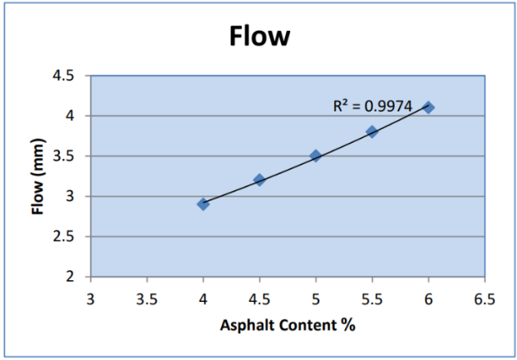

**(a)**

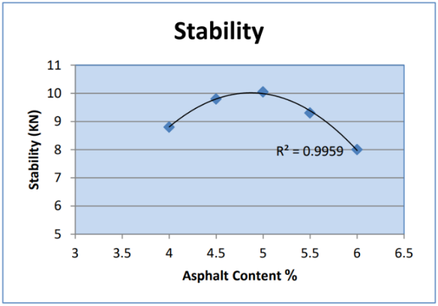

**(b)**

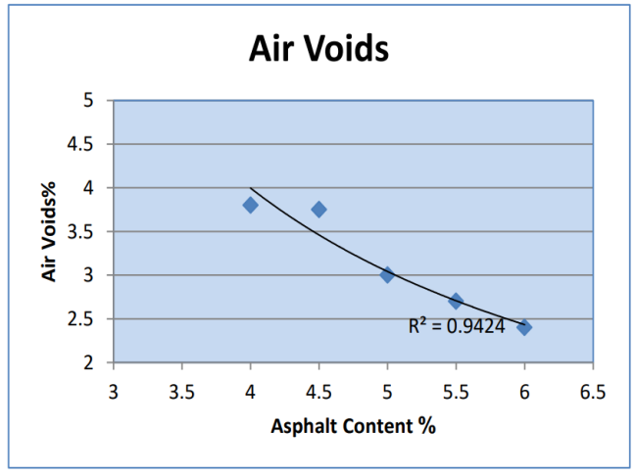

**(C)**

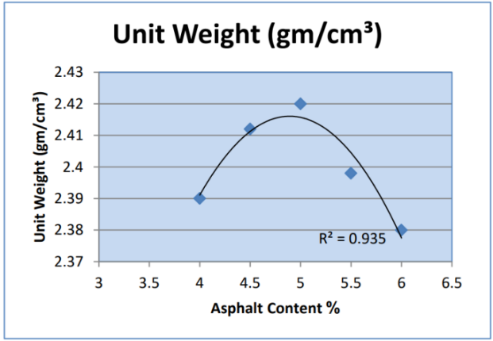

**(d)**

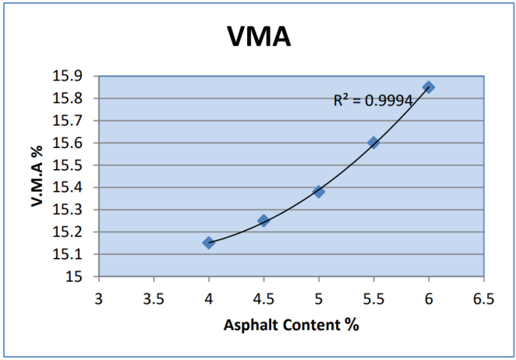

**(e)**

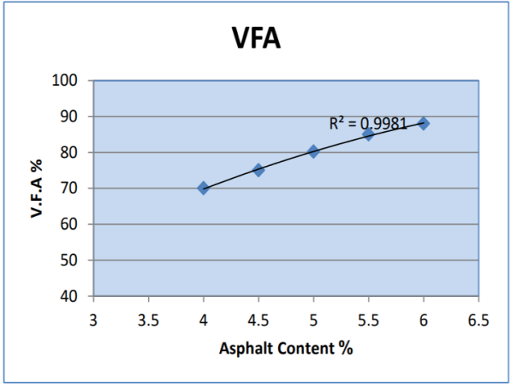

**(f)**

Figure (6): Marshall properties with asphalt content of the surface layer (a) Marshall stability, (b) Flow, (c) Unit weight, (d) Air voids, (e) Void in mineral aggregate, (f) Voids filled with asphalt

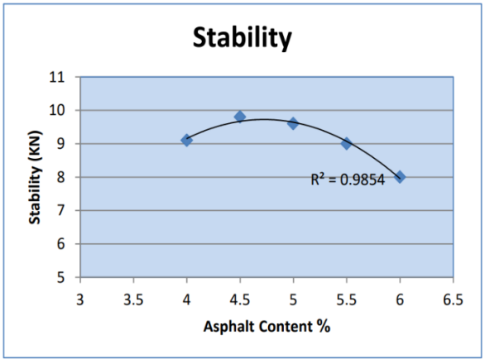

**(a)**

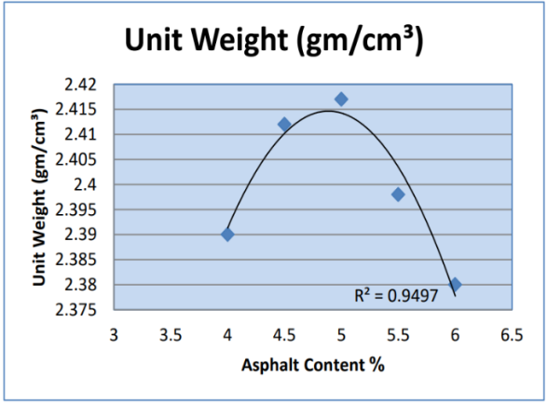

**(C)**

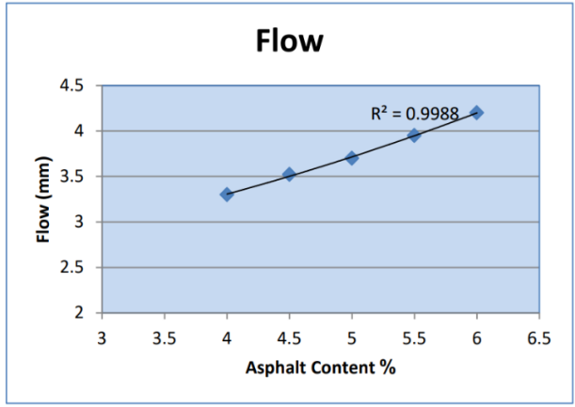

**(b)**

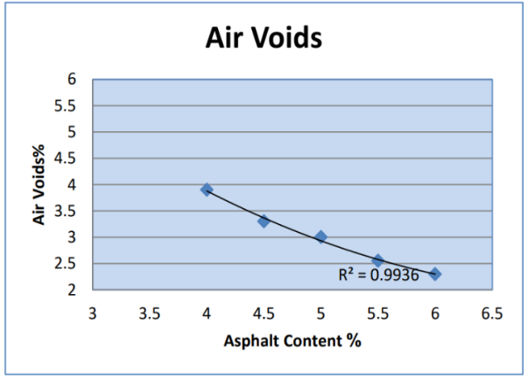

**(d)**

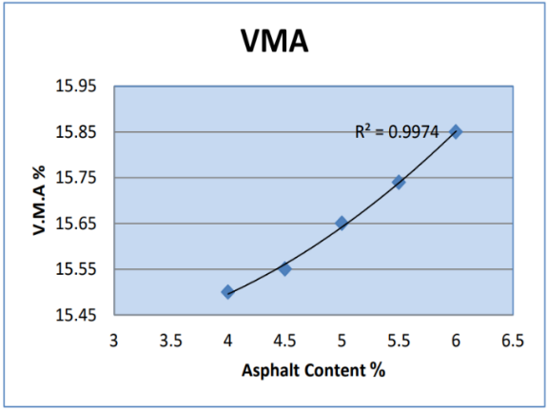

**(e)**

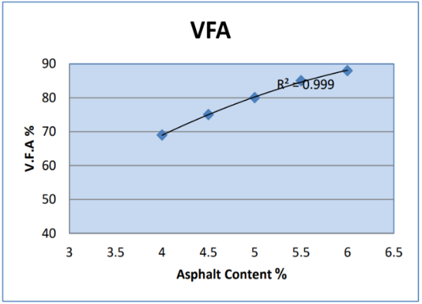

**(f)**

Figure (7): Marshall properties with asphalt content of the binder layer (a) Marshall stability, (b) Flow, (c) Unit weight, (d) Air voids, (e) Void in mineral aggregate, (f) Voids filled with asphalt

* + 1. **Comparison for Vertical Stresses**

Figure (8) shows the relationship of the four analysis cases of the vertical stress and the change in the type of axle at depth of 12 cm i.e. at the bottom of the HMA layers and at depth of 70 cm i.e. above the subgrade. It is noted that the vertical stress in the case of the linear analysis of the standard single axle at the depth of 12 cm was (368.9Kpa) and this stress gradually increased by 11.2%, 11.7%, and -2.4% for the viscoelastic static vehicle, viscoelastic moving vehicle, and non-linear analysis respectively. It was also found that the value of the vertical stress at the depth of 70 cm was (9.172 Kpa) and gradually increased for the viscoelastic static vehicle, viscoelastic moving vehicle, and non-linear analysis with percentages of 5%, 15.6%, and 147.2% respectively.

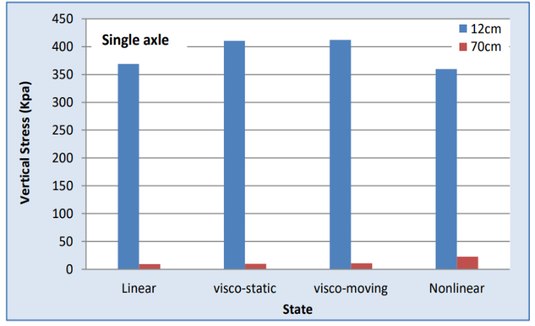

(a)

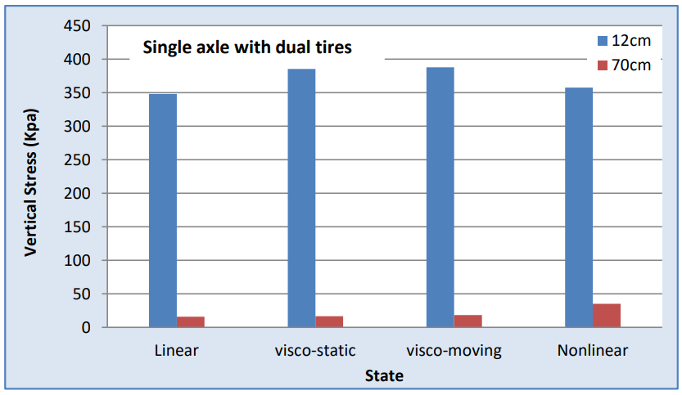

(b)

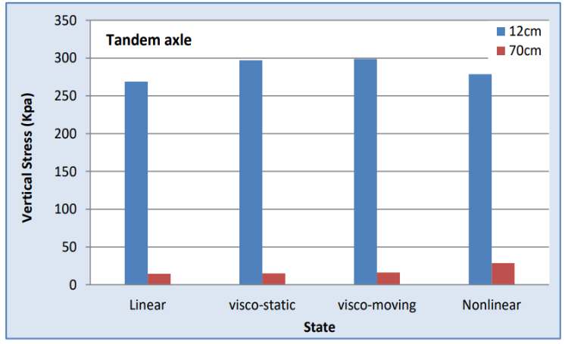

(c)

Figure (8): Relationship of the analysis cases with vertical stress (a) single axle, (b) single axle with dual tires, (c) tandem axle

It was also found that the vertical stress in the case of linear analysis of the standard single axle decreases at the depth 12 cm by rates of 5.6% and 27% for the cases of the single axle with double tires and the tandem axle respectively. While the stress increases in the case of linear analysis of the standard single axle at the depth 70 cm with percentages of 72.4% and 57.7% for the cases of the single axle with double tires and the tandem axle respectively due to the overlap of the tire loads within the same axle. The lowest value of the vertical stress at the depth 12 cm was for the tandem axle for all cases of analysis; this is attributed to the distribution of the axle load on four tires.

* + 1. **Comparison for the Deformation of the Pavement**

Figure (9) shows the relationship between the four analysis cases with the deformation of the pavement and the change in the type of axle at the depth 12 cm i.e. at the bottom of the HMA layers and at depth of 70 cm i.e. above the subgrade. It is noted from the figure that the value of the deformation for the case of the linear analysis of the standard single axle at a depth 12cm was (0.04729 cm), and this value increased by 1.96%, 9.98%, and 146% for the viscoelastic static vehicle, viscoelastic moving vehicle, and non-linear analysis respectively. It was also found that the deformation value for the linear analysis of the standard single axle at depth 70 cm was by (0.03534 cm), and this value increased by 2.8%, 8.1%, and 42% for the viscoelastic static vehicle, viscoelastic moving vehicle, and non-linear analysis respectively.

It was also found that the deformation value for the case of the linear analysis of the standard single axle increases at the depths 12 cm and 70 cm by percentages 71.8% and 81% for the single axle with double tires, and by percentages 88.8% and 112.8% for the tandem axle respectively. In general, it is noted that the highest deformation occurred in the case of non-linear at both depths 12 cm and 70 cm due to the weakness of the pavement's soil layers in the presence of water.

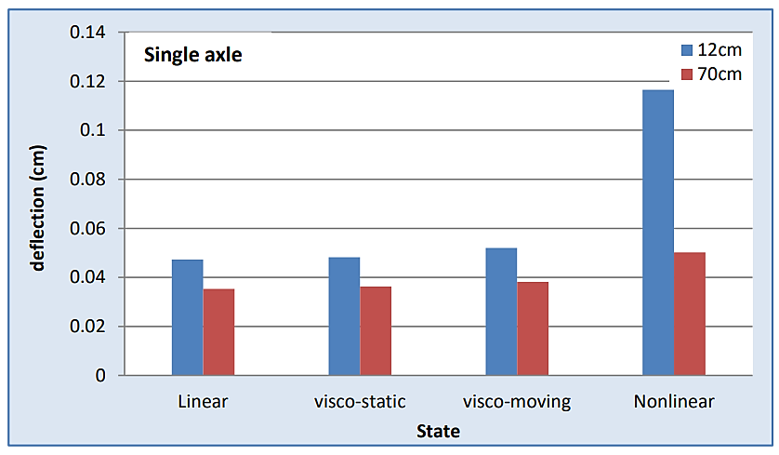

(a)

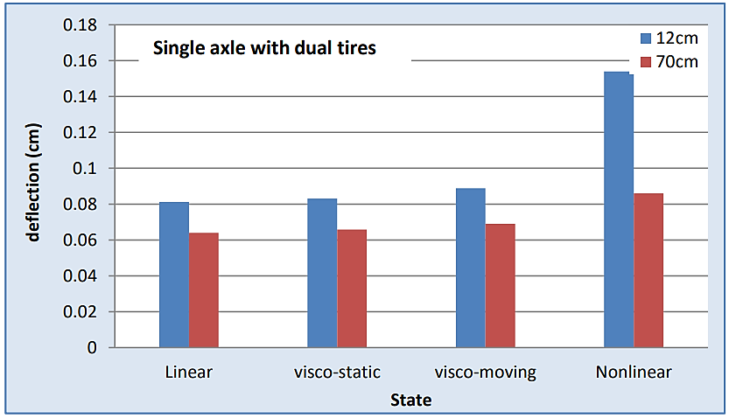

(b)

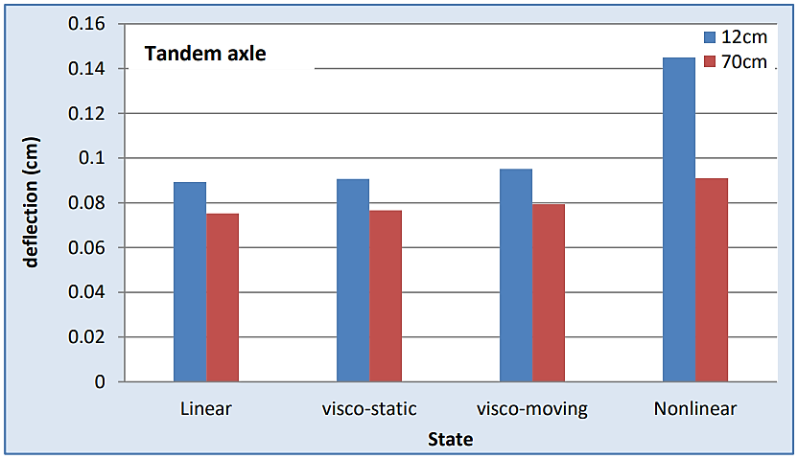

(c)

Figure (9): Relationship of the analysis cases with deformation (a) single axle, (b) single axle with dual tires, (c) tandem axle

* 1. **Comparison between Linear, Viscoelastic (for both Static and Moving Vehicle)**
     1. **Comparison for Tensile Strain and Compressive Strain**

Figure (10) shows the relationship of the analysis cases with tensile strain and compressive strain at standard load and temperatures of 33.2°C. It was found that the highest value of tensile strain in the single axle was in the base layer with a value of (-0.0001501) for linear analysis, where this value increased to (2.7) and (1.15) times for the viscoelastic static vehicle, and viscoelastic moving vehicle respectively. It was observed that in the case of linear analysis, the value of the tensile strain increased by (1.5) and (1.1) times for the single axle with double tires and the tandem axle, respectively. For the compressive strain values, it was found that the highest compressive strain was in the subbase layer, where it was found that its value for the linear analysis was (0.0003566), and this value increased by (2.8) and (1.2) times for the viscoelastic static vehicle, and viscoelastic moving vehicle respectively. In addition, it was found that the value of the compressive strain for linear analysis increased by (1.3) and (1.1) times for the single axle with dual tires and the tandem axle respectively. It is also noted that the highest values of tensile and compressive strain for all axles were for the case of viscoelastic static vehicle, so that the static vehicle on the pavement gives the largest values of strain.

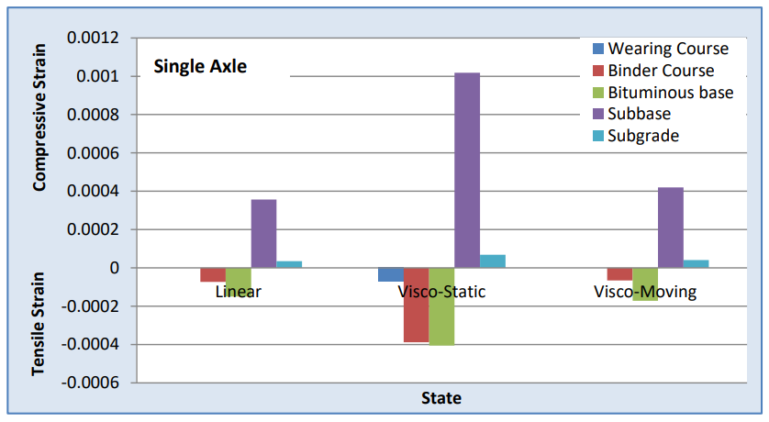

(a)

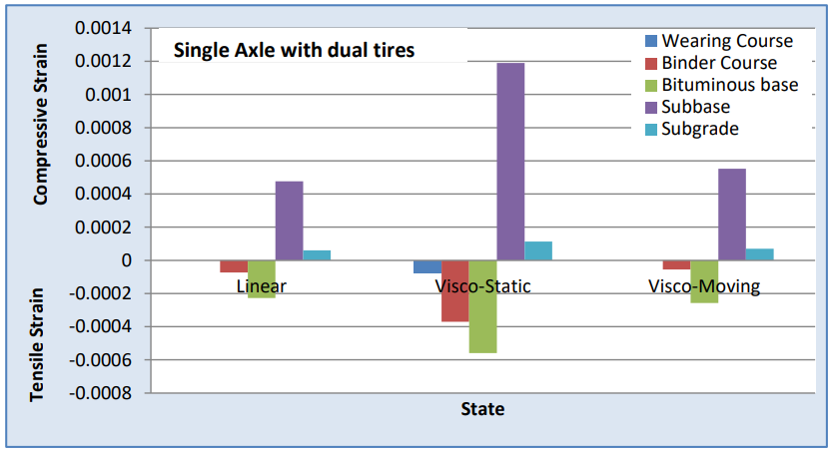

(b)

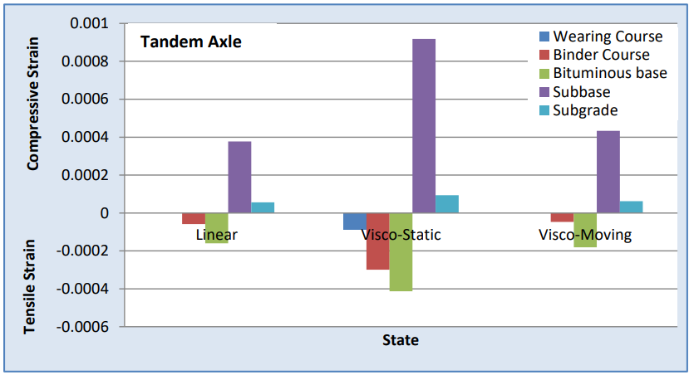

(c)

Figure (10): Relationship of the analysis states with strain values (a) single axle, (b) single axle with dual tires, (c) tandem axle

* + 1. **Comparison for the Highest Damage Ratio**

The relationship of the highest damage ratio with the cases of analysis is shown in Figure (11), where the effect of the damage increases with the increase in the loads applied to the pavement. It is noted that the highest damage ratio for the linear analysis was (0.0442600). This value increased by (28.5) times in the case of a static vehicle, while this value decreased in the case of vehicle movement by (1.27) times.

To study the effect of varying the weight of axle loads on the damage rate, the percentage of load of 50%, 150% and 200% of the standard load were considered. It was found that the damage ratio decreased at 50% load in the case of linear analysis by (5.5) times, while the damage ratio increases by (3.5) and (9) times at 150% and 200% loading amounts respectively. From the observation of the figure, it becomes clear that the viscoelastic condition of static vehicles gave the highest damage ratio for all cases of loading, and this enhances the occurrence of the viscoelastic condition of the static vehicle at the highest strain values.

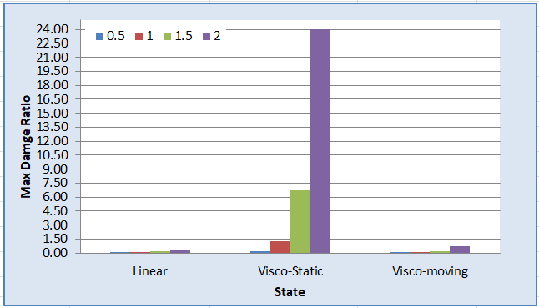

Figure (11): Relationship of the analysis cases with the max. damage ratio at different axle loads.

* + 1. **Comparison for Design Life**

The relationship between the analysis cases and the design life of the pavement is shown in Figure (12). The figure shows that the design life in the case of linear analysis at the standard load is (22.5 years), where the design life for the viscoelastic analysis decreases in the case of the vehicle static by (95.5%), while it increases in the case of the moving vehicle by (27%). It was also found that the design life increases in the case of linear analysis at 50% of the standard load by (451.7%), while the design life decreases in the case of linear analysis by increasing the loads applied to the pavement of (71.8%) and (88.8%) at loading rates of 150% and 200% of the standard load respectively.

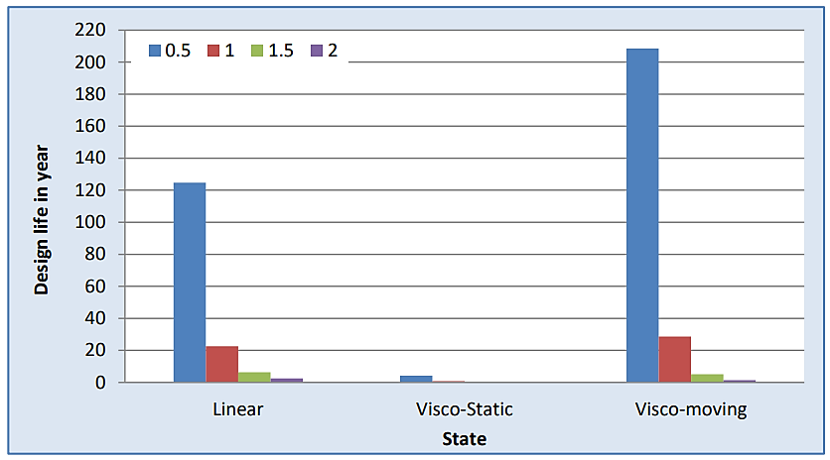

Figure (12): Relationship of the analysis cases with the design life

1. **CONCLUSIONS**

Through the thickness of the pavement layers used in this study, the quality of the materials, and the traffic volumes that pass, the following points can be concluded:

1. The lowest value of the vertical stress at the bottom of the binder layer i.e. at depth 12 cm was for the tandem axle and for all cases of the analysis. This is due to the distribution of the axle load on four tires, while the value of the vertical stress at the top of the subgrade i.e. at depth 70 cm increases for the single axle with dual tires and the tandem axle due to the overlap of the tire loads within same axle.
2. The highest value of deformation occurred in the case of non-linear analysis compared to linear and viscoelastic analysis (in the cases of static and moving vehicle) at both depths 12 cm and 70 cm due to the weakness of the soil layers of pavement in the presence of water.
3. The highest tensile and compressive strain values for all axle were for the viscoelastic condition (static vehicle) on the pavement compared to the linear and non-linear analysis.
4. The highest value of damage ratio was also in the case of viscoelastic analysis (static vehicle), where it gave the highest damage ratio value and for all loading cases. This is due to the viscoelastic condition (static vehicle) attained the highest strain values.
5. The design life of the pavement in the case of linear analysis at the standard load is (22.5 years), as the design life of pavement for the viscoelastic analysis decreases in the case of static vehicles by (95.5%), while the design life increases in the case of the movement of vehicles by (27%).
6. **REFERENCES**

[1]Pereira, P., and Pais, J. (2017). "**Main Flexible Pavement and Mix Design Methods in Europe and Challenges for the Development of a European Method**", Journal of Traffic and Transportation Engineering (English Edition), 4(4), pp 316–346. https://doi.org/10.1016/j.jtte.2017.06.001.

[2] Asphalt Institute. (1981). "**Thickness Design Asphalt Pavements for Highways and Streets**", Manual Series No.1 (MS-1). Asphalt Institute, Lexington, Kentucky.

[3] Montuschi, A. (2012). "**Flexible Pavement Design Using Mechanistic-Empirical Methods: The Californian Approach**", MSc thesis. University of Bologna, Department of Civil, Chemical, Environmental and Material Engineering.

[4] Jasim, A.A. (2015). "**Effect of Pavement Layers Properties on Optimum Performance by Mechanistic–Empirical Method**", Journal of Babylon University, Engineering Sciences No. (2), Vol. (23).

[5] Huang, Y.H. (2012). "**Pavement Analysis and Design**", 2nd Edition, New Jersey, Prentice-Hall.

[6] Kerkhoven, R., and Dormon, G.M. (1953). "**Some Considerations on the California Bearing Ratio Method for the Design of Flexible Pavements**", Shell Petroleum Company, London.

[7] Pell, P.S.,(1962) , "**Fatigue Characteristics of Bitumen and Bituminous Mixes**". An Arbor, Michigan: International Conference on the Structural Design of Asphalt Pavements.

[8] Samad, E. (2011). "**Sensitivity Analysis in Flexible Pavement Performance Using Mechanistic-Empirical Method**", Civil Engineering Forum, Volume XX/1, pp 1189-1200.

[9] Muniandy, R., and Aburkaba, E.E. (2013). **"Comparison of Flexible Pavement Performance Using Kenlayer and Chev PC Software Program"**, Australian Journal of Basic and Applied Sciences, pp 112–119.

[10] State Corporation of Roads and Bridges, (SCRB), (2004), "**Standard Specification for Roads & Bridges**", Ministry of Housing and Construction, Iraq.

[11] American Society for Testing and Materials (ASTM), (2015), **"Standard Specification"**, Section 4, Vol. 04-03.

[12] Asphalt Institute, (1984), **"Mix Design Method For Asphalt Concrete and Other Hot-Mix Design"**, Manual Series No.2 (MS-2). Asphalt Institute, Lexington, Kentucky.

[13] Albayati, A.H. (2006). **"Permanent Deformation Prediction of Asphalt Concrete under Repeated Loading"**, Ph.D. Thesis, Civil Engineering Department, College of Engineering, University of Baghdad.

[14] Yoder, E., and Witczak, M. (1975). **"Principles of Pavement Design"**, 2nd Edition, John Wiley and Sons.

[15] Iraqi Expressway No. one, 1983, Consulting Engineers, Munich, W. Germany.

[16] Iraqi Meteorological Department Reports - (2020) - Mosul Stations.

[17] Braja, M. Das. (2008). **"Advanced Soil Mechanics",** 3rd Edition, Taylor and Francis Group, USA.

[18] AASHTO (1993). **"Guide for Design of Pavement Structures"**, American Association of State Highway and Transportation Officials, Washington, D.C.

[19] ITMP. (2005). **"Iraqi Transport Master Plan"**, A joint project between the Iraqi Government and Italian Government.

[20] AASHTO Guide for Design of pavement Structures. (2010). American Association of State Highway and Transportation Officials, Washington, D. C., USA.

[21] Papagiannakis, A.T., and Masad, E.A. (2008). **"Pavement Design and Materials"**, John Wiley & Sons.

[22] Ameri, M., and Khavandi, A. (2009). "**Development of Mechanistic-Empirical Flexible Pavement Design in Iran**", Journal of Applied Sciences, Vol.9, Issue2, pp 354–359. https://doi.org/10.3923/jas.2009.354.359.

[23] Abdel Motaleb. (2007). "**Flexible Pavement Components for Optimum Performance in Rutting and Fatigue**", Mansour Engineering Journal, Volume 32, Issue 2, pp 1-9.

[24] Subhy, A. (2017). **"Advanced Analytical Techniques in Fatigue and Rutting Related Characterisations of Modified Bitumen: Literature Review",** Construction and Building Materials, Vol. 156, pp 28–45. https://doi.org/10.1016/j.conbuildmat.2017.08.147.

**Influence of Elastomeric Polymer Modified Bitumen on Fatigue and Rutting Performance of Bituminous** **Pavement**

Gagandeep Singh1, Satish Pandey1, M.N.Nagabhusana2, P.K.Jain3

1Principal Scientist, CSIR- Central Road Research Institute, New Delhi, India

2Ex- Senior Principal Scientist, CSIR- Central Road Research Institute, New Delhi, India

3Ex-Chief Scientist, CSIR- Central Road Research Institute, New Delhi, India

Corresponding Email ID- singh1830@gmail.com, satishpandey.crri@nic.in

doi: 10.1515/ijpeat-2016-0053

**Abstract**

Viscosity graded bitumen remains the major binder employed in flexible pavement construction in India, while modified bituminous binders are also used. The reasons for recommending modified binders are not too unknown, but there is a need to establish a clear criterion for the use of such binders justifying their higher costs. Unmodified (VG 30) and polymer-modified (PMB 40) bitumen were subjected to an array of physical and performance tests. The performance tests were carried out on unmodified and modified bituminous mixtures. Multilayer–linear elastic analysis was performed to determine the Traffic Benefit Ratio (TBR) for the pavement structure having a modified binder. The laboratory study confirmed the improvement in various mechanical properties of PMB mixes besides a reduction in temperature susceptibility. The results of the multi-layer linear elastic analysis presented herein indicated that the pavement consisting of PMB binder in bituminous layers is beneficial by increasing the pavement service life for the same pavement structure.

*Key Words*: Polymer Modified Binder, Resilient Modulus, Pavement Design, Rutting

**1. INTRODUCTION**

Over the years, the majority of flexible pavements in India have deteriorated more rapidly due to increases in service traffic density, axle loading, and low maintenance services. To minimize the damage to the pavement surface and to increase the durability of flexible pavement, the conventional bitumen needs to be improved with regard to performance-related properties, such as resistance to permanent deformation (rutting) and fatigue cracking. Bitumen is a thermoplastic material, which liquefies when heated and solidifies when cooled. It binds the aggregates and thus provides stiffness to the bituminous mix. Bitumen is characterized by the varying consistency to flow at different temperatures and thus plays a significant role in controlling the visco-elastic properties of the bituminous mix. It also influences the performance properties of the bituminous mix such as indirect tensile strength, marshal stability, resilient modulus, fatigue, and rutting resistance.

A problem with all applications that involve bitumen is the tendency of the bitumen to become brittle at low temperatures and to become soft at high temperatures which is defined as temperature susceptibility. Asphalt Handbook [1], some bitumen, depending on crude oil source and refining practice are more temperature susceptible than others. Bitumen may be modified by an array of additives to increase the strength of the material by altering its visco-elastic properties. Various polymers such as styrene-butadiene-styrene (SBS), natural rubber, crumb rubber, etc. have been increasingly used to improve the high and low-temperature characteristics of bitumen compositions, as well as to enhance various engineering properties of the bituminous mix. Vonk W.C. et al [2], Improvement in resistance to rutting, thermal cracking, fatigue damage, stripping, and temperature susceptibility have led polymer-modified binders to be a substitute option for neat bitumen in many paving and maintenance applications. It is the polystyrene end block that imparts strength to the polymer and the mid-block that gives the material its exceptional elasticity. Becker Yvonne et al [3], Modified Bitumen is used in cases where extra performance and durability are desired, to reduce the life cycle costs of pavement.

Shell Bitumen Handbook [4], predominantly among the expected improvements, the role of a bitumen modifier is to increase the resistance of the binder to permanent deformation at high temperatures without adversely affecting the properties of bitumen or bituminous mix at lower temperatures. It can be achieved either by stiffening the bitumen so that the total visco-elastic response of the bituminous mix is reduced or by increasing the elastic component of the bitumen. Both modifications will result in a reduction in permanent strain. Increasing the stiffness of the bitumen is also likely to increase the dynamic stiffness of the asphalt. This will improve the load-spreading capability of the material, increase the structural strength, and lengthen the expected design life of the pavement.

An effective mechanistic analysis for the critical response is helpful in providing the required understanding of the nature and extent of improvement in pavement performance. A number of mechanistic design methodologies have been developed over the last few years that rely on more fundamental models of vehicular loading, material, and structural system response and environmental interaction to model the critical pavement responses [5, 6]. This approach needs a greater number of material and system parameters to model the system, and specific failure mechanisms may be addressed such as fatigue and rutting. Rutting is one of the major causes of the failure of bituminous pavement. It either occurs due to shear deformation of the bituminous mix or the consolidation of various layers or that of subgrade. The permanent deformation within the bituminous layer can be controlled by properly designing the hot mix whereas by limiting the value of vertical compressive strains on top of the subgrade, the consolidation rutting can be checked. The value of vertical compressive strains can be controlled either by providing the thick pavement composition or increasing the stiffness of different layers of pavement so that load can be spread on a wider area thus limiting the values of vertical strain. Under this present study, an attempt has been made to quantify the structural performance of polymer-modified bituminous pavement through laboratory and mechanistic studies to quantify the effects of elastomeric polymer modified bitumen on fatigue and rutting resistance of the pavement.

**2. LITERATURE REVIEW**

Polymer-modified Bitumen (PMB) binders have been used in India for many years with moderate to excellent results for improving hot bituminous pavement and overlay performance. Specifically, polymer modification has been reported to reduce pavement cracking caused by thermal stresses and repetitive loads and decrease rutting due to plastic or inelastic deformations in the Hot Bituminous mixture. Numerous laboratories and field studies have been conducted by various researchers over the past decade to support that hypothesis. Ping W. Virgil [7] studied the effect of SBS polymer-modified binder on the engineering properties of the HMA mixture by analyzing the resilient modulus properties through an indirect tensile strength test. The SBS polymer modifier made the HMA mixture softer at mid to low test temperatures and maintained stiffness level at high temperatures, which are favorable attributes for the improvement of HMA performance in terms of low-temperature thermal cracking and high-temperature rutting.

Gupta S et al [8] studied the benefit of SBS (Styrene Butadiene Styrene) polymer-modified bituminous mixes on fatigue performance. The physical and mechanical properties of polymer-modified and conventional binder mixes were evaluated through laboratory investigation. The fatigue life of SBS-modified mixes was reported to be 2.1 to 2.4 % higher than conventional mixes.

Isacsson U. et al [9] tested the various properties of modified binders and showed that elastomeric binders increase both rut resistance and fatigue life. They observed that SBS-modified bituminous mixes have a longer life than conventional mixes.

A project report prepared by Harold L. et al [10] for the Colorado Asphalt Pavement Association explores the possibility of reducing flexible pavement distress in Colorado through the use of Polymer Modified Asphalt mixture. The mechanistic Empirical distress prediction model given by the Asphalt Institute was calibrated through actual distress measurement. The pavements constructed with modified mixtures within this study were found to have lower amounts of fatigue cracking, transverse cracking, and rutting, as compared to projects with neat HMA mixtures. Based on the comparisons completed within this study, an average increase in service life of three years was determined for the modified HMA overlays of flexible pavements.

Being a tropical country, India has four distinct seasons i.e. Summer, Monsoon, Post Monsoon, and Winter. Significant variations in diurnal and seasonal temperatures in different climatic seasons render bituminous pavement prone to premature failures. In this study, an attempt has been made to explore the improvement in the various engineering properties of the hot bituminous mix having Polymer Modified Binder in place of conventional viscosity-graded bitumen (VG-30). Widely used pavement analysis program KENPAVE is used to carry out mechanistic analysis of bituminous pavement having modified and unmodified bituminous mix. Critical pavement responses are calculated under a legal axle weight of 10.5 kN to quantify the possible increase in the service life of the pavement. Legal axle load limit of 10.5 kN is the limiting load carrying capacity on rear axle by commercial trucks in India.

**3. AIM AND OBJECTIVES**

Aim of the study is to assess the structural performance of the asphalt pavement having elastomeric polymer modified bitumen as binder in asphalt layers against rutting and fatigue strains caused by the traffic loading. To achieve the aim of the study following objectives are identified:

* Evaluation of mechanistic properties of hot bituminous mixes prepared with polymer-modified and conventional bituminous binder.
* To evaluate the effects of polymer-modified bitumen on the performance properties of hot bituminous mixtures.
* Establish the benefits of polymer-modified hot bituminous mix in terms of improvement in fatigue and rutting life through mechanistic analysis.

**4. LABORATORY INVESTIGATION**

4.1 AGGREGATES

The aggregates used in the present study were tested as per Bureau of Indian Standards (BIS) standards and found to meet MoRTH [11] (Ministry of Road Transport and Highways) Specification for Road and Paving work (Fifth Revision). Coarse aggregate, fine aggregate, and quarry dust were used in the bituminous concrete mix. The coarse and fine aggregates used for the preparation of the bituminous mixtures were obtained from a local quarrying. The properties of aggregates determined through laboratory investigation are given in Table 1.

Table 1: Properties of Aggregates

|  |  |  |  |
| --- | --- | --- | --- |
| Properties Tested | Test Results | MoRTH Specification | Testing Standard |
| Aggregate Impact Value | 21.64% | 27% max | IS 2386 (Part IV) |
| Combined (EI + FI) Index | 25.2% | 30% max | IS 2386 (Part I) |
| Water Absorption Value | 0.70% | 2% max | IS 2386 (Part III) |
| Stripping | 99% | Min,95%,Retained | IS 6241 |
| Specific Gravity | 2.75 | 2.5 – 3.0 | IS 2386 (Part II) |

4.2 BINDER

For the laboratory study, viscosity-graded bitumen binder (VG 30) and SBS modified bitumen binder (PMB 40) were utilized for preparation of asphalt mixes. Viscosity graded binder VG 30 is the most commonly used binder for construction of asphalt layers in India while polymer modified bitumen binder is recommend under heavy traffic and high temperature conditions. To find out the suitability of bitumen binders for the preparation of bituminous mix, various physical tests are performed on the polymer modified and unmodified (viscosity graded) binder. Results obtained from laboratory testing are presented in Table 2.

Table 2: Physical Properties of Binder

|  |  |  |  |  |  |
| --- | --- | --- | --- | --- | --- |
| Property | BIS Test Method | VG  30 | Requirements of IS 73:2013 for VG 30 | PMB 40 | Requirements  of IS 15462: 2004 for PMB 40 |
| Penetration 25°C ,100 g, 5 s 0.1mm, min | IS 1203-1978 | 62 | 45 | 40 | 30-50 |
| Softening point (R & B),°C, Min | IS1205-1978 | 49 | 47 | 61 | 60 |
| Ductility, cm at 25°C (5 cm/min pull), min. | IS 1208-1978 | 78 | - | 94 | \_ |
| Specific gravity at 27°C | IS 1202-1978 | 1.01 | min 0.99 | 1.03 | \_ |
| Absolute Viscosity, at 60°C, (Poises) | IS1206 (Part 2) | 2570 | 2400-3600 | \_ | \_ |
| Absolute Viscosity, at 150°C (Poises,) | IS 1206 (Part 1) | 3.10 | \_ | 8.25 | 3-9 |
| Elastic recovery, at 15°C, % (min) | IS 15462: 2004 | - | \_ | 76 | 70 |

4.3 PREPARATION OF BITUMINOUS MIX

The bituminous mix was designed using the Marshall method of mix design, outlined in the Asphalt Institute Asphalt Mix Design specification (MS-2) [12]. The grading of aggregate selected for the preparation of bituminous concrete (BC) is given in Table 3.

Table 3: Aggregate Gradations for BC Mix

|  |  |  |
| --- | --- | --- |
| Sieve Size (mm) | Cumulative % by weight of total aggregate passing | Gradation Adopted |
| 26.5 | 100 | 100 |
| 19 | 79 - 100 | 100 |
| 13.2 | 59 - 79 | 69 |
| 9.5 | 52 - 72 | 62 |
| 4.75 | 35 - 55 | 45 |
| 2.36 | 28 - 44 | 36 |
| 1.18 | 20 - 34 | 27 |
| 0.6 | 15 - 27 | 21 |
| 0.3 | 10 - 20 | 15 |
| 0.15 | 5 - 13 | 9 |
| 0.075 | 2 - 8 | 3 |

To find out the optimum binder content three Marshall Specimens were prepared at different binder content commencing from 4.5% (with an increment of 0.5%) to 6%. The binder is heated to produce kinematic viscosity of 170 ± 20 x 10-6 m2/s and 280 ± 30x10-6 m2/s at mixing and compaction temperature. A mixing temperature of 1800C and a compaction temperature of 1650C were selected for SBS-modified mixes. The optimum binder content of the bituminous mix having VG 30 and PMB 40 binders comes out to 5.1% and 5.0% (by weight of aggregate) respectively. The volumetric and mechanical properties of the bituminous mix at optimum binder content are presented in Table 4.

Table 4: Volumetric and Mechanical properties of Bituminous mix at OBC

|  |  |  |  |  |  |  |
| --- | --- | --- | --- | --- | --- | --- |
| Binder type in mix | Optimum Binder Content (%) | Bulk Density  (g/cc) | Marshall  Stability  (kN) | Flow  (mm) | Air voids (%) | VFB (%) |
| VG30 | 5.1 | 2.57 | 13.2 | 3.0 | 4.8 | 71.7 |
| PMB-40 | 5.0 | 2.58 | 13.85 | 2.5 | 4.7 | 74 |

4.4 PERFORMANCE TESTS ON BITUMINOUS MIXES

Various laboratory tests were performed on conventional, and polymer modified bituminous mixes to assess the fatigue and rutting resistance of the modified mix. Fatigue resistance of the bituminous mixture was assessed mainly through beam fatigue test and indirect tensile strength test while rutting resistance was quantified through wheel tracking test, static creep test, and by estimation of resilient modulus of the bituminous mix at different temperatures.

4.4.1 INDIRECT TENSILE STRENGTH TEST

Since fatigue failures are the result of cyclic tensile strains or stresses it was postulated by numerous researchers that tensile stiffness would correlate best with fatigue. An indirect tensile strength test is used to assess the tensile strength of modified and unmodified bituminous mixes. The test was carried out according to the ASTM 4867M-04 [13] test method by loading a Marshall specimen with compressive load acting parallel to and along the vertical diametric-loading plane. The tensile strength is calculated as follows:

$S_{t} =\frac{2P}{πtD}$ (1)

Where St = tensile strength, P = maximum load, t = specimen height immediately before test, D = specimen diameter.

The tensile strength ratio of moisture conditioned and dry subsets was also calculated to find out the moisture susceptibility of modified and unmodified mixes. The following formula was used to find out the tensile strength ratio of unmodified and PMB-modified bituminous mixes

$TSR = \left(\frac{S_{tm}}{S_{td}}\right)*100$ (2)

Where TSR = tensile strength ratio, Stm = average conditioned tensile strength of the moisture conditioned subset, Std = average tensile strength of the dry subset.

The tensile strength and tensile strength ratio of modified and unmodified mixes are reported in Table 5.

Table 5: Results of Indirect Tensile Strength Test

|  |  |  |  |  |
| --- | --- | --- | --- | --- |
| Binder Content Type | Average tensile strength of conditioned subset, Stm, (MPa) | Average tensile strength of the dry subset, Std,( MPa) | TSR (%) | Retained Marshall Stability, % |
| VG 30 | 1.047 | 1.262 | 83 | 74 |
| PMB 40 | 1.275 | 1.401 | 91 | 83 |

4.4.2 BEAM FATIGUE TEST

The fatigue response of the straight and modified bitumen mixtures was studied through repeated flexural bending tests. The test was performed as per AASHTO T 321 [14] on a small beam specimen (380 mm long x 50 mm thick x 63 mm wide), in a strain-controlled mode. All tests were conducted at a constant strain of 300µ and temperature of 25°C. For all tests, fatigue life was defined as no of cycles to reach terminal flexural stiffness (50% reduction in initial flexural stiffness). The flexural stiffness was noted down for each cycle of load with the help of beam fatigue apparatus and control data acquisition system. The results of the beam fatigue test are presented in Table 6.

Table 6: Result of Beam Fatigue Test.

|  |  |  |  |
| --- | --- | --- | --- |
| Binder Type | Initial  Flexural Stiffness  (MPa) | Termination Flexural Stiffness (MPa) | No of Cycles to Failure |
| VG 30 | 785 | 389 | 8,19,110 |
| PMB 40 | 1,039 | 500 | 10,00,000 |

4.4.3 STATIC CREEP TEST

Permanent deformation or rutting accrues as a result of repeated loading due to heavy traffic loading, which causes progressive accumulation of permanent deformation under repetitive tire pressures. Static creep test was used to assess elastic recovery and permanent deformation in modified and unmodified bituminous mixes under controlled stress conditions. This test is performed as per AASHTO TP 9 protocol and bituminous mix specimens were subjected first to a seating load of 78.5N for ten minutes followed by a constant axial load of 785.4N for a duration of one hour. After one hour of loading, elastic recovery of the sample was noted for one hour. When the load is removed from the specimen, it will partially rebound to its original shape however, some permanent deformation remains in the test specimen. Creep modulus or stiffness, is determined at different temperatures by dividing the applied stress through observed strain. The results of the static creep test are given in Table 7. Figure 1 and 2 depicts the development of creep strain as a function of time in modified and unmodified mixes.

Figure1: Creep Strain as a function of Time in PMB Modified Bituminous Mix

4.4.4 WHEEL TRACKING TEST

The improvement in resistance to permanent deformation or rutting with polymer modification is investigated through the Wheel Tracking Test. The test was carried out as per AASHTO specification T-324 [16] on a bituminous concrete slab of 300×300×50mm in size. Test samples were prepared at optimum binder content for VG 30 and PMB 40 bituminous mixes. Bi-directional loading is applied with the help of a steel wheel with a solid rubber tire subjected to a total load of 31 kg and producing a mean normal pressure of 5.6 kg/cm2. Loading was applied at the rate of 42 passes per minute along the length of the slab at 40 °C test temperature. Two specimens were tested for each mix and the average rut depth after 10000 cycles (20000 passes) was calculated. Figure 3 depicts the progression of a rut in unmodified and polymer-modified mixes as a function of a number of cycles. Average rut depths after 10000 cycles were found to be 4.08 mm and 2.63 mm in unmodified and polymer-modified bitumen mixes respectively.

Figure 2: Creep Strain as a function of Time in Unmodified Bituminous Mix

Table 7: Static Creep Test Results of Bituminous Concrete Mix Prepared with VG-30 and PMB-40 Binder.

|  |  |  |  |  |  |  |  |  |
| --- | --- | --- | --- | --- | --- | --- | --- | --- |
| Temp.  0C | Total Deformation (mm) | | Permanent Deformation (mm) | | Elastic Recovery (%) | | Creep Modulus (MPa) | |
| VG-30 | PMB-40 | VG-30 | PMB-40 | VG-30 | PMB-40 | VG-30 | PMB-40 |
| 25 | 0.221 | 0.125 | 0.144 | 0.079 | 34.84 | 36.64 | 31.15 | 51.65 |
| 35 | 0.378 | 0.151 | 0.289 | 0.114 | 23.54 | 24.50 | 17.72 | 42.99 |
| 45 | 0.443 | 0.184 | 0.399 | 0.102 | 9.93 | 44.56 | 15.66 | 37.07 |

Figure 3: Development of Rut vs Time in Wheel Tracking Test

4.4.5 RESILIENT MODULUS TESTING

The value of resilient modulus is used to evaluate the relative quality of material as well as an input for mechanistic analysis. The test was carried out on a Universal Testing Machine (UTM-16) according to ASTM D 4123-82 [17] specifications. The test was conducted at five different test temperatures (25°C, 30°C, 35°C, 40°C and 45°C) to simulate the average pavement temperature in four different climatic seasons in India. The specimen was subjected to repeated loading in haversine pulse form of 100 ms width and 1000 ms frequency, having a peak amplitude of 1000N. The total resilient modulus (ERT) is defined as:

$Ert=\frac{P\left(ν_{RT}+ .27\right)}{tΔHt}$ (3)

Where Ert = total resilient modulus of elasticity (MPa), P = Repeated load (N),

νRT = total resilient Poisson’s ratio (a value of normally 0.35 used), t = the thickness of specimen (mm) , ΔHt = total recoverable horizontal deformation (mm). The test results are presented in Figure 4.

Figure 4: Variation of Resilient Modulus with temperature

**5. MECHANISTIC ANALYSIS**

To evaluate the benefits of modifying the bituminous concrete mix with PMB 40, a mechanistic-empirical design approach has been used. The subject of the analysis was the bituminous pavement structure as shown in Figure 5, for heavy traffic loads i.e. 50 million equivalent axle repetition of 105 kN weight. Two variants of bituminous layer i.e bituminous layer having conventional bituminous binder, VG-30 (Unmodified pavement) and modified bituminous layer having PMB-40 (PMB modified pavement) were considered for analysis.

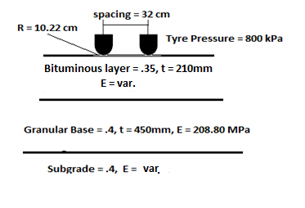

Figure 5: Pavement Structure for Analysis

The constitutive models for all materials of which the pavement structure was composed, were assumed as linear elastic (Hooke’s model). The values of the resilient modulus for the bituminous layers, which are the function of the speed at which the vehicles travel (relating to the time of loading) and the temperature, were calculated through laboratory investigation for a specific temperature range (Fig.4). The resilient modulus of bituminous layers replaces Hooke’s modulus, for simplification in analyses. Hooke’s modulus for granular base course and sub grade for 8% C.B.R value were calculated through the following empirical equations recommended in Indian Road Congress Specification “Guideline for Design of Flexible Pavement”:

${ E}_{3}=17.6*{CBR}^{.64}$ (4)

${ E}_{2}=E_{3}*.2*h^{.45}$ (5)

Where E2 is composite elastic modulus of granular sub-base (MPa) and base, E3 is elastic modulus of sub-grade (MPa) and h is the thickness of granular layer in mm.

Critical pavement responses i.e fatigue strain (underneath the bituminous layer) and rutting strain (on the top of sub grade) were determined for unmodified and PMB modified pavement using KENPAVE program. Single axle dual wheel assembly having total axle load of 105 kN is considered for analysis purpose. Critical pavement strains for modified and unmodified bituminous pavements were calculated for four distinct climatic season i.e Summer, Monsoon, Post Monsoon and Winter in India. Seasonal changes in material properties and resulting pavement strains are given in Table 8.

5.1 ESTIMATION OF SERVICE LIFE AND DAMAGE ANALYSIS:

The number of load repetitions to reach up to the threshold level of rutting and fatigue damage was calculated for different climatic seasons using the distress models recommended in the Indian Road Congress code entitled “Guideline for Design of Flexible Pavement” (IRC:37:2018) [18]. These distress models were developed and validated on the basis of a large amount of field performance and laboratory analysis data of bituminous pavement constructed across India under various climatic conditions. Following fatigue and rutting life relations are recommended in IRC: 37:2018 for Indian conditions:

Nf  = 2.21 \*10-4 [1/εt] 3.89 [1/E] 0.854 (5)

Nr = 4.1656 \*10-8 [1/εz] 4.5337 (6)

Where

Nf  : Number of cumulative standard axles to produce 20% cracked surface area.

Nr  : Number of cumulative standard axles to produce 20 mm rutting.

εt : Tensile strain at the bottom of BC layer.

εz  : Vertical compressive strain at the top of the subgrade.

E : Elastic modulus of Bituminous surfacing (MPa)

The pavement life or the number of load repetitions for pavement failure are the lowest number of load repetitions to failure obtained from either the fatigue or rutting model.

Table 8: Seasonal Changes in Material Properties and Resulting Strain

|  |  |  |  |  |  |  |  |  |
| --- | --- | --- | --- | --- | --- | --- | --- | --- |
| Season  (Avg. Pavement Temp °C) | Resilient Modulus (MPa) | | Subgrade Modulus (MPa) | Unmodified Pavement | | PMB Modified Pavement | | |
| Bituminous Layer | | Fatigue Strain  (µƐt) | Rutting Strain  (µƐz) | Fatigue Strain  (µƐt) | Rutting Strain  (µƐz) |
| VG 30 | PMB 40 |
| Summer (45) | 682 | 1042 | 66.6 | 342.7 | 279.8 | 292.5 | 264.8 |
| Monsoon(40) | 1230 | 1478 | 33.3 | 276.8 | 300.5 | 255.4 | 287.8 |
| Post Monsoon(35) | 1600 | 2000 | 46.62 | 243.3 | 257.5 | 217.6 | 243.0 |
| Winter (25) | 3828 | 3923 | 53.28 | 149.3 | 192.3 | 147.1 | 190.7 |

${ N}_{r}=4.1656 × {10}^{-8} × {\left(\frac{1}{Ɛ_{z}}\right)}^{4.5337}$ The assessment of improvement in pavement life is carried out using the cumulative damage concept [19]. For each separate condition of load and combination of material properties expected over the life of the pavement, the incremental damage is calculated for modified and unmodified pavement. Incremental damage is simply the number of a particular axle load expected during a given seasonal condition divided by the number of load cycles to failure (ni/Nfi). The incremental damage is summed for all the loads and conditions to determine the expected cumulative damage (D) over the life of the pavement in unmodified and modified pavement system:

$D=\sum{\frac{n_{i}}{N_{fi}}}$ (7)

If D is less than a value of one, then the pavement can be expected to sustain design traffic. If D is greater than one, then the pavement is expected to fail prematurely. The results of the damage analysis are given in Table 9.

**6. SUMMARY OF RESULTS AND DISCUSSION**

Indirect tensile strength test revealed that polymer-modified binder improved the tensile strength of the moisture-conditioned and dry subsets of the bituminous mix by 21.77% and 11 % respectively. Higher tensile strength is an indicator of improved resistance to fatigue cracking. Moisture susceptibility is typically a problem that can cause the bitumen binder to strip from the aggregate, leading to ravelling and disintegration of the mixture. Resistance against moisture susceptibility was assessed by comparing the tensile strength ratio and retained Marshall Stability of the modified and unmodified mix. Higher tensile strength ratio (91%) and better retained Marshall Stability (83%) were found in polymer-modified mixes.

Table 9: Damage Analysis

|  |  |  |  |  |  |
| --- | --- | --- | --- | --- | --- |
| Season  (Avg. Pav. Temp °C) | Expected Load Repetitions  in Design life (ni) | Unmodified Pavement | | PMB Modified Pavement | |
| Fatigue Damage | Rutting Damage | Fatigue Damage | Rutting Damage |
| Summer (45) | 12,50000 | 0.49 | 0.02 | 0.38 | 0.01 |
| Monsoon (40) | 12,50000 | 0.35 | 0.03 | 0.30 | 0.02 |
| Post Monsoon (35) | 12,50000 | 0.08 | 0.0 | 0.08 | 0.0 |
| Winter (25) | 12,50000 | 0.33 | 0.01 | 0.21 | 0.01 |
| Cumulative Damage | | 1.25 | 0.06 | 0.97 | 0.04 |

The stiffness of the mix obtained from the static creep test is considered to be an important indicator of the resistance to rutting. The creep modulus value of the mix at different temperatures is given in Table 6. The comparison between the creep modulus value of the unmodified and modified mix shows unambiguously the better resistance to rutting of the modified mix. It appears that the stiffness is about thrice as high, which is a strong indication of insensitivity to rutting.

The final rut achieved in slab made with PMB 40 binder as compared to that made with VG 30 is about 72.88% less, this is due to the presence of polymers in binder. Polymers provide a three-dimensional networking effect in bituminous concrete stabilizing the binder on the surface of aggregate particles and preventing any movement at higher temperatures [20].

The fatigue life in terms of a number of cycles to cause a 50% reduction in the initial flexural stiffness is obtained for the conventional and modified mix. No of cycles to produce failure for the conventional mix is around 8,19,110 whereas for the modified mix it is 10,00,000 which clearly presents that the development of crack during fatigue is much more resisted by PMB 40 binder as compared to VG 30 binder. The initial phase angle obtained during the test for the modified mix is 38.9° whereas for the unmodified mix is 46.8°. This clearly shows that the modified mix is more recoverable in nature as compared to the unmodified mix.

The use of the resilient modulus provides a basis for the comparison of changes in mix stiffness at different temperatures. It is reported that the resilient modulus is an important parameter in predicting pavement performance and to analysis the pavement response to traffic loading. The modified asphalt concrete mixtures consistently exhibited higher resilient modulus values than conventional mixtures at different temperatures. The increase in modulus value is 33.7%, 25.23%, 23% and 32.5% at 25°C, 35°C, 400C and 45°C temperatures respectively. This might be due to the higher viscosity and thick bitumen films which impart elastic properties to the mixtures that lead to better resilience properties.

The results of the multi-layer elastic analysis are presented in Table 8. Lower fatigue and rutting strains were found in modified pavement invariably in all climatic seasons. Critical strains were used to find out the load repetition to cause either fatigue an rutting damage using distress models recommended in IRC: 37:2018. Damage analysis presented in Table 9 reveals that unmodified pavement may have premature failure under the present state of loading while modified pavement will complete its design life. Cumulative damage in the unmodified pavement is found to be 28.8% higher than in the modified pavement section.

**7. CONCLUSIONS:**

Based upon the data generated through the laboratory testing and mechanistic analysis the following conclusions can be drawn about the uses of elastomeric polymer modified (SBS) binder for uses in asphalt pavement:

* The tensile strength ratios for the mixtures containing the PMB 40 are greater by 9.65%. This indicates that modified mixes are more resistant to moisture.
* The Creep Modulus of the modified mix is about three times compared to the unmodified mix, which is a strong indication of insensitivity to rutting.
* The final rut achieved in slab made with PMB 40 binder as compared to that made with VG 30 is about 72.88% less, this is due to the presence of polymers in a binder.
* The phase angle of the unmodified mix is about 20% higher than that of the modified mixture which leads to more dissipation of energy during flexural fatigue test and finally less resistance to fatigue failure.
* The increase in modulus value is 33.7%, 23%, and 32.5% at 25°C, 35°C, and 45°C respectively. This increase in the modulus value is due to the modification of bitumen with polymer.
* If the pavement section is kept the same for the unmodified and modified BC mixture, the pavement gives a TBR value of 1.12.

**8. ACKNOWLEDGEMENT**

The authors would like to thank Dr. S. Gangopadhyay, Ex-Director, CRRI for providing the opportunity to pursue this study at CSIR-CRRI. The authors would also like to thank Dr. Devesh Tiwari, Chief Scientist, CSIR-CRRI for helping us during the laboratory testing.

**9. REFERENCES**

1. The Asphalt Handbook (2004), Asphalt Institute, MS-4, 7th Edition pp 7-10.
2. Vonk W.C. and Gooswilligen G. Van. (1989), “*Improvement of paving grade bitumens with SBS polymers*”, Proc 4th Eurobitume Sypm, Madrid pp 298-303.
3. Becker Yvonne, Mendez Maryro P. and Rodríguez Yajaira. (2001), “*Polymer Modified Asphalt*”, Vision Tecnologica, Vol. 9 No1.
4. The Shell Bitumen Handbook(2004), 5th Edition, pp 61-63
5. Zhen Liu, XiGu, Hua Ren, Z Zhou, X Wang and S Tang (2022) “Analysis of the dynamic response of asphalt pavement based on full scale accelerated testing and finite element simulation” Journal of the Construction and Building Materials, vol. 325, Mar. 2022, 126429
6. S.Yang, B.Qi, Z.Cao, S. Zhang, H. Cheng and R. Yang (2020), “Comparison between Asphalt Pavement Responses under Vehicular Loading and FWD Loading”, Journal of Advances in Material Science and Engineering , 2020, Article ID 5269652
7. Ping W. Virgil and Xiao Yuan. (2001), “*Evaluation* *of SBS Polymer Binder Effect on Resilient Modulus Properties of Florida HBM Mixtures*”, The 24th ICTPA Annual Conference & NACGEA International Symposium on Geo-Trans, Paper No. S2-001.
8. Gupta S. & Veeraragavan A. (2009), “*Fatigue Behaviour of Polymer Modified Bituminous Concrete Mixtures*”, Journal of the Indian Roads Congress, January-March, Paper Number 548.
9. Isacsson U. and Xiaohu L. (1999), “*Laboratory Investigation of Polymer Modified Bitumens*”, Journal of the Association of Asphalt Paving Technologists Vol. 68, pp 3563-3582.
10. Harold L. and Von Q. (2005), “*Reducing Flexible Pavement Distress In Colorado Through The Use Of PMA Mixture*s”, Final Report No. 16729.1/1, Colorado Asphalt Pavement Association 6880 South Yosemite Ct., Suite 110 Englewood, Colorado 80112.
11. Ministry of Road Transport and Highways (MoRTH) (2013), “*Specifications for Road and Bridge Works*”, Fifth Revision, Indian Roads Congress, New Delhi, India.
12. MS-2 (2014) Asphalt Mix Design Methods; published by Asphalt Institute, 7th edition.
13. ASTM 4867M-04, Standard Test Method for Effect of Moisture on Asphalt Concrete Paving Mixtures
14. AASHTO T 321, Standard Method of Test for Determining the Fatigue Life of Compacted Asphalt Mixtures Subjected to Repeated Flexural Bending
15. AASHTO TP 9: Standard Test Method for Determination of creep Compliance and Strength of HMA using the Indirect Tensile Test Device
16. AASHTO T-324, Standard Method of Test for Hamburg Wheel-Track Testing of Compacted Asphalt mixture
17. ASTM D4123-82, Standard Test Method for Indirect tension test for Resilient Modulus of Bituminous Mixture
18. IRC:37:2018 (2018): Indian Road Congress Specification for Design of Flexible Pavement
19. Z.Zhang, M. Oeser (2020): Residual strength model and cumulative damage characterization of asphalt mixture subjected to repeated loading published in International Journal of Fatigue, vol.135, June 2020
20. B.V.Kok, and N. Kuloglu (2007) The Effects of Different Binders on Mechanical Properties of Hot Mix Asphalt, published in International Journal of Science & Technology, Vol. 2 No. 1, 41-48-2007

**IMPERATIVE ROLE OF WASTE JAROSITE ON RUTTING AND FATIGUE PROPERTIES OF ASPHALT MASTIC AND MIXES**

Sk Sohel Islama\*, GD Ransinchung R.Nb, Jayvant Choudharyc,

aPhD Scholar, Department of Civil Engineering, Indian Institute of Technology Roorkee, Uttarakhand, India-247667, ssohelislam@ce.iitr.ac.in (***Corresponding author***) \*

bProfessor, Department of Civil Engineering, Indian Institute of Technology Roorkee, Uttarakhand, India-247667, g.n@ce.iitr.ac.in

cAssistant Professor, Department of Civil Engineering, Madhav Institute of Technology & Science, Gwalior, India-474005, jayvant.chaudhary.civ13@itbhu.ac.in

doi: 10.1515/ijpeat-2016-0054

**ABSTRACT**

Jarosite (JS) is a hazardous waste, substantially obtained from zinc industries and faces difficulty in its safe disposal. This novel study aimed to consume JS as an alternative filler which not only could resolve the disposal issues of the stated waste, but the asphalt mixes made with JS might also deliver the superior performance against rutting and fatigue as compared to their counterparts made with conventional stone dust (SD) and well-recognized alternative (fly ash (FA)) fillers. Firstly, the detailed physical and chemical characterization of JS, SD, and FA was done followed by the designing of asphalt mixes containing all fillers at different proportions (2, 4, 6, and 8%). Thereafter, the asphalt mastics corresponding to each mix were designed and their rheological properties along with the performance against rutting and fatigue were analysed. Finally, the performance of asphalt mixes against permanent deformation, ravelling and fatigue cracking was also estimated using wheel rut test, cantabro tests and four-point beam bending test, respectively. In general, it is observed that asphalt mastic and mixes containing JS exhibited higher stiffness, higher elasticity and better rutting resistance than SD and FA counterparts, which was primarily due to its fine size and porous nature. However, higher stiffening due to JS was also found to marginally deteriorate the performance of its asphalt mastics and mixes against fatigue and that was observed at a higher strain level. Additionally, the design of flexible pavements utilizing aforesaid mixes was conducted as per MEPDG guidelines. Overall, it was concluded that judicious utilization of JS in optimum quantity superior performing asphalt mastics and mixes.

**Keywords:** Alternative filler; jarosite; industrial waste; asphalt mastic; rutting; fatigue cracking.

**INTRODUCTION**

Asphalt mixes are made up of carbon-based asphalt binders and non-renewable aggregates. The finest part of the aggregates (which passes through 0.075mm sieve) is known as a filler and is considered to substantially influence the characteristics and efficiency of the asphalt mixes (Anderson et al., 1992). Compact packing of coarse aggregate, fine aggregate, and filler serves as the foundation of a mix (Vavrik et al., 2002). The combination of asphalt binder and filler forms mastic which is denser than base binder and causes the aggregates together to bind into a thick mass (Huang et al., 2007). The filler has the ability to increase the viscosity of the mastic and give more resistance for aggregate particles to move within the mix (Cardone et al., 2015; Muniandy et al., 2013). The influence of filler content and their properties such as their particle size, shape, surface area, surface texture, chemical nature and mineralogy significantly influence the performance of asphalt mixes. Hence choosing the optimum quantity and type of filler is vital to ensure satisfactory performance of asphalt mixes. Nevertheless, the growing demand for conventional fillers like stone dust, cement and hydrated lime would not meet the required supply in many areas. Therefore, researchers around the globe are emphasizing on recycling of waste materials as an alternative and have delivered superior performance against various pavement distresses as compared to asphalt mixes containing conventional fillers (Arbani et al., 2017; Chandra and Choudhary, 2013; Choudhary et al., 2018a, b, 2020; Mistry et al., 2019; Modarres and Bengar, 2019).

In India, rapid industrialization and large-scale infrastructural development have resulted in a huge scarcity of construction materials and a tremendous increase in environmental pollution due to the generation of ample quantities of waste material. Metal producing industries is one such sector where several waste materials are produced as by-products along with the primary products. Zinc industry released a substantial quantity of hazardous waste products known as jarosite (JS) during the zinc extraction through the hydrometallurgical process (Leclerc et al., 2003; Pappu et al., 2007, 2010). It is estimated that zinc extraction plants of India produce approximately four hundred thousand metric tons of Jarosite annually (Sinha et al., 2016). Numerous researchers have attempted the suitability of utilizing JS as a construction material with or without mixing with cement and lime additives (Arora et al., 2015; Debberma and Ransinchung, 2021; Mehra et al., 2016). The optimum combination of jarosite, coal fly ash, and clay can be used to form bricks that could deliver adequate compressive strength (Pappu et al., 2006a, b). Moreover, recent studies have identified the sustainable utilization of waste jarosite in asphalt pavements as an alternative filler material. The study inferred that JS incorporated asphalt mix provides higher stiffness and moisture susceptibility property as compared with conventional fillers and also revealed that consumption of jarosite hinders the leaching of harmful heavy metals from the prepared mix and may thus prevent the ground water pollution (Islam et al., 2020, 2021). However, despite being advantageously utilized the potential of JS in the development of asphalt pavements, there has not been enough evidence on the effect of jarosite on the rutting and fatigue behaviour of asphalt mastic. Since the fundamental aspect in asphalt pavements is the correct understanding of rutting and fatigue performance of asphalt materials, which is strictly linked to the properties of the mastic phase and its components this novel investigation has been carried to explore the impact of JS as a filler on the rutting and fatigue performance of asphalt mastic and mixes.

**MATERIALS**

The VG-10 asphalt binder was used in this study, which was procured from Tiki Tar industries located in Indian state of Gujarat. In this current investigation, three different types of fillers namely, Stone dust (SD), fly ash (FA), and Jarosite (JS) was used and average filler-binder ratios for 2, 4, 6, and 8% fillers were calculated as 0.40, 0.80, 1.20, and 1.60, respectively. All the studied fillers were sieved on 0.075 mm sieve and the finer portion of materials was used for the preparation of mastic. Sandstone aggregates along with Asphalt Concrete (BC) grade-I gradation as per the Ministry of Road Transport and Highways (MoRTH) specification of India was opted for preparing the asphalt mixes (MoRTH, 2018).

**EXPERIMENTAL PROGRAMME**

**Testing on asphalt mastic**

*Mastic preparation*

In this investigation, melt-blending technique was adopted to produce asphalt-filler mastics (Ali et al., 2015). To relate the performance of asphalt mastic with its corresponding mix, it is essential to decide filler-binder ratio of the mastic based on the filler content in the mix and their respective optimum asphalt content (OAC). Hence, in this study, the filler-binder ratio corresponds to each filler percentage (2, 4,6 and 8%) in the asphalt mix was decided by taking the average value of filler-binder ratio at similar filler percentage. This will not only eliminate the variability in the amount of binder in all mastics prepared at the same filler percentage, but also it will provide the binder content approximately equivalent to OAC of the mix. Firstly 400 g of asphalt binder was heated at a temperature of 165°C and stirred mechanically at 3500 rpm for 5 minutes. Then a pre-specified amount of filler was added slowly to the binder. Two minutes of initial blending followed by manual mixing was applied to help disperse the filler into the binder. Subsequently, mixing was continued at the same temperature for 1 hour at the speed 4000 rpm with the Silverson high shear mixer. Prepared asphalt mastics were subjected to short-term aging with the thin-film oven (TFO) and long-term aging by pressure aging vessel (PAV) instrument in accordance with ASTM standards (ASTM D1754, 2020; ASTM D6521, 2019).

*Physical and rheological properties of asphalt mastic*

The physical properties of mastics were determined by conducting the penetration (PE) and softening point (SP) tests according to the ASTM D5 and ASTM D36, respectively (ASTM D5, 2020; ASTM D36, 2020). The temperature susceptibility of asphalt mastics was assessed by the determination of penetration index (PI), which measures the change in the consistency of asphalt mastic with temperature. The lower PI indicates a higher susceptibility of asphalt mastics and vice versa. In order to identify the effect of type of filler and its content on the rheological properties and viscoelastic behavior of mastics, dynamic shear rheometer (DSR) was used in accordance with AASHTO T315 guidelines (AASHTO T315, 2012). To measure the complex shear modulus (G\*) and phase angle (δ) values of long and short-term aged mastics, frequency sweep tests were performed at intermediate (25⁰C) and high (60⁰C) temperatures, respectively. Although the analysis was performed at the frequency range of 0.1-100 rad/s, the results in this study are only reported at the frequencies of 1 and 10 rad/s for simplification. The testing was done at 0.5% strain to ensure that the testing was conducted within the linear visco-elastic region. In the case of short-term aged mastic, the superpave rutting parameter (G\*/sinδ) was calculated to determine the rutting resistance of asphalt mastics at a higher temperature. While, in the case of long-term aged mastic, the superpave fatigue parameter (G\*sinδ) was calculated to analyze the fatigue resistance of asphalt mastics at intermediate temperature. The lower fatigue resistance signifies its superior fatigue resistance and vice versa.

*FTIR study of asphalt mastic*

To understand the chemical interaction of added filler in asphalt and to quantify the chemical functional group in asphalt-filler mastic, Fourier transform-infrared spectroscopy (FT-IR) analysis was performed by using the ‘Perkin Elmer-C 911580 instrument. In this study for the FT-IR analysis, only one F/B ratio of 1.60 was used for each filler type. The mastic sample was homogeneously dispersed in Potassium Bromate (KBrO3) pellets, and the test was conducted for the selected wavelength from 4000 cm-1 to 500 cm-1.

**Testing on asphalt mixes**

*Design of asphalt mixes*

The asphalt concrete mixes containing various fillers were designed and their optimum asphalt content (OAC) was determined with the Marshall mix design method as per MS-2 specification (Asphalt Institute, 2014). Marshall specimens were prepared by mixing 1200 g of aggregates at specified gradation with seven different asphalt binder content (4.5-6.0% at 0.25% increment). Aggregates, filler and preheated asphalt binder were initially weighed and mixed at specified mixing temperature and then subsequently compacted with mechanical compactor to produce standard Marshall specimens. The filler proportion in the mix was increased by simultaneously decreasing the same amount of fine aggregate proportion to maintain the chosen gradation.

*Cantabro abrasion Test*

The resistance to abrasion is one of the significant properties of mixes as abrasion is generally generated in the asphalt pavement due to the wear and tear action of heavily loaded vehicle tyres. The abrasion resistance of the mixes under consideration in this study was conducted in accordance to ASTM D7064 (ASTM D7064, 2013). The resistance of abrasion was evaluated using Los Angeles Abrasion apparatus. The cylindrical specimens of size 100×63.5mm were prepared to correspond to individual OAC. For performing the Cantabro Abrasion test, each mix was replicated through six specimens and tested for loss in abrasion. The prepared samples were immersed in a water bath at a fixed temperature of 20°C for 20 hours. After the stipulated time period, samples were placed in Los Angeles abrasion machine for conducting the test, without including any abrasive charges. The machine was subjected to around 300 revolutions with an approximate speed of 30-34 rev/min. Abrasion loss was calculated with respect to the loss in mass of the specimens on exposure.

*Permanent deformation test*

Rutting is one of the fundamental performance parameters indicating the permanent deformation characteristic of asphalt mixes. Wheel Tracking Device (WTD) was used to determine the rutting resistance of the asphalt concrete mixes (AASHTO T324, 2019). In this study rutting resistance behaviour of respective mixes has been presented in terms of their dynamic stability (DS) value, which indicates the efficacy exhibited by these asphalt mixes in resisting plastic deformation. DS fundamentally denotes the number of wheel passes required to produce a rut depth of 1 mm. An increased DS value represents a stiffer mix exhibiting higher performance against rutting.

|  |  |
| --- | --- |
| $$DS=\frac{(t_{1}-t_{2})×V}{D_{1}-D_{2}}$$ | [1] |

Where, DS = Dynamic stability (passes/mm); t1 = 60 min; t2 = 45 min; D1 = Deformation at time t1 (mm); D2 = Deformation at time t2 (mm); V = running speed of test wheel, (usually taken as 42 passes/min).

*Fatigue cracking Test*

The fatigue life of asphalt mixes incorporating various fillers was evaluated through a four-point bending beam fatigue test (AASHTO T321, 2007). The experiment was conducted at 20°C in a temperature-controlled cabinet by applying a repeated sinusoidal loading at 10 Hz frequency in controlled strain mode. Test parameters such as beam deflections, load cycles, and dissipated energy, were recorded by the software-controlled test apparatus. For every mix, rectangular beams with dimensions 382 mm × 50 mm × 50 mm were cast at 4% air voids. The sinusoidal wave shape loading with 10 Hz frequency was applied to each beam. The fatigue life of specimen is stated as no of load cycles required to reduce the stiffness of specimen to 50% of its initial value. Experiments were conducted at strain levels from 200 to 1000 micro-strains and three beams were tested for each mix at each strain level. The Poisson’s ratio of 0.35 was assumed for all asphalt concrete mixes (Arabani et al., 2017; Modarres and Bengar, 2019).

**Statistical analysis**

In statistics, analysis of variance (ANOVA) is an important technique to determine whether there is a significant difference between two or more sample means of populations. To statistically evaluate the effects of filler concentration and different types of fillers, on the rutting and fatigue performance of studied mixes, two-way ANOVA with a 95% confidence interval (𝛼 = 0.05) was carried out in this research. The independent variables are the type of filler (SD, JS, and FA) and filler content (2, 4, 6 and 8%), whereas, dynamic stability and fatigue life of the asphalt mix are the dependent variables.

**Design of flexible pavement utilizing various designed mixes as surface course**

In this section, the suitability of designed mixes in the surface course of flexible pavement is analyzed. To achieve this, the design traffic is assumed as 150 million standard axles, and the calculation of optimum surface layer was done as per mechanistic-empirical pavement design guidelines based on IRC: 37 (2018) specifications. The thickness of all other pavement layers was kept constant in all cases while the optimum thickness of surface course for each type of asphalt mix was individually calculated. The principal material properties (stiffness moduli and Poisson’s ratio) and layer thickness for each course are shown in Fig. 1. The value of resilient modulus of mixes determined in previous section was adopted as elastic modulus values for the surface course. The strains at critical locations of pavement system were determined using IITPAVE software which is prescribed by IRC: 37 (2018) guidelines.

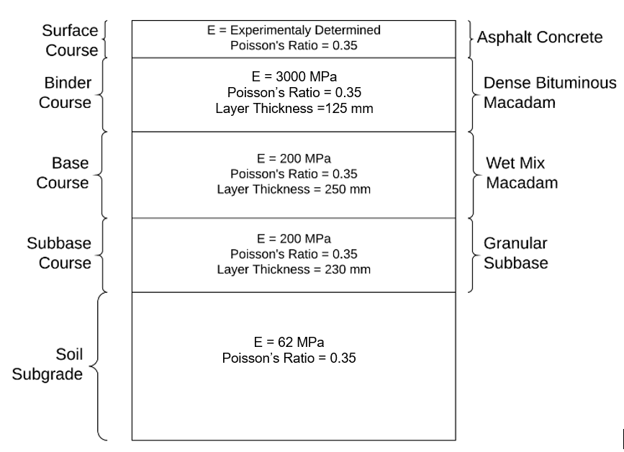

**Figure 1.** Pavement structure designed in this study.

**RESULTS AND DISCUSSION**

**Characterization of fillers**

The physical and chemical characteristics of studied fillers are presented in Table 1. Conducting the specific gravity test revealed that FA exhibits the lowest specific gravity of 2.193 amongst the three fillers. Moreover, its value for JS (2.770) was comparable to SD (2.701). Stiffening of the mixes is predominantly influenced by the individual specific gravity of the fillers since higher specific gravity indicates lower volume occupancy for the same mass in the mix and vice versa. Lowest FM and D50 values of JS entitled it to be the finest filler followed by FA and SD respectively. The interaction of fillers with asphalt is proportional to its fineness and thereby influences its rutting and fatigue characteristics. On conducting the delta ring and ball test it was evident that JS (24°C) displayed the highest interaction with asphalt followed by FA (18°C) and SD (11°C). This interaction may be explained in terms of the smaller particle size of JS along with its high specific surface area and porosity. An in-depth study on the shape and texture of various fillers was determined using scanning electron microscopy (SEM). Figure 2 exhibits the obtained SEM images of all the fillers clearly illustrating well-rounded FA particles as well as sub angular to angular shape of SD particles. Moreover, JS displayed cubical-shaped particles with smooth surface texture. The texture of SD was evidently rough, while that of other waste fillers was found to be relatively smooth. The primary mineralogical composition of fillers was analyzed through X-Ray Diffraction (XRD) analysis and is represented in Figure 3. Silica was primarily found in the form of quartz in both SD and FA, as well as Silica is also found in the form of sillimanite in FA. JS predominantly consisted of sulfides and oxides of iron and zinc in the form of Carphosiderite, Natrojarosite, sphalerite and hematite.

**Table 1.** Characterization of studied fillers

|  |  |  |  |  |
| --- | --- | --- | --- | --- |
| Test Parameters | SD | | JS | FA |
| Specific gravity | | 2.701 | 2.770 | 2.193 |
| Fineness Modulus | | 5.25 | 2.79 | 3.77 |
| D50 (µm) | | 39 | 6 | 10 |
| Specific surface area (m2/kg) | | 293 | 1128 | 345 |
| Delta Ring and Ball value (°C) | | 11 | 23 | 18 |

|  |  |
| --- | --- |
| 1_004 | 1_017 |
| (a) Stone Dust | (b) Fly Ash |
|  |  |
| Figure 2. SEM images of studied fillers | |
| (c) Jarosite | |

**Figure 2.** SEM images of studied fillers

|  |  |
| --- | --- |
|  |  |
|  | |

**Figure 3.** XRD diffractograms of studied fillers (a) SD (b) FA (c) JS

**Determination of Various performance parameters of mastics**

*Physical Properties of asphalt mastics*

In this study, the asphalt mastics corresponding to different mixes were prepared as per their effective filler-binder ratios. The average filler-binder ratios of asphalt mixes containing 2, 4, 6, and 8% fillers were calculated as 0.40, 0.84, 1.24, and 1.66, respectively. These filler-binder ratios were further rounded off to 0.40, 0.80, 1.20, and 1.60 respectively for further simplification. The physical properties of different mastics are stated in Table 2. It can be observed that the PE of various mastics was found to decrease with the increase in filler content. Similarly, the SP of various mastics was increased with the escalation in filler-binder ratio. It was attributed to the hardening effect of the fillers due to the increase in filler volume fraction in mastic with the higher filler-binder ratio. It can also be perceived that at the same filler-binder ratio, the mastics containing JS exhibited a higher stiffening effect, followed by FA and SD mastics. It might be attributed to the highest specific surface area, high porosity, and higher filler binder interaction due to the fine nature of JS.

**Table 2.** Physical properties of studied mastics

|  |  |  |  |  |
| --- | --- | --- | --- | --- |
| Filler type | Filler to binder ratio | Penetration (dmm) | Softening point (°C) | Penetration Index |
| SD | 0.4 | 70 | 51 | -0.121 |
| 0.8 | 59 | 55 | 0.382 |
| 1.2 | 42 | 63 | 1.157 |
| 1.6 | 27 | 69 | 1.061 |
|  |  |  |  |  |
| FA | 0.4 | 66 | 53 | 0.22 |
| 0.8 | 53 | 60 | 1.149 |
| 1.2 | 40 | 66 | 1.584 |
| 1.6 | 25 | 70 | 1.379 |
|  |  |  |  |  |
| JS | 0.4 | 61 | 55 | 0.472 |
| 0.8 | 48 | 64 | 1.706 |
| 1.2 | 30 | 72 | 1.842 |
| 1.6 | 15 | 80 | 1.671 |

Similarly, FA displayed higher stiffening than SD due to relatively higher porosity and lower specific gravity than SD. It can be inferred that mastic having a higher amount of JS may perform satisfactorily in hot climatic regions. The PI of various mastics was found to increase with the increase in filler-binder ratio, which suggested that the thermal susceptibility of mastics decreased with the increase in filler contents. The mastics containing JS displayed the lowest temperature susceptibility as evidenced by their highest PI, followed by FA and SD mixes.

*Rheological* *Properties of asphalt mastics*

The rheological parameters (complex shear modulus (G\*) and phase angle (δ)) of short and long-term aged mastics were determined at 60°C and 20°C, respectively at a frequency of 1 rad/s and are depicted in Table 3. As expected, the G\* of all mastics was found to be higher at lower temperatures and at the same temperature, modulus values of all mastics were found to increase with the filler-binder ratio, while the phase angles of mastics were found to decrease. At both temperatures, the mastics containing JS displayed highest G\* and lowest δ values followed by FA and SD. The higher complex modulus in JS mastics might be due to the reinforcement and stiffening provided by filler particles due to their higher porosity, high specific surface area and finer particle size. FA also displayed higher G\* value compared to conventional SD mastics which might be due to its higher volumetric concentration in the mastic than SD.

The rutting parameter of short-term aged asphalt mastics was calculated at 60°C whereas the fatigue parameter of long-term aged mastics was determined at 20°C. Variation of mastic rutting and fatigue properties with different filler-binder ratios is presented in Figure 4 and Figure 5, respectively. It can be observed that mastics displayed higher rutting resistance at the studied frequency, which verified that the fast-moving traffic causes lower rutting. It can also be inferred that the rutting resistance of asphalt mastics increased with the filler-binder ratio. JS mastics exhibited superior rutting resistance followed by FA and SD mastics. The difference in the magnitude of rutting parameter of SD and FA is predominant at the filler-binder ratio of 0.4 and 0.8, however, this difference is reduced considerably at 1.6 filler-binder ratio. This might be due to the agglomeration of FA in the mastic having a 1.6 filler-binder ratio, which reduces the rate of increase of G\*/sinδ values.

**Table 3.** Rheological properties of studied mastics

|  |  |  |  |  |  |
| --- | --- | --- | --- | --- | --- |
| Filler type | Filler-Binder Ratio | Short-term aged mastic (60°C) | | Long-term aged mastics (25°C) | |
| G\* (Pa) | δ (°) | G\* (Pa) | δ (°) |
| SD | 0.4 | 483 | 89.3 | 1.3×106 | 54.6 |
| 0.8 | 1928 | 88.8 | 2.8×106 | 52.8 |
| 1.2 | 6619 | 87.9 | 6.4×106 | 51.9 |
| 1.6 | 15534 | 85 | 13.8×106 | 51.2 |
| FA | 0.4 | 808 | 88.9 | 2.1×106 | 52.8 |
| 0.8 | 2832 | 86.7 | 4.2×106 | 51.9 |
| 1.2 | 8589 | 83.9 | 9.0×106 | 50.5 |
| 1.6 | 18947 | 82.4 | 17.0×106 | 50.1 |
| JS | 0.4 | 1211 | 88.7 | 3.8×106 | 50.3 |
| 0.8 | 3687 | 85.5 | 5.5×106 | 48.4 |
| 1.2 | 11362 | 81.2 | 11.3×106 | 48.1 |
| 1.6 | 27148 | 80.3 | 23.9×106 | 47.1 |

On the other hand, the SD filler particles tend to disperse uniformly at all filler-binder ratio, which enables the mastic to maintain the rate of growth of G\*/sinδ values. In DSR, the damage accumulation due to each cycle of oscillatory loading can be minimized by lowering the dissipated energy per cycle which can be done by minimizing the parameter “G\*sinδ”. Hence low values of G\* and δ are desirable from the standpoint of fatigue resistance. The fatigue parameters of long-term aged mastics were determined at 20°C. It can be observed that the fatigue resistance of all asphalt mastics was found to decrease with the increase in filler-binder ratio. Amongst different mastics, the JS mastics displayed the lowest fatigue resistance followed by FA and SD mastics as displayed in Figure 5. Mastics containing JS displayed poor fatigue resistance due to their tendency to show brittle behavior due to higher binder absorption caused by its higher specific surface area and higher porosity. FA mastics also displayed lower fatigue resistance than SD mastics due to their relatively porous nature.

*FTIR analysis of mastics*

The resultant chemical changes due to the addition of fillers to the binder were observed through FTIR studies and are presented in Figure 6. From the FTIR result, it can be inferred that the base binder has an aliphatic group around 1460 and 1376 cm-1, known as symmetric and asymmetric bending vibrations of CH3 which is commonly used as a reference group, since it is anticipated that these structures are stable and not affected by the addition of fillers into it. The band spectra observed in the 3000-2800 cm-1 region correspond to the asymmetric and symmetric stretches of C-H in CH2 and CH3. The bands associated with the fillers (SD, JS, and FA) didn’t mark any shift changes in the FTIR spectra of mastic prepared with fillers. As, no new peaks were generated, or any shift in the location of peaks takes place, the interaction was most likely physical in nature.



**Figure 4.** Variation of rutting parameter for mastics with different filler to binder ratio



**Figure 5.** Variation of fatigue parameter for mastics with different filler to binder ratio

**Performance analysis of asphalt mixes**

*Raveling Resistance*

In order to assess the bonding and cohesion between the aggregates and asphalt mastic, Cantabro test is normally used. Moreover, it indirectly measures the abrasion resistance of the asphalt mixes. The abrasion loss of the asphalt mixes containing different fillers along with their concentration is portrayed in Figure 7. It seemed that for all mixes, there was a decrease in Cantabro loss with an increase in filler content. However, this increment was limited, following which it increased at a higher proportion of filler. Increased stiffening of mastic due to filler addition leading to better cohesion in the mix might be the cause for initial declination in Cantabro loss. However, it is interesting to note that adding an excessively high quantity of filler might have resulted in extreme stiffening and consequent lower adhesion, thereby leading to an increase in Cantabro loss (Choudhary et al. 2020; Islam et al., 2020). The Cantabro loss for SD and FA mixes was decreased up to 4% filler content, and then a gradual increase in Cantabro loss was observed. Whereas, in the case of JS-containing mixes, the Cantabro loss was found to reduce up to 6% filler. It can be observed that mixes having JS as a filler, displayed higher raveling resistance (lowest Cantabro loss) followed by FA and SD mixes at each filler content. This betterment in the abrasion resistance property for JS incorporated asphalt mix might be due to the development of stiffer asphalt coating resulting in increased resistance of the mixes to impact.



**Figure 6.** FTIR spectra of fillers and mastic prepared with different fillers

*Dynamic stability study*

The rutting resistance of asphalt mixes was asserted in terms of their dynamic stability (DS) values as presented in Figure 8. The DS of studied mixes was determined at 60°C, corresponding to 20000-wheel passes. The higher DS value signified lower rutting resistance of the mix and vice versa. The rutting resistance of asphalt mixes was found to increase with the increase in filler contents for all mixes. As discussed in the previous section, the increased rutting resistance of the mix might be associated with the increase in G\*/sinδ value of the mastics. Amongst the different mixes, JS mixes displayed the highest dynamic stability value at all filler concentrations. JS possesses highest specific surface area, finest particle size, rough texture, and highest interaction with binder. The FA mixes also exhibited superior properties than conventional SD mixes, irrespective of filler content, which might be attributed to the higher porosity and finer nature of FA.



**Figure 7.** Cantabro abrasion loss for various mixes



**Figure 8.** Dynamic stability of various asphalt mixes after 20000 passes

*Fatigue cracking analysis*

The fatigue life of asphalt mixes containing different fillers was determined at 20°C at a strain level of 600 micro-strain as depicted in Figure 9. It can be seen that fatigue life of the mixes containing SD and FA was found to improve marginally when filler content was increased from 2 to 4%. Subsequently, the fatigue life of these mixes decreased with the increase in filler content. The improvement of fatigue life with an initial increase in filler content might be due to the “crack pinning” behavior of the filler particles. Several studies have observed that the fine filler particles in the mastic can act as barriers and stop or deflect the propagation of microcracks in it (Evans, 19772; Smith and Hesp, 2000). Few recent studies have also verified the cracking pinning behavior of the FA in the mastic (Sobolev et al., 2013, 2014). However, this mechanism seemed to diminish at higher filler contents due to the excessive stiffening of the mastic, which consequently decreases the fatigue life of mixes by exhibiting brittle behavior. The mixes containing JS displayed the lowest fatigue life at all filler contents. Also, in contrast to their counterparts, JS mixes also didn’t show any crack-pinning behavior and their fatigue life deteriorated continuously with an increase in filler content. This result is attributed to the fact that JS is the most porous filler and exhibited excessive higher stiffening in comparison to the other two fillers. Hence the higher stiffening behavior of its mastic might have overshadowed the pinning behavior of fillers which in turn resulted in the continual lowering of the fatigue life of its mixes. Overall, the conventional SD mixes displayed the highest fatigue life followed by FA and JS mixes respectively.



**Figure 9.** Fatigue test result for various asphalt mixes at 600 micro strain

**Statistical analysis of asphalt mixes test data**

The statistical significance of aforesaid results is validated by performing two two-way ANOVA. The objective of the first ANOVA test was to substantiate the effect of filler types and quantity on the dynamic stability parameter of all the studied mixes. The results of the analysis are presented in Table 4 which exhibited that there is statistical significance between the aforementioned dependent and independent parameters (p = 0.00 < 0.05). The second ANOVA primarily analyzed the impact of the type of filler and their respective quantity on fatigue resistance. The obtained outcome values are stated in Table 5, which validated that the type of filler and its corresponding quantity are found to be statistically significant for the fatigue life of all the studied asphalt mixes. (p = 0.00 < 0.05).

**Table 4 Two-way Anova of dynamic stability test results**

|  |  |  |  |  |  |  |  |
| --- | --- | --- | --- | --- | --- | --- | --- |
| *Source of Variation* | *Sum of square* | *df* | *Mean square* | *F* | *P-value* | *F critical* | *Result* |
| Filler content | 81881.23 | 3 | 27293.74 | 45.35 | 2.58E-12 | 2.87 | Significant |
| Filler type | 228376.17 | 2 | 114188.08 | 189.75 | 7.57E-20 | 3.26 | Significant |
| Interaction | 19601.83 | 6 | 3266.97 | 5.43 | 4.42E-04 | 2.36 |  |
| Within | 21664.25 | 36 | 601.78 |  |  |  |  |
| Total | 351523.48 | 47 |  |  |  |  |  |

**Table 5 Two-way Anova of fatigue life test results**

|  |  |  |  |  |  |  |  |
| --- | --- | --- | --- | --- | --- | --- | --- |
| *Source of Variation* | *Sum of square* | *df* | *Mean square* | *F* | *P-value* | *F critical* | *Result* |
| Filler content | 71941475.1 | 3 | 23980491.7 | 901.24 | 6.62E-34 | 2.87 | Significant |
| Filler type | 101220459.9 | 2 | 50610229.9 | 1902.05 | 3.13E-37 | 3.26 | Significant |
| Interaction | 7062615.8 | 6 | 1177102.6 | 44.24 | 3.65E-15 | 2.36 |  |
| Within | 957898.5 | 36 | 26608.3 |  |  |  |  |
| Total | 181182449.3 | 47 |  |  |  |  |  |

*Design of flexible pavements*

The optimum design thickness required for the surface course made with various asphalt mixes to support design traffic of 150 msa was worked out. The optimum thickness of surface course layer corresponds to each mix was determined using IITPAVE software as per IRC: 37 (2018) and stated in Table 6. It can be inferred that the increase in filler content significantly improved the stiffness of the mixes, which ultimately resulted in a considerable reduction in the required surface layer thickness. The allowable vertical compressive strains and horizontal tensile strains at critical locations were determined as 0.2917 × 10-3 and 0.1448 × 10-3, respectively. From the results obtained, it can be observed that all the computed strains are well below than the aforementioned allowable strain levels. It can be concurred that in all mixes, despite the increase in OAC with the filler content, the minimum thickness required to support design traffic decreases. This was attributed to the higher stiffness (resilient modulus) of asphalt concrete mixes made with higher filler content, which enables them to support similar traffic volume at relatively lower thicknesses. In general, it is also observed at similar filler content, asphalt mixes containing waste fillers (FA and JS), required lower pavement layer thickness than conventional SD mixes. It could be seen that flexible pavement containing surface layer made by JS needed the thinnest layer as compared to its other counterparts, which will translate into a significant amount of savings in the form of pavement materials (aggregate and binder), manpower, and construction time at field. It will also help to positively contribute in the issues concerning excessive stone quarrying as well as will enhance sustainability in pavement construction practices by lowering the greenhouse gas emissions. Overall, it can be said that incorporation of JS in asphalt concrete mixes as filler will not only improve the engineering performance of asphalt mixes but will also lead to the development of more economical and ecofriendly flexible pavements.

**Table 6.** Adopted thickness and computed strains for mixes containing different fillers (using IITPAVE)

|  |  |  |  |  |  |  |
| --- | --- | --- | --- | --- | --- | --- |
| Type of Asphalt Mix | | Percentage of filler in the mix (%) | Resilient modulus at 35⁰C (MPa) | Adopted thickness of surface course (mm) | Computed vertical compressive strain at top of subgrade (× 10-3) | Computed horizontal tensile strain at the bottom of bottommost asphalt layer (× 10-3) |
| SD | 2 | | 1375 | 82 | 0.2549 | 0.1447 |
| 4 | | 1565 | 80 | 0.2520 | 0.1444 |
| 6 | | 1742 | 77 | 0.2510 | 0.1445 |
| 8 | | 1765 | 77 | 0.2505 | 0.1443 |
| FA | 2 | | 1442 | 81 | 0.2541 | 0.1446 |
| 4 | | 1605 | 79 | 0.2520 | 0.1443 |
| 6 | | 1688 | 78 | 0.2513 | 0.1443 |
| 8 | | 1730 | 77 | 0.2513 | 0.1446 |
| JS | 2 | | 1730 | 77 | 0.2513 | 0.1446 |
| 4 | | 1815 | 76 | 0.2505 | 0.1446 |
| 6 | | 1934 | 75 | 0.2492 | 0.1444 |
| 8 | | 1990 | 74 | 0.2492 | 0.1447 |

**CONCLUSION**

This study explored the suitability of waste Jarosite as an alternative filler by performing the rutting and fatigue resistance properties of asphalt mastics and mixes and was compared with their counterparts made with SD and FA. The primary conclusions derived from the study are depicted as follows.

* JS exhibited traits of good filler since it displays high fineness, the highest specific surface area, and the highest interaction with asphalt binders amongst all studied fillers.
* Asphalt mastics containing JS exhibited the highest stiffness and lowest temperature susceptibility followed by FA and SD mastics at each filler-binder ratio.
* Mastics containing JS also displayed the highest complex shear modulus, elastic nature, and rutting resistance than FA and SD mastics at high temperatures.
* The rutting resistance of all mixes followed the following trend: JS > FA > SD. Asphalt mixes containing JS showed inferior fatigue performance than FA and SD mixes due to their relatively brittle nature.
* The fatigue resistance of JS mixes was found to decrease with the increase in filler content. The SD mixes displayed the highest fatigue resistance followed by FA and JS mixes.
* Anova study confirmed that the type of filler, as well as filler quantity, is statistically significant for dynamic stability and fatigue life test data of asphalt mixes containing different studied fillers.
* Incorporation of JS in asphalt concrete mixes as filler will not only improve the engineering performance of asphalt mixes but will also lead to the development of more economical flexible pavements.

**REFERENCE**

AASHTO, 2004. Standard Method of Test for Hamburg Wheel-Track Testing of Compacted Hot-Mix Asphalt (HMA). American Association of State Highway and Transportation Officials, T324, Washington, DC.

AASHTO, 2007. Determining the Fatigue Life of Compacted Hot Mix Asphalt (HMA) Subjected to Repeated Flexural Bending. American Association of State Highway and Transportation Officials, T324, Washington, DC.

AASHTO, 2012. Standard Method of Test for Determining the Rheological Properties of Asphalt Binder Using a Dynamic Shear Rheometer (DSR). American Association of State Highway and Transportation Officials, T315, Washington, DC.

Ali, S.I.A., Ismail, A.B., Md, Y., Mohamed, R.K., Mansob, R., Dhawo, I.A., 2015. “Physical and rheological properties of acrylate–styrene–acrylonitrile modified asphalt cement”. *Constr. Build. Mater*. 93, 326-334. DOI: 10.1016/j.conbuildmat.2015.05.016

Anderson, D.A., Bahia, H. U., Dongre, R., 1992. “Rheological properties of mineral filler-asphalt mastics and its importance to pavement performance”. *ASTM STP*. 1147. https://doi.org/10.1520/STP24215S

Arabani, M., Seyed, A. T., Mohammad, T., 2017. “Laboratory investigation of hot mix asphalt containing waste materials”. *Road Mater. Pavement Des*. 18(3), 713–729. https://doi.org/10.1080/14680629.2016.1189349

Arora, V., Sachdeva, S. N., Aggarwal, P., 2015. “Effect of use of Jarosite on workability and early age strength of concrete”. *Int. J. Comp. Math. Sc.* 4, 136-144.

Asphalt Institute, 1997. “Mix design methods for asphalt concrete and other hot-mix types”. manual series No. 2 (MS-2) 6th ed.

ASTM D1754-94, 1995. Standard Test Method for Effect of Heat and Air on Asphaltic Materials (Thin Film Oven Test). American Society for Testing and Materials, Philadelphia, USA.

ASTM D6521-19, 2019. Standard Practice for Accelerated Aging of Asphalt Binder Using a Pressurized Aging Vessel (PAV). American Society for Testing and Materials, Philadelphia, USA.

ASTM D7064, 2013. Standard Practice for Open-Graded Friction Course (OGFC) Mix Design. ASTM, West Conshohocken. (2013)

ASTM D5, 2020. Standard Test Method for Penetration of Bituminous Materials. American Society for Testing and Materials, West Conshohocken, PA

ASTM D36, 2020. Standard Test Method for Softening Point of Bitumen (Ring-and-Ball Apparatus). American Society for Testing and Materials, West Conshohocken, PA.

Chandra, S., Choudhary, R., 2013. “Performance characteristics of bituminous concrete with industrial wastes as filler”. *J. Mater. Civ. Engg*. 25(11), 1666-1673 DOI: 10.1061/(ASCE)MT.1943-5533.0000730

Cardone, F., Frigio, F., Ferrotti, G., Canestrari, F., 2015. “Influence of mineral fillers on the rheological response of polymer-modified bitumens and mastics”. *Journal of Traffic and Transportation Engineering*. 2(6), 373-381. DOI: 10.1016/j.jtte.2015.06.003

Choudhary, J., Kumar, B., Gupta, A., 2018. “Application of waste materials as fillers in bituminous mixes”. *Waste Management* 78, 417–425. DOI: 10.1016/j.wasman.2018.06.009

Choudhary, J., Kumar, B., Gupta, A., 2018. “Effect of filler on the bitumen-aggregate adhesion in asphalt mix”. *Int. J. Pavement Engg*. 1-9. DOI: 10.1080/10298436.2018.1549325

Choudhary, J., Kumar, B., Gupta, A., 2020. “Feasible utilization of waste limestone sludge as filler in bituminous concrete”. *Constr. Build. Mater.* 239. 117781 https://doi.org/10.1016/j.conbuildmat.2019.117781

Evans, A. G., 1972. “The strength of brittle materials containing second phase dispersions”. *Philosophical Magazine*. Vol. 26 (6). 1327-1344.

Huang, B., Shu, X., Chen, X., 2007. “Effects of mineral fillers on hot-mix asphalt laboratory-measured properties”. *Int. J. Pavement Engg*. 8(1), 1-9. https://doi.org/10.1080/10298430600819170

IRC: 37, 2018. Guidelines for the Design of Flexible Pavements. 4th Revision. Indian Roads Congress, New Delhi, India.

Islam, S., Ransinchung, GDRN., Choudhary, J., 2020. “Analyzing the effect of waste Jarosite as an alternative filler on the engineering properties of asphalt mixes”. *Constr. Build. Mater.* 270(1):121466. DOI: 10.1016/j.conbuildmat.2020.121466

Islam, S., Ransinchung, GDRN., Choudhary, J., 2021. “Sustainable Utilization of Waste Jarosite As Alternative Filler in Asphalt Mixes”. *J. Mater. Civ. Eng.* 33 (11)

Leclerc, N., Meux, E., Lecuire, J. M., 2003. “Hydrometallurgical extraction of zinc from zinc ferrites”. *Hydrometallurgy*. 70, 175-183. DOI: 10.1016/S0304-386X (03)00079-3

MoRTH, 2013. Specifications for Road and Bridge Works (Fifth Revision), Ministry of Road Transport and Highways. Indian Road Congress, New Delhi, India.

Muniandy, R., Aburkaba, E., Mahdi, L.M.J., 2013. “Effect of mineral filler type and particle size on asphalt-filler mastic and stone mastic asphalt laboratory measured properties”. *Australian Journal of Basic and Applied Sciences.* 7 (11), 475–487.

Mehra, P., Chandra, R., Skariah, B., 2016. “Assessment of durability characteristics of cement concrete containing Jarosite”. *J. Cleaner Prod.* 119, 59–65. DOI: 10.1016/j.jclepro.2016.01.055.

MoRTH, 2018. Annual report 2017–18. Ministry of road transport and highways. New Delhi: Government of India.

Mistry, R., Karmakar, S., Roy, T. K., 2019. “Experimental evaluation of rice husk ash and fly ash as alternative fillers in hot-mix asphalt”. *Road Mater. Pavement Des*. 20(4), 979-990. https://doi.org/10.1080/14680629.2017.1422791

Modarres, A., Bengar, P., 2019. “Investigating the indirect tensile stiffness, toughness and fatigue life of hot mix asphalt containing copper slag powder”. *Road Mater. Pavement Des.* 20(8), 977–985. https://doi.org/10.1080/10298436.2017.1373390

Pappu, A., Saxena, M., Asolekar, S.R., 2006a. “Jarosite characteristics and its utilization potentials”. *Science of the total environment*. 359 (1-3), 232-243. DOI: 10.1016/j.scitotenv.2005.04.024

Pappu, A., Saxena, M., Asolekar, S.R., 2006b. “Hazardous jarosite use in developing non-hazardous product for engineering application”. *J. Hazard. Mater.* 137, 1589-1599. DOI: 10.1016/j.jhazmat.2006.04.054

Pappu, A., Saxena, M., Asolekar, S.R., 2007. “Solid wastes generation in India and their recycling potential in building materials”. *Build. Environ.* 42, 2311-2320. DOI: 10.1016/j.buildenv.2006.04.015

Pappu, A., Saxena, M., Asolekar, S.R., 2010. “Recycling hazardous jarosite waste using coal combustion residues”. *Material Characteristics* 61, 1342–1355. https://doi.org/10.1016/j.matchar.2010.09.005

Sinha, A., Havanagi, V., Ranjan, A., Mathur, S., Singh, B., 2013. “Geotechnical characterization of jarosite waste material for road construction*”. Proceedings of Indian Geotechnical Conference*. 22-24.

Smith, B. J., Hesp, S. A., 2000. “Crack pinning in asphalt mastic and concrete: regular fatigue studies”. *Transportation Research Record*. 1728(1). 75-81.

Sobolev, K., Vivian, I. F., Saha, R., Wasiuddin, N. M., Saltibus. N. E., 2014. “The effect of fly ash on the rheological properties of bituminous materials” *Fuel*. 116. 471-477.

Sobolev, K., Vivian, I. F., Saha, R., Wasiuddin, N. M., Saltibus. N. E., 2013. “Application of fly ash in asphalt concrete: from challenges to opportunities”. *In Proceedings of World of Coal Ash Conference.*

Vavrik, W. R., Pine, W. J., Carpenter, S. H., Bailey, R., 2002. “Bailey method for gradation selection in hot-mix asphalt mixture design”. *Transportation Research Board, National Research Council. USA*.

**LARGE SCALE STATIC TESTING OF ASPHALT UNDERLAYS IN RAILWAY TRACK FOUNDATION**

Zelong Yu1\*, David Connolly2, Peter Woodward3, Omar Laghrouche4

1\* Lecturer, School of Civil Engineering and Built Environment, Liverpool John Moores University, L3 3AF. Email: Z.Yu@ljmu.ac.uk.

2 Associate Professor, School of Civil Engineering, University of Leeds, Leeds, LS2 9JT. Email: D.Connolly@leeds.ac.uk.

3 Professor, School of Civil Engineering, University of Leeds, Leeds, LS2 9JT. Email: P.K.Woodward@leeds.ac.uk.

4 Professor, Institute for Infrastructure and Environment, Heriot-Watt University, Edinburgh, EH14 4AS. Email: [o.laghrouche@hw.ac.uk](mailto:o.laghrouche@hw.ac.uk).

\* Corresponding author

doi: 10.1515/ijpeat-2016-0055

**ABSTRACT**

Asphalt has been widely used within ballasted railway tracks for over 40 years to aid its load distribution qualities. In most cases, asphalt underlays are placed directly below the ballast, however more recent tracks have been developed where the ballast is entirely replaced with asphalt. This paper investigates the short-term settlement characteristics of asphaltic track in the presence of a subgrade stiffness transition zone. To assess settlement response, a bespoke railway fatigue testing facility, ‘Geo-pavement and Railways Accelerated Fatigue Testing facility’ (GRAFT II) is used for the laboratory testing. Static compression tests are performed on two large-scale asphaltic tracks 1) with ballast on the top of the asphalt layer; 2) without ballast. Both asphaltic tracks are supported by subgrade with varying stiffness, representing typical soft and stiff subgrades found on UK railway lines. Displacements of three sleepers and the asphalt surface are measured for comparison. It is found when loading the asphalt directly (i.e. without ballast), sleeper displacements are larger than for the case with ballast, showing evidence of spreading the load through the track structure. After short-term recovery time, the results show that sleeper and foundation settlement over the soft subgrade is likely not fully recovered and the potential permanent settlement may occur if no ballast layer is involved.

**KEYWORDS**: railway track, asphalt, large scale test, static loading, settlement

# INTRODUCTION

Ballast railway track foundation typically consists of the ballast, the subballast and the subgrade. The nature of ballast means it is subjected to degradation due to particle breakage and fouling (Indraratna, Nimbalkar & Tennakoon, 2010), thus requiring frequent maintenance. To reduce this maintenance cost, a variety of methods have been investigated. One common method is to use a geogrid which decreases both vertical and lateral deformation, leading to reduced track maintenance (Indraratna *et al.*, 2006, Brown *et al.*, 2007a, Aursudkij *et al.*, 2009, Indraratna *et al.*, 2010a, Indraratna *et al.*, 2013b). Alternatively, Dersch *et al.*, (2010) used an elastomer polyurethane for coating the ballast particles to increase shear strength. Further, Woodward *et al.*, (2014) injected XiTrack into ballast layer, resulting in a 40% increase in track stiffness. Alternatively, D’Angelo *et al.*, (2016) proposed injecting bitumen into ballast to improve stiffness, while Sol-Sánchez *et al.*, (2014) and Ho *et al.*, (2015) inserted rubber crumbs into the ballast to reduce abrasion.

Instead of directly modifying the ballast, it is possible to modify other track components using under sleeper pads and/or asphaltic layers. Considering the use of under sleeper pads, both numerical and experimental investigations have shown improved track behaviour (Dahlberg, 2010, Lakušic *et al.*, 2010, Schneider *et al.*, 2011, Insa *et al.*, 2012 and Sol-Sánchez *et al.*, 2014b). For the use of asphalt layers, early work included (Buonanno and Mele, 2000, Li *et al.*, 2001, Rose *et al.*, 2002, Rose and Lees, 2008, Rose and Bryson, 2009, Rose *et al.*, 2010 and Rose *et al.*, 2011) and focused on the field application of asphalt. Throughout these works it was concluded that asphaltic layers served to increase the longevity of ballast tracks, however quantitative measurement data was sparse.

Therefore, to better understand the underlying behaviour of asphalt tracks, Esmaeili *et al.*, (2014) used KENTRACK (Rose, Su & Twehues, 2004) to investigate their effect on lateral track resistance. Alternatively, Di Mino *et al.*, (2012) developed an analytical model to compare the performance of ballast track with and without asphalt. The results confirmed that the asphalt layer reduced dynamic forces and ground vibration. Also, Fang *et al.*, (2011) and Fang and Cerdas, (2015) used the finite element method to analyse asphalt railway substructures. It was found that the asphalt improved resilient performance and stress distribution, while also lowering vibration levels.

Although numerical modelling is useful for assessing dynamic response, laboratory testing is often preferred when investigating longer-term settlement response. Therefore, using physical tests, Momoya *et al.*, (2005) and Momoya and Sekine, (2007) also showed that asphalt reduced residual settlement and that thicker asphalt improved performance. Further, Teixeira *et al.*, (2009) investigated bituminous subballast on a high-speed line and proposed a theoretical asphalt design to protect the subgrade and reduce life-time maintenance cost. Similarly, Sol-Sánchez *et al.*, (2016) tested warm-mix asphalt as subballast in railway track and found better performance with lower permanent deformation and higher static and dynamic modulus compared with traditional granular subballast. To investigate the performance of asphalt in cold regions, Liu *et al.*, (2018) used mastic asphalt as a waterproofing layer and performed the tests in both laboratory and field. Finally, Lee *et al.*, (2015) and Lee *et al.*, (2016) performed full-scale static tests to evaluate the performance of an asphalt track-bed system. Results showed that, an asphalt layer can support a railway track without incurring major cracking.

When investigating the long-term behaviour of railway track settlement, it is important that the excitation is representative of the loading experienced in the field (Connolly *et al.*, 2014). To achieve this, test samples should be of similar scale to real tracks and load cycles should be accelerated to allow for a large number of train passages to be simulated in a reasonable time. Therefore, large scale testing apparatus are often required. To achieve this, Al Shaer *et al.*, (2008) used a one-third scale testing facility to study the dynamic behaviour of railway tracks. It was found that global stiffness is variable in terms of the number of load cycles. It was also observed that the settlement depended strongly on the moving train speed due to increased levels of ballast acceleration. Further, Hasnayn *et al.*, (2017) used a full-scale, single sleeper testing facility to study the performance of railway track substructure during flooding. It was found that subgrade behaviour is significantly affected by changes in water content.

Alternatively, to include the effect of multiple sleepers on track response, Liu *et al.*, (2018) used a full-scale test facility with 4 sleepers to study the characteristics of ballast track under cyclic longitudinal loading. It was found that the ballast track was subject to cyclic softening with increased load cycles, resulting in reduced longitudinal bearing capacity. This cyclic softening was found dependent on the exerted displacement amplitude. Expanding upon this approach, Bian *et al.*, (2014) developed a full-scale test facility with 8 sleepers to investigate dynamic performance and long-term durability of railway track. Ballastless track was tested and it was found that the roadbed shielded the underlying subgrade from slab vibrations.

Although long-term performance of ballast railway track has been studied as mentioned above, the track performance at subgrade stiffness transition zones requires further clarification when asphalt layer is involved. To have a better understanding of this, this paper describes large scale physical tests to access the short-term settlement characteristics of asphaltic track in the presence of a subgrade stiffness transition zone with and without ballast layer.

# LABORATORY TESTING

‘Geo-pavement and Railways Accelerated Fatigue Testing facility’ (hereafter called GRAFT II – more details could be found in the paper from Čebašek *et al.*, (2018)), was used to investigate both short-term and long-term performance of railway track components and infrastructure (Figure 1 left). The test frame of GRAFT II is 6.2 m long, 3.4 m wide and 3.8 m high, with the ability to house a test sample of 6 m long, 2 m wide and 2 m high (Figure 1 right). The I-beams beneath the top of the frame are used to place the actuators. GRAFT II is capable of operating 6 independent hydraulic actuators with a 300 mm stroke, across 3 or 6 sleepers to simulate the passage of a moving train. Each actuator is connected to a load cell and a linear variable displacement transducer (LVDT) for control and measure purposes.

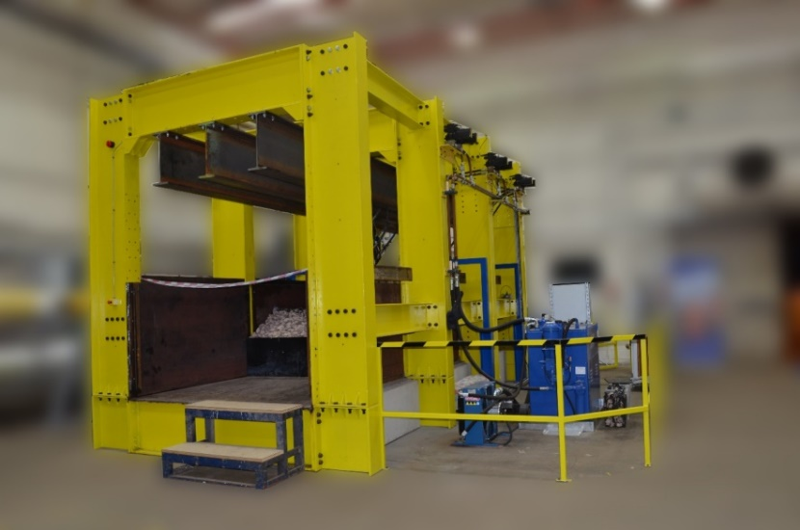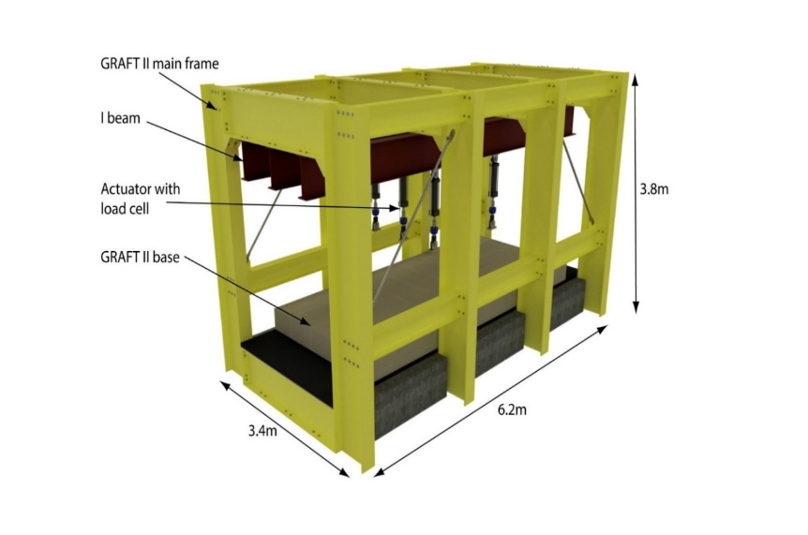

Figure 1. GRAFT II Photograph (left) and Specifications (right)

## Test Overview

The set up for two railway track systems are presented. One is the ballast-asphalt track system, which has been used increasingly all over the world (Figure 2). The other one is a novel railway track called the asphalt track system (Figure 3). The general setup consisted of 3 half sleepers of 200 m depth, laid at 600 mm centres. They were fully embedded in the 400 mm of ballast in ballast-asphalt track sample (Figure 2), while placed on the surface in asphalt track sample. They were constructed from metal, however designed to have mass and dimensions equal to the typical concrete sleepers used on UK railway lines. In both track samples, a 200 mm thick asphalt layer supported by a homogenous 100 mm deep granular layer. This granular layer also extended to a further depth of 300 mm, however at its horizontal centre was a low-stiffness rubber layer of width 1200 mm. The rubber material was intended to represent a ‘wet-spot’ type defect, commonly found on ballast rail lines. The stiffness of the resulting layers was determined by using light weight reflectometer (LWD) measurements. The detailed results were presented in Yu *et al.*, (2019).

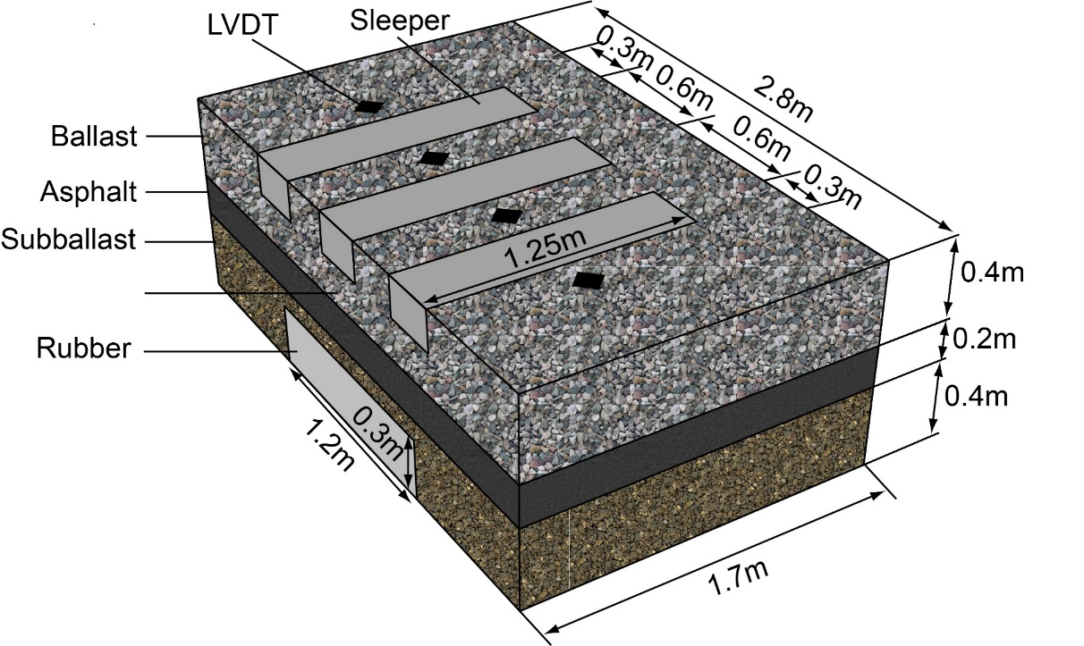

Figure 2. The layout of ballast-asphalt track sample

Figure 3. The layout of asphalt track sample

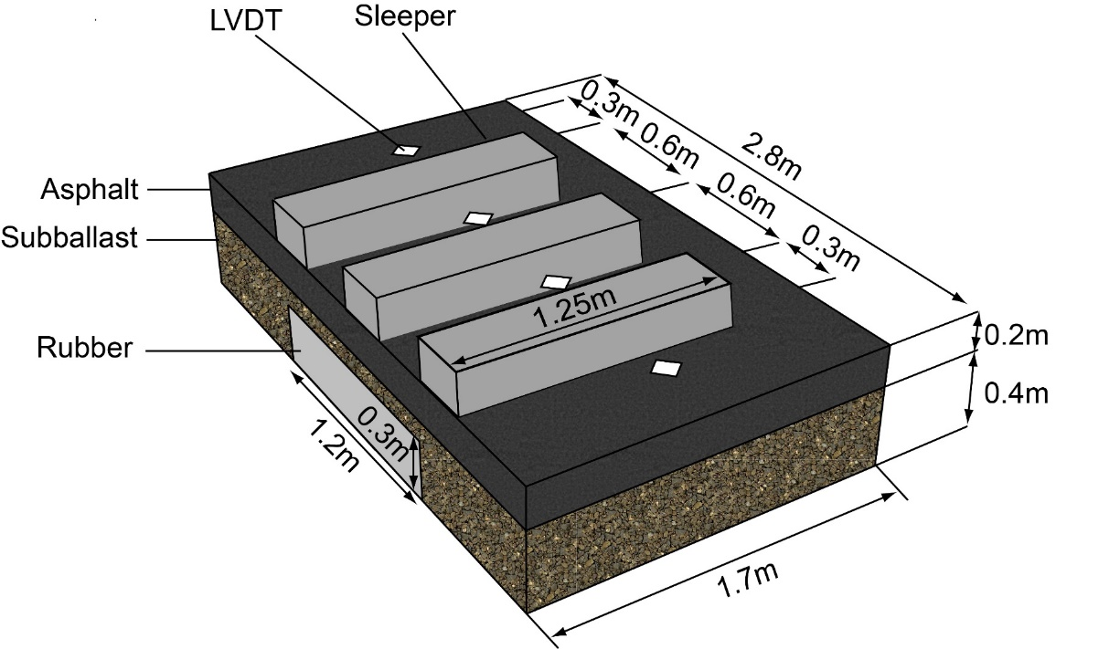

Figure 3. The layout of asphalt track sample

## Ballast-asphalt Track System

Due to the space restrictions inside GRAFT II, the ballast-asphalt track sample was partly constructed inside a bespoke steel box outside the rig, and then craned into the rig. The test sample included four different materials: ballast, asphalt, subballast (Type 1 granular filling, widely used in the UK railway industry) and rubber mats. Once craned inside GRAFT II, the ballast was added, and sleepers were placed. The detailed materials’ properties, preparation and construction processes are presented in Yu *et al.*, (2019). Here is the brief introduction:

1. Subgrade: The first layer of ballast-asphalt track system was made of the rubber mats, placed in the centre of the test box and filled with compacted subballast in outer areas to the same vertical height as the rubber (300 mm). The rubber was designed to represent a typical soft subgrade found on UK railway lines, whereas the areas consisting of subballast were designed to represent a typical stiff subgrade. An additional 100mm layer of subballast was added on top of the lower subballast-rubber layer.
2. Asphalt: 200 mm height of asphalt was poured and compacted on the top of the subgrade. This total thickness of asphalt was chosen in accordance with (Huang, Shen & Tutumluer, 2009) which concluded that increasing asphalt thickness from 100 mm to 200 mm significantly extended its fatigue life and decreased subgrade stress.
3. Ballast and sleeper: Ballast was firstly poured to a depth of 200 mm. The sleepers were then placed on the ballast surface before pouring a second 200 mm thickness of ballast around them. The sleepers were half-width constructed from metal as only half of the track was modelled, due to symmetry. Steel sleepers were used due to their ease of bespoke manufacture, thus allowing for straightforward connecting of the hydraulic rams.
4. Actuators: After the sleepers were in position, three hydraulic actuators (with built-in 300 mm LVDTs) were connected to the sleepers. Then, four 25 mm LVDTs were fixed to the wooden poles to measure the foundation settlement. The detailed sensor’s locations are shown in Figure 4 top.

## Asphalt Track System

This asphalt track sample was constructed identically as the ballast-asphalt track sample, excepting the removal of the ballast on the top of the asphalt, using three different materials: asphalt, subballast and rubber mats. In order to save the construction time, the subgrade (consisting of the rubber mats and subballast) and asphalt were reused from the ballast-asphalt track sample. The detailed sensor’s locations are shown in Figure 4 bottom.

Considering the sensor location and to have a better comparison over the transition zone during analysis, LVDT locations are described in Table 1. The foundation settlement includes the settlement of both asphalt and subgrade. It should be noticed that in the ballast-asphalt track, the sleeper settlement includes foundation settlement and ballast settlement, while in the asphalt track, sleeper settlement includes only foundation settlement.

## Ballast Settlement Interpretation

To approximate the ballast settlement, it was assumed that the foundation displaced linearly between the loading location and test box edge. Thus, the foundation settlement was interpolated as follow:

* The settlement at transition entry is the mean value of foundation settlement at the pre-transition and transition centre.
* The settlement at transition centre is the mean value of foundation settlement at the transition centre
* The settlement at transition exit is the mean value of foundation settlement at the transition centre and post-transition.

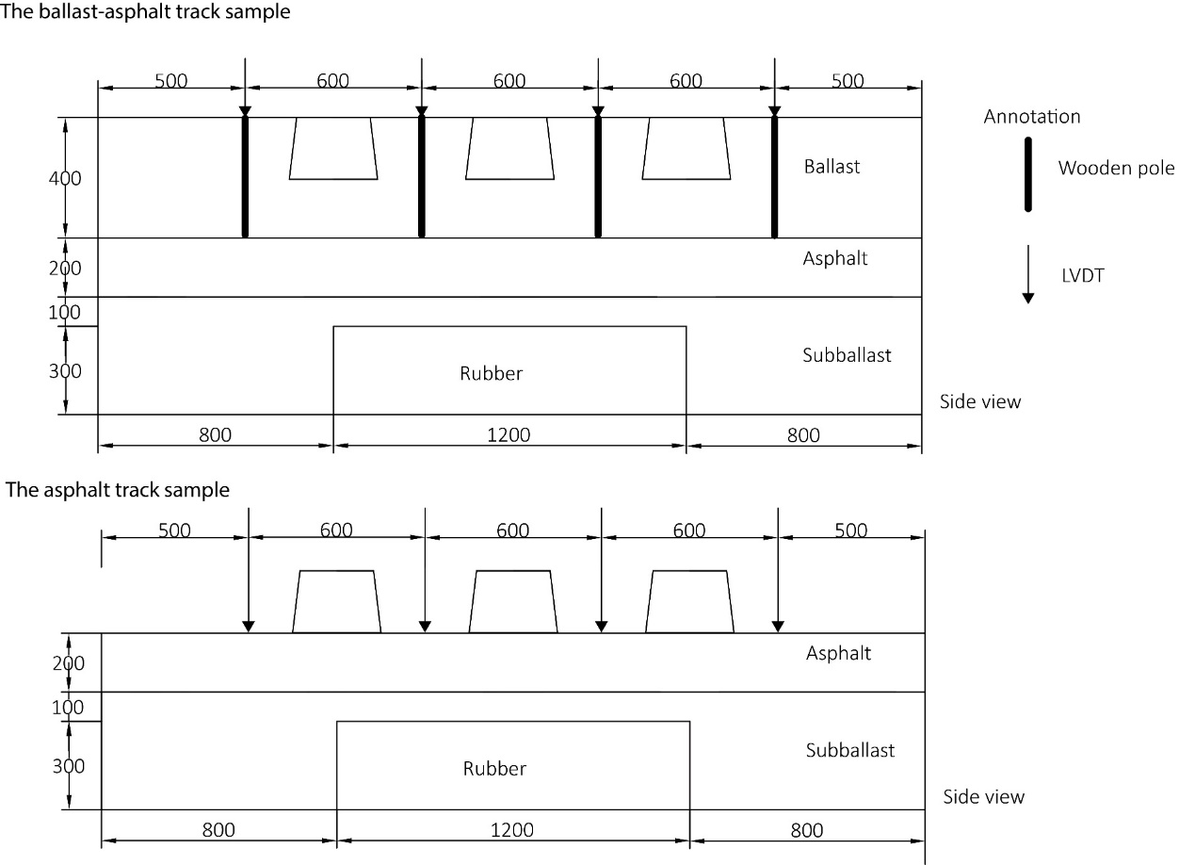

Figure 4. Test sample schematics

Table 1. Description of measured parameters

|  |  |  |
| --- | --- | --- |
| Sensor name | Measured parameter | Location description |
| LVDT 1 | Foundation settlement | Pre-transition (stiff subgrade) |
| LVDT 2 | Foundation settlement | Transition centre (soft subgrade) |
| LVDT 3 | Foundation settlement | Transition centre (soft subgrade) |
| LVDT 4 | Foundation settlement | Post-transition (stiff subgrade) |
| LVDT 5 | Sleeper settlement | Transition entry |
| LVDT 6 | Sleeper settlement | Transition centre |
| LVDT 7 | Sleeper settlement | Transition exit |

Particularly, subtracting sleeper settlement from the interpolated foundation settlement at transition entry, centre and exit, ballast settlement in the ballast-asphalt track sample was approximately determined by Equation (1).

$δ_{Ballast}=δ_{Sleeper}-δ_{foundation}$ (1)

## Test Plan

Static compression tests were carried out on the ballast-asphalt track system (Test 1， Figure 5 left) and asphalt track system (Test 2, Figure 5 right). The force distribution in the static test is assumed to be 0.25/0.5/0.25 across the side/middle/side sleepers respectively to simulate the static moving loading. Also assuming an axle load of 25 t, the equivalent wheel load is 12.5 t. and the force is given by Equation (2):

F=m×a=6.25 t × 9.81 m/s^2=61.3 kN (2)

The loading on the middle sleeper was gradually increased to 61.3 kN (25 tonnes), while loading on the side sleeper increased to 30.7 kN. Next, an increment of 2.4 kN per 10 minutes, which is to ensure the settlement is achieved before increasing the loading, were applied until the loading of 73.6 kN was reached (20% greater to investigate the settlement performance under the ultimate condition).

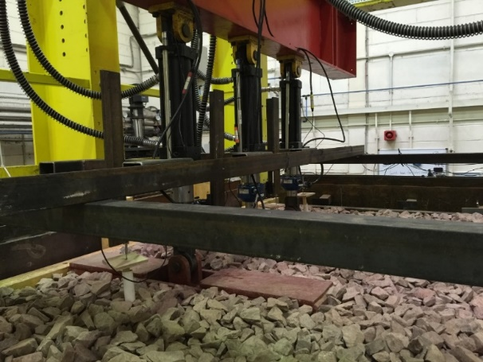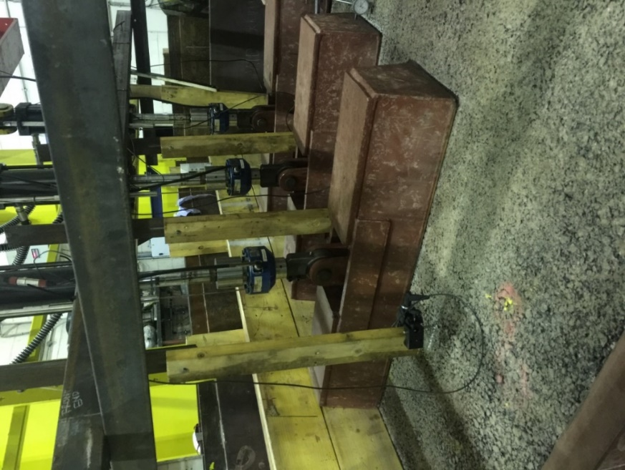

Figure 5. Static test setup of the ballast-asphalt track (Test 1, left) and asphalt track (Test 2, right)

# RESULTS AND DISCUSSION

## Test 1 - Static Test Results on Ballast-asphalt Track

Figure 6 shows the loading magnitude, which was followed with a loading plan in section 0 step by step. After 10 minutes of static loading of 73.6 kN on ballast surface, the test was stopped, and the compression force was released to 0 kN.

Figure 7 presented the settlement of the sleeper in the static test on ballast surface, giving the largest settlement at transition centre with 4.07 mm due to the soft stiffness of the subgrade, while it was 2.23 mm at the transition entry and 2.42 mm at the transition exit. The majority of the settlement happens during static loading increasing to the 61.3 kN stage, and settlement change was slower afterwards. However, after 61.3 kN, the settlement change at the transition centre is greater than that at the transition edge. This indicates that settlement behaviour of the ballast-asphalt track under static loading is highly relevant to the subgrade stiffness. After around 20 minutes recovery, sleeper settlements recovered to 0.42 mm, 0.64 mm and 0.21 mm, giving recovery percentages of 83%, 84% and 90% at transition entry, centre and exit, respectively.

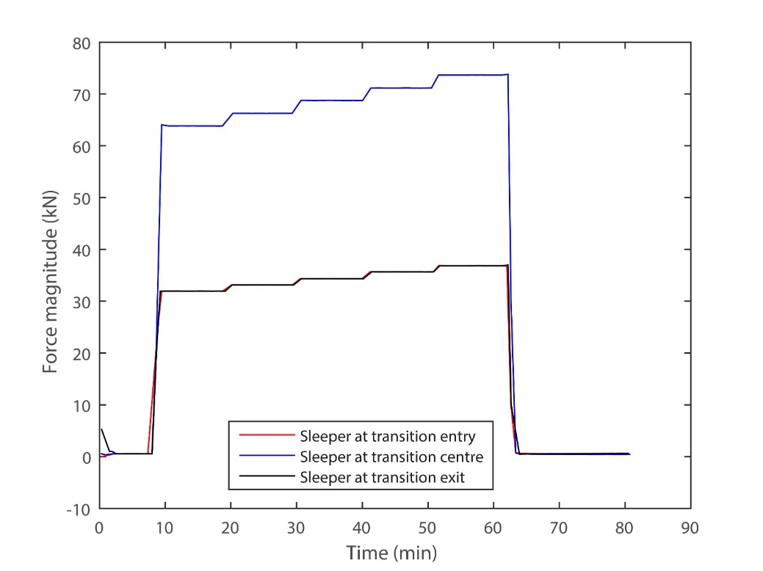

Figure 6. Force magnitude in the static test on the ballast surface

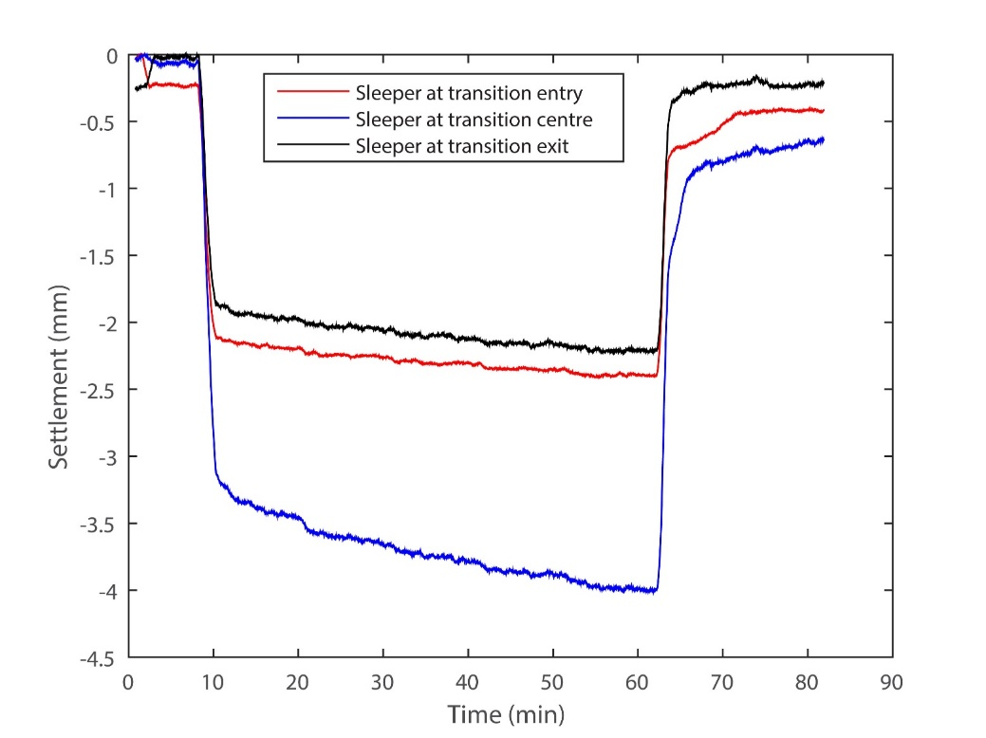

Figure 7. Sleeper settlement in the static test on the ballast surface

Figure 8 exhibits foundation settlement in the static test on the ballast surface. Similarly, foundation settlements at transition centre (over soft subgrade) were 1.92 mm and 1.90 mm, with the mean value of 1.91 mm. It was 0.54 mm at pre-transition and 0.47 mm at post-transition (over stiff subgrade), with the mean value of 0.51 mm. The results show the settlement at the stiff subgrade is 74% less than that at the soft subgrade. After around 20 minutes recovery, foundation settlements recovered to 0.03 mm, 0.29 mm, 0.31 mm and 0.03 mm, giving recovery percentages of 94%, 85%, 84% and 94% at pre-transition, transition centre, transition centre and post-transition, respectively.

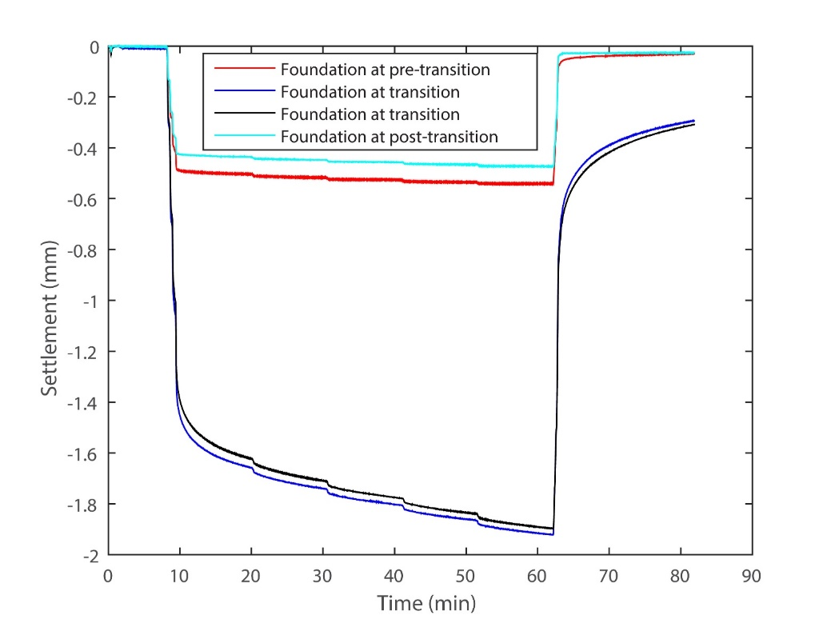

Figure 8. Foundation settlement in the static test on the ballast surface

Using interpolation method (described in section 0), the settlements of ballast were approximately 1.19 mm, 2.16 mm and 1.05 mm, at transition entry, centre and exit, respectively. After around 20 minutes recovery, ballast permanent settlements were calculated as 0.25 mm, 0.34 mm and 0.05 mm with recovery percentages of 79%, 84% and 96% at the location of transition entry, centre and exit, respectively (Figure 9).

## Test 2 - Static Test Results on Asphalt Track

Figure 10 shows the loading magnitude, which was followed with a loading plan in section 0 step by step. After 10 minutes of static loading of 73.6 kN on ballast surface, the test was stopped, and the compression force was released to 0 kN.

Figure 11 presents the settlement of the sleeper, giving the largest settlement at the transition centre with 16.36 mm due to the soft stiffness of the subgrade, while it was 6.04 mm at the transition entry and 5.81 mm at the transition exit. Similar to the static test on the ballast surface, the majority of settlement happens during static loading increasing to the 61.3 kN stage, and settlement change was slower afterwards. However, after 61.3 kN, the settlement change at the transition centre is still greater than that at the transition edge. This indicates that settlement behaviour of the ballast-asphalt track under static loading is highly relevant to the subgrade stiffness. After around 20 minutes recovery, sleeper settlements recovered to 0.67 mm, 6.68 mm and 0.58 mm, giving recovery percentages of 89%, 59% and 90% at the transition entry, centre and exit, respectively. This shows that sleeper settlement over the soft subgrade is likely not fully recovered and potential permanent settlement may occur if no ballast layer is involved.

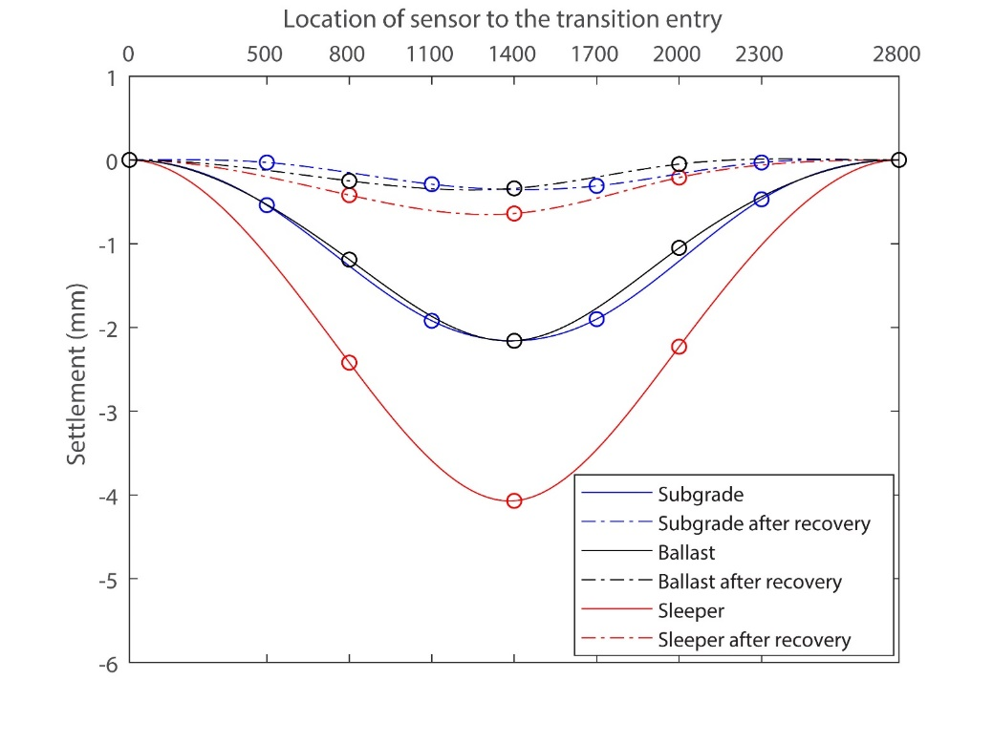

Figure 9. Settlement comparison during the static test on the ballast surface (Circle points = raw data; solid = interpolated curve)

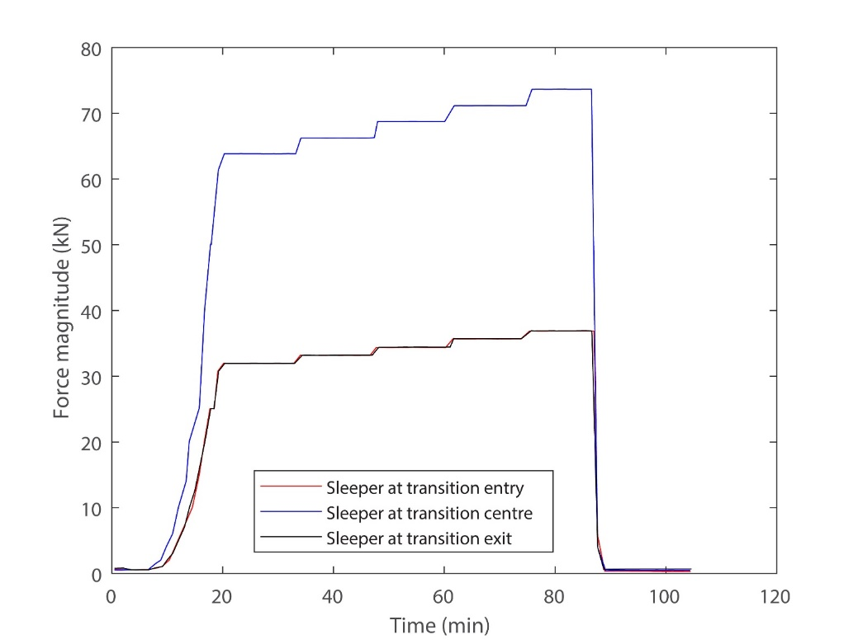

Figure 10. Force magnitude in the static test on the asphalt surface

Figure 12 exhibits the foundation settlement. Similarly, foundation settlements at the transition centre (over soft subgrade) were 9.74 mm and 10.16 mm, with the mean value of 9.95 mm. It was 0.65 mm at the pre-transition and 0.29 mm at the post-transition (over stiff subgrade), with the mean value of 0.47 mm. The results show the settlement at the stiff subgrade is 95% less than that at the soft subgrade. After around 20 minutes of recovery, it is interesting to see those foundation settlements expanded to positive values of 0.95 mm and 1.61 mm at the pre-transition and the post-transition, respectively, while they recovered to 3.0 mm and 3.30 mm at the transition centre. A possible reason is that during the loading, large settlement occurred over the soft subgrade. When the load was released, some settlement recovery at the transition centre transferred to the transition edge as there was no loading over the asphalt surface (ballast layer removed), resulting in an expanding of the transition edge (pre-transition and post-transition). Due to this, it is hard to calculate the ballast settlement in the static test on the asphalt surface. For the recovery of the transition centre, it was 69% and 68%, respectively. This again proved that foundation settlement over the soft subgrade is likely not fully recovered and potential permanent settlement may occur if no ballast layer is involved.

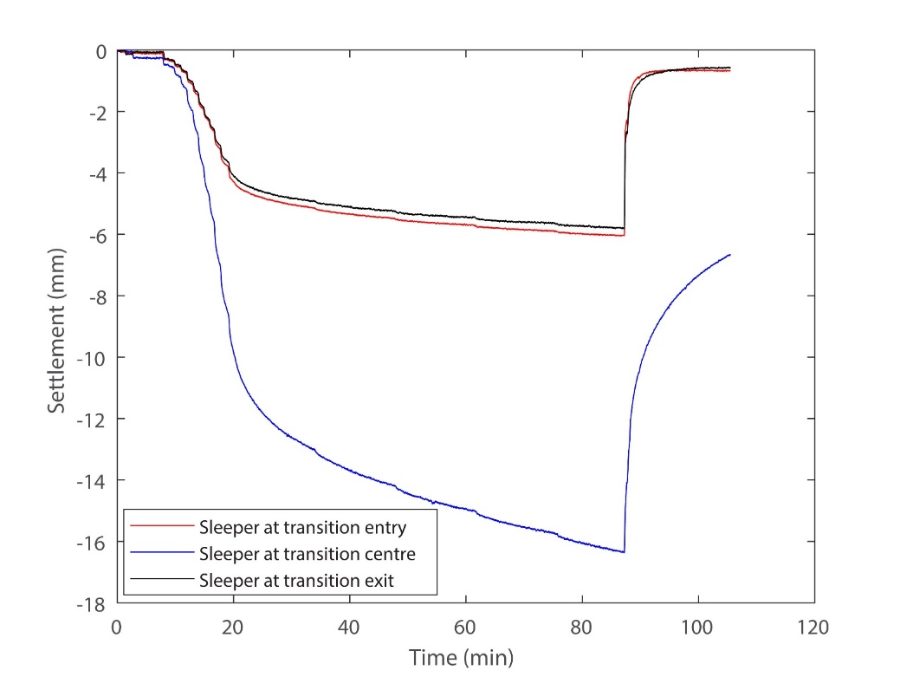

Figure 11. Sleeper settlement in the static test on the asphalt surface

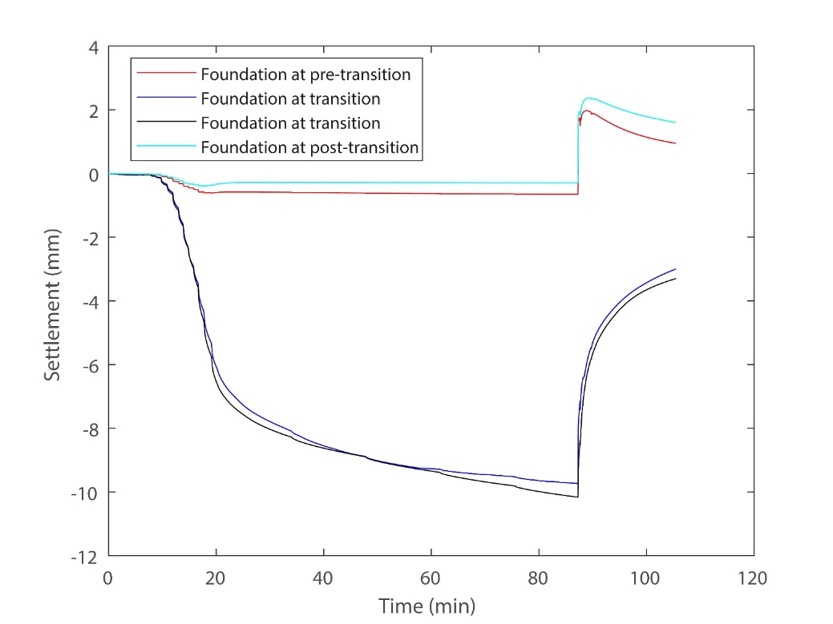

Figure 12. Foundation settlement in the static test on the asphalt surface

# **Conclusions**

The use of asphalt within railway track structures is becoming of increased interest due to its potential to improve track performance and lifecycle costs. To assess the performance of asphalt railway tracks, both numerical and laboratory research activities have been carried out recently. However, little research has been done to determine the performance of asphalt railway track (with and without ballast) in the presence of a subgrade transition zone, intended to present a track wet-spot.

This paper described a series of laboratory tests performed by using a large scale railway testing facility, GRAFT II. The static tests were undertaken, in the presence of a subgrade transition zone: a static compression test on the ballast-asphalt track and a static compression test on the asphalt track, with the ballast removed, thus exposing the asphalt slab underlay.

The following findings are made:

* When loading the asphalt directly (i.e. asphalt track), sleeper displacements were larger than for the case in the asphalt-ballast track. Similarly, the maximum differential sleeper displacement is larger at the asphalt track (10.55mm) compared with the ballast-asphalt track (1.84mm). Therefore, the ballast showed evidence of spreading the load through the track structure.
* After short-term recovery time, the recovery percentage of sleeper settlement at the soft subgrade in the static test on asphalt surface was 59%, much lower than that on ballast surface with 84%. Similarly, in the foundation settlement, the recovery percentage at the soft subgrade in the static test on asphalt surface was 68% compared to the case with the ballast of 84%. This shows that sleeper and foundation settlement over the soft subgrade is likely not fully recovered and potential permanent settlement may occur if no ballast layer is involved.
* After testing, visual inspection showed the asphalt layer to be in good condition, with virtually no evidence of abrasion or ballast penetration.

Therefore, it was concluded that the use of asphalt as an underlayment treatment within track formations shows a better performance with ballast above at the localised areas of lower stiffness (e.g. ‘wet spot’ type failures that are commonly observed in real track conditions). The material composition and thickness of the underlayment are still to be fully defined, however the asphalt-ballast track behaved positively compared to the asphalt track, and did not show detrimental signs of deterioration or structural failure. It is recommended that future project stages explore the use of concrete track-bed on the top of the asphalt instead of standalone sleepers without ballast.

**REFERENCES**

Aursudkij, B., McDowell, G.R. & Collop, A.C. (2009) Cyclic loading of railway ballast under triaxial conditions and in a railway test facility. *Granular Matter*. 11 (6), 391–401.

Bian, X., Jiang, H., Cheng, C., Chen, Y., Chen, R. & Jiang, J. (2014) Full-scale model testing on a ballastless high-speed railway under simulated train moving loads. *Soil Dynamics and Earthquake Engineering*. 66, 368–384. Available from: doi:10.1016/j.soildyn.2014.08.003.

Brown, S.F., Brodrick, B. V., Thom, N.H. & McDowell, G.R. (2007) The Nottingham railway test facility, UK. *Proceedings of the Institution of Civil Engineers - Transport*. 160 (2), 59–65. Available from: doi:10.1680/tran.2007.160.2.59.

Buonanno, A. & Mele, R. (2000) The use of bituminous mix sub-ballast in the Italian state railways. *2nd Eurasphalt & Eurobitume congress*. 1–11. Available from: https://trid.trb.org/view/674000.

Čebašek, T.M., Esen, A.F., Woodward, P.K., Laghrouche, O. & Connolly, D.P. (2018) Full scale laboratory testing of ballast and concrete slab tracks under phased cyclic loading. *Transportation Geotechnics*. 17, 33–40. Available from: doi:10.1016/j.trgeo.2018.08.003.

Chen, R., Zhao, X., Wang, Z., Jiang, H. & Bian, X. (2013) Experimental study on dynamic load magnification factor for ballastless track-subgrade of high-speed railway. *Journal of Rock Mechanics and Geotechnical Engineering*. 5 (4), 306–311. Available from: doi:10.1016/j.jrmge.2013.04.004.

Connolly, D.P., Kouroussis, G., Woodward, P.K., Alves Costa, P., Verlinden, O. & Forde, M.C. (2014) Field testing and analysis of high speed rail vibrations. *Soil Dynamics and Earthquake Engineering*. 67, 102–118. Available from: doi:10.1016/j.soildyn.2014.08.013.

D’Angelo, G., Thom, N.H. & Lo Presti, D. (2016) Bitumen stabilized ballast: A potential solution for railway track-bed. *Construction and Building Materials*. 124, 118–126. Available from: doi:10.1016/j.conbuildmat.2016.07.067.

Dahlberg, T. (2010) Railway track stiffness variations–consequences and countermeasures. *International Journal of Civil Engineering*. 8 (1), 1–12. Available from: http://ijce.iust.ac.ir/files/site1/user\_files\_6k93w6/ijce-A-10-3-242-712841b.pdf.

David H.Timm,Angela L.Priesr, T.V.M. (2004) Design and Instrumentation of the Structural Pavement Experiment At the NCAT Test Track. *NCAT Report 04-01*. (April). Available from: http://www.eng.auburn.edu/research/centers/ncat/files/reports/2004/rep04-01.pdf.

Dersch, M.S., Tutumluer, E., Peeler, C.T. & Bower, D.K. (2010) Polyurethane Coating of Railroad Ballast Aggregate for Improved Performance. In: *2010 Joint Rail Conference, Volume 1*. 1 January 2010 ASME. pp. 337–342. Available from: doi:10.1115/JRC2010-36215.

Esmaeili, M., Amiri, S. & Jadidi, K. (2014) An investigation into the use of asphalt layers to control stress and strain levels in railway track foundations. *Proceedings of the Institution of Mechanical Engineers, Part F: Journal of Rail and Rapid Transit*. 228 (2), 182–193. Available from: doi:10.1177/0954409712468850.

Fang, M. & Cerdas, S.F. (2015) Theoretical analysis on ground vibration attenuation using sub-track asphalt layer in high-speed rails. *Journal of Modern Transportation*. 23 (3), 214–219. Available from: doi:10.1007/s40534-015-0081-3.

Fang, M., Qiu, Y., Rose, J., West, R. & Ai, C. (2011) Comparative analysis on dynamic behavior of two HMA railway substructures. *Journal of Modern Transportation*. 231 (1), 26–34. Available from: doi:10.3969/j.issn.2095-087X.2011.01.005.

Hasnayn, M.M., McCarter, W.J., Woodward, P.K., Connolly, D.P. & Starrs, G. (2017) Railway subgrade performance during flooding and the post-flooding (recovery) period. *Transportation Geotechnics*. 11, 57–68. Available from: doi:10.1016/j.trgeo.2017.02.002.

Ho, C.L., Kashani, H.F., Humphrey, D.L., Hyslip, J.P. & Moorhead, W.H. (2015) Modifying the One-Dimensional Response of Ballast Box System Using Resiliently Bound Ballast. In: *2015 Joint Rail Conference*. 23 March 2015 ASME. p. V001T01A005. Available from: doi:10.1115/JRC2015-5637.

Huang, H., Shen, S. & Tutumluer, E. (2009) Sandwich Model to Evaluate Railroad Asphalt Trackbed Performance under Moving Loads. *Transportation Research Record: Journal of the Transportation Research Board*. 2117 (1), 57–65. Available from: doi:10.3141/2117-08.

Indraratna, B., Hussaini, S.K.K. & Vinod, J.S. (2013) The lateral displacement response of geogrid-reinforced ballast under cyclic loading. *Geotextiles and Geomembranes*. 39, 20–29. Available from: doi:10.1016/j.geotexmem.2013.07.007.

Indraratna, B., Khabbaz, H., Salim, W. & Christie, D. (2006) Geotechnical properties of ballast and the role of geosynthetics in rail track stabilisation. *Journal of Ground Improvement*. 10 (3), 91–102. Available from: doi:10.1680/grim.2006.10.3.91.

Indraratna, B., Nimbalkar, S., Christie, D., Rujikiatkamjorn, C. & Vinod, J. (2010) Field assessment of the performance of a ballasted rail track with and without geosynthetics. *Journal of Geotechnical and Geoenvironmental Engineering*. 136 (7), 907–917. Available from: doi:10.1061/(ASCE)GT.1943-5606.0000312.

Indraratna, B., Nimbalkar, S. & Tennakoon, N.C. (2010) The behaviour of ballasted track foundations: track drainage and geosynthetic reinforcement. In: *GeoFlorida 2010: Advances in Analysis, Modeling & Design (GSP 199)*. 2010 Florida. pp. 2378–2387.

Insa, R., Salvador, P., Inarejos, J. & Roda, A. (2012) Analysis of the influence of under sleeper pads on the railway vehicle/track dynamic interaction in transition zones. *Proceedings of the Institution of Mechanical Engineers, Part F: Journal of Rail and Rapid Transit*. 226 (4), 409–420. Available from: doi:10.1177/0954409711430174.

Lakušic, S., Ahac, M. & Haladin, I. (2010) Experimental investigation of railway track with under sleeper pad. *Proceedings of the 10th Slovenian road and transportation congress*. (October), 386–393. Available from: https://bib.irb.hr/prikazi-rad?rad=495700.

Lee, S.H., Choi, Y.T., Lee, H.M. & Park, D.W. (2016) Performance evaluation of directly fastened asphalt track using a full-scale test. *Construction and Building Materials*. 113, 404–414. Available from: doi:10.1016/j.conbuildmat.2016.02.221.

Lee, S.H., Park, D.W., Vo, H.V. & Dessouky, S. (2015) Asphalt mixture for the first asphalt concrete directly fastened track in Korea. *Advances in Materials Science and Engineering*. 2015. Available from: doi:10.1155/2015/701940.

Li, D., Rose, J.G. & LoPresti, J. (2001) Test of hot-mix asphalt trackbed over soft subgrade under heavy axle loads. *Technology Digest-01-009, Assoc. of American Railroads, April*. (April), 1–4. Available from: http://scholar.google.com/scholar?hl=en&btnG=Search&q=intitle:Test+of+HOt-Mix+Asphalt+trackbed+over+soft+subgrade+under+heavy+axle+loads#0.

Liu, H., Xiao, J., Wang, P., Liu, G., Gao, M. & Li, S. (2018a) Experimental investigation of the characteristics of a granular ballast bed under cyclic longitudinal loading. *Construction and Building Materials*. 163, 214–224. Available from: doi:10.1016/j.conbuildmat.2017.12.037.

Liu, S., Yang, J., Chen, X., Yang, G., Cai, D., Liu, S., Yang, J., Chen, X., Yang, G. & Cai, D. (2018b) Application of Mastic Asphalt Waterproofing Layer in High-Speed Railway Track in Cold Regions. *Applied Sciences*. 8 (5), 667. Available from: doi:10.3390/app8050667.

Di Mino, G., Di Liberto, M., Maggiore, C. & Noto, S. (2012) A Dynamic Model of Ballasted Rail Track with Bituminous Sub-Ballast Layer. *Procedia - Social and Behavioral Sciences*. 53, 366–378. Available from: doi:10.1016/j.sbspro.2012.09.888.

Momoya, Y. & Sekine, E. (2007) Performance-based design method for railway asphalt roadbed. *Doboku Gakkai Ronbunshuu E*. 63 (4), 608–619. Available from: doi:10.2208/jsceje.63.608.

Momoya, Y., Sekine, E. & Tatsuoka, F. (2005) Deformation Characteristics of Railway Roadbed and Subgrade Under Moving-wheel Load. *Soil and Foundations*. 45 (4), 99–118.

Rose, J. & Bryson, L. (2009) Hot mix asphalt railway trackbeds: trackbed materials, performance evaluations, and significant implications. *Proceedings of the International Conference on Perpetual Pavements*. Available from: http://www.engr.uky.edu/~jrose/papers/Hot Mix Asphalt Railway Trackbeds.pdf.

Rose, J. & Lees, H. (2008) Long-term assessment of asphalt trackbed component materials’ properties and performance. *Proceedings of AREMA 2008 Annual Conference*. (September), 28.

Rose, J.G., Li, D. & Walker, L. (2002) Test measurements and performance evaluations of in-Service railway asphalt trackbeds. *Proceedings of the AREMA 2002 annual Conference*. 30.

Rose, J.G., Su, B. & Twehues, F. (2004) Comparisons of railroad track and substructure computer model predictive stress values and in-situ stress measurements. In: *AREMA 2004 Annual Conference*. 2004 p. 16p. Available from: http://www.engr.uky.edu/~jrose/papers/AREMA 2004 Presentation.pdf.

Rose, J.G., Teixeira, P.F. & Ridgway, N.E. (2010) Utilization of Asphalt/Bituminous Layers and Coatings in Railway Trackbeds – A Compendium of International Applications. In: *Proceedings of the 2010 Joint Rail Conference*. 2010 pp. 1–17.

Rose, J.G., Teixeira, P.F. & Veit, P. (2011) International design practices, applications, amd performances pf asphalt/bituminous railway trackbeds. *Railway Geotechnical Engineering International Symposium (GeoRail 2011)*. 1–23. Available from: http://www.engr.uky.edu/~jrose/papers/GeoRail 2011 International.pdf.

Schneider, P., Bolmsvik, R. & Nielsen, J.C.O. (2011) In situ performance of a ballasted railway track with under sleeper pads. *Proceedings of the Institution of Mechanical Engineers, Part F: Journal of Rail and Rapid Transit*. 225 (3), 299–309. Available from: doi:10.1177/2041301710392479.

Al Shaer, A., Duhamel, D., Sab, K., Foret, G. & Schmitt, L. (2008) Experimental settlement and dynamic behavior of a portion of ballasted railway track under high speed trains. *Journal of Sound and Vibration*. 316 (1–5), 211–233. Available from: doi:10.1016/j.jsv.2008.02.055.

Sol-Sánchez, M., Moreno-Navarro, F., Rubio-Gámez, M., Sol-Sánchez, M., Moreno-Navarro, F. & Rubio-Gámez, M.C. (2014) The Use of Deconstructed Tires as Elastic Elements in Railway Tracks. *Materials*. 7 (8), 5903–5919. Available from: doi:10.3390/ma7085903.

Sol-Sánchez, M., Moreno-Navarro, F. & Rubio-Gámez, M.C. (2014) Viability of using end-of-life tire pads as under sleeper pads in railway. *Construction and Building Materials*. 64, 150–156. Available from: doi:10.1016/j.conbuildmat.2014.04.013.

Sol-Sánchez, M., Pirozzolo, L., Moreno-Navarro, F. & Rubio-Gámez, M.C. (2016) A Study for the Viability of using Warm Mix Asphalt as Bituminous Sub-Ballast for Railway Tracks. In: *Proceedings of the Third International Conference on Railway Technology: Research, Development and Maintenance*. 2016 Stirlingshire, UK, Civil-Comp Press. p. Paper 6. Available from: doi:10.4203/ccp.110.6.

Teixeira, P.F., Ferreira, P.A. & Andrés Lopés-Pita (2009) The use of bituminous subballast on future high-speed lines in Spain: structural design and economical impact. *International Journal of Railway*. 2 (1), 1–7. Available from: http://www.ijr.or.kr/On\_line/admin/files/Vol.2\_No.1\_01.pdf.

Woodward, P.K., Kennedy, J., Laghrouche, O., Connolly, D.P. & Medero, G. (2014) Study of railway track stiffness modification by polyurethane reinforcement of the ballast. *Transportation Geotechnics*. 1 (4), 214–224. Available from: doi:10.1016/j.trgeo.2014.06.005.

Yu, Z., Connolly, D.P., Woodward, P.K. & Laghrouche, O. (2019) Settlement behaviour of hybrid asphalt-ballast railway tracks. *Construction and Building Materials*. 208, 808–817. Available from: doi:10.1016/j.conbuildmat.2019.03.047.

CONTENTS OF PREVIOUS ISSUES

***May 2000 – Volume 1 Issue 1***

**TECHNICAL PAPERS**

**A unified approach to reporting and evaluating asphalt characteristics**

*Nunn, C.R.T., United Kingdom*

**Optimum design of rigid road pavements using Austroads**

*Hadi, M.N.S., Australia*

**Backcalculation of flexible pavement layers moduli and bonding conditions between wearing and base courses**

*Al-Nageim, H.K. & Al-Hakim, B., United Kingdom*

**Highway performance modelling in Hungary**

*Gaspar, L., Hungary*

**Edge drainage details for porous asphalt**

*Santhalingam, V. & Nicholls, J.C., United Kingdom*

**TECHNICAL NOTES**

**Waste materials in pavement engineering**

*Chan, W.W.J. & Lawrence, C.M., Hong Kong*

**Introduction to the current types of asphalt surfacings**

*Nicholls, J.C., United Kingdom*

***November 2000 - Volume 1 Issue 2***

**TECHNICAL PAPERS**

**Upgrading low quality aggregates for use in flexible pavement**

*Al-Nageim, H.K., United Kingdom*

**Subgrade failure criterion for the design of flexible pavements based on higher wheel loads**

*Hadi, M.N.S., Australia*

**Preparation of samples for wheel tracking test**

*Gibney, A., Webster, T. & O’Callaghan, R., Ireland*

**Techniques for the rehabilitation of concrete pavements in tropical, developing countries**

*Parry, J.D. & Freer-Hewish, R.J., United Kingdom, Beaty, A.N.S., Canada*

***May 2001 - Volume 2 Issue 1***

**TECHNICAL NOTES**

**A brief introduction to bitumen viscosity / rheology and why it is important**

*Reid J.M., United Kingdom*

**TECHNICAL PAPERS**

**Dynamic shear rheometers: measurement, accuracy, precision and prediction**

*Carswell, J., United Kingdom*

**Laboratory study of the resistance of bituminous overlays to reflective cracking**

*Gibney, A. Lohan, G. & Moore, V., Ireland*

**A new test for assessing the durability of asphalt mixtures for severe winter conditions**

*Hobeda, P., Sweden*

**Life cycle cost analysis of pavements**

*Hadi, M.N.S., Australia*

**Effect of lower grade aggregates on the performance of concrete surfacing**

*Collins, R.J., United Kingdom.*

***November 2001 - Volume 2 Issue 2***

**TECHNICAL PAPERS**

**The performance and behaviour of stone element pavements**

*Fordyce, D. & Khweir, K., United Kingdom*

**Developing specifications for unsealed road pavements**

*Muhammed, M.N.S., Australia*

**Optimisation of bituminous pavement thickness in mechanistic pavement design**

*Narasimham, K.V., Misra, R & Das, A., India*

**Cellulose oil palm fibre as a binder stabiliser in stone mastic asphalt**

*Muniandy, R., Vasudevan, J & Omar, H. India*

***October 2002 - Volume 3 Issue 1***

**TECHNICAL PAPERS**

**Evaluation of effective pavement layer moduli using genetic algorithms**

*Reddy, M.A., Reddy, K.S. & Pandey, B.B., India*

**Sustainable pavements**

*Walsh, I.D., United Kingdom*

**The design and laying of a road trial in Thessaloniki for road markings**

*Oikonomou, N., Greece, Nicholls, J.C. & Woodside, A.R., United Kingdom, Delivopoulos, I., Greece*

**A model for the prediction of the elastic stiffness of bituminous mixtures under pulse loading**

*Santagata, E. & Bassani, M., Italy*

***January 2003 - Volume 3 Issue 2***

**TECHNICAL PAPERS**

**Design of high modulus composite pavements**

*James, D.J., MacGregor, I.D. & Hammond, J.E., United Kingdom*

**Microsurfacing of concrete roads in Romania: case histories**

*Oikonomou, N., Papakatiskas, C. & Dimpoulos, K., Greece*

**Prediction for pumping in concrete pavements on cement-treated base**

*Kuo, C-M. & Huang, Y.T. Taiwan*

**European co-operation in pavement research using accelerated loading test facilities – an introduction**

*Nunn, M.E., United Kingdom, Hildebrand, G., Denmark*

***May 2003 - Volume 4, Issue 1***

**TECHNICAL NOTES**

**Overcoming barriers to recycling**

*Barritt, J., United Kingdom*

**TECHNICAL PAPERS**

**The use of neural networks for backcalculation of layer moduli**

*Gossain, V. & Reddy, K.S., India*

**Cold Recycling (SMART project)**

*Carswell, I., United Kingdom*

**A low-cost falling weight deflectometer for pavement evaluation in India**

*Reddy, M.A., Kumar, R.S. & Reddy, K.S., India*

**LANDREC – a remediation technology for re-using contaminated soil**

*Phillips, P., United Kingdom, Hildebrand, G., Denmark*

***December 2003 - Volume 4, Issue 2***

**TECHNICAL PAPERS**

**Using Drucker-Prager Model for the Analysis of Recycled Road Pavements**

*Hadi, M.N.S. and Symons, M.G., Australia*

**Models for Estimation of Sub grade Moduli from DCP Tests**

*Kumar, R.S., Reddy, K.S., Mazumdar, M. and Pandey, B.B., India*

**Back calculation of Pavement Layer Moduli from FWD Data Using Genetic Algorithm**

*Manish K., Maheshwari, N. and Das, A., India*

**Finite Element Implementation and Verification of an Elastoplastic Model for Unsaturated Soils**

*Nesnas, K., United Kingdom*

***May 2004 - Volume 5, Issue 1***

**TECHNICAL NOTES**

**Cold paving in the UK: a Case Study**

*Day, D. & Staples, S., United Kingdom*

**TECHNICAL PAPERS**

**Pavement Condition before and after Rehabilitation**

*Gáspár, L., Hungary*

**Prediction of Flexible Pavement Layer Moduli in India**

*Kumar, R.S. & Reddy, K.S. India*

**Developments in Sustainable Asphalt Technology**

*Thom, N.H., United Kingdom*

**Exploitation and Use of Quarry Fines: A Preliminary Report**

*Woods, S., Mitchell, C.J., Harrison, D.J. & Manning, D.A.C.*

***December 2004 - Volume 5, Issue 2***

**TECHNICAL NOTES**

**DTI/ WRAP Research: Wastes and Resources Action Programme**

**TECHNICAL PAPERS**

**Ground Penetrating Radar for Monitioring of English Roads**

*Forest, R. Pynn, J. Alani, A. & Ferne, B. United Kingdom*

**A Revised Mechanistic Method for Design of Indian Highways**

*Kumar, R.S. & Reddy, K.S. India*

**Design of Flexible Pavements Based on Finite Element Analysis**

*Bodhinayake, B.C. & Hadi MNS. Australia*

**Reservoir Pavements: A solution of Sustainable Urban Drainage**

*Nunn, M.E. United Kingdom*

***May 2005, Volume 6, Issue 1***

**TECHNICAL PAPERS**

**Practical Aspects Surrounding a Full-Scale Implementation of a Performance- Based Specification for New Road Construction in the United Kingdom**

*I. Widyatmoko, R.C. Elliot, J. McCulloch and J. Norman, UK*

**Bottom Ash Embankments and Their Long-Term Performance**

*L. Gaspar, Hungary*

**A continuing Study of the Skid Resistance Performance of BOS Slag Used as a Road Surface Course Aggregate**

*P.G. Roe, UK*

**A Review of Recent Research Into Sustainability Pavement Materials and Techniques**

*I. Walsh, UK*

***December 2005, Volume 6, Issue 2***

**TECHNICAL PAPERS**

**The Use Of Natural Flax Fibres In Stone Mastic Asphalt**

*G. Airey (UK), J. O. Vidana Vencomo (Mexico) & J. Harwood (UK)*

**How Surplus Quarry Dust Is Being Put To Good Use In New Applications In South Wales**

*M. Lamb & M. Reid (UK)*

**A Proposed Quantitative Model For Highway Repair And Maintenance**

*A. Alani. A. Teo & J. Goulding (UK)*

**The Feasibility Of Recycling Thin Surfacing Systems**

*J. C. Nicholls (UK)*

***May 2006, Volume 7, Issue 1***

**TECHNICAL PAPERS**

**The Influence of Ageing on Dry Process Crumb Rubber Modified Asphalt Mixtures**

*M. Rahman (UK), G. Airey (UK) and A. Collop (UK)*

**Structural Evaluation of a Concrete Filled Cell Pavement**

*U.C. Sahoo, K.S. Reddy, B.B. Pandey (India)*

**Laboratory Measurement of Bond Between Asphalt Layers**

*M. Sutanto (UK), A. Collop (UK), G. Airey (UK), R. Elliott (UK) and Y. Choi (Australia)*

**Reuse of Thermally Purified Tar- Containing Asphalt**

*A.R.G. Vanderwall (The Netherlands)*

***December 2006, Volume 7, Issue 2***

**TECHNICAL PAPERS**

**Laboratory Evaluation Of Cement Kiln Dust (CKD) As Filler In Asphalt**

*Cliff Nicholls (TRL Ltd, UK) John Lay (CEMEX UK Materials Limited) and Murray Reid (TRL Ltd, UK)*

**Effect Of Shelf Life Time On The Performance Of Foamed Bitument Bound Mixtures**

*Kadhim Khweir (Pavement Technology Limited, Heriot-Watt University, UK)*

**A Review Of Geotechnical Specfications For Sustainable Infrastructure**

*P.R Fleming, M.W Frost, J.P Lambert (Loughborough University)*

**A Life Cycle Approach To The Selection Of Construction Materials**

*Y Huang, R Bird (Newcastle University), B Allen (Aggregate Industries, UK)*

***May 2007, Volume 8, Issue 1***

**TECHNICAL PAPERS**

**Laboratory investigation of recycled binder performance**

*Laurent Porot and Dr. Sophie Nigen-Chaidron, Shell Bitumen, France*

**Evaluation of roller compacted concrete pavement with bottom ash by ultrasound measurements – an experimental study**

*Glicério Trichês , Roberto C. A. Pinto and Alexandre José Silva*

*Universidade Federal de Santa Catarina, Brazil*

**Procedures for identifying hazards in component materials for asphalt**

*Cliff Nicholls – TRL Ltd, UK*

*Virginie Mouillet – Régional des Ponts et Chaussées d’Aix-en-Provence, France*

*François Deygout – Shell Bitumen, France*

*Burgard Koenders – Shell Bitumen, France*

*Piouslin Samuel – TRL Ltd, UK*

**Technical feasibility of the use of eva discarded by the footwear industry in hot-mix asphalt**

*Jesner Sereni Ildefons and, Jose Leomar Fernandes Jr., University of Sao Paulo, Brazil*

**Laboratory Investigation of Recycled Binder Performance**

*Laurent Porot and Dr. Sophie Nigen-Chaidron, Shell Bitumen, France*

***December 2007, Volume 8, Issue 2***

**TECHNICAL PAPERS**

|  |
| --- |
| **Laboratory Evaluation of TBM Super a Crumb Rubber Modified Bitumen and Waste Plastics Modified Bitumen Using Superpave Methology For Indian Conditions**  *B.V. Kiran Kumar, Dr. H.S. Jagadeesh, Dr. R. Sathyamurthy and Dr. Sunil Bose* |
| **A Review of the Development of Pervious Pavements and Sustainable Urban Drainage (SUDS) in the UK**  *C. J. Pratt, Emeritus Professor of Stormwater Management, Coventry University, Coventry* |
| **Innovation in the Production and Commerical use of Energy Extracted from Asphalt Pavements**  *C. Sullivan, Managing Director, Material Edge Ltd*  *Arian De Bondt & Rob Jansen, Ooms International Holding bv*  *Henk Verweijmeren, Invisible Heating Systems Ltd* |
| **Numerical Modelling of Asphalt Mixture Wheel Tracking Experiments**  *Dr Alistair Hunter, Prinicipal Engineer, Scott Wilson, Nottingham*  *Dr Gordon Airey, Nottingham Centre for Pavement Engineering, University of Nottingham*  *Ouahid Harireche, Nottingham Centre for Pavement Engineering, University of Nottingham* |

***May 2008, Volume 9, Issue 1***

**TECHNICAL PAPERS**

|  |
| --- |
| **A Sustainable Hot Binder for Surface Dressing – With Improved Performance** |
| *Bert Jan Lommerts, Martin R. Verweij and Huig van Duijn*  *Latexfalt B.V., the Netherlands*  **Evaluation of Roller Compactor Cum Rut Analyzer an Alternative Compactor For Bituminous Mix Design**  *B.V. Kiran Kumar, Dr. H.S. Jagadeesh, Dr. R. Sathyamurthy and Dr. Sunil Bose, Dayananda Sagar College of Engineering, Bangalore-50 078, Karnataka, India*  **Using Coal Fly Ash in Road Construction**  *Lindon K. A. Sear, UK Quality Ash Association, UK*  **Reach Ahead – The Implications of the New Chemicals Regulation within Europe for the Bitumen & Asphalt Industry**  *M. Southern, Eurobitume, Belgium* |

***December 2008, Volume 9, Issue 2***

**TECHNICAL PAPERS**

|  |
| --- |
| **Pollutant Potential Of Soil Stabilized With Bottom Ash To Be Used In Pavement Structures**  *Glicerio Triches, Edney Rodrigues de Farias, Marciano Maccarini, Federal University of Santa Catarina, Brazil*  **Sustainability Through Durability Of Asphalt**  *Cliff Nichols, TRL Ltd., UK*  **The Influence Of Pavement Layers Behaviour On Thickness Design Using Kenlayer Program**  *Amir Kavussi, Ali Babazadeh, Tarbiat Modares University, Iran*  **Use Of Bitumen Emulsion And Worn Mobile Tyres In The Production Of Concrete Paving Blocks**  *Nikolaos Oikonomou, Sofia Mavridou, Aristotle University of Thessaloniki (A.U.Th), Greece* |

***May 2009, Volume 10, Issue 1***

**TECHNICAL PAPERS**

|  |
| --- |
| **Durable Pavement Maintenance Using Reinforced Asphalt, 20 Years of Experience**  *J. L. Walter, Group Asphalt Solutions Manager, Tensar International Limited, Blackburn, UK*  *N. Reck, Application Technology Manager, Tensar International Corporation, Atlanta, USA*  *E. Luce, Produktmanager Asphalteinlagen, Tensar International GmbH, Germany*  **Measuring and Evaluating the Characteristics of Asphalt at Low Temperatures**  *C. Karcher, Universität Karlsruhe (TH), Institute of Highway and Railroad Engineering, Germany*  *K. Mollenhauer, Braunschweig Pavement & Engineering Centre, Technische Universität Braunschweig, Germany*  **Simple Indices For Rapid Evaluation of Workability and Rutting Resistance of Indonesian Wearing Course Mixtures**  *I. Haryanto -University of Gadjah Mada Jalan Yacaranda, Indonesia*  *O. Takahashi, Nagaoka University of Technology, Japan*  **Effects of Grading of Fine Aggregate on the Strength and Permeability of Concrete Used In Pavement Construction**  *K. Thamer, A.S.K. Kwan & B.I.G. Barr – Cardiff School Of Engineering, Cardiff University, UK* |
| ***December 2009, Volume 10, Issue 2***  **TECHNICAL PAPERS** | | |
| **Sustainable Maintenance of a UK Trunk Road Using Crack and Seat and Ex Situ Cold Mix Recycling – A Case Study**  *P. Langdale, I. Carswell Transport Research Laboratory, Wokingham, UK*  *T. McHugh, Cemex UK Construction Limited, Worsley, UK*  *M. Ashfield, Cemex UK Construction Limited, Worsley, UK* | | |
| **Development of Best Practice for Recycling Surface Course Materials Back Into Thin Surfacing**  *I. Carswell, Transport Research Laboratory, Wokingham, UK*  *J. C. Nicholls, Transport Research Laboratory, Wokingham, UK*  *I. Widyatmoko, Scott Wilson Limited, Nottingham, UK*  *J. Harris, Lafarge Aggregates Limited, Lutterworth, UK*  *R. Taylor, Shell Bitumen Limited, Manchester, UK*  *D. Lee, Highways Agency, Bedford, UK* | | |
| **Permeable Pavements - A Case Study Milton Keynes Park and Ride**  *Sukalpa Biswas, Pavement Engineer, Mouchel, Birmingham, UK* | | |
| **Mechanical Characterization and Influence of Water On WMA By Adding Synthetic Zeolite**  *M. Bocci, Full Professor - Università Politecnica delle Marche, Ancona, Italy*  *A. Grilli, Ph.D. - Università Politecnica delle Marche, Ancona, Italy*  *V. Pannunzio, Ph.D. Student – Università Politecnica delle Marche, Ancona, Italy*  *P.P. Riviera, Ph.D. – Politecnico di Torino, Abruzzi, Torino* | | |
| ***May 2010, Volume 11, Issue 1*** | |  | |
| **TECHNICAL PAPERS** | |  | |
| **MECHANICAL AND FRACTURE MECHANICAL PROPERTIES OF ASPHALT GEOSYNTHETIC INTERLAYER SYSTEMS**  *Thomas Hasslacher, Eng. & Rainer Lugmayr, C. Eng., TenCate Geosynthetics, A-4021 Linz, Schachermayerstr. 18, Austria* | |  | |
| **IMPROVING THE DURABILITY OF LONGUITUDINAL JOINTS IN ASPHALT PAVEMENTS**  *Ignacio Artamendi, Bob Allen, Chris Allpress, Daniel Morgan, Aggregate Industries, Research & Development Department, Ashbourne, Derbyshire ,UK.*  *Chris Sullivan, Material Edge, 9 Wheat Moss, Chelford, Macclesfield, Cheshire ,UK* | |  | |
| **THE USE OF X-RAY CT TO CHARACTERIZE RUTTING IN UK ASPHALT MIXTURES**  *Andrew Dawson, Rawid Khan, Andrew C Collop and Yang Lintao, Nottingham Transportation Engineering Centre (NTEC), University Park, Nottingham,UK* | |  | |
| **TERMINAL CONDITION FOR THIN SURFACED LOW VOLUME ROADS**  *U. C. Sahoo, Department of Civil Engineering, Birla Institute of Technology, Mesra, Ranchi, India*  *K. S. Reddy, Department of Civil Engineering, Indian Institute of Technology, Kharagpur, India* | |  | |

***December 2010, Volume 11, Issue 2***

|  |
| --- |
| **TECHNICAL PAPERS** |
| **Future Developments in Asphalt Technology From A German**  **Viewpoint**  *Michael P. Wistuba, ISBS Institut für Straßenwesen, Braunschweig Pavement Engineering Centre, Germany* |
| **Strength Properties of Roller Compacted Concrete Containing**  **Rice Husk Ash**  *Joe Arnaldo Villena Del Carpio, Glicério Trichês and Luiz Roberto Prudêncio Jr., Department of Civil Engineering, Universidade Federal de Santa Catarina, Brazil* |
|  |
| **Swedish Pavement Performance Specification**  *Safwat F. Said, Swedish National Road & Transport Research Institute (VTI)* |
|  |
| **Subgrade Strength Characterization For Low Volume Roads In**  **India**  *U. C. Sahoo and K. S. Reddy, Department of Civil Engineering, Indian Institute of Technology, Kharagpur, India* |

***May 2011, Volume 12, Issue 1***

|  |
| --- |
| **TECHNICAL PAPERS** |
| **DYNAMIC FIELD ASSESSMENT OF SHORT TERM BEARING CAPACITY FOR COLD RECYCLED LAYERS**  *Alessandro Marradi, Dynatest Denmark A/S, Naverland 32 – DK 2600 Glostrup, Denmark* |
| **FROM VEHICLE / SURFACE INTERACTION TO QUIET SURFACE DRESSINGS**  *David Woodward, Phillip Millar and Shaun Friel, School of the Built Environment, Shore Road, Newtownabbey, Co. Antrim, Northern Ireland* |
| **CEMENTITIOUS ACTIVITY OF CALCINED RED MUD**  *Daniel Véras Ribeiro, Marcio Raymundo Morelli, Department of Materials Engineering / Federal University of São Carlos, Rodovia Washington Luis, Km 235. 13565-905. São Carlos/SP, Brazil* |
| **FLUSHING SLAG BOUND MIXTURE IN THE UK**  *John Kennedy, Pavement Engineering Consultant, UK* |

***December 2011, Volume 12, Issue 2***

|  |  |
| --- | --- |
| **TECHNICAL PAPERS** |  |
| **EVALUATION OF AIRPORT PAVEMENTS USING A COMBINED INDEX**  *Rafiqul A. Tarefder, Raju Bisht and Mesbah U. Ahmed, Department of Civil Engineering, University of New Mexico, USA.* |  |
| **THE ROLE OF DURABILITY OF SURFACING IN HIGHWAY ASSET MANAGEMENT**  *Prof. Ian. D. Walsh, Road Consultants Ltd , UK* |  |
|  |  |
| **COMPARATIVE STUDY OF EMPIRICAL AND MECHANISTIC-EMPIRICAL PAVEMENT DESIGN METHODOLOGY USING KENLAYER SOFTWARE**  M*. Waseem Mirza, Imran Hafeez and Mumtaz A. Kamal, Department of Transportation Engineering and Management,University of Engineering and Technology, Lahore, Pakistan* |  |
|  |  |
| **LABORATORY PREDICTION OF THIN SURFACING EARLY LIFE ASPHALT SURFACING PROPERTIES**  *Shaun Friel, David Woodward and Alan Woodside, University of Ulster, Jordanstown, Northern Ireland* |  |

***May 2012, Volume 13, Issue 1***

|  |  |
| --- | --- |
| **TECHNICAL PAPERS** |  |
| **MONITORING THE PERFORMANCES IN REAL WORKING CONDITIONS OF C & D WASTE MATERIALS IN ROAD CONSTRUCTION USING EMBEDDED INSTRUMENTS**  *Mauro Coni, James Rombi, Valentina Zedda, Silvia Portas, Salvatore Pistis, Faculty of Engineering, University of Cagliari, Italy* |  |
| **GB5®: AN ALTERNATIVE TO EME2 FOR LONG-LASTING AND COST-EFFECTIVE ASPHALT CONCRETES BY USE OF AGGREGATE PACKING CONCEPTS AND SBS MODIFIED BINDERS**  *François Olard, EIFFAGE Travaux Publics, R&D Project Manager, 8 rue du Dauphiné BP 357, F-69960 Corbas Cedex, France* |  |

***December 2012, Volume 13, Issue 2***

|  |  |
| --- | --- |
| **TECHNICAL PAPERS** |  |
| |  | | --- | | **EVALUATION OF MOISTURE SUSCEPTIBILITY IN HOT MIX ASPHALT PAVEMENT USING A MODEL MOBILE LOAD SIMULATOR**  *Mansour Solaimanian, Senior Research Associate, Penn State University,USA.*  *Chieh-Tang Chang, Engineer, CECI Engineering Consultants, Inc., Taiwan*  *Ghassan Chehab, Assistant Professor, American University of Beirut, Beirut, Lebanon* | | **EFFECTS OF AIRVOIDS ON LOW TEMPERATURE FRACTURE STRENGTH OF ASPHALT CONCRETE**  *Adnan Qadir, Professor, NED University, Karachi*  *Murat Guler, Associate Professor, Middle East Technical University, Dumlupinar Blvd* | | **EQUIVALENT LINEAR ELASTIC MODULUS OF GRANULAR LAYER FOR LOW VOLUME ROADS**  *Umesh Chandra Sahoo, Assistant Professor, Indian Institute of Technology Bhubaneswar, India*  *K. Sudhakar Reddy, Professor, Indian Institute of Technology, India* | | **AUTOMATIC DETECTION AND ANALYSIS OF SURFACE DISTRESSES USING A MULTI FUNCTIONAL VEHICLE**  *Alessandro Marradi, Senior Engineer – Dynatest Denmark A/S, Naverland, Denmark*  *Kars Drenth, Head of Pavement Engineering – Dynatest Denmark A/S, Naverland, Denmark*  *Martyn Stonecliffe-Jones, Senior Engineer – Dynatest UK Ltd.* | |  |

***May 2013, Volume 14, Issue 1***

|  |  |
| --- | --- |
| **TECHNICAL PAPERS** |  |
| |  |  |  |  |  |  |  |  |  |  | | --- | --- | --- | --- | --- | --- | --- | --- | --- | --- | | |  | | --- | | **AN EVALUATION METHOD FOR THE PERFORMANCE OF STRESS ABSORBING MEMBRANE INTERLAYERS (SAMIs) AGAINST REFLECTIVE CRACKING UNDER THERMAL LOADING**  *O.M. Ogundipe,Civil Engineering Department, Ekiti State University Ado-Ekiti, Nigeria*  *N.H.Thom, NTEC, University of Nottingham, UK*  *A.C.Collop,Faculty of Technology, De-Montfort University, UK* | | **DEVELOPING THE USE OF RECYCLED AND SECONDARY AGGREGATES IN QATAR**  *Dr K E Hassan, TRL QSTP-B, Doha, Qatar*  *Dr M S Al-Kuwari, Qatar Standards, Ministry of Environment, Doha, Qatar*  *Dr J M Reid, A Berhane and C Collis, TRL, Wokingham, Berkshire,UK* | | **ASSESSMENT OF WATER AND TEMPERATURE SUSCEPTIBILITIES OF COLD**  **RECYCLED BITUMINOUS EMULSION MIXTURES USING THE NAT IN THE ITSM MODE OF TESTING**  *O. L. Oke,Lecturer - Ekiti State University - Civil Engineering Department, Faculty of Engineering, Ekiti State University, P.M.B. 5363, Ado–Ekiti, Ekiti State, Nigeria*  *T. Parry, Associate Professor – University of Nottingham - Nottingham Transportation Engineering Centre, University of Nottingham, Nottingham, UK*  *N. H. Thom,Lecturer – University of Nottingham - Nottingham Transportation Engineering Centre, University of Nottingham, Nottingham, UK* | | **A NEW PRESERVATION TECHNOLOGY FOR POROUS ASPHALT - A MULTI-MODAL, BIOPOLYMER STABILIZED, REJUVENATING ASPHALT EMULSION**  *Bert Jan Lommerts, Latexfalt bv, P.O. Box 6, 2396 ZG Koudekerk aan den Rijn, the Netherlands*  *Jan Struik, Latexfalt bv, P.O. Box 6, 2396 ZG Koudekerk aan den Rijn, the Netherlands*  *Irina Cotiugă, Latexfalt bv, P.O. Box 6, 2396 ZG Koudekerk aan den Rijn, the Netherlands*  *Gerbert van Bochove, Breijn bv, Heijmans R&D Laboratories, Rosmalen, the Netherlands* | | ***December 2013, Volume 14, Issue 2***  **TECHNICAL PAPERS** | |  |   **EVALUATION OF TEST METHODS AND SELECTION OF AGGREGATE GRADING FOR TYPE III APPLICATION OF MICRO-SURFACING**  *Masoud Robati, M.Eng, PhD Student, École de technologie supérieure (ÉTS), Montreal, Canada*  *Alan Carter,Professor (ÉTS)*  *Daniel Perraton, Professor (ÉTS)*  **COMPARISON STUDY BETWEEN LIME APPLICATION METHODS ON HMA ASPHALT CONCRETE IN IRAQ**  *Amjad H. K. Albayati, Assist prof. Transportation. Engineering, University of Baghdad*  *Ahmed M. M. Alani, M.Sc Candidate Transportation Engineering, University of Baghdad*    **MECHANICAL PERFORMANCE OF BITUMINOUS CONCRETE INCORPORATING STEEL SLAG WITH NATURAL AGGREGATE**  *Satish Pandey, Scientist, CSIR-Central Road Research Institute, Mathura Road, New Delhi 110025, India*  *Dr. P.K.Jain, Chief Scientist, CSIR-Central Road Research Institute, Mathura Road,New Delhi 110025, India*  **EVALUATION OF WARM-MIX ASPHALT MIXTURES USING LEADCAP ADDITIVE**  *Kim, Yongjoo, Ph. D, Senior Researcher, Dept. of Highway Division, Korea Institute of Construction Technology, 1190,*  *Simindae-Ro, Ilsanseo-Gu, Goyang-Si, Gyeonggi-Do, Republic of Korea*  *Lee, Jaejun, Baek, Cheolmin, Kwon, Sooahn,*  *Suh, Youngchan, Professor, Department of Transportation Engineering, Hanyang University, Republic of Korea.*  *Son, Jongcheol, Director, Road Planning & Construction Division, Ministry of Land, Transport and Maritime Affairs, Gyeonggi-Do, Republic of Korea*  ***May 2014, Volume 15, Issue 1***   |  |  | | --- | --- | | **TECHNICAL PAPERS** |  |   **COMPARATIVE STRUCTURAL ANALYSIS OF FLEXIBLE PAVEMENTS USING FINITE ELEMENT METHOD**  *Ankit Gupta, Assistant Professor, Department of Civil Engineering, NIT Hamirpur, India*  *Abhinav Kumar,Former Graduate Student, Department of Civil Engineering, NIT Hamirpur, India*  **COHESION, FRACTURE AND BOND - UNDERSTANDING THE DATA FROM THE VIALIT COHESION PENDULUM TEST AND OTHER FRACTURE TESTS FROM AN ANALYSIS OF RHEOLOGICAL PROPERTIES**  *Geoffrey M. Rowe Abatech Inc., PO Box 356, Blooming Glen, PA 18911, U.S.A*  **PERFORMANCE CHARACTERISTICS OF FIBER MODIFIED ASPHALT CONCRETE MIXES**  *Manoj Shukla, Senior Scientist, Central Road Research Institute (CRRI), New Delhi, India*  *Dr. Devesh Tiwari, Principal Scientist, Central Road Research Institute (CRRI), New Delhi, India*  *K. Sitaramanjaneyulu, Senior Principal Scientist, Central Road Research Institute (CRRI), New Delhi, India*  **EXPERIMENTAL ANALYSIS OF WATERPROOFING POLYMERIC PAVEMENTS FOR CONCRETE BRIDGE DECKS**  *Marco Pasetto, Professor, University of Padua, Department of Civil, Environmental and Architectural Engineering - Padova, Italy*  *Giovanni Giacomello, Ph.D. student, University of Padua, Department of Civil, Environmental and*  *Architectural Engineering - Padova, Italy* |   ***December 2014, Volume 15, Issue 2***  **TECHNICAL PAPERS**  **ANALYSIS OF RUNWAY DEFLECTOMETER CAMPAIGN FOR IMPLEMENTATION ON AIRPORT PAVEMENT MANAGEMENT SYSTEM**  *Franco Pigozzi, Silvia Portas, Francesca Maltinti and Mauro Coni, Department of Civil, Environmental and Architectural Engineering, University of Cagliari, Italy*  **CORRELATIONS BETWEEN AGGREGATE PARTICLE SHAPE PARAMETERS AND SIZE BASED ON IMAGES CAPTURED USING A 3-D LASER SCANNING DEVICE**  *Martin B Mgangira and Julius Komba, CSIR Built Environment, P.O Box 395, Pretoria, 0001, South Africa*  **SITE TRIALS OF RECYCLED AND SECONDARY AGGREGATES IN CONCRETE AND CONCRETE BLOCKS IN QATAR**  *Dr. K. E. Hassan, TRL, QSTP-B, Doha, Qatar*  *Dr. M. S. Al-Kuwari, Qatar Standards, Ministry of Environment, Doha, Qatar*  *Dr. J. M. Reid, Senior Technical Manager, Infrastructure, TRL, Crowthorne House, Nine Mile Ride,*  *Wokingham, Berkshire RG40 3GA, United Kingdom*  **INVESTIGATING FILLER CHARACTERISTICS IN UPGRADING COLD BITUMINOUS EMULSION MIXTURES**  *Dr. Shakir Al-Busaltan, Lecturer, Department of Civil Engineering, College of Engineering, University of Kerbala, Kerbala, Iraq*  ***May 2015, Volume 16, Issue 1***   |  |  | | --- | --- | | **TECHNICAL PAPERS** |  |   **WARM MIX ASPHALT FOR AUSTRALIAN AIRPORTS**  *Greg White Technical Manager Airports, Fulton Hogan 2404 Logan Road, Eight Mile Plains, Brisbane, Australia*  **INVESTIGATION AND DESIGN OF DURABLE PAVEMENT STRUCTURE REHABILILATION**  *Márton Karoliny Senior Advisor, EULAB Ltd., 1 Székesdűlő Str. Dunakeszi, Hungary, 2120*  *László Gáspár Research Professor, KTI Non-profit Ltd., 3-5 Thán Károly Str. Budapest, Hungary, 1119*  **DEVELOPMENT OF A PAVEMENT RUTTING MODEL USING SHAKEDOWN THEORY**  *Mostapha Boulbibane, Faculty of Engineering, Sports and Sciences, University of Bolton, BL3 5AB, UK*  *Ian F. Collins, Department of Engineering Science, University of Auckland, New Zealand*  **THE STRESS RELAXATION OF MODIFIED BITUMENS**  *Pavel Coufalík, Ondřej Dašek, Jiří Kachtík and Jan Kudrna, Brno University of Technology, Faculty of Civil Engineering, Czech Republic*  *Svatopluk Stoklásek, RNDr., Independent consultant, Czech Republic*  **LABORATORY TRIALS OF COLD RECYCLED FOAMED BITUMEN ASPHALT:**  **RAF WADDINGTON**  *Helena Isabel Lacalle Jiménez and Jessica Tuck, URS Infrastructure & Environmental UK Limited,*  *12 Regan Way, Chetwynd Business Park, Chilwell, Nottingham NG9 6RZ, UK*  ***December 2015, Volume 16, Issue 2***  **TECHNICAL PAPERS**  **INVESTIGATION OF HOT IN-PLACE RECYCLING EFFECTS ON HOT MIX ASPHALT PAVEMENT**  *Dr Nadeem Anwer Qureshi & Dr Bilal Khurshid, Military College of Engineering (MCE), National University of Science and Technology (NUST), Risalpur Campus, Pakistan*  **ESTIMATION OF JOINT AND INTERFACE PARAMETERS FOR THE FINITE ELEMENT ANALYSIS OF JOINTED CONCRETE PAVEMENT USING STRUCTURAL EVALUATION RESULTS**  *Swati Roy Maitra, K. S. Reddy & L. S. Ramachandra, Civil Engineering Department, Indian Institute of Technology, Kharagpur, Pin 721 302, West Bengal, India*  **EFFECT OF AGGREGATE GRADATION ON THE STIFFNESS OF ASPHALT MIXTURES**  *Hasan Al-Mosawe, Nick Thom & Gordon Airey, Nottingham Centre for Pavement Engineering, School*  *of Civil Engineering, University of Nottingham, University Park, Nottingham NG7 2RD, UK*  *Amjad Al-Bayati, Department of Civil Engineering, University of Baghdad, Baghdad, Iraq*  **VARIABILITY IN PAVEMENT DESIGN**  *Paola Dalla Valle, Senior Engineer, Arup, The Arup Campus, Blythe Valley Park, Solihull, B90 8AE, UK*  *Dr Nick Thom, Lecturer, Department of Civil Engineering, Nottingham Centre for Pavement Engineering,*  *University of Nottingham, NG7 2RD, UK*  ***May 2016, Volume 17, Issue 1***   |  |  | | --- | --- | | **TECHNICAL PAPERS** |  |   **PERFORMANCE VARIATION DUE TO AIR VOID DISTRIBUTION IN OPEN-GRADED FRICTION COURSE PAVEMENTS**  *Dr Nadeem Anwer Qureshi & Dr Bilal Khurshid, Military College of Engineering (MCE), National University of Science and Technology (NUST), Risalpur Campus, Pakistan*  **AIRPORT ASPHALT SURFACE INTERFACE SHEAR RESISTANCE: FACTORS**  **AFFECTING AND ADVANCED CHARACTERISATION**  *Greg White & Tom Gabrawy, Fulton Hogan Australia, 2404 Logan Road, Eight Mile Plains,*  *Queensland, Australia.*  **ANALYSIS OF THE LINEAR VISCOELASTIC BEHAVIOUR OF BITUMEN WITH HIGH QUANTITIES OF FILLER**  *Professor Marco Pasetto & Giovanni Giacomello, University of Padua, Department of Civil,*  *Environmental and Architectural Engineering, Via F. Marzolo, 9, 35131, Padova, Italy*  **LIFETIME ENGINEERING PRINCIPLES AND DURABLE ROADS**  *Laszlo Gaspar, KTI (Institute for Transport Sciences), Budapest, Hungary*  ***December 2016, Volume 17, Issue 2***  **TECHNICAL PAPERS**  **INVESTIGATIONS OF PREMATURE FAILURE OF AN ASPHALT OVERLAY**  *Cherif Amer-Yahia, Julia Miller, Todd Majidzadeh, Chhote Saraf & Kamran Majidzadeh – USA*  **THE IMPACT OF RAINFALL DURING ASPHALT PAVING OPERATIONS**  *Greg White – Australia*  **REQUIRED MECHANICAL PROPERTIES OF A CLEAR BINDER FOR COLOURED ASPHALT CONCRETE**  *Kees Plug & Arian De Bondt – Netherlands*  **A NEW AND INNOVATIVE STEEL-BASED ANTI-REFLECTIVE CRACKING INTERLAYER**  *F. Vervaecke & H. Cornelus - Belgium & P. Straubinger – Germany*  ***May 2017, Volume 18, Issue 1***  **TECHNICAL PAPERS**  **STUDY ON EFFECT OF VICOSITY OF FOAMING CHARACTERISTICS AND STABILIZED MIX PROPERTIES**  *Siksha Swaroopa Kar, Dr P K Jain, Dr A K Swammy & Dr. Devesh Tiwari - India*  **CLIMATE RESILIENCE OF FLEXIBLE PAVEMENT HIGHWAYS: ASSESSMENT OF CURRENT PRACTICE**  *Yaning Qiao, Dermot B Casey, Kranthi K Kuna, Kieran Kelly, Bingling Mei, & Iain D MacGregor – United kingdom*  **EFFECT OF LABORATORY COMPACTION METHOD ON THE MECHANICAL PROPERTIES OF BITUMINOUS MATERIALS**  *C. Allpress, I. Artamendi, B. Allen & P. Phillips – United Kingdom*  **INCREASED DAMAGE TO UPHILL FLEXIBLE PAVEMENTS FROM 11.22+2.22 FULL-TRAILER TRUCKS**  *Sabah Said Razouki, Raid R. Al-Muhanna , & Zahraa H. M. Al-hashimi - Iraq*  ***December 2017, Volume 18, Issue 2***  **TECHNICAL PAPERS**  **ACCELERATED DURABILITY TESTING USING THE IMMERSION AGEING TEST FOR THIN ASPHALT SURFACINGS**  *Chibuzor Ojum, Iswandaru Widyatmoko, Martin Heslop, & Arash Khojinian*  **WARM CHEMICAL ADDITIVES TO IMPROVE WATER RESISTANCE OF ASPHALT MIXTURES CONTAINING STEEL SLAGS: A MULTI-SCALE APPROACH**  *Marco Pasetto, Emiliano Pasquini, Giovanni Giacommello, & Andrea Baliello*  “**GREEN” PAVEMENT OVERLAYS. PART I: FLEXURAL PERFORMANCE OF COMPOSITE BEAMS ON ELASTIC FOUNDATION**  *J.N. Karadelis, Y. Lin, & Y. Xu*  **“GREEN” PAVEMENT OVERLAYS. PART II. SHEAR PERFORMANCE OF COMPOSITE BEAMS ON ELASTIC FOUNDATION AND THEIR NUMERICAL REPRESENTATION**  *J.N. Karadelis, Y. Xu, & Y. Lin*  ***May 2018, Volume 19, Issue 1***  **TECHNICAL PAPERS**  **CHARACTERIZING THE CRACK RESISTANCE PROPERTIES OF HALF-WARM BITUMINOUS EMULSION MIXTURES INCORPORATED CRUSHED WASTE GLASS**  *Mustafa Amoori Kadhim, Shakir Al-Busaltan, & Raid R. Almuhanna, Iraq*  **CALIBRATION OF HDM-4 PAVEMENT PERFORMANCE MODELS FOR INDIAN NATIONAL HIGHWAYS**  *Sanjay Deori, Rajan Choudhary, Devesh Tiwari, & S. Gangopadhyay, India*  **A NOVEL LABORATORY TEST METHOD TO MEASURE DYNAMIC WATER PRESSURE UNDERNEATH A CRACKED CONCRETE PAVEMENT**  *Fauzia Saeed , Mujib Rahman, & Denis Chamberlain, UK*  **EVALUATING THE DEFORMATION RESISTANCE OF HALF-WARM BITUMEN EMULSION MIXTURE**  *Muna Al- AL-Kafaji, Shakir Al-Busaltan, & Hussein A. Ewadh, Iraq*  ***December 2018, Volume 19, Issue 2***  **TECHNICAL PAPERS**  **ASSESSING THE IMPACT OF POLYMER ADDITIVES ON DEFORMATION AND CRACK HEALING OF ASPHALT CONCRETE SUBJECTED TO REPEATED COMPRESSIVE STRESS**  *Saad Issa Sarsam & Sara Ali Jasim, Iraq*  **ENHANCING STABILITY OF CLAYEY SUBGRADE MATERIALS WITH CEMENT KILN DUST STABILIZATION**  *Magdy A. Abd El-Aziz & Mosatfa A. Abo-Hashema, Egypt*  **SKIDDING RESISTANCE: MEASUREMENT AND USE OF DATA**  *Mark Stephenson, UK*  **INVESTIGATION OF THE EFFECTS OF ADDITIVES ON MOISTURE SUSCEPTIBILITY OF ASPHALT MIXES CONTAINING SULFUR-POLYMER**  *Amir Kavussi, Mozhgan Jahantighi & Javad Bakhtiari, Iran*  ***May 2019, Volume 20, Issue 1***  **TECHNICAL PAPERS**  **MONITORING AND SELF-HEALING OF SURFACE-INITIATED CRACKS IN GAP-GRADED ASPHALT PAVEMENTS**  *Miguel A. Franesqui, Juan Gallego*  **IMPROVED METHODS FOR THE IMPUTATION OF MISSING DATA IN PAVEMENT MANAGEMENT SYSTEMS**  *Pedro Marcelino, Maria de Lurdes Antune, Eduardo Fortunato, Marta Castilho Gomes*  **PERFORMANCE EVALUATION OF FOAMED BITUMEN BOUND MIXTURES MADE WITH RECYCLED AND ARTIFICIAL AGGREGATES AND FIBRES**  *Marco Pasetto , Giovanni Giacomello, Andrea Baliello , Emiliano Pasquini*  **COMPARATIVE ANALYSIS OF EFFECT OF HIGHER AXLE LOADING AND TYRE PRESSURES ON PAVEMENT PERFORMANCE OF FLEXIBLE PAVEMENT USING IITPAVE & KENPAVE**  *Abhishek Sharma, Tanuj Chopra*  ***March 2020, Volume 21, Issue 1***  **TECHNICAL PAPERS**  **REFLECTIVE CRACKING IN INVERTED PAVEMENTS: FINDINGS FROM SIMULATIVE LABORATORY TESTS**  Imtiaz Ahmed, Nick Thom, Syed Bilal Ahmed Zaidi, Andrew Dawson  **MODERNISATION OF THE DESIGN MANUAL FOR ROADS AND BRIDGES (DMRB) VOLUME 7, PAVEMENT DESIGN & MAINTENANCE**  *Dave Gershkoff, Martin Greene, Matt Wayman, Peter Langdale, Arash Khojinian*  **USE OF WASTE TYRE PYROLYTIC PRODUCTS FOR ASPHALT BINDER MODIFICATION**  *Abhinay Kuma and Rajan Choudhary*  **CHARACTERIZATION OF SEASONAL VARIATIONS ON AIRPORT PAVEMENT LAYER RESPONSES USING IN-SITU MEASUREMENTS**  Richard Y. Ji, P.E., Ph.D  **DEVELOPMENT OF OMAN PERFORMANCE GRADE PAVING MAP FOR SUPERPAVE ASPHALT MIX DESIGN**  Mostafa A. Abo-Hashema, Ragab M. Mousa, Samiha Abdulrahim Al-Zedjali, Qais Abdullah Al Balushi, Mohamed Metwally, and Majid Hamood Al-Rashdi  **BITUMINOUS BINDERS EXTENDED WITH A RENEWABLE PLANT-BASED OIL: TOWARDS A CARBON NEUTRAL BITUMEN**  Xiaohu Lu, Carl Robertus, Jenny-Ann Östlund  **RAVELLING RESISTANCE OF UK THIN ASPHALT SURFACE COURSE SYSTEMS UNDER A LARGE-SCALE ACCELERATED TEST METHOD**  Giacomo D’Angelo, Chibuzor Ojum, Iswandaru Widyatmoko, Matthew Wayman, Arash Khojinian  **DEVELOPING THE CASE FOR EXTENDING SERVICE LIFE OF ASPHALT SURFACINGS USING HYDRATED LIME**  Dr Rebecca Hooper, Dr Helen K Bailey, Richard Givens, Mike Haynes, and Darren Scutt  **PERFORMANCE EVALUATION OF COMPOSITE ASPHALT BINDER**  Nawazish Ali, I. Hafeez, M.A. Baluch  **SIMULATING THE INFLUENCE OF SURFACE FREE ENERGY ON MOISTURE DAMAGE OF RECYCLED ASPHALT CONCRETE**  Saad Issa Sarsam, Rana Khalid Hamdan  **EVALUATING OF AGING BEHAVIOR OF THIN ASPHALT OVERLAY MODIFIED WITH SUSTAINABLE MATERIALS**  Nadia Abduljabbar, Shakir Al-Busaltan, Anmar Dulaimi, Ola Al Jawad  **FIELD PERFORMANCE OF RECYCLED AND ALTERNATIVE AGGREGATE IN CONCRETE**  Dr K E Hassan, IRD QSTP-LLC, Doha, Qatar  ***March 2021, Volume 21, Issue 2***  **TECHNICAL PAPERS** |  |

**REFLECTIVE CRACKING IN INVERTED PAVEMENTS: FINDINGS FROM SIMULATIVE LABORATORY TESTS**

Imtiaz Ahmed, Nick Thom, Syed Bilal Ahmed Zaidi, Andrew Dawson

**MODERNISATION OF THE DESIGN MANUAL FOR ROADS AND BRIDGES (DMRB) VOLUME 7, PAVEMENT DESIGN & MAINTENANCE**

Dave Gershkoff, Martin Greene, Matt Wayman, Peter Langdal, Arash Khojinian

**USE OF WASTE TYRE PYROLYTIC PRODUCTS FOR ASPHALT BINDER MODIFICATION**

Abhinay Kumar and Rajan Choudhary

**CHARACTERIZATION OF SEASONAL VARIATIONS ON AIRPORT PAVEMENT LAYER RESPONSES USING IN-SITU MEASUREMENTS**

Richard Y. Ji, P.E., Ph.D

**DEVELOPMENT OF OMAN PERFORMANCE GRADE PAVING MAP FOR SUPERPAVE ASPHALT MIX DESIGN**

Mostafa A. Abo-Hashema, Ragab M. Mousa, Samiha Abdulrahim Al-Zedjali, Qais Abdullah Al Balushi, Mohamed Metwally, and Majid Hamood Al-Rashdi

**BITUMINOUS BINDERS EXTENDED WITH A RENEWABLE PLANT-BASED OIL: TOWARDS A CARBON NEUTRAL BITUMEN**

Xiaohu Lu, Carl Robertus, Jenny-Ann Östlund

**RAVELLING RESISTANCE OF UK THIN ASPHALT SURFACE COURSE SYSTEMS UNDER A LARGE-SCALE ACCELERATED TEST METHOD**

Giacomo D’Angelo, Chibuzor Ojum, Iswandaru Widyatmoko, Matthew Wayman, Arash Khojinia

**DEVELOPING THE CASE FOR EXTENDING SERVICE LIFE OF ASPHALT SURFACINGS USING HYDRATED LIME**

Dr Rebecca Hooper, Dr Helen K Bailey, Richard Givens, Mike Haynes, and Darren Scutt

**PERFORMANCE EVALUATION OF COMPOSITE ASPHALT BINDER**

Nawazish Ali, I. Hafeez, M.A. Baluch

**SIMULATING THE INFLUENCE OF SURFACE FREE ENERGY ON MOISTURE DAMAGE OF RECYCLED ASPHALT CONCRETE**

Saad Issa Sarsam, Rana Khalid Hamdan

**EVALUATING OF AGING BEHAVIOR OF THIN ASPHALT OVERLAY MODIFIED WITH SUSTAINABLE MATERIALS**

Nadia Abduljabbar, Shakir Al-Busaltan, Anmar Dulaimi, Ola Al Jawad

**FIELD PERFORMANCE OF RECYCLED AND ALTERNATIVE AGGREGATE IN CONCRETE**

Dr K E Hassan, Dr M S Al-Kuwari, Dr J M Reid

***March 2021, Volume 22***

**TECHNICAL PAPERS**

**ASSESSING THE VARIABILITY OF DEFORMATION UNDER REPEATED TENSILE AND SHEAR STRESSES FOR ASPHALT CONCRETE**

*Saad Issa Sarsam*

**EFFECTIVENESS OF TACK COATS AND BOND COATS IN ASPHALT PAVEMENTS**

*Dr Robert N Hunter*

**IMPACTS OF LOW-DENSITY POLYETHYLENE (PLASTIC SHOPPING BAGS) ON STRUCTURAL PERFORMANCE AND PERMEABILITY OF HMA MIXTURES**

*Chayanon Boonyuid, Dr. Shohel Amin MCIHT FHEA*

**STUDY ON PRODUCTION TEMPERATURES OF ASPHALT BINDERS MODIFIED WITH WASTE TYRE PYROLYTIC CHAR**

*Abhinay Kumar, Rajan Choudhary and Ankush Kumar*

**ASSET MANAGEMENT IN ACTION**

**WORLD PREMIERE FOR COLAS - PORTSMOUTH PFI & ISO 55001 CERTIFICATION**

*Shine Salur, MSc, MPhil, CEng MICE MCIHT*

***March 2022, Volume 23***

**TECHNICAL PAPERS**

**A STUDY ON USE OF WASTE PLASTICS IN SMA MIXES: EFFECT OF PLASTIC TYPE, SIZE, AND DOSAGE**

Rajan Choudhary, Pankaj Kumar Singh, Ankush Kumar and Santanu Pathak

**CLASSIFICATION OF UNDERGROUND CAVITY BASED ON GEOMETRIC PARAMETERS FROM GROUND PENETRATING RADAR DATA**

Carlo Elipse, Julius Marvin Flores,Van Phuc Tran, Son Dong Nguyen, Hyun Jong Lee1

**ASPHALT REINFORCEMENT – A PROVEN ECONOMIC & ECOLOGICAL ASHPALT REHABILTIATION METHOD**

Andreas Elsing, Christoph Hessing, Graham Horgan

**THE USE OF REPETITIVE STRAIN OSCILLATION TO MEASURE RELAXATION CAPACITY IN BITUMEN**

F. Walmsley; R. Haigh; and G. Schofield

**THERMAL FATIGUE ANALYSIS OF PAVEMENT DESIGN USING HYDRATED LIME MODIFIED ASPHALT CONCRETE**

Yu Wang, Azedin Al Ashaibi, Amjad Albayati, Jonathan Haynes

Information for Prospective Authors

Manuscripts in the format detailed below should be sent as a word document via email to:

Professor Al Nageim

Liverpool John Moores University

E-mails: [h.k.alnageim@ljmu.ac.uk](mailto:h.k.alnageim@ljmu.ac.uk)

Dr. Anmar Dulaimi

Liverpool John Moores University

E-mails: [a.f.dulaimi@ljmu.ac.uk](mailto:a.f.dulaimi@ljmu.ac.uk)

Assist. Prof. Dr. Shakir Al-Busaltan

University of Kerbala, Iraq

E-mail: [s.f.al-busaltan@uokerbala.edu.Iq](mailto:s.f.al-busaltan@uokerbala.edu.Iq)

**Copyright**

Authors submitting manuscripts for publication warrant that the work is not an infringement of any existing copyright and will indemnify the publisher against any breach of such warranty. Papers and contributions published in the Journal become the legal copyright of the publisher unless otherwise agreed in writing. The publisher will not refuse any reasonable request by the author for permission to reproduce any contributions made.

**Manuscript form and refereeing procedure**

* All papers should be written in English and submitted in Microsoft Wordformat.
* All papers will be independently refereed by at least two members of the Editorial Review Board or other acknowledged expert in the field.
* The font should be Times New Roman, font size 12, with single spacing used throughout the document, save for the title.
* Page margins: top and bottom 1 inch; left and right 1.25 inches with full justification. The opening page should contain the **title** (font: Times New Roman, font size: 15; format**: bold**, centred and in **capital letters**).
* Double space down for author’s name, brief affiliation and address, (use upper and lower case). The address should include street, building etc., town, country, post/zip code, telephone, facsimile and email details.
* Leave three blank lines and then type **Abstract** (**centred**, **in bold**, **capital letters –** the style for all main headings). Space down two – begin abstract of approximately 250 words that should concisely describe content.
* Sub-headings are **bold**, initial cap only, left justified, immediately above the paragraph.
* Papers should not exceed 8,000 words (approximately 14 pages).
* Use standard A4 sized paper (the US 8 ½ x 11-inch paper size is also acceptable).
* Use the SI system for all scientific and laboratory data. Temperature should be in degrees Celsius.
* If you include a photograph, figures, or extract which has been published, written consent must be obtained from the original publisher and/or person who retains the copyright for reprints. All illustrations and tables should be placed in the text near to the point where they are referred to or at the end of the paper. Tables and drawings should be produced by a computer or drawn on white paper with black waterproof drawing ink.
* Tables should be labelled at the top left corner. Example: **Table 1. Title** initial cap only **(bold)**.
* Figures should be captioned beneath, and centred: **Figure 1. Effect of plate….** Also initial cap and bold.
* References within the text should be cited with parenthesis without numbering: (Al-Nageim, 1992) or (Morley and Couch, 1987). For more than two authors, use the name of the first author followed by et al., (Al-Nageim et al, 2000). Two or more references cited together should be separated by semicolons (Al-Nageim, 1998; Morley 2000).
* References should be listed in alphabetical order at the end of the document under **references** (centred and **bold**). The authors surname should be listed first, followed by a comma and initial(s). All authors of a given reference should be listed followed by: (i) year of publication in parenthesis *e.g.* (2001); (ii) title of “article” in quotation marks, *journals* and *books* italicised [books should include name(s) of editor(s), publisher, and place of publication. For journals include volume, year/month of issue]. Page numbers should comprise the initial page and the number of the final page *e.g.* pp 45-48 or p.12.
* Papers or other contributions and the statements made or opinions expressed therein are published on the understanding that the author is solely responsible for the opinion expressed therein and that its publication does not imply that such statements and/or opinions reflect the views or opinions of the Editors, Editorial Review Board or Publisher.

Subscription Form

The International Journal of Pavement Engineering and Asphalt Technology is published twice a year. The subscription rates are:

£120.00 annual subscription (electronic copy/s)

£150.00 annual subscription (hard copy/s inclusive of postage) £60.00 single issue (electronic copy)

£80.00 single issue (hard copy inclusive of postage) £30.00 single paper (electronic copy)

**Please use the online payment by the:**

**https://buyonline.ljmu.ac.uk/product-catalogue/ljmu/faculty-shop/faculty-of-engineering-technology/the-international-journal-of-pavement-engineering-and-asphalt-technology**

**Alternatively, please complete and send the subscription form to the address below.**

Total Cost (£)

Name:

Company Name:

Address:

Telephone:

Facsimile:

E-mail:

By Cheque Only Payable in £ from a UK Bank account

Please return this form with your payment to the address specified below (cheques should be drawn on a British bank and be made payable to Liverpool John Moores University):

**Professor Hassan Al Nageim**

Department of Civil Engineering

Liverpool John Moores University

Room 2.01 Peter Jost Building

Byrom Street

Liverpool

L3 3AF

UK

**If you have any subscription enquiries please contact us at** [h.k.alnageim@ljmu.ac.uk](mailto:h.k.alnageim@ljmu.ac.uk)

Instructions to make online payment for subscription

1. Go to the university website: [www.ljmu.ac.uk](http://www.ljmu.ac.uk)
2. Choose **online payments** (click on the right at the bottom).
3. Choose **LJMU online shop** (click on the left).
4. Click on the option **for all other products**.
5. Choose **product catalogue**.
6. Choose **faculty shop** (click on the left).
7. Click on **technology & environment**.
8. Select **International Journal of Pavement Engineering and Asphalt Technology, PEAT**.
9. Choose your desierd products **(annual subscription, single issue, single paper in hard or electronic format)**.
10. Choose the **quantity** of products.
11. Select **add to basket** and the select **proceed to basket**.
12. Choose **proceed** **to checkout** and finish payment following the instructions.

**N.B.**

* You will get the information and confirmation of your payment through your e-mail address.
* Payments are accepted by credit or debit card - Visa, MasterCard.
* No American Express please.

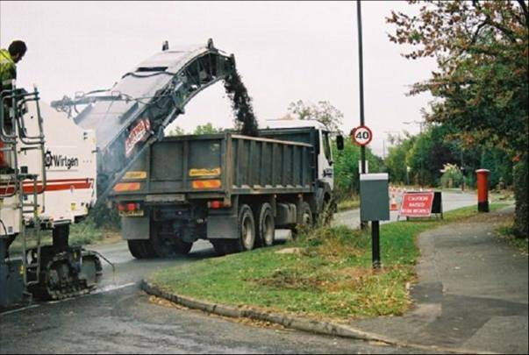

**Call for Papers**

The *International Journal of Pavement Engineering & Asphalt Technology* has been established as a leading refereed forum. It reports on innovative research; design breakthroughs; construction practices; evaluation techniques; industrial applications; specification & analysis of asphalt binders & mixtures. Authors are invited to submit papers for inclusion in future editions. Theoretical papers should deal with innovation and, wherever possible, the implementation of new materials or techniques. Papers describing work in progress should discuss the long-term practical implications of the research undertaken. Contributions are especially welcome from designers and contractors dealing with new materials or construction / testing techniques (including destructive and non-destructive testing). Papers discussing IT, construction management, environmental maintenance and pavement material performance will also be considered.

The **International Journal of Pavement Engineering & Asphalt Technology** (ISSN: 1464-8164) is published twice yearly. All rights including translation reserved. The Editors and members of the Journal’s Editorial Review Board are from a range of organisations including academic institutions, oil and chemical producers, government institutions, consulting companies and equipment developers with a wide range of expertise.

Papers or other contributions and the statements made or opinions expressed therein are published on the understanding that the author of the contribution is solely responsible for the opinion expressed in it and its publication does not imply that such statements and / or opinions are, or reflect the views or opinions of, the Editors, the Editorial Review Board or the Publisher. The views expressed in the Journal do not represent any of the organisations for which the Editors or members of the Editorial Review Board are associated.

**ISSN 1464-8164 March 2023**

**Volume 24 ay 2010**

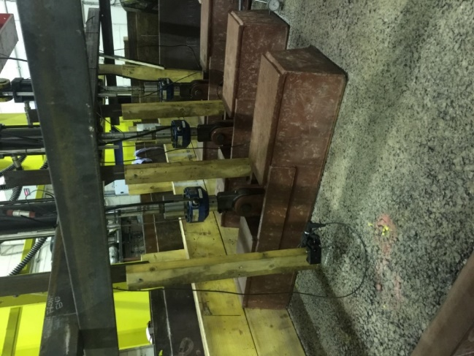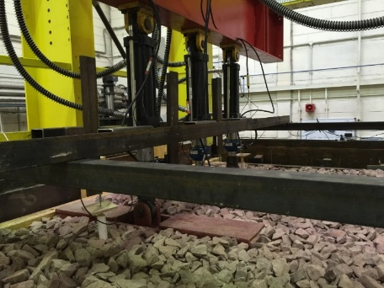

**The International Journal of Pavement Engineering & Asphalt Technology**