# C:\Users\CPHCLEWI\Desktop\logo.png PHI Logo - Grey

**‘What is evidence based health and wellbeing?’ workshop**

**11th January 2018**

**Workshop report**

Table of Contents

**1. Introduction 1**

**2. Background and workshop summary 2**

**2.1 Background 2**

**2.2 Workshop summary 2**

**2.3 Summary of presentations 2**

**2.4 Workshop discussion 3**

**3. Summary of future training needs of participants 5**

**4 . Summary of evaluation forms 6**

**5. Next steps 9**

**Appendix 1 - Future training needs of participants in full 10**

**Appendix 2 – Invitation and programme 11**

**Appendix 3 – Online survey for participants 13**

**Appendix 4 - Resources relating to the presentation on evidence hierachy….17**

**Appendix 4 – Full list of participants 18**

# 1. Introduction

This report is a summary of the Champs Public Health Collaborative workshop on ‘what is evidence based health and wellbeing?’. The event was organised in partnership with Cheshire and Merseyside Directors of Public Health, and was held at the Halliwell Jones Stadium in Warrington on the 11th January, 2018. Researchers from the Public Health Institute at Liverpool John Moores University delivered the workshop as part of the Champs Public Health Intelligence Programme. Support in organising the workshop was provided by Champs.

The workshop was well attended, with 47 participants from a wide range of disciplines and organisations from across Cheshire and Merseyside. The event included a series of presentations and discussions, and feedback was gathered from participants on their current training and support needs on applying evidence to practice. Overall, participants found the event informative and useful.

# 2. Background and workshop summary

## 2.1 Background

In order to ensure that the event was focused on the needs of attendees, prior to the workshop, an online survey was distributed to 1500 people on the Champs database. A full list of the questions asked is provided in Appendix 3. Although the response rate to the survey was low. Only 9 of the 254 (3.5%) of those who opened the email completed the survey. However, the survey findings were used as far as possible to inform the content of the presentations that were delivered at the event. Participants were also asked what additional training or support they would like, if any, in terms of using evidence to inform practice.

## 2.2 Overview of the workshop – what is evidence based health and wellbeing?

The workshop was opened by Matt Ashton, Joint Director of Public Health, Sefton and Knowsley Council. He discussed the background to the workshop, and the importance of applying evidence to practice.

A presentation from Dr Hannah Timpson, Head of Research, Engagement and Impact, at the Public Health Institute, Liverpool John Moores University followed. She delivered the content for the workshop; this included discussion around the different types of evidence, the best ways to access high quality evidence, and issues around applying evidence in practice. Please see Appendix 4 for more information.

After the presentation, workshop participants worked in small groups with Lego®, following a brief to construct models showing ‘What does evidence based health and wellbeing look like?’. A variety of different models were built, images of which are shown in photographs 1 to 5 below. This group activity was followed by a wider group discussion on why is evidence based health and wellbeing is important. Participants were also invited consider and critique sources and credibility of evidence, as well as the barriers and facilitators to accessing appropriate evidence and applying it to practice.

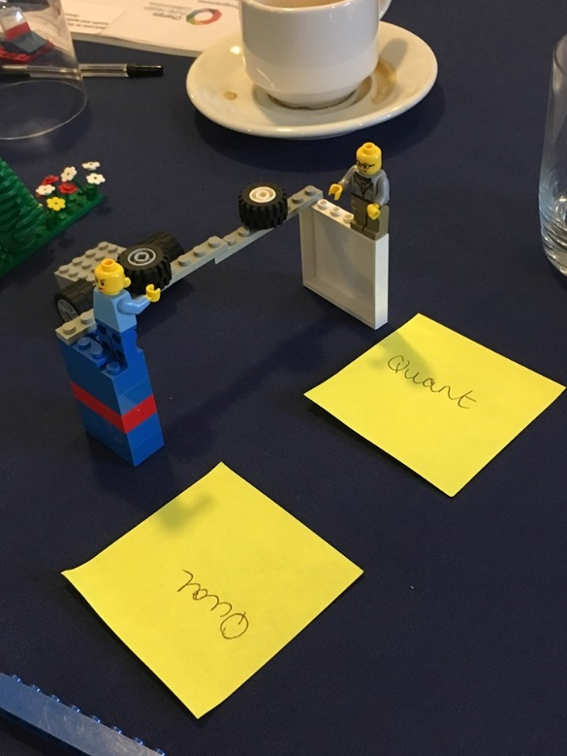

**Photograph 1 shows the balance between qualitative and quantitative research**

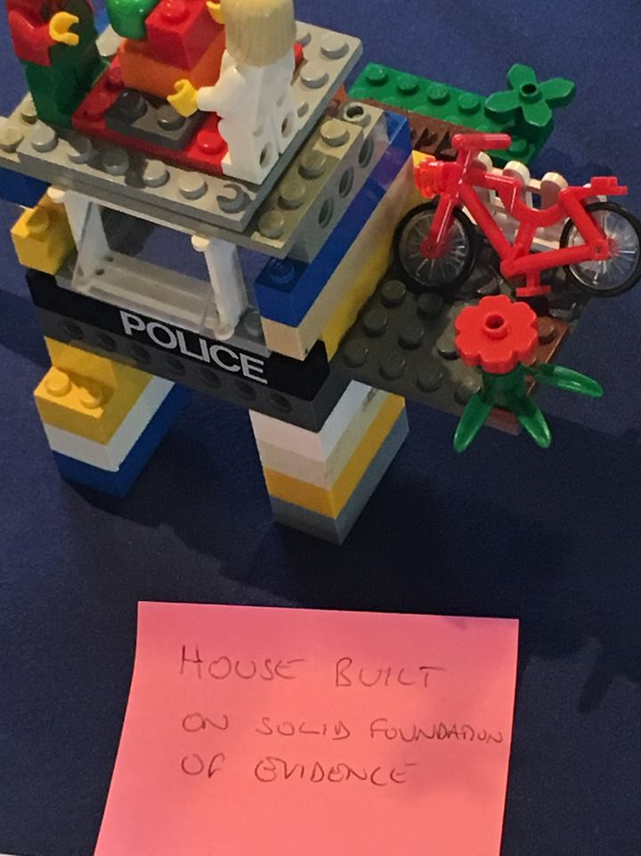

**Photograph 2 shows practice based on solid evidence**

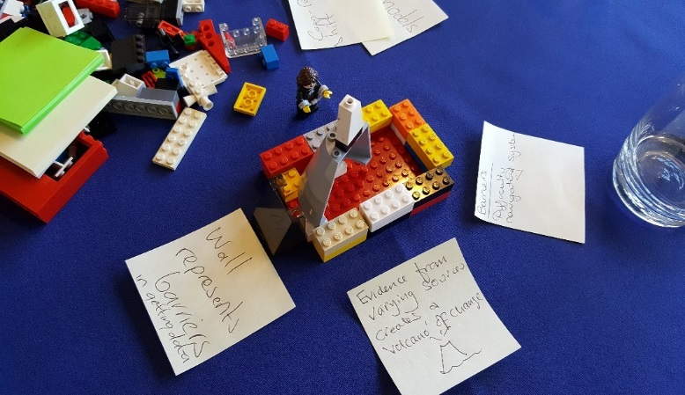

**Photograph 3 shows a ‘volcano of evidence’, and barriers to obtaining evidence**

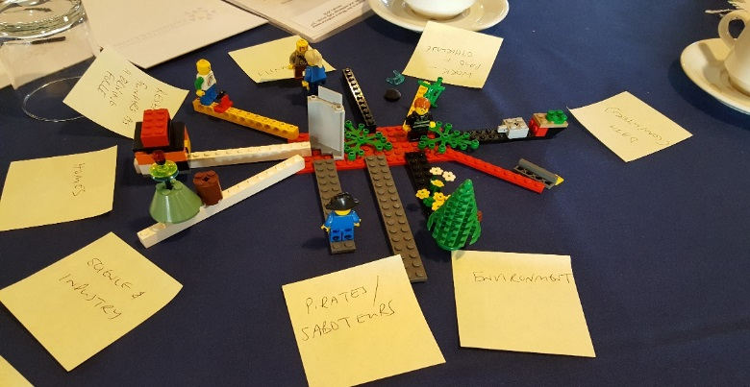

**Photograph 4 shows a number of issues that impact on evidence based health and wellbeing**

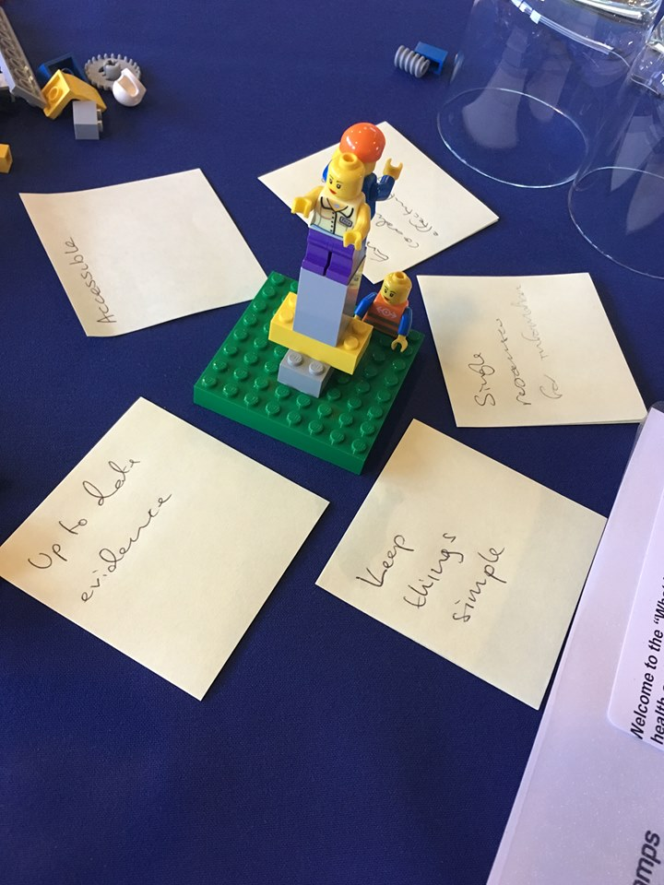

**Photograph 5 shows a simple, streamlined model of using evidence**

# 3. Summary of future training needs of participants

In terms of specific support required through resources or further sessions, participants asked for access to a single resource for the information. They wanted to know how to set indicators of wellbeing, as well as performance indicators, and how to develop outcomes frameworks.

They also felt that they would benefit from evaluation training, to know how to effectively evaluate programmes, as well as support or training in undertaking systematic reviews.

Participants discussed how to effectively present evidence once you have established it, as well as communicating evidence to wider groups, who may be non-experts. They also mentioned issues around furthering collaboration between academics, practitioners and policy-makers, and building collaborative infrastructures.

Additional comments included:

* *Within community individuals grow their own bed of evidence they share and turn to*
* *The evidence that we all see as best may just be what everyone is talking about! We act as a herd and follow each other*
* *If evidence does not support the programme or is not relevant how do we ensure that we do not waste the opportunity to innovate? How do we answer this?*
* *CHAMPs has a key role!*
* *Move from power of hierarchy to power of network*
* *Evidence coordinated effectively*

# Section 4 – Summary of evaluation forms

Following the event, participants were asked to complete an evaluation form. Overall, participants found the event informative and useful.

1. **How did you rate the content of the event overall?**

Participants were asked how they would rate the event, ranging from poor to excellent. A total of 28 people answered this question. Nine participants thought that the event was good, 13 very good, and six thought that it was excellent.

1. **What did you find the most useful?**

Participants were asked which elements of the event they found the most useful. Responses included:

* Opportunities to network across Cheshire & Merseyside
* Meeting others from different organisations who share the same issues and the resources provided in the presentation
* Links/information about websites to use for evidence
* Resources related to the hierarchy of evidence
* Discussion on levels of evidence
* The group discussion at the end about challenges was very useful
* All of it
* Model building fun!

1. **What did you find the least useful?**

Responses included;

* Icebreaker
* Whilst useful outlining the examples of the hierarchy of evidence; I suspect many already knew this, but may have preferred a closer look at the advantages/disadvantaged of some of those sources
* Critique of evidence – would hope this is already done by all
* Lego® exercise

1. **‘Did the programme meet your learning requirements and why?’.** Responses included;

* *I had hoped we would look at the evaluation today, so would be interested in attending a future event on this*
* *Interesting but not all role appropriate*
* *The programme was what I expected but still provided me with some bits of new information*
* *Yes good level of detail*
* *Yes as I am very new to this type of working environment so to learn as much as I can on evidence based health and wellbeing is very useful!*
* *Provided a new perspective of evidence collection and related resources*
* *… The hierarchy of evidence was very useful*

1. **I have learnt a lot as a result of today’s event**

30 participants answered this question. Overall, the majority of participants (80%) agreed or strongly agreed that they had learnt a lot as a result of the event.

1. **I will change/modify my practice as a result of today’s event**

27 participants answered this question. Overall, most of the participants agreed or strongly agreed that they would change or modify their practice as a result of the event. Additional comments in answer to this question included;

* *How do you propose evidence is better used to influence policy?*
* *Small amount of practical information – generally good content but not very stimulating or ground breaking*
* *The course reaffirmed my understanding for the need to provide evidence and comparisons when remodelling services*

1. **How do you rate the venue, the administration, the speakers and the information?**

The vast majority of respondents rated these elements good, very good, or excellent.

1. **How can future CPD sessions be improved?**

A number of responses were given in response to this question;

* *Be clear who the target audience is and whether the level is basic/advanced*
* *More time for interactions*
* *More comprehensive and detailed sessions could be produced to expand on today’s session*
* *Potentially make the sessions on all day event rather than just morning events*
* *Sometimes a certificate for CPD would be good*

1. **Other comments**

* An excellent and useful morning. Well worth prioritising
* There is nothing out there (data sets) which look at social housing tenants. This would benefit many organisations
* I would like a session specifically on evaluation method/tools/support please
* Useful mix of input, creative working group (with a purpose) and presumably useful slide circulated after the event
* Thank you again for another great event

# Section 5 – Next steps

A future training programme will be agreed by Champs in response to training needs identified at the event.

Several of the survey respondents, as well as participants, said that they would further support to focus on how to conduct evaluations. Participants would also like a focus on conducting systematic reviews.

Possibility of contacting people who took part on asking them to choose from a list of which workshops they would find most useful, as well as asking about their current level of knowledge and understanding. Also contact the original list of people that Champs sent the survey to, to ask which additional sessions would be useful?

# Appendix 1 - Future training needs of participants in full

Participants were asked what specific support was required through resources or further sessions.

*Specific support required through resources or further sessions:*

* Single resource for the information
* Evaluation training- How do we effectively evaluate our programmes?

-How do we set indicators of wellbeing?

* Future ideas- evaluation in practice
* Creating effective key performance indicators
* Undertaking systematic reviews
* Developing outcomes/ outcomes frameworks
* Presenting evidence once you have established it
* Communicating evidence to wider groups (non-experts)
* How do we further the collaboration between academics, practitioners and policy-maker?
* Building collaborative infrastructure and move from programmes to platform.

*Comments:*

* For evidence to be relevant to a certain population we need to understand the belief systems, priorities and potential enablers for that population.
* Within community individuals grow their own bed of evidence they share and turn to.
* The evidence that we all see as best may just be what everyone is talking about! We act as a herd and follow each other.
* Evidence and guidelines need to be aligned with what is important (or would be important to a patient/individual) if it is going to result in an enabler.
* If evidence does not support the programme or is not relevant how do we ensure that we do not waste the opportunity to innovate? How do we answer this?
* Influencing- giving the evidence conversation more weight.
* Tenants- health deprivation stats on social housing tenants to help inform evidence based health and wellbeing services/ interventions.
* CHAMPs has a key role!
* Understanding the gain/world of the other.
* Move from power of hierarchy to power of network.
* ‘Branches’ out- multifaceted.
* 360 degree approach.
* Evidence coordinated effectively.
* Accessibility, Holistic, Bridge support, Subjective.

# Appendix 2 – Invitation and programme



**Draft Programme**

|  |  |
| --- | --- |
| **9:00am** | **Registration, tea and coffee** |
| **9:30 to 9:45am** | Welcome and introductions |
| **9:45am to 10:10am** | Scoping activities:  Presentation and explorating of scoping survey findings |
| **10:10am to 10:30am** | Facilitated discussion on the challenges and approaches to translating public health evidence into policy and practice |
| **10:30am to 10:45am** | **Refreshment break** |
| **10:45am to 10:55am** | Introduction to focus of main session |
| **10:55am to 11:50am** | Delivery of main session content |
| **11;50am to 12 noon** | Circulation of resources/further information  Next steps (to include evaluation and confirmation of whether further sessions would be valuable and what this could include) |
| **11:50am to 12 noon** | **Close** |

***Notes:***

***Please note lunch is not provided for delegates at this event although refreshments are available.***

***Presentations will be available on the Champs website www.champspublichealth.com following the event.***

***A photographer may be present on the day; please let the Champs support team know if you would rather not be photographed.***

# Appendix 3 – Online survey for participants

The survey was distributed to participants prior to the event.

**What is evidence based health and wellbeing?**

**Pre-event online questionnaire for the Champs CPD Event**

**Background**

The Champs Collaborative are hosting an event to support local authorities, NHS and third sector organisations to use evidence in practice. The event will explore local experiences, barriers and challenges and provide practical tools and resources to support people who work in the field of health and wellbeing.

In order to ensure the event is focused on the needs of attendees, you are invited to complete this short questionnaire.

**SECTION 1: About You**

Please tell us the type of organisation you represent:

1. Local authority
2. CCG
3. NHS
4. Other (please specify) __________________

Please tell us the location in which you are based:

1. Cheshire East
2. Cheshire West and Chester
3. Halton
4. Knowsley
5. Liverpool
6. Sefton
7. St Helens
8. Warrington
9. Wirral

**SECTION 2: Accessing Evidence**

**By ‘evidence’ we mean facts, research findings, literature, policy documents and other guidance. This information may be derived from research, evaluation, audits, routinely collected data, and experiences of the public, patients, service users and health professionals.**

Do you agree or disagree with the following statements:

1. My role requires me to access and review evidence
2. I feel confident in knowing what constitutes credible evidence
3. I know the importance of using/looking for credible evidence
4. I know where to look for credible evidence
5. I feel confident in searching for evidence
6. I know where to access grey literature (such as case studies)
7. I know where to access peer-reviewed journals
8. I have access to a wide range of sources of evidence
9. I have enough time to search for appropriate evidence

Where do you routinely look for evidence? (please tick all that apply)

1. Local evidence (such as Joint Strategic Needs Assessments and PHE Fingertips)
2. Internet search (e.g. Google)
3. Peer reviewed research journals
4. Policy documents
5. Electronic scholarly databases (such as PubMed and Web of Science)
6. News or newspaper websites (such as the BBC)
7. Wikipedia
8. Other: please state____________________

**SECTION 3: Appraising Evidence**

Do you agree or disagree with the following statements:

1. My role requires me to appraise the content and quality of evidence in order to inform the decisions I make
2. I have received training in how to assess the relevance and importance of evidence
3. I am confident in my ability to critically appraise evidence
4. I have enough time to review and consider evidence in my role
5. I have enough resources to review and consider evidence in my role

**SECTION 4: Presenting Evidence**

Do you agree or disagree with the following statements:

1. I feel confident interpreting evidence and using it to inform the decisions I make
2. I feel confident presenting and discussing evidence to justify and inform decisions
3. I feel confident in applying evidence to local need
4. I feel confident aligning the evidence with the local political context

**SECTION 5: Evaluating Local Programmes and Understanding Needs**

**By ‘local programmes’ we mean services, interventions or initiatives that are delivered locally, either within or outside your organisation. Your role may involve you commissioning, managing or delivering these programmes.**

Do you agree or disagree with the following statements:

1. Evaluation is an important part of service development
2. I feel confident in designing appropriate evaluations
3. I know where to access advice on how to evaluate local programmes
4. I feel confident in interpreting and using the findings from evaluations
5. I feel I need further support to use evaluation in my work
6. I feel I need further training on using evaluation
7. I have the resources available to incorporate evaluation into the work I am involved with

Do you agree or disagree with the following statements:

1. I am confident that I know what data needs collecting in order to evidence the impact of our local programmes
2. I have the resources to ensure the right types of data are collected
3. I feel confident in analysing and interpreting the data
4. I have the resources to ensure the data are analysed and reported on
5. I am able to access all of the data I need, including externally held data (such as Hospital Episode Statistics)

Do you agree or disagree with the following statements:

1. I understand the purpose of using needs to assessments to inform service development
2. We use needs assessments to inform service design within our local programmes
3. We regularly undertake benchmarking audits to see how local programmes compare to best practice

**Anything else?**

Is there anything else you would like to tell us about your experiences of accessing, using or presenting evidence?

_________________________________________________________________________________

Are there any specific things that you would like the CPD session to explore?

_________________________________________________________________________________

# Appendix 4 – Resources from the presentation by Dr. Hannah Timpson: using and applying evidence

Please click on the link below to access the PowerPoint presentation from the event;



# Appendix 5 – Full list of participants

|  |  |  |  |  |
| --- | --- | --- | --- | --- |
| **SURNAME** | **FIRST NAME** | **JOB TITLE** | **ORGANISATION** | **EMAIL** |
| Anwar | Elspeth | Public Health Consultant | Halton Borough Council | elspeth.anwar@halton.gov.uk |
| Ashiq | Usman | Strategic Partnerships Manager | Plus Dane Housing | usman.ashiq@plusdane.co.uk |
| Ashton | Matthew | Joint Director of Public Health | Sefton and Knowsley Council | matthew.ashton@knowsley.gov.uk |
| Bayliss | Joanne | Specialist Public Health Analyst | Warrington Council | jbayliss@warrington.gov.uk |
| Birkett | Chris | Affordable Warmth Project Officer | St.Helens Council | chrisbirkett@sthelens.gov.uk |
| Bolton-Maggs | Diane |  |  | [DianeBolton-Maggs@sthelens.gov.uk](mailto:DianeBolton-Maggs@sthelens.gov.uk) |
| Bradburn | Dave | Acting Consultant in Public Health | Warrington Borough Council | dbradburn@warrington.gov.uk |
| clarke | dianne | operations manager (healthy living) | LiveWire | dclarke1@livewirewarrington.org |
| Daly | Matthew | Insight Officer | MSP | m.daly@merseysidesport.com |
| Dickinson | Helen | Public Health Programme Manager | NHS England Cheshire and Merseyside | helen.dickinson7@nhs.net |
| Ellie | McCoy | Research and Project Manager | Liverpool John Moores University | E.J.McCoy@ljmu.ac.uk |
| Farrington | Elizabeth | Health Care Public Health Manager | PHE NW | elizabeth.farrington@phe.gov.uk |
| Finegan | Kate | Health and Wellbeing practitoner | Merseycare NHS ( secure services ) | kate.finegan2@merseycare.nhs.uk |
| Font | Jack | Data Analyst Apprentice | Wirral Council | jackfont@wirral.gov.uk |
| Grimes | Kerry | Health Improvement Practitioner | Health Improvement Team HBC | grimsk66@gmail.com |
| Harrison | Rebecca | Public Health Impact Officer | Liverpool John Moores University |  |
| Hayes | Julie | Infection Control and Health Protection | Cheshire West and Chester council | julie.ann.hayes@cheshirewestandchester.gov.uk |
| Hill | Gareth | public health manager | wirral la | garethhill@wirral.gov.uk |
| Jones | Lisa | Reader in Public Health (Evidence Synthesis) | Liverpool John Moores University | [l.jones1@ljmu.ac.uk](mailto:l.jones1@ljmu.ac.uk) |
| Janet | Joyce |  |  | [janet.joyce@nhs.net](mailto:janet.joyce@nhs.net) |
| Kennedy | Justine | Warrington Sexual Health | Bridgewater Trust | justine.kennedy@nhs.net |
| Kinsella | Karina | Research Assistant | Liverpool John Moores University | [K.F.Kinsella@ljmu.ac.uk](mailto:K.F.Kinsella@ljmu.ac.uk) |
| Kokolay | Cheryl | Health and Well-Being Consultant | Self Employed | ckokolay@hotmail.co.uk |
| Lawrenson | Karen | Public Health Practitioner | Liverpool City Councol | karen.lawrenson@liverpool.gov.uk |
| Lewis | Cath | Researcher | Liverpool John Moores University | C.E.Lewis@ljmu.ac.uk |
| McAteer | Sharon | Public Health Manager | Halton Borough Council | sharon.mcateer@halton.gov.uk |
| McGurghan | Lisa |  |  | [lisa.mcgurgan@knowsley.gov.uk](mailto:lisa.mcgurgan@knowsley.gov.uk) |
| Meredith | Wendy | independent public health consultant | self employed | wightmere@gmail.com |
| Middleton | Elaine | Head of Services | Age Concern Liverpool &Sefton | elaine.middleton@ageconcernliverpool.org.uk |
| Monaghan | Gemma | Business Intelligence Officer | Sefton Council | [gemma.monaghan@sefton.gov.uk](mailto:gemma.monaghan@sefton.gov.uk) |
| Norman | Lee | Manager Private Sector Housing Services | St Helens Council | leenorman@sthelens.gov.uk |
| Perris | Neil | Head of Sexual HEalth & Wellbeing | Wirral Community NHS Foudation Trust | n.perris@nhs.net |
| Russell | jayne | Health and wellbeing Co-ordinator | Lancashire Teachin Hospitals NHS Trust | Jayne.Russell@LTHTR.nhs.uk |
| Salla | Michael | Director of Health | Everton in the Community | Michael.Salla@evertonfc.com |
| Smith | Charlotte | Specialty Registrar | Halton MBC | charlotte.smith@halton.gov.uk |
| Stott | Helen | Health Protection Specialist | Cheshire West and Chester Council | Helen.Stott@cheshirewestandchester.gov.uk |
| Swift | Lynn | Service Manager | Wellbeing Enterprises CIC | l.swift@wellbeingenterprises.org.uk |
| Taylor | Carolyn | Project Manager | Wellbeing Enterprises CIC | [c.taylor@wellbeingenterprises.org.uk](mailto:c.taylor@wellbeingenterprises.org.uk) |
| Timpson | Dr Hannah | Head of Research Engagement and Impact | Liverpool John Moore's University | H.Timpson@ljmu.ac.uk |
| Uglow | Jane | Programme Manager | Knowlsey CCG | jane.uglow@knowsleyccg.nhs.uk |
| Unsworth | Helen | Project Officer | Champs Support Team | helenunsworth@wirral.gov.uk |
| Ward | Steven | Research Assistant | The Mersey Forest | steven.ward@merseyforest.org.uk |
| Williams | Helen | Head of Integrated Commissioning | St Helens Council | helenjwilliams@sthelens.gov.uk |
| Wilson | Richard | Foundation Year 2 Doctor | Public Health Halton | richard.wilson@halton.gov.uk |
| Wright | Angela | Commissioning Manager | NHS West Cheshire CCG | angela.wright11@nhs.net |
| Wyatt | Thomas | GP with interest in Public Health working with Wirral Public Health Department | Wirral Public Health Department | thomaswyatt@nhs.net |
| Zammit | Rachel | Public Health Lead | Sefton MBC | rachel.zammit@sefton.gov.uk |