Research informed teaching case study
Dr Adam Shore and Dr Track Dinning
Liverpool Business School
Business Clinics; developing a mind-set ready for work
Utilising real world experience to develop student’s skills, awareness, knowledge and networks within the curriculum

Introduction
The need to develop students into individuals with a skill set that can help them navigate the jobs market has never been so vital as we enter the 5.0 industrial revolution. In 2020 the World Economic Forum predicted that there would be an increase in the need for skills associated with multiple learnings. Both Shore and Dinning have a background in experimental learning approaches to teaching, learning and assessment in management education. Working across various disciplines the authors have taken their research on project-based learning and learning through failure to develop the Business Clinic within the Liverpool Business School.
The Business Clinic provides students with the opportunity for both the contextual practice of skills and the demonstration of the application of theory. Specifically, this experiential learning opportunity comes through students working on a ‘real world’ live problem or challenge that has been provided by external organisations or businesses.
A research informed framework to support this approach to learning has been designed to ensure this experience offers a deep learning experience for the students and value to the external organisations (Shore and Dinning, 2023)
Figure 1: The Liverpool Business School Approach
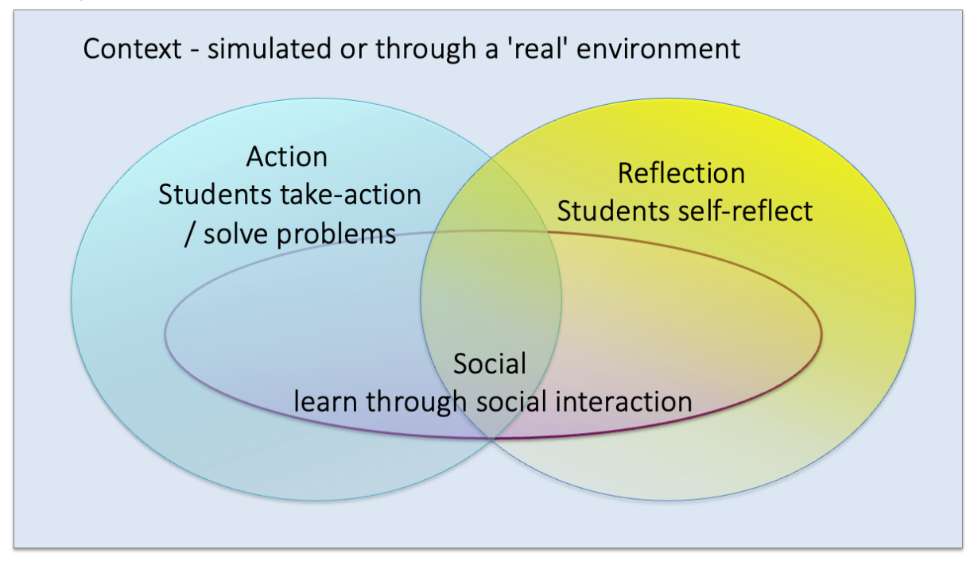
Within the Business Clinic approach, students undertake a research/ consultancy project in self-selecting groups of 4- 6 individuals putting the students in a position where social interaction will take place. In this case the social aspect will be between the students, between external project host and the students and between the students and academics tutors. To enact the context and action element, each group of students is be provided with a project brief that has been procured from an external organisation [context], either by the university or the students themselves. The students need to be given time to undertake primary research to address the business problem generating an improvement plan driven by data and academic analysis [action]. Students are taught the art of reflection and encouraged to reflect throughout the project and not just at the end.
Specific project work
Working with external stakeholders is a key element to the success of the Business Clinic approach and one early stakeholder was a social enterprise based in Liverpool. Each year this social enterprise provides a project to support the development of the organisation’s social media presence. What has been nice to see with this particular partner is how their business has grown over the years and how each year they come to us with a meaningful project to support their business or grow their social presence. The enterprise has now been supporting LJMU students for over 8 years and recently the CEO was part of the Business Clinic promotional video. Some of her comments include:
‘Students are coming to me with fresh ideas, so I am learning from them at the same time’
‘The students have helped us steer the business ‘
‘A current project is to develop a marketing strategy it is imperative work and we have taken things in a different direction’
‘It’s a benefit to our business and I definitely recommend it’

The projects are supported in the classroom through a series of taught sessions and one to one tutorials that students access to guide them through the project. Shore and Dinning found that whilst working with small numbers of groups support from academic staff was manageable, however, other academics adopting the Business Clinic approach were anecdotally reporting this much more difficult to manage, when dealing with larger number of project groups. For example, Dr Jan Brown introduced the use of professional business mentors to support the student group with the applied nature of their Business degree. This approach has also enabled Jan to manage and work with larger numbers of student groups.
In 21/22 the Business Clinic saw 290 students provide a service to over 50 organisations (public, private and third sector) across the region and beyond. In 22/23 this increased to 416 of our students working across 95 projects with the Business Clinic supporting 70 organisations on a range of projects within the Liverpool City Region. Already in 23/24 there are again over 400 students set to work on similar projects.

Impact on the curriculum
Currently the model is embedded into some of the Business School programmes, however through the periodic programme review process the intention is for Business Clinic projects to run across all undergraduate and post graduate programmes within the school. Through strategically looking at staff recruitment and workloads, Shore and Dinning have been able to grow the number of staff involved in Business Clinic work with the recent appointment of a teaching fellow for Business Consultancy. Over the past 12 months we have also started to reflect on what specific subject focussed projects our students are best placed to delivery. The challenge now is to ensure that the content being taught by programme teams is reflective of what employers want, making it easier for student to respond to the project briefs. Whilst equally, allowing the student to work on a project that can enhance their employability skills and knowledge of the ‘real world’.

‘The project work is very creative and to be able to work on a live project alongside a client is really interesting. The skills I am learning from this project will help improve my career prospects’
Final year Sport Business students

‘Applying theory into practice has helped me to find a tangible solution for a business and understand how valuable my knowledge can be. It has given me the confidence to explore employment options once I complete my course’
Final year Business with Marketing student

Broader change
- Student’s awareness of the external environment and the expectations of them whilst working in such a manner. Research has shown (Dinning, 2017) that students can over-estimate their own ability.
- Impactful solutions and knowledge for the external host, as the students deliver fresh ideas informed by current theory.
- Two-way links between the external businesses and the university ensuring that both parties can learn from each other. The students get to experience real world experiences and the businesses get a fresh lens on their situation from the students.

‘It has been a pleasure to work with so many passionate LJMU students who have been keen to showcase their credentials as the marketeers of the future in our industry. They have provided genuine help to us by undertaking a real-life research project that we’re putting to direct use in order to offer the best possible ticketing packages for our supporters’
Business Clinic client

Shore, A. & Dinning, T. (2023). Developing student’s skills and work readiness: an experiential learning framework, Journal of Work-Applied Management, Vol.15 (2), pp. 188-199.
Dinning, T. (2017). Embedding employability and enterprise skills in sport degrees through a focussed work - based project; a student and employer viewpoint. Cogent Education, 4(1), pp.1-14.

