LJMU MAJOR STUDY ABROAD EXCHANGE PARTNERS INFORMATION

Please note this is not the full list, but only a sample of our major and most popular partnerships. If you want to look at other partnerships, then look at their websites were you will find all the information

The information contained in this document was correct according to the partners/ accommodation providers and the relevant government’s visa information in January 2022, but this may change and LJMU is not responsible for this, so we advise you to check the links provided. For cost of living use online checkers like here.
This is a short description of the host and you should do further research beyond these profiles.
To ensure your programme can attend the partner you must always refer to the approved partnerships in the partner to programme matrix on the Study Aboard website or consult with your school Internationals Mobility Coordinator. Modules change each year at host so we cannot always guarantee availability.

INTERNATIONAL RELATIONS - STUDY ABROAD TEAM

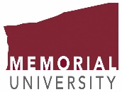 MEMORIAL UNIVERSITY
ST JOHN’S, NEWFOUNDLAND, CANADA
Introduction
At Memorial University more than 18,000 students from over 100 countries come together to discover. From the classics to advanced technology, Memorial offers programmes across four campuses and online. The university is one of Canada’s top ranked universities and has the capacity and reputation for leadership in research, teaching and public engagement.
Founded in September 1925 as a living memorial to Newfoundlanders and Labradorians who died in the First World War, Memorial is the largest university in Atlantic Canada, and Newfoundland and Labrador's only university.

Programmes of study
Memorial University offers a range of programmes of study that include:
Business Administration, | Humanities & Social Sciences | Engineering | Applied Sciences | Arts
Full details of the majors on offer can be found on the Memorial University website.
Exchange students are recommended to follow a full programme of study for the academic year based at Memorial University.
Places available are 2 full year or 4 semester only.

Learn more about campus activities and events

Travel & accommodation
- Travel – the nearest major airport to Memorial University is St. John’s International airport. You can request the free Memorial University airport pick up service which is highly recommended. More information can be found on the Memorial University website.
- Accommodation – you will need to apply to live in the Memorial University student halls of residence. For more information, check out the Memorial University Residence webpage.

Visas, insurance and costs
- Visas – To take part in this exchange you are responsible for ensuring that you meet the requirements of the Canadian immigration requirements and further information can be found here.
- Insurance – LJMU insurance is not sufficient for studying on exchange in Canada, and students are required to purchase medical insurance while attending Memorial University.
- Living costs -in Canada tend to be higher than those in the UK & it is recommended that you research this to gain a better understanding of the cost of your year abroad. To help you, we have a created a simple cost comparison between the UK and Canada:

Higher Higher Higher

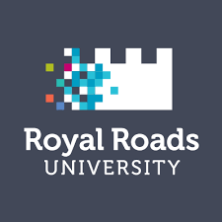 ROYAL ROADS UNIVERSITY VANCOUVER ISLAND, BRITISH COLUMBIA CANADA

Introduction

Royal Roads University (also referred to as RRU or Royal Roads) is a public university with its main campus in Colwood, British Columbia. It is located at Hatley Park National Historic Site on Vancouver Island. Following the decommissioning of Royal Roads Military College in 1995, the government of British Columbia created Royal Roads University as a public university with an applied and professional degree-granting focus. The University website can be found here or a virtual tour.
LJMU has 2 places per year or 4 by a semester. Some students may need to achieve a specific GPA.

Learn more about campus activities and events

Travel & accommodation
- Travel – Recommended airport is Vancouver BC and then ia BC Ferries, from Tsawwassen to Swartz Bay ferry terminals.
- Accommodation – students can live onsite or select to stay off campus. Further information can be found here. Temporary campus accommodation can be booked while students seek their own accommodation in Victoria. The University estimates that accommodation costs around $750 a month with around $300 for food. Further information is here.

Visas, insurance and costs
- Visas – To take part in this exchange you are responsible for ensuring that you meet Canadian immigration requirements.
- Insurance – LJMU insurance is not sufficient for studying on exchange in Canada, and students are required to purchase medical insurance Includes quick analysis of costs in relation to Liverpool.
- Charges from the university – you have to pay ancillary fees
- Living costs -in Canada tends to be higher than in the UK and you have the travel costs to Vancouver. Vancouver and Vancouver Island are relatively expensive locations to live in. We recommend that you do further independent research to gain a better understanding of the cost of your year abroad and check out their website here. To help you, we have created a simple cost comparison between the UK and Canada:
- Higher Higher Higher

EM STRASBURG, FRANCE

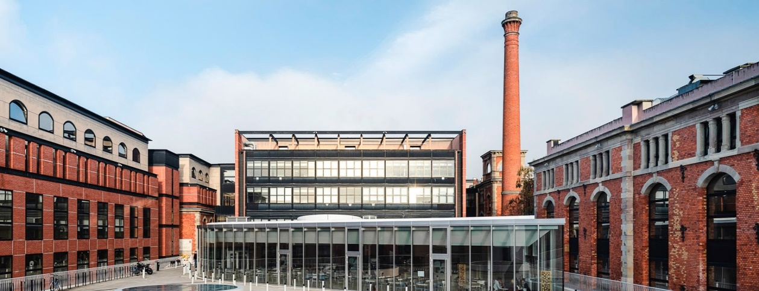

Introduction

EM Strasbourg Business School is a French business school created in 1919 in Strasbourg, Alsace. Since 2000 it is one of the elite grandes écoles in France, ranking in the top 17 business schools in the nation.^{[1]} It is the only French Business School to operate under the umbrella of a traditional University: the University of Strasbourg. For further information go to the website here

Programme of study introduction
Business School programmes only.
Places available currently to LJMU is 2 students by a year or 4 by a semester.

Learn more about campus activities and events

Travel & accommodation
- Travel – Strasbourg is easily reached from the UK by air or train. The city is well serviced by public transport.
- Accommodation -The CROUS is in charge of university residences and restaurants in France. Accommodations are designed for limited budgets with different levels of comfort. Places available are limited and only for exchange students. Further information can be found here. However, it should be noted that many students who have been to this host have found their own accommodation privately and this can be more cost effective and websites such as Erasmusu or Housing Anywhere can be used. According to their website accommodation costs between €200-500 a month.

Visas, insurance, and costs
- Visas – To take part in this exchange you are responsible for ensuring that you meet French immigration requirements and further information here.
- Insurance – All students are recommended to purchase travel insurance for the duration of their time in Europe to cover personal possessions and healthcare. UK and EU nationals can apply for a UK Global Health Insurance Card (GHIC), which is time-limited to the length of the exchange period.
- Living costs in France tend to be higher in major cities but in others like those in the UK. We recommend that you do further independent research to gain a better understanding of the cost of your year abroad. Accommodation varies in price and depends on students preference to type, distance from the old city centre and sharing arrangement. To help you, we have created a simple cost comparison between the UK and France:

Similar Similar Similar
UNIVERSITY OF LILLE – FRANCE
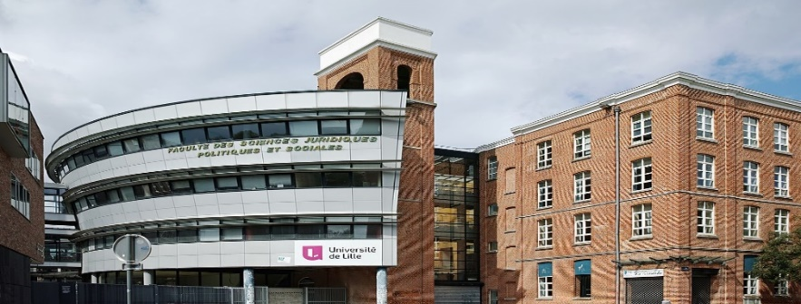
Introduction
The University of Lille (French: Université de Lille, abbreviated as ULille, UDL or univ-lille) is a French pluridisciplinary public university located in and around Lille, Hauts-de-France (Métropole européenne de Lille). It has its origins in the University of Douai (1559), and resulted from the merger in 2018 of the three universities Lille 1 University of Science and Technology, Lille 2 University of Health and Law, and Charles de Gaulle University – Lille III. With more than 74,000 students, it is one of the largest French universities and one of the largest French-speaking universities in the world.
Programme of study introduction
- International Relations | - Law

LJMU has 4 by a year or 8 by a semester places each year.

Learn more about campus activities and events
- Travel – Travel via Eurostar directly to Lille. Alternatively, you can fly into Brussels.
- Accommodation-French universities do not commonly provide accommodation and students have had to difficulty finding accommodation on arrival, so we strongly recommend making sure that you have housing before your arrival in France which may be sourced from a previous visit before arrival. The Department of international mobility makes rooms available in CROUS university residences and further information can be found here. The university helps connect outgoing students. Also, scheme called Housing Anywhere to help find private accommodation LJMU students have stayed in private accommodation in Lille.

Visas, insurance and costs
- Visas – To take part in this exchange you are responsible for ensuring that you meet French immigration requirements and further information here.
- Insurance – All students are recommended to purchase travel insurance for the duration of their time in Europe to cover personal possessions and healthcare. UK and EU nationals can apply for a UK Global Health Insurance Card (GHIC), which is time-limited to the length of the exchange period.
- Living costs -in France tend to be higher in major cities but in others similar to those in the UK. We recommend that you do further independent research to gain a better understanding of the cost of your year abroad. Accommodation varies in price and depends on students preference to type, distance from the old city centre and sharing arrangement. To help you, we have created a simple cost comparison between the UK and France:

Similar/Higher Similar Similar

CATHOLIC UNIVERSITY OF LILLE - FRANCE
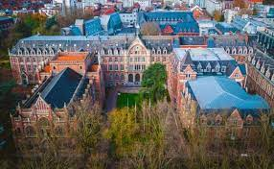
Introduction
Founded in 1875, the Université Catholique de Lille is a multidisciplinary institution with 5 faculties, 20 schools, institutes, and grandes écoles, with a cumulative student body of 38,500 in 2021.
Now the largest private, not-for-profit university in France, the Université Catholique de Lille was from its beginnings ground
Further information is available here or take a virtual tour
Programme of study
- Business and law programmes only

LJMU has 2 by a year or 4 by a semester places.

Learn more about campus activities and events
Travel & Accommodation
- Travel – Travel via Eurostar directly to Lille. Alternatively, you can fly into Brussels.
- Accommodation-It can be difficult to find housing upon arrival in Lille, so we strongly recommend making sure that you have housing before your arrival in France. For housing during your studies at Université Catholique de Lille, 2 options: Student Dorms or private housing and advice is given. However, it should be noted that many students who have been to this host have found their own accommodation privately and this can be more cost effective and websites such as Erasmusu or Housing Anywhere can be used.

Visas, insurance and costs
- Visas – To take part in this exchange you are responsible for ensuring that you meet French immigration requirements and further information here.
- Insurance – All students are recommended to purchase travel insurance for the duration of their time in Europe to cover personal possessions and healthcare. UK and EU nationals can apply for a UK Global Health Insurance Card (GHIC), which is time-limited to the length of the exchange period.
- Living costs - in France tend to be higher in major cities, but in others like those in the UK. We recommend that you do further independent research to gain a better understanding of the cost of your year abroad. Accommodation varies in price and depends on students’ preference to type, distance from the old city centre and sharing arrangement. To help you, we have created a simple cost comparison between the UK and France:

Similar/Higher Similar Similar

IPAG BUSINESS SCHOOL
NICE & PARIS, FRANCE
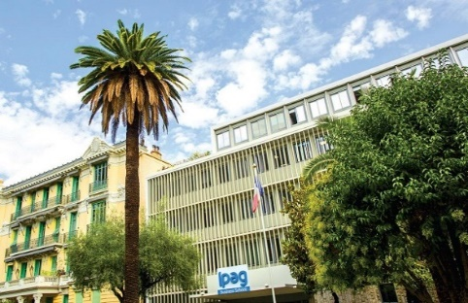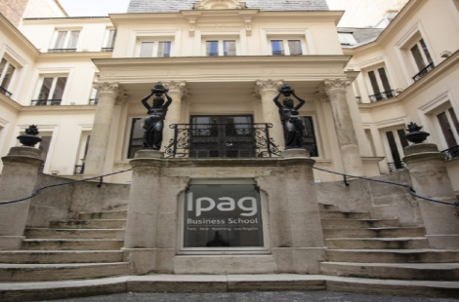
ICE PARIS
Introduction
The Ipag Business school (formerly Institut de preparation a L’adminstration et a la geston) is a French private business school founded in 1965. LJMU has an exchange agreement with Paris and Nice.
Programme of study introduction
Liverpool Business school programmes
LJMU has 6 places by a year and 12 by a semester.

Learn more about campus activities and events

Travel & accommodation
- Travel – Both Paris and Nice are easily reached from the UK by air or train (Paris via Eurostar). Both locations are serviced by local public transport.
- Accommodation –In France university halls are limited but support is available to find accommodation. However, it should be noted that many students who have been to this host have found their own accommodation privately and this can be more cost effective and websites such as Erasmusu or Housing Anywhere can be used.

Visas, insurance and costs
- Visas – To take part in this exchange you are responsible for ensuring that you meet French immigration requirements and further information here.
- Insurance – All students are recommended to purchase travel insurance for the duration of their time in Europe to cover personal possessions and healthcare. UK and EU nationals can apply for a UK Global Health Insurance Card (GHIC), which is time-limited to the length of the exchange period.
- Living costs -in France tend to be higher in major cities but in others similar to those in the UK. We recommend that you do further independent research to gain a better understanding of the cost of your year abroad. Accommodation varies in price and depends on students’ preference to type, distance from the old city centre and sharing arrangement. To help you, we have created a simple cost comparison between the UK and France:

Higher Similar Similar

Université Jean Moulin Lyon 3, LYON, FRANCE
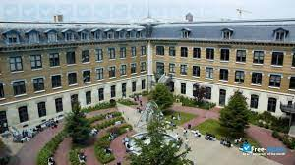

Introduction
University Lyon 3 was established in the early 1970s (26 July 1973), part of the reorganisation of higher education following the events of May 68 that rocked the academic world. It was named after Jean Moulin, a wartime resistance leader who was captured in Lyon.
The university is located on three different campuses: the first one, called "Les Quais", is by the Rhône (river), the second, called "Manufacture des Tabacs" in the south part of Lyon, and the last one in Bourg-en-Bresse, about 70km north of the city.^{[4]}
Programme of study introduction
Liverpool Business school programmes
LJMU has 1 place by a year and 2 by a semester.

Learn more about campus activities and events

Travel & accommodation
- Travel – To access the University’s campuses from the Lyon airport, you can take the Rhônexpress, the shuttle service that links Lyon’s airport to the city centre (Part Dieu railway station) in less than 30 minutes.
Lyon has several stations, with the main one (Part Dieu railway station) being only a few minutes from the Manufacture des Tabacs campus. The two Lyon campuses and the Bourg-en-Bresse campus are easily accessible by train. Rail pass options for young people can be found on the SNCF website.
Accommodation – Exchange students have access to the Lyon III International Association that provides students with assistance in finding accommodation in the CROUS university residences, private residences or with a host family.
It serves as a useful link between students and the residences. There is a basic service fee of 20€. Added costs include: 30€ application fee and 350€ deposit (compulsory reservation deposit that will be reimbursed at the end of your stay).
However, it should be noted that many students who have been to this host have found their own accommodation privately and this can be more cost effective and websites such as Erasmusu or Housing Anywhere can be used.

Visas, insurance and costs
- Visas – To take part in this exchange you are responsible for ensuring that you meet French immigration requirements and further information here.
- Insurance – All students are recommended to purchase travel insurance for the duration of their time in Europe to cover personal possessions and healthcare. UK and EU nationals can apply for a UK Global Health Insurance Card (GHIC), which is time-limited to the length of the exchange period.
- Living costs -in France tend to be higher in major cities but in others similar to those in the UK. We recommend that you do further independent research to gain a better understanding of the cost of your year abroad. Accommodation varies in price and depends on students’ preference to type, distance from the old city centre and sharing arrangement. To help you, we have created a simple cost comparison between the UK and France:

Higher Similar Similar

SCIENCE PO UNIVERSITY - PARIS FRANCE

Introduction
The Paris Institute of Political Studies (French: Institut d'études politiques de Paris, commonly known as Sciences Po [sjɑ̃s po] or Sciences Po Paris) is a public research university, with the status of grande école and grand établissement, located in Paris, France, with further campuses in Dijon, Le Havre, Menton, Nancy, Poitiers and Reims.Further information is available here or take a virtual tour
Programme of study
At this partner we can exchange the following programmes:
International Relations and Politics | History

LJMU has 2 by a year or 4 by a semester places available.

Learn more about campus activities and events
Travel & Accommodation
- Travel – Travel via Eurostar directly to Paris or fly directly to Paris across the whole of the UK. Paris is serviced by extensive Metro and bus service.
- Accommodation- In France it is not normal for universities to have extensive accommodation available but they will provide support in finding accommodation and you can find more here. It can be difficult to find housing upon arrival in Pris, so we strongly recommend making sure that you have housing before your arrival in France. However, it should be noted that many students who have been to this host have found their own accommodation privately and this can be more cost effective and websites such as Erasmusu or Housing Anywhere or have visited prior to arrival.

Visas, insurance and costs
- Visas – To take part in this exchange you are responsible for ensuring that you meet French immigration requirements and further information here.
- Insurance – All students are recommended to purchase travel insurance for the duration of their time in Europe to cover personal possessions and healthcare. UK and EU nationals can apply for a UK Global Health Insurance Card (GHIC), which is time-limited to the length of the exchange period.
- Living costs - in France tend to be higher in major cities, but in others like those in the UK. We recommend that you do further independent research to gain a better understanding of the cost of your year abroad. Accommodation varies in price and depends on students’ preference to type, distance from the old city centre and sharing arrangement. To help you, we have created a simple cost comparison between the UK and France:

Higher Similar Higher

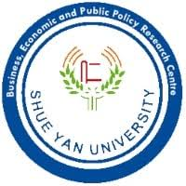HONG KONG SHUE YAN UNIVERSITY – HONG KONG 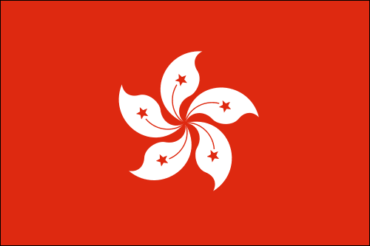
DUE TO THE POLITICAL SITUATION IN HONG KONG THIS PARTNERSHIP HAS BEEN SUSPENDED FOR 2023-24 AND STUDENT ARE UNABLE TO APPLY TO ATTEND IT
Introduction
Hong Kong Shue Yan University (HKSYU) is the first private university in Hong Kong. It was founded as Shue Yan College in 1971 and attained its university status in 2006. During the past four decades, the University has built up a solid reputation in the educational community both in Hong Kong and internationally. Ranked at 301-305 in the QS Asia University Rankings 2021, HKSYU is now comprised of 12 academic departments under the Faculties of Arts, Commerce and Social Sciences. The University currently offers undergraduate and postgraduate programmes for more than 4000 students. To find out more, why not take a virtual tour of the campus here.
Hong Kong itself is a special administrative region of China (SAR). With a population of over 7.5 million people and over 200 islands, it is a cosmopolitan financial and technological hub. While Cantonese is the most common language, English and Mandarin is spoken.

Programmes of study
LJMU students on the following study programmes are eligible to apply to study on exchange at HSKYU:
Creative Writing | English Literature | History | Accounting & Finance
Business Administration | International Business | Journalism | Marketing
Media | Health and Wellbeing | Psychology.
A tentative list of modules offered to exchange students can be found here. To view further details, select the relevant department from this page and check the programme structure.
Exchange students will be required to follow a full programme of study for the academic year based at Hong Kong Shue Yan University. This includes enrolling into 4 courses or 12 credits (3 credits per course) per 15-week semester.
Places available are 2 full year or 4 semester only.

Learn more about campus activities and events

Travel & accommodation
- Travel – the nearest major airport to Hong Kong Shue Yan University is Hong Kong International Airport (HKG). Upon arrival, an HKSYU student (exchange buddy), will meet students at the airport to take them to their accommodation by the airport express train or bus.
- Accommodation – guaranteed on-campus accommodation is available in the undergraduate residence hall. This is designed in a dormitory style and is gender-segregated by floor. As Hong Kong has limited space and an outdoor lifestyle students usually reside in twin (approx. £180 per month) or triple (approx. £150 per month) rooms as single-occupancy rooms are limited. Rooms are en-suite with shared common areas and a pantry with basic equipment for food preparation. Further details are available here.

Visas, insurance and costs
- Visas – to take part in this exchange you are responsible for ensuring that meet Hong Kong immigration requirements.
- Insurance – LJMU insurance is not sufficient for studying on exchange in Hong Kong, and students are required to purchase their own policy. The insurance should cover, but is not limited to, travel, personal accidents, medical expenses (accident and non-accident), hospitalization and emergency evacuation/ repatriation.
- Living costs - in Hong Kong tend to vary therefore we recommend that you do further independent research to gain a better understanding of the cost of your year abroad. To help you, we have a created a simple cost comparison between the UK and Hong Kong:

Lower Similar Similar

CEU San Pablo University – Madrid, Spain
Introduction
CEU San Pablo University is a private university based in Madrid and is part of the number 1 private university group in Spain. With a diverse and international student body from over 50 different countries, it aims to train students to be excellent professionals and well-rounded individuals through its high quality teaching and research.
The university has two large campuses located in exciting areas of Madrid (Moncloa and Montepríncipe), offering the chance to study in a trend-setting and international environment, with advanced facilities and services.

Programmes of study
LJMU’s exchange agreement with CEU San Pablo allows students enrolled on the following programmes to study abroad:
- Most Business programmes | - Journalism & Media Production | - Architecture | - Education
Modules will be available in English and further information about the study options can be found here. Exchange students will be required to follow a full programme of study for the academic year based at CEU San Pablo.
Places available are 2 full year or 4 semester only.

Learn more about campus activities and events

Travel & accommodation
- Travel – The nearest major airport to CEU San Pablo is Madrid Barajas International Airport. You can take a taxi or public transportation to your accommodation, but one of the easiest and cheapest ways is to take a metro to Plaza de Castilla and make use of the Free University Bus – Autobus Ceu.
- Accommodation – You will receive information about and will be able to apply for your accommodation after you are formally accepted by CEU San Pablo. You can view information about accommodation here. However, it should be noted that many students who have been to this host have found their own accommodation privately and this can be more cost effective and websites such as Erasmusu or Housing Anywhere can be used.

Visas, insurance and costs
- Visas – To take part in this exchange you are responsible for ensuring that you meet Spanish immigration requirements.
- Insurance – All students are recommended to purchase travel insurance for the duration of their time in Europe to cover personal possessions and healthcare. UK and EU nationals can apply for a UK Global Health Insurance Card (GHIC) which is time-limited to the length of the exchange period.
- Living costs - in Spain tend to be lower than those in the UK. We recommend that you do further independent research to gain a better understanding of the cost of your year abroad. Accommodation varies in price and depends on students’ preference to type, distance from the old city centre and sharing arrangement. To help you, we have created a simple cost comparison between the UK and Spain:

Higher Lower Lower

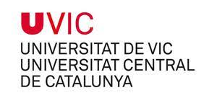UNIVERSITY OF VIC

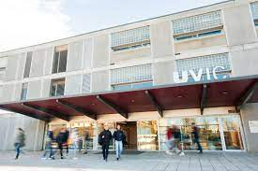
Introduction
The University of Vic - Central University of Catalonia (UVic-UCC), is a Catalan university with premises in Vic, Manresa and Granollers. It is a privately managed institution
It was recognised as a university in 1997, fruit of the fusion of several centres in Vic affiliated to other universities. Initially, there was a campus only in Vic, but in 2014 the University of Vic was reconstituted as the University of Vic - Central University of Catalonia (UVic-UCC), as a result of the federation between the University of Vic and university centres in Manresa managed by the Bages University Foundation.
The emblem of the University of Vic is the A of Charlemagne, a Carolingian gold ornament symbolising the principles of learning and boundless expansion. The university lemma, Scientiae patriaeque impendere vitam, is a verse of Lucan that means "Devoting life to the service of science and the community".

Check the University’s here or take a virtual tour

Programmes of study
LJMU’s exchange agreement with this partner allows students enrolled on the following programmes to study abroad:
Business | Education | Media and Journalism
Places available are 10 full year or 20 semester only.

Learn more about campus activities and events

Travel & accommodation
- Travel – The nearest major airport is El Prat Barcelona airport. From here travel into Barcelona and either use the Coach service from Carrer Casp, 34 (near Plaça Catalunya) or the train Train services, which operates from Sants and Plaça Catalunya stations in Barcelona on Line 3 to Vic, Ripoll, Puigcerdà and La Tour de Carol (all of which stop at Vic). Alternatively, you can fly into Girona (60km) and use the coach service. For further information see here
- Accommodation – University accommodation is limited and can be found here. It should be noted that students who have been to this host have found their own accommodation privately via websites such as Erasmusu or Housing Anywhere . Cost varies according to your style, location and number of people you share with.Visas, insurance and costs
- Visas – To take part in this exchange you are responsible for ensuring that you meet Spanish immigration requirements.
- Insurance – All students are recommended to purchase travel insurance for the duration of their time in Europe to cover personal possessions and healthcare. UK and EU nationals can apply for a UK Global Health Insurance Card (GHIC) which is time-limited to the length of the exchange period.
- Living costs - in Spain tend to be lower than those in the UK. We recommend that you do further independent research to gain a better understanding of the cost of your year abroad. Accommodation varies in price and depends on students’ preference to type, distance from the old city centre and sharing arrangement. To help you, we have created a simple cost comparison between the UK and Spain:

Varies Lower Lower

AUTONOMA DE BARCELONA – BARCELONA, SPAIN

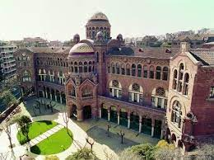
Introduction
The Autonomous University of Barcelona (Catalan: Universitat Autònoma de Barcelona; IPA: [uniβəɾsiˈtat əwˈtɔnumə ðə βəɾsəˈlonə], Spanish: Universidad Autónoma de Barcelona; UAB), is a public university mostly located in Cerdanyola del Vallès, near the city of Barcelona in Catalonia, Spain. The main campus of the UAO CEU is the Bellesguard Campus, in the district of Sarrià-Sant Gervasi. The architect Miquel Àngel Armengou, based in Barcelona, designed and built the university around the church at its centre
Check the University’s here or take a virtual tour

Programmes of study
LJMU’s exchange agreement with Autonoma de Barcelona allows students enrolled on the following programmes to study abroad:
Events Management
Places available are 4 full year or 8 semester only.

Learn more about campus activities and events

Travel & accommodation
- Travel – The nearest major airport is Barcelona airport. You can use a taxi but the university is on the far side of Barcelona from the airport and the airport bus is the most cost effective method to reach the city. You can use the comprehensive bus and underground to reach the University.
- Accommodation – Unlike many universities in Barcelona there is accommodation available and further information and prices can be found here. You will receive information about and will be able to apply for your accommodation after you are formally accepted by Autonoma. However, it should be noted that many students who have been to this host have found their own accommodation privately via websites such as Erasmusu or Housing Anywhere can be used.

Visas, insurance and costs
- Visas – To take part in this exchange you are responsible for ensuring that you meet Spanish immigration requirements.
- Insurance – All students are recommended to purchase travel insurance for the duration of their time in Europe to cover personal possessions and healthcare. UK and EU nationals can apply for a UK Global Health Insurance Card (GHIC) which is time-limited to the length of the exchange period.
- Living costs - in Spain tend to be lower than those in the UK. We recommend that you do further independent research to gain a better understanding of the cost of your year abroad. Accommodation varies in price and depends on students’ preference to type, distance from the old city centre and sharing arrangement. To help you, we have created a simple cost comparison between the UK and Spain:

Higher Lower Lower

UNIVERSITY OF NAVARRA, SPAIN

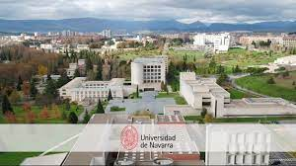
Introduction
The University of Navarra is a private research university located on the southeast border of Pamplona, Spain. It was founded in 1952 by St. Josemaría Escrivá de Balaguer, the founder of Opus Dei, as a corporate work of the apostolate of Opus Dei. The University of Navarra has consistently been ranked as the best private university in Spain. In 2021, the university's School of Law was ranked best in Spain and 44th in the world by Times Higher Education's international rankings.
Check the University’s here and virtually here.

Programmes of study
LJMU’s exchange agreement allows students enrolled on the following programmes to study abroad:
Engineering | Business | Some Biological and Earth Sciences | Law | Criminal Justice
Architecture | Computing | Education | Some media | Sociology
Places available are 4 full year or 8 semester only.

Learn more about campus activities and events

Travel & accommodation
- Travel – The nearest major airport is Malaga Costa del Sol airport and low cost airlines such as Easyjet fly directly from across various UK airports. You can use a taxi but the university is on the far side of Barcelona from the airport and the airport bus is the most cost effective method to reach the city. You can use the comprehensive bus, metro and train lines called the EMT network.
- Accommodation – You will receive information about and will be able to apply for your accommodation after you are formally accepted and the university recommend you use certain supplier that can be found here. However, it should be noted that many students who have been to this host found their own accommodation privately and this can be more cost effective and websites such as Erasmusu or Housing Anywhere can be used.

Visas, insurance and costs
- Visas – To take part in this exchange you are responsible for ensuring that you meet Spanish immigration requirements.
- Insurance – All students are recommended to purchase travel insurance for the duration of their time in Europe to cover personal possessions and healthcare. UK and EU nationals can apply for a UK Global Health Insurance Card (GHIC) which is time-limited to the length of the exchange period.
- Living costs - in Spain tend to be lower than those in the UK. We recommend that you do further independent research to gain a better understanding of the cost of your year abroad. Accommodation varies in price and depends on students’ preference to type, distance from the city center and sharing arrangement. To help you, we have created a simple cost comparison between the UK and Spain:

Higher Lower Lower

UNIVERSITY OF MALAGA, SPAIN

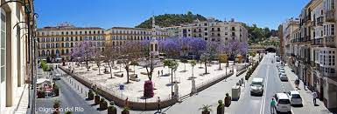
Introduction
The history of the University of Málaga begins in 1968 with the creation of the Association of Friends of the University of Málaga (Asociación de Amigos de la Universidad de Málaga). This association sought the creation of the university because of the needs of the city (it was the only European city of over 300,000 inhabitants which did not have a university.) The University of Málaga was founded by decree of 18 August 1972 by grouping existing centers in the late 1960s: the Higher Polytechnic School (Spanish: Escuela Universitaria Politécnica) (1927), the Normal School (1846), the Faculty of Economics of the University of Granada in Málaga (1963) and the Seminar (1587).
Check the University’s here

Programmes of study
LJMU’s exchange agreement allows students enrolled on the following programmes to study abroad:
Engineering | Business | Law | Criminal Justice
Architecture | Computing | Education
Places available are 8 full year or 16 semester only.

Learn more about campus activities and events

Travel & accommodation
- Travel – The nearest major airport is Malaga Costa del Sol airport and low cost airlines such as Easyjet fly directly from across various UK airports. You can use a taxi but the university is on the far side of Barcelona from the airport and the airport bus is the most cost effective method to reach the city. You can use the comprehensive bus, metro and train lines called the EMT network.
- Accommodation – You will receive information about and will be able to apply for your accommodation after you are formally accepted and the university recommend you use certain supplier that can be found here. However, it should be noted that many students who have been to this host found their own accommodation privately and this can be more cost effective and websites such as Erasmusu or Housing Anywhere can be used.

Visas, insurance and costs
- Visas – To take part in this exchange you are responsible for ensuring that you meet Spanish immigration requirements.
- Insurance – All students are recommended to purchase travel insurance for the duration of their time in Europe to cover personal possessions and healthcare. UK and EU nationals can apply for a UK Global Health Insurance Card (GHIC) which is time-limited to the length of the exchange period.
- Living costs - in Spain tend to be lower than those in the UK. We recommend that you do further independent research to gain a better understanding of the cost of your year abroad. Accommodation varies in price and depends on students’ preference to type, distance from the city center and sharing arrangement. To help you, we have created a simple cost comparison between the UK and Spain:

Higher Lower Lower

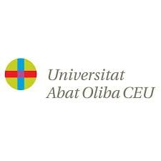 CEU ABAT OLIBIA UNIVESITY – BARCELONA, SPAIN

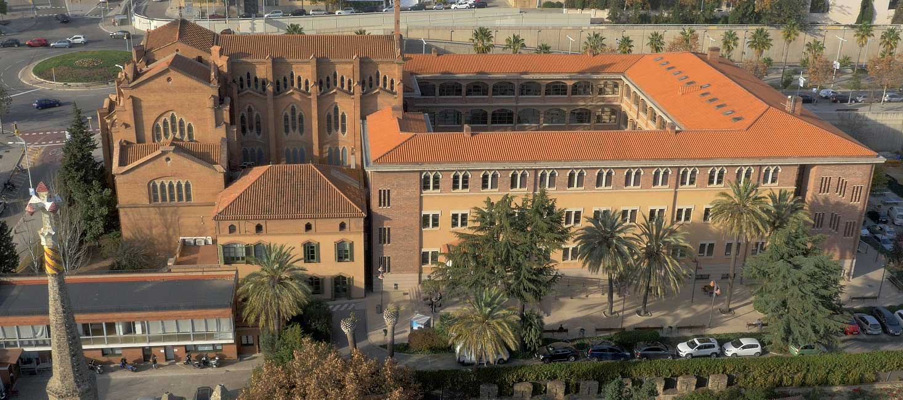
Introduction
Abat Oliba CEU University (official name: Universitat Abat Oliba CEU; UAO CEU) is a private university located in Barcelona, Spain. It was founded in 1973 as the Abat Oliba College. In 2003, the Parliament of Catalonia approved its conversion to Abat Oliba CEU University. The CEU group of universities is the number 1 private university chain in Spain
The main campus of the UAO CEU is the Bellesguard Campus, in the district of Sarrià-Sant Gervasi. The architect Miquel Àngel Armengou, based in Barcelona, designed and built the university around the church at its centre
Check the University’s here or take a virtual tour

Programmes of study
LJMU’s exchange agreement with CEU Albat Oliba allows students enrolled on the following programmes to study abroad:
Journalism | Business | Education | Criminology | law
Places available are 4 full year or 8 semester only.

Learn more about campus activities and events

Travel & accommodation
- Travel – The nearest major airport to CEU Albat Oliba University is Barcelona airport. You can use a taxi but the university is on the far side of Barcelona from the airport and the airport bus is the most cost effective method to reach the city. You can use the comprehensive bus and underground to reach the University.
- Accommodation – You will receive information about and will be able to apply for your accommodation after you are formally accepted by CEU Abat Oliba. However, it should be noted that many students who have been to this host have had to find their own accommodation privately and this can be more cost effective and websites such as Erasmusu or Housing Anywhere can be used.

Visas, insurance and costs
- Visas – To take part in this exchange you are responsible for ensuring that you meet Spanish immigration requirements.
- Insurance – All students are recommended to purchase travel insurance for the duration of their time in Europe to cover personal possessions and healthcare. UK and EU nationals can apply for a UK Global Health Insurance Card (GHIC) which is time-limited to the length of the exchange period.
- Living costs - in Spain tend to be lower than those in the UK. We recommend that you do further independent research to gain a better understanding of the cost of your year abroad. Accommodation varies in price and depends on students’ preference to type, distance from the old city centre and sharing arrangement. To help you, we have created a simple cost comparison between the UK and Spain:

Higher Lower Lower

COMILLAS PONTIFICAL UNIVERSITY – MADRID, SPAIN

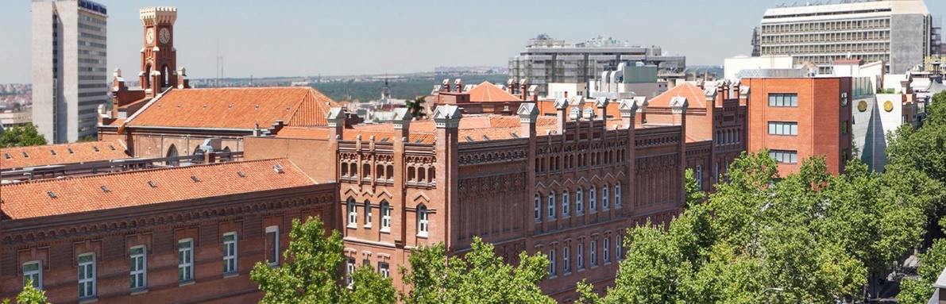
Introduction
Comillas Pontifical University (Spanish: Universidad Pontificia Comillas) is a private Catholic higher education institution run by the Spanish Province of the Society of Jesus in Madrid Spain.
The university is involved in a number of academic exchange programmes, work practice schemes and international projects with over 200 institutions of higher education in Europe, Latin America, North America and Asia.
Founded in 1890 and in 1969 the university moved to Madrid and expanded.
The universities website is found here or you can take a virtual tour here.

Programmes of study
LJMU’s exchange agreement with Comillas allows students enrolled on the following programmes to study abroad:
- Humanities and Social Science | - Engineering | - Law
Modules will be available in English and further information about the study options can be found here. Exchange students will be required to follow a full programme of study for the semester or academic year based at Comillas.
Places available are 2 full year or 4 semester only.

Learn more about campus activities and events

Travel & accommodation
- Travel – The nearest major airport to Comillas is Madrid Barajas International Airport. You can take a taxi or public transportation to your accommodation, but one of the easiest and cheapest ways is to take a metro
- Accommodation – Students will need to find their own accommodation, but we will have students at both Comillas and San Pablo and students will be introduced to one another at predeparture and students can arrange to live together. However, it should be noted that many students who have been to this host have had to find their own accommodation privately and this can be more cost effective and websites such as Erasmusu or Housing Anywhere can be used.

Visas, insurance and costs
- Visas – To take part in this exchange you are responsible for ensuring that you meet Spanish immigration requirements.
- Insurance – All students are recommended to purchase travel insurance for the duration of their time in Europe to cover personal possessions and healthcare. UK and EU nationals can apply for a UK Global Health Insurance Card (GHIC) which is time-limited to the length of the exchange period.
- Living costs -in Spain tend to be lower than those in the UK. We recommend that you do further independent research to gain a better understanding of the cost of your year abroad. Accommodation varies in price and depends on students’ preference to type, distance from the old city centre and sharing arrangement. To help you, we have created a simple cost comparison between the UK and Spain:

Higher Lower Lower

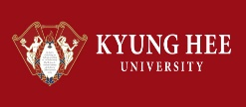KYUNG HEE UNIVERISTY – SEOUL, SOUTH KOREA
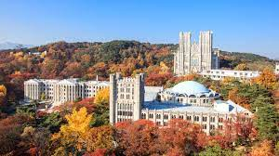
Introduction
Kyung Hee University is a private university located in Seoul, South Korea. The emblem of the university is the Chinese character for “university” and has a world map in the background. This symbolizes Kyung Hee’s vision for globalization as well as an open mind and humanism for the world.
KHU, home to over 34,000 students is considered as one of the best universities in South Korea, comprising of 3 campuses; Seoul, Global (Yongin) and Gwangneun.
Since its founding in 1949, Kyung Hee University has pursued the Kyung Hee Spirit of “Scholarship and Peace” as well as the founding principle of “creating a civilized world.” It has established an academic tradition combining education, research and practice while pursuing the universal values of peace and mutual prosperity.

Programmes of study
Modules taught in English are available for students of the following programme areas at LJMU: Textile Design, Arts and Festival Management, English literature, all Business Studies, Management, Accounting and Finance, Politics, and International Relations. There are also General Education elective modules available to complement your studies and provide an insight into Korean culture and society, as well as Korean language classes. An overview of the course offer in English can be found here.
Exchange students are recommended to follow a full programme of study for the academic year based at Kyung Hee University.
Places available are 2 full year or 4 semester only.

Learn more about campus activities and events

Travel & accommodation
- Travel – the nearest major airport to Kyung Hee University is Incheon International Airport (ICN). An airport pick-up service is available for students arriving at ICN on the designated arrival date provided by KHU upon request. A taxi would be approximately £45-£55 or alternative means of transport are available.
- Accommodation – Accommodation is available at Sehwa Hall (Sehwawon) for students studying at the Seoul campus. Other options are also available. For more information check out the Kyung Hee University Housing page.
Visas, insurance, and costs
- Visas – To take part in this exchange you are responsible for ensuring that you meet South Korean entry requirements and further government advice can be found here.
- Insurance – LJMU insurance is not sufficient for studying on exchange in South Korea, and students are required to purchase adequate travel and health insurance, further information can be found here.
- Living costs - in South Korea tend to be similar to those in the UK. We recommend that you do further independent research to gain a better understanding of the cost of your year abroad. To help you, we have a created a simple cost comparison between the UK and South Korea:

Lower Lower Higher

SOUTHERN CONNETICUT STATE UNIVERSITY
NEW HAVEN, USA

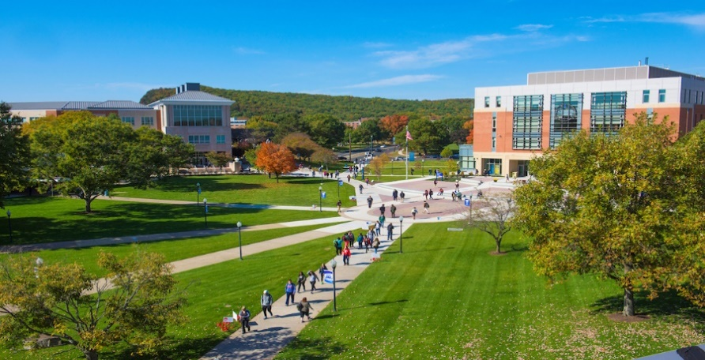
Introduction
Southern Connecticut State University is a public university in New Haven, Connecticut. Part of the Connecticut State University System, it was founded in 1893 and is governed by the Connecticut Board of Regents for Higher Education.
Southern has one campus located at 501 Crescent Street, in New Haven, bordering parts of Hamden, Connecticut. Fitch Street separates the academic and residential sections of the campus. The School of Business was moved to the renovated former student centre in mid-2012. The building houses meeting rooms, offices for faculty, and trading rooms. As part of an effort to expand on the university's science programs, the laboratory science building was opened in 2015. The four-story building specializes with cancer research, physics and optics, along with other fields of sciences.
The University can be found here or take a virtual tour.

Programmes of study
LJMU have a university wide agreement with SCSU that includes:
All Business | Art | Sport Science | Teaching | Psychology | Sociology | Geography | Science
Places available are 4 full year or 8 semester only.

Learn more about campus activities and events

Travel & accommodation
- Travel – John F. Kennedy International Airport, also in Queens, is a major international airport. Airport shuttle service to New Haven is available, or you can get to Grand Central Terminal in New York and then a train to New Haven. Newark Liberty International Airport, in northern New Jersey, is a major international airport. Airport shuttle service to New Haven is available, or you can take Amtrak to New Haven or a train from Grand Central Terminal. Metro-North Railroad provides service between New Haven, New York, and intermediate points. In general, this will be significantly cheaper than Amtrak. Runs roughly every half hour on weekdays and every hour on weekends. The last train departs New Haven shortly before midnight, the last train from New York to New Haven departs shortly before 2am. See the Metro-North website for prices of intermediate points and schedules.
- Accommodation – You will receive information about and will be able to apply for your accommodation after you are formally accepted. You can view information about accommodation and food packages here . You will have to purchase a food package as part of your accommodation booking but there are varying ones available. Please note, that as part of your J1 visa you will have to live in accommodation property.

Visas, insurance and costs
- Visas – To take part in this exchange you are responsible for ensuring that you meet US visa requirements. Please note, as part of the J1 visa you will only be able to work on campus for 20 hours and there is no option to work outside the campus under this visa.
- Insurance – LJMU insurance is not sufficient for studying on exchange in America, and students are required to purchase medical insurance and your host will provide details of specific providers when you are accepted.
- Living costs in USA vary and can be similar to higher than in the UK. We recommend that you do further independent research to gain a better understanding of the cost of your year abroad. To help you, we have created a simple cost comparison between the UK and USA:

Higher Lower Lower

UNIVERSITY CENTRAL MISSOURI - USA

UNIVERSITY CENTRAL MISSOURI – USA

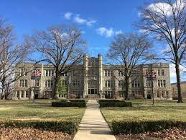
The University of Central Missouri is a public university in Warrensburg, Missouri. In 2019, enrolment was 11,229 students from 49 states and 59 countries on its 1,561-acre campus. UCM offers 150 programs of study, including 10 pre-professional programs, 27 areas of teacher certification, and 37 graduate programmes. University website is here and there is a virtual tour available

Programmes of study
LJMU have a university wide agreement with UCM that includes:
Arts | Humanities and Social Sciences | Business & Professional Studies | Education | Health, Science, & Technology

Places 1 full year or 2 by a semester only

Learn more about campus activities and events

Travel & accommodation
- Travel – Kansas City International Airport (airport code MCI) is the closest airport and there are links to other US airports
- Accommodation – You will receive information about and will be able to apply for your accommodation after you are formally accepted. You can view information about accommodation and food packages here Students have to live on the campus as part of their visa.

Visas & insurance
- Visas – To take part in this exchange you are responsible for ensuring that you meet US visa requirements. Please note, as part of the J1 visa you will only be able to work on campus for 20 hours and there is no option to work outside the campus under this visa.
- Insurance – LJMU insurance is not sufficient for studying on exchange in America, and students are required to purchase medical insurance and your host will provide details of specific providers when you are accepted.
- Living costs in USA vary and can be similar to higher than in the UK. We recommend that you do further independent research to gain a better understanding of the cost of your year abroad. To help you, we have created a simple cost comparison between the UK and USA:

Similar Lower Lower

UNIVERSITY OF MILIKIN – DECATUR, ILLNOIS USA
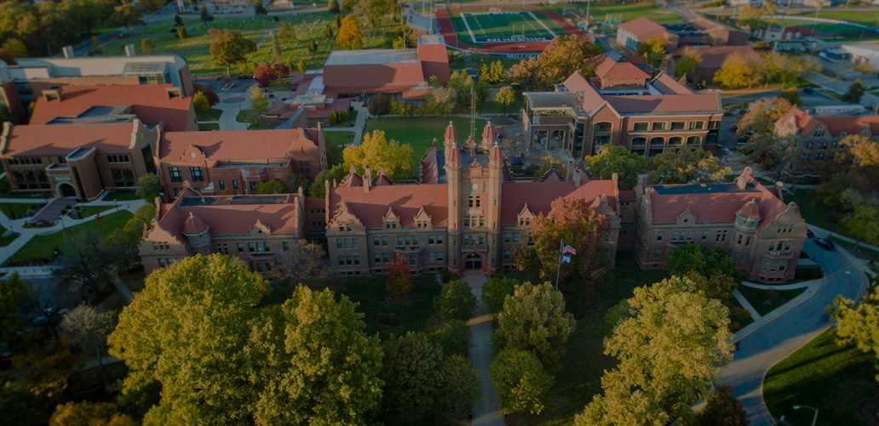
Introduction
Millikin University is a private university in Decatur, Illinois. It was founded in 1901 by prominent Decatur businessman James Millikin . The student has a population of 2000 undergraduates.
More information is available on their website. Take a virtual tour
Programme of study introduction
Art and Design | Business | Culture and History | Human Behaviour
Politics | Science and Mathematics | Sports and Recreation | Teaching
Technology

Places available to LJMU students are 3 students by a year and 6 by a semester.

Learn more about campus activities and events

Travel & accommodation

Travel – The Decatur Airport is conveniently located 7.1 miles from Millikin’s campus. The Decatur Airport is serviced by Cape Air and offers cheap flights to either the St. Louis Lambert International Airport or Chicago’s O’Hare International Airport. For information on the Decatur Airport, you can call (217) 428-2423 or visit the Decatur Airport homepage. Both Lyft and Uber operate in the Decatur area. Although there are no trains to Decatur, there are train stations located in both downtown Springfield and Bloomington, both of which are approximately 45 minutes away from Decatur. Information on trains can be found at the Amtrak homepage.

Accommodation – You will receive information about and will be able to apply for your accommodation after you are formally accepted. You can view information about accommodation and food packages here. There is $150 deposit. You must live on campus as part of your visa.

Visas, insurance and costs
- Visas – To take part in this exchange you are responsible for ensuring that you meet US visa requirements. Please note, as part of the J1 visa you will only be able to work on campus for 20 hours and there is no option to work outside the campus under this visa.
- Insurance – LJMU insurance is not sufficient for studying on exchange in America, and students are required to purchase medical insurance and your host will provide details of specific providers when you are accepted.
- Living costs in USA vary and can be similar to higher than in the UK. We recommend that you do further independent research to gain a better understanding of the cost of your year abroad. To help you, we have created a simple cost comparison between the UK and USA:

Higher Higher Lower

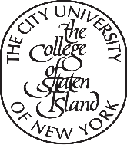COLLEGE UNIVERSITY NEW YORK, STATE ISLAND
NEW YORK STATE, USA
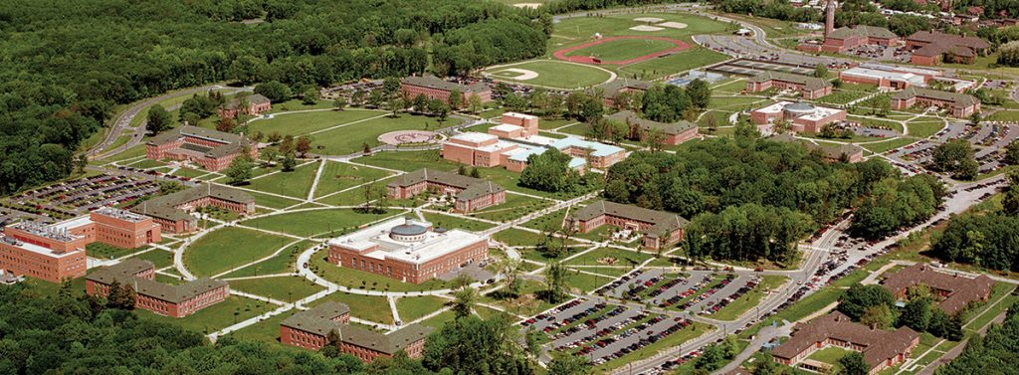
The College of Staten Island (CSI) is a public college in Staten Island, New York. It is one of the 11 four-year senior colleges within the City University of New York system.
The College of Staten Island is the product of a merger in 1976 of Staten Island Community College (SICC), founded in 1956, and Richmond College, founded in 1965. Richmond College had been threatened with closure because of New York City's financial crisis, while SICC, because of its status as a community college, received state support. The merger was particularly logical since the community college offered two-year degrees, while Richmond College was an "upper divisional" college (the third in the nation) that offered degrees to those in their third and fourth years of schooling.
For further information check out the website and take a virtual tour.
Programme of study introduction
Accounting and Finance | Biology | Chemistry | Computer Science | Economics
Educational Studies | Engineering & Environmental Science | English | History | Management
Marketing | Mathematics | Media | Performing & Creative Arts | Physical Therapy
Political Science and Global Affairs | Psychology | Sociology and Anthropology

Places available to LJMU students 1 by a year or 2 by a semester.

Learn more about campus activities and events

Travel & accommodation

Travel – entry via any New York airport and then use public transport either bus or Staten Island Ferry. Further information available here

Accommodation – You will receive information about and will be able to apply for your accommodation after you are formally accepted. You can view information about accommodation and dining packages here. There is non-refundable $400 reservation fee deposit. Prices currently range from $3774 (room only) and dining fee is in addition.

Visas, insurance and costs
- Visas – To take part in this exchange you are responsible for ensuring that you meet US visa requirements. Please note, as part of the J1 visa you will only be able to work on campus for 20 hours and there is no option to work outside the campus under this visa.
- Insurance – LJMU insurance is not sufficient for studying on exchange in America, and students are required to purchase medical insurance and your host will provide details of specific providers when you are accepted.
- Living costs in USA vary and can be similar to higher than in the UK. We recommend that you do further independent research to gain a better understanding of the cost of your year abroad. To help you, we have created a simple cost comparison between the UK and USA:

Higher Similar Lower

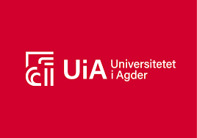 UNIVERSITY OF AGDER, NORWAY 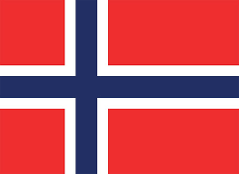

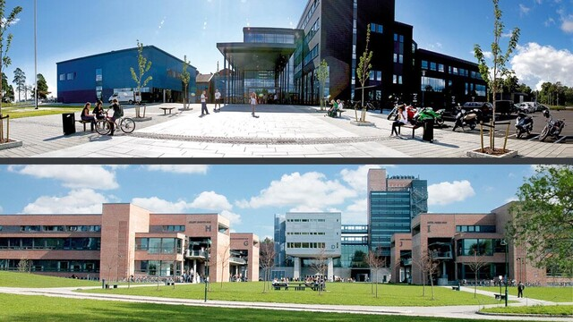

Introduction

The University of Agder (Norwegian: Universitetet i Agder), formerly known as Agder College and Agder University College, is a public university with campuses in Kristiansand and Grimstad, Norway. The institution was established as a university college (høgskole) in 1994 through the merger of the Agder University College and five other colleges, including a technical college and a nursing school, and was granted the status of a full university in 2007. Further information on the University can be found here.
Programme of study introduction

Most Business school | Law | Most education

LJMU has 2 by a year or 4 by a semester places.
- Travel – Flights are available via Norwegian air directly in Oslo Airport and then you can use the extensive Norwegian train service to Kristiansand taking less than 5 hours and there are 10 trains a day. Alternatively, you can fly direct to Kristiansand from the North West of England via Schiphol in The Netherlands direct.
- Accommodation – Students from outside the EU are guaranteed accommodation and prompt applications lead to students being guaranteed a place in halls, as there is a high demand for student accommodation and is provided by Student Association of Agder. Accommodation is excellent but modest and is relatively inexpensive for Norway and is from around £350 per month. Further information can be found here Please note, that if students do not stick to deadlines and payment schedules then they will have to find accommodation in the private sector and this can be considerably higher.

Visas, insurance and costs
- Visas – To take part in this exchange you are responsible for ensuring that you meet Norway immigration requirements and further information here. Note there is a charge of around £420 for the visa.
- Insurance – All students are recommended to purchase travel insurance for the duration of their time in Europe to cover personal possessions and healthcare. UK and EU nationals can apply for a UK Global Health Insurance Card (GHIC), which is time-limited to the length of the exchange period.
- Living costs - Norway tend to be higher than in the UK, but accommodation and public transport is lower due to subsidise from their government. We recommend that you do further independent research to gain a better understanding of the cost of your year abroad. To help you, we have created a simple cost comparison between the UK and Norway:

Lower (in university accommodation) Similar Higher

UNIVERSITY OF SOUTH EAST NORWAY, NORWAY
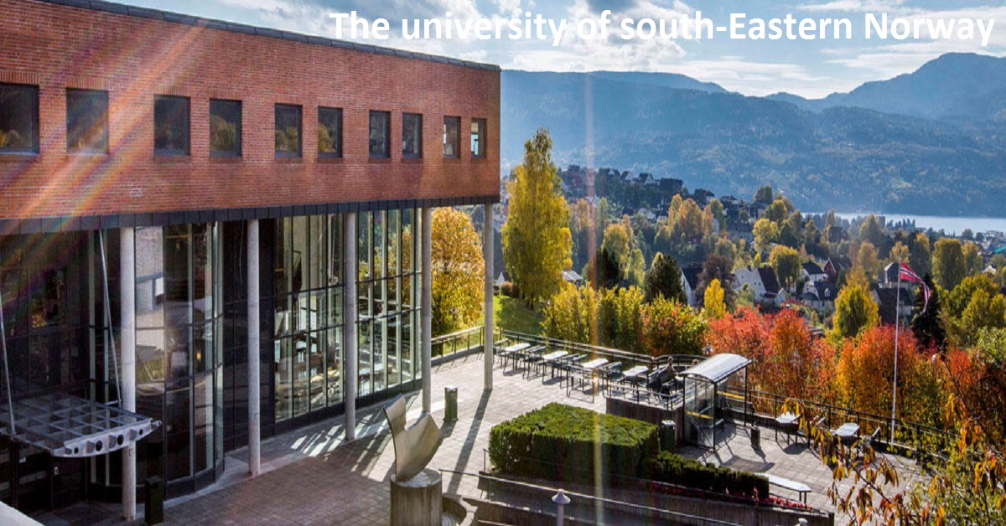
Introduction
The University of South-Eastern Norway (Norwegian: Universitetet i Sørøst-Norge), commonly known as USN, is a Norwegian state university. It has campuses in Bø, Telemark, Porsgrunn, Notodden, Rauland, Drammen, Hønefoss, Kongsberg and Horten. USN is a continuation of the three former university colleges, Telemark University College, Buskerud University College and Vestfold University College, which merged between 2014 and 2016 to form the University College of South-Eastern Norway. The institution was granted the status of a full university by the King-in-Council on 4 May 2018.^{[1]} It has 1,360 employees and 17,152 students.
The website is available here and the virtual tour here.
Programme of study introduction

- Business various | - Engineering including Maritime | - English and cultural studies
- Sport | - History & Human Rights | - Information Technology
Places available 8 students by a year or 16 students by a semester.

Learn more about campus activities and events
Travel & Accommodation
- Travel - USN is a wide-spread institution, located in 8 different campuses in the southeastern region of Norway, within a distance from 40 (Drammen) – 210 km (Rauland) to the capital Oslo. However, most of our campuses can easily be accessed by public transport; train or express bus. For more information about how to arrive, please see usn.no/student-at-usn/students-az/arrival-article81154-8035.html
- Accommodation – All 8 campuses have affordable university accommodation and you need to apply for it promptly. Contracts are based on that the student pay for a full semester and full academic year. Accommodation is good quality but is relatively inexpensive from around £350 a month. Further information can be found here.

Visas, insurance and costs
- Visas – To take part in this exchange you are responsible for ensuring that you meet Norway immigration requirements and further information here. Note there is a charge of around £420 for the visa.
- Insurance – All students are recommended to purchase travel insurance for the duration of their time in Europe to cover personal possessions and healthcare. UK and EU nationals can apply for a UK Global Health Insurance Card (GHIC), which is time-limited to the length of the exchange period.
- Living costs - Norway is higher than in the UK, but accommodation and public transport is lower due to subsidise from their government. We recommend that you do further independent research to gain a better understanding of the cost of your year abroad. To help you, we have created a simple cost comparison between the UK and Norway:

Lower Similar Higher

BI BUSINESS SCHOOL, OSLO CAMPUS, NORWAY

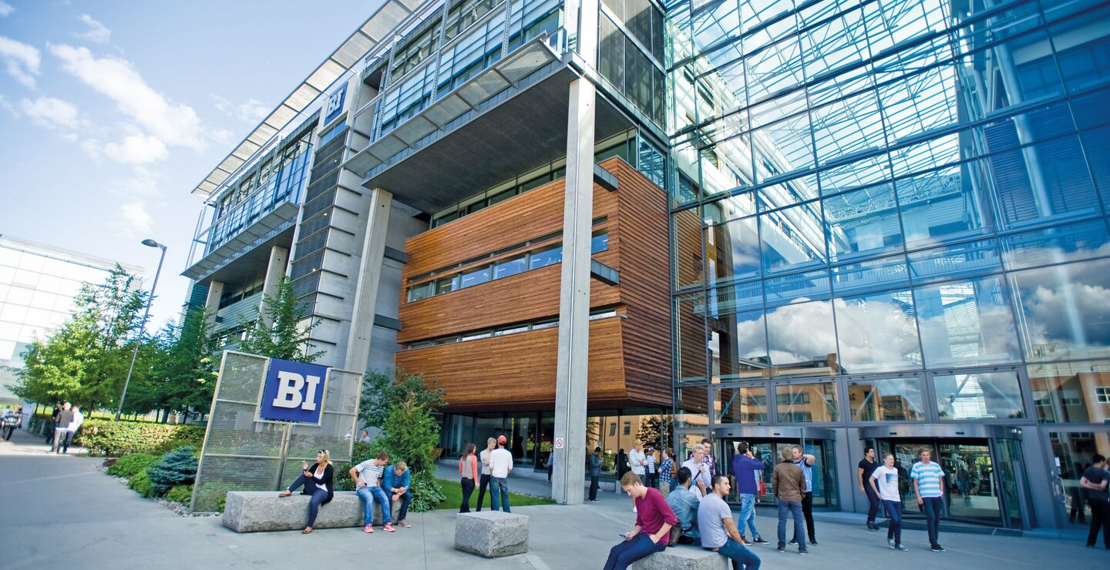

Introduction

BI Norwegian Business School (Bokmål: Handelshøyskolen BI) was founded in 1943 and is the largest and highest ranked business school in Norway and the second largest in all of Europe. BI has in total four^{[1]} campuses with the main one located in Oslo. The University website can be found here and you can take a virtual tour.

Programme of study introduction
LJMU has 2 by a year or 4 by a semester places.
- Travel – Flights are available via Norwegian air directly in Oslo Airport. You can easily travel on the airport train into the centre of Oslo and then use the subway straight to BI.
- Accommodation –Prompt applications lead to students being guaranteed a place in halls, as there is a high demand for student accommodation in Oslo. Contracts are based on that the student pay for a full semester and full academic year. Accommodation is excellent but is relatively inexpensive from around £400 a month. Pre application fee of 1000 NOK, which is refundable. Further information can be found here. Please note that if students do not stick to deadlines and payment schedules then they will have to find accommodation in the private sector and this can be considerably higher.

Visas, insurance and costs
- Visas – To take part in this exchange you are responsible for ensuring that you meet Norway immigration requirements and further information here. Note there is a charge of around £420 for the visa.
- Insurance – All students are recommended to purchase travel insurance for the duration of their time in Europe to cover personal possessions and healthcare. UK and EU nationals can apply for a UK Global Health Insurance Card (GHIC), which is time-limited to the length of the exchange period.
- Living costs - Norway tend to be higher than in the UK, but accommodation and public transport is lower due to subsidise from their government. We recommend that you do further independent research to gain a better understanding of the cost of your year abroad. To help you, we have created a simple cost comparison between the UK and Norway:

Lower (in university accommodation) Similar Higher

Norwegian School of Sports Sciences (Norges Irdrettshogskole), Oslo Norway

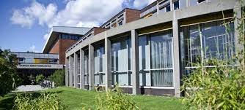

Introduction

The Norwegian School of Sport Sciences (Norwegian: Norges idrettshøgskole, NIH) is a public university located at Sognsvann in Oslo, Norway and was founded in 1870. It has the national responsibility for education and research related within sport sciences. It provides education at the Bachelor, Master and Doctorate levels.
Programme of study introduction
This partner is for Sports Science School programmes, and you can find more information here.
LJMU has 2 by a year or 4 by a semester places available.
- Travel – Flights are available via Norwegian air directly in Oslo Airport. You can easily travel on the airport train into the centre of Oslo and then use the subway straight to the host.
- Accommodation –Prompt applications lead to students being guaranteed a place in halls, as there is a high demand for student accommodation in Oslo. Contracts are based on that the student pay for a full semester and full academic year. Accommodation is excellent but is relatively inexpensive from around £400 a month. Pre application fee of 1000 NOK, which is refundable. Further information can be found here. Please note that if students do not stick to deadlines and payment schedules then they will have to find accommodation in the private sector and this can be considerably higher.

Visas, insurance and costs
- Visas – To take part in this exchange you are responsible for ensuring that you meet Norway immigration requirements and further information here. Note there is a charge of around £420 for the visa.
- Insurance – All students are recommended to purchase travel insurance for the duration of their time in Europe to cover personal possessions and healthcare. UK and EU nationals can apply for a UK Global Health Insurance Card (GHIC), which is time-limited to the length of the exchange period.
- Living costs - Norway tend to be higher than in the UK, but accommodation and public transport is lower due to subsidise from their government. We recommend that you do further independent research to gain a better understanding of the cost of your year abroad. To help you, we have created a simple cost comparison between the UK and Norway:

Lower (in university accommodation) Similar Higher

Norwegian University of Science and Technology TRONDHEIM, GJOVIK, ALESUND - NORWAY

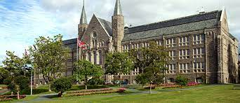

Introduction
NTNU is a young institution with a long history. The university, in its current form, was established in 1996 by the merger of six research and higher education institutions in Trondheim
Further information can be found here.
Programme of study introduction
This partner is for Built Environment programmes, and you can find more information here.
LJMU has 1 by a year or 2 by a semester places available.
- Travel – Flights are available from the UK to Trontheim but currently not directly. However via Norwegian air you can fly directly in Oslo Airport. You can easily travel on the airport train into the centre of Oslo and around the whole of Norway.
- Accommodation –Student accommodation is guaranteed to students from outside of the EU. Prompt applications lead to students being guaranteed a place in halls and further information can be found here. Please note that if students do not stick to deadlines and payment schedules then they will have to find accommodation in the private sector and this can be considerably higher.

Visas, insurance and costs
- Visas – To take part in this exchange you are responsible for ensuring that you meet Norway immigration requirements and further information here. Note there is a charge of around £420 for the visa.
- Insurance – All students are recommended to purchase travel insurance for the duration of their time in Europe to cover personal possessions and healthcare. UK and EU nationals can apply for a UK Global Health Insurance Card (GHIC), which is time-limited to the length of the exchange period.
- Living costs - Norway tend to be higher than in the UK, but accommodation and public transport is lower due to subsidise from their government. We recommend that you do further independent research to gain a better understanding of the cost of your year abroad. To help you, we have created a simple cost comparison between the UK and Norway:

Lower (in university accommodation) Similar Higher

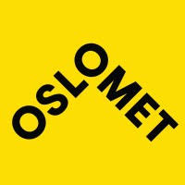OSLO METROPOLITAN UNIVERSITY, NORWAY

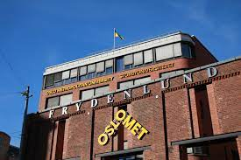
Introduction

Oslo Metropolitan University (Oslomet; Norwegian: Oslomet – storbyuniversitetet)] is a state university in Oslo and Akershus in Norway. It is the result of the merger of many former vocational colleges in the Greater Oslo Region BS Qa xewRWS UB 2018. There is further information available here or check out the virtual tour.

Programmes of study
The partnership is for Sports programmes only and further information can be found here.
LJMU has 2 places by a year or 4 by a semester.

Learn more about campus activities and events
- Travel – Flights are available via Norwegian air directly in Oslo Airport. You can easily travel on the airport train into the centre of Oslo and then use the subway/trams to reach anywhere in the city.
- Accommodation –Housing in Oslo can be challenging at times, as there are thousands of new students every year beginning their studies at one of the universities in town. It is important to begin looking for housing as soon as you have received admission from NIH. NIH have limited housing units available with SIO. A non-refundable fee of 1000NOK (payable to NIH) will apply for those who wish to be on the NIH priority list. Costs are around £500 – 700 per month. Further information can be found here. Please note that in the last few years the demand for student accommodation in Oslo has been high and therefore prompt response to any requests for registration or payment is required. If you have to go to the private market for accommodation then costs can be much higher.
Visas, insurance and costs
- Visas – To take part in this exchange you are responsible for ensuring that you meet Norway immigration requirements and further information here. Note there is a charge of around £420 for the visa.
- Insurance – All students are recommended to purchase travel insurance for the duration of their time in Europe to cover personal possessions and healthcare. UK and EU nationals can apply for a UK Global Health Insurance Card (GHIC), which is time-limited to the length of the exchange period.
- Living costs - Norway tend to be higher than in the UK, but accommodation and public transport is lower due to subsidise from their government. We recommend that you do further independent research to gain a better understanding of the cost of your year abroad. To help you, we have created a simple cost comparison between the UK and Norway:
Lower (in university accommodation) Similar Higher

HOSEI UNIVERSITY – JAPAN

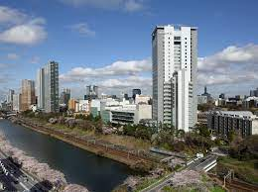

Introduction
Hosei University (法政大学, Hōsei Daigaku, lit. University of Law and Politics) is a private university based in Tokyo, Japan.
The university originated in a school of law, Tōkyō Hōgakusha (東京法学社, i.e. Tokyo association of law), established in 1880, and the following year renamed Tōkyō Hōgakkō (東京法学校, i.e. Tokyo school of law). This was from 1883 headed by Dr. Gustave Boissonade, and was heavily influenced by the French legal tradition. It merged in 1889 with a school of French studies, Tōkyō Futsugakkō (東京仏学校, i.e. Tokyo French school), that had been founded three years earlier. It adopted the name Hosei University (法政大学, Hōsei daigaku, i.e. university of law and politics) in 1903 and was recognized as a private university in 1920.
For further information go here
Students follow an international exchange programme and it is recommended that students consider attending this partner for a full year, rather than a semester. The programme can be found here.
LJMU has 2 full year student placements or 4 by a semester.

Learn more about campus activities and events

Travel & Accommodation
- Travel – There are daily services from the UK to Tokyo, alternatively you can fly to any Japanese city and use the train. Around Tokyo it is best to use the subway.
- Accommodation - International students are able to live in a dormitory along with Japanese students and learn from them about Japanese culture and inter-cultural communication at the same time as deepening mutual understanding. RAs (Residents Assistants) are in place to support international students and hold international exchange events. Further information can be found here as there are varying types of accommodation. Exchange Student pay 41,200 JPY per month/ approximately £250 per month (subsidy applied amount) for single sex dormitory single room accommodation – Hosei subsidise the monthly rent (25,000 JPY) for exchange students ONLY.

Visas, insurance, and costs
- Visas – To take part in this exchange you are responsible for ensuring that you meet Japanese visa requirements. Further government advice can be found here. A single entry visa cost 3000 yen (approx.. £20) or for multiple is 6000 yen (approx. £40). This may change and students should check with the university.
- Insurance – All students will receive the LJMU insurance but Exchange students must enrol in “National Health Insurance” (Kokumin Kenko Hoken) after arrival. 1,600 JPY per month (approx)/£9.50. If you receive medical treatment anywhere in Japan, please be sure to take along NHI Certificate. You will need to pay only 30% of the medical costs incurred or you use LJMU’s insurance.
- Living costs -in Japan costs tend to vary in comparison to the UK. We recommend that you do further independent research to gain a better understanding of the cost of your year abroad. Please note that Hosei University may recommend specific exchange students as candidates for “JASSO (Japan Student Services Organization) SCHOLARSHIP FOR SHORT-TERM STUDY IN JAPAN” Students accepted by the Organization will receive scholarships of 80,000 yen per month

less Higher Similar

KANAGAWA UNIVERSITY, YOKOHAMA – JAPAN

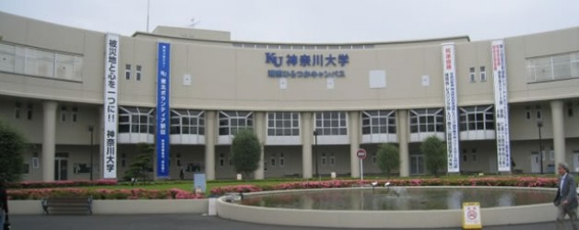

Introduction

Kanagawa University (神奈川大学, Kanagawa Daigaku), abbreviated to Jindai (神大) is a private university in Japan. The main campus is located in Rokkakubashi, Kanagawa-ku, Yokohama, Kanagawa Prefecture.Programme of study introduction
Founded I 1928 as Yokhama Academy and in 1949 became a university
For further information go here or take a virtual tour.
Students follow an international exchange programme and it is recommended that students consider attending this partner for a full year, rather than a semester. The programme can be found here.
LJMU has 2 full year student placements or 4 by a semester.

Learn more about campus activities and events
Travel & Accommodation
- Travel – There are daily services from the UK to Yokahama, alternatively you can fly to Tokyo and use the train. Yokahama is serviced by a subway and train system.
- Accommodation - International students are able to live in a dormitory along with Japanese students and learn from them about Japanese culture and inter-cultural communication at the same time as deepening mutual understanding. RAs (Residents Assistants) are in place to support international students and hold international exchange events. Further information can be found here. Accommodation is approximately 200,000 yen a semester, which is approximately £1200

Visas, insurance and costs
- Visas – To take part in this exchange you are responsible for ensuring that you meet Japanese visa requirements. Further government advice can be found here. A single entry visa cost 3000 yen (approx.. £20) or for multiple is 6000 yen (approx. £40). This may change.
- Insurance – All students will receive the LJMU insurance but Kanagawa have their own, which is 12,000 yen per semester, which is approximately £80.
- Living costs -in Japan tend to vary in comparison to the UK. We recommend that you do further independent research to gain a better understanding of the cost of your year abroad. Please note that this partner offers a scholarship of 50,00 yen per month that exchange students can apply for and this is in addition to Turing. To help you, we have created a simple cost comparison between the UK and Japan:

Similar Higher Similar

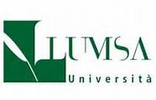LUMSA UNIVERSITY – ROME, ITALY
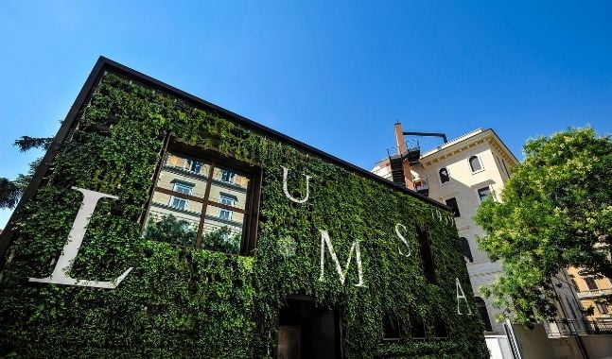
Introduction
The Libera Università Maria SS. Assunta, often simply abbreviated as "LUMSA", is a private Roman Catholic university founded in 1939 in Rome. It is the second oldest university in Rome after Sapienza.^{[2]}
LUMSA was privately founded, but belongs to the national Italian network of universities and is therefore able to confer recognised degrees and diploma titles which have full legal force.
University of Rome LUMSA have further information.
Programme of study introduction
Law and some law and criminal justice programmel only and there are 5 year long places. This location is only available for a year long placement.

Learn more about campus activities and events

Travel & Accommodation
- Travel – There are direct from the UK including Ryanair. A subway system and bus service is available throughout Rome.
- Accommodation - In Italy accommodation, provision is limited, and further information can be found here. Students who have attended this institution have always source their own accommodation and since Covid this has been challenging with depends for refugees and the tourist industry. Students will need to source their own accommodation and will be provided with guidance from their host or they can do this privately through websites such as Erasmusu or Housing Anywhere can be used. Students are also recommended to network with other LJMU students going to LUMSA and visit the city prior to arrival to ensure they get the best option accommodation for them. Cost varies and it depends on distance from central Rome and accommodation type.

Visas, insurance and costs
- Visas – To take part in this exchange you are responsible for ensuring that you meet Italian immigration requirements and further information can be found here.
- Insurance – All students are recommended to purchase travel insurance for the duration of their time in Europe to cover personal possessions and healthcare. UK and EU nationals can apply for a UK Global Health Insurance Card (GHIC), which is time-limited to the length of the exchange period.
- Living costs –Rome is an international catalogue and students will need to stay away from tourist providers. Transport is cheap and eating out can be done. We recommend that you do further independent research to gain a better understanding of the cost of your year abroad. To help you, we have created a simple cost comparison between the UK and Italy

Depends on choice, but usually higher Lower Lower

THE HAGUE UNIVERSITY OF APPLIED SCIENCES 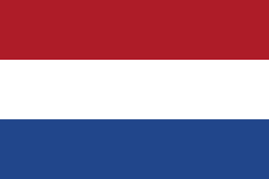NETHERLANDS

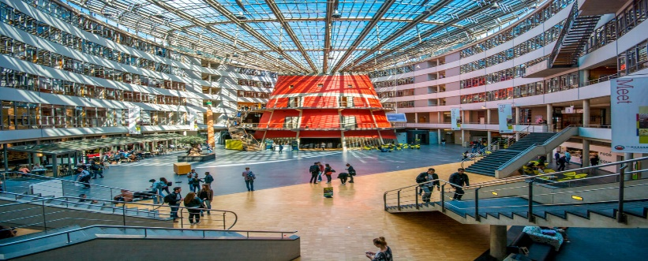

Introduction

The Hague University of Applied Sciences (Dutch: De Haagse Hogeschool), abbreviated THUAS, is a university of applied sciences with its campuses located in and around The Hague in the Randstad metropolitan region in the west of the Netherlands. The city is the Dutch seat of government and home to many major international legal, security and peace institutions. Since the university was founded in 1987 it has expanded to four campuses in the near-side cities of The Hague, Delft and Zoetermeer. The main campus in The Hague is located behind The Hague Hollands Spoor railway station by the Laakhaven Canal.

Programme of study introduction
LJMU have a cross university agreement at The Hague and currently includes
Business School | Humanities and Social Science | Psychology | Bioscience
Computer Science and Mathematics | Sports and Exercise Science | Environmental Sciences
LJMU has 10 yearly places or 20 by semesters only placements, across all our subject areas
Travel & Accommodation
- Travel – regular flights from the UK to Schiphol airport in Amsterdam via various airlines including Easyjet. There is a direct train from Schiphol airport station to The Hague and the university is locked adjacent to one of the main railway stations. The city is linked by a tram system.
- Accommodation – As a major political city accommodation searching has to be started early. Like many Dutch universities, THUAS does not have its own accommodation, but provides support in helping you find it for a charge of €275 (non-refundable). The Netherlands has a national crisis with student accommodation due to a lack of affordable graduate accommodation, demands for places for refugees and tourist industry requirements. Further information can be found here. Students will need to source their own accommodation and will be provided with guidance from their host or they can do this privately through websites such as Erasmusu or Housing Anywhere can be used. Students are also recommended to network with other LJMU students going to The Hague and visit the city prior to arrival to ensure they get the best option accommodation for them. Cost varies and it depends on distance from centre and accommodation type.

Visas, insurance and costs
- Visas – To take part in this exchange you are responsible for ensuring that you meet Netherlands immigration requirements and further information here.
- Insurance – All students are recommended to purchase travel insurance for the duration of their time in Europe to cover personal possessions and healthcare. UK and EU nationals can apply for a UK Global Health Insurance Card (GHIC), which is time-limited to the length of the exchange period.
- Living costs -in the Netherlands tend to be higher in major cities, but in others, similar to those in the UK. We recommend that you do further independent research to gain a better understanding of the cost of your year abroad. To help you, we have created a simple cost comparison between the UK and the Netherlands:

varies Similar Similar

RADBOUD UNIVERSITY NIJMEGEN NETHERLANDS
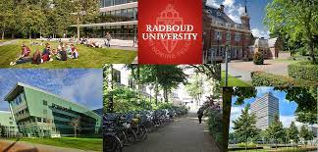
Introduction
Radboud University (abbreviated as RU, Dutch: Radboud Universiteit, formerly Katholieke Universiteit Nijmegen) is a public research university located in Nijmegen, Netherlands. The university bears the name of Saint Radboud, a 9th century Dutch bishop who was known for his intellect and support of the underprivileged.
Established in 1923, Radboud University has consistently been included in the top 150 of universities in the world by four major university ranking tables. As of 2020, it ranks 105th in the Shanghai Academic Ranking of World Universities.
Further information can be found here and you can take a virtual tour.

Programme of study introduction
Faculty of Arts | Faculty of Social Sciences | Nijmegen School of Management
Faculty of Law | Faculty of Science
LJMU has 4 study places by a year or 8 places by a semester.

Learn more about campus activities and events
Travel & Accommodation
- Travel – regular flights from the UK to Schiphol airport in Amsterdam via various airlines including Easyjet. There is a direct train from Schiphol airport station to Nijmegen and then the university is 5-minute bus ride away (6512 AB), which is caught right outside the station.
- Accommodation – University has its own accommodation, which is unique in the Netherlands and to ensure allocation student must follow all instructions and deadlines. Accommodation is between €370 and €470 per month During the pandemic there have been accommodation issues and students can turn to the private sector. The Netherlands has a national crisis with student accommodation due to a lack of affordable graduate accommodation, demands for places for refugees and tourist industry requirements. Further information can be found here. Students will need to source their own accommodation and will be provided with guidance from their host or they can do this privately through websites such as Erasmusu or Housing Anywhere can be used. If students are not placed in halls then we recommend to network with other LJMU students going to Nijmegen and visit the city prior to arrival to ensure they get the best option accommodation for them. Cost varies and it depends on distance from centre and accommodation type.

Visas, insurance and costs
- Visas – To take part in this exchange you are responsible for ensuring that you meet Netherlands immigration requirements and further information here.
- Insurance – All students are recommended to purchase travel insurance for the duration of their time in Europe to cover personal possessions and healthcare. UK and EU nationals can apply for a UK Global Health Insurance Card (GHIC), which is time-limited to the length of the exchange period.
- Living costs -in the Netherlands tend to be higher in major cities, but in Nijmegen it is similar to those in the UK. We recommend that you do further independent research to gain a better understanding of the cost of your year abroad. To help you, we have created a simple cost comparison between the UK and the Netherlands:

Lower Similar Similar

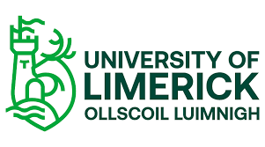UNIVERSITY OF LIMERICK, REPUBLIC OF IRELAND
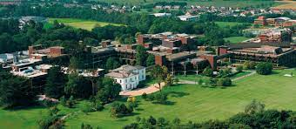

Introduction
The University of Limerick (UL) (Irish: Ollscoil Luimnigh) is a public research university institution in Limerick, Ireland. Founded in 1972 as the National Institute for Higher Education, Limerick, it became a university in 1989 in accordance with the University of Limerick Act 1989.^{[2]} It was the first university established since Irish independence in 1922.
UL's campus lies along both sides of the River Shannon, on a 137.5-hectare (340-acre) site with 46 hectares (110 acres) on the north bank and 91.5 hectares (226 acres) on the south bank at Plassey, County Limerick, 5 kilometres (3.1 mi) from the city centre.

You can more information here and a virtual tour here.
Programme of study introduction
LJMU have a cross university agreement at this partner and currently includes:
Business School | Humanities and Social Science | Psychology | Engineering
Computer Science and Mathematics | Sports and Exercise Science | Natural Sciences
LJMU has 10 yearly places or 20 by semesters only placements, across all our subject areas
Travel & Accommodation
- Travel – A number of airlines serve Shannon International Airport which is located approximately 36km from the University of Limerick. A number of bus routes operate from Shannon Airport to Limerick City Centre and the University of Limerick on a regular basis. Alternatively you could fly to Dublin Airport and use the train/bus to reach Limerick.
- Accommodation – While student accommodation is not guaranteed students can apply for student halls. information can be found here. Cots vary from €4.5 to €7.5k Students can source their own accommodation and will be provided with guidance from their host or they can do this privately through websites such as Erasmusu or Housing Anywhere can be used. Visas, insurance and costs
- Visas – To take part in this exchange you are responsible for ensuring that you meet the Irish visa requirement and they can be found here.
- Insurance – All students are recommended to purchase travel insurance for the duration of their time in Europe to cover personal possessions and healthcare. UK and EU nationals can apply for a UK Global Health Insurance Card (GHIC), which is time-limited to the length of the exchange period.
- Living costs -in the Republic of Ireland costs tend to be higher in major cities, especially Dublin. We recommend that you do further independent research to gain a better understanding of the cost of your year abroad. To help you, we have created a simple cost comparison between the UK and the Netherlands:

higher Similar higher

UNIVERSITY OF APPLIED SCIENCES AND ARTS NORTHWESTERN (FHNW) – BASEL, SWITZERLAND

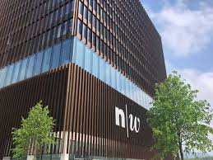

Introduction
The FHNW was founded on January 1, 2006, based on a state treaty between the cantons of Aargau, Basel-Landschaft, Basel-Stadt, and Solothurn. It was created from the merger of the Aargau University of Applied Sciences (FHA), the Basel University of Applied Sciences (FHBB), the Solothurn University of Applied Sciences (FHSO), and the Basel University of Education and Social Work and the Solothurn University of Education..
You can more information here and a virtual tour here.
Programme of study introduction
LJMU have a cross university agreement at this partner and currently includes:
Business School | Humanities and Social Science | Psychology | Engineering
Computer Science and Mathematics | Sports and Exercise Science | Natural Sciences
LJMU has 10 yearly places or 20 by semesters only placements, across all our subject areas
Travel & Accommodation
- Travel – You can fly directly to Basel Airport, or you can fly into any other city and use the excellent Swiss train system
- Accommodation Swiss universities do not usually have on-campus accommodation, so students organise their own shared flats („WG“ or „Wohngemeinschaft“), where people rent a flat together and share the rent. WoVe We recommend contacting WoVe, the local student housing association that helps students find affordable accommodation. You can register for furnished or unfurnished rooms here. Students can source their own accommodation and will be provided with guidance from their host or they can do this privately through websites such as Erasmusu or Housing Anywhere can be used. As in other cities, the housing market in Basel is busy, so start looking for suitable accommodation early! Prices vary according to students requirements but you should budget between CHF 450 to CHF 600 per month .

Visas, insurance and costs
- Visas – In order to enter Switzerland to study, a visa is required by most non-EU/EFTA citizens. It can take up to 3 months from the application until a visa is actually issued. It is your responsibility to apply for an appropriate visa within a reasonable timeframe. Citizens from Europe‘s Schengen area, the European Union and EFTA do not require visas to enter Switzerland but must apply for a residence permit. Please do NOT enter Switzerland with a tourist visa, as this cannot be changed to a student residence permit after you arrive. If you do not have a visa when you arrive in Switzerland, you will have to leave the country and reapply! To find out if you need a visa, check the here.
- Insurance – All students are recommended to purchase travel insurance for the duration of their time in Europe to cover personal possessions and healthcare. UK and EU nationals can apply for a UK Global Health Insurance Card (GHIC), which is time-limited to the length of the exchange period. Basic health insurance is compulsory in Switzerland. If you come to live in Switzerland for more than 90 days, you must take out health insurance within three months of your arrival. However, as an international student, special provisions might apply to you and depending on your situation, an exemption is possible:
- Living costs -Switzerland generally has higher costs than the UK. We recommend that you do further independent research to gain a better understanding of the cost of your year abroad. To help you, we have created a simple cost comparison between the UK and the Netherlands:

higher higher higher

ROSKILDE UNIVERSITY, DENMARK 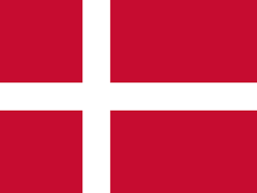

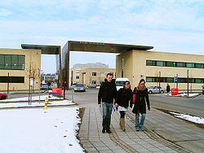

Introduction
Roskilde University (Danish: Roskilde Universitet, abbreviated RUC or RU) is a Danish public university founded in 1972 and located in Trekroner in the Eastern part of Roskilde.
You can more information here and a virtual tour here.
Programme of study introduction
LJMU have a cross university agreement at this partner and currently includes:
Business School | Education | Built Environment
LJMU has 1 yearly place or 2 by semesters only placements, across all our subject areas.
Travel & Accommodation
- Travel – Many airlines fly directly through Copenhagen from across the UK Roskilde is located 30 kilometers west of the capital, Roskilde can be reached within 30 minutes by car or train. From København H (Copenhagen Central Station) there are frequent train departures to Roskilde. The journey time is about 20-30 minutes, depending on which train you catch.
- Accommodation – While student accommodation is not guaranteed students can apply for student halls. information can be found here. Cots vary from €4.5 to €7.5k Students can source their own accommodation and will be provided with guidance from their host or they can do this privately through websites such as Erasmusu or Housing Anywhere can be used. Visas, insurance and costs
- Visas – To take part in this exchange you are responsible for ensuring that you meet the Danish visa requirement and they can be found here.
- Insurance – All students are recommended to purchase travel insurance for the duration of their time in Europe to cover personal possessions and healthcare. UK and EU nationals can apply for a UK Global Health Insurance Card (GHIC), which is time-limited to the length of the exchange period.
- Living costs -in Denmark costs tend to be higher in major cities, especially in Copenhagen. We recommend that you do further independent research to gain a better understanding of the cost of your year abroad. To help you, we have created a simple cost comparison between the UK and Denmark:

higher Similar higher

VIA UNIVERSITY, DENMARK

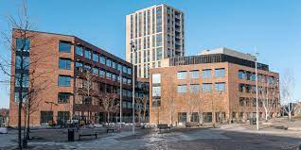

Introduction
VIA University College is a university college (Danish: professionshøjskole) organisation in Central Denmark Region, Denmark, established in January 2008. It is present in the region with a total of eight campuses.
You can more information here and a virtual tour here.
Programme of study introduction
LJMU have a cross university agreement at this partner and currently includes:
Business School | Humanities and Social Science
LJMU has 6 yearly place or 12 by semesters only placements, across all our subject areas.
Travel & Accommodation
- Travel – Many airlines fly directly through Copenhagen from across the UK. From København H (Copenhagen Central Station) there are frequent train across Denmark.
- Accommodation – Student halls are guaranteed to international students and information can be found here. Costs vary from DKK 3000-4000 per month. Students can source their own accommodation and will be provided with guidance from their host or they can do this privately through websites such as Erasmusu or Housing Anywhere can be used.

Visas, insurance and costs
- Visas – To take part in this exchange you are responsible for ensuring that you meet the Danish visa requirement and they can be found here.
- Insurance – All students are recommended to purchase travel insurance for the duration of their time in Europe to cover personal possessions and healthcare. UK and EU nationals can apply for a UK Global Health Insurance Card (GHIC), which is time-limited to the length of the exchange period.
- Living costs -in Denmark costs tend to be higher in major cities, especially in Copenhagen. We recommend that you do further independent research to gain a better understanding of the cost of your year abroad. To help you, we have created a simple cost comparison between the UK and Denmark and you can read the university breakdown here:

Similar Similar higher

