Courseloop – guidance for FMT secretaries – September 2023
Permissions for FMT secretaries were updated in September 2023 to allow the following:
- Attachment of Planning and Full Proposals to APFP
- Submission of Planning Proposals from Faculty to APFP stage of the workflow
- Submission of Full Proposals from Faculty PVC to University level stage of the workflow
This guidance should be read in conjunction with the following documents:
how-do-i-allocate-a-proposal-to-a-meeting.pdf (ljmu.ac.uk)
how-do-i-record-the-governance-meeting-outcome.pdf (ljmu.ac.uk)

Governance – what needs to be considered by FMT?
FMT needs to consider the following:
- Planning Proposals – requests for new programmes or title changes that will require new programme codes to be set up.
- Academic Item Proposals to make any of the following changes to existing programmes:
  - Changes to intake months, including addition or removal of intakes
  - Addition of a sandwich degree option
  - Suspension or closure of a programme
NB – other academic item proposals should not go to FMT

If endorsed, the FMT decision need to be recorded in Courseloop and the proposal needs to be sent to APFP for approval – this will be done within Courseloop.

Requests for new programmes should have been accompanied by financial modelling. This should be emailed separately to APFP

Access rights
FMT secretaries are set as Faculty Approvers within Courseloop – this gives you access to the admin view and allows you to manage proposals and meetings. Most users only see the Dashboard view of Courseloop.

Courseloop URL – https://courseloop.ljmu.ac.uk

Setting FMT meetings

Each Faculty FMT exists as a separate meeting type in Courseloop:

FMT-APS
FMT-BUS
FMT-FET
FMT-FHE
FMT-SCS

In the Admin view scroll down to find your faculty’s meeting:

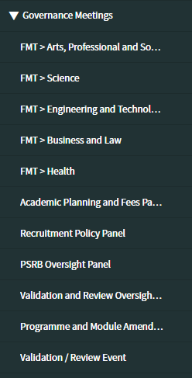

Click on your Faculty and you will get a list of existing meetings
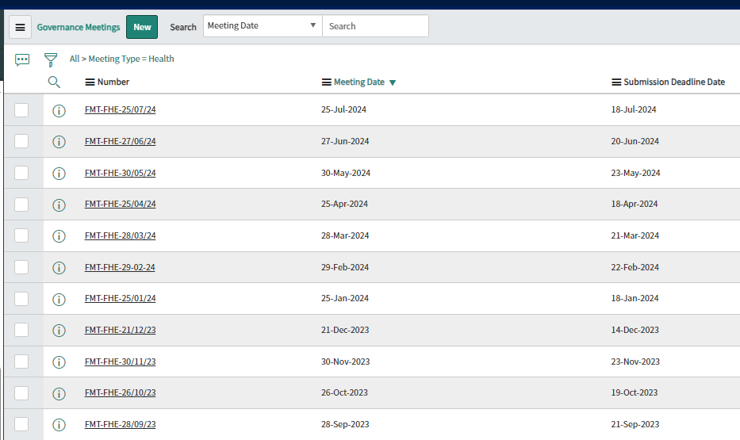

To add further meetings you should click on New at the top of the page:

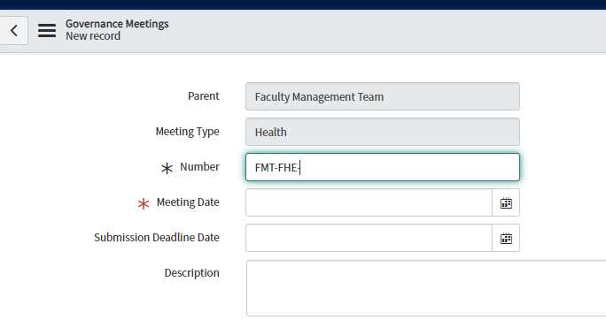
Fill in the details – description can be left blank – Submit

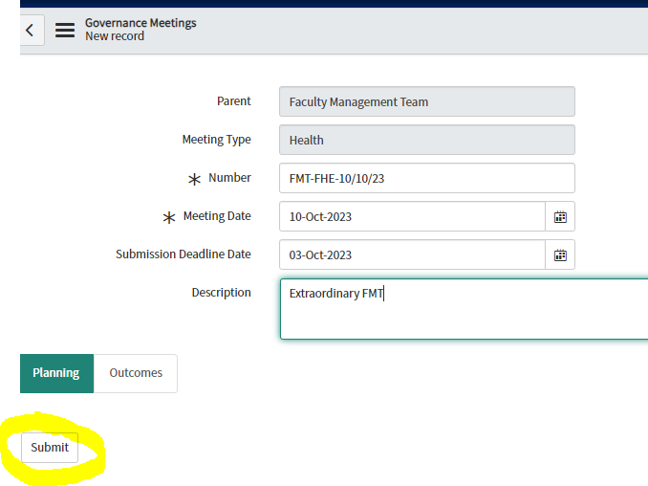

Workflows – Planning Proposal
Go from School to Faculty to APFP
Proposals at FMT should be at Faculty level
Workflows – Academic Item Proposal
Go from School to Faculty PVC to University level

Proposals at FMT should be at Faculty PVC level

Attaching a proposal to FMT meeting

It’s possible that proposals will be added to your FMT meeting either by a School Director or your AAR. However, sometimes you will be asked to add the proposal to the agenda.
Hopefully you will be given a Proposal number and told whether the type of proposal – these will look like this – Proposal-46663

In the admin view you can see this:

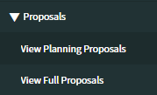

Set the search to Search Number and then enter the proposal number
When you find the record:
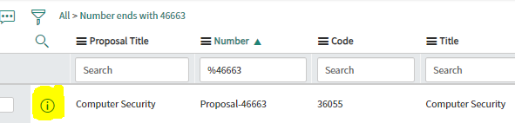
Click on the i and the Select Open Record (top right)

Check that the proposal is at the correct stage of the workflow – if it is still at School stage, submit to Faculty/Faculty PVC level using the button at the top right.

In the bottom left of the screen you will see this:

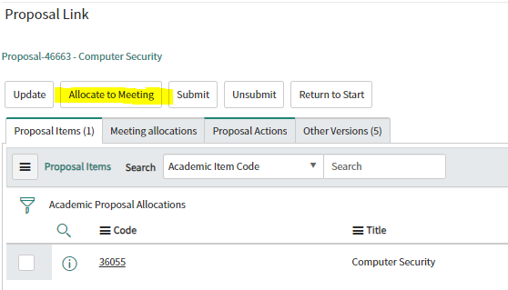

Click on the Allocate to Meeting tab, and then start typing your FMT name
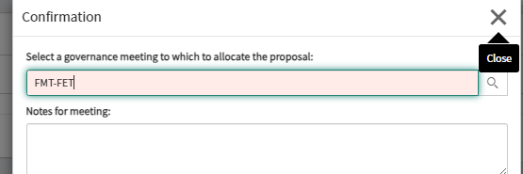
You will be presented with a list of future meetings – allocate to the next meeting.
It would be helpful to add notes explaining the proposal. These notes appear on the meeting view in Courseloop.

The proposal is now allocated to the next FMT meeting.

Sharing the agenda with FMT members
Go to the Courseloop Dashboard view.
If not already open then:
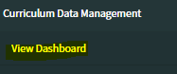

On the LHS please select Approval Meetings:
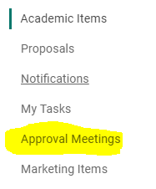

In the search box add your FMT code –

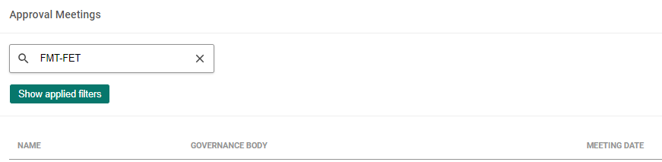
Clicking on the MEETING DATE header puts the meetings in date order

Select the upcoming meeting and click on the right arrow:

This gives the meeting view and shows all the Proposals and Planning Proposals that are on the agenda. If you share the URL of this page with your FMT members (as a link within the agenda), then they will be able access the proposals in advance and during the meeting.

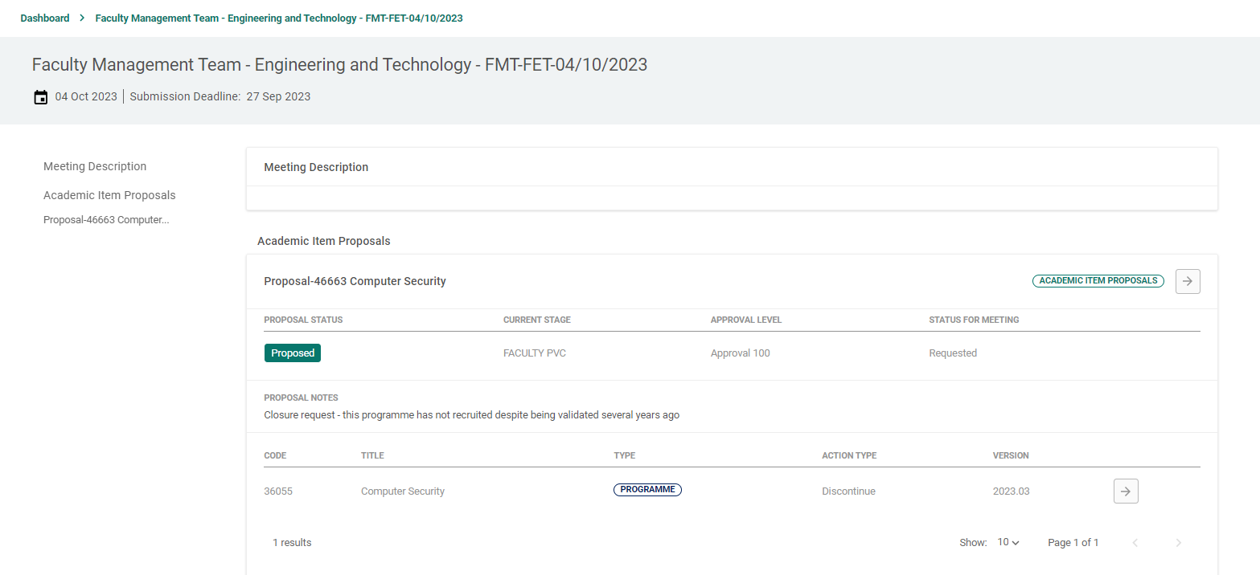

Entering the Outcomes
The outcome of the FMT meeting needs to be recorded:

This is done in the Admin view of the meeting:

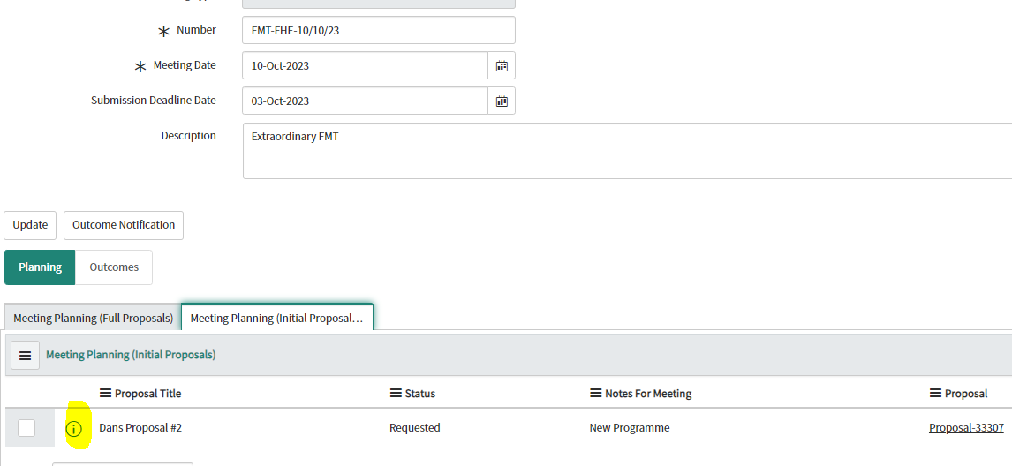
Click on i and then Open Record
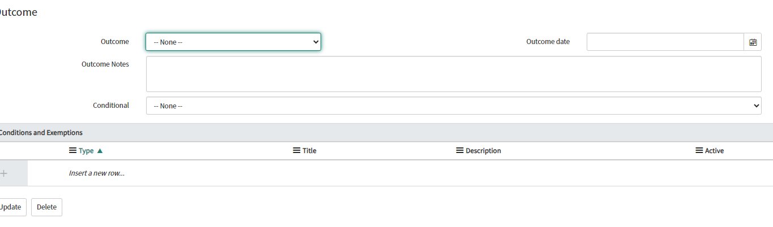
Select an Outcome – Endorsed or Chair’s action if ok – Deferred if needs to come back to later meeting or Rejected. Enter the decision date (meeting date unless approved by Chair’s action and then press Update. You can add Outcome Notes – e.g. FMT felt this new programme was of strategic importance.
Remember there are two tabs on the meeting – one for full and one for planning proposals. If you have both types on the agenda then outcomes need to be entered for both.
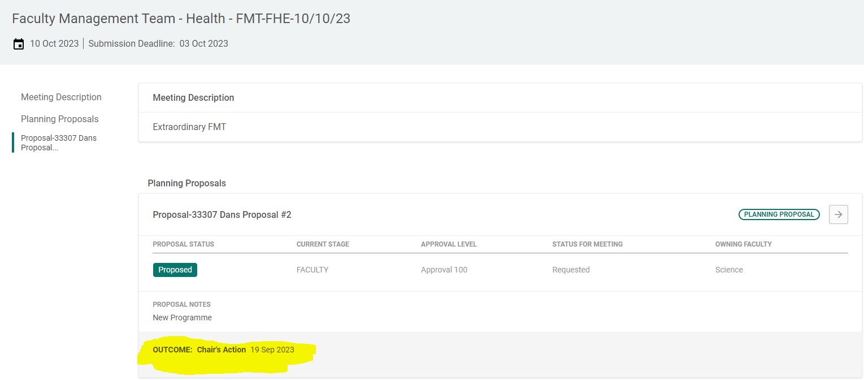 Once entered in the admin view the decision will be visible in the Dashboard view for all to see.

Submitting to APFP
Assuming the proposal has been endorsed it should then be moved onto the next stage of the workflow and attached to the next available APFP meeting. Note that the deadline for paperwork for APFP is 10 working days before the meeting date – do not attach proposals after that date – attach to the next meeting.
Firstly, the proposal needs to be moved to the next stage in the workflow – this should be done in the Admin view.
Use
and the proposal number search to find the proposal, then Open Record
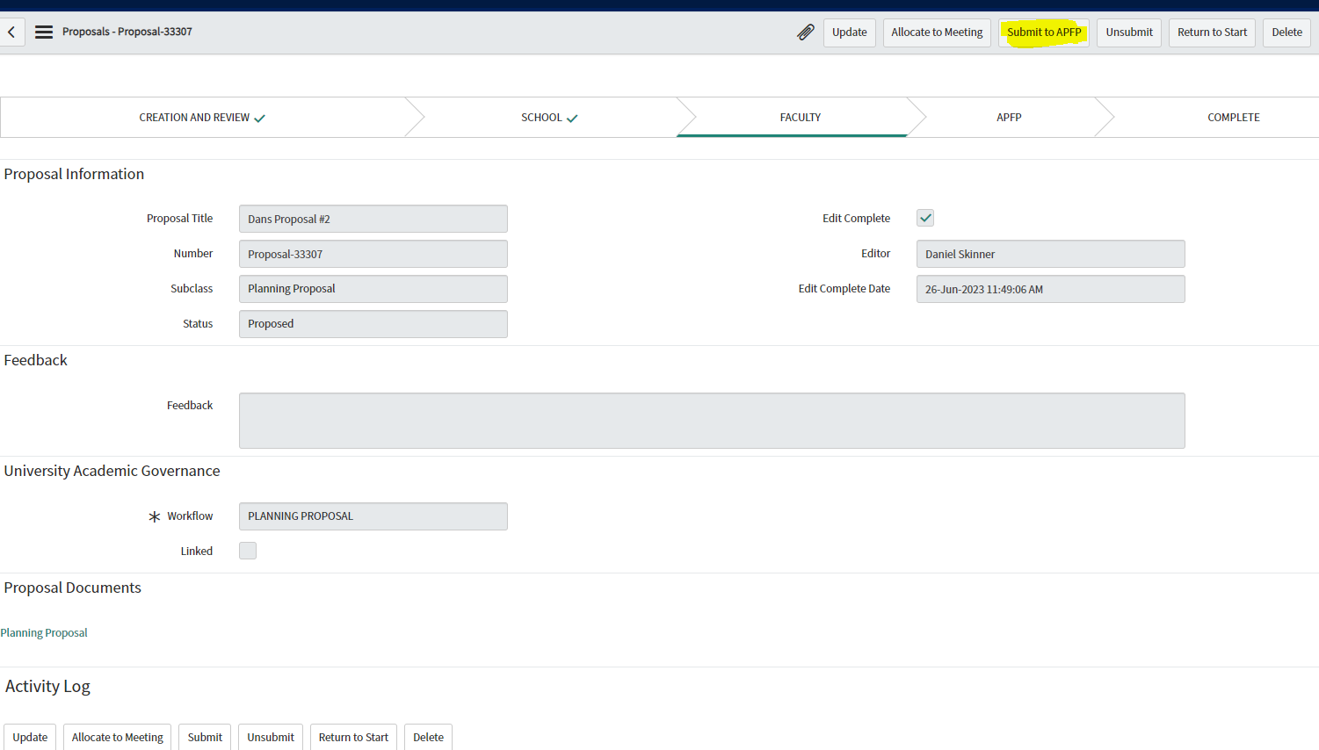
Click on the Submit to APFP or Submit to University level button in the top right.
Then select Allocate to Meeting
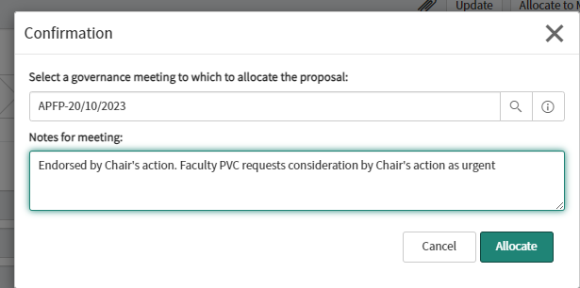

The APFP secretary has requested that if the proposal was endorsed at Faculty level by Chair’s action, that is stated clearly in the Notes for meeting section.

Queries
Any issues regarding this guidance, please contact Graham Sherwood
Rev. 19/09/2023

