The programme performance report explained:
These plots show the performance of students across the modules on a programme – referral/deferral classes, non-attempts and zero marks are excluded from the analysis.
All marks will have been moderated by the module team and external examiner, and finalised. The purpose of this report is to provide discussion points to the Board of Examiners, and to feed forward to the following academic year.
For each level of the programme four graphs are provided.
Graph 1 -The ‘box and whisker’ plot (Fig. 1) displays the range of non-zero marks awarded for each assessment item. Across the range of modules and assessment you would expect broadly similar performance. This may be less true with optional modules taken by a small number of students. During the moderation process module leaders will have been asked to comment in their moderation report on differences in performance between assessment items on their modules, and this should feed into the discussion at the Board of Examiners.
The whiskers show the total range of non-zero marks for the assessment. The box shows the inter-quartile range – 50% of students fall in this area. If this is narrow then there is clustering in the marks awarded. The yellow line shows the median – if the middle 50% of marks are evenly distributed the median will fall in the middle of the box. If it is towards the top or bottom of the box then there is a skewed distribution. For a module with an even spread of marks the mean and the median will be very similar. A few low (or high) marks may skew the mean to be noticeably below (or above) the median.
If an assessment is achieving consistently higher or lower marks than other assessments taken by the same cohort of students, or not discriminating sufficiently between different abilities (i.e. a very narrow range of marks), then the assessment for the following year needs to be considered carefully by the module team.
Graph 2 - The assessment item mean mark shows comparative marks for the previous two years (where available).
Graph 3 - The module mean mark plot shows the mean mark for each module on the programme at a particular level. The left-hand column shows the overall module mean, whereas the right-hand column shows the module mean mark for students on the programme in question. If a module is only taken by a single programme then both columns will be identical. There is an expectation that the module mean mark for students on undergraduate programmes will be at least 55% (60% for level 7). Module Leaders will be required to report in CME on any module not reaching that target.
Graph 4 - The module pass rate plot shows the pass rate for the module overall and the programme in particular (as per Graph 3). This chart includes Pass/No-Pass modules, all others do not. There is an expectation of a module pass rate of 85% or above for the programme. Module Leaders will be required to report in CME on any module not reaching that target.
Module index – this gives the name of each module displayed on the plots along with the number of valid student attempts by students on this programme and the number of students from the programme enrolled on the module.
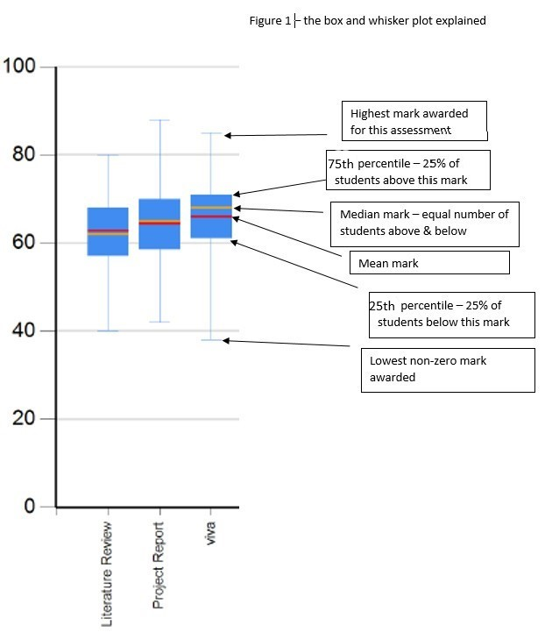Updated June 2020

