Using the External Examiner Moderation site – a guide for academic staff
We have introduced an automated enrolment process that will enrol External Examiners onto all the Canvas module sites associated with their programme of study – this will be managed by Academic Registry.
An External Examiner Moderation SharePoint site has been set up to allow moderated work for each module to be shared with External Examiners. Module teams (including collaborative staff with LJMU usernames) can upload both documents (e.g. scanned exam scripts) and hyperlinks to individual pieces of marked work in Canvas that will allow External Examiners to view the markers’ feedback.
Module leader Access to this site is via WebHub – if you are listed as module leader there will be a link from the front page, otherwise the link will be via the MVI interface (via Boards).
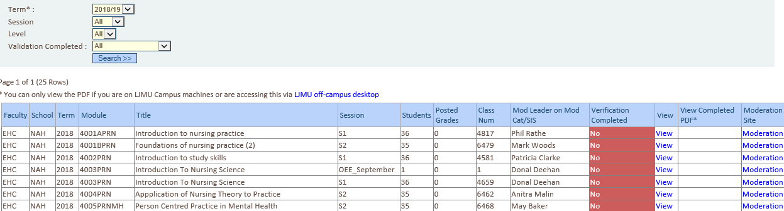
The Moderation link takes you straight to the filestore for the module.

You can create a new folder by selecting “New Folder” – it is recommended that you create a separate folder for each assignment in the module.

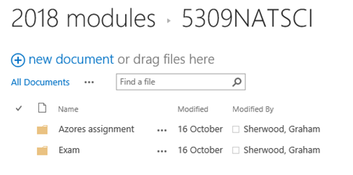

In order to upload a file or create a link to a piece of work in Canvas Select the Files tab at the top of the page –
You can add a new Document by selecting new document (clicking on the down arrow gives you the option of either a Document or a Link to a Document – Links to marked work in Canvas are particularly helpful if work has been marked online within Canvas or Turnitin as it will allow External Examiners to see the markers’ comments alongside the student work itself.
If you want to select a particular piece of work, open it within Speedgrader and copy the URL of the piece of work – this will take the EE to the actual piece of work with comments.
N.B. Always link to the work in Canvas – do not link directly to Turnitin as the link won’t work.
VERY LARGE FILES – if work is too large for students to upload to Canvas, then it is also too large to upload to SharePoint. Use your OneDrive to make the work available to the external.
When selecting within SharePoint a link or PDF to view you are strongly advised to right-click and open in a new tab – this will reduce potential navigation issues that can arise moving between SharePoint and Canvas.
Marked exam papers may be scanned and uploaded as PDF files.
Remember that the external examiner needs to see clear evidence of internal moderation, so the uploaded sample should be sufficient for them to be able to come to an informed judgement. Ideally upload links to all internally moderated work.
External examiner access is via WebHub and the MVI page – every external examiner has a link to the moderation folder for every module on the programmes that they are responsible for. External examiners have write access to the moderation folder so may upload comments for the module team following moderation.
Please note the following:
Please let the programme leader know when you have uploaded work for the external examiner to moderate. Remember that externals need sufficient time to view the work and confirm whether they are happy PRIOR to the Board Reporting Deadline (on the Academic Calendar for standard delivery).
When modules are used on a number of programmes, or there is team of external examiners on the programme, it is normal practice for the programme leaders to assign primary responsibility for moderation of each module to one external examiner (the key exception being dissertation modules, which are usually looked at by all externals (with a different sample of work being provided for each)).
It is the responsibility of the programme team to inform External Examiners when and how work for each module will be available for external moderation, and the date by which moderation should be completed. External moderation needs to be completed prior to confirmation of marks and the board reporting deadline.
FAQs
What is the University policy on moderation of assessed work?
https://www.ljmu.ac.uk/academic-registry/staff/policies
When should I upload the work for moderation?
As soon as the internal moderation is completed, and once it is uploaded tell the programme leader it is available for the external to view
You need to give the external a reasonable amount of time to view the work – they should be able to raise any concerns about moderation prior to the Board Reporting Deadline
Does this apply to referrals as well?
Yes – internal and external moderation applies to all summative assessments
What happens if I don’t hear from the external examiner?
As long as the external examiner has been given an opportunity to confirm that moderation has been carried out in accordance with policy, you are compliant with the moderation policy.
Do I have to use the SharePoint site for my module?
No, but any alternative method of sharing with the external must be secure and in accordance with University IT policy. It is suggested that all modules on a programme follow the same methodology.
Revised December 2019

