Using the Module Mark Verification tool (2020 edition)
Following user feedback we have made some modifications to the Module Mark Verification tool. The new version divides the questions into two sections – moderation and verification.
There is a new option to download a moderation form that can be shared with the External Examiner – this should replace any previous faculty-designed moderation forms.
Remember that all assessments should be approved by the external examiner in advance, and the external examiner must be involved in the moderation process. This applies to all modules irrespective of level.
Accessing the Module Mark Verification tool
If you are recorded as the module leader, then you will be able to access via the Module leader resources button in WebHub:
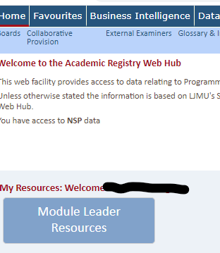
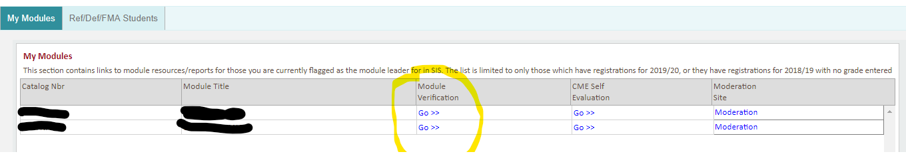
If you are not the module leader then it is still possible to access the Module Verification tool via the Module Tools menu on the WebHub home page.
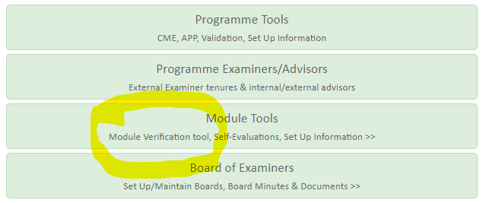
and selecting module mark verification.

Whichever way you access the MMV tool you will end up on the search screen page:
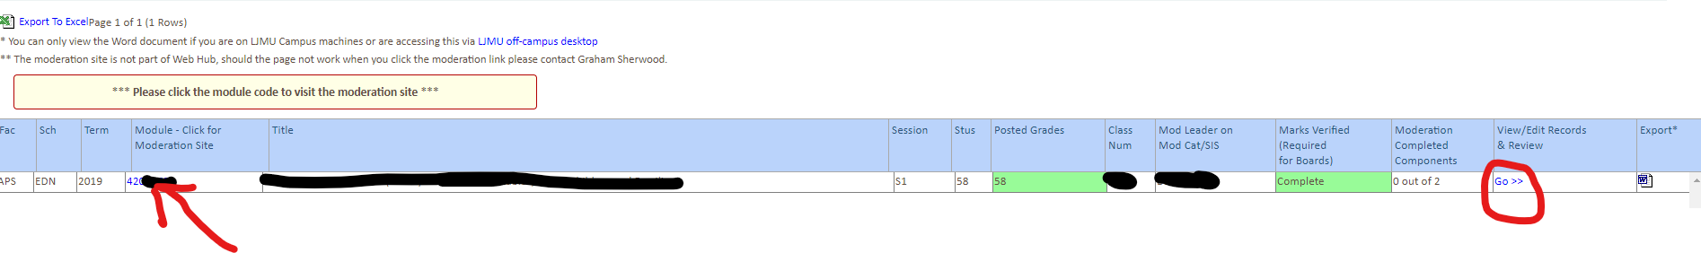
The moderation site in SharePoint can be accessed by clicking on the module code (left hand side of screen).
In order to complete the moderation and verification reports click on Go (right hand side of screen).

This will take you to the Verification Screen:
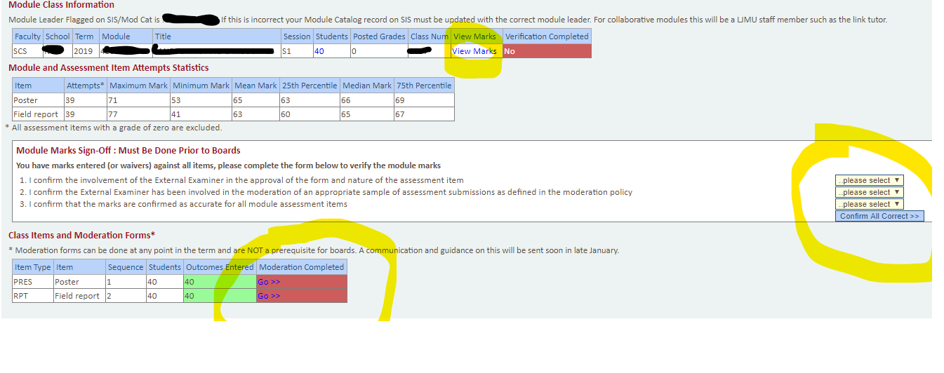
Moderation forms (one per assessment item) should be completed before samples of work are provided to the external examiner. There is an option to Export the moderation information for a module as a Word file (Word icon on right hand side of search page), which could then be shared with the external examiner by uploading to the moderation site on SharePoint.
For each assessment item there are 7 questions (6 for exams). Apart from question 7 which is to record external examiner comments, all have a pulldown Yes/no with an optional comments box.
Sections 4 and 7 can be updated following feedback from the external examiner.
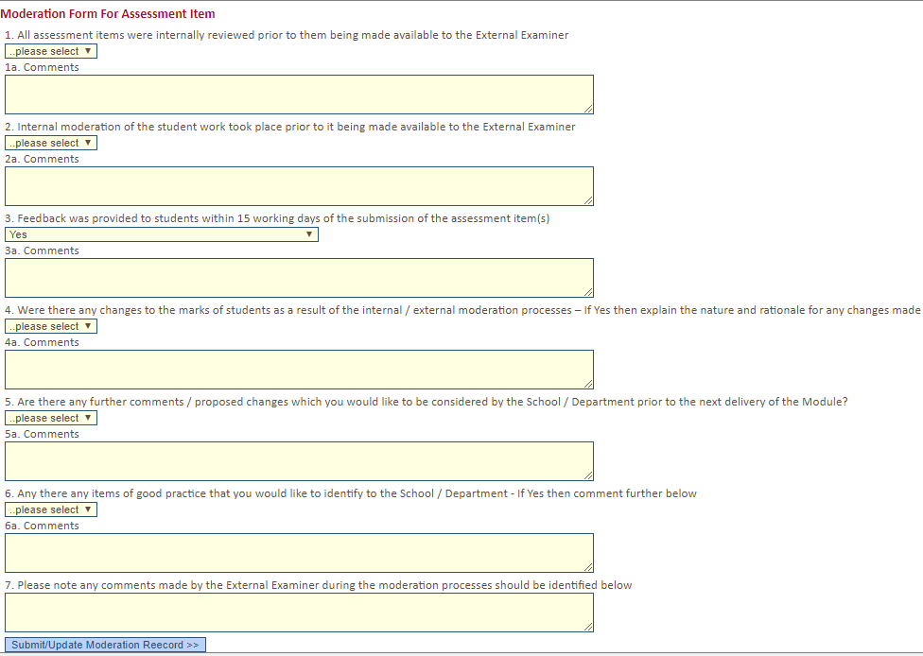
Verification
The marks that have been entered in SIS can be viewed by clicking “View Marks” (towards the top of the screen).
Once you have checked that the marks are correct you will be asked to confirm three things to verify the module:
- That the external examiner was involved in the approval of the form and nature of the assessment
- That the external examiner has been involved in the moderation of an appropriate sample of assessment submission as defined in the moderation policy
- That the marks are accurately recorded for all module assessment items
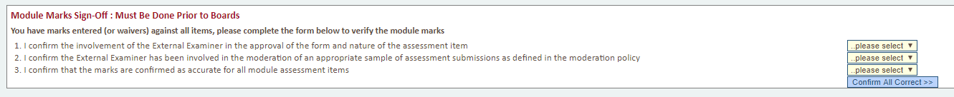
Module grades will only be finalised in SIS if marks have been confirmed as correct. Verification must be completed at least 24 hours prior to the Board Reporting Deadline.
If you have any queries regarding the use of the verification interface or the University’s Moderation and Feedback policies please contact the Faculty Registrars.

