Process Document

CRM – Centre for Entrepreneurship
Liverpool John Moores University

CFE Case Management
Dashboard

Version 0.1, November 2020
Author: SL Business Support Team

Contents
Locating your Dashboard 3
Pinning a Dashboard 3
Views ‘Pop Out’ Function 4
Sorting 4
CFE Case Managment Dashboard 4
Processing emails from your Dashboard 6
Replying to an new email on the dashboard 7
Removing emails from the Dashboard 7

Locating your Dashboard
Each Department who use CRM have their own dashboard, which normally acts as a ‘home’ page. The ‘CFE Case Management’ Dashboard has been split into 6 views to help manage emails and cases.
Next to Dynamics 365, there will be an Entity Name. e.g. My Work/Student Services
• Click on the downward arrow next to Entity Name
• Select ‘Dashboards’
- Select the CFE Case Management from the list
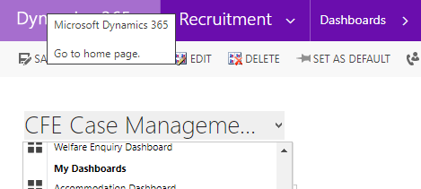

Pinning a Dashboard
To do this, select the Dashboard, and select ‘Set as Default’.
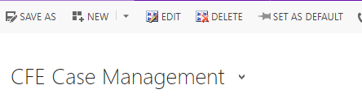

Views ‘Pop Out’ Function
You may find the Views within the Dashboard cut off information.
You can ‘pop out’ the view from the Dashboard by clicking on the grid button below:
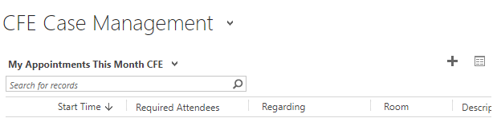

Sorting
Remember that from within the pop out you can sort or arrange any information by clicking on the headers. You can sort (Ascending, Descending, numerical or alphabetical).
Additionally there is a Search box in the top right where you can search for a student.

CFE Case Management Dashboard
The 6 Views are:
My Appointments This Month CFE: This will display any 1-2-1 Appointments you have scheduled that month.
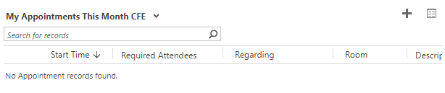
CFE Emails to Be Processed: This replaces your individual inbox and this is where new emails will come to when someone emails the your ‘queue’. From here you will check incoming emails to convert to case, assign and respond. See further instructions below.
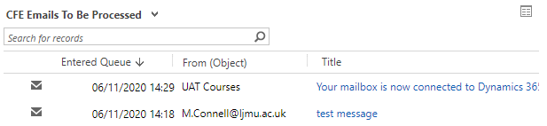
CFE Emails Related to Existing Record: Emails that have come in that relate to an existing Case. The Regarding (Object) column will display the Case name.
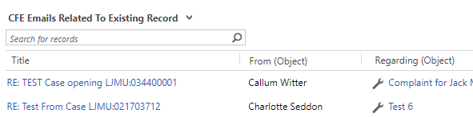
Cases Created From an Event: This will show any cases that have been created via campaign responses
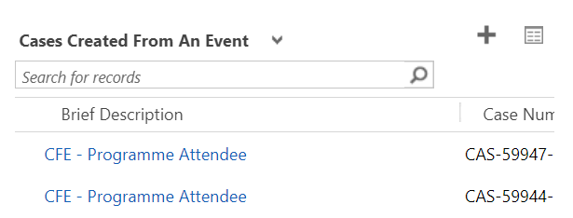
Cases to Follow Up CFE: These are cases that have had a follow up date set within the case, and they will appear here to remind you that they need following up.
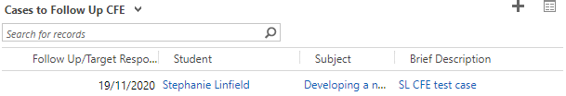
My Active Cases: All Current Open Cases owened by you.
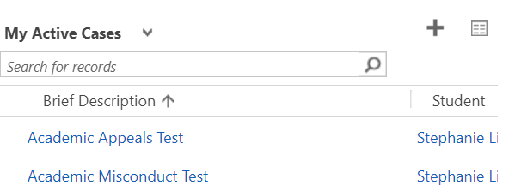

Processing emails from your Dashboard

Please note there is a separate document ‘CRM Activities Sending Emails’ which provides further instructions on sending emails from within a Case – but the below will explain how to process them off your dashboard.
As mentioned above, emails coming in to CRM can be viewed on your CFE Case Management Dashboard.
If the contact is already known on our systems then the email should automatically link to them and the ‘From’ column on the dashboard should display as a name rather than an email address.
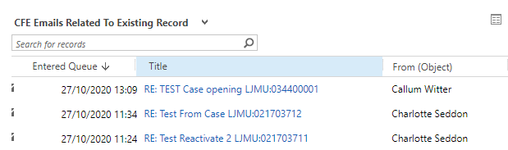
To respond to an email from your dashboard, double click on the white space within the row of the email and it will open the email form
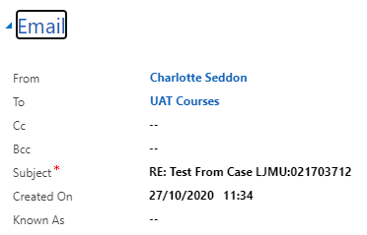
The email will show us who it is from, and that it has come into your default queue. It will show the subject of the email and when it was created. The ‘Known as’ field will display if the contact would like to be known as something different to their primary name.
The ‘Email sent from’ will show which of the three possible emails on the contact record, that the email has come from.
‘Attachments’ will show any attachments that have come in with the email
The email content will be shown near the bottom of the page.

Replying to an new email on the dashboard
Before replying to a brand new email on your dashboard (these will be under CFE Emails to be Processed) you must decide whether it needs to be converted to a case first (see Creating a Case doc for instructions how to do this). If you decide to create a case first, when you navigate back to the case, you can open the email back up to reply.
You can also reply to emails that you do not convert to a case but it is important to note that if an email is not set regarding correctly, the email will not be clearly visible for yourselves. You can also forward emails on but you should only forward an email where you need to pass it to someone else within LJMU.
To reply to an email, click the ‘Reply’ button in the top left of the ribbon at the top of the page.
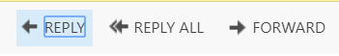
The From will default to your Team email automatically as this is set up for you at the time your access to CRM is applied.
Note: The email will not send if the ‘From’ is an Individual name. It MUST be a Team.
When the email page loads, you will see an option of where to send the email to on the ‘Send to Email Address’ drop down list.
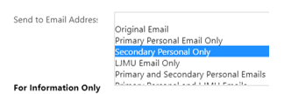
Underneath the ‘Send to Email Address’ it shows the email addresses that the contact has available to send to. Original Email will reply to the email address that the email was sent from. You can write your content at the bottom of the page. Once you are ready to send, you can press the ‘Send’ button in the ribbon at the top of the page.
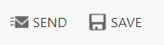
Once a new email has been converted to a case, it will disappear from the CFE Emails To Be Processed dashboard view. Any further email replies relating to this record will land on the CFE Emails Related to Existing Record area of the dashboard. You can pick these up and reply in the same way. The email should already be set regarding the existing case.

Removing emails from the Dashboard
Once you are happy that the email has been dealt with and want to remove it from the dashboard, select the grid next to the view in the dashboard.
It will open up the following window; you can highlight the email so a tick appears next to it and click Remove
Please note this does not delete the email, it simply removes it from the dashboard
