Process Document

CRM – Centre for Entrepreneurship
Liverpool John Moores University

CFE: Creating a Case

Version 0.1, November 2020
Author: SL Business Support Team

Contents
Creating a Case 3
Setting up the case from ‘Cases’ 4
Setting up a Case from Contacts 7
Setting up a Case from an Email 10

Creating a Case

Following any kind of initial contact/communication e.g. drop in/email/phone call with a student, or third party, you should set up a case for each issue so that all of the information is held in one place, securely. The overarching aim is to a build up a ‘story’ of the student.
There are a number of ways in which a Case can be created in CRM. The recommended way would be to create cases from ‘Contact’s (No.2). This enables you to see the Contacts history, e.g. any other cases/interactions they have had with your team. However, there is not necessarily an ‘incorrect’ way.
There are quick create ‘+’ buttons at the top of the screen which you may wish to use.
However, in this guide we will outline a few ways which we recommend you follow depending on the circumstance:

- Setting up the Case from ‘Cases’.
- Setting up the Case from ‘Contacts’.
- Converting an Email to a Case.

Setting up the case from ‘Cases’
If you are using this method, then usually the client will be a student, and has contacted you via phone/email/referral/drop in and you will already have their student ID to hand.

- You will start off at your default Dashboard CFE Case Management upon log in.
- Click on to the arrow next to Student Services
- Beneath the row of boxes, you will see a menu called ‘Services’.
- Select ‘Cases’.

- The ‘Cases’ window will open up. You will note it will default to showing a particular view, e.g. My Active Cases.
- You can pin any Cases view if you like so that it shows this view each time you log in. You can do this by clicking on the push pin: 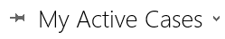

- In the left hand corner click on to the plus sign for ‘New Case’.

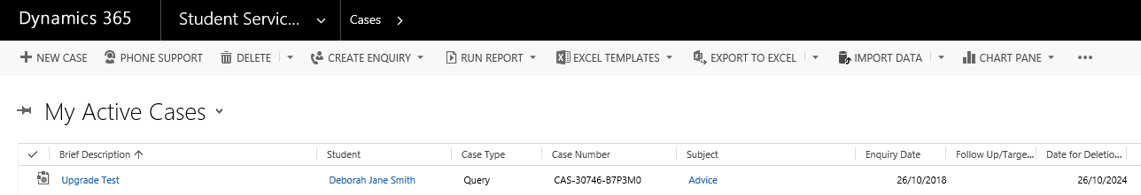

- Another window will open up,
Note: You will notice the workflow chevrons across the top of the screen. Please do not be concerned if these are incorrect, they are driven by the Subject, and may change once the Subject is selected. Please also ensure the form view is set to CASE: CASE SA
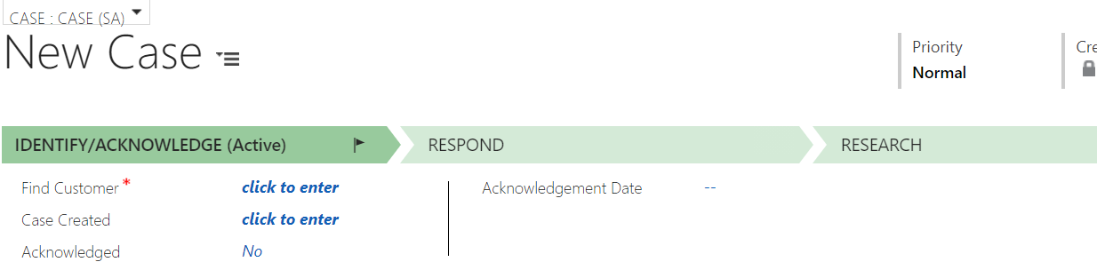

- Click into the Student field and type in the Student ID. The system will bring back the correct student.
- Next enter a Brief Description. This will form the name of the case.
***Please note you may find it useful to use a naming convention here e.g. put your initials at the start of the brief description. This will make the owner of the case easier to identify if an email comes in to your dashboard about an existing case***
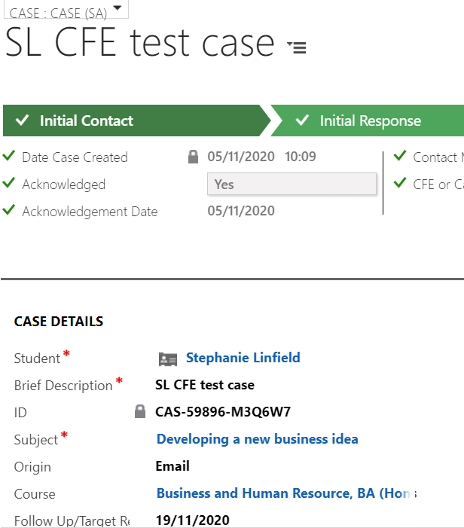

- Next, select a Subject and the Sub-Subject from the drop down list.
Please Note: Selecting a Subject from the top line Subject List (shown below) drives the correct process.

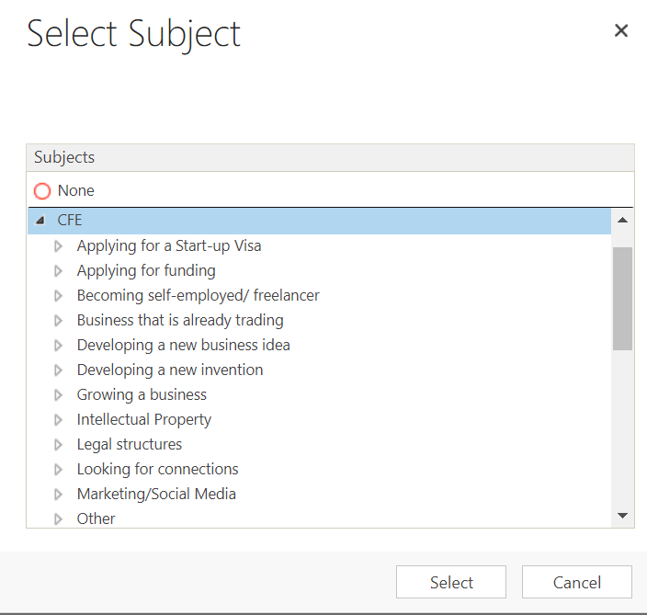

- Finally, click on the Save Icon in the bottom right corner of the screen
You will note that the name you entered into the Brief Description field will populate at the top of the case, and the status will show ‘New Case’.

A Case ID number will also default in
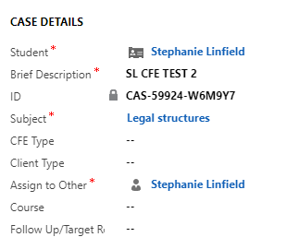

Case has been created!

Setting up a Case from Contacts

If you do not know the Student ID or if the client is not a student, you can set up a Case via ‘Contacts’.
- First you will need to navigate to Contacts, and check if the ‘Contact’ is set up on CRM already.

The ‘view’ may default to ‘My Active Contact’
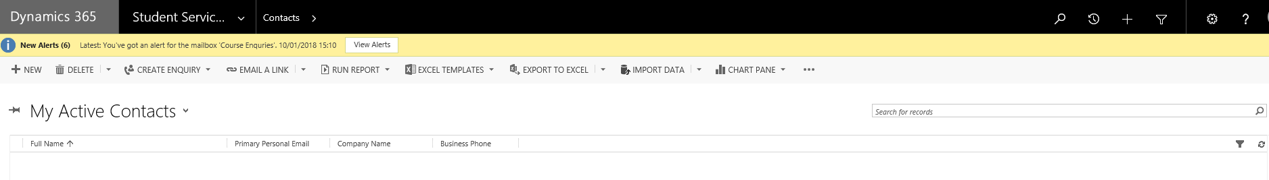
- You can change the view, by clicking on the downward arrow.
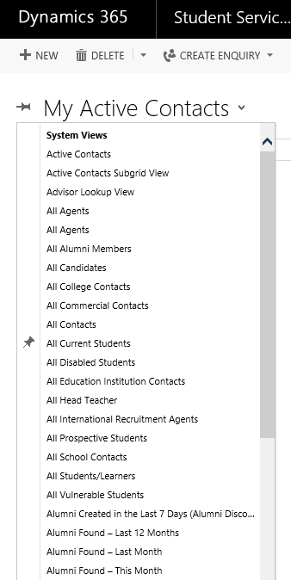
- There are a number of views, you could select to narrow down your search. If you know the contact is definitely a student, then select ‘All Current Students’.
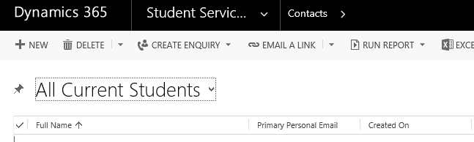
- Then, click into the search field and search for the student.
Note: You can search using the wildcard function ‘*’ if you are not sure of the student’s full name.
- Select the correct Contact from the results displayed to bring up the Contact Record.

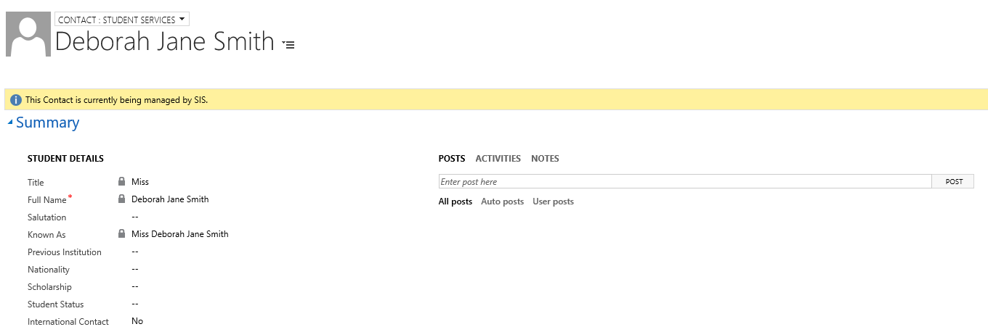

- Ensure that the Contact view is ‘SA’. You can change this by clicking on the ‘Contact’ arrow above the Contacts Name.
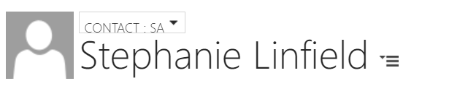

- Scroll down and look for ‘Cases’ on the right hand side.

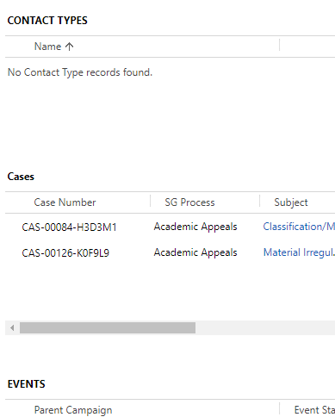

- Click on the ‘plus +’ icon next to Cases section

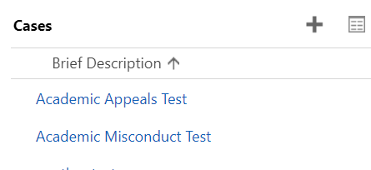

- This will bring up a Quick Create: Case window at the top of the screen.

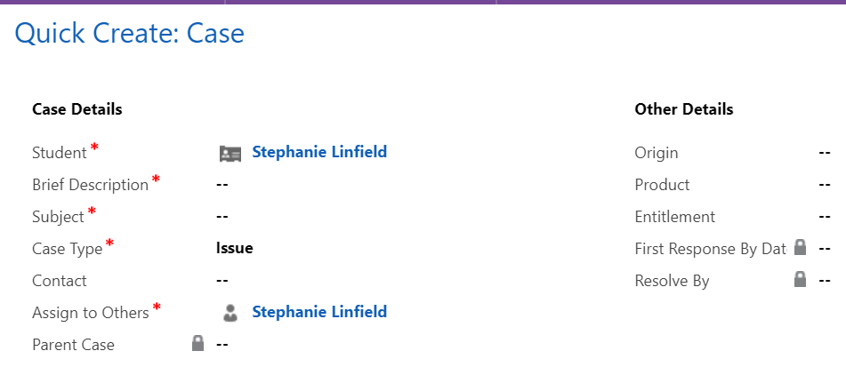

- You will note that the Student is already selected. Complete the Brief Description, Subject, the Case Type will default to issue for you. The case owner will default to the person creating the case but this can be changed in the Assign to Others field.
- Click Save

- If you look back over at ‘Cases’ you will note that the new Case now appears at the bottom of the list of Cases.
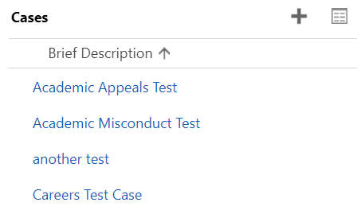

- Click on the link in blue to open up the case.

Setting up a Case from an Email

- Click into the Email you want to Convert.

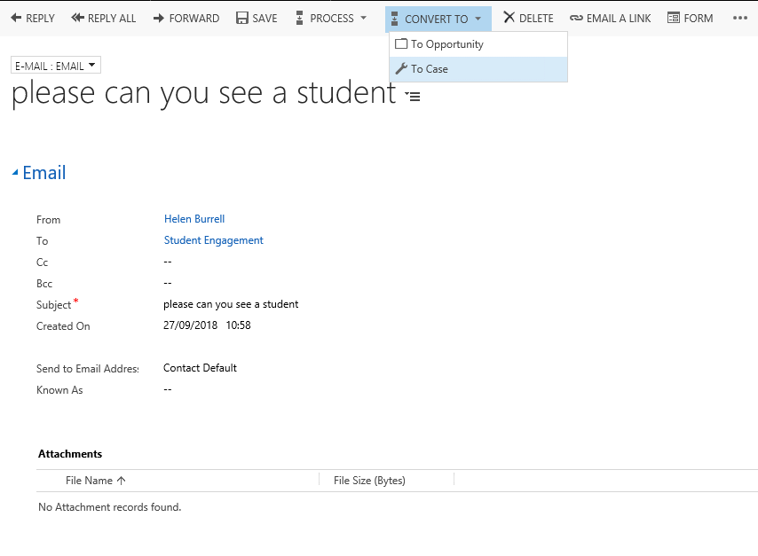

- Select the Convert to option.
- Select ‘Case’. Do not use Opportunity.
- This will bring up a dialog box asking which student it is for (‘Customer’ field) and also the Subject, which you will select from the list (under Careers).
- It is important that the correct Subject is selected as this will drive the process flow across the top of the screen.

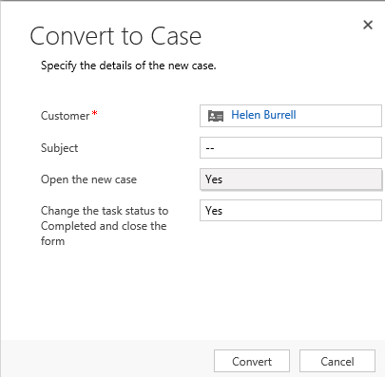

- Ensure both ‘Open the New Case’ and ‘Change the task status to Completed and close the form’ are both set to Yes
- Click the Convert button:
- This will open up a new Case.
- Save

