Process Document

CRM – Centre for Entrepreneurship
Liverpool John Moores University

CFE:
Creating a Contact

Version 0.1, November 2020
Author: SL Business Support Team

Contents

- Creating a Contact

- Creating a Contact
All current students/alumni have already been set up as a Contact in CRM. However, there may be occasions where you may still need to set up a Contact
To create a new contact, first ensure you are within the Student Services and select Contacts from the Customers menu.

Click on the New + button
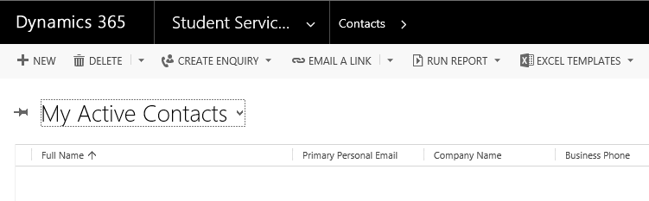
This will take you to the New Contact form.
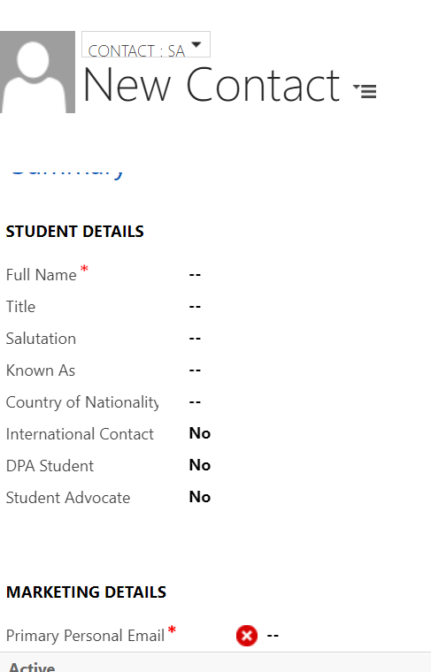

Note that you can change the type of Contact by clicking on the drop down above ‘New Contact’.
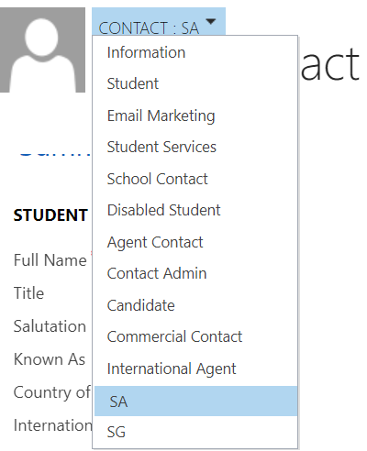

Note: Please ensure you have the form set to SA Contact type.
- Depending on the type of Contact, there will be different Mandatory fields, but you will always need to enter Name and Email address.
- Click Save.

Note: Remember that Notes can be left against the Contact record, but for auditing purposes and that so a full picture can be given, all notes should be held against a Case.

