Process Document

CRM – Centre for Entrepreneurship Events
Liverpool John Moores University

CFE: Events

Version 0.1 November 2020
Author: Debbie Smith Business Support Team

Version Control
Version 0.1 | November 2020 | Original Version

Contents:

- CFE Events Dashboard

- Creating an Event

  - Programme CFE Events

- Saving the Event

- Adding an Event Venue and Room

  - Adding an Event Venue
  - Adding an Event Room
  - Adding a Room to an Existing Venue

- Managing Registration/Restrict Numbers/Waiting Lists

  - Manage Registration/Restrict Numbers
  - Waiting Lists
  - Increasing Capacity of an Event after it has gone to Wait List

- CFE – Adding an Image

- CFE - Alumni

- Open Registration & Publish Event to Website

- Booking an Event

- Via the Events Website
- Navigating the Website

- Reviewing Booking Registrations in CRM

- Event Changes & Cancellation

- Event Changes
- Cancelling a Students Event Booking
- Cancelling an Event

- Event Registration

- Manual Register

- Adding Students on to an Event Manually in CRM

- Completing an Event

- Creating a Case from a Programme Event for an Attendee

- Workflow Emails/SMS

- CFE Events Dashboards

- Each Team have their own Dashboard in CRM, which acts as a sort of Home page.
- The CFE Events dashboard is ‘CFE Events Management’ and this is a System Dashboard. Please note that you will have a separate dashboard to manage Cases.
- You can toggle between different dashboards by clicking on the downward arrow at the end of the Dashboard name.
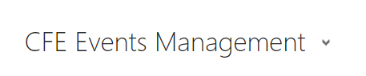
The CFE Events Management Dashboard has 2 Views:

CFE Upcoming Events: All future CFE Events will display here.

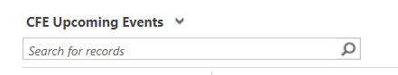

CFE Past Events: All past CFE Events will display here.

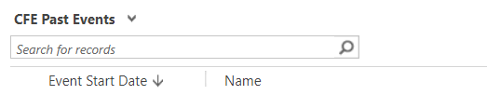

You can click into the Events from the dashboard, ensuring you click on the name of the event highlighted in blue

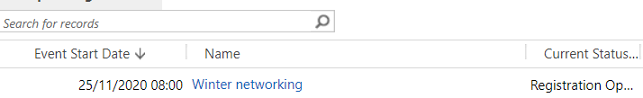

- You can also pop any view out by clicking on the following, which is in the corner of all views:
- Popping out a view may give you more columns and make it easier to filter if you wish.

- You can still filter on any of the headings without popping out the view – just click the column headers to filter.
*Remember you can pin dashboards by clicking on Set as Default at the top of the page*

- Creating an Event

- To create an Event, you first need to select the Events entity.

- Next to Dynamics 365, there will be an Entity Name. e.g. Recruitment /My Work/ Student Services. Yours should be Student Services by default.

- Click on the downward arrow next to the Entity Name.
- Search for Events Management

- Select Events
- A page will appear called ‘My Campaigns’. You can change this to a more meaningful view if you wish e.g the views mentioned above that also appear on the dashboard.

- If you change the view, then you can pin it by clicking on Set as Default.
- In the top left hand corner, you will see 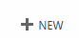

- Click here and a New Campaign page will open up.

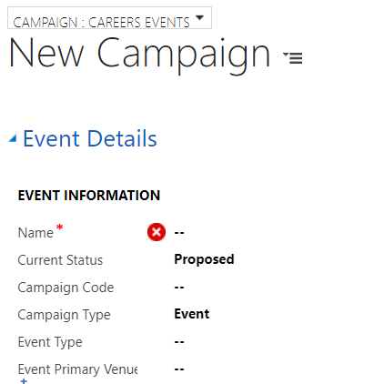

- Under the Save Button at the top of the page it should state ‘Campaign: Careers Events’

- If it doesn’t, you can change this by clicking on the downward arrow.

You need to ensure you change this so that the correct fields appear.

- On this page, you will need to complete the following:

- Name: Enter the Name of the Event.

- Current Status: Change this to ‘Registration Open’

- Campaign Type: Select ‘Event’.

- Event Type: Select Enterprise Social (Cfe), Network (Cfe), Programme (Cfe) Walk (Cfe), Webinar (Cfe) and Workshop (Cfe)

*Programme (Cfe) Events are dealt with slightly differently and this will be detailed below in s.2.1.*

- Event Start Date: Enter the Date of the Event and Start Time

- Event End Date: Enter the Date of the Event and End Time.

- Event Primary Venue: Select the Venue which the Event is taking place.

*SEE BELOW, S.15.1 FOR ONLINE EVENTS*

- To Look Up the Venue: Click on the magnifying glass icon.

- A few venue options will pop up, but if you scroll down to ‘Look up more records’ a more detailed pop up box will appear to select the correct venue.

- If the Venue is not set up, then please see section below called : Adding an Event Venue/Room and follow the process through.

**Please be mindful here that you just add the Building the Event is being held into this field. The room is then added separately.**

  - ONLINE EVENTS

- If you select Webinar then you will not have options for adding Event venue or room

- If any other Event Type is selected and is happening Online, then please select ‘Online’ as the Event Primary Venue. You will not need to add an Event Room.

- Select your Event Venue from the list, by ticking it on the left hand side.

- Click Add

- Event Venue Room field underneath and select the Room the Event is taking place

*ONLINE - If Event is happening ONLINE – you do not need to add a room.*

- To Look up the Event Venue Room: Click on the magnifying glass icon.

- A few room options will pop up, but if you scroll down to ‘Look up more records’ a more detailed pop up box will appear to select the correct venue.

- If the Venue is not set up, then please see section below called : Adding an Event Venue/Room and follow the process through.

- Event URL: Enter Webinar URL if Event is happening ONLINE.

- The link will be sent to all registered candidates, as well as reminders.

  - Programme (Cfe) Event

- These Events are slightly different to the others in that in addition to the above, you will also need to fill in two other fields.

- You will need to add an Event Deadline date

- You also need to complete the Event URL field with the link to the Application.

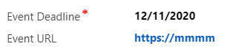

- The URL and Deadline will be sent in an Email to anyone who registers an interest on the booking website.

- No other usual emails will be sent to the attendee.

- Those who register their interest through the booking site will appear in CRM as ‘Interested Attending’

- Everything else will be managed ‘manually’ off CRM with regards to these expressions of interest.

- Saving the Event
- Click on Save at the top of the screen 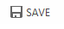 Or
- Click on the ‘Save’ icon at the bottom right of the screen 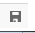

- Once Saved, you will notice the Name of the Event will appear in the top left corner.

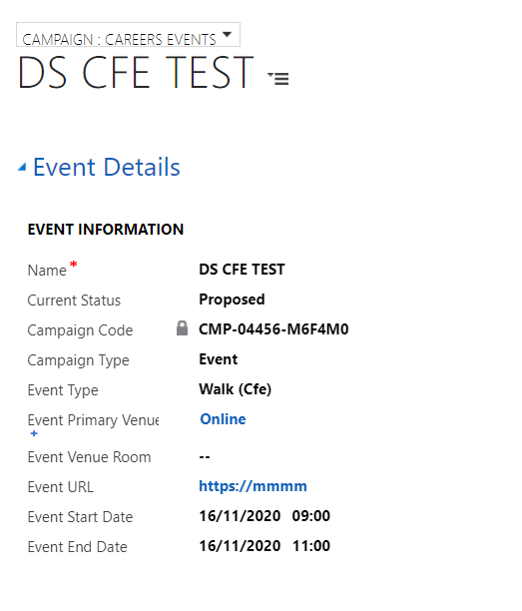

**PLEASE NOTE: At this point – the Event is NOT LIVE on the website just yet… We are only partway through setting the Event up**

- Adding an Event Venue and Room

**Not required if Event is Online**
If your Event Venue is not available in the list, then you can add this yourself.
  - Adding an Event Venue

- If the Venue you require is not in the drop down list, you can add a new Venue & Room

- Click on the look up (magnifying glass icon)

- Scroll down to the bottom of the list.

- Click on Look Up New Records
- Click on New
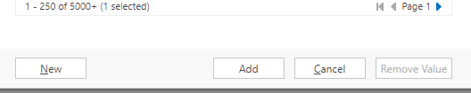
- A new window will pop up.

- Ensure that above the words ‘New Organisation’ it says ‘Organisation Venue’.

- You can change this by clicking on the downward arrow.
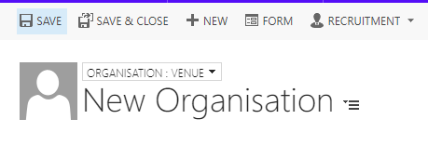
- You will need to complete the ‘Organisation Name’ and ‘Is a Venue’ initially.
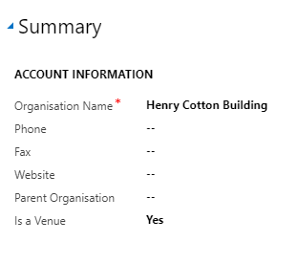
- Scroll down to Address field and enter the address.
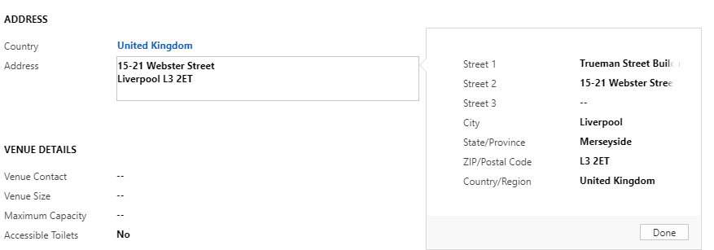

- You can add additional details into Venue Details if you wish. This is not compulsory.

- Click Save.

  - Adding a Room to an existing Event Venue

- Once you have selected the Event Primary Venue on the Event page, click on it.

- You will be taken to the Organisation:Venue page

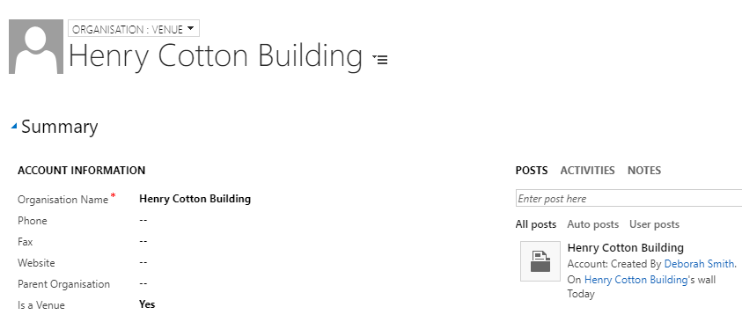

- Scroll down the page and to the right hand side you will see a section called ‘Venue Rooms’.
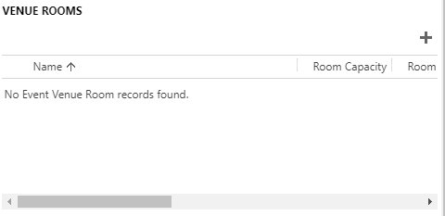
- Click on the plus icon.
- Complete the Room Name:
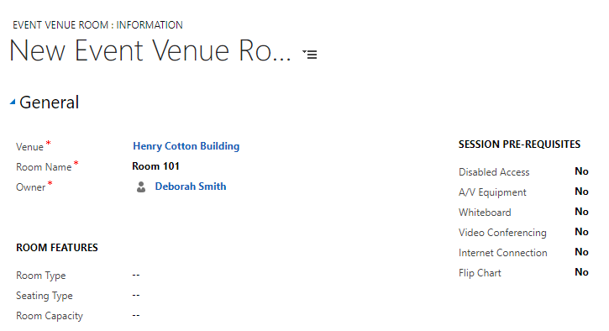
- Click Save & Close

- Navigate back to the Event and select the room you have created.

- Managing Registration/Restrict Numbers/Waiting Lists

- Navigate to the Event Page.

- Scroll down the page to ‘Delegate Management’.

  - Manage Registration/ restrict numbers.
Here, you can restrict the numbers attending the Event, and set up a Waiting List if you wish.
- To restrict the numbers attending the Event, ensure ‘Yes’ is selected in the Manage Registration checkbox

- Then, enter an amount into the Maximum Event Capacity field.

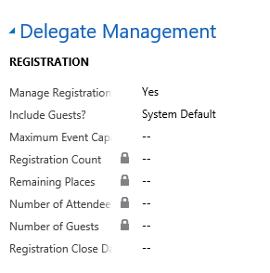

- Click Save (small floppy disk icon in bottom right)

- The amount entered into the the Maximum Event Capacity field will be used to calculate ‘Remaining Places’ at the top of the Event Page.

**You will need to refresh the page to be able to see this**
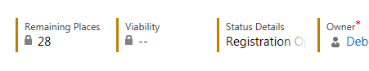

  - Waiting Lists

1. To add a Wait List to an Event, navigate to ‘Wait List’.
2. Select ‘Yes’ in the Waitlist this Event field.
3. Next, click into Waitlist Starting Point, and add the number you wish the Waitlist to start at. This should be the same as the Maximum Event Capacity. E.g. If you have a capacity of 30, add 30 into the Wait List starting point.
4. Save (bottom right – floppy disk icon)
If someone is added to a Waiting List, then an Email will be sent to them via an automatic workflow. If a place does later come available, the ‘waiting list’ person will be emailed advising them that space has become available, and inviting them to book on to the Event (on a first come first served basis)

    - Increasing Capacity of Event after it has gone to Wait List.

- If you wish to increase Capacity of the Event, navigate back to the Event and change both the Maximum Event Capacity field and the Waitlist Starting Point.

- Next, change the status of the Event back to Registration Open.

- Students on the Waiting List will then receive an email notifying them that they can now book on to the event via website – this will be first come first served.

- CFE: Adding an Image

- You can add an Image to your Event that will display along with the Event details on the booking website.

- You can search for the Image you would like.

- Select the Image

- Right click and select ‘Copy Image Address’

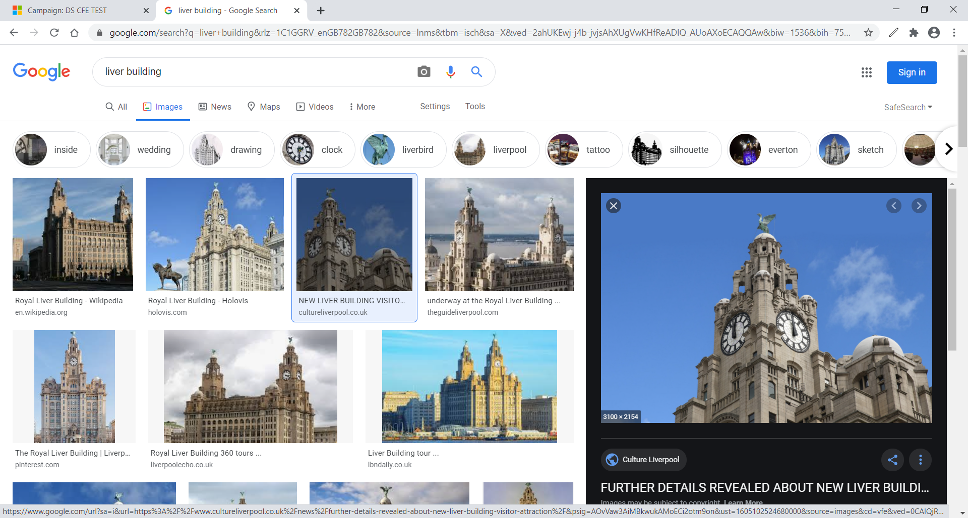
- Head back to CRM and paste the address into the Event Website Image field
- CRM will automatically resize it so that it fits correctly on the website.

- If you don’t select an image then a default one will display.

7.CFE: Alumni

- Click into this field if you wish to allow Alumni to attend an Event:

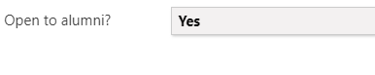

- On the website, Alumni will be able to book on to these Events:

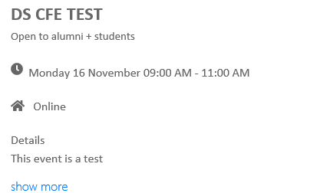

- Publishing your Event to the Website

- Once all Registration Detail has been added to an Event, you are ready to make it Live & Publish to the Website.

- Staying on the Event screen, scroll back up to ‘Event Details’.

- Navigate to the section called ‘Marketing’
- Change the Publish to Web field to ‘Publish’.

**Changing from ‘Publish’ to ‘Don’t Publish’ will remove it from the Website.**

- IGNORE ‘Publish to Facebook’ as this is currently not supported.

- Navigate to Web/Facebook Details section.

- IGNORE Published Event Name and Event Topic

- Click into Published Event Details field & enter a description/some detail about the Workshop/Webinar. **This detail will appear on the Website.**

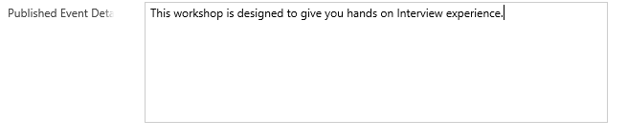
- Click on the small Save icon (bottom right)

- This Event is now live for students/alumni if requested to book on to on the Website.

- Booking on to an Event

- People can book on to an Event in a number of ways:

- Self Service: via the Website
- Booked on by Staff.

- When booked on to an Event an Email will be sent to the Attendee automatically. Please see details in Appendix 1.

- A reminder of the Event will also be sent 24 hours before the date and time of the Event.

  - Via the Website
The preferred option for booking on to an Event is for attendees to do it themselves via this web address:
https://sat.ljmu.ac.uk/
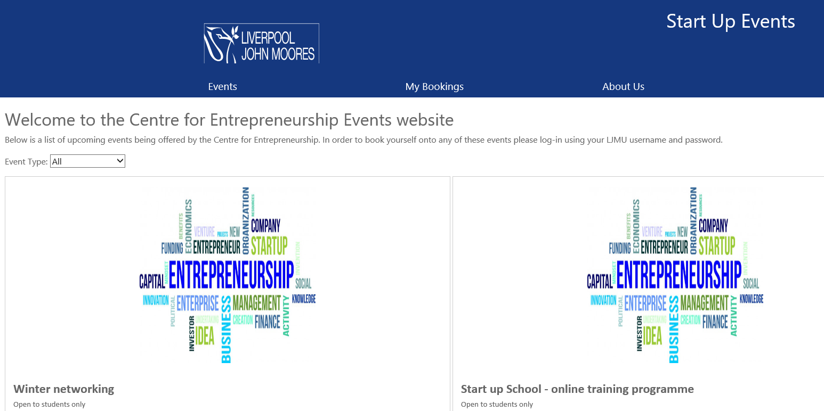

- Students can logon using their usual Credentials to gain access or Alumni will have the option to bypass.

- They will be taken to a page where they can view all CFE Events

- Events can be sorted by Event Type:

- To book onto an Event, attendees will click the ‘Book’ button.

- Attendees will have the option to tick Receive SMS Reminder, and add their mobile number if they so wish.

- They will also have the option to tick ‘Additional Support Required’ if necessary and enter details. (These details will appear on the Event Register in CRM)

- Then click on ‘Confirm Booking’

- They will receive a pop up to tell them that their Booking was Successful. This Event will now also appear under ‘My Bookings’

- The attendee will receive an Email (which is sent from CRM) confirming that they have booked on to the event. Please see Appendix 1: Automatic Emails/SMS

- Cancelling: Attendees can also cancel a booking on the website via My Bookings. This will remove them from the event in CRM – although you will still be able to see that they booked on the event originally.

  - Navigating the website

- Events
A list of all Events currently open for CFE

- My Bookings
Here, attendees can view bookings previously made and cancel bookings for Events and Appointments if they need to.

- About Us
This is some information about the services CFE offer and contact details.

- Reviewing Booking Registration in CRM

- Back in CRM, on the Event Page, you are able to review who has booked on to an Event, within the ‘Bookings’ section.
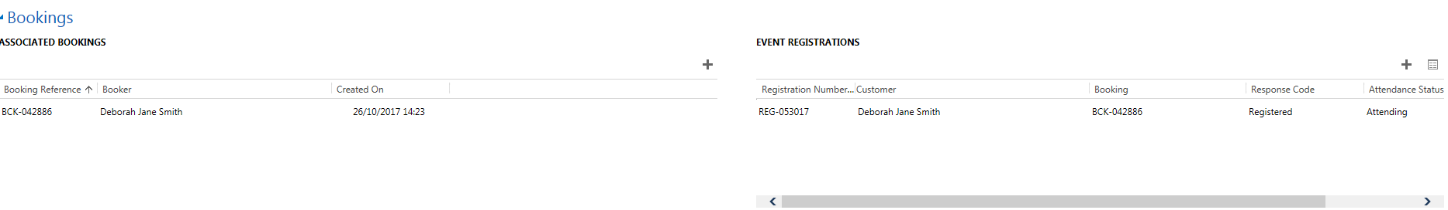
- All Bookings will appear under ‘Event Booking’. This includes if any Bookings have been cancelled. All Active Bookings will appear under Event Registrations.

- Event Changes & Event Cancellation

  - Event Changes
If an Event has:
- A Date Change
- A Time Change
- Date & Time Change
- Location Change
You can do this by just updating the ‘Event Page’ and clicking Save.
Once these changes have been updated in CRM by a member of staff, an Email will be automatically sent to all Attendees advising them of the changes.

  - Cancelling an Attendee’s Event Booking
A student may cancel their booking via the Website, this is the easiest and preferred option! However, a member of Staff may cancel an Event on an attendees behalf.
You can cancel a person’s Event Booking by scrolling to Bookings.
- Navigate to the right hand table ‘ Event Registrations’
- Locate the person from the list
- Click on the Registration Number, it will start with ‘REG –‘
- The Campaign Response screen will update.
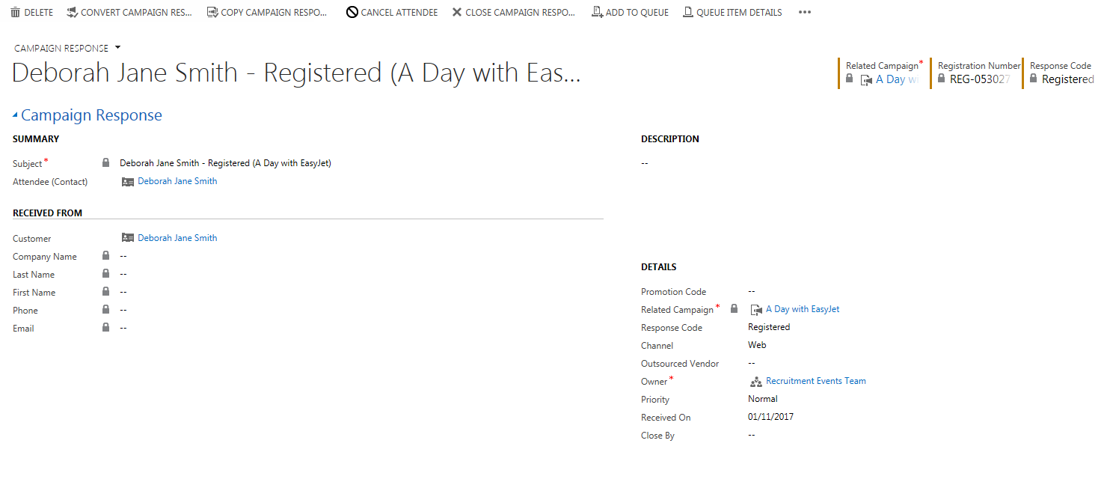

- Along the top of the screen, you will see ‘Cancel Attendee’ button.
- Click here, and a ‘Cancel Attendee’ window will open up.
- Click ‘Yes’, as this to ‘Refund Event Fee’s’.
- Click ‘Next’
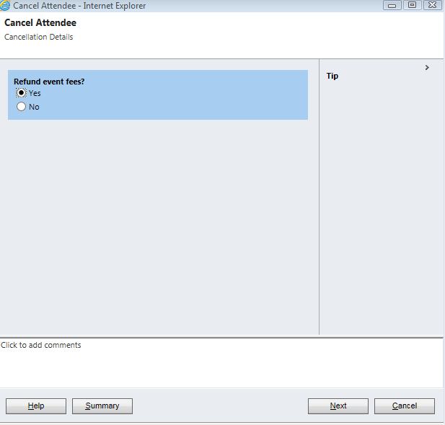
- Click ‘Finish’
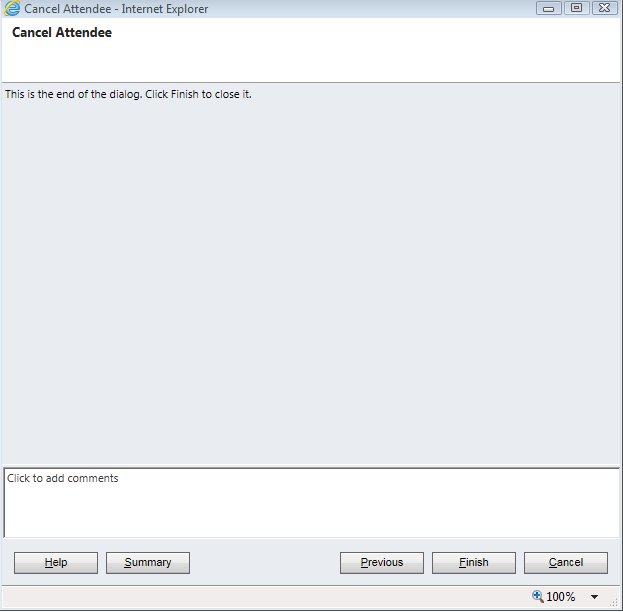
- You will note that the status has now changed from ‘Registered’ to ‘Registration Cancelled’.
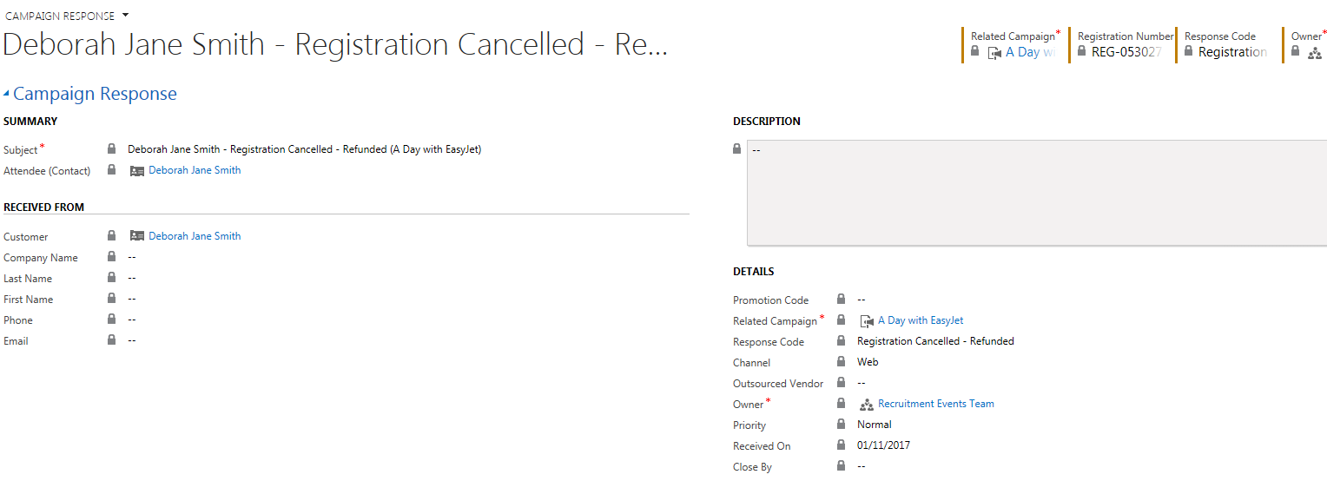

- If you head back to the Event Page
- Navigate to Bookings section
- You will note that the attendee’s name will no longer appears under Event Registrations. The attendee’s name will still appear under Associated Bookings if they booked via the Website.
Once an attendee’s booking has been cancelled, then an email will be sent to the attendee automatically.

  - Cancelling an Event.

- Navigate to the Event Page
- Scroll down the page to Marketing
- Change Publish to Web to Don’t Publish

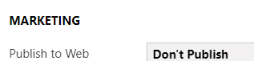

- Click into Current Status
- Update this to ‘Cancelled’
- Click Save.
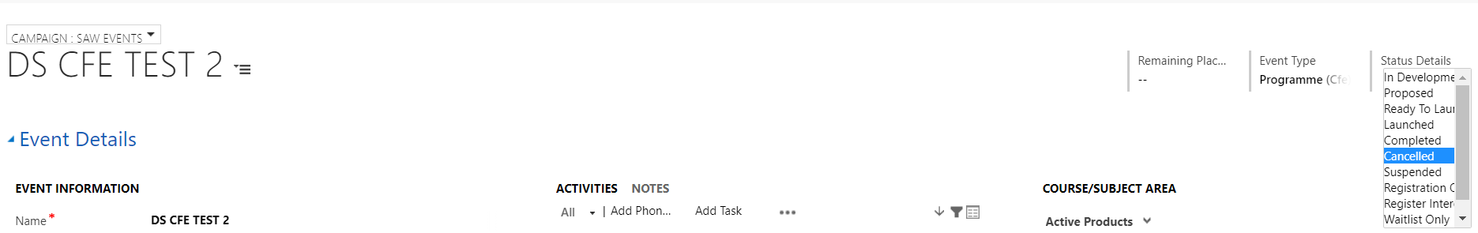
An Email will be sent to those registered as attending, advising them of the Booking Cancellation and Event will be removed from the website.

- Event Registration
Registering Students Attendance at an Event

  - Manual Register

- Navigate to the Event Page

- Click on the three dots along the top (next to Start Dialog)
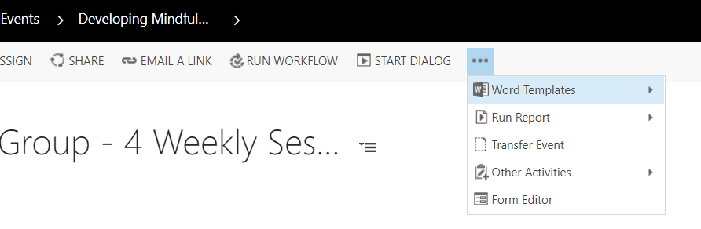
- Click on Run Report

- Select SAW Event Register
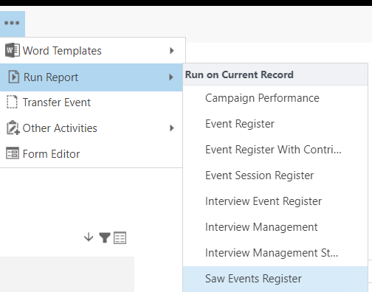

- A list of students who are registered for the Event will appear and you can print this out/Save it.

- Adding Students on to an Event Manually in CRM

- Although preferable for attendees to book themselves via the Website, you may need to manually add a student on to an Event directly into CRM.

- You can do this via the Event page.

- Once you have added the attendee, then an Email will be sent to the attendee automatically from CRM confirming the Booking.

- A reminder email will also be sent 24 hours prior to the date & time of the Event.

- Navigate to your Event Booking.

- Scroll down to ‘Bookings’
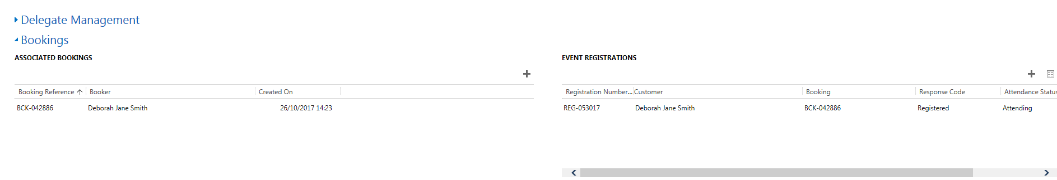
- Where it says ‘Event Registrations’ click on the ‘+’.
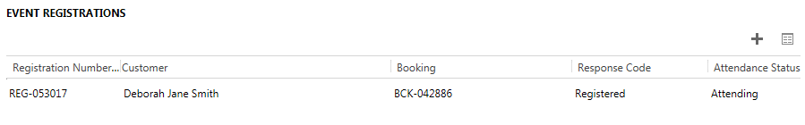
- ‘New Campaign Response’ box will open

- Ensure that the header above ‘Campaign Response is set to Campaign Response: Attendee by clicking on the downward arrow.

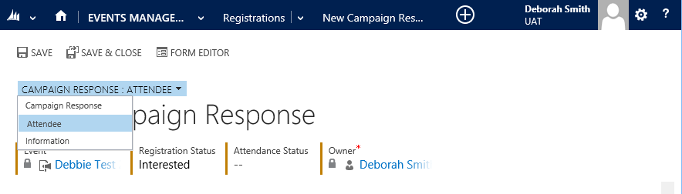

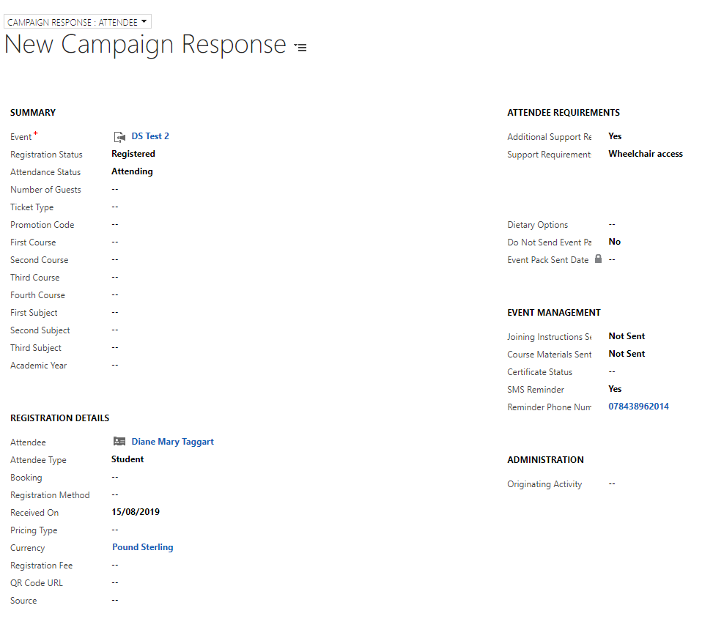
4
3
2
1

4

- Click into the Registration Status field, and select Registered (1)
- Next, click into the Attendance Status field and select Attending (or Attended if adding after the Event)
- Navigate to the Registration Details section (2)
- Click into the Attendee field and search for the student.
- You can search for the student by using the wildcard * or by student ID number.
- Once you find the student, click the ‘tick’ to the left of their name and then ‘Add’.
- Click into Attendee Type and select ‘Student’
- If the student has any Additional Support Requirements, navigate to Attendee Requirements and complete relevant boxes. (3)
- If the Student would like an SMS reminder, then navigate to ’Event Management’, SMS Reminder, select Yes and enter students Mobile Number. (4)
- Make sure you Save!

- Completing an Event

Once an Event has been held, all attendees have been added either automatically or manually, the attendees need to have their Attendance Status Updated.
- To do this, click into the Event & navigate to Bookings section.
- Click into the Event Registration’s & ‘pop out’, by clicking on the small square.
- A larger window will open up giving a list of students registered to attend the event.
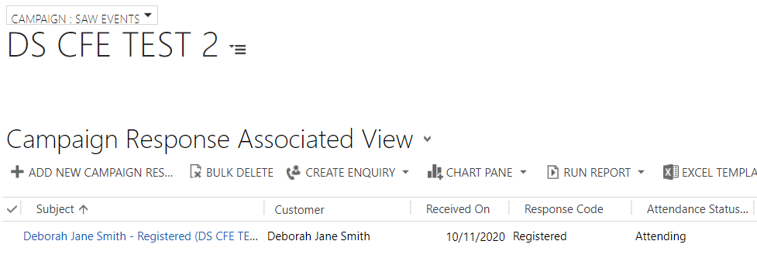

- If you have used a device to capture attendees at the event then the Attendance Status should have updated ‘Attending’ to ‘Attended’ automatically.

*Please note that this will update roughly every hour*

- If a Device was not used, or you need to manage those that have not shown up/scanned in then you can update the Attendance Status manually.
- To the left of ‘Subject’ and the students name you will see a tick column.
- Once you have ticked against the student, you will notice options appear along the top, Attended and No Show.
- You will be able to select multiple students, and amend their Attendance Status
- Once you have done this, you need to navigate back to the Event so that you can ‘Complete’ it.
- From the Event page, change the ‘Current Status’ to Completed.
- Click on the ‘Save’ Icon.

- Creating a Case for those who have Registered Interest in a Programme Event.

- You may wish to create a Case for those that have registered an Interest in a Programme Event so that you can store interactions and documents in one place.
- Navigate to the Event page.
- Scroll down the page to Event Registrations
- Click on the small box to pop out the window.
- Tick on the individual attendees you would like to create a case for.

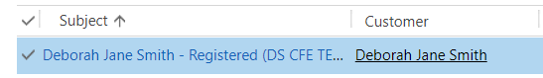

- Next, click on the 3 dots at the top of the window
- Select Run Workflow from the options.
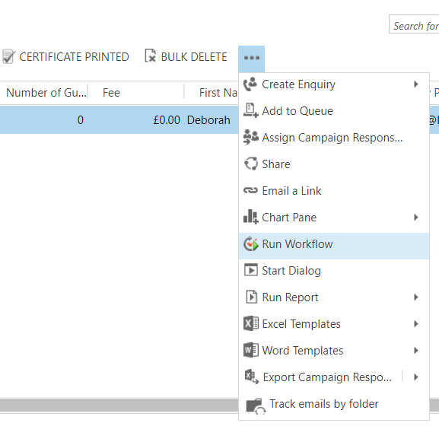

- A ‘Look Up Record’ window will open.
- Type ‘cfe’ in the Search field.
- A Process Name ‘CFE-Create Case’ will appear selected.

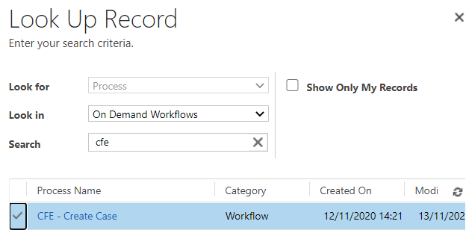

- Click Add

- Click Ok on the ‘Confirm Application of Workflow’ window pop up.
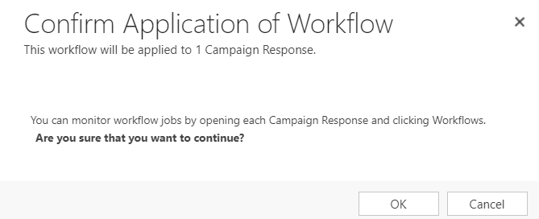

- The case will then be created, and details of how you pick this up can be found within your Cases Documentation.

- Workflow Emails/SMS
A number of Workflows have been created within CRM to send emails automatically at different stages of the Event process. Emails will be sent to LJMU Email Addresses only. More details on email content can be found in a separate document Appendix 1.
The workflows are:
- Booking onto an Event
- Reminder of an Event
- Event Change
- Event Cancellation
- Event full – on a waiting list
- Event full – on a waiting list and place becomes available.
Any changes to Workflows, need to be requested via Helpdesk.
SMS will be used in the following situations:
- Reminder of Event (If student opts for this and adds mobile number).
- Event Cancellation (by CFE Staff)
- Event Change (Venue/Room/Time)

