Process Document

CRM – Centre for Entrepreneurship
Liverpool John Moores University

Processing a Case

Version 0.2 November 2020
Author: SL Business Support Team

Version Control
Version | Date
Version 0.1 | November 2020 | Original Version
Version 0.2 | November 2020 | Section added: Add Contact to a Business Organisation

Contents
Processing a Case in CRM: Overview 4
Checking the Contact Record 4
Checking the Information on a Contact 4
Activities 5
Processing the Case: Initial Contact 5
Processing the Case: Initial Response 6
Processing the Case: Training/Development/Support 6
Assigning a Case to Others 8
Processing the Case: Trading 9
Creating a Business Organisation 9
Add Contacts to a Business Organisation 12
Processing the Case: Outcome 13
Reactivating a Resolved Case 15
Cases Created from Campaign Responses 15
Case Referrals 15
Case Chevron Errors 16

Processing a Case in CRM: Overview
Once you have created a case (details available in separate guide: ‘Creating a Case’), you will notice the chevrons along the top of the screen. These chevrons effectively make up the Case Management Flow for the case you have created. This flow will take you through the life of the case from beginning to resolution. The Case Management Flow changes depending upon the Subject selected on Case creation. For all CFE cases, the subject selected will ensure that the correct process is used.
Stages of a CFE Case:
- Initial Contact
- Initial Response
- Training and Development/Support
- Trading
- Outcome
All CFE cases will have 5 stages and these will show as a flow along the top of the case. The current stage will be highlighted in green and have the word ‘Active’ displayed.
To work through each stage, the user will need to complete relevant information which is displayed below each stage. Any field with a red star is mandatory.
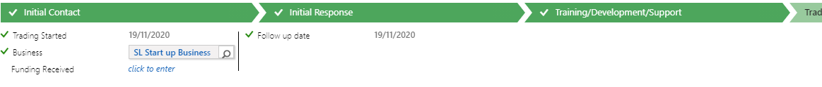

Checking the Contact Record
The CFE customers will be normally be students.
All current students (and staff) will already be set up as a Contact in CRM. Users need to set up external contacts manually, for example external agencies.

Checking the Information on a Contact
To navigate to the Contact:
- Select Student Services.
- Then select Contacts
- Search for the correct Contact.
- Ensure the form is Contact: SA
- Navigate to Student Details
Here you can check the contact information to ensure it is the right person in the case.
Or if you are already in an open case, click on the contacts name to bring up the record.

Activities
To ensure all of our emails and activities relating to this case are stored correctly, it is best practice to add the relevant activity from within the case. To do this, find the middle panel that has the following headings: Posts, Activities and Notes.
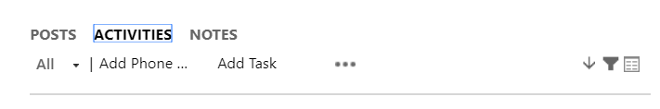
There are separate guides for:
- Adding Phone Calls
- Adding an Appointment
- Uploading Documents
- Sending Emails
- Adding Notes
You can complete any of the above at any point throughout the life of the case.

Processing the Case: Initial Contact
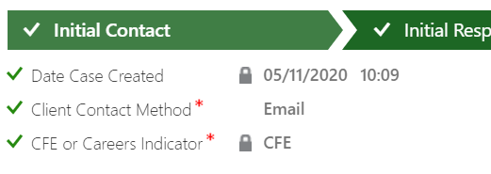
- Date Case Created – This is a locked field and will default in the date/time the case was created
- Client Contact Method – Walk in, Phone, Email, Web, Facebook, Twitter, Appointment (this will display further down the case form in the Case Origin field)
- CFE or Careers Indicator – locked field, CFE will default here for you
On the Case Details section of the form you can also populate the following;
- CFE Type – Select the relevant one from the dropdown list
- Client Type – Select the relevant one from the dropdown list
- Follow Up/Target – The date entered here is the date by which the Case should be followed up. By entering a date here, this will ensure the case is displayed on the CFE Case Management Dashboard under the view Cases to Follow up CFE
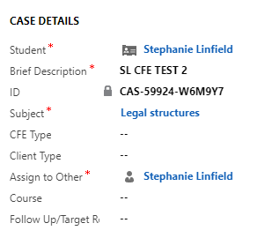
When the information has been populated and you want to move on to the next stage click the green ‘Next Stage’ to move on.
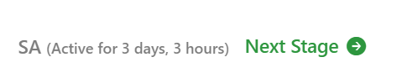
You will notice the flag will now move to the next chevron (e.g. the Resolve stage). You can also move back a stage by following the same process.

Processing the Case: Initial Response
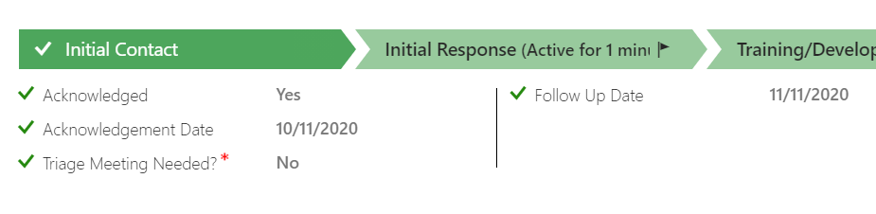
Fill out the relevant fields:
- Acknowledged – Yes or No
- Acknowledged date – enter date
- Triage Meeting Needed – Mandatory field, Yes/No/Completed
- Follow Up Date – Enter date

Processing the Case: Training/Development/Support

Fill out the relevant fields:
- Date of Triage Meeting – Enter date
- Startup Visa – Yes or No
- Additional Needs – free text box
- Assign to Others – You can assign this to another member of the team here – this will send them an email to let them know they have a case assigned to them
- Follow up date – The date entered here is the date by which the Case should be followed up. By entering a date here, this will ensure the case is displayed on the CFE Case Management Dashboard under the view Cases to Follow up CFE
- Year of Graduation – enter the Academic year
- Start-up Visa Endorsement – yes or no
- Sector 1 (2 and 3) – You can enter the relevant sector here.
Click the magnifying glass, and scroll to Look Up More Records to search for the correct sector.
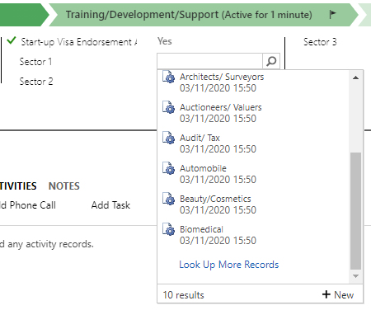
The following box will open;
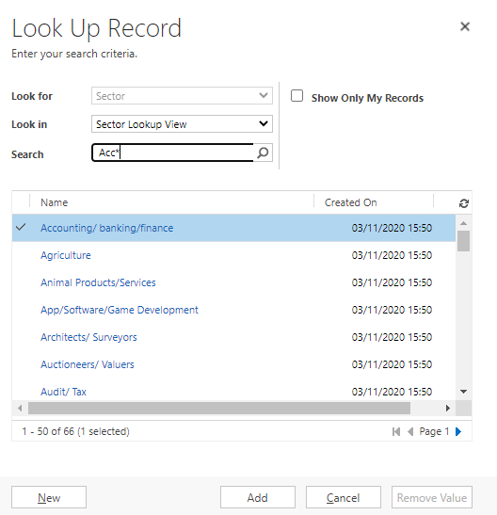
- Search for the sector (you can use the wildcard * to do this), select the record and click Add

Assigning a Case to Others

- Click the magnifying glass next to the Assign to Others field and select Look Up More Records
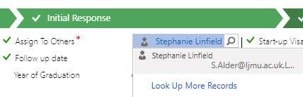

- On the box that opens ensure Look For is set to User and Look in set to User Look Up View. You can then search the staff name (using the wildcard*). Select the record, and Add.
- The team member will receive an email to let them know a case has been assigned to them.
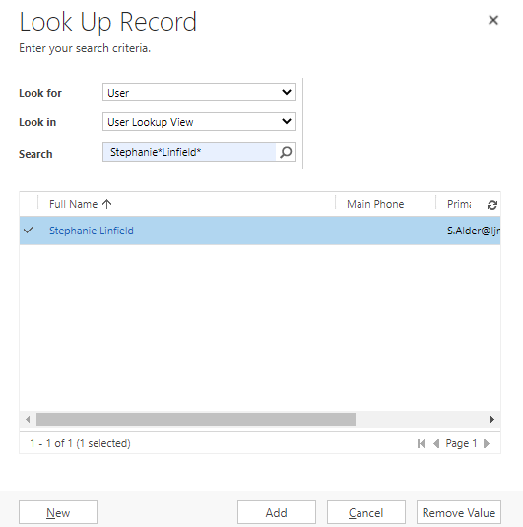

Processing the Case: Trading
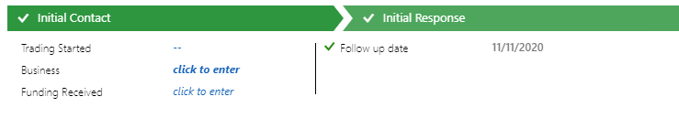
Enter the following details:
- Trading Started – Enter date
- Business – Click to enter the Business (it is likely you will need to create a new Business, further instructions below)
- Funding Received – Free text box
- Follow up date – this will default what was previously entered, but can be changed

Creating a Business Organisation

- To create the Business Organisation click to enter on the Business field, then click the magnifying glass and scroll to Look Up More Records
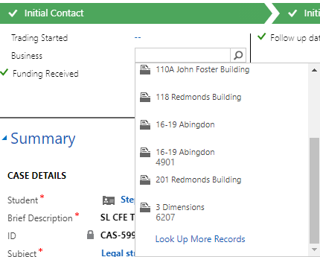
The following box will open;
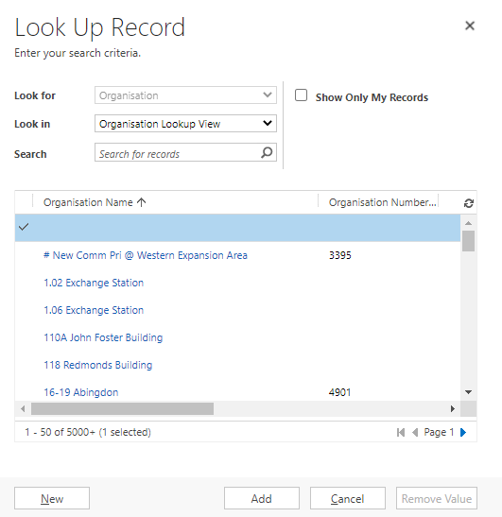
- You can search to ensure the business does not already exist (make sure you are using the Organisation View as above), and if it doesn’t exist select New and the New Organisation form will open
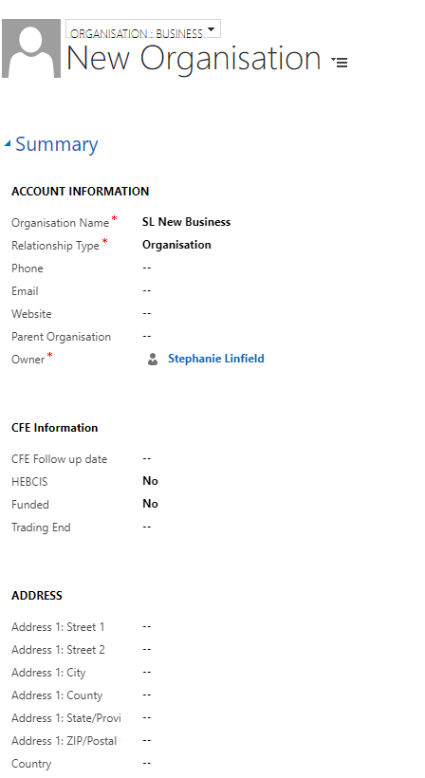
Ensure you are on the Organisation: Business form (as highlighted above)
Populate the mandatory fields;
- Organisation Name – Enter the name of the Business
- Relationship Type – You must select Organisation
- Owner – this should default to the person who is setting up the business
Then enter as much information as possible in the optional fields including the CFE Information Section
- CFE Follow up date – Enter Date
- HEBCIS – Yes or No
- Funded – Yes or No
- Trading End – Enter date
Once you have entered all the information click Save & Close
You will then be taken back to this box where you need to highlight the record (so a tick appears next to it), then click add.
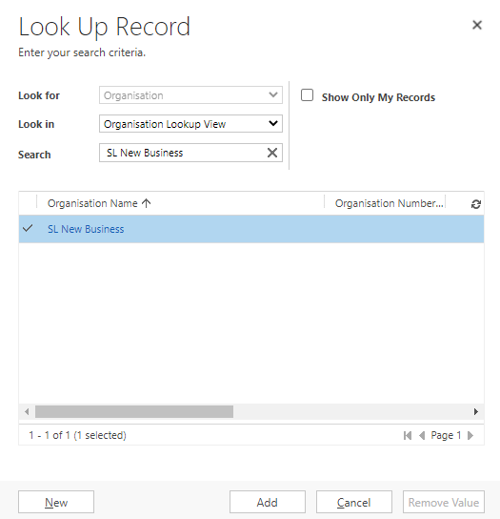
The Business name will then display on the Business field of the case record
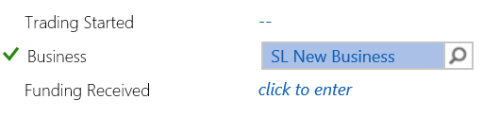

Add Contacts to a Business Organisation
When a Business is created and saved, you can add a contact record to it.
Open the Business record back up (click on the blue name within the case and it will open up the Business Organisation form again), click on the grid view under Contacts
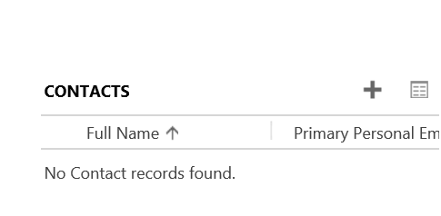
Then click either;
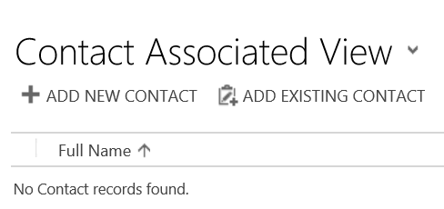
Add New Contact – this will open up the new contact form enabling you to create a new contact, populate the relevant information and save the new contact.
Add Existing Contact – this will enable you to search for an existing contact. Click the magnifying glass, scroll to look up more records, and search for the contact, highlight the name so a tick appears next to the record, then click select and add
When you have added any contact/s required they will display on the Business Organisation record.

Processing the Case: Outcome
- Resolve Case: Click on the blue Mark Resolved and a new form will pop out

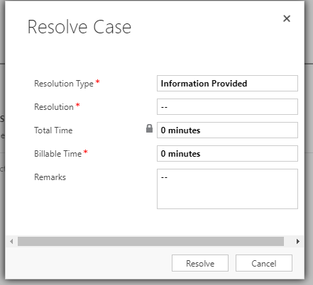
- Resolution Type – select the relevant option from the drop down list (please note these options are the same for all teams using cases on CRM – they are not specific to CFE) It is recommended to select Information Provided
- Resolution – Free text box, type Resolved
- Total time – locked field, this will add up any time added to activities e.g. phone calls, appointments etc.
- Billable time – you can add this manually
- Remarks – remarks can be entered here
- Click Resolve
In the Activities pane on the case form it will now show as Resolved
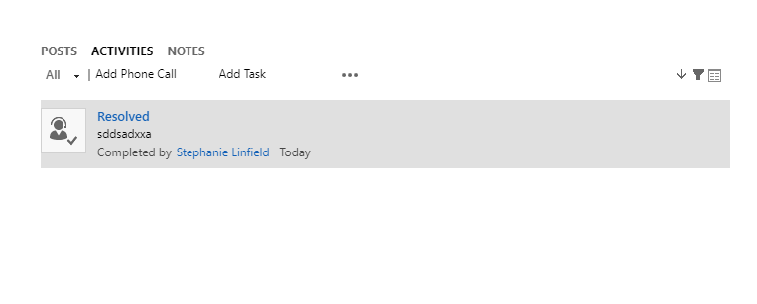

Reactivating a Resolved Case
A situation may arise where a case will need to be reopened. To do this, you will need to return to the case that you would like to reactivate. In the ribbon at the top of the page, there is a button called ‘Reactivate Case’.
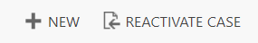
This will allow you to edit the case and add more components.

Cases Created from Campaign Responses
You are able to automatically create Cases for contacts who register interest in a Programme Event (See Event documentation for details).
Once the case has been created, this will appear on your dashboard under the Cases Created From an Event view. These will be assigned to your team. When you pick up one of these cases, you will need to assign it to the correct owner (see instructions on how to assign a case above).
The subject will default to Training and Events. You may wish to amend this (click in the subject field and select the correct CFE subject type, as you would when creating a case).
The Brief Description will default to CFE – Programme Attendee. You may wish to amend this description as this is the case name, but it is an internal decision.
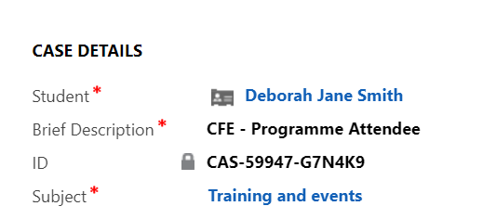
You should then continue to process the case as you would any other case.

Case Referrals
You can refer a case to another team in LJMU if necessary.
On the Case form, scroll to the Case Referrals section
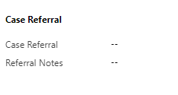
- Case Referral – select the LJMU team from the drop down list
- Referral notes – Add your notes here. This is a mandatory field. Please be aware that as soon as you enter something here it will send the Referral. If you have no notes to add then you will still need to type something in this box.
****It’s important to note that because the Case form AutoSaves if you type something in the box and then move away from the box the Email to the team selected will be sent.****

Case Chevron Errors

If you ever notice that the Chevrons are not correct across the top of the screen for your cases, you can resolve this yourself.

When in a case, click the 3 dots at the top of the page
Select Process
Select Switch Process

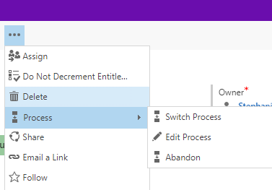

The following screen will open
Select SA
Press Select

