Process Document

CRM – Accommodation Booking Management
Liverpool John Moores University

Accommodation Team

Version 0.3 March 2020
Author: Stephanie Linfield Business Support Team

Version Control
Version 0.1 | January 2020 | Original version
Version 0.2 | February 2020 | Updated 12 to include manually entering the Academic Year
Version 0.3 | March 2020 | Added 6.2, updated 15 and 16 to show new email communications
Contents
2 Business Context 3
3 Maintaining Accommodation Providers 4
3.1 Accommodation Providers 4
3.2 Adding a Building or Halls 5
3.2.1 Accommodation Details 7
3.3 Adding/editing room types 8
3.4 Link to Campuses 9
4 Accommodation Management Dashboard in CRM 10
4.1 Locating your Dashboard 10
4.2 Pinning Your Dashboard 10
5 Accommodation Requests – Yet to be allocated 11
5.1 Allocating a request 11
5.2 Selecting the correct application / changing an application 12
5.3 Adding a note to booking request 13
6 Allocated bookings to be sent – All years 13
6.1 Sending allocated requests to the Accommodation building 14
6.2 Re-allocating a booking request 15
7 Accommodation Requests – On Hold 15
8 Cancelling an accommodation request 16
8.1 Cancelled by student 16
8.2 Cancelled by Accommodation Office 17
8.3 Cancelled by Application 17
9 Allocated bookings to be cancelled with Halls 18
10 Confirmed/Allocated – Application Change 19
11 Confirmed as Cancelled with the Provider 20
12 Creating a booking on behalf of a student 20
13 Viewing all Accommodation Bookings 24
14 Report 25
15 Workflows emails 26
16 Appendix A: Communications 27
16.1 New Accommodation Request 27
16.2 Clearing Booking Request confirmation 27
16.3 Accommodation request withdrawn 28
16.4 Accommodation request cancelled by Accommodation Office 29
16.5 Accommodation Sent to Halls 29
16.6 Accommodation Requests – On Hold 30
17 Appendix B: SIS Trigger Application Statuses 31

Business Context
This document will explain the new process that has been built-in to CRM to help the Accommodation Team to maintain Accommodation Provider information and manage Student accommodation bookings.
The Accommodation Team will be able to update Accommodation Provider/building/room information in CRM. This information will feed through to the accommodation website, making it visible to students to help inform their accommodation choices. Students who are at the correct application status will be eligible to request an accommodation booking via the LJMU applicant area (CF – Conditional Firm, UF – Unconditional Firm, CLA – Clearing Accept, for the full list of trigger statuses - see appendix B).
When a student has made an accommodation booking request through the applicant area, a new booking record will be created in CRM. The Accommodation Team will have the ability to manage student bookings via a bespoke dashboard and send allocation information to the relevant halls.

Maintaining Accommodation Providers
The Accommodation Provider records will have been set up by the CRM Systems Engineers. The Accommodation Team can update the buildings and rooms as per the process below. However, if a new Accommodation building is set up, then a helpdesk job should also be raised through the LJMU Help me icon. This is to ensure the web team are informed of the new building, so they can create the corresponding web page in Sitecore.

Accommodation Providers
These are Organisation records, which have a relationship type set to be Accommodation Provider.
- Next to Dynamics 365, there will be an Entity Name. e.g. Recruitment
- Click on the downward arrow next to Entity Name, select ‘Recruitment’
- Select ‘Organisations’
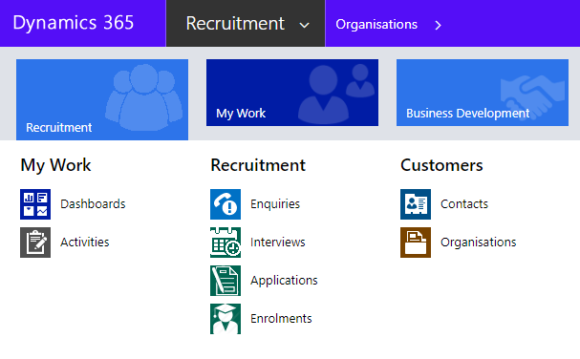
In the drop down list, change the view to ‘All Accommodation Providers’. This will list all the Providers set up in the system. You can pin this view by clicking on the pin symbol
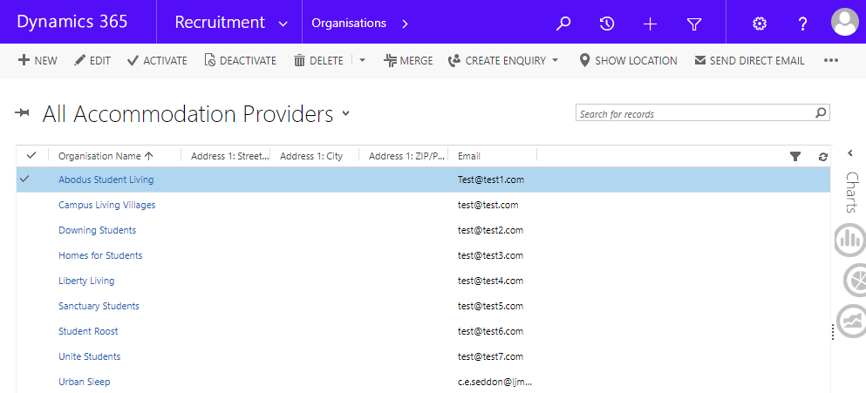
- Select the Accommodation Provider you wish to maintain and it will take you to the Provider information
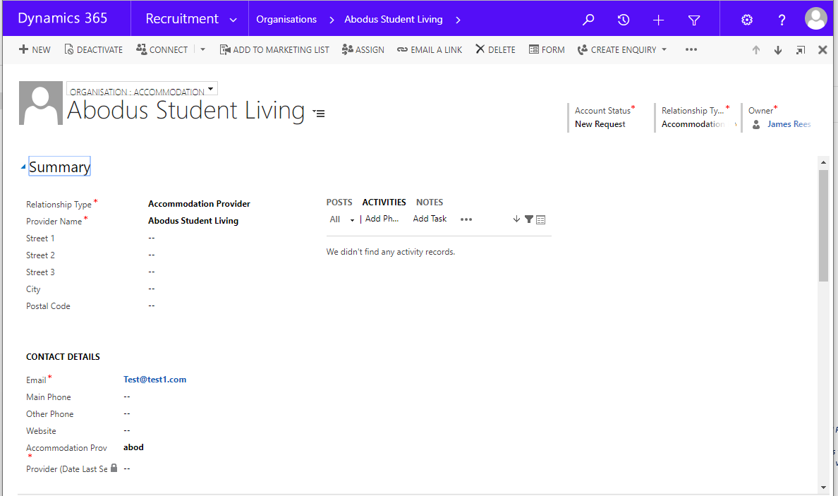
Here you can maintain the Accommodation Provider email address and the password. Ensure the Organisation Form view is set to ‘Organisation: Accommodation’
- Click in the relevant fields to amend information
- Email – This is an overall contact email address for the Provider should you wish to add one. This will not be the email that the accommodation allocations are sent to.
- Accommodation Provider Password – here you should type the beginning of the password that you want to use for this provider for all buildings linked to this accommodation – this should be four letters. Please note, the date will be added to the end of the password during the function in six-digit format. For example, if you set this to be TEST and then send the allocations on the 14 September 2020, the password will be TEST140920.
- Click ‘Save’

Adding a Building or Halls
You can add a new building to a Provider, or maintain the details on an existing building (if adding a new building, then please also raise a helpdesk job as per the previous instruction).
Whilst on the Provider record;
- Scroll down to the ‘Buildings’ grid on the provider record (if you wish to maintain an existing building then open up the record and follow the steps below)
- To create a new building click on the Plus Symbol, then the magnifying glass and then New.
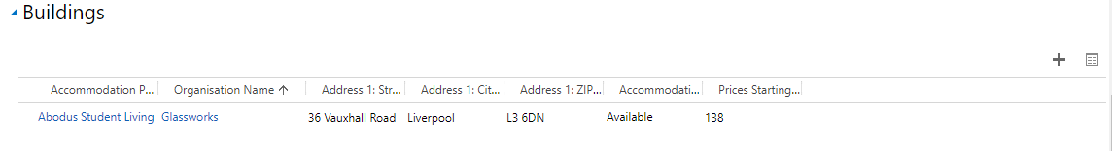
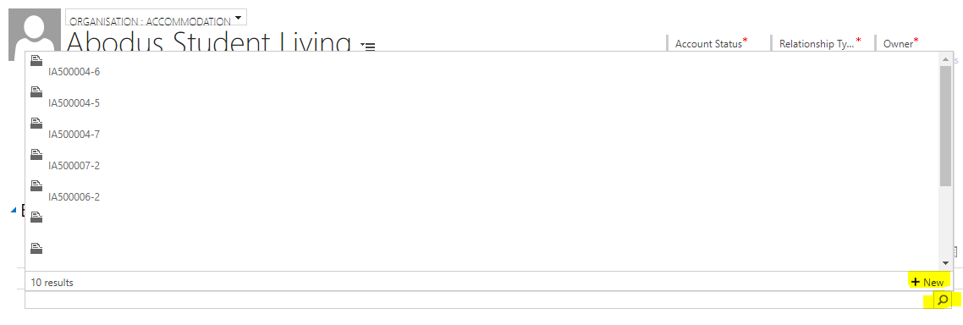
In the window that opens, populate the following fields;
- Relationship Type*: Select Accommodation (ensure you click the correct parameter here)
- Accommodation Provider*: Provider Name (this should be pre-populated with the Provider name if created via provider sub grid)
- Building Name*: Enter the name of the building
- Street 1*: First line of the address
- City*:
- Postcode*:
- Once all information populated click ‘Save’

***Please note the building address fields are needed for displaying on the website, so must be entered correctly***
Scroll down to the ‘Contact Details’ of the form and add the following details;
- Email – This is the email address you want to send the accommodation allocations to. This should always be a generic address. It will also be included in the email communication sent to a student when an accommodation request has been sent to halls
- Phone numbers – This is will also be included in the email communications sent to a student when accommodation allocations have been sent to halls
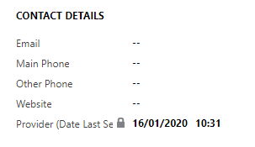
To note: If you ever need to check the last time an email was sent to the building provider then you can view this in the building record under the ‘Contact Details’ section of the form, in the field ‘Provider (Date Last Sent)’.

Accommodation Details
Whilst still in the Building record, on the right hand side of the page the ‘Accommodation Details’ need to be populated.
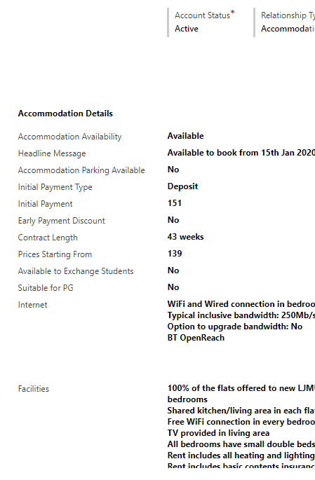
Complete the following fields:
- Accommodation Availability: Set to Available or Unavailable (This will display accordingly on the website, and will only allow students to book if it is set to available).
- Headline message: This is a free text box to write your headline message that will display on the website (100 characters max) e.g. Available to book from 3 February 2020
- Accommodation Parking Available: Set to Yes or No (students will only be able to select this as an option in their booking if it is set to yes).
- Initial Payment Type: Free text box e.g. Deposit
- Initial Payment: Enter a number e.g. 150 (do not add currency here)
- Early payment Discount: Free text box e.g. No or 5%
- Contract Length: Free text box e.g. 42 Weeks
- Prices starting from: Enter a number e.g. 138 (do not add currency here)
- Available to Exchange Students: YES/NO – used in filtering on the web pages (set to YES, as all buildings will be available to Exchange students who study for a year).
- Suitable for PG: YES/NO – used in filtering on the web pages – this does not stop PG students from making a booking, it is just used as an indication of suitable PG accommodation
- Internet: Free text box (max 2000 characters, cannot enter bullet points)
- Facilities: Free Text (max 2000 characters, cannot enter bullet points)

Once all information is populated click ‘Save’
***These records sync to the website (hourly) to display the information on the accommodation pages***

Adding/editing room types
Once the accommodation building is saved, you can add or edit rooms.
Scroll to the right hand side of the page to the ‘Room Type’ section
- Click the plus symbol to add a room (or click on an existing room to edit)
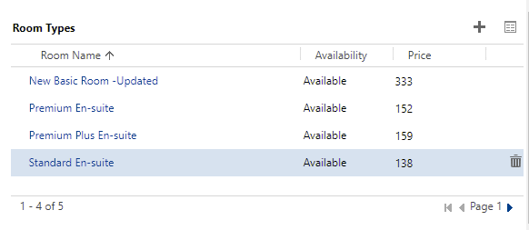

In the new window that opens, populate the following fields:
- Room Name: Super Superior Deluxe Room with Ensuite
- Short Description*: SSDE – this short description is determined by the Accommodation Team
- Accommodation Building*: Should be auto Populated with the building
- Room Type*: En-suite, Studio or Shared – Used for filtering on the website
- Availability: Available or Unavailable (if set to unavailable then students will not be able to book this)
- Price: 123

Then click ‘Save’ and close.
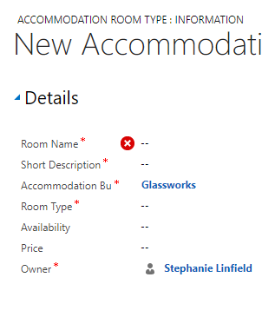
***New rooms will be automatically picked up by the synchronisation processes (hourly) and display on the website***

Link to Campuses
In order for the website searches to work correctly, the building must be linked to the relevant campus or campuses (students can search by campus on the website).
On the right hand side of the page (beneath the Room Type) is the ‘Campuses’ sub grid.
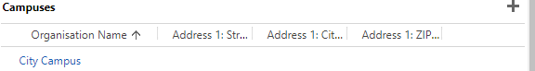
There are currently only 4 campuses set up in CRM.
- City Campus
- IM Marsh Campus
- Mount Pleasant Campus
- Partner College Campus (unlikely to pick this)

To select the campus;
- Click on the plus symbol, then the magnifying glass and pick one of them – repeat as necessary
- Click ‘Save’ at the bottom right corner of the page

Accommodation Management Dashboard in CRM

Locating your Dashboard
Each Department who use CRM have their own dashboard, which normally acts as a ‘home’ page. There is now a new dashboard called ‘Accommodation Management’. This has been split into six views to help manage incoming booking requests;
Accommodation Requests – Yet to be allocated
Allocated Bookings to be sent – All Years
Accommodation Requests – On Hold
Accommodation bookings to be cancelled with Halls
Confirmed/Allocated – Application Change
Confirmed as Cancelled with the Provider
Next to Dynamics 365, there will be an Entity Name. e.g. My Work/ Recruitment
- Click on the downward arrow next to Entity Name
- Select ‘Dashboards’
- Select the ‘Accommodation Management’ dashboard from the drop down:
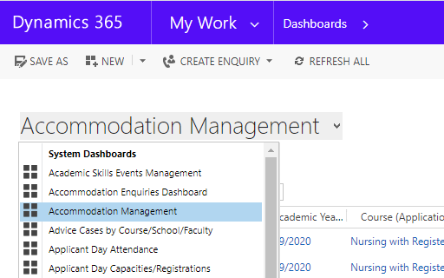

Pinning Your Dashboard
You can pin your Dashboard so that it appears each time you log in to CRM.
Click on ‘Set as Default’ on the toolbar
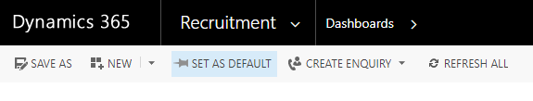

Accommodation Requests – Yet to be allocated
These are all the accommodation request received during the main cycle of requests.
- Click on the booking record to process it – (do not click on the blue writing or this will take you to a different page e.g. the student contact record)
Here you can view the booking request details (student preferences/special requests/friend requests, key dates and the booking status).
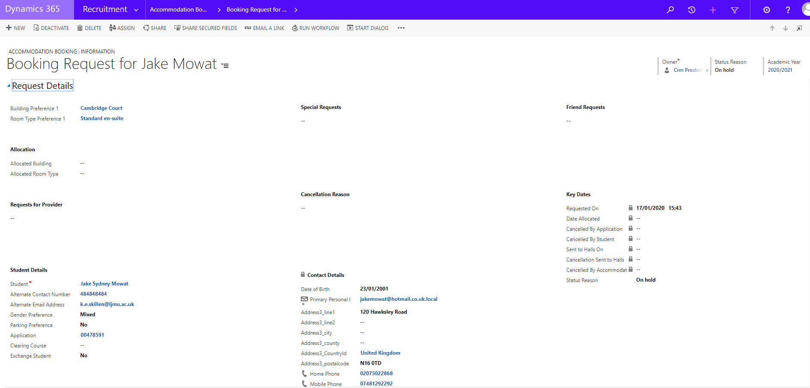

Allocating a request
Open up the relevant booking request and populate the following fields;
- Allocated Building – start typing the building name and press enter to search for it, then select
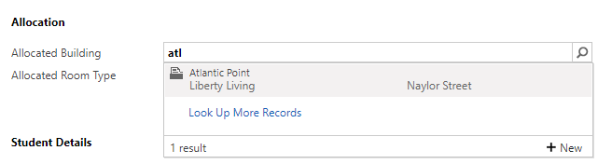
- Allocated Room Type*- click the magnifying class in this field and select the appropriate room type.
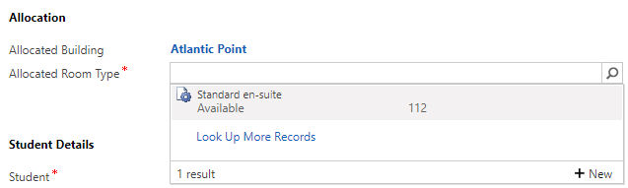
- Click ‘Save’
The status reason (top right hand side of the page) will then change to ‘Allocated’ and a time/date stamp will default in the ‘Key Dates’ section under ‘Date Allocated’
You should also add any information in the booking requests that you want to be sent to the provider in the ‘Requests for Provider’ field
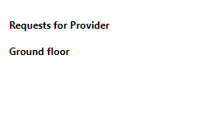
- Click in ‘Requests for Provider’ field
- Manually enter the relevant information (combined from the Special Request/Friend Request sections of the form)
- Click ‘Save’
***Check all the booking details are correct before sending to an Accommodation Provider, including the correct application number***

Selecting the correct application / changing an application
On the student booking form there is an ‘Applications’ section to show all the student applications. Please ensure the correct application from this list is set in the ‘Application’ field in the ‘Student Details’ section of the form.
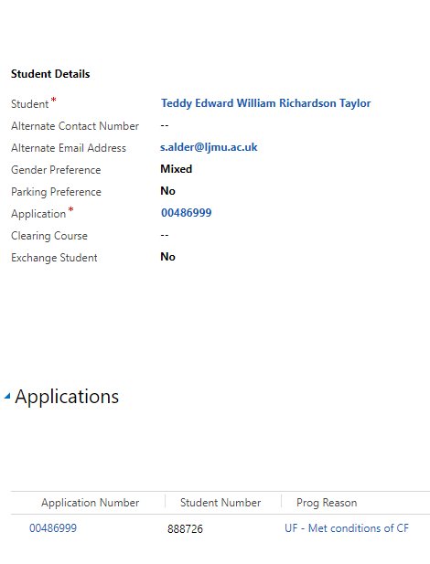
If for any reason the application needs to be changed (e.g. during clearing or for any other reason);
- Click the magnifying glass in the ‘Application’ field and select the appropriate application from the drop down list.
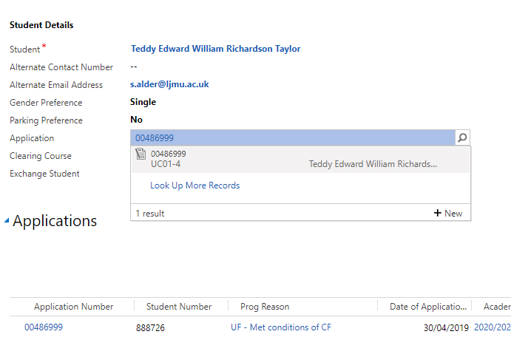
You must also ensure the correct ‘Academic Year’ is set at the top right hand side of the page; this will default to the academic year for the student’s original application. If an application is changed, check this is still correct.
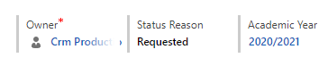

Adding a note to booking request
To add notes to a student booking request that can only be viewed by the Accommodation Team;
- Open the relevant booking request form
- Scroll down to the bottom of the form to ‘Activities’
- Select the ‘Notes’ tab
- Write the note and click ‘Done’
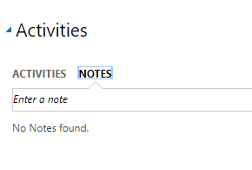

Allocated bookings to be sent – All years
When a booking has been allocated, it will move to this area of the dashboard until it has been sent to the building provider. Here you can keep track of what needs to be sent to halls.

Sending allocated requests to the Accommodation building
The new Accommodation Bookings website will enable the Accommodation Team to send allocated bookings to accommodation building.
Navigate to the Accommodation Bookings website via the following link
https://crmweb.ljmu.ac.uk/accommodation/ (this is the link to the LIVE webpage)
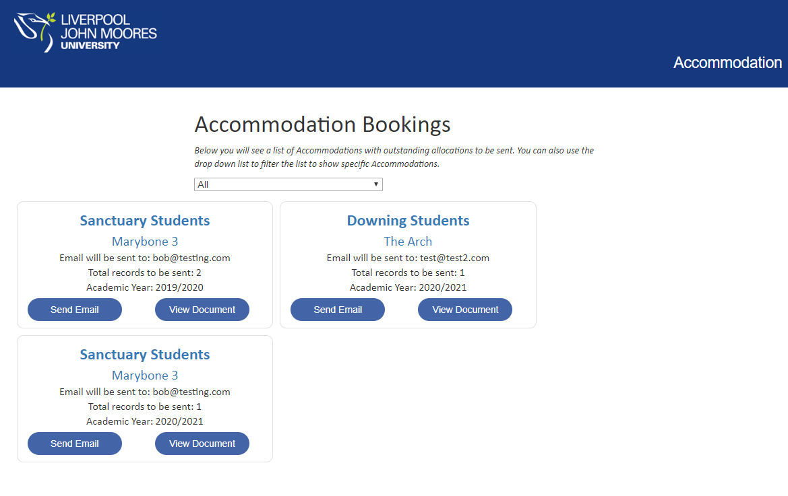
To note;
- Allocations are grouped by Building
- The building and provider is a clickable link and will take you to the relevant pages in CRM
- The email address that the information will be sent to is displayed (this should be the email address that is stored against the building record)
- When clicking ‘View document’, you will be able to see what information will be sent to the halls
- When clicking ‘Send Email’, the information will be sent to the email address displayed with a password protected excel spreadsheet attached. The password is the Accommodation Provider Password (stored on the Provider record) with the date it was sent in DDMMYY format at the end. When allocations are sent to the halls an email will also be sent to the student to inform them their request has been sent to halls.
The status of the booking will automatically change to ‘Sent to Halls’ with a time and date stamp. It will then drop off the dashboard.
You can check what emails have been sent to each building. The emails will be stored on the building record under the activities pane.
Navigate back to the building record via ‘Organisations’
- Select the view ‘All Accommodation’ to bring up a list of all buildings
- Select the relevant building
- View emails under ‘Activities’ pane
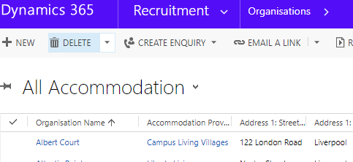
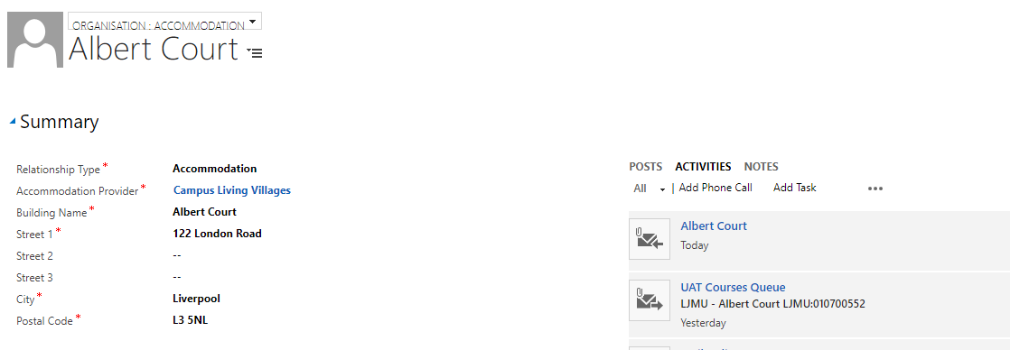

Re-allocating a booking request
If a booking request has been allocated and sent to halls, and the student subsequently gets back in touch with the accommodation team to amend the booking (without cancelling) then this can be done;
- Set the accommodation booking status back to ‘Requested’. Please note the student will not get another email notification.
- Change the allocated accommodation building and/or Room type and ‘Save’.
- Then the booking will be available to send over to the provider again (follow the process above).

Accommodation Requests – On Hold
If a booking request comes in but there is additional information required (e.g. the student has made a friend request, but the friend has not made a booking yet), then the status can be changed to ‘On Hold’.
- Open up the relevant booking request
- Select the field ‘Status Reason’
- From the drop down list select ‘On Hold’
- Click ‘Save’
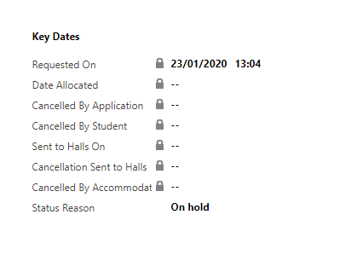
Once this status is applied, it will move to the dashboard view ‘Accommodation Requests – On Hold’. An automated email will be sent to the student to inform them their booking request is on hold.

Cancelling an accommodation request
There are three routes to cancelling an accommodation request and a status reason that corresponds with each route.
- Cancelled by Student
- Cancelled by Accommodation Office
- Cancelled by Application
In all three scenarios, if the student booking request has not been sent to the halls, then nothing further needs to be done and it will drop off the relevant dashboard.
If the booking has been allocated and sent to the provider then it will appear in the following dashboard view to be processed further ‘Allocated bookings to be cancelled with halls’

Cancelled by student
The student may cancel accommodation requests through the applicant portal. If a student cancels on the applicant portal then this will change the status reason of the booking in CRM to ‘Cancelled by Student’. The student will receive an email notification to say they have cancelled their booking.
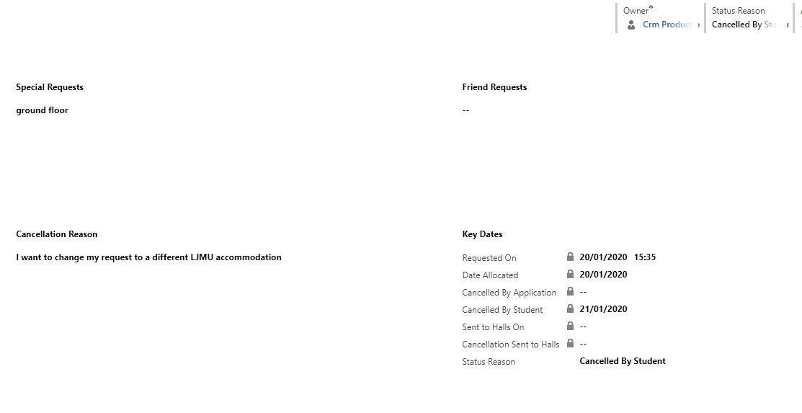
*** Please note that students who cancel an accommodation booking themselves, can re-book accommodation at any time providing they are still at the correct application status***

Cancelled by Accommodation Office
The Accommodation Team have the ability to cancel a booking at any time for reasons they deem appropriate.
Navigate to the relevant student booking form;
• Select ‘Status Reason’
• From the dropdown list select ‘Cancelled by Accommodation Office’
• Click ‘Save’ in the bottom right corner of the form
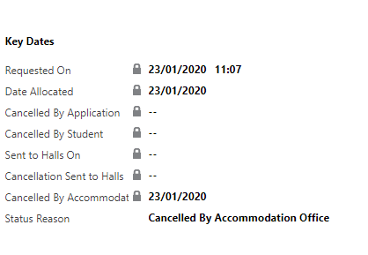
This will add a date stamp when it happened and an email will be sent to the student and the allocated provider to notify them the booking request has been withdrawn.

Cancelled by Application
If a booking is agreed to be cancelled due to the students application being declined/withdrawn etc. then the status reason on the booking will need to be manually changed to ‘Cancelled by Application’. This will date stamp when it happened and an email will be sent to the student.
Navigate to the relevant student booking form;
- Select ‘Status Reason’
- From the dropdown list select ‘Cancelled by Application’
- Click ‘Save’ in the bottom right corner of the form
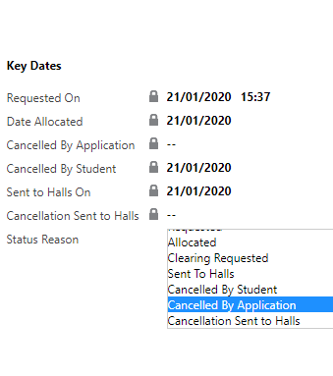

Allocated bookings to be cancelled with Halls
If a student booking has been allocated and sent to halls and is subsequently cancelled by either the student/application/accommodation team it will appear in the dashboard view ‘Allocated bookings to be cancelled with Halls’ for processing.
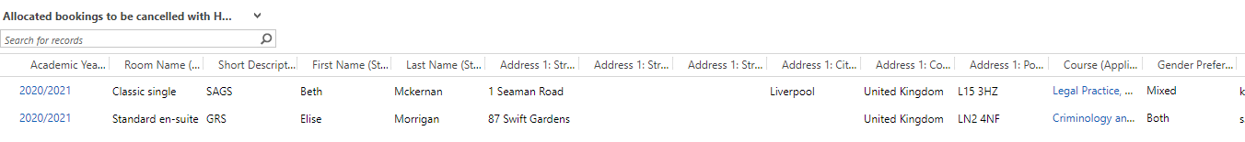
In any of the cancellation scenarios above, if the allocation has previously been sent to halls then they will need to be informed (manually) that a booking is being cancelled. After notifying the halls, the student booking record must be updated with the correct status;
- Open the correct student booking record
- Select ‘Status Reason’
- From the dropdown list select ‘Cancellation Sent to Halls’
- Click ‘Save’ in the bottom right corner of the form
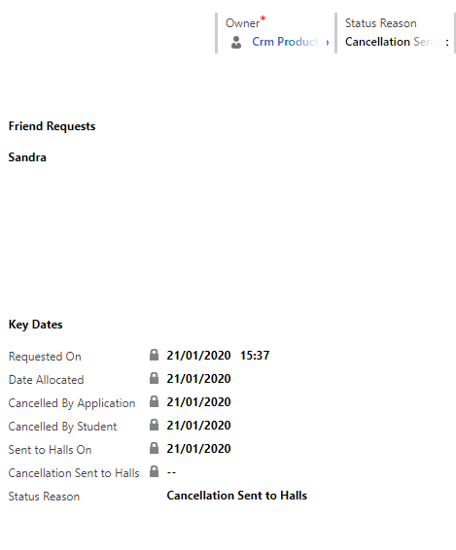
The student booking record will then move to the dashboard view ‘Confirmed as cancelled with provider’

Confirmed/Allocated – Application Change
If allocations have been sent to halls and then an application status changes e.g. the application is deferred, the booking records will appear in this view of the dashboard to highlight any potential cancellations. This view is only for consideration as it is only looking at the application the student originally applied for accommodation against. If necessary, a booking record can be opened here for any further processing.
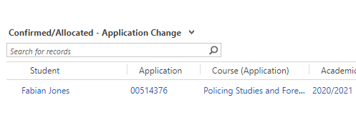

If the booking needs to be cancelled, then open up the booking record and select the appropriate Status Reason to cancel it (as per the instructions on how to cancel a booking)
If a change happens to an application, but the booking does not need to be cancelled, then you can select to ‘Ignore’ this application change.
- Open the student booking request
- Under ‘Student Details’, click on the blue application number in the ‘Application’ field
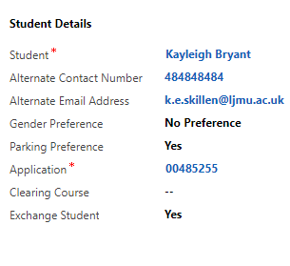
This will open up the Application Record. Ensure the form view is set to ‘Application: SIS’
- Click in the ‘App Status Change (Accommodation) ’ field
- Select ‘Ignore’
- Click ‘Save’
This is only for use by the Accommodation Team and once a status is set to ignore the booking request will drop off this section of the dashboard.
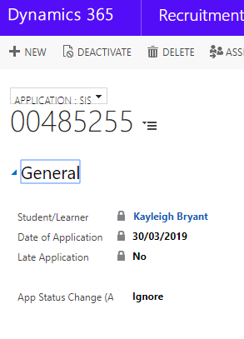

Confirmed as Cancelled with the Provider
This provides a view of all booking requests that have the status set to ‘Cancellation sent to Halls’. These records will stay here for approx. 3 months.

Creating a booking on behalf of a student
On occasions where it may be necessary to create a booking on behalf of a student, you should log on to the applicant portal using the students SIS/UCAS ID and email address to create a booking.
If this is not possible (e.g. because the student is a Foundation student commencing level 4 and therefore, no longer an applicant), then a booking can be created manually.
- Navigate to the Accommodation Management Dashboard
- Under Accommodation Requests – Yet to be allocated, click on the plus symbol on the right hand side of the page
This will open a new ‘Accommodation Booking’ form
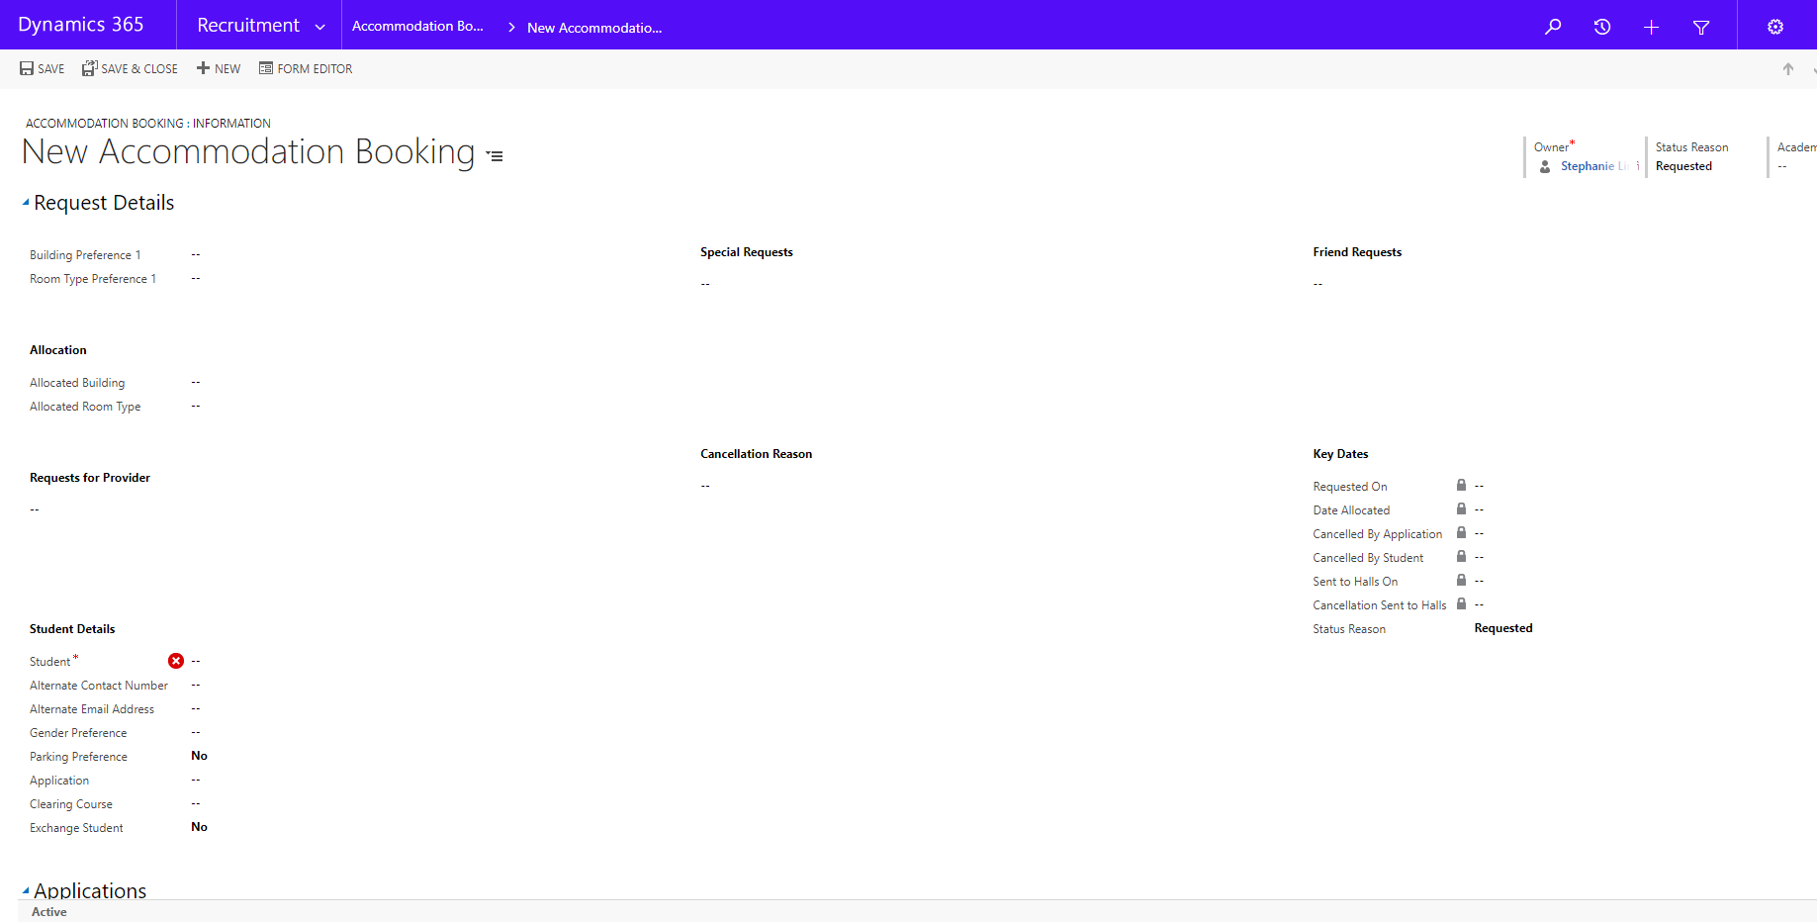
First, populate the relevant fields under ‘Student Details’
- Student: Enter the student number or search to select the student (instructions below)
- Alternate Contact Number: If provided
- Alternate email address: Enter the email address that communications should be sent to
- Gender preference: Select single, mixed, no preference (if known)
- Parking preference: Yes or No
- Application: Ensure you select the correct application number (these will appear under the ‘Applications’ section of the form, once the student field has been populated)
- Clearing course: Only if applicable
- Exchange student: Yes or No

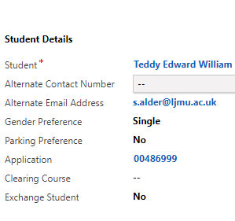
- Also add the ‘Academic Year’ in the top right hand corner – this must be the correct year for the application
Once you have populated the fields, click ‘Save’. This will set the status reason to ‘Requested’ and the student will receive an email notification. The booking can then be managed in the same way as all other bookings (allocating buildings/rooms, sending to halls etc.). Please note that if the building/room is allocated before saving the student details, then the student will not receive an email communication.
How to find a student record if you do not have the student number;
- Under ‘Student Details’, click on the magnifying glass in the Student field to search for the student
- Scroll down and click on ‘Look up more records’
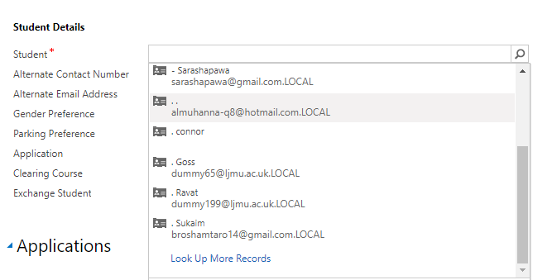

The following box will pop out;
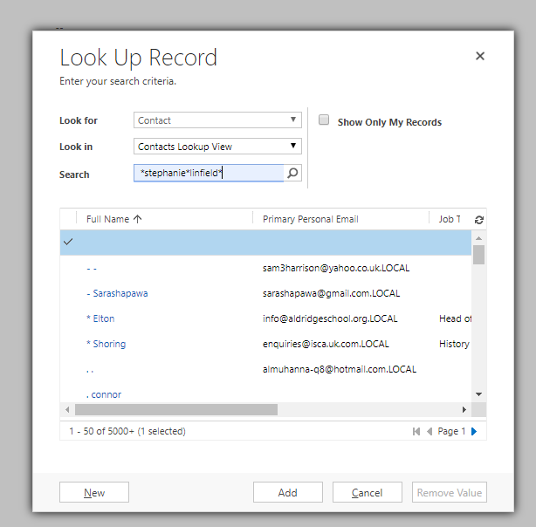
- Ensure the Look for box is set to Contact and the Look in box is set to Contacts Lookup View
- In the Search box, you can search for a student by typing the name using * as wildcard (see screen shot above), then click the magnifying class to search
- The search results will bring back relevant students, select the correct student (a tick will appear next to their name)
- Click ‘Add’

Viewing all Accommodation Bookings
To view all accommodation bookings created (including ones that are no longer on the dashboard)
- Next to Dynamics 365, there will be an Entity Name. e.g. My Work/ Recruitment
- Click on the downward arrow next to Entity Name
- Select ‘Accommodation Booking’
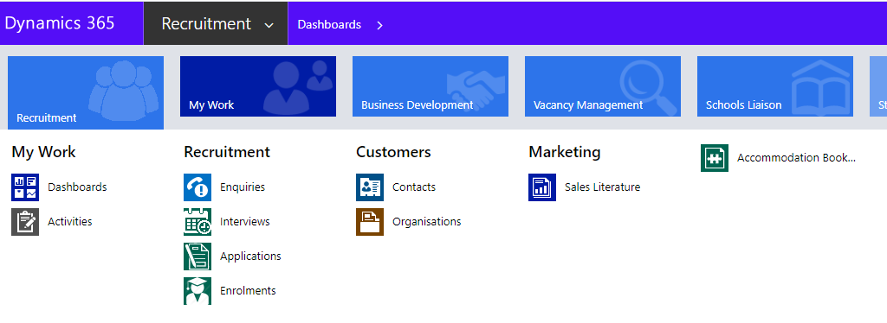
A list of all ‘Active Accommodation Bookings’ will appear
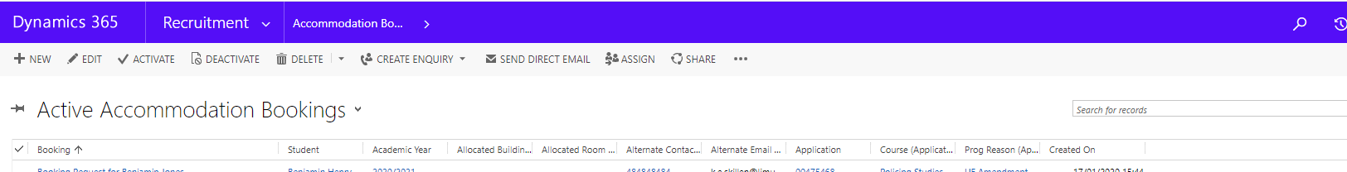

Report
There is also a new report that will give you a summary of the allocations by Building.
To access the report navigate to the appropriate building
- Click on the ‘…’ (three dots) on the menu bar
- Click ‘Run Report’
- Click on ‘Accommodation Summary’
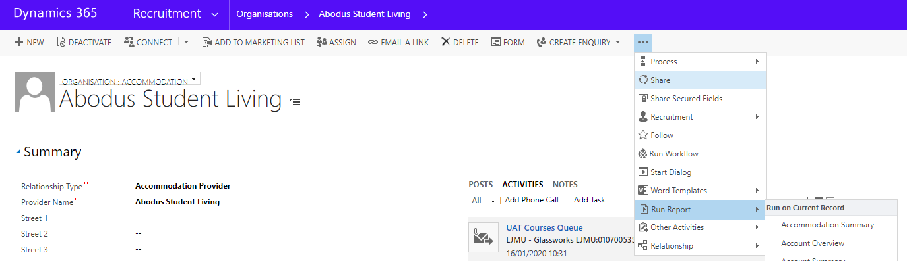
The report will generate and appear as below. Here you can also change the academic year to run a report for a different year. Change the ‘Academic Year’ and the click ‘View Report’.
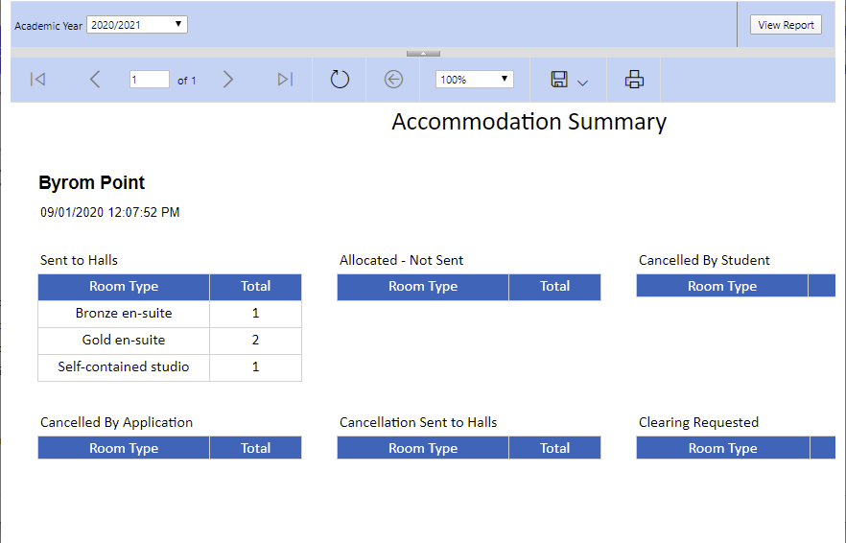
There are two further reports available;
Accommodation Overview - This shows a total of rooms and buildings per academic year
Accommodation Campus Summary - This shows information about the student including the course, the campus that the course is mainly taught in (based on the application) and the allocated room and building of the student per academic year
You can access these two reports by going to the main menu bar at the top of the screen:
- Click ‘My Work’
- Click ‘Reports’
Choose the relevant report from the list

Workflows emails
A number of Workflows have been created within CRM to send emails automatically at different stages of the booking process. Emails will be sent to the applicants preferred email address (this is the email provided at the time of the booking) or the Primary Personal Email address if nothing different is provided. More details on email content can be found in the appendix.
Emails will be sent to the student in the following circumstances:
- When the student has created a new accommodation request via the applicant portal (or if the Accommodation Team make a booking on behalf of a student)
- When the booking has been allocated and sent to halls by the Accommodation Team
- If the student cancels a booking themselves via the applicant portal, or if the booking status is set to ‘Cancelled by Accommodation Team’ or ‘Cancelled by Application’. Please note that if the booking status is set to ‘Cancelled by Accommodation Team’ an email will also be sent to the provider automatically.
- If a booking request status is set to ‘On Hold’ the student will be notified

Appendix A: Communications

New Accommodation Request

Subject New Accommodation Request
Dear <First Name>
This email confirms you have requested the following accommodation:
First Choice: {Building Preference 1(Accommodation Booking)} {Room Type Preference 1(Accommodation Booking)}
Preferences
Gender Preference: {Gender Preference(Accommodation Booking)}
Special requests: {Special Requests(Accommodation Booking)}
Friend requests:
For information on the next stage of the process please see <hyperlink><name>What happens after I submit my accommodation request</name><value>https://www.ljmu.ac.uk/discover/your-student-experience/accommodation/faq</value></hyperlink> in our FAQ page.
Further Information
If you have not already applied for you student funding, you should do so as soon as possible. Don’t worry about changing your mind about the course you want to study or university, as you can change these later if you need to. Finance applications for September 2020 entry will open from the end of February onwards. If you are an applicant from the UK or EU you can apply for your student funding online and the website you need to use will vary, depending on where you normally live:
- Students from Wales should go to https://www.studentfinancewales.co.uk/
- Students from Northern Ireland should go to https://www.studentfinanceni.co.uk/
- Students from Scotland should go to https://www.saas.gov.uk/
- Student from England and also student from the rest of the EU outside of the UK should go to https://www.gov.uk/student-finance
As with anything new, many first year students find managing their money a challenge to begin with and we have a useful online budgeting tool called blackbullion that you can access for free: https://www.blackbullion.com/. You will need the access code LJMUAPPLICANT to register to use blackbullion.
We will provide you with further updates shortly.
Regards,
Liverpool John Moores University

Clearing Booking Request confirmation
Dear {First Name(Student (Contact))}
This email confirms you have requested the following accommodation:
First Choice: {Building Preference 1(Accommodation Booking)} {Room Type Preference 1(Accommodation Booking)}
Second Choice: {Building Preference 2(Accommodation Booking)} {Room Type Preference 2(Accommodation Booking)}
Third Choice: {Building Preference 3(Accommodation Booking)} {Room Type Preference 3(Accommodation Booking)}
Preferences
Gender Preference: {Gender Preference(Accommodation Booking)}
Special Requests: {Special Requests(Accommodation Booking)}
Friend Requests:
Further Information
If you have not already applied for your student funding, you should do so as soon as possible. UK Students should go to <hyperlink><name>this website</name><value>https://www.gov.uk/student-finance</value></hyperlink> and follow the instructions.
We will provide you with further updates shortly.
Thanks
Liverpool John Moores University

Accommodation request withdrawn
Dear xxx
We acknowledge that you wish to cancel your request for accommodation at LJMU
We will aim to pass this cancellation to the accommodation owner within 3 working days and you will then receive a confirmation Email.
Please feel free to contact us by Email to accoff@ljmu.ac.uk if you do not receive that Email within 3 working days or if you wish us to confirm the cancellation sooner.
Regards,
Liverpool John Moores University
Student Accommodation Office
Aquinas Building
Maryland Street
Liverpool
L1 9DE
Telephone: 0151 231 4166
Email ACCOFF@ljmu.ac.uk

Accommodation request cancelled by Accommodation Office
Email to student
Dear XXX
Your request for accommodation at LJMU has been cancelled by the LJMU Student Accommodation Office
This may have happened because you have asked us to cancel the request. Alternatively, it has happened because you have not completed the booking of your room within the specified timescale, despite several reminders from the accommodation owner.
If you have paid a deposit, the owner has 28 days to make a full refund but they will attempt to do it as fast as possible.
If you decide that you do still require accommodation at LJMU, you will need to submit a new request via our website. Please do not contact the accommodation owner directly as they are not able to allocate you a room until they have received a new request from us.
Regards,
Liverpool John Moores University
Student Accommodation Office
Aquinas Building
Maryland Street
Liverpool
L1 9DE
Telephone: 0151 231 4166
Email ACCOFF@ljmu.ac.uk
Email to provider
Accommodation request cancellation: Applicant name / Hall and Room Type
Please delete the above-named student from your bedlist because we have cancelled their accommodation request.
If they have paid a deposit, please make a full refund as soon as possible.
If they decide that they require accommodation, they have been told that they must submit a new request via our website. Please do not allocate them a room until we send you a new referral.
Regards,
LJMU Student Accommodation Office

Accommodation Sent to Halls
Subject Accommodation Allocated
Dear {First Name(Student (Contact))}
I am pleased to inform you that in response to your recent accommodation request you have been allocated the following bedroom:
{Allocated Building(Accommodation Booking)} Room Type: {Allocated Room Type(Accommodation Booking)}
The accommodation owner {Accommodation Provider(Allocated Building (Organisation))} will contact you by email soon to start the booking process. Please contact {Accommodation Provider(Allocated Building (Organisation))} at {Email(Allocated Building (Organisation))} or by {Main Phone(Allocated Building (Organisation))} if you have not heard from them within 48 hours of receiving this email. Please feel free to contact us here at LJMU at any stage if you have a query about your accommodation.
Regards,
Liverpool John Moores University
Student Accommodation Office
Aquinas Building
Maryland Street
Liverpool
L1 9DE
Telephone: 0151 231 4166
Email ACCOFF@ljmu.ac.uk

Accommodation Requests – On Hold
Subject Accommodation request awaiting confirmation
Dear {First Name(Student (Contact))}
Your accommodation request has been received but no accommodation has been allocated yet because there is an outstanding query with the request. The LJMU Accommodation Office may have already contacted you regarding this - but if not, they will do so soon. Please feel free to contact the Office at ACCOFF@ljmu.ac.uk or by phone on 0151 231 4166 if you wish to discuss your request.
Thanks
Liverpool John Moores University

Appendix B: SIS Trigger Application Statuses

Conditional Firm
DATA-0045
DATA-0057
DATA-0058
DATA-2004

Clearing Accepted
DEIN 0014

Unconditional Firm
DATA-0028
DATA-0037
DATA-2003
DEIN-0010
DEIN-0011
DEIN-0012
DEIN-0013
DEIN-0015
DEIN-0054
DEIN-0056
DEIN-2002

