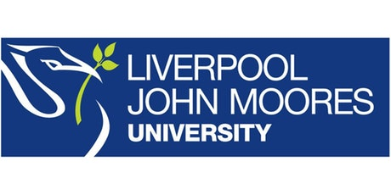

Process Document

CRM – Accommodation
Liverpool John Moores University

Accommodation Team

Version 0.7. November 2018
Author: Debbie Smith Business Support Team
Contents
1
Process Document 1
1. Dashboards 4
1.1 Locating your Dashboard 4
1.3. What’s on the Dashboard 5
2. Email In-box 6
2.1 Working with your queue. 6
3. Enquiries – from email 7
3.1 Converting an email into an enquiry 7
3.2 Progressing an enquiry 9
4. Email Templates 12
4.1 Creating an email template 12
5. Version Control 15

1. Dashboards

1.1 Locating your Dashboard
Each Department who use CRM will have their own dashboard, which acts as a ‘home’ page:
The page should default to your dashboard when you log in and is called ‘Accommodation Enquiries Dashboard’
    - Click on the downward arrow next to ‘My Work’
    - Select ‘Dashboards’
1.1.3. Select the ‘ Accommodation Enquiries Dashboard’ from the drop down:
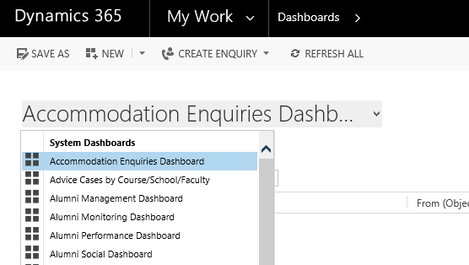

1.2. Pinning Your Dashboard
You can pin your Dashboard so that it appears each time you log in to CRM.
Click on ‘Set as Default’.

1.3. What’s on the Dashboard
The dashboard displays all your team’s incoming emails from various sources such as direct email or webforms:
Incoming emails are displayed in “General Accommodation emails to be processed”.

Some emails will be placed in the alternative queue of ‘General Accommodation Emails Regarding Existing Enquiries’.
Any email you convert into an enquiry will be removed from the ’Main emails to be processed’ queue, but will be added to the ‘My Team’s Accom Enquiries’ list.

Email In-box

Working with your queue.
2.1.1. Your Email Queue (accommodation@ljmu.ac.uk) is effectively spread across two Views: General Accommodation Emails to be processed and General Accommodation Emails Regarding Existing Enquiries.
2.1.2. Click on the email title from one of the views to open it and read the contents.
You can then decide to:
- Delete – only applicable for spam/trash:
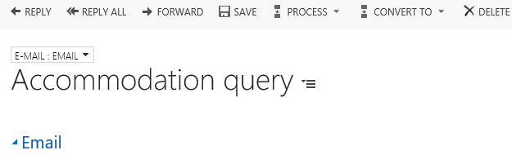
Click ‘Delete’ on the ‘Confirm Deletion’ box which appears, and the email deletes, and you are taken back to the dashboard.
- Forward – only forward an email where you need to pass it to someone else within LJMU, but they are not a CRM user:

Click ‘Forward’, type the full email address into the ‘To’ field, then click ‘Send’. You can then delete the original email.

Enquiries – from email

Converting an email into an enquiry
- Before you convert an email into an enquiry check whether the contact already exists in CRM.
- If it does the ‘from’ address will display their name. If an email address is displayed then if you have the person’s name available click on the email address which will open a small box allowing you to input the first and last name.
- Double click on the email title to open it and read the contents.
- If you decide to convert it to an enquiry, click on the three dots,
- Select Convert to Enquiry
- Select General Accommodation Enquiry

- Once the enquiry has been generated you will see that there are chevrons across the top of the screen. It will also say General Accommodation Enquiry: <contact’s name>
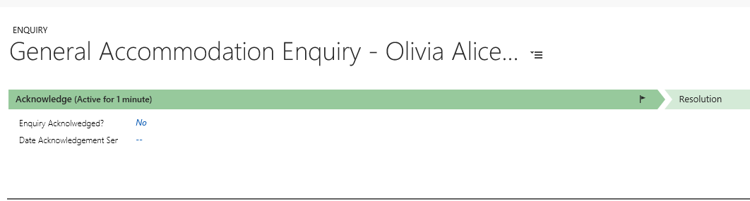
In the middle of the screen, you will see the original Email.
- Click on the Envelope to open up the Email.
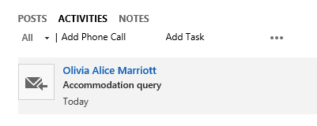
- Click Reply
- Click on Insert Template
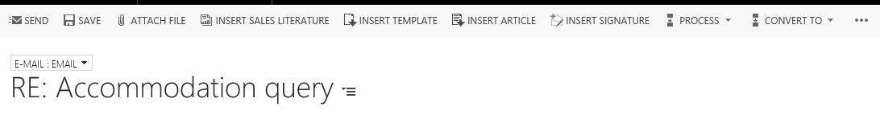
- A Select Record window will appear.
- Click on the record under ‘To Recipients’
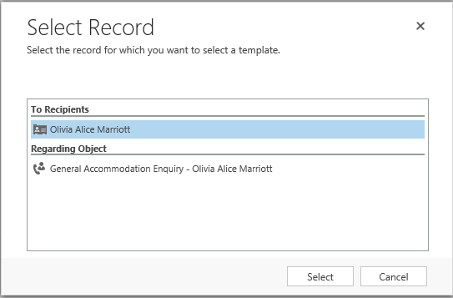
- Select Accommodation Template from the List of Values.
- This will insert the teams Email Signature.
- You can now type your response above the signature.
- Once you have finished click Send.
- Click the Dynamics 365 button. This is the ‘Home Button’.
- You will be taken back to your Dashboard.
- The email you have just replied to will now appear in the bottom section named “My Teams Accom Enquiries (Assigned)”

3.2 Progressing an enquiry
All Accommodation enquiries appear with the same process bar once converted:
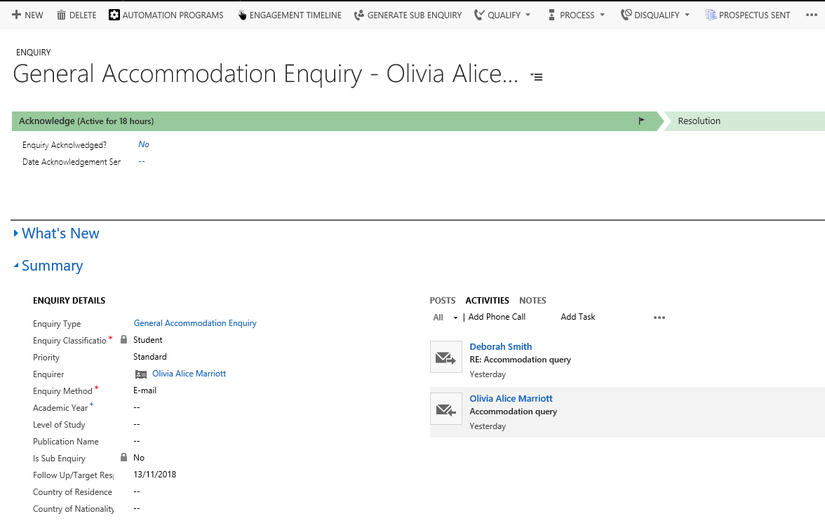
The Enquiry Type, Enquiry Classification, Enquirer and Enquiry Method will already be filled in for you, as you have already chosen the enquiry type and it was created through an email.

CRM has recognised the email address and thus sets the enquirer to the correct student.
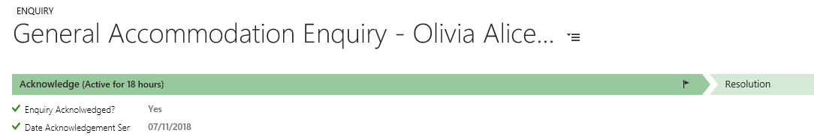

The flag icon in the process bar shows where you are up to – it will not let you click ‘Next Stage’ and move on until all the mandatory fields are complete.
- Click ‘Yes’ in the ‘Enquiry Acknowledged’ field, and the date will auto-fill.
- Click ‘Next Stage’ on the process bar and you will move into the ‘Resolution’ stage, and the blue flag will move across.
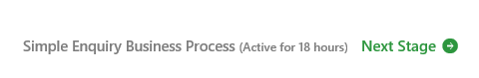
- At the Resolution stage, you can now set the Resolution to Yes and set the Resolution Category to Info Provided by Team.

- Click Save Icon (bottom right hand corner)
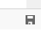
This completes the process and resolves the enquiry for you.

Email Templates

4.1 Creating an email template
Navigate to Settings by clicking on the arrow next to the ‘My Work’ or ‘Recruitment’button and finding the Red Box ‘Settings’:
Then click on Templates, under the ‘Business’ menu.
Click the hyper-link to ‘Email Templates’ from the next page:
This opens a list of all current email templates. Click ‘New’ in the top left:
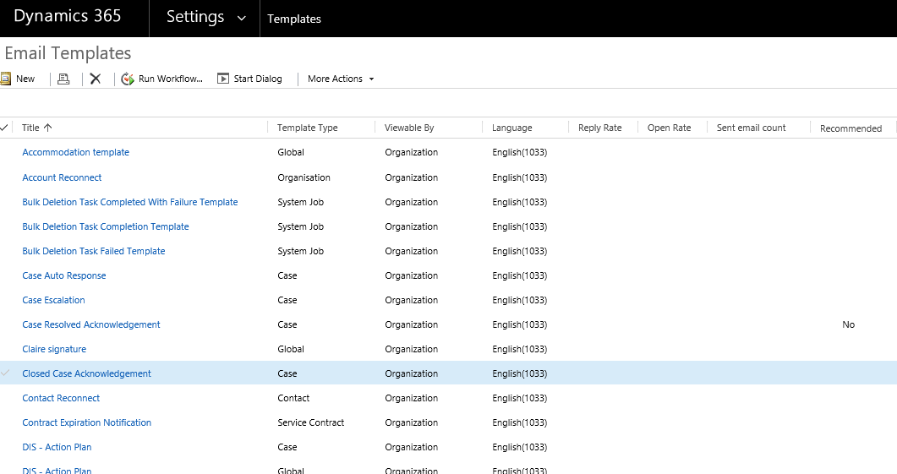

Select Global as the template type from the dropdown, and click ‘OK’:
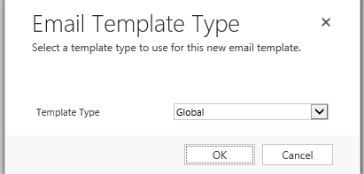

- Complete the mandatory fields ‘Title’ and ‘Subject’ (can be the same).
- In the free-text box below, type (or copy and paste in) the text of the template.

- If you need to insert an image (for a signature for example), the image must be a live image from the internet.

- Locate the image, right click and copy, then paste into the template.

- Click ‘Save and Close’ (top left), and the template will be added to the list of available templates.

Should you wish to change your template in the future return to the Email Templates screen and locate your template. By clicking on the template name you will open up your latest copy which you can edit.

5. Version Control

Date | Version | Author | Change from last version
12.12.17 | V1 | AGP | Baseline
07/11/2018 | V2 | DJS | Updated for Upgraded CRM. 2016

