Process Document

CRM – Careers
Liverpool John Moores University

CRM Activities: Adding Notes to a Case

Version 0.1, November 2020
Author: SL Business Support Team

Adding Notes to a case in CRM

Notes are held securely against a case.

- In order to record a Note you must first ensure you are in a Case and not a Contact record. Check you are in a case by looking for the ‘chevrons’ which will appear along the top of the screen, as shown below.

If notes are left against a Contact they may not be held securely.
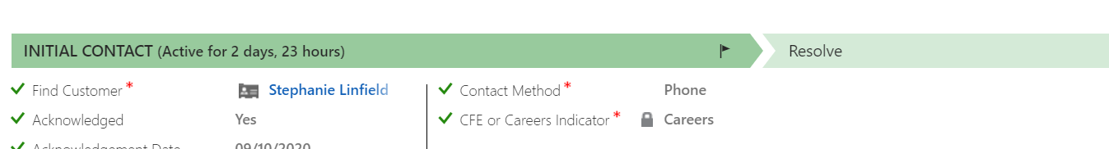
- Click on Notes in the centre of the screen

- Type the note in the space provided and click on the ‘Done’ button

- Please be mindful that notes are provided under Student Access Requests (FOI) so please keep notes professional.

- Your note will then be saved.

