Process Document

CRM – Careers
Liverpool John Moores University

Careers:
Creating a Case

Version 0.2 January 2021
Author: DS Business Support Team

A Case should be created for each appointment you have with a student.. The aim of a case is to keep everything stored together about that particular student/meeting – e.g. details of things discussed, documents, appointments, emails. If the student later came back and wanted another appointment, another ‘new’ case should be created.

There are a number of ways in which a Case can be created in CRM. However, you should only need to create cases from the appointment, which will be covered here.

- Creating a Case from an Appointment

Once you have marked the appointment as Attended or No Show, you can convert the Appointment to a Case.

Open up the Appointment.

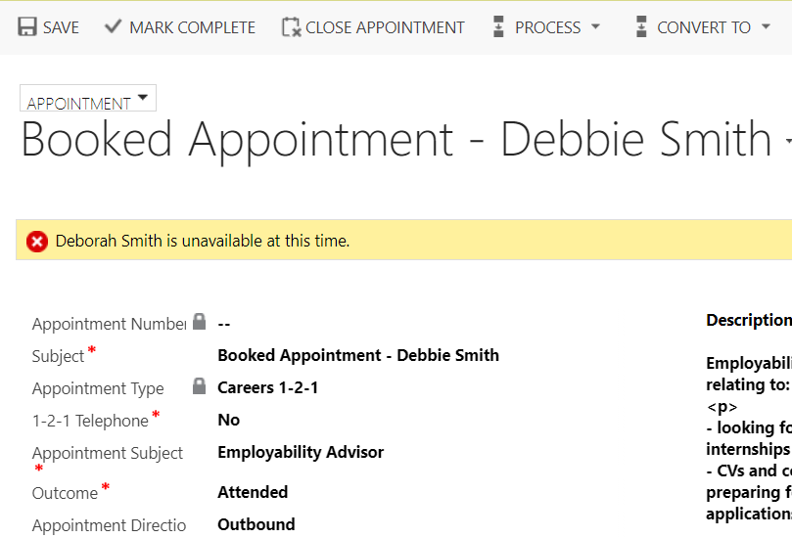
Click on ‘Convert To’ field
Select ‘To Case’ from the menu.
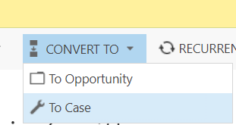

A Convert to Case window will appear.
The student will pull through to fill the ‘Customer’ field from the ‘Required’ field on the Appointment form.

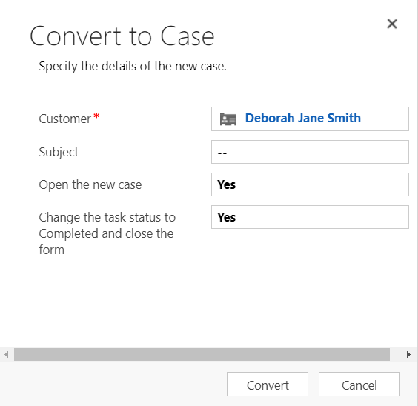
You now need to pick a Subject.
The Subject Header is Careers.
There are many different Subjects you can drill down to depending on what the meeting was about. Use the Notes that have been added to the appointment to assist you. You can drill down into sub-subjects by clicking on the triangle:
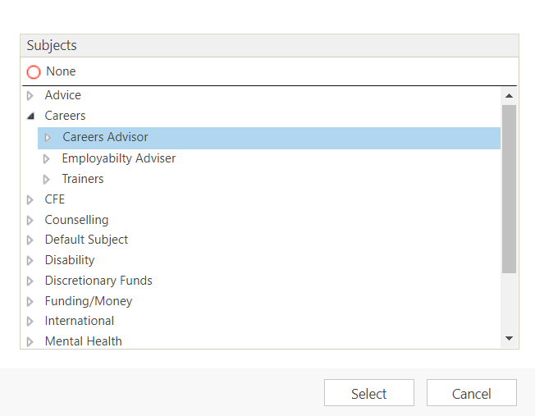
Click Select when you have picked the correct Subject
A ‘Convert to Case’ window will again appear.
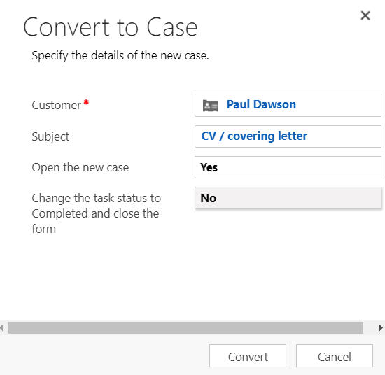
Please ensure that you update ‘ Change the Task Status to Completed and close the form’ to ‘No’.
Then click Convert.
The Case will be created and will now appear under My Active Cases on your Dashboard.
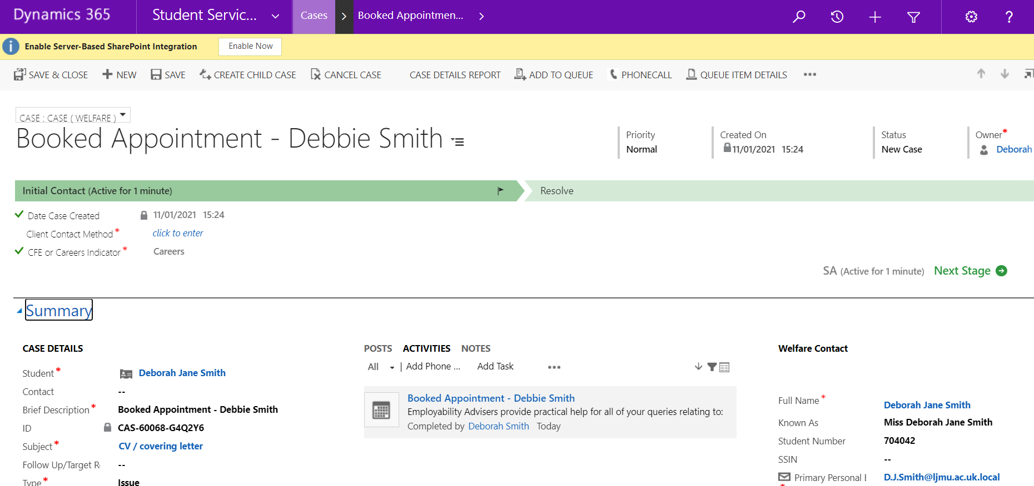

Assigning a Case

You can assign a case to another member of your team. Whilst in the case, on the menu ribbon at the top right of the screen click the 3 dots
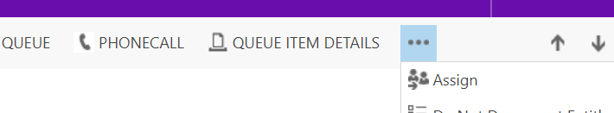

Click Assign, the following box will open up
Assign to - select either Me or User or Team

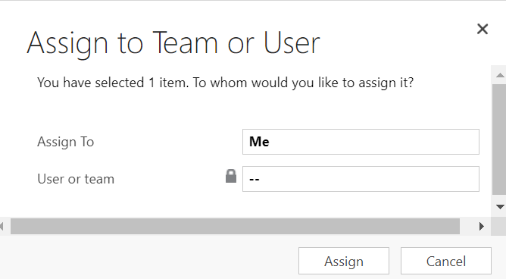
If you select User or Team, you can then search for the staff member. Click on the magnifying glass, Look up more records and the following box will open

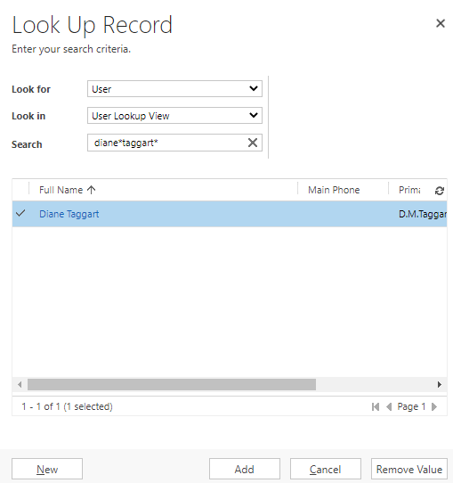
Look for – should default to User
Look in – User Lookup View
Search – start typing the name of the team member (using * to wildcard), search
Select the correct person from the search results (the tick will appear next to their name once selected) and click Add, then Assign.
Save

