Process Document:

CRM – Careers
Liverpool John Moores University

CRM Activities: Adding a Phone Call

Version 0.1 November 2020
Author: SL Business Support Team

Adding a Phone Call to a case in CRM

Phone calls will be added retrospectively.
There are several ways of adding a Phone Call Activity to a case. This guide will show you the quick way to add a phone call.

- In order to record a Phone Call you must first ensure you are in a Case and not a Contact record. Check you are in a case by looking for the ‘chevrons’ which will appear along the top of the screen, as shown below.
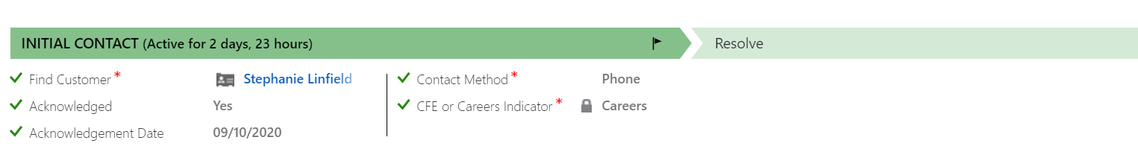
- Once you are in the correct case, navigate to the middle of the screen, and click on ‘Activities’

- Click on Add Phone Call and the following box will open

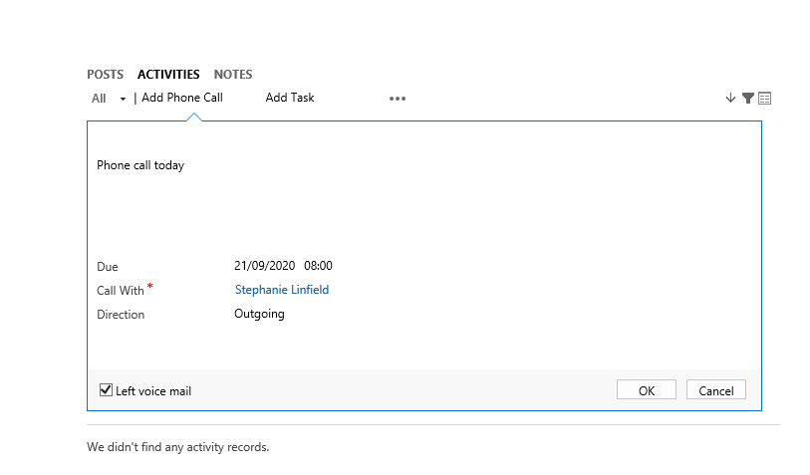

- Populate the following;
You will need to enter a description
Due – add the date and time
Call with – this will default to the name of the person the case is about
Direction – outgoing or incoming
You can also tick the Left voice mail box if necessary.
- Click ok
- Return to the case by clicking on the Case Name on the top ribbon. When you return back to the case, the saved phone call will show under ‘Activities’ in the centre of the screen. You may have to refresh the screen to check it appears.

