Process Document:

CRM – Careers
Liverpool John Moores University

CRM Activities: Upload Documents

Version 0.1, November 2020
Author: SL Business Support Team

Uploading Documents to a case in CRM

- In order to upload documents you must first ensure you are in a Case and not a Contact record. Check you are in a case by looking for the ‘chevrons’ which will appear along the top of the screen, as shown below.
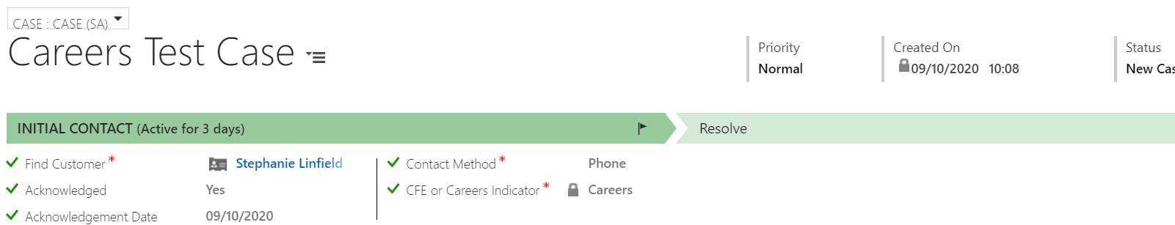
- Once you are in the correct case, navigate to the top Ribbon and click on to the arrow next to the Case Name and click on to Documents Icon.

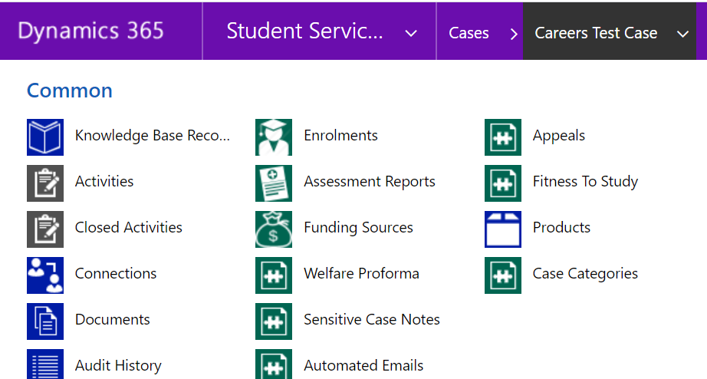

- SharePoint will now open up within CRM automatically.
- To Add a document, click on the Add button

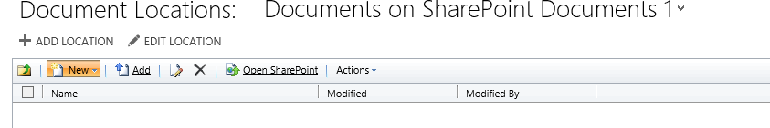

- Click Browse in the Choose a file field to search your own folders for the file to attach.

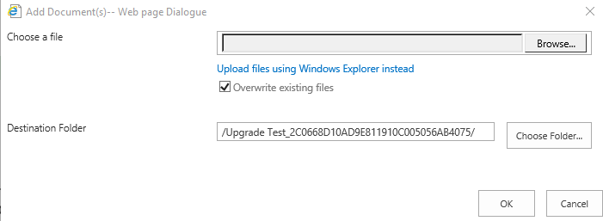

- Do not change anything in ‘Destination Folder’ field.
- Click Ok when correct file is located.
- The ‘Open SharePoint’ button will open up Sharepoint in a separate window.

Please note: SharePoint is automatically available when you follow the navigation in CRM above, you do not need to log in to SharePoint separately.

**If you don’t think you have access to the document/SharePoint CRM please ask your line manager to request access for you via Helpdesk**

