Process Document

CRM – Student Advancement
Liverpool John Moores University

Careers EA/CA: Managing 1-2-1 Appointments

Version 0.2, February 2021
Author: DS Business Support Team

Contents

- Reviewing Booked Appointments

- Creating a Single Appointment

- Deleting an Appointment from within an Appointment

- Booking an Appointment

- Adding Notes

- Changing the Outcome to Attended or No Show on an Appointment

- Face to Face Appointments

Appendix: Automatic Emails/SMS

Appointment slots for students/graduates with our advisers; Employability Advisers (generic appointments) and Careers Advisers (school-specific appointments) will be added to CRM ahead of the semester or on a rolling basis as necessary by System Officer.
20% of appointments for EAs will be available for online booking via https://careers.ljmu.ac.uk and will be marked accordingly on the appointment record (‘publish to site’ will be ticked). The 20% will be allocated by the Logistics Officer
Appointments slots will be edited or deleted as necessary depending on staff availability and commitments (could be appointments already booked or appointments not yet booked)

Reviewing your appointments

Your Booked appointments can be found on your Dashboard – view under ‘My Booked 1-2-1 Appointments Next 12 Months’.

  - In Outlook

Booked Appointments will appear within your Outlook Calendar.

CRM Calendar View

You can view all your appointments in calendar format within CRM – this makes it easier to identify any clashes.
Navigate to;
- My work
- Calendar
The following page will open:
You can sort the calendar view by month, week or day. Appointments with an exclamation mark next to them will indicate a potential clash.

Creating a Single Appointment in CRM

Appointments will be created by SO/LO/EO/SIO AND ESM, however you may need to do this on occasion.
Click on to Student Services, which is next to the Dynamics 365 button.
From the drop down, scroll across and click on My Work
Click on Recurring Appointments.

Next click on Appointment on the bar along the top:
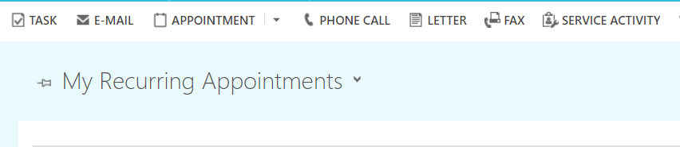

.A form will open called ‘New Appointment’
On the form that opens you must enter the following details:
Subject – The subject should be ‘Available 1-2-1’.
Appointment Type – Select 1-2-1 Careers. If you do not select this, the other options will be incorrect.
Organiser – this will default to you, but will need to be updated to the person who is running the 1-2-1 session. This will be whose calendar the appointment appears in.
To change the organiser;
- Click the magnifying glass
- Scroll to Look up more records, ensure the Look for field is set to User and Look in User Look up view
- In the search field type the name of the person and search, using the * as a wildcard
- Once you find the correct person select their name so a tick appears next to it and click Add.
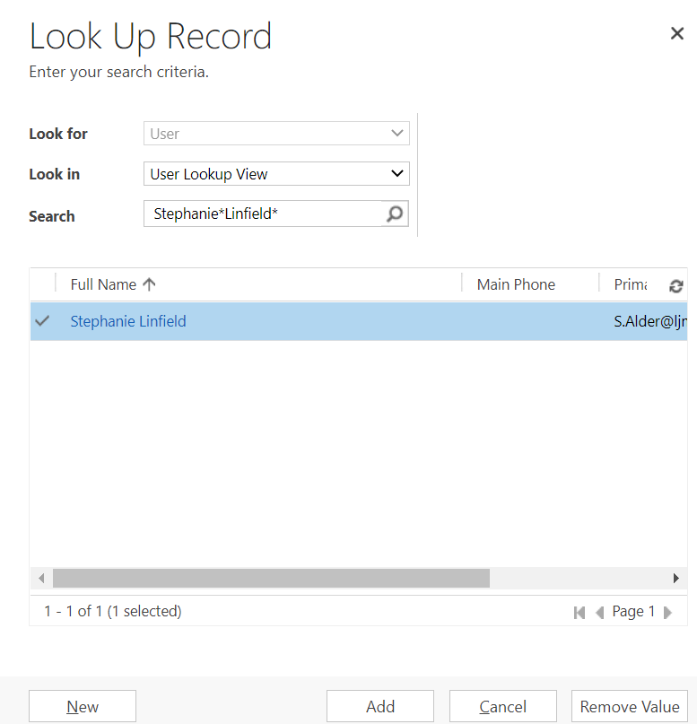
- Appointment Subject – Pick the correct Subject for your 1-2-1 e.g. Careers Advisor, Employability Advisor.

- 1-2-1 Telephone – Yes or No, if set to No you will need to populate the Location and Room fields. If set to Yes the Meeting Link field will appear. (Whilst meetings are held online – you will need to select Yes)

- Teams Meeting – Yes or No if meeting is to be held on MS Teams

- Meeting Link – If you click Yes on Teams Meeting a Meeting Link will automatically populate here.

- Location* and Room* – only mandatory when 1-2-1 Telephone is set to No. Enter the details of where the 1-2-1 session will be, by clicking on Look Up More Records.

- Publish to Site – Yes or No, this will only publish to the Careers website if set to Yes.

- Description – Give the attendee some information about what the appointment is about. You can change the description on individual appointments within a reoccurrence by going into the appointment, changing the description and press save.

Deleting an appointment from within an appointment

Appointments will be created/deleted and amended by SO/LO/EO/SIO AND ESM, however you may need to do this on occasion.
Find the appointment within your dashboard that you would like to delete and double click to open the appointment. In the ribbon at the top of the page, press the ‘Delete’ button to delete the appointment.
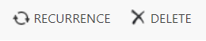
*Please note, if the appointment has already been booked by a student, you will need to notify the student that the appointment is no longer going ahead.
- Booking an Appointment
The majority of appointments will be booked by SIO’s or by students themselves online. You may only need to do this occasionally.

- You will need to note the students details, date/time requested and the type of appointment. You may need to email back and forth to get this information. If the student is on Live Chat/Phone/Walk in you will need to request this information.

- Once you have it, look at the My Available 1-2-1 Appointments view for a suitable appointment.

- Look down the list to avoid those that have Publish to Site <Yes> selected (if possible!).

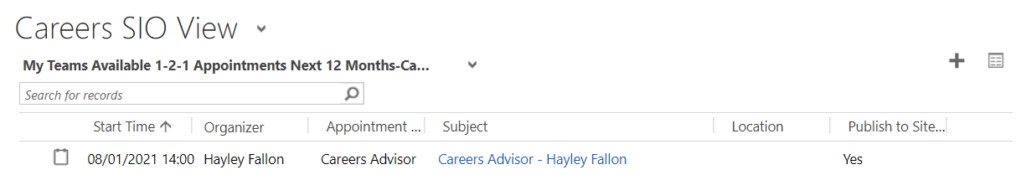
**Remember the option to pop out the view to see a larger screen next to the plus sign.
- Once you have located an appointment, click on it to open it up.

- You will then to fill in the following information:

- Subject: Update this to ‘Careers Appointment <Student Name>’ Or ‘Employability Appointment <Student Name>’ depending on what the Appointment is for.

- Outcome: Update to ‘Attending’

- Scroll down the page to the ‘1-2-1 Appointment’ section
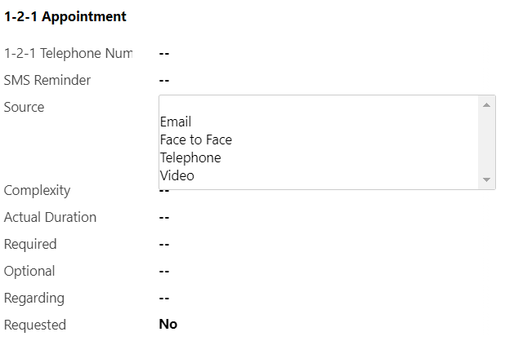
- 1-2-1 Telephone Number: Whether the meeting is to be held by phone or via MS Teams please always ensure you collect a phone number from the student. This is required in case the student needs to be contacted at late notice about the appointment.

- SMS Reminder : Enter with the students mobile number if the student would like a text message reminder of the meeting.

- Required: This is where you will enter the name of the student. Click into the box & type the students name, or copy and paste the students ljmu email address/ID number if you have it.

- Do not click anything, the system should return some suggestions.

- If the option you want appears, click on it and it will populate the field. If it doesn’t appear/no options appear, click Look Up More Records for more options.

- It is useful here to use the * asterisk as a wildcard when searching. CRM records the full name, including any middle names, so it is useful to use the * where the middle name will be. e.g. Deborah* Smith.

- If you know the students ID number, this will take you straight to the students record as it is a unique identifier.
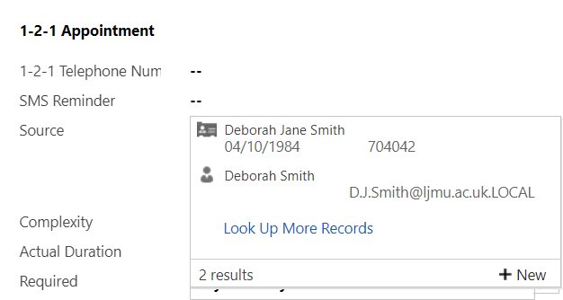
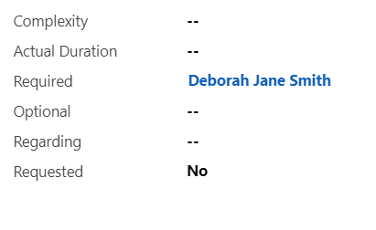
Next you need to add a Note with information about the type of appointment that will help the advisor.

- Adding Notes

Appointments will be created/deleted and amended by SO/LO/EO/SIO AND ESM, however you may need to do this on occasion.

- Notes can be found in the middle of the screen:
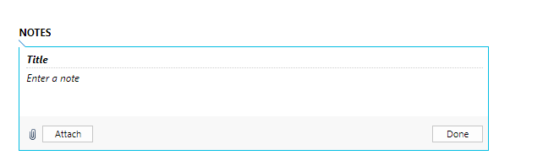
- Click where it says ‘Title’ and enter details of the type of appointment e.g. ‘ CV and Covering Letter Check’, or Career Options Help’.

- Click where it says ‘Enter a note’ too add any additional information the student has provided, or copy and paste it in from the email. This isn’t compulsory.

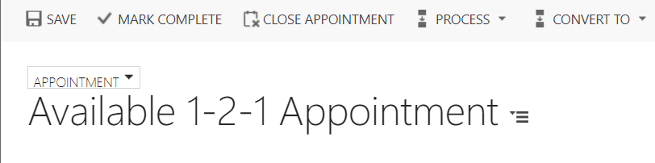

- The booking confirmation email will be sent to the student.

- The booked appointment will move into the advisors ‘My Booked Appointments’ view within their dashboard.

- Changing the Outcome to Attended or No Show on Appointments

- Whilst you are in the Appointment, or at some point after it has concluded, you will need to update the Outcome of the Appointment.

- Navigate to Careers CA/EA Adviser View Dashboard

- Navigate to My Booked 1-2-1 Appointments Next 12 months.

- Open up the Appointment

- Navigate to ‘Outcome’

- Amend to Attended or No Show.
Next, you will need to convert the appointment into a case…..
**Conversion to Case will be covered in the ‘Creating a Case’ guide.**

- Face to Face Appointments

SIO/EA/CA: Booking a face to face appointment
All 30 minute appointments will be set as default to a remote MS Teams appointment, apart from drop-in appointments, which will be set to a particular locations, either; ‘Byrom Street – Careers Zone’ or ‘Student Life Building - Careers Zone’.

If a student requests a face to face appointment, the SIO should find a suitable appointment. Within the ‘My teams available appointments’ view on the SIO dashboard, a check should be made that the location field is blank and does not state ‘working remotely’. If ‘working remotely’ is present, then an alternative appointment should be chosen.

Once the appointment has been selected, the 1-2-1 telephone appointment should be changed to ‘No’. The following should be inputted into the relevant location fields:
Location/venue: ‘James Parsons Building’ or ‘Student Life Building’
Room: ‘Byrom Street Careers Zone’ or ‘Careers Zone’ (the latter for use only with Student Life Building).

The usual process of booking an appointment should then continue.

SIO/EA/CA: Booking a drop-in appointment
Drop-in appointments (15 minutes) can be booked on the day only and are only available in a physical, pre-set location. These are booked by simply changing the subject field from ‘Available 1-2-1 Drop-in’ to ‘Student Name 1-2-1 Drop-in’, entering the student ID/name into the ‘required’ field, and pressing ‘save’. A workflow email will be sent to the student confirming this 15 minute drop-in appointment.

Appendix

Automatic emails

Currently there are 3 workflow reminders, all emails only go to the LJMU email address:
- A booking confirmation
- Student Cancellation Confirmation to the meeting organiser only.
- Reminder Email and SMS (24hrs but not if booking less than 24 hours before the start)
Booking Appointment - Telephone (mobile number)

Employability Adviser

Hello
Thanks for booking your 1-2-1 telephone appointment with [Organizer]. [Organizer] will telephone you at [Start Time] on the number you have provided.

For further information about what to expect from your appointment, please click here.

If your appointment is concerning a CV/cover letter, job application/application form or interview, please use the links provided to work through the suggested actions in Careers Zone 24/7 to help prepare before the appointment.
If you are no longer able to make this appointment, please cancel it as soon as possible so we can free up this slot for another student. To do this, visit https://careers.ljmu.ac.uk/, and ‘Cancel Registration’ via the ‘My Bookings’ tab. You can arrange another appointment via the same URL or more appointment slots are available by telephoning 0151 231 2048/3719, or emailing careers@ljmu.ac.uk or by visiting your nearest Careers Zone.
Kind Regards
Careers, Employability & Enterprise Team
------------------------------------------------------------------------------
Careers Adviser

Hello
Thanks for booking your 1-2-1 telephone appointment with [Organizer]. [Organizer] will telephone you at [Start Time] on the number you have provided.

For further information about what to expect from your appointment, please click here.
If you are no longer able to make this appointment, please cancel it as soon as possible so we can free up this slot for another student. To do this, visit https://careers.ljmu.ac.uk/, and ‘Cancel Registration’ via the ‘My Bookings’ tab. You can arrange another appointment by telephoning 0151 231 2048/3719, or emailing careers@ljmu.ac.uk or by visiting your nearest Careers Zone.

Kind Regards
Careers, Employability & Enterprise Team

Booking Appointment via MS Teams (video or audio)

Employability Adviser

Hello
Thanks for booking your 1-2-1 Teams appointment with [Organizer]. Please can you click on the link below on [Start Time] and start either an audio call or video call to begin the meeting.
Start Meeting
https://teams.microsoft.com/l/chat/0/0?users=LIDJGLOV@ljmu.ac.uk&topicName=Appointment

For further information about what to expect from your appointment, please click here. On this page, you will also find advice about using Microsoft Teams. If you experience any difficulties trying to access your appointment, please email: careers@ljmu.ac.uk.

If your appointment is concerning a CV/cover letter, job application/application form or interview, please use the links provided to work through the suggested actions in Careers Zone 24/7 to help prepare before the appointment.
If you are no longer able to make this appointment, please cancel it as soon as possible so we can free up this slot for another student. To do this, visit https://careers.ljmu.ac.uk/, and ‘Cancel Registration’ via the ‘My Bookings’ tab. You can arrange another appointment via the same URL or more appointment slots are available by telephoning 0151 231 2048/3719, or emailing careers@ljmu.ac.uk or by visiting your nearest Careers Zone.
Kind Regards
Careers, Employability & Enterprise Team
------------------------------------------------------------------------------
Careers Adviser

Hello
Thanks for booking your 1-2-1 Teams appointment with [Organizer]. Please can you click on the link below on [Start Time] and start either an audio call or video call to begin the meeting.
Start Meeting
https://teams.microsoft.com/l/chat/0/0?users=LIDJGLOV@ljmu.ac.uk&topicName=Appointment

For further information about what to expect from your appointment, please click here. On this page, you will also find advice about using Microsoft Teams. If you experience any difficulties trying to access your appointment, please email: careers@ljmu.ac.uk.
If you are no longer able to make this appointment, please cancel it as soon as possible so we can free up this slot for another student. To do this, visit https://careers.ljmu.ac.uk/, and ‘Cancel Registration’ via the ‘My Bookings’ tab. You can arrange another appointment by telephoning 0151 231 2048/3719, or emailing careers@ljmu.ac.uk or by visiting your nearest Careers Zone.

Kind Regards
Careers, Employability & Enterprise Team

Booking Non-Telephone Appointment (physical appointment in a Careers Zone)

Careers Adviser

Hello
Thanks for booking an appointment with [Organizer] at [Location] on [Start Time].

For further information about what to expect from your appointment, please click here. On this page, you will also find advice about using Microsoft Teams. If you experience any difficulties trying to access your appointment, please email: careers@ljmu.ac.uk.
If you are no longer able to make this appointment, please cancel it as soon as possible so we can free up this slot for another student. To do this, visit https://careers.ljmu.ac.uk/, and ‘Cancel Registration’ via the ‘My Bookings’ tab. You can arrange another appointment by telephoning 0151 231 2048/3719, or emailing careers@ljmu.ac.uk or by visiting your nearest Careers Zone.

Kind Regards
Careers, Employability & Enterprise Team
Non-Telephone (physical appointment in a Careers Zone)
Employability Adviser
Hello
Thanks for booking an appointment with [Organizer] at [Location] on [Start Time].
For further information about what to expect from your appointment, please click here. On this page, you will also find advice about using Microsoft Teams. If you experience any difficulties trying to access your appointment, please email: careers@ljmu.ac.uk.
If your appointment is concerning a CV/cover letter, job application/application form or interview, please use the links provided to work through the suggested actions in Careers Zone 24/7 to help prepare before the appointment.
If you are no longer able to make this appointment, please cancel it as soon as possible so we can free up this slot for another student. To do this, visit https://careers.ljmu.ac.uk/, and ‘Cancel Registration’ via the ‘My Bookings’ tab. You can arrange another appointment via the same URL or more appointment slots are available by telephoning 0151 231 2048/3719, or emailing careers@ljmu.ac.uk or by visiting your nearest Careers Zone.
Kind Regards
Careers, Employability & Enterprise Team

