# [Image result for liverpool john moores university logo](https://www.google.co.uk/url?sa=i&rct=j&q=&esrc=s&source=images&cd=&cad=rja&uact=8&ved=0ahUKEwjZuerSu4nXAhWGchQKHbT9CwIQjRwIBw&url=https://www.eventbrite.co.uk/o/liverpool-john-moores-university-roscoe-lectures-3233158788&psig=AOvVaw2rEDE_dQz3fMXV7J1A9n9g&ust=1508941556822069)

Process Document:

**CRM – Careers**

Liverpool John Moores University

**CRM Activities: Sending and Processing Emails**

Version 0.1, November 2020

Author: SL Business Support Team

Contents

Email Labels 3

SA: Case View 3

SA: Contact View 4

Sending an Email 5

Inserting a Template 7

Replying to an Email from the Queue or a Case: 9

Set Regarding 9

Attaching a document to an outgoing email 11

Downloading documents from an email in CRM 12

Processing emails from your Dashboard 13

Replying to an new email on the dashboard 14

Removing emails from the Dashboard 14

# Email Labels

There are three Email labels in CRM, to help us correctly store and manage the different email addresses that our Enquirers/Applicants/Students/Staff use.

These are:

* Primary Personal Email
* Secondary Personal Email
* LJMU Email

The following table shows which fields are Editable/Locked down and how this will change with the lifecycle of the student.

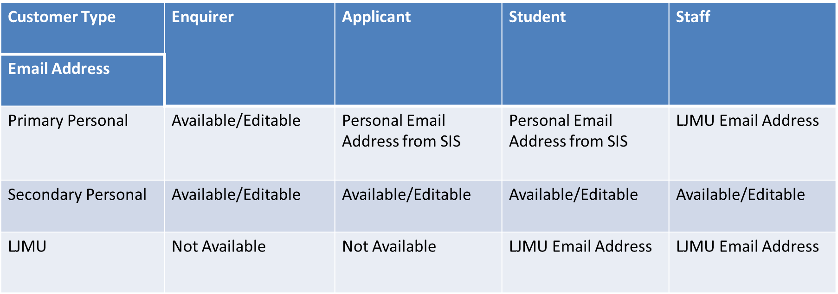







The Secondary Personal Email address will always remain unlocked, meaning that if a student requests that you contact them via a specific email address that is not already listed, then you can add it here.

As CRM is used by different users for different reasons, it is good practice to check this email address is entered each time you email, as it is possible that other users may amend it to suit their own needs

# SA: Case View

From the Case screen, you will notice that the different Email labels appear in the ‘Student Details’ Panel to the right of the the Case Screen.

You will not be able to amend the Secondary Email address within this view. You will only be able to do this in the **Contact View** (see below)

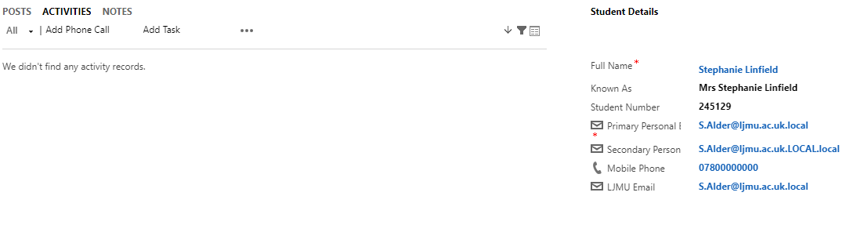

# SA: Contact View

The same labels will also show in the Contact Form under ‘Marketing Details’.

You can click to the Contact record from the Case by clicking on the Highlighted Blue ‘Full Name’

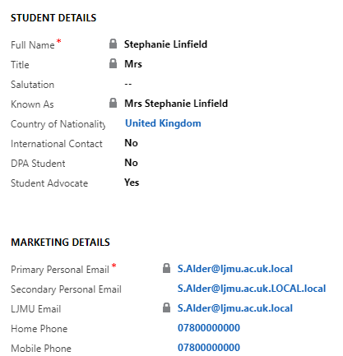

# Sending an Email

In order to send an Email you must first ensure you are in a **Case** and not a Contact record. The **Creating a Case** document tells you how to create a case from an appointment.

Check you are in a case by looking for the ‘chevrons’ which will appear along the top of the screen. Also, check it says ‘Case’ and the name of the Case, as shown below.

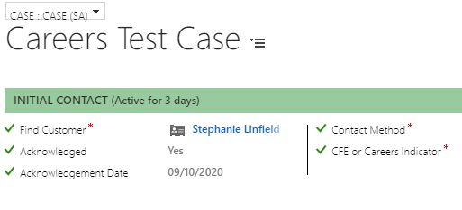

Click on to **Activities** in the Centre of the screen

Click on to the **3 dots (ellipsis)** underneath

Select **‘E-Mail’**

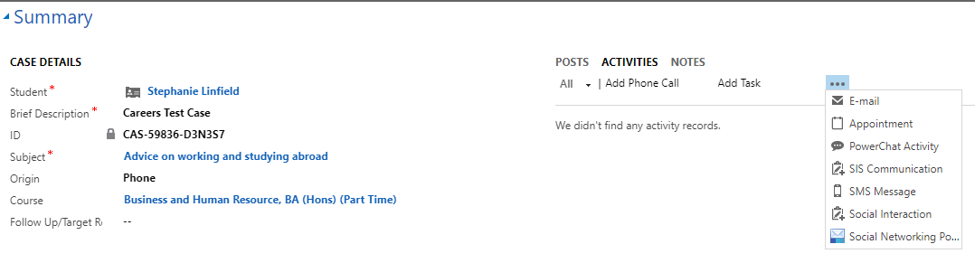

The New E-mail window will open.

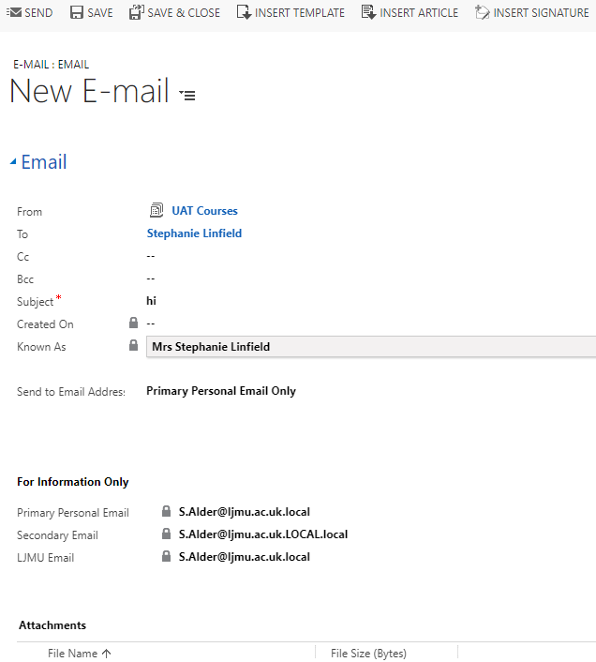

The From will default to your Team email automatically as this is set up for you at the time your access to CRM is applied. You can change this if you need to amend the email address your email is being sent from, e.g. sending a Post Appointment Email from **EmployabilityAdvisers@ljmu.ac.uk**

**Note: The email will not send if the ‘From’ is an Individual name. It MUST be a Team.**

**Note: Please remember to check if any of your Emails have a status of Pending regularly. You have access to a Pending Email Dashboard. Pending means the email is stuck. Contact Helpdesk for support if required.**

You must add a subject for the email.

**‘Send to Email Address’** will always default to **Primary Personal Email Only**.

But, If you click into this, a drop down list of all the different Email Labels & Combinations will appear.

These are:

* Primary Personal Email Only
* Secondary Personal Only
* LJMU Email Only
* Primary & Secondary Personal Emails
* Primary Personal & LJMU Emails
* Secondary Personal & LJMU Emails
* All

**You will need to select the correct Email Label(s) from the drop down menu option.**

*Please note that this drop down list relates only to the Emails held against the ‘To’ Contact and does not relate to anyone cc’d or bcc’d in. There is no option to select the Email address for those contacts cc’d or bcc’d.*

Next, complete the text of the email.

Then, navigate to the bottom of the text box, and click on to Duration.

Select the time spent writing the email.

Please note – that you can also record the duration by changing the Complexity – (Short – 5 mins, Medium – 15 mins or Complex – 30 mins)

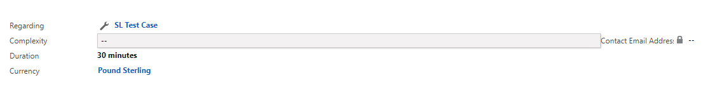

Click **Send.**

Once the Email has sent, you will notice at the bottom of the email, there is a field called **Contact Email Address.**

This field will display the Email address(es) which the Email was sent to and will correspond to the label you selected when you sent the Email.

This field is especially useful for Audit purposes: checking where an email has gone, **after** the email has been sent.

# Inserting a Template

When in a new email, click on to **Insert Template** which can be found at the top of the screen.

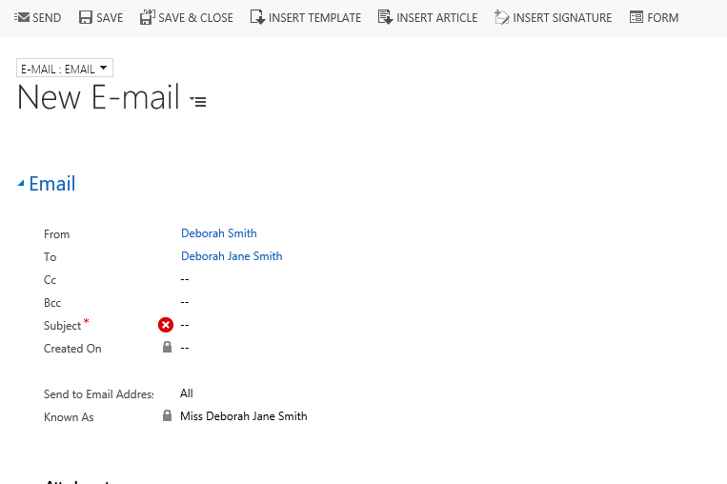

The select record box will open up, select the regarding object record and click Select

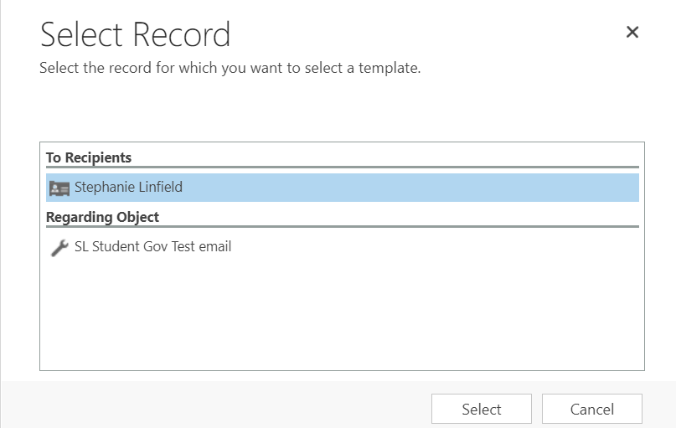

The **Select Template** box will pop up. Click on the required template.

Click Select.

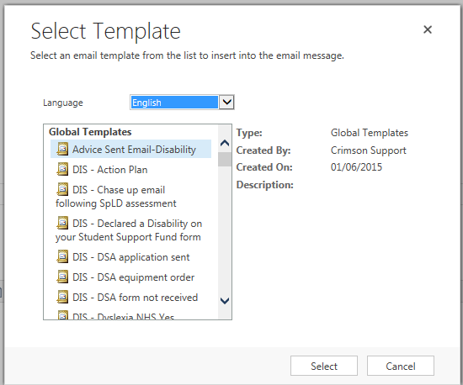

The Email template will populate in the Email.

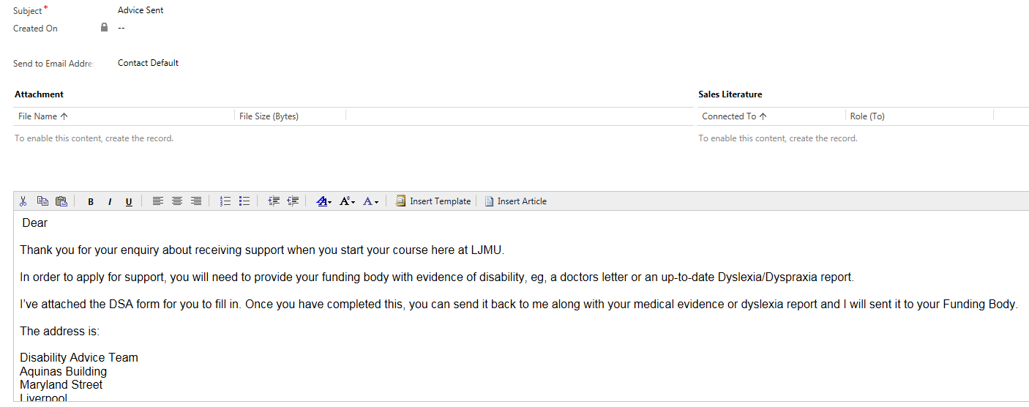

# Replying to an Email from the Queue or a Case:

If you click reply to an Email, the ‘Send to Email Address’ field will default to ‘Default Contact’. This is effectively defaulting to reply back to the email address that the email was sent from.

This can be changed if you wish to email a different email address, although you will need to check the Email labels within the Contact screen first.

# Set Regarding

If you email a Student from a Case, then the Email will automatically ‘Set Regarding’ to the correct student and Case.

Sometimes, if an email has not been set regarding the case for some reason, you will need to manually set it:

First of all, find the Email. To do this, click on the students name to access their contact record, and look under Activities to find it.

Open the Email

Scroll to the bottom of the email where it says ‘Regarding’

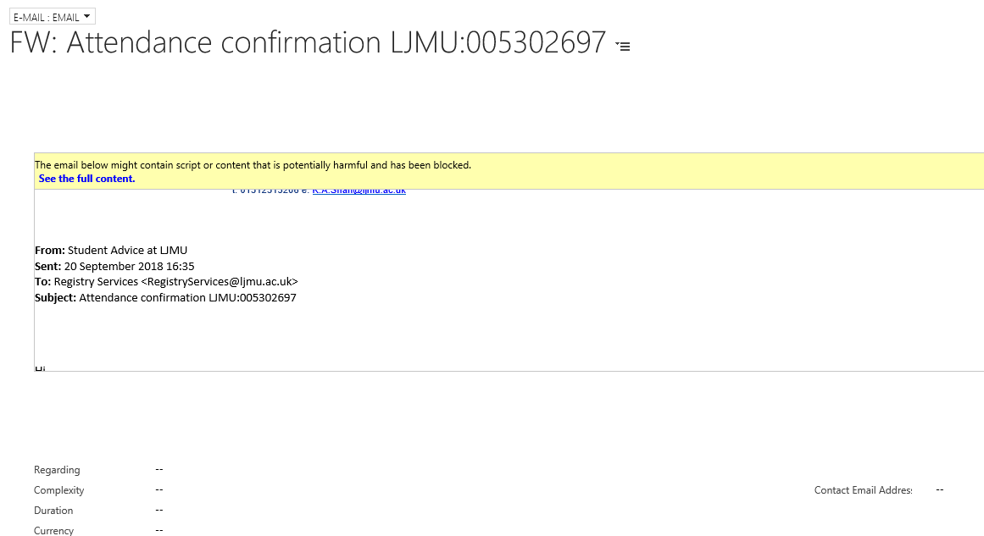

Open up the Look Up

Scroll down to Look up more Records:

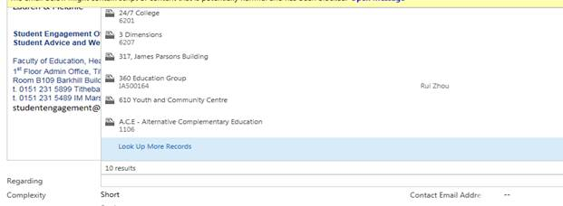

This panel will open up. You need to change the options to the following:

* Look For: **Case**
* Look In: **My Active Cases**
* Search: Search for either the student name or what you have named the case.

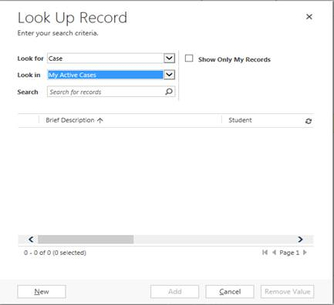

Then select the correct case, by ticking it to the Left.

Click **Add**

This box will then disappear and you will end up back in your Email.

You will notice that the **Regarding** now has a spanner symbol and the name of your case.

Click **Save.**

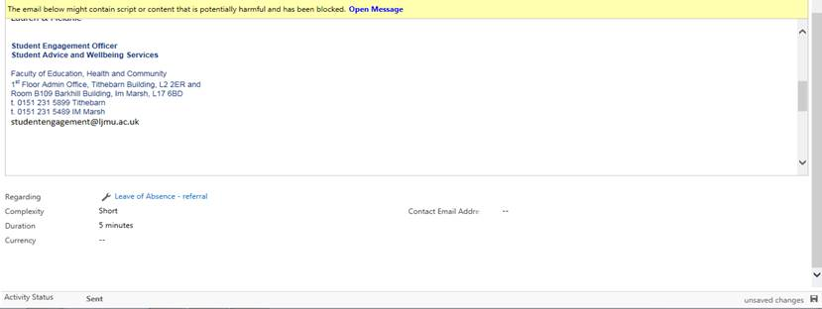

If you now head back into the case, the email will now appear on under Activities.

# Attaching a document to an outgoing email

When sending an email from a case, open up a new email from the 3 dots by the activities pane within the case.

Write the body of the email and check all details are correct (e.g. the contact and the email address you are sending to etc.)

Click **Save** at the top, before sending

Upon saving, the **Attach File** option will appear at the top, click **Attach File**

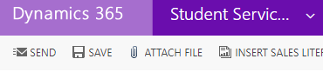

The following box will open, click choose file and select the correct document from you PC or SharePoint, click **Attach** and **Close**. This will then appear as an attachment on the email. You can only attach one document at a time.

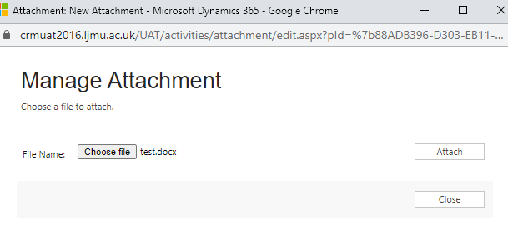

# Downloading documents from an email in CRM

Navigate to the relevant Case and open up the email with attachment.

Click on the attachment title in blue

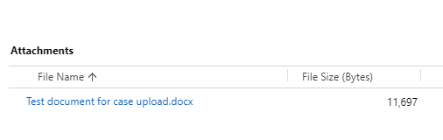

The Manage Attachment box will open

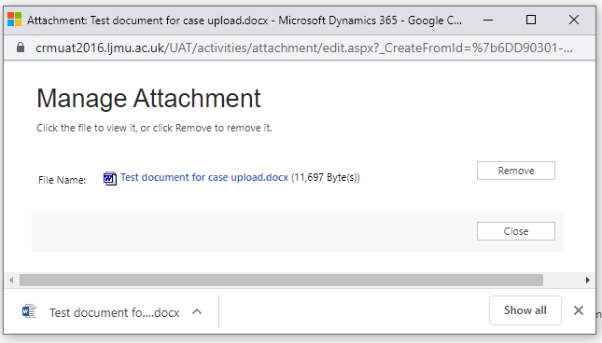

Click on the attachment title in blue and this will download the document to your PC

**\*\*Please also remember to regularly delete any downloaded files from you M drive that may contain sensitive information\*\***

# Processing emails from your Dashboard

Emails coming in to CRM can be viewed on your Dashboard.

If the contact is already known on our systems then the email should automatically link to them and the **‘From’** column on the dashboard should display as a name rather than an email address.

To respond to an email, double click on the white space within the row of the email and it will open the email form

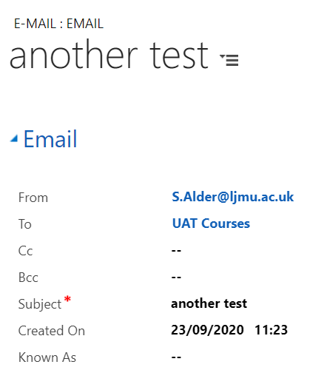

The email will show us who it is from, and that it has come into your default queue. It will show the subject of the email and when it was created. The ‘Known as’ field will display if the contact would like to be known as something different to their primary name.

The ‘Email sent from’ will show which of the three possible emails on the contact record, that the email has come from.

‘Attachments’ will show any attachments that have come in with the email

The email content will be shown near the bottom of the page.

# Replying to an new email on the dashboard

If you have converted an appointment to a case then when you navigate back to the case you can open the email back up to reply. You can also reply to emails that you do not convert to a case. It is important to note that if an email is not set regarding correctly, the email will not be clearly visible for yourselves.

To reply to an email, click the ‘Reply’ button in the top left of the ribbon at the top of the page.



When the email page loads, you will see an option of where to send the email to on the ‘Send to Email Address’ drop down list.

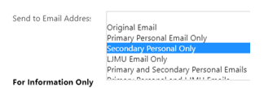

Underneath the ‘**Send to Email Address**’ it shows the email addresses that the contact has available to send to.

**Original Email** will reply to the email address that the email was sent from.

You can write your content at the bottom of the page.

Once you are ready to send, you can press the ‘**Send**’ button in the ribbon at the top of the page.



# Removing emails from the Dashboard

Once you are happy that the email has been dealt with and want to remove it from the dashboard, select the grid next to the view in the dashboard.

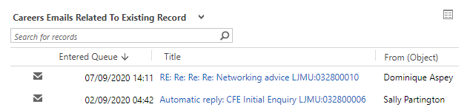

It will open up the following window, you can highlight the record and click **Remove**

