Process Document

CRM – Student Advancement
Liverpool John Moores University

Careers: SO/EO/LO/SIO/ESM: Managing 1-2-1 Appointments

Version 0.3, October 2021
Author: DS Business Support Team

Contents

- Create Recurring 1-2-1 Appointments

- Create Single Appointments

- Delete Unbooked Appointment

- Booking an Appointment

- Face to Face Appointments & Drop In’s

- Adding Notes

- Attaching Documents

- Update an Appointment

- Cancel an Appointment – Advisor Unavailable

- Cancel an Appointment – at Students Request

- Appendix – Automatic Emails/SMS

Appointment slots for students/graduates with our advisers; Employability Advisers (generic appointments) and Careers Advisers (school-specific appointments) will be added to CRM ahead of the semester or on a rolling basis as necessary by System Officer.
20% of appointments for EAs will be available for online booking via https://careers.ljmu.ac.uk and will be marked accordingly on the appointment record (‘publish to site’ will be ticked). The 20% will be allocated by the Logistics Officer
Appointments slots will be edited or deleted as necessary depending on staff availability and commitments (could be appointments already booked or appointments not yet booked)
Below we will cover how to create recurring and single appointments although you may only need to do this on occasion

Creating Recurring 1-2-1 Appointments in CRM (SO/LO)

- A recurring appointment follows the same concept as a reoccurring appointment in outlook.

- Next to Dynamics 365, click the down arrow on the entity name and navigate to My Work, then Recurring Appointments
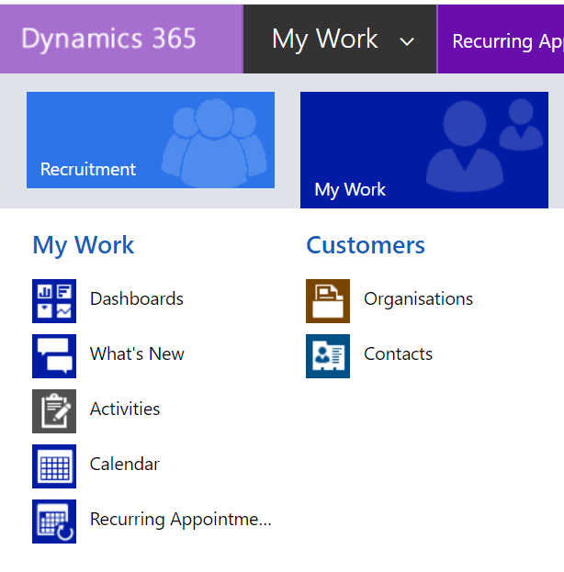
Then select Recurring Appointment click on the down arrow next to Appointment.
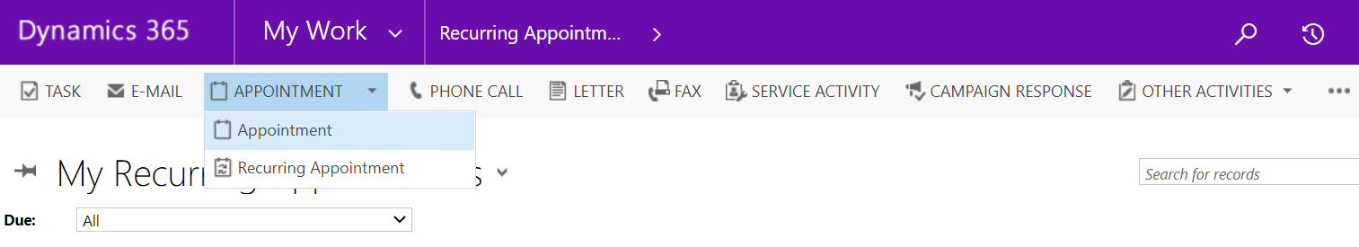
- On the form that opens you must enter the following details:
- Subject – The subject should be ‘Available 1-2-1’.
- Appointment Type – Select 1-2-1 Careers. If you do not select this, the other options will be incorrect.
- Organiser – this will default to you, but will need to be updated to the person who is running the 1-2-1 session. This will be whose calendar the appointment appears in.

- To change the organiser:

  - Click the magnifying glass
  - Scroll to Look up more records, ensure the Look for field is set to User and Look in User Look up view
  - In the search field type the name of the person and search, using the * as a wildcard
  - Once you find the correct person select their name so a tick appears next to it and click Add.

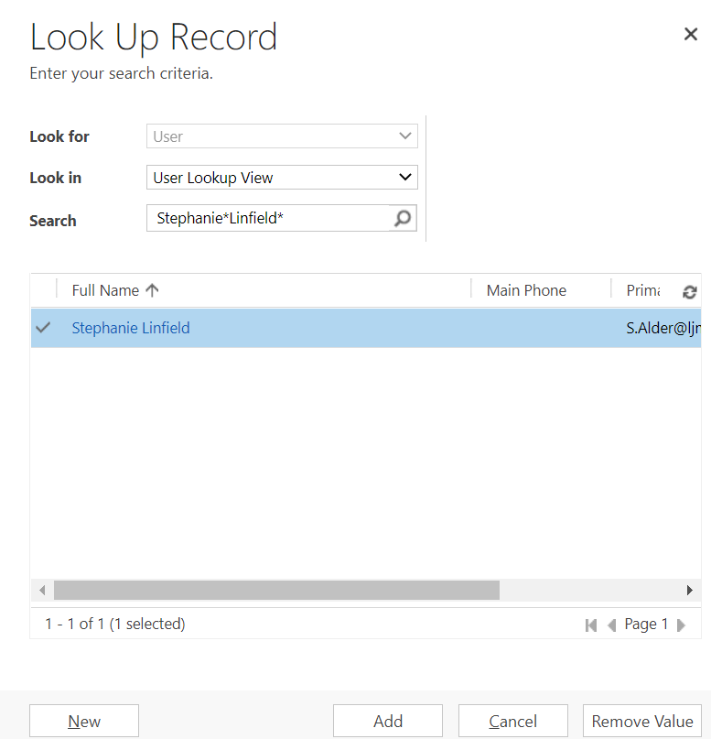
- Appointment Subject – Pick the correct Subject for your 1-2-1 e.g. Careers Advisor, Employability Advisor.
- Outcome – Set to Available.

- 1-2-1 Telephone – Yes or No, if set to No you will need to populate the Location and Room fields. If set to Yes the Meeting Link field will appear. (Whilst meetings are held online – you will need to select Yes)

- Teams Meeting – Yes or No if meeting is to be held on MS Teams

- Meeting Link – If you click Yes on Teams Meeting a Meeting Link will automatically populate here.

- Location* and Room* – only mandatory when 1-2-1 Telephone is set to No. Enter the details of where the 1-2-1 session will be, by clicking on Look Up More Records.

- Publish to Site – Yes or No, this will only publish to the Careers website if set to Yes.

- Description – Give the attendee some information about what the appointment is about. You can change the description on individual appointments within a reoccurrence by going into the appointment, changing the description and press save.

- Once you have entered the details you can click on Recurrence at the top of the screen to set the recurrence of the appointments
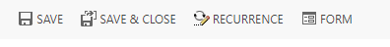

- Start: This is the time you would like all of the appointments to start.
- End: This is the time you would like all of the appointments to end.
- Duration: This is automatically calculated from the times you have entered in to start and end.
- Recurrence Pattern: How often you would like the appointments.
- Recur every x weeks: This allows you to set bi-weekly and bi-monthly appointments by entering ‘2’ into the box. If you would like this weekly or monthly, you can leave the value at 1.
- Day Selection: You can select which days you would like the appointment to occur on.
- Start Range: This is when the recurring appointments will start.
- End Range: We would not advise selecting ‘No end date’. You can set the end to be after x amount of appointments, or by an end date.
- Once you are happy with your recurrence details, press set. You will be directed back to the recurring appointment details page. You can now save and close using the save and close button in the ribbon.

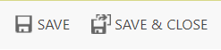

- The individual appointments will now be generated by the system. This may take a couple of minutes depending on how many occurrences the system needs to generate.

- *Please note, the system does not take into consideration bank holidays and annual leave. These appointments will need to be deleted on an as needed basis. Please see deleting appointments.

- The system will now create all your appointments.

Create a Single Appointment (ALL)
Click on to Student Services, which is next to the Dynamics 365 button.

From the drop down, scroll across and click on My Work
Click on Recurring Appointments.

Next click on Appointment on the bar along the top:
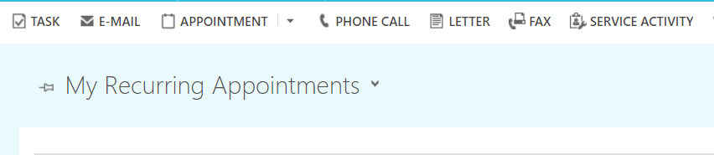

.A form will open called ‘New Appointment’
On the form that opens you must enter the following details:
- Subject – The subject should be ‘Available 1-2-1’.

- Appointment Type – Select 1-2-1 Careers. If you do not select this, the other options will be incorrect.

- Organiser – this will default to you, but will need to be updated to the person who is running the 1-2-1 session. This will be whose calendar the appointment appears in.

- To change the organiser:

  - Click the magnifying glass
  - Scroll to Look up more records, ensure the Look for field is set to User and Look in User Look up view
  - In the search field type the name of the person and search, using the * as a wildcard
  - Once you find the correct person select their name so a tick appears next to it and click Add.

- Appointment Subject – Pick the correct Subject for your 1-2-1 e.g. Careers Advisor, Employability Advisor.

- Outcome – Set to Available.

- 1-2-1 Telephone – Yes or No, if set to No you will need to populate the Location and Room fields. If set to Yes the Meeting Link field will appear. (Whilst meetings are held online – you will need to select Yes)

- Teams Meeting – Yes or No if meeting is to be held on MS Teams

- Meeting Link – If you click Yes on Teams Meeting a Meeting Link will automatically populate here.

- Location* and Room* – only mandatory when 1-2-1 Telephone is set to No. Enter the details of where the 1-2-1 session will be, by clicking on Look Up More Records.

- Publish to Site – Yes or No, this will only publish to the Careers website if set to Yes.

- Description – Give the attendee some information about what the appointment is about. You can change the description on individual appointments within a reoccurrence by going into the appointment, changing the description and press save.

- Click Save and Close
- Ignore any scheduling alerts

- Click Ignore and Save

- Deleting an appointment that has not been booked.
- Some appointments may need to be removed by staff to account for bank holidays, errors and annual leave.

- Find the appointment within your 1-2-1 dashboard and select the appointment row on the left hand side.

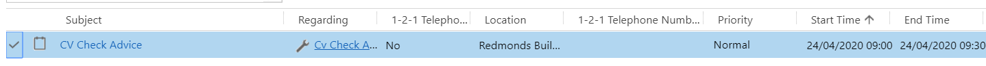

- The row will highlight blue to show that this has been selected. In the ribbon at the top of the page, click the ‘Delete Appointment’ button.

- This will delete the appointment and remove it from your dashboard.

- Booking an Appointment

- You will need to note the students details, date/time requested and the type of appointment. You may need to email back and forth to get this information from the student. If the student is on Live Chat/Phone/Walk in you will need to request this information.

- Once you have it, look at the My Teams Available 1-2-1 Appointments view for a suitable appointment.

- Look down the list to avoid those that have Publish to Site <Yes> selected (if possible!).
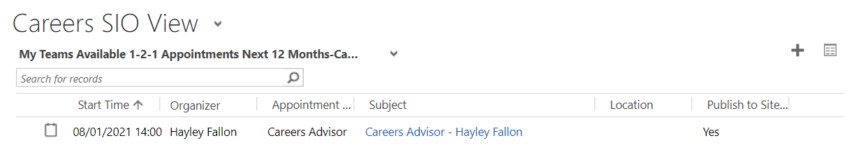
**Remember the option to pop out the view to see a larger screen, click on the small box next to the plus sign. **
- Once you have located an appointment, click on it to open it up.

- You will then to fill in the following information:

- Subject: Update this to ‘Careers Appointment <Student Name>’ Or ‘Employability Appointment <Student Name>’ depending on what the Appointment is for.

- Outcome: Update to ‘Attending’

- Scroll down the page to the ‘1-2-1 Appointment’ section
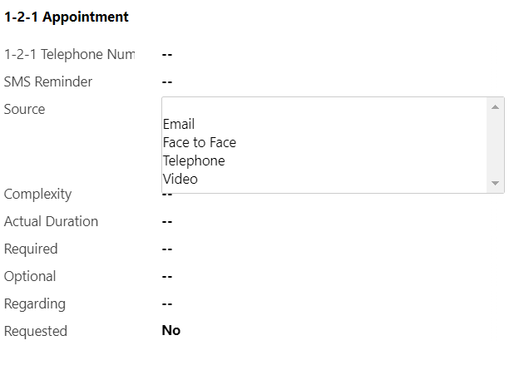
- 1-2-1 Telephone Number: Whether the meeting is to be held over the phone or virtually via MS Teams, you will need to collect a preferred phone number from the student. This phone number can be used if theres any issues on the day.

- SMS Reminder : Enter with the students mobile number if the student would like a text message reminder of the meeting.

- Required: This is where you will enter the name of the student. Click into the box & type the students name, or copy and paste the students ljmu email address/ID number if you have it so that the system can locate the students record.

- Do not click anything, the system should return some suggestions.

- If the option you want appears, click on it and it will populate the field. If it doesn’t appear/no options appear, click Look Up More Records for more options.

- It is useful here to use the * asterisk as a wildcard when searching. CRM records the full name, including any middle names, so it is useful to use the * where the middle name will be. e.g. Deborah* Smith.

- If you know the students ID number, this will take you straight to the students record as it is a unique identifier.
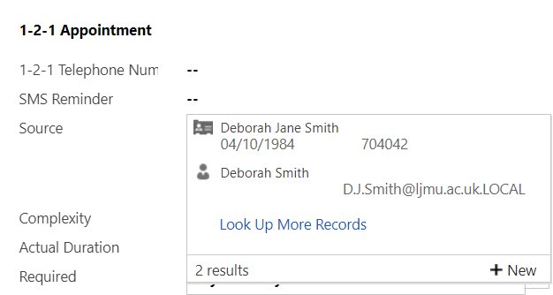
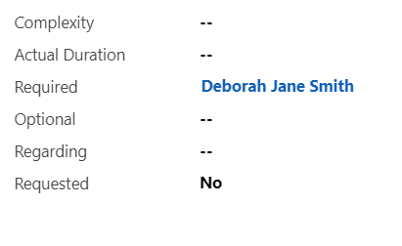
Next you need to add a Note with information about the type of appointment that will help the advisor.

- Face to Face Appointments & Drop In’s

Booking a face to face appointment
All 30 minute appointments will be set as default to a remote MS Teams appointment, apart from drop-in appointments, which will be set to a particular locations, either; ‘Byrom Street – Careers Zone’ or ‘Student Life Building - Careers Zone’.

If a student requests a face to face appointment, the SIO should find a suitable appointment. Within the ‘My teams available appointments’ view on the SIO dashboard, a check should be made that the location field is blank and does not state ‘working remotely’. If ‘working remotely’ is present, then an alternative appointment should be chosen.

Once the appointment has been selected, the 1-2-1 telephone appointment should be changed to ‘No’. The following should be inputted into the relevant location fields:
Location/venue: ‘James Parsons Building’ or ‘Student Life Building’
Room: ‘Byrom Street Careers Zone’ or ‘Careers Zone’ (the latter for use only with Student Life Building).

The usual process of booking an appointment should then continue.

Booking a drop-in appointment
Drop-in appointments (15 minutes) can be booked on the day only and are only available in a physical, pre-set location. These are booked by simply changing the subject field from ‘Available 1-2-1 Drop-in’ to ‘Student Name 1-2-1 Drop-in’, entering the student ID/name into the ‘required’ field, and pressing ‘save’. A workflow email will be sent to the student confirming this 15 minute drop-in appointment.

- Adding Notes

- Notes can be found in the middle of the screen:
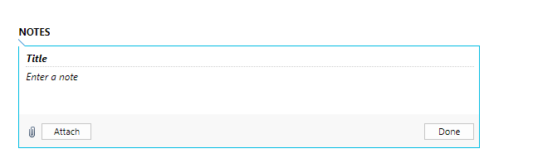
- Click where it says ‘Title’ and enter details of the type of appointment e.g. ‘ CV and Covering Letter Check’, or Career Options Help’.

- Click where it says ‘Enter a note’ too add any additional information the student has provided, or copy and paste it in from the email. This isn’t compulsory.

- Attach Documents

- You can also attach documents within the notes area (e.g. CV, application form, job descriptions, person specification etc) by clicking on the paperclip.

- Next select ‘Choose File’ and the option to select the file will appear. Please note that you will need to save the file to your own computer to be able to upload.

- When uploaded, click Done.

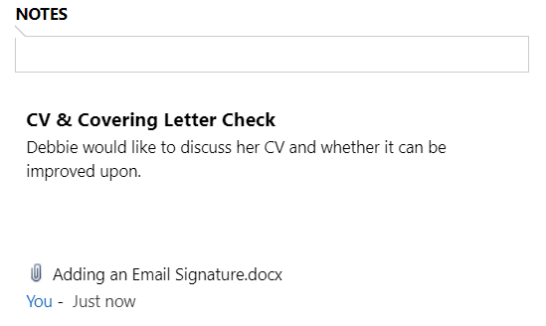
- Click Save
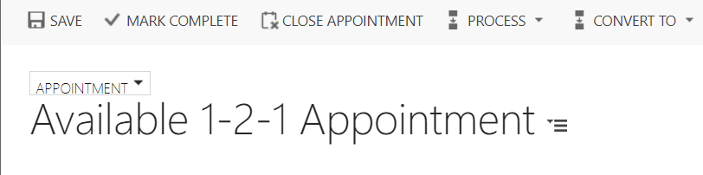

- The booking confirmation email will be sent to the student.

- The booked appointment will move into the advisors ‘My Booked Appointments’ view within their dashboard.

You will now need to set any dealt with email booking requests to Worked on to move them out of the Emails to be processed queue.

*Please see the Email guide on how to do this.

- Update Appointment

- You can update available individual appointments – date/time/description by simply clicking into the appointment and updating what you need to.

- Remember to Save.

- You will not be able to amend the Subject of the Appointment.

- Cancelling an Appointment - Advisor Unavailable

Cancelling an appointment (because the Advisor is no longer available) that has been booked

- Navigate to the appointment and open it up.

- Make a note of the student who is booked on to the appointment.

- Scroll down to Outcome, and change it to Rescheduled.

- Then, in the Notes, note why the appointment has been rescheduled.
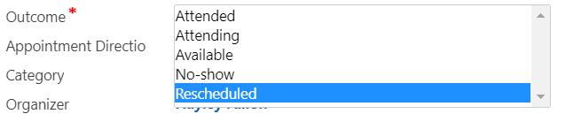

You will need to then contact the student separately (outside of CRM) to advise of the cancellation and rearrange a new appointment if necessary.
- Cancelling an Appointment – at request of student

- A Student may contact you to change/cancel an appointment.

- If the appointment is to be rescheduled, then you can look to re-booking the student on to another available appointment. However you will need to make the ‘Cancelled Appointment’ available again.

- Click into the Appointment.

- Update the Outcome to Available

- Update the Subject to ‘Available 1-2-1 Appointment’.

- Scroll to ‘Required’ and delete the students name.

- Remove any information from the ‘Note’s section.

- Be sure to delete any phone numbers/personal information as this appointment can be booked on by another student.

- The appointment will become available again for other students to book on to. If the cancellation is very late notice, you may not wish to update the Outcome to Available, but to register it as a No Show.

- You can search for an alternative appointment for the student and book on in the usual way.

Appendix

Automatic emails

Currently there are 3 workflow reminders, all emails only go to the LJMU email address:
- A booking confirmation
- Student Cancellation Confirmation to the meeting organiser only.
- Reminder Email and SMS (24hrs but not if booking less than 24 hours before the start)
Booking Appointment - Telephone (mobile number)

Employability Adviser

Hello
Thanks for booking your 1-2-1 telephone appointment with [Organizer]. [Organizer] will telephone you at [Start Time] on the number you have provided.

For further information about what to expect from your appointment, please click here.

If your appointment is concerning a CV/cover letter, job application/application form or interview, please use the links provided to work through the suggested actions in Careers Zone 24/7 to help prepare before the appointment.
If you are no longer able to make this appointment, please cancel it as soon as possible so we can free up this slot for another student. To do this, visit https://careers.ljmu.ac.uk/, and ‘Cancel Registration’ via the ‘My Bookings’ tab. You can arrange another appointment via the same URL or more appointment slots are available by telephoning 0151 231 2048/3719, or emailing careers@ljmu.ac.uk or by visiting your nearest Careers Zone.
Kind Regards
Careers, Employability & Enterprise Team
------------------------------------------------------------------------------
Careers Adviser

Hello
Thanks for booking your 1-2-1 telephone appointment with [Organizer]. [Organizer] will telephone you at [Start Time] on the number you have provided.

For further information about what to expect from your appointment, please click here.
If you are no longer able to make this appointment, please cancel it as soon as possible so we can free up this slot for another student. To do this, visit https://careers.ljmu.ac.uk/, and ‘Cancel Registration’ via the ‘My Bookings’ tab. You can arrange another appointment by telephoning 0151 231 2048/3719, or emailing careers@ljmu.ac.uk or by visiting your nearest Careers Zone.

Kind Regards
Careers, Employability & Enterprise Team

Booking Appointment via MS Teams (video or audio)

Employability Adviser

Hello
Thanks for booking your 1-2-1 Teams appointment with [Organizer]. Please can you click on the link below on [Start Time] and start either an audio call or video call to begin the meeting.
Start Meeting
https://teams.microsoft.com/l/chat/0/0?users=LIDJGLOV@ljmu.ac.uk&topicName=Appointment

For further information about what to expect from your appointment, please click here. On this page, you will also find advice about using Microsoft Teams. If you experience any difficulties trying to access your appointment, please email: careers@ljmu.ac.uk.

If your appointment is concerning a CV/cover letter, job application/application form or interview, please use the links provided to work through the suggested actions in Careers Zone 24/7 to help prepare before the appointment.
If you are no longer able to make this appointment, please cancel it as soon as possible so we can free up this slot for another student. To do this, visit https://careers.ljmu.ac.uk/, and ‘Cancel Registration’ via the ‘My Bookings’ tab. You can arrange another appointment via the same URL or more appointment slots are available by telephoning 0151 231 2048/3719, or emailing careers@ljmu.ac.uk or by visiting your nearest Careers Zone.
Kind Regards
Careers, Employability & Enterprise Team
------------------------------------------------------------------------------
Careers Adviser

Hello
Thanks for booking your 1-2-1 Teams appointment with [Organizer]. Please can you click on the link below on [Start Time] and start either an audio call or video call to begin the meeting.
Start Meeting
https://teams.microsoft.com/l/chat/0/0?users=LIDJGLOV@ljmu.ac.uk&topicName=Appointment

For further information about what to expect from your appointment, please click here. On this page, you will also find advice about using Microsoft Teams. If you experience any difficulties trying to access your appointment, please email: careers@ljmu.ac.uk.
If you are no longer able to make this appointment, please cancel it as soon as possible so we can free up this slot for another student. To do this, visit https://careers.ljmu.ac.uk/, and ‘Cancel Registration’ via the ‘My Bookings’ tab. You can arrange another appointment by telephoning 0151 231 2048/3719, or emailing careers@ljmu.ac.uk or by visiting your nearest Careers Zone.

Kind Regards
Careers, Employability & Enterprise Team

Booking Non-Telephone Appointment (physical appointment in a Careers Zone)

Careers Adviser

Hello
Thanks for booking an appointment with [Organizer] at [Location] on [Start Time].

For further information about what to expect from your appointment, please click here. On this page, you will also find advice about using Microsoft Teams. If you experience any difficulties trying to access your appointment, please email: careers@ljmu.ac.uk.
If you are no longer able to make this appointment, please cancel it as soon as possible so we can free up this slot for another student. To do this, visit https://careers.ljmu.ac.uk/, and ‘Cancel Registration’ via the ‘My Bookings’ tab. You can arrange another appointment by telephoning 0151 231 2048/3719, or emailing careers@ljmu.ac.uk or by visiting your nearest Careers Zone.

Kind Regards
Careers, Employability & Enterprise Team
Non-Telephone (physical appointment in a Careers Zone)
Employability Adviser
Hello
Thanks for booking an appointment with [Organizer] at [Location] on [Start Time].
For further information about what to expect from your appointment, please click here. On this page, you will also find advice about using Microsoft Teams. If you experience any difficulties trying to access your appointment, please email: careers@ljmu.ac.uk.
If your appointment is concerning a CV/cover letter, job application/application form or interview, please use the links provided to work through the suggested actions in Careers Zone 24/7 to help prepare before the appointment.
If you are no longer able to make this appointment, please cancel it as soon as possible so we can free up this slot for another student. To do this, visit https://careers.ljmu.ac.uk/, and ‘Cancel Registration’ via the ‘My Bookings’ tab. You can arrange another appointment via the same URL or more appointment slots are available by telephoning 0151 231 2048/3719, or emailing careers@ljmu.ac.uk or by visiting your nearest Careers Zone.
Kind Regards
Careers, Employability & Enterprise Team

