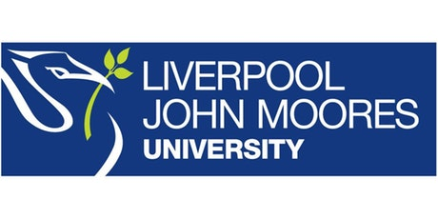
Process Document

CRM – Student Advancement
Liverpool John Moores University

Careers SIO: Emails

Version 0.1, January 2021
Author: DS Business Support Team

Contents

- Your Email ‘Inbox’

- Downloading Documents

- Replying to an Email on a Dashboard

  - Email Labels
  - Sending Your Email

- Inserting a Template

- Attaching a Document to an Outgoing Email

- Marking Emails ‘Worked On’

- Assign to Team Members

- Deleting Junk Emails

- Your Email ‘Inbox’

Emails will come into the Careers Inbox and can be viewed under ‘Careers Emails To Be Processed’:
You can make the view bigger and ‘pop out’ this view by clicking on the small box 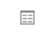
If the contact is already known on our systems then the email should automatically link to them and the ‘From’ column on the dashboard should display as a name rather than an email address.
To respond to an email, double click on the white space within the row of the email and it will open the email form
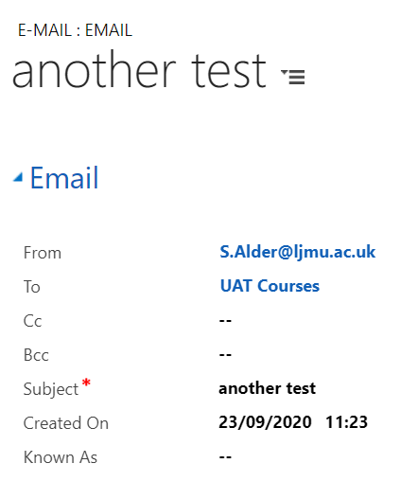
The email will show us who it is from, and that it has come into your default queue. It will show the subject of the email and when it was created.
The ‘Known as’ field will display if the contact would like to be known as something different to their primary name.
The ‘Email sent from’ will show which of the three possible emails on the contact record, that the email has come from.
‘Attachments’ will show any attachments that have come in with the email
The email content will be shown near the bottom of the page.

Downloading documents from an email in CRM

Navigate to the relevant Case and open up the email with attachment.
Click on the attachment title in blue
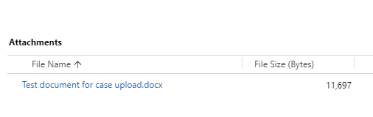
The Manage Attachment box will open

Click on the attachment title in blue and this will download the document to your PC
**Please also remember to regularly delete any downloaded files from you M drive that may contain sensitive information**

- Replying to an new email on the dashboard
To reply to an email, click the ‘Reply’ button in the top left of the ribbon at the top of the page.
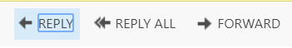
When the email page loads, you will see an option of where to send the email to on the ‘Send to Email Address’ drop down list.
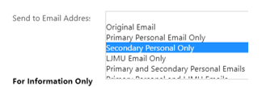

Email Labels

There are three Email labels in CRM, to help us correctly store and manage the different email addresses that our Enquirers/Applicants/Students/Staff use.
These are:
- Primary Personal Email
- Secondary Personal Email
- LJMU Email

The following table shows which fields are Editable/Locked down and how this will change with the lifecycle of the student.
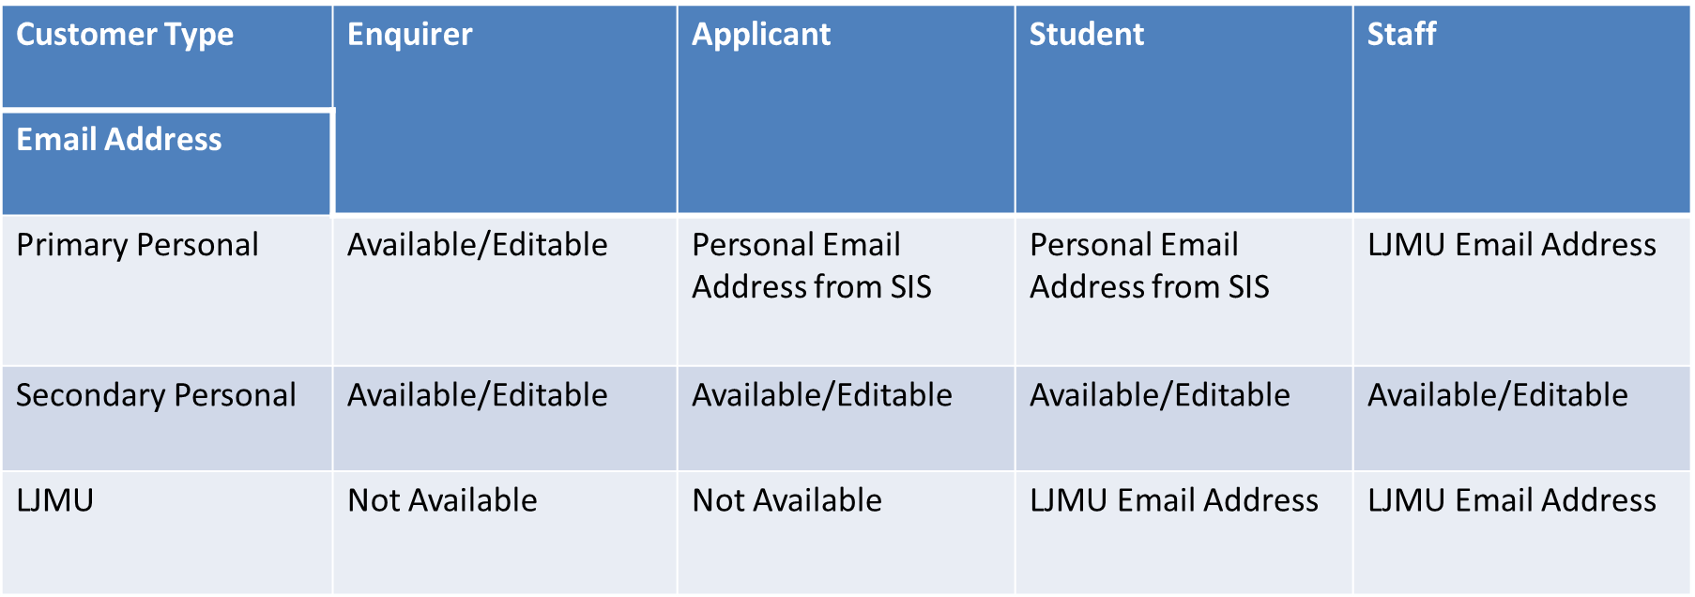

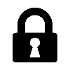

The Secondary Personal Email address will always remain unlocked, meaning that if a student requests that you contact them via a specific email address that is not already listed, then you can add it here.
As CRM is used by different users for different reasons, it is good practice to check this email address is entered each time you email, as it is possible that other users may amend it to suit their own needs
Please note that this drop down list relates only to the Emails held against the ‘To’ Contact and does not relate to anyone cc’d or bcc’d in. There is no option to select the Email address for those contacts cc’d or bcc’d.
Underneath the ‘Send to Email Address’ it shows the email addresses that the contact has available to send to. Original Email will reply to the email address that the email was sent from.
  - Sending your Email
You can write your content at the bottom of the page.
Once you are ready to send, you can press the ‘Send’ button in the ribbon at the top of the page.

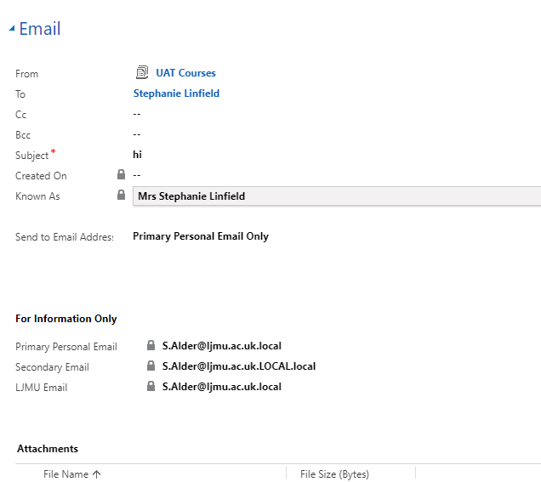
Note: The email will not send if the ‘From’ is an Individual name. It MUST be a Team and the system should show your Default Team.
Note: Please remember to check if any of your Emails have a status of Pending regularly. You have access to a Pending Email Dashboard. Pending means the email is stuck. Contact Helpdesk for support if required.
Once the Email has sent, you will notice at the bottom of the email, there is a field called Contact Email Address.
This field will display the Email address(es) which the Email was sent to and will correspond to the label you selected when you sent the Email.
This field is especially useful for Audit purposes: checking where an email has gone, after the email has been sent.

Inserting a Template

When in a new email, click on to Insert Template which can be found at the top of the screen.
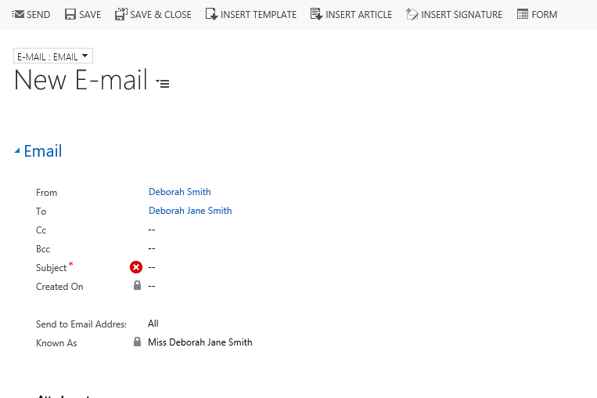
The select record box will open up, select the regarding object record and click Select
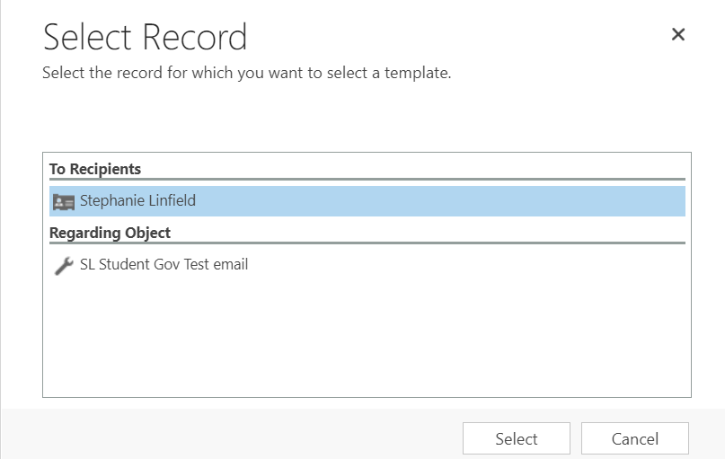
The Select Template box will pop up. Click on the required template.
Click Select.

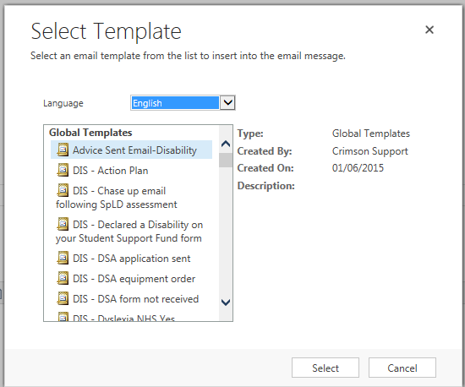
The Email template will populate in the Email.
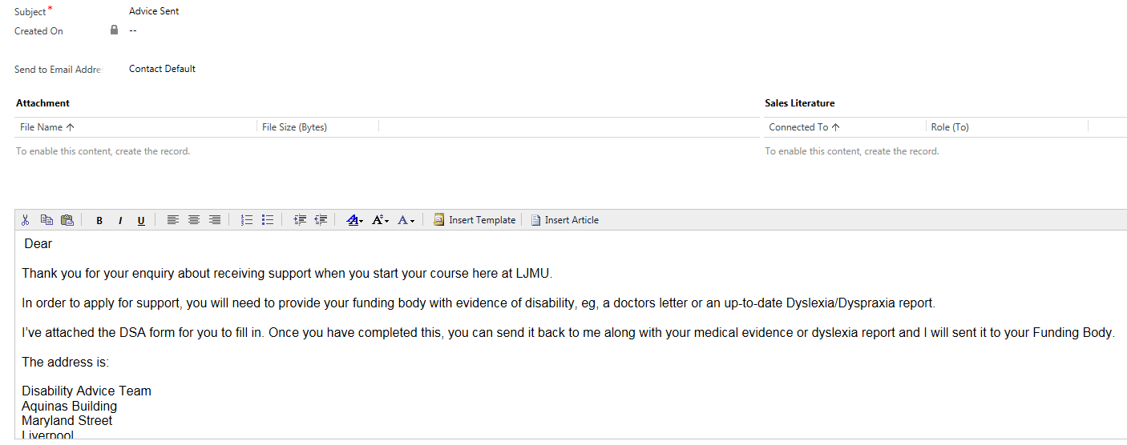

Attaching a document to an outgoing email
When sending an email from a case, open up a new email from the 3 dots by the activities pane within the case.
Write the body of the email and check all details are correct (e.g. the contact and the email address you are sending to etc.)
Click Save at the top, before sending
Upon saving, the Attach File option will appear at the top, click Attach File
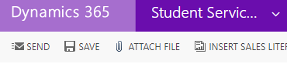
The following box will open, click choose file and select the correct document from you PC or SharePoint, click Attach and Close. This will then appear as an attachment on the email. You can only attach one document at a time.
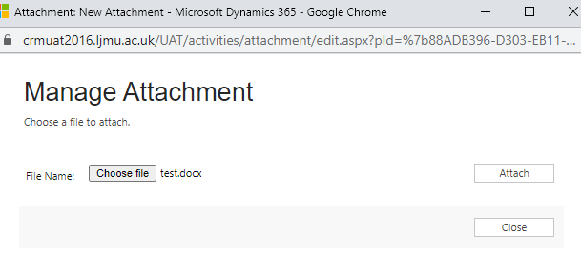

- Marking Emails ‘Worked On’
Once you have dealt with an Email – e.g. booked them in to an appointment, or dealt with an enquiry, you need to remove the email from the Careers Email to be Processed view. You can also assign the email to a Careers or Employability Advisor in the same way.
To do this, from the dashboard, find the email you have dealt with,, and tick the box to the left of the email.
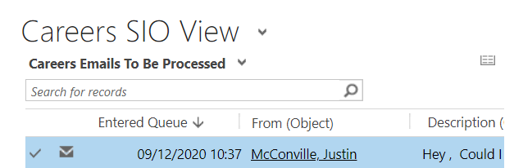
A WorkOn option will then appear at the top of the screen
Click on ‘WorkOn’
Ensure ‘Assign to me to work on’ is highlighted.
Click Assign
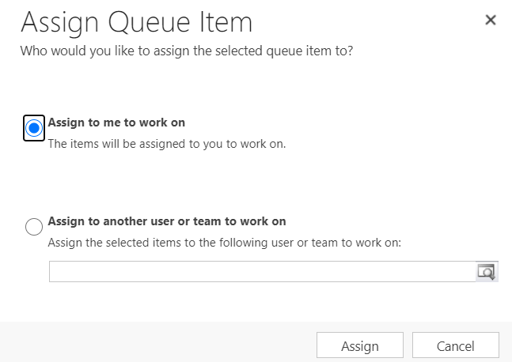
Emails will then move to the next view ‘ Careers- My Emails to be Processed’. They can be left here with no further action.

- Assign to Team Members.
If an Email requires the attention of a Careers or Employability Advisor, you can assign the email to them, using WorkOn.
Open up the Email and click WorkOn button.
Select Assign to another user or team to work on.
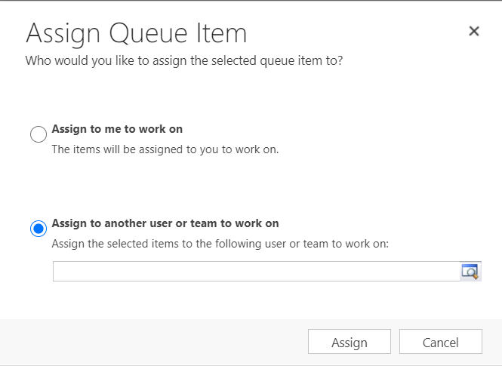
Type your colleagues name – remember to use the *asterisk as a wild card
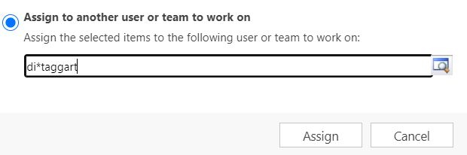
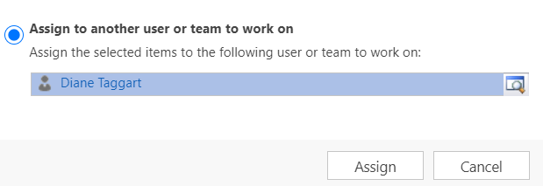
Then click Assign.
The email will now appear on your colleagues dashboard under My Emails to be processed.

Deleting Junk Emails from the Dashboard

You may come across emails that are junk and can be removed from the queue.
Click on the small square to expand the view.
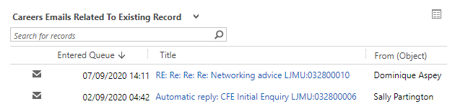
It will open up the following window, you can highlight the record and click Remove
