10. Enter details about the Event which you would like to be visible on Website.

7. End Date & Time

6. Start Date & Time

2. Leave at Proposed, until you are ready to Publish & Open Reg.

1. Name of your Event

You only need to complete ‘Marketing’ & Web/Facebook Details’ section once you are ready to publish

8. Update to Publish

9. Leave as Don't Publish

Once Status is updated (2.) the change can also be seen here.

Remaining Places on course will Count Down here.

5. Location

4. Change to Careers Workshop, Careers Webinar, and Careers Event Fair.

3. Leave as ‘Event’

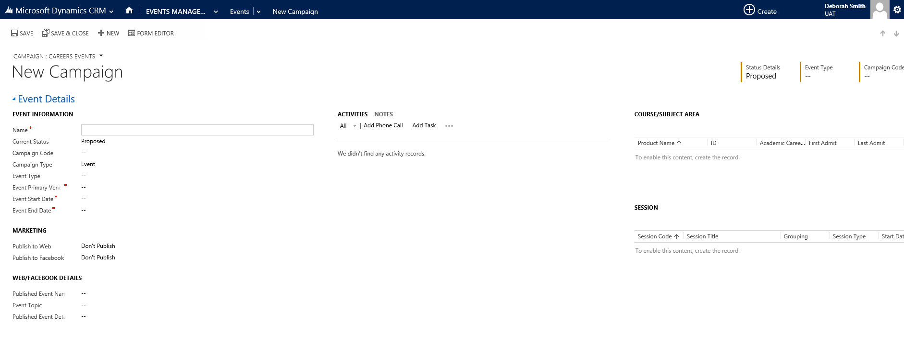

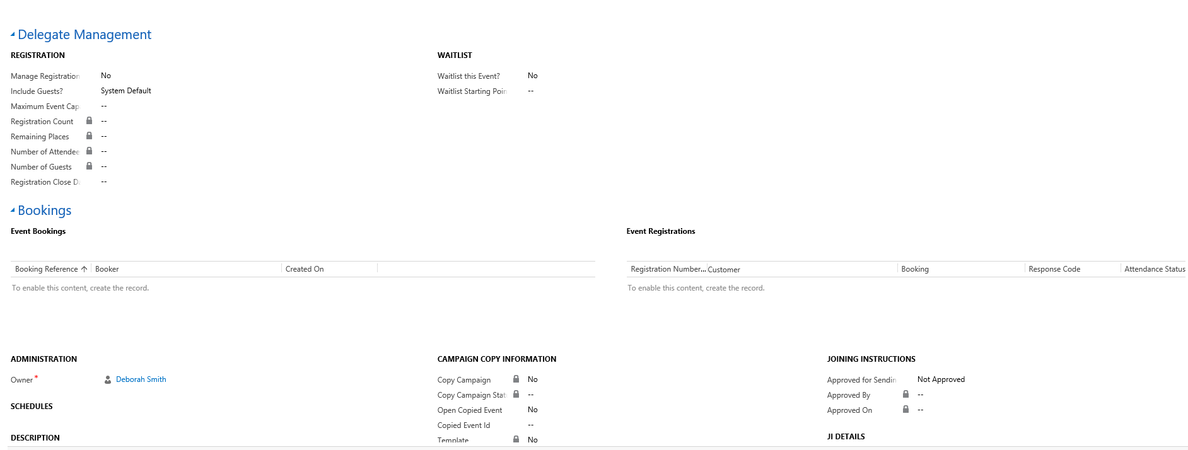

16. Event Registration will show all Students who have booked on to Event.

15. Associated Bookings will show all Bookings ever made on an Event, including those which are now Cancelled.

14. Number after Max number entered. E.g. Max is 30, Wait List would start at 31.

13. Yes if Wait List

12. Enter Max Number

11. Click Yes.