Careers: First Time Logging on to CRM Production….

- Logging in for the first time:

  - CRM Production/Live: CRM LIVE LINK

  - Also, via App Player:

    - You should also be able to find CRM via JMU App Player:
    - Search ‘CRM’.

    - This is the Icon for Dynamics. Be sure to pick this and not the CRM Legacy system

    - Once you have accessed the system for the first time, you can save it as a favourite on your browser.

**Please note, we recommend you use Internet Explorer as this is the University’s supported browser.**

- Settings

On logging in to CRM for the first time, you will need to:
- Set the Entity
- ‘Pin’ the Dashboard

  - Set the Entity

    - When you first log in to CRM, you will need to set the ‘Entity’.

    - On the top ribbon, click on the cog on the top right corner

    - Next click on Options

    - ‘Set Personal Options’ window will open up.

    - Ensure that the Default Pane is set to ‘Events Management’ and Default Tab ‘Dashboard’

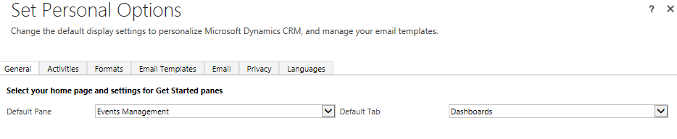

    - Click Ok.

- Pin the Dashboard

    - This is advised so that your Dashboard appears whenever you open up CRM.

    - To do this, click on the arrow to the right of the Dashboard name that your Home Page defaults to on first log in:

    - Select ‘Careers Events Management’ from the list.

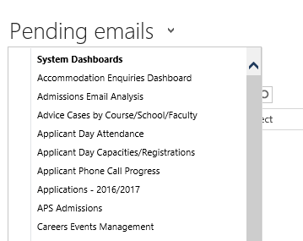

    - The Dashboard will open up.
    - At the top of the page, under the blue ‘ribbon’, you will see a ‘Set as Default’ icon. Click here.
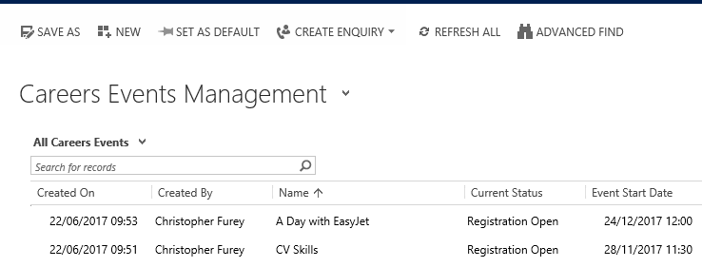
    - Your Dashboard is now ‘pinned’ and will appear whenever you open up CRM.

