Process Document

CRM – Careers
Liverpool John Moores University

Careers:
Set an Email Regarding a Case

Version 0.1 November 2020
Author: SL Business Support Team

Contents

- If the Sender is a Student Page 3

- If the Sender is an Academic/Staff Page 4

- Setting the Email against the Case Page 5

First of all you need to read the email & check if it appears to relate to an existing issue.
You also need to check if the person sending the email is the Student or an Academic/ or Member of Staff Emailing about a student.

- If the Sender is a Student:

- Click on their name in the ‘From’ box of the Email highlighted in Blue to access their contact record.

- Once you are in the Contact Record, you can then check whether they have any other cases which the email may relate to.

- Please make sure you are in the ‘SA’ version of the Contact Form. This is displayed above the student’s name.

- You can click into the students cases by clicking on the Brief Description highlighted in blue (if you have the correct access).

- If you are satisfied that a New Case is required, you can head back to your dashboard, open
up the email and convert it to a new case.

- If you find this email is related to an Existing case then you will next need to make a note of the particular case and set the email regarding the existing case. (See section 3: Setting the Email against the Case)

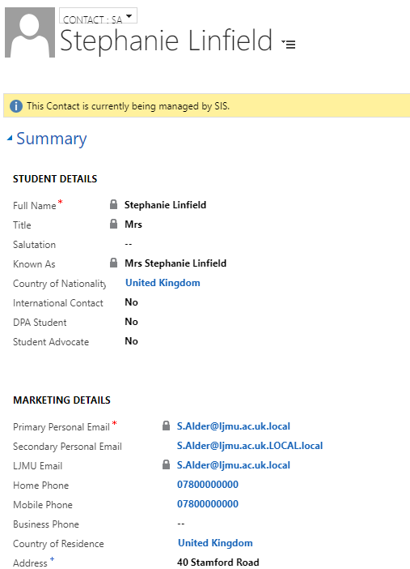

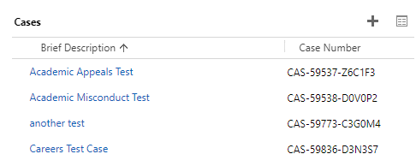
- If the Sender is an Academic/Staff:

- You will first need to read the email and ascertain which student the email is regarding.

- Make a note of any details that have been provided about students (including: Name/Student ID etc).

- You will then need to navigate to ‘Contacts’ and search using the information given. If you have the Student ID this is the best way to search.

- Once you have located the students Contact record, you again need to check the students Cases.

- If you are satisfied a New Case is required then you will need to set a new Case up from here by clicking on the plus ‘+’ symbol.
If you think the email relates to an existing case for this student, make a note of the Case.
Next, you will need to set the email regarding this case.

- Setting the Email against the Case.

- In both above scenarios, once you have the case set up, or have found the existing case, navigate back to the Email.

- Scroll down to the bottom of the email to locate the Regarding field

- Click on the Look Up

- Click on ‘Look Up More Records’

- A ‘Look Up Record’ window will appear.
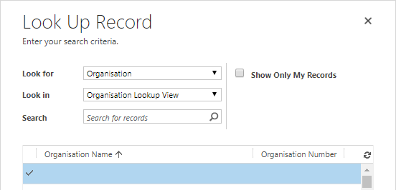

- You will need to change the ‘Look For’ to Case. The ‘Look in’ will automatically update to ‘Case Lookup View’

- You can change the ‘Look In’ view to narrow down your search. There are various views available e.g. ‘My Active Cases’
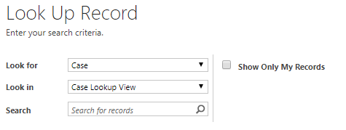
- In the search box you can search for the Students Name (remember to use wildcard), or Student ID or Case Number which you want to attach the email to.

- Search results will then display.

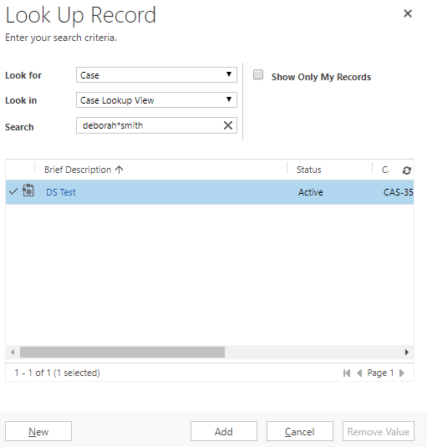
- Tick (in the left hand column) the case you wish to ‘Add’ the email to.

- Click Add.

- Automatically you will see that the Regarding field is now populated with the case you selected (displayed with a spanner)

- If you click on to the Case Name you will be taken to the Case & you will see the email has attached.

