CRM – Course Enquiries
Liverpool John Moores University

Course Enquiries
Prospectus Letters

Version 0.4. May 2019
Author: DS Business Support Team
Liverpool John Moores University
Course Enquiries Desk Processes
Contents

- Set Up Letters in CRM

- Generating the Letters

- What to Send

- Produce Letters in CRM

  - Navigate to Recruitment and then click on Enquiries
  - You are now on a screen called “All Enquiries”.
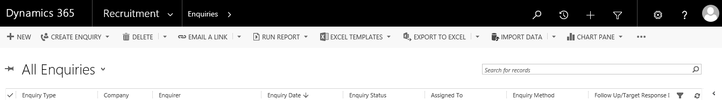

  - Next, click on the small arrow to the right of ‘All Enquiries.
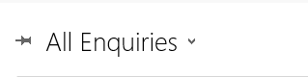
  - Scroll down and click on “Prospectus Requests Due to be Sent”.

  - You will see the following screen:

- Set Up Letters

  - The ‘Prospectus Requests Due to be Sent’ screen will list all records that have requested a prospectus. The default setting is to list 50 records.

  - First, sort the list into separate Undergraduate and Postgraduate sections by clicking on the Enquiry Type column.
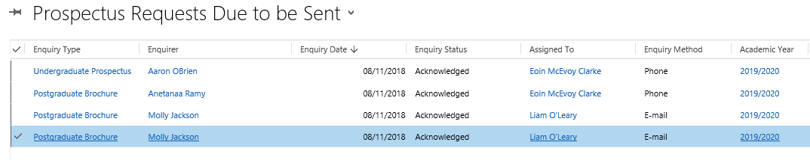
  - Click on the tick to the left of Enquiry Type column to select each request.

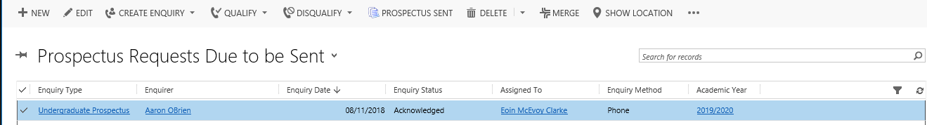

  - You can select multiple records by scrolling to the bottom of the section and pressing and holding shift key as well as clicking the mouse button.

  - Next, at the top of the screen, click on the three dots [···].

  - Click on Run Report.

  - A sub-menu will appear.

  - Click on either “UG Prospectus Send Letter” or “PG Brochure Send Letter” as appropriate.

  - A window will appear saying “Select Records”.

  - Click on “The Selected Records”.

  - Click Run Report button

  - A window will appear saying “Running report”

  - A letter should then appear.

  - Click on the Printer Icon.

Note: If it is the first time you click print, CRM will try to download and install ActiveX so a window will appear saying “Enter authorisation code”. It will be necessary to contact the IT helpdesk at this point to ask them for the code. This only has to be done once.

  - A Print Window will appear as below:
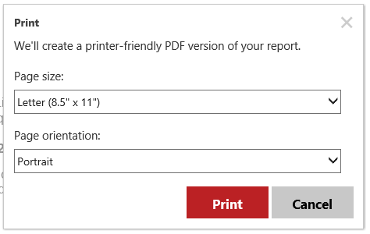

  - Click in the top drop down menu: ‘Page Size’ and select A4. This is an important step to ensure that letters print off correctly.

  - Click Print.

  - A Window will appear that will show a preview of the letter, see below:
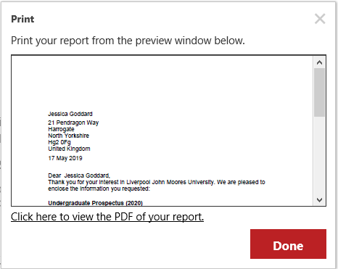

  - An Adobe Acrobat print window will appear on top of this window almost immediately.

  - Click the Properties button at the top of the page.

  - Click the large button where it says Paper and then move onto Other Type, then select Letterhead.

  - Change “2-Sided print” to “1-Sided print”. Then click OK.

  - Back on the Print window again, click Print.

  - The letters will now be sent to the printer.

  - The letter in the window that pops up is a PDF file which can be saved if need be. Save by clicking on the floppy disk icon. You will not normally need to save this.

  - Assuming all letters were printed okay, click the X button to close PDF window, then close the letter window.

  - You are now back on the CRM Dynamics screen with all the names still highlighted in blue.

  - Click on Prospectus Sent.

  - A small window will appear with an orange bar that slowly fills up. There is no need to click anything.

  - Now, at the very right-hand side of the screen you will see the word “Charts” written sideways. Immediately to the left of this there is a symbol that looks like a circle of two arrows pointing towards each other. Click this button (if you hover the mouse over it, it will say “Refresh list”).

  - The names will now vanish from the screen. If you can still see some names on the screen, they are either new ones that have just come in, or there were more records than were shown on the screen (the screen will display 50 at a time by default, unless changed). If any names still remain, return to step 1.

  - If you have just done Undergraduate letters, you should now go back and do Postgraduate letters as well (or vice versa). If you have done both lots then that’s it all done! Please check if tray 1 needs more headed paper. Load it face down with the LJMU logo towards you.

  - Click on Dynamics 365 to return to the ‘home’ dashboard.

- What to send out:

  - Undergraduate Letters

- Send an undergraduate prospectus corresponding to the year of entry on the letter.
- When open days are near you should send them an open day postcard as well.

  - Postgraduate Letters

- You need to send one or more course information booklets for the courses the enquirer is interested in.

- Look at the courses listed on their letter; you then need to find which course brochure contains that course.

- Each postgraduate course brochure contains several courses. They may or may not be in related areas. The only way to know which brochure contains which course is to consult the Excel file located on the shared drive:

Srwateam > Postgraduate > Courses > Latest list > PG Courses List.xlsx

- This file ostensibly contains a list of all postgraduate courses, showing which course appears in which brochure. So please send out the brochure containing the course the enquirer is interested in.

- Please note that new PG courses appear from time to time and they will of course not appear in any brochures until the next time they are reprinted (and they may not appear in the Excel file either), so in that case you must instead email the enquirer with a link to the relevant webpage.

Version Control

Date | Version | Author | Change from last version
15.09.15 | v0.1 | SG | Draft
23.10.15 | v0.2 | SG | Expanded Draft
29.10.15 | v0.3 | SG | Addition to 1.3.1. & 4.2
30.10.15 | v1 | SG | Baselined
28.11.2018 | V2 | DS | Included C.Enq team notes for Upgrade to CRM 2016
13.12.2018 | V3 | DS | Updated s. 2.14, 2.31 and 3.2 following updates from John Davies (Course Enquiries).
20.05.2019 | V4 | DS | Updated printing process.

