CRM – Course Enquiries
Liverpool John Moores University

Course Enquiries
Contacts, Emails & Enquiries

Version 0.4. February 2019
Author: DS Business Support Team
Contents
Liverpool John Moores University
Course Enquiries Desk Processes
- Dashboards

  - Locating your Dashboard
  - Pinning your Dashboard
  - What’s on your Dashboard
  - Alternative Dashboards

- Processing Emails

- Contacts & Enquiries

  - Search for Contact in Search bar
  - Searching with Wildcard
  - Set Regarding
  - Duplicate Enquiries
  - Email sent to Multiple Queues
  - Converting an Email to an Enquiry
  - Prospectus Request
  - Converting an Email into an Enquiry for another team
  - Converting an Email into an Enquiry when it has been forwarded internally.

- Progress an Enquiry

  - Progress an Enquiry
  - Phone Calls
  - Notes
  - Resolving an Enquiry

- Enquiries- Other Sources

  - Directly from a Contact
  - My Team Enquiry from Dashboard

Dashboards

1.1. Locating your Dashboard
- Each team have their own dashboard, which acts as a sort of ‘home’ page.
- Each Dashboard is built up of different ‘views’ to show different information.
The Dashboard for Course Enquiries is:
Course Enquiries Dashboard
    - Ensure you are in Recruitment area.

    - You can select Recruitment by clicking in the box to the right of ‘Dynamics 365’.
    - Select Dashboards
    - The top dashboard in the list will display, but this is not likely to be your dashboard.

    - Click on the arrow to the right to bring up a list to select your dashboard.

    - Navigate to Recruitment:
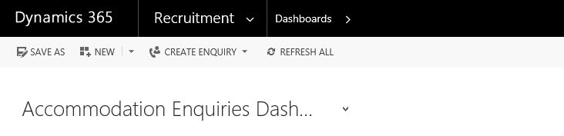

  - Pinning your Dashboard
You can then ‘pin’ your dashboard so that the correct dashboard displays each time you log in to CRM.
    - Click on ‘Set as Default’ button as shown below.

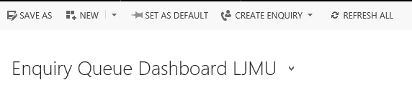

What’s on the Dashboard
- The dashboard displays all your team’s incoming emails and open enquiries. Incoming emails are displayed in ‘Course emails to be processed’ with the International and Confirmation emails in the grids to the right.
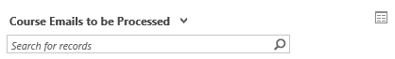
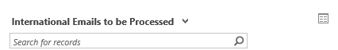
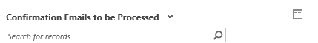
- Any email you convert into an enquiry will be removed from the ’Course emails to be processed’ queue, but will be added to the ‘My Team’s Enquiries LJMU’ list below with the status ‘New Enquiry’.

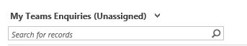
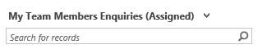

- Any emails which come in relating to an open enquiry will bypass the top grid and go directly to ‘My Team’s Enquiries LJMU’ with a status of ‘Contacted’
- You can expand either of these entities by clicking on the grid to the right of the dropdown:
- This will create a pop out box showing all the emails or enquiries in much greater detail, much easier to search:
- You can sort any of the columns by clicking at the top of the column (ascending or descending, numerical or alphabetical dependant on contents), or you can use the search function at top right to search for a student by name for example.
- Both of these views also now contains a ‘Priority’ column if you wish to triage Enquiries. Priority can be set within the Enquiry view and can be set at Low, Standard or High Priority.

1.4. Alternative Dashboards
There are alternative dashboards you can select to view data:

1.4.1. ‘My Email Dashboard’

- Navigate to Recruitment:
- Then Dashboards:
- Select ‘My Email Dashboard’ from the drop down:
This dashboard shows the queue’s draft, sent and pending emails .All views can be searched like any other, as well as expanded using the grid to the right of each view.
1.4.2. Pending Emails
- Select ‘Pending Emails’ from the drop down menu to view your Pending Emails.

- If you have a Pending Email appearing in your queue then this means that the email has not correctly sent. You will need to check the email and re-send. If you require help please raise a Helpdesk and BST will assist you.

Processing Emails

- Click on the Email title to open it and read the contents.

- If you click on the senders Email address (coloured BLUE) you will be taken to the senders contact record. You can amend contact information on this screen.

- Please include as much information as you can.

- Options available to you are:

- Delete – Only delete if Spam or Trash.
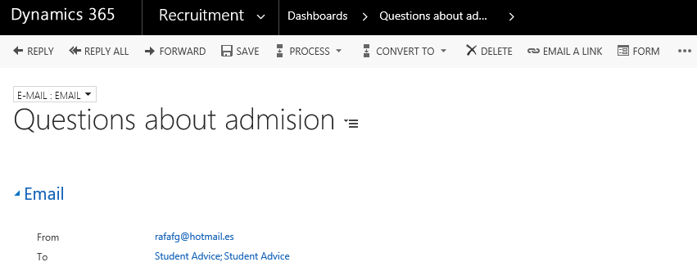
- Click Delete on the ‘Confirm Deletion’ box which appears, and the email deletes, and you are taken back to the dashboard.

- Forward – only forward an email where you need to pass it to someone else within LJMU, but they are not a CRM user:

- Examples of this are Awards Queries or Registry Services Queries.

- Please note that the best way to get the Email query to specific teams within CRM is to convert an email to a specific Enquiry Type. E.g. Accommodation Enquiry, Funding Enquiry (If SAW). It will automatically route to their queue.

- If you do need to Forward: Click ‘Forward’, type the full email address into the ‘To’ field, then click ‘Send’. You can then delete the original email, or (to keep it on the contact’s activities), remove it from the queue.

Contacts & Enquiries

3.1. Search for the Contact in the Search bar.
Before you convert the email to an enquiry you should search CRM to check whether the contact already exists and if the email should be related to an existing enquiry.

    - Click on ‘Recruitment’

    - Click on ‘Contacts’

- If you find Duplicate Contacts then add the new email address to the Contact and arrange for the contacts to be merged by raising a Helpdesk Job. BST will pick this up and carry out the merge.

- If not a duplicate, then update the existing contact record with the correct name if available and any further information that you may have gathered such as level of entry, course of interest and year of entry.
3.2. Searching with the Wildcard ‘*’
- An important tip to remember when searching for a Contact is to use the wildcard function which is an asterisk. ‘*’

- It is important that you use the wildcard in place of a Middle Name (as CRM will search for full names including Middle Name) or if you are unsure of the contacts full name.

  - Set Regarding
Whilst reviewing the Contacts record, you may find an existing Enquiry which the new Email received should be attached to, instead of a new Enquiry being created. In this case, you will need to set the email ‘Regarding’ the existing enquiry.

    - Open up the Email and scroll down to the bottom of the window.

    - Click into the Regarding field.
    - Click on the look up
    - Scroll down to ‘look for more records’.
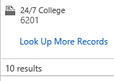
    - Change the Look for and Look In as below:
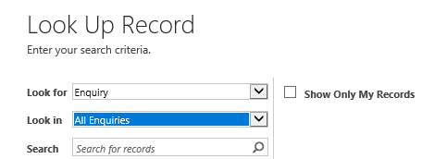
    - Search for the contacts name with ‘* ‘prior to and after their name.

    - Highlight and click on ‘Add’ when you have identified the appropriate enquiry.

    - Click on Save.

    - Double click on the email title to open it and read the contents.

3.4. Duplicate Enquiries
- If you notice that a duplicate Enquiry has already been set up which wasn’t required, then you will first need to ensure all Emails have been set regarding one Enquiry using the steps above.
- Then, raise a Helpdesk job asking BST to delete the duplicate Enquiry.

3.5. Email sent to Multiple Queues
- If you notice that an Email has been received that has been sent to Multiple Queues, then the Email can only be converted to one enquiry.

- Other Enquiries will need to be created from the Contact record and the email copied into Notes. Replies will be sent by creating a new email.

3.6. Converting an email into an enquiry
- Once you have checked the Contact and have established that the Email is a new enquiry, then proceed to convert the email to an Enquiry.

3.7. Prospectus requests
- You can choose to convert an email into an Undergraduate Prospectus or Postgraduate Brochure Enquiry Type.

- These are selected in the same way as a Course Enquiry.

- When the enquiry opens, ensure you complete the type of prospectus, academic year, and format, before completing the process bar as usual:

3.8. Converting an email into an enquiry for another team
- If an Email comes into your dashboard but it is apparent that the query needs to be answered by Engineering, then, select the Engineering and Technology Enquiry. This will then disappear from ‘Science Admission’s emails to be processed’ dashboard, and appears on Engineering & Technology’s ‘My Team’s Enquiries LJMU’ with a status of ‘New Enquiry’.

- The following requests should all be set up as a Course Enquiry Type:

- Undergraduate Prospectus
- Postgraduate Brochure
- Open Day Registration

- Other Enquiry Types are:

Enquiry | Team it goes to: | Additional Notes
Accommodation Enquiry | Accommodation Team
Advocate Enquiry | Outreach Team
APS Admissions Enquiry | APS Admissions
Awards Enquiry | Your Dashboard | This is used, it is auto routed to remain on the user’s dashboard if they created this enquiry type. And then the email should be forwarded on to awards@ljmu.ac.uk
BUS Admissions Enquiry | Bus Admissions Team
Careers/Placement Enquiry | Your Dashboard | This is used, it is auto routed to remain on the user’s dashboard if they created this enquiry type. And then the email is forwarded on to employerengagement@ljmu.ac.uk or careers@ljmu.ac.uk
China Recruitment Enquiry | International Recruitment Team
Clearing Enquiry |  | This is not to be selected as it is only relevant to the enquiries that are brought over from the SIS integration
Complaint | Your Dashboard | This Enquiry type is also routed to remain on the user’s dashboard as they are not always associated with recruitment only.
Course Enquiry | Course Enquiries
Engineering & Technology Admissions Enquiry | Engineering & Technology Team
Event Enquiry | Your Dashboard | This auto routes to remain on the user’s dashboard if they created this enquiry type, as many other users are involved with events not just recruitment
Funding Enquiry | SAW Finance Team
General Accommodation Enquiry | Accommodation Team
Health Admissions Enquiry | Health Admissions Team
Int Fee Status Enquiry | International Admissions Team
Int Admissions Agent Enquiry | International Admissions Team
Int Admissions Counsellor | International Admissions Counsellor
Int Admissions Decision Enquiry | International Admissions Team
Int Admissions Enquiry | International Admissions Team
Int CAS Enquiry | International Admissions Team
Int pre-application Enquiry | International Admissions Team
Int pre-sessional Enquiry | International Admissions Team
Int supporting documents | International Admissions Team
Int Third Party | International Admissions Team
Marsh Admissions Enquiry | Marsh Admissions Team
Middle East & Africa Recruitment Enquiry | International Relations Team | Not used/monitored so please beware if wishing to use.
Postgraduate Brochure | Course Enquiries
Scholarship Enquiry | SAW Finance Team
School Enquiry | Outreach Team
Science Admissions Enquiry | Science Admissions Team
South Asia Recruitment Enquiry | International Relations Team | Not used/monitored so please beware if wishing to use.
South East Asia Recruitment Enquiry | International Relations Team | Not used/monitored so please beware if wishing to use.
Student Admin Enquiry | Your Dashboard | This is used, it is auto routed to remain on the user’s dashboard. Please email to RegistryServices@ljmu.ac.uk
Summer University Enquiry | Outreach Team
Undergraduate Prospectus | Course Enquiries

3.9. Converting an email into an enquiry when it has been forwarded internally
- If an email comes into your dashboard and it has been forwarded from another LJMU email address (not a CRM user), first of all, search for the Contact which the Email relates to.

- You need to firstly check the Contact exists, and if not, create a new contact record.

- Secondly, if the contact does exist, check that the Enquiry doesn’t already exist.

- If you are satisfied the Contact exists and the Enquiry doesn’t already exist, you can create an Enquiry from the Contact record.

- Once Saved, you can navigate back to the original Email & follow guidelines to Set Regarding (Refer to Section 3)

- Then continue to progress the enquiry as usual.
- This functionality can also be used where an email is received from, for example ‘What Uni?’. The email address will not correspond to the email contents, and the enquirer should be set as per the contents of the body of the email, not the email address.

4. Progressing an enquiry
All Course Enquiries appear with the same process bar once converted
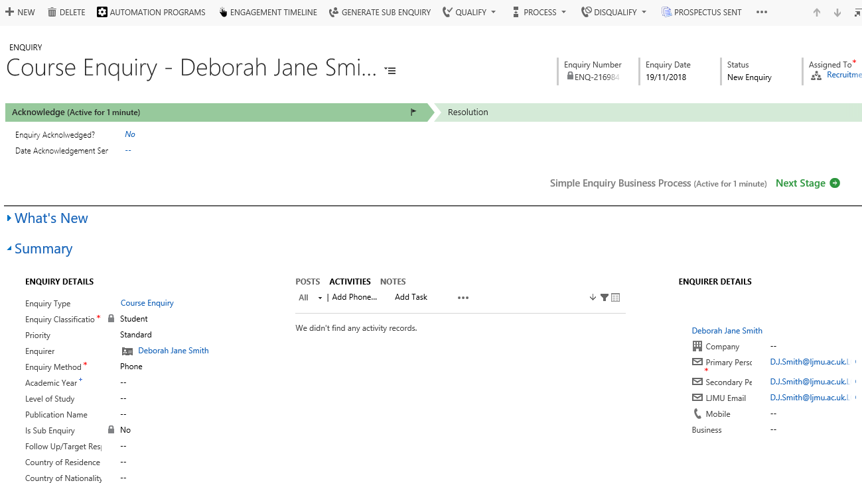
- The Enquiry Type, Enquiry Classification, Enquirer and Enquiry Method will already be filled in for you, as you have already chosen the enquiry type and it was created through an email. CRM has recognised the email address and thus sets the enquirer to the correct student.

- The flag in the process bar shows where you are up to Click ‘Yes’ in the ‘Enquiry Acknowledged’ field, and the date will auto-fill.

- Click ‘Next Stage’ on the process bar and you will move into the ‘Resolution’ stage, and the blue flag will move across.

- You can add a Follow Up Date. Usually 1 week after you have converted the email to an enquiry.

- At this point you may want to add an activity, such as an email or phone call (unable to reply in prospectus/brochure enquiry).

- Click on Activities in the centre pane:

4.1. Sending emails
Apart from replying to an email as part of the enquiry process as above, you can send an email at any point via the ‘Activities’ pane:
A new email will open, complete as for Outlook. There is no need to make a note of emails, as they are all saved to activities in date order (newest first).

4.2. Phone calls
- Click on the Activities pane
- Click ‘Add Phone Call’:
- In the free text field, type the detail of the call.
- Click into the ‘Direction’ field to change the default ‘Outgoing’ to ‘Incoming’ if necessary,
- Click ‘OK’ to save.

4.3. Notes
- If you are waiting for more information before you can complete the enquiry, ensure you have saved (bottom right), and add a note:
- Click ‘Done’ to save
- You can see if a Note is attached to an Enquiry as a number will appear next to ‘Notes’ which tells you how many notes are attached.
- Click amend the status of the enquiry as appropriate
- Click Save

4.4. Resolving an enquiry
- When you have replied and completed everything you need to, you are able to resolve the enquiry, click ‘Yes’ in the ‘Resolution’ field, and ‘Date Enquiry was Resolved’ and ‘Resolved By’ autofill:

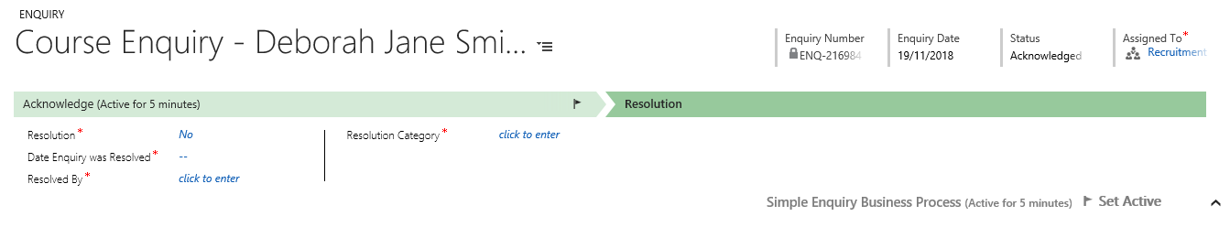

- Click into ‘Resolution Details’ and free text type the detail of how you resolved the enquiry. Select an appropriate dropdown from ‘Resolution Category’, then save. The status will change to ‘Resolved’ and the enquiry is complete; it will disappear from the dashboard.

- If a further email is received from the enquirer as part of the same chain (e.g. a reply to your email resolving the enquiry), the enquiry will re-open, and it will sit in the dashboard with the status ‘Contacted’.

- If a further email is received from the enquirer but they have sent a new email (i.e. not a ‘reply’ but a new email), this will go into the dashboard as new email, and require a new enquiry creating.

5. Enquiries – other sources

5.1. Directly from a contact
- If an enquirer calls and you need to create an enquiry directly for example, navigate to Contacts:
- Using the search bar, search for the contact you wish to create the enquiry for:
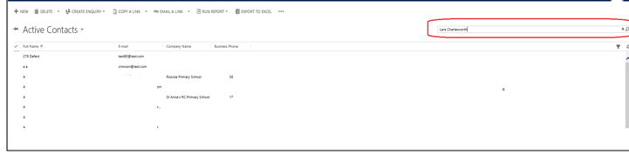
- In the list displayed, locate the correct enquirer, and click on the name to open

- If the contact does not exist then click on ‘New’ to create one.

- If creating a New Contact, you must complete certain mandatory criteria, these include:
    - Full Name
    - Primary Personal Email Address

- It is good practice to include as much information to the Contact record as possible.
- Once created, you can create your enquiry.

- From the contact record, click on the 3 dots and select ‘Create Enquiry’ and the correct enquiry type:

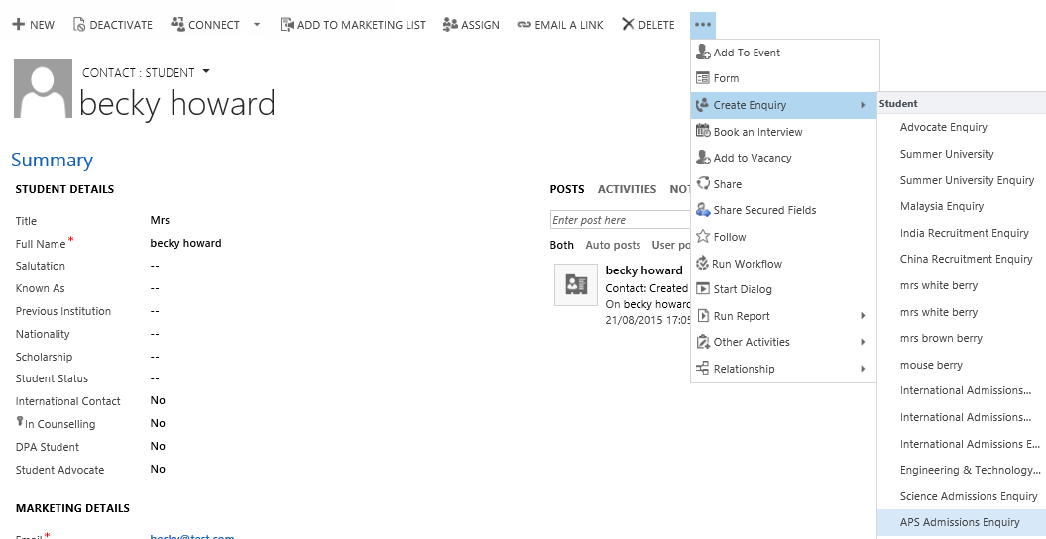

- Once you have created the enquiry, ensure that the correct ‘Enquiry Method’ is selected:

- Save

- Complete the enquiry as before

5.2. ‘My Teams Enquiries’ from dashboard
The bottom half of the dashboard shows all the outstanding enquiries assigned to your team:
All columns can be sorted by clicking on the column title, and selecting either the up or down arrow. You can create a new enquiry from here by clicking on the ‘+’.
You can expand the view (to make searching easier for example) by clicking on the icon top right which causes the view to ‘pop out’ into a new box.
- Any enquiries with the status ‘New Enquiry’ and the method ‘E-mail’ are those that have just been converted from an email.

- Any enquiries with the status ‘New Enquiry’ and the method ‘Web’ are those that have originated from the web enquiry form on the LJMU website, and have been redirected by the Course Enquiries Team. CRM will automatically create an ‘outgoing’ email. This outgoing email will be from the queue that is associated to the enquiry type.

- Any enquiries with the status ‘Contacted’ and the method ‘E-mail’ are those that have just been converted from an email, answered and resolved, and the enquirer has sent another email in regarding the same matter. When you have read and decided on an appropriate response (e.g. phone call, another email, no response required), you will need to manually change the status from ‘Contacted’ to ‘Resolved’ – this does not happen automatically. If you don’t do this, the enquiry will sit in the bottom pane and not disappear.

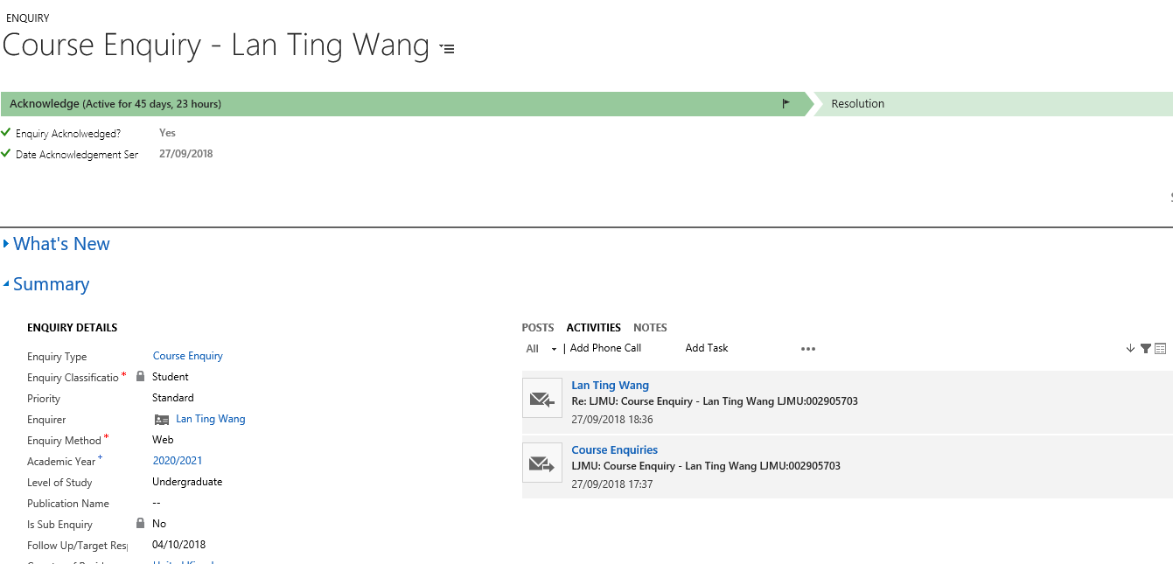

You now need to answer the email, and manually change the status to ‘Resolved’, then save:

This will remove the enquiry from the ‘My Teams Enquiries’ grid on the dashboard.

Version Control

Date | Version | Author | Change from last version
15.09.15 | v0.1 | SG | Draft
23.10.15 | v0.2 | SG | Expanded Draft
29.10.15 | v0.3 | SG | Addition to 1.3.1. & 4.2
30.10.15 | v1 | SG | Baselined
20.11.18 | V1.3 | DS | Updated documents, layout and pictures to reflect CRM 2016.
22.02.19 | V1.4 | DS | Updated Dashboard Name  Added information about Enquiry Prioirties

