CRM – Course Enquiries
Liverpool John Moores University

Course Enquiries
Event Registration

Version 1.5. November 2018
Author: DS Business Support Team
Liverpool John Moores University
Course Enquiries Desk Processes
Contents
- Registering attendees manually to an Applicant Day (via contact)

- Registering attendees manually to an Applicant Day (via event)

- Cancelling an event registration & the associated booking

- Engagement Timeline

- Registering attendees manually to an Applicant Day (via contact)

- If a student calls/emails to register their attendance at an event, you can manually register them against the event.

- Search for the Contact.

- Once you are in the persons Contact record, click ‘Add to Event’ on the top bar.
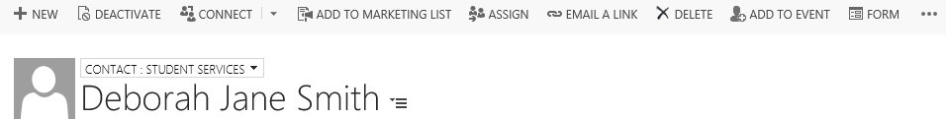
This opens the ‘Add Contact to Event Process’:
- Select the event type you wish to register the contact against (Applicant Day)

- Click ‘Next’. A list of available Applicant Days will appear.
TIP: if the Applicant Day you are looking for does not appear, open another tab, search for the Applicant Day and check that the status is ‘Open for Registration’. Amend if required.
- Select the correct Applicant Day from the list:
- Click ‘Next’:
- Then, you will have the option to select Courses of Interest for the Attendee or, just skip this by clicking ‘Next’.
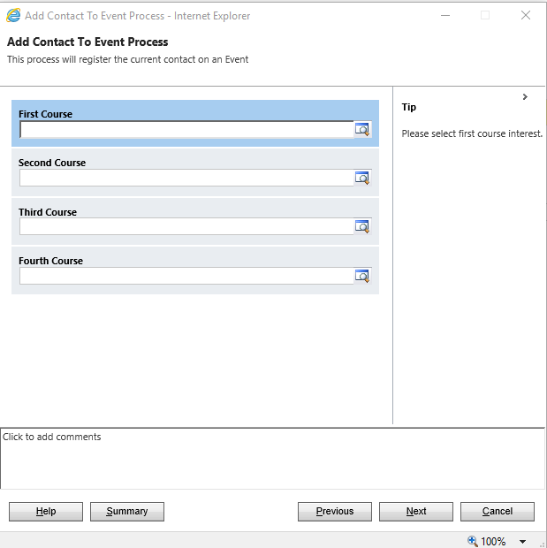

- You will then be asked Year of Entry and Level of Study.
- Again, this can be skipped if unknown, by clicking Next.
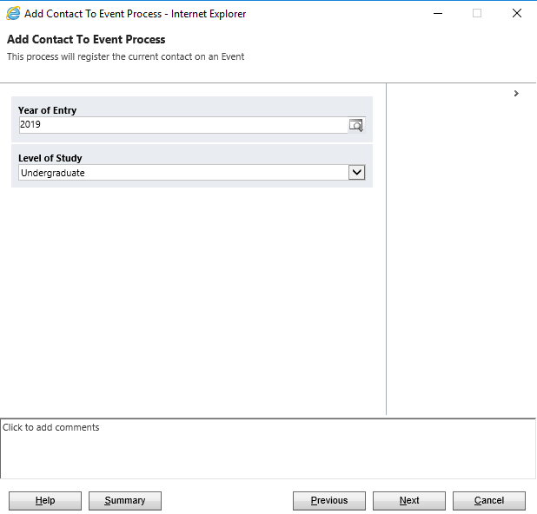
You will then be asked to complete any Additional Support Requirements:
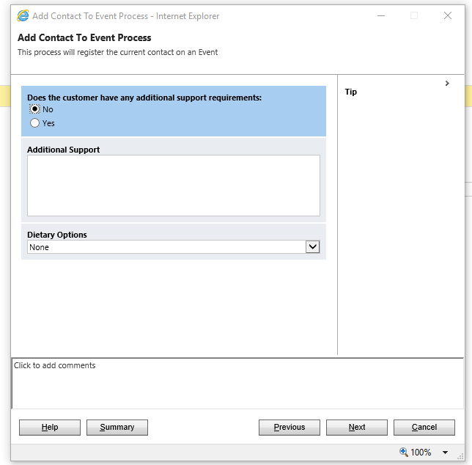

- If there are any support requirements, click ‘Yes’ and complete the free-text ‘Additional Support’ box.
- Select the appropriate ‘Dietary Options’ dropdown.
- Click Next
- The option to select Guests:

- Complete the guest requirements, then click ‘Next’:
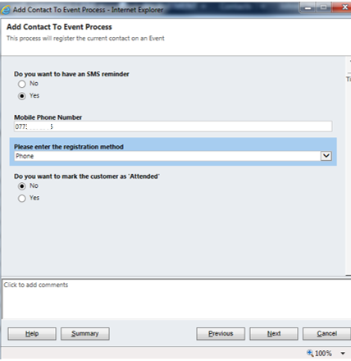
- Click ‘Yes’ if the student wants a text reminder before the event, and complete their mobile number.
- Complete the registration method from the dropdown (email, phone etc.). Only click ‘Yes’ to ‘Do you want to mark the customer as ‘Attended’? if you are manually completing registrations on the day of the event, or after the event. Click ‘Next’.

Click ‘Next’ to add the student to the event and complete the process. Click ‘Finish’ to close.
On returning to the contact, you can see the event by scrolling down the screen to ‘Current Events’:

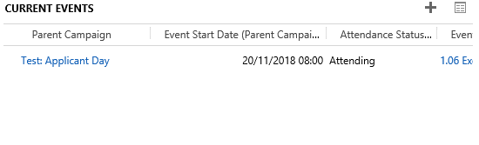

Registering attendees manually to an Applicant Day (via event)
- If a student calls/emails to register their attendance at an event, you can also manually register them against the event.

- Navigate to Events and, search for the event you require using the search bar in the top right corner, narrowing the choices by selecting ‘All Events’ in the dropdown

- Open up the Event.

- Scroll down the page to the ‘Bookings’ section
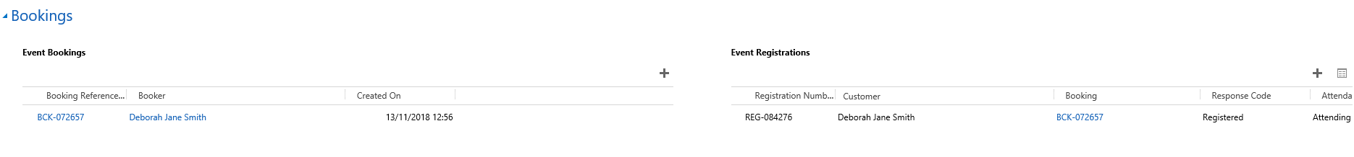
Locate ‘Event Registrations’
Click on ‘+’
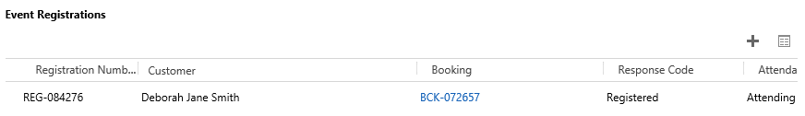
- Click the + to add a registration, which opens the ‘New Campaign Response’ box

- Ensure that the header above where it says ‘Campaign Response’ is set to to ‘Campaign Response: Attendee’.

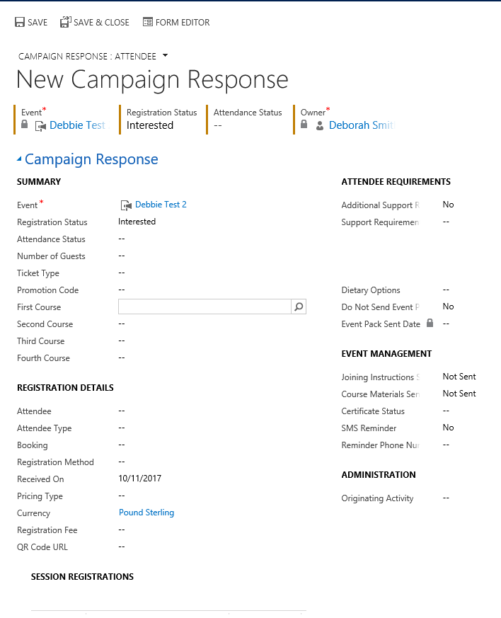
4
3
2
1
- Click into the Registration Status field, and select Registered (1)
- Next, click into the Attendance Status field and select Attending
- Navigate to the Registration Details section (2)
- Click into the Attendee field and search for the attendee
- You can search for the attendee by using the wildcard *.
- Once you find the attendee, click the ‘tick’ to the left of their name and then ‘Add’.
- If the attendee has any Additional Support Requirements, navigate to Attendee Requirements and complete relevant boxes. (3)
- If the attendee would like an SMS reminder, then navigate to ’Event Management’, SMS Reminder. (4)
- Make sure you Save

- Cancelling an event registration & the associated booking

- It may be necessary to cancel an event booking.

- Navigate to ‘Events’

- Search for the event using bar in the top right corner, narrowing the choices by selecting ‘All Events’ in the dropdown (top left).

- Alternatively, you could navigate to Recruitment then Dashboards, and select ‘Events Management Dashboard’ in the dropdown, which should display all current events.

- Click in the event required to open.

- Scroll down the page, to ‘Bookings’:
- Navigate to ‘Event Registrations’

- Locate the Students on the list.

- Click on the Registration Number, it will start with ‘REG…’.

- The Campaign Response Screen will update.

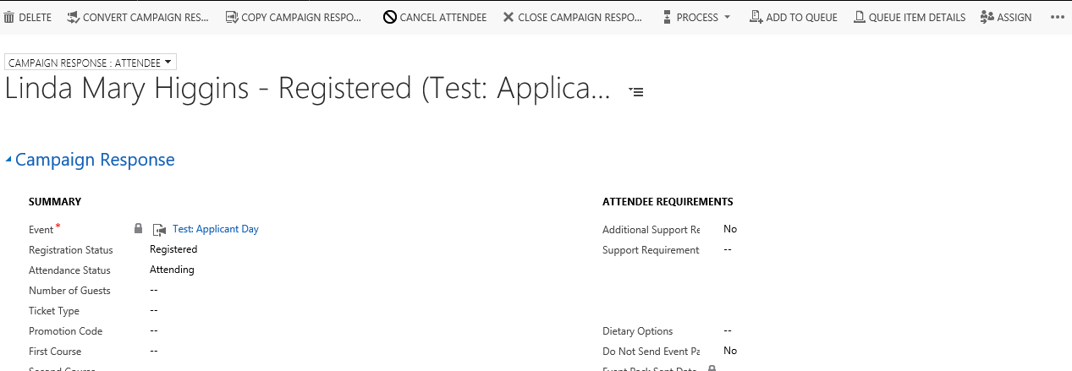

Click ‘Cancel Attendee’.
Complete the ‘Cancel Attendee’ box that appears:

- Ignore ‘Refund Event Fees’

- Click ‘Next’

- Click ‘Finish’.

- Note that the ‘Registration Status’ changes to cancelled
- To deactivate the booking, click on the booking (2), and in the ‘Event Booking: Information’ screen that appears, click ‘Deactivate’:

The bottom of the screen will now show an inactive bar:

The applicant’s booking has now been cancelled, and the count of attendees at the event will be updated.

Engagement Timeline
This is an area of the system which you may find useful to check emails/communications which attendees/enquirers may have received which are sent via Dotmailer.
- First you need to search for a Contact.

- Along the top bar beneath the Black toolbar, click on the three dots.

- Click on Engagement Timeline
- A separate window will open which will display all Emails sent to contact.
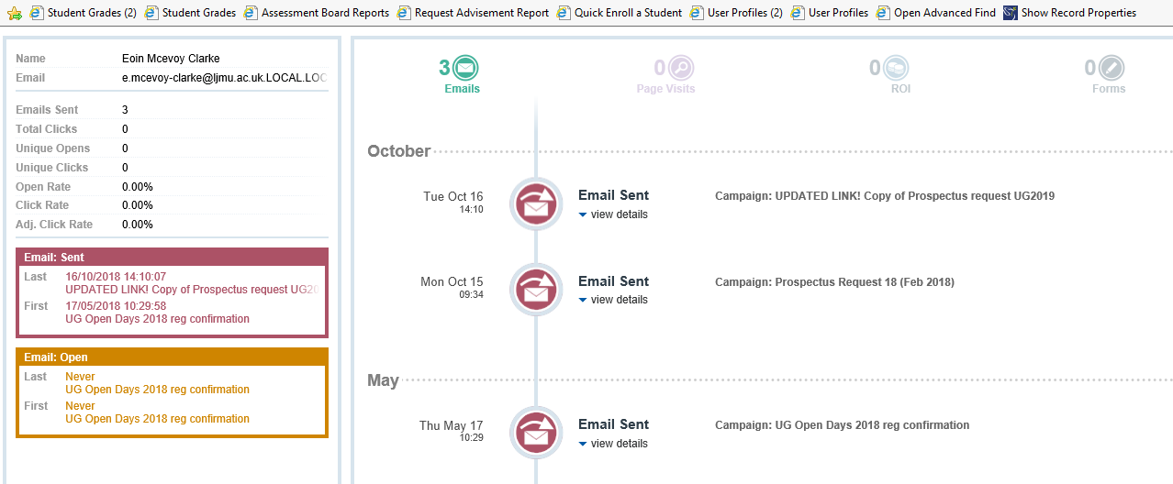

Version Control

Date | Version | Author | Change from last version
15.09.15 | v0.1 | SG | Draft
23.10.15 | v0.2 | SG | Expanded Draft
29.10.15 | v0.3 | SG | Addition to 1.3.1. & 4.2
30.10.15 | v1 | SG | Baselined
28.11.2018 | V2 | DS | Updated for CRM 2016 Upgrade

