CRM – Faculty Admissions
Liverpool John Moores University

Faculty Admissions:
Events

Version 1.5. November 2018
Author: DS Business Support Team

Contents

- Creating an Applicant Day Event

  - Creating an Event

  - Event Requirements

  - Delegate Management

  - Open Registration via Web

  - Register Attendees manually to an Applicant Day (via a Contact)

  - Register Attendees manually to an Applicant Day (via an Event)

  - Cancelling Event Registration & Associated Booking

  - Completing the Event

  - Updating attendees who attended Applicant Day.

- Creating an Applicant Day Event

Creating an Event
To create an Applicant Day Event, you first need to navigate from the Recruitment area to the Events area.
- Click on ‘Recruitment’ on the top bar,
- Then select ‘Events Management’ (Located next to Recruitment.)
- Then, click on ‘Events’
- A screen will then pop up called ‘My Campaigns’
- Click on the ‘+New’ button in the top left corner
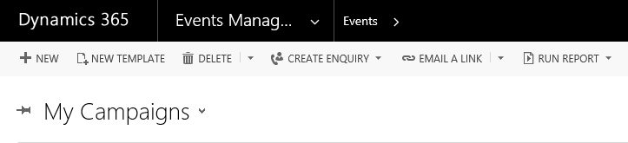
- This will bring up a new Events Form

- You will need to ensure you amend the ‘Campaign: Event’ dropdown to ‘Faculty Event’

- This is found above the words ‘New Campaign’ :
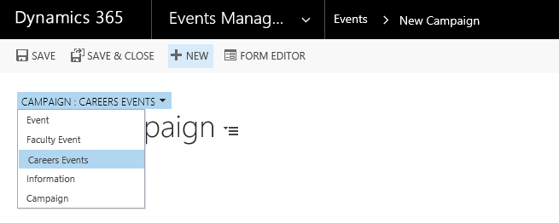

To create the event, you now need to complete the fields:
- Name : Name of Event and date of the event as this will appear on the booking form
- Campaign Type: Event
- Event Type: Applicant Day
- Event Primary Venue < click on look up to select venues>
- Event Start Date <date & time>
- Event End Date <date & time>
Then click SAVE
- Once saved, the event name will populate where ‘New Campaign’ was, and the Campaign Code will be automatically generated.

- The status remains ‘Proposed’.
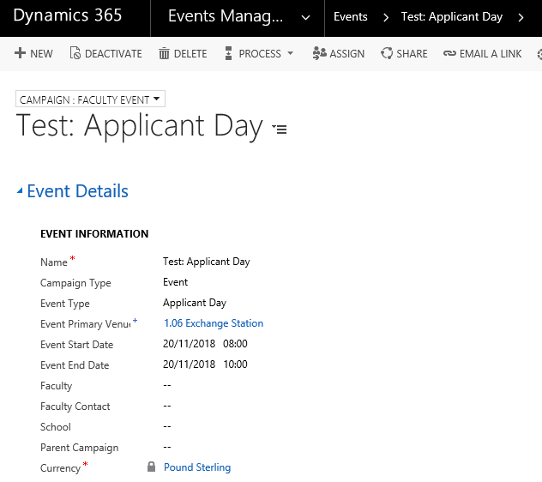
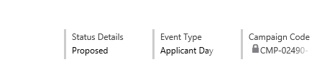
- Leave the Faculty and School fields blank

- Scroll down to Web/Facebook Details.
- Enter the Published Event Name: Name of the Event
- Enter Event Topic field : Faculty Name
- Enter Published Event Details: Enter your Event Name.
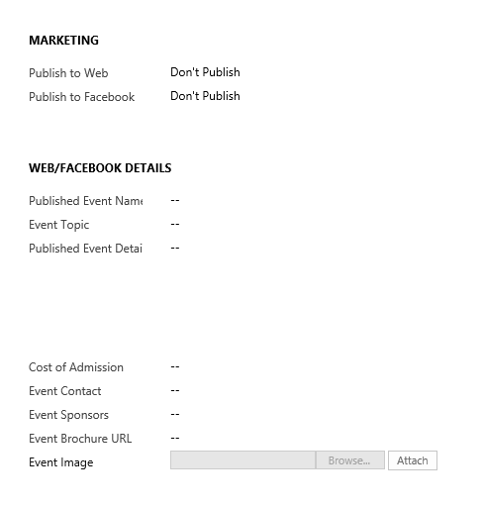
- Add Faculty email address to the Event Contact field
- Add Faculty telephone number to the Event Sponsors field

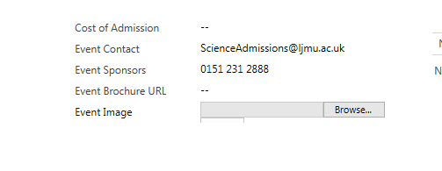

- If this event applies to certain courses, they can be selected in ‘Course/Subject Area’.
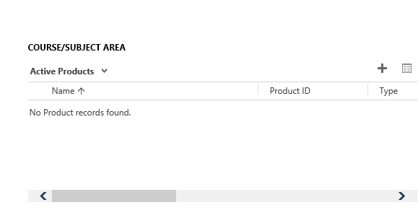

- Remember to Save!

Event Requirements
Once set up, you can now add in any event requirements. Scroll down the page to locate:

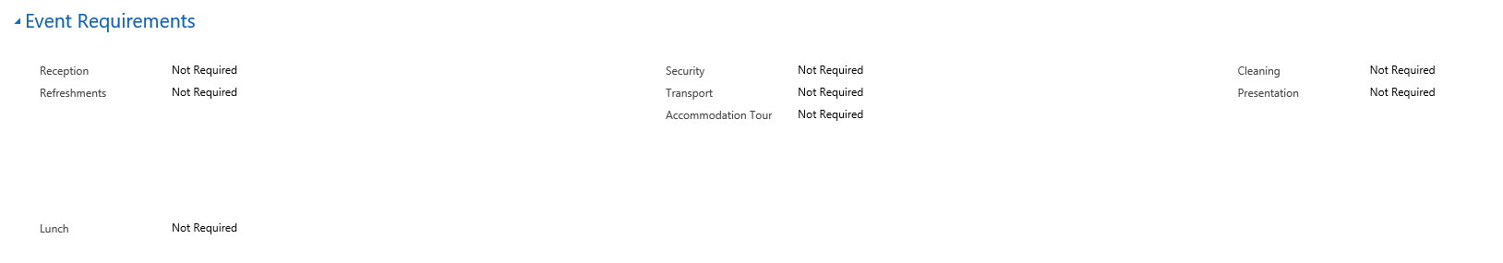

Select any further requirements:
- Reception <Not Required/Required>. An automated email will be sent to Reception if activated.
- Refreshments <Not Required/Required>. This should be completed at least 1 week prior to the event. If you select ‘Required’ further fields will appear:

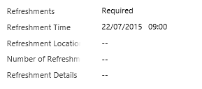

If completed, an automated task will be assigned to the Events Team.

- Lunch <Not Required/Required>. This should be completed at least 1 week prior to the event. If you select ‘Required’ further fields will appear:

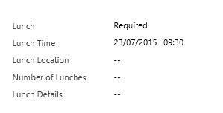

If completed, an automated task will be assigned to the Events Team.

- Security <Not Required/Required>. If required an automated email will be sent to Security once the status is set to ‘Open for Registration’.

- Transport <Not Required/Required>. This should be completed at least 1 week prior to the event. If you select ‘Required’ further fields will appear:
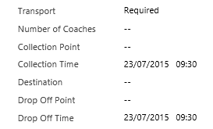
If completed, an automated task will be assigned to the Events Team.

- Accommodation Tour <Not Required/Required>. This should be completed at least 1 week prior to the event. If you select ‘Required’ further fields will appear:

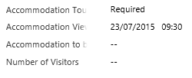

If completed, an automated task will be assigned to the Events Team.

- Cleaning <Not Required/Required>. If required an automated email will be sent to the Cleaning Team once the event status has been set to ‘Open for Registration’.

- Presentation <Not Required/Required>. If you select ‘Required’ further fields will appear:

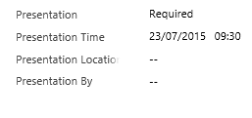

If completed, an automated task will be assigned to the Events Team.

The automatic tasks and emails will sit within ‘Activities’ within the event form in the middle of the screen.

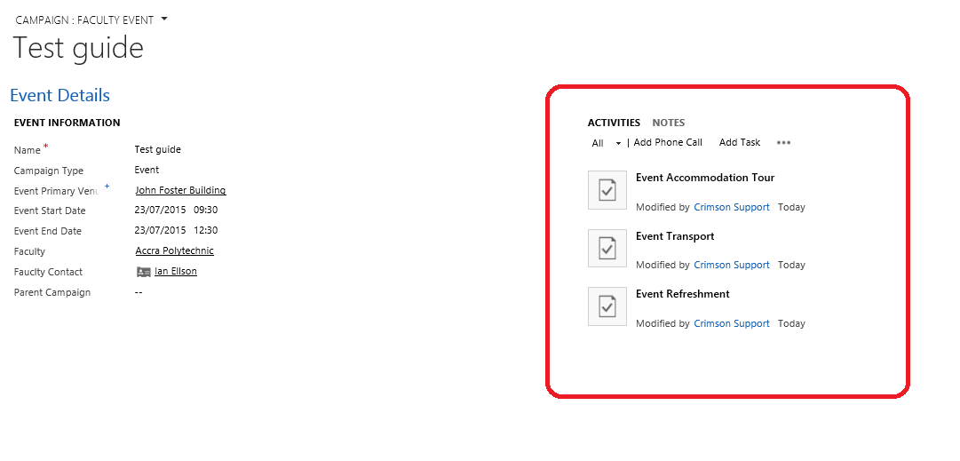

Delegate management
Scroll down the screen and click on ‘Delegate Management’ to expand:
- If you need to restrict the numbers attending the event, change ‘Manage Registration’ to ‘Yes’. If not necessary, leave this blank.

- If Yes, enter the maximum number of attendees in the ‘Maximum Event Capacity’ field. This amount will be used in the calculation for the ‘Remaining Places’ field at the top of the page.

- You can add a waiting list to the event by selecting ‘Yes’ in ‘Waitlist this Event’.

- This will then open up the field below and you can add the ‘Waitlist Starting Point’
(i.e. if the event capacity is 30 and 30 people have registered, the waiting list opens at 31 registrations, so enter 31 into this field.

- Save

Open event for registration via the web
- Scroll back up to ‘Marketing’ section.
- Select ‘Publish in the ‘Publish to Web’ field.
- Next, change the Status.
- Select ‘Registration Open’ in the ‘Status Details’ field within the header
- Now when the student applies online to attend an event these will fall into the ‘Bookings’ section of the event form.

- All bookings will show in under ‘Event Booking’ (even if they are cancelled)

- All active bookings will fall under ‘Event Registration’:
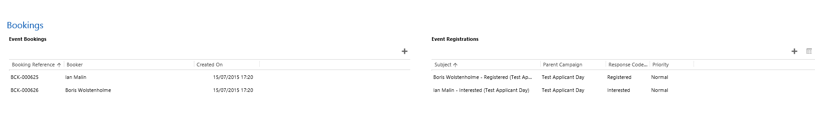

  - Registering attendees manually to an Applicant Day (via contact)

- If a student calls/emails to register their attendance at an event, you can manually register them against the event.

- Search for the Contact.

- Once you are in the persons Contact record, click ‘Add to Event’ on the top bar.
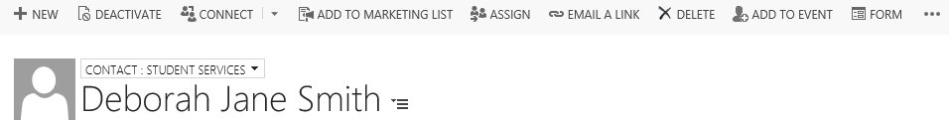
This opens the ‘Add Contact to Event Process’:
- Select the event type you wish to register the contact against (Applicant Day)

- Click ‘Next’. A list of available Applicant Days will appear.
TIP: if the Applicant Day you are looking for does not appear, open another tab, search for the Applicant Day and check that the status is ‘Open for Registration’. Amend if required.
- Select the correct Applicant Day from the list:
- Click ‘Next’:
- Then, you will have the option to select Courses of Interest for the Attendee or, just skip this by clicking ‘Next’.
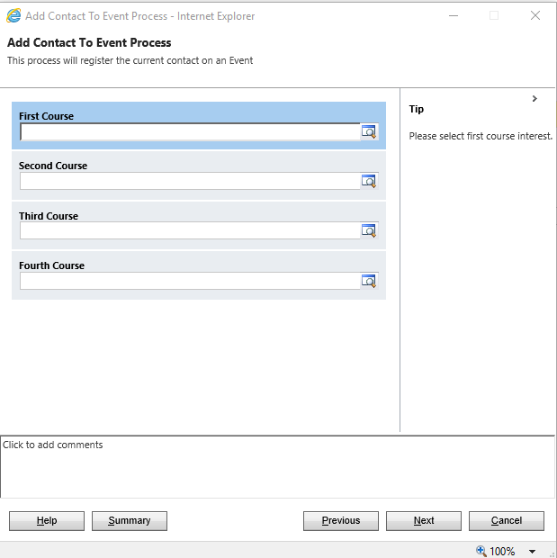

- You will then be asked Year of Entry and Level of Study.
- Again, this can be skipped if unknown, by clicking Next.
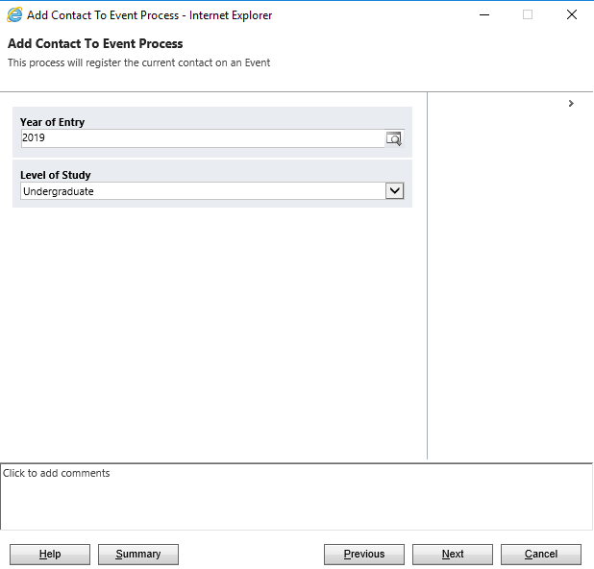
You will then be asked to complete any Additional Support Requirements:
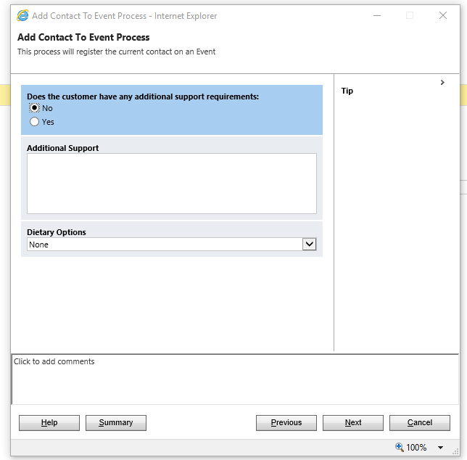

- If there are any support requirements, click ‘Yes’ and complete the free-text ‘Additional Support’ box.
- Select the appropriate ‘Dietary Options’ dropdown.
- Click Next
- The option to select Guests:

- Complete the guest requirements, then click ‘Next’:
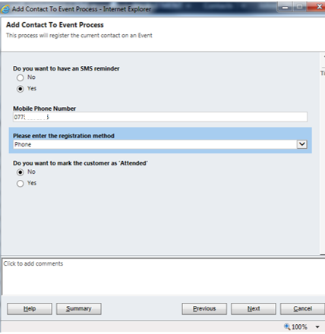
- Click ‘Yes’ if the student wants a text reminder before the event, and complete their mobile number.
- Complete the registration method from the dropdown (email, phone etc.). Only click ‘Yes’ to ‘Do you want to mark the customer as ‘Attended’? if you are manually completing registrations on the day of the event, or after the event. Click ‘Next’.

Click ‘Next’ to add the student to the event and complete the process. Click ‘Finish’ to close.
On returning to the contact, you can see the event by scrolling down the screen to ‘Current Events’:

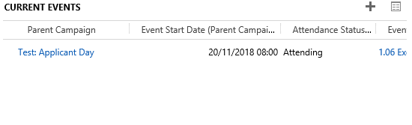

Registering attendees manually to an Applicant Day (via event)
- If a student calls/emails to register their attendance at an event, you can also manually register them against the event.

- Navigate to Events and, search for the event you require using the search bar in the top right corner, narrowing the choices by selecting ‘All Events’ in the dropdown

- Open up the Event.

- Scroll down the page to the ‘Bookings’ section
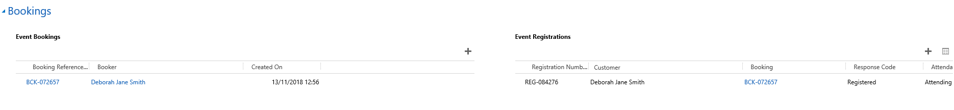
Locate ‘Event Registrations’
Click on ‘+’
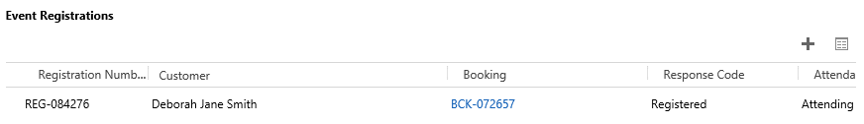
- Click the + to add a registration, which opens the ‘New Campaign Response’ box

- Ensure that the header above above where it says ‘Campaign Response’ is set to to ‘Campaign Response: Attendee’.
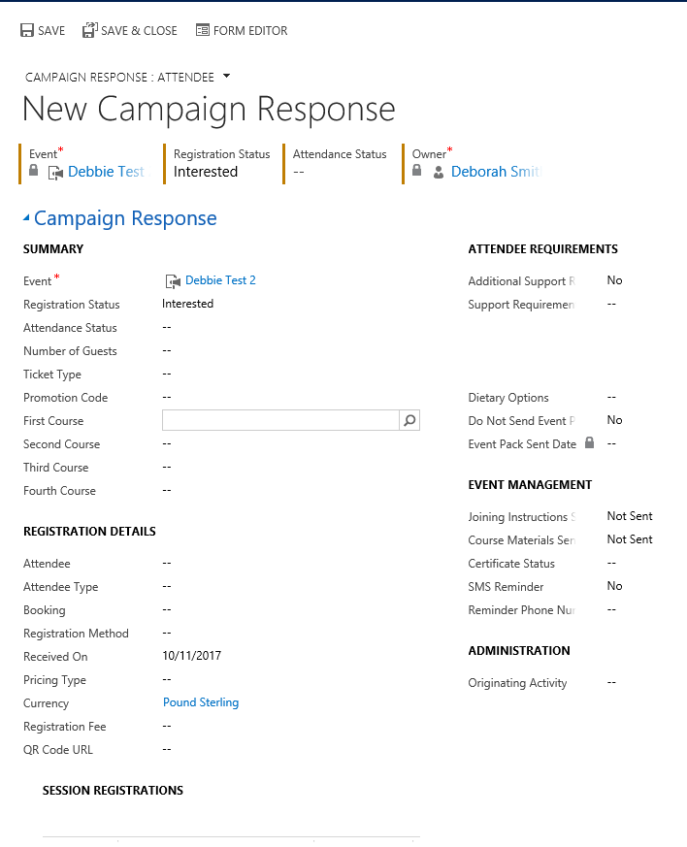
4
2
3
1
- Click into the Registration Status field, and select Registered (1)
- Next, click into the Attendance Status field and select Attending
- Navigate to the Registration Details section (2)
- Click into the Attendee field and search for the attendee
- You can search for the attendee by using the wildcard *.
- Once you find the attendee, click the ‘tick’ to the left of their name and then ‘Add’.
- If the attendee has any Additional Support Requirements, navigate to Attendee Requirements and complete relevant boxes. (3)
- If the attendee would like an SMS reminder, then navigate to ’Event Management’, SMS Reminder. (4)
- Make sure you Save!

Cancelling an event registration & the associated booking
- It may be necessary to cancel an event booking.

- Navigate to ‘Events’

- Search for the event using bar in the top right corner, narrowing the choices by selecting ‘All Events’ in the dropdown (top left).

- Alternatively, you could navigate to Recruitment then Dashboards, and select ‘Events Management Dashboard’ in the dropdown, which should display all current events.

- Click in the event required to open.

- Scroll down the page, to ‘Bookings’:
- Navigate to ‘Event Registrations’

- Locate the Students on the list.

- Click on the Registration Number, it will start with ‘REG…’.

- The Campaign Response Screen will update.

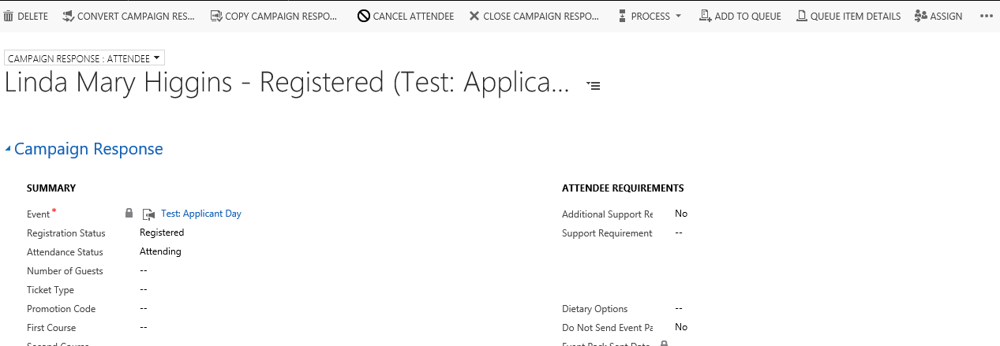

Click ‘Cancel Attendee’.
Complete the ‘Cancel Attendee’ box that appears:

- Ignore ‘Refund Event Fees’

- Click ‘Next’

- Click ‘Finish’.

- Note that the ‘Registration Status’ changes to cancelled
- To deactivate the booking, click on the booking (2), and in the ‘Event Booking: Information’ screen that appears, click ‘Deactivate’:

The bottom of the screen will now show an inactive bar:

The applicant’s booking has now been cancelled, and the count of attendees at the event will be updated.

Completing the event
Once the event has been held, and all attendees have been added either manually via the contact or via the event, change the event’s status to ‘Completed’ in the dropdown, and save.

Updating Attendees who have attended your applicant day
- Go into your Event and click the three dots (ellipsis)
- Select Run Report
- Click on Event Register

- A report will now be produced which will produce a ‘register’.

- At the Event tick off the people who have attended on the report.

- Click on the print icon to Print the report.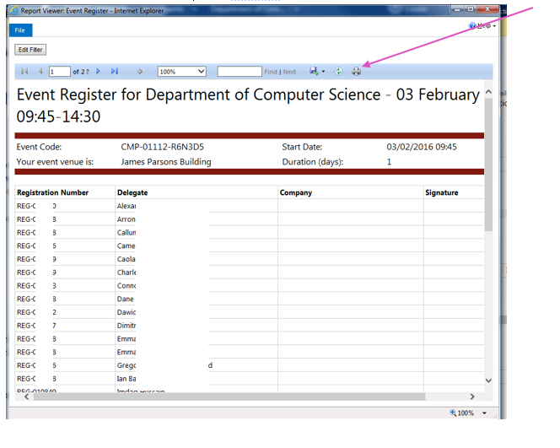
- After the Event the people that attended must be updated on CRM.

- Open up your Event and click the ‘box’ icon to open up the Registrations

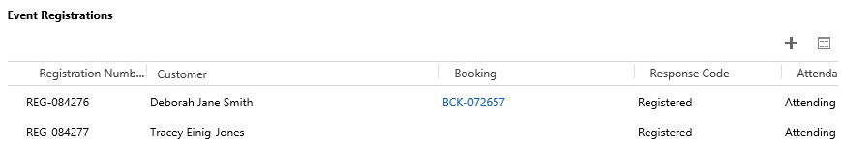

- Click to the left hand side to put a tick against anyone that attended and then click the ‘Attended’ to update the status
