**[](https://www.google.co.uk/url?sa=i&rct=j&q=&esrc=s&source=images&cd=&cad=rja&uact=8&ved=0ahUKEwjZuerSu4nXAhWGchQKHbT9CwIQjRwIBw&url=https://www.eventbrite.co.uk/o/liverpool-john-moores-university-roscoe-lectures-3233158788&psig=AOvVaw2rEDE_dQz3fMXV7J1A9n9g&ust=1508941556822069)**

**Process Document**

**CRM – SIS Search/Match**

Liverpool John Moores University

**Faculty Admissions**

Version 2.0. November 2018

Author: Diane Taggart, Business Support Team

**Version Control**

|  |  |  |
| --- | --- | --- |
| **Version 1.0** | **July 2015** | **Original Version created by Crimson Consultants** |
| **Version 2.0** | **November 2018** | **Updated for the Upgrade to CRM 2016.** |
|  |  |  |
|  |  |  |
|  |  |  |

Contents

1

**Process Document** 1

1. Overview of Find a Person 4

1.1 Process Overview 4

1.2 Find a Person Process Flow 5

2. Searching for a Person in SIS 6

2.1 Reviewing SIS Search Results 8

2.2 Importing a record from CRM 9

3. Searching for a Person in CRM 11

3.1 Reviewing CRM Search Results 12

3.2 Creating a New Contact Record 12

# Overview of Find a Person

## Process Overview

‘Find a Person’ (External Search/Match) within SIS should be used when a person is making a direct application to LJMU needs to be processed manually i.e. where it is not possible to re-direct them to an online application form.

The Find a Person function allows you to perform a preliminary search across both SIS and CRM in order to locate any potentially existing data set that we may already hold and import it between the two systems.

SIS expects any CRM record eligible for import to meet the following minimum data set criteria:

* First Name*
* Surname* (If single name please repeat in both and set the Single Name Service Indicator upon import into SIS).
* Email Address*
* Valid Date of Birth
* Address Details
* 1 contact point

*Mandatory on CRM

## Find a Person Process Flow

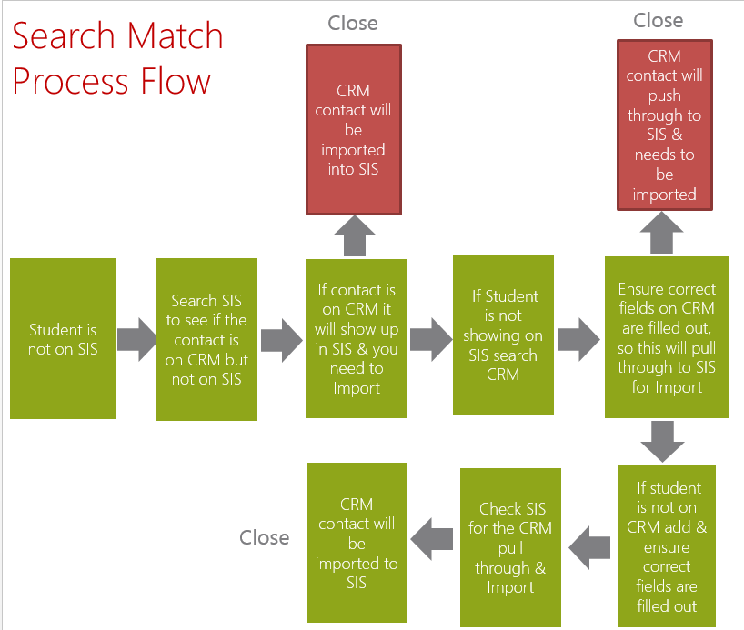

# Searching for a Person in SIS

Log into **SIS** and **Navigate to Main Menu > Campus Community > Personal Information > Find a Person.**

Enter the following criteria to begin your search:

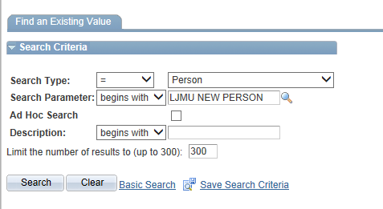

Ensure your settings are the same as below, noting that you may need to set the **Search Result Code** if blank by clicking the **User Default link** and selecting **LJMU Person Search Results** from the list of values

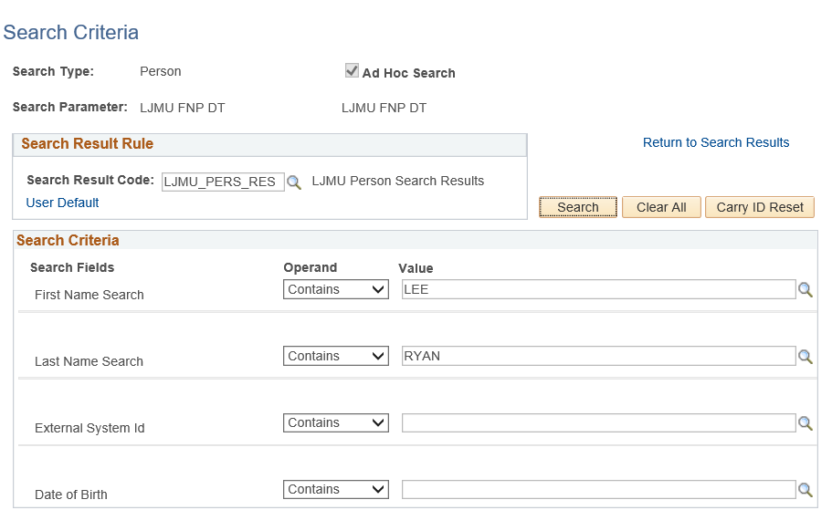

Enter in your search parameters noting the following:

* **‘**Contains’ operandallows you to perform a **Wildcard Search**
* First and Last Name fields will automatically be transposed as standard when you submit your search
* External System ID search field can be used to search for records based on ID’s from other systems such as UCAS, UTT etc
* If using Date of Birth as part of your search criteria that you must also enter something in both the first and last name search fields
* You can convert any element of the Date of Birth to a wildcard search by substituting * into any element of the value (e.g. 01/**/1980)

Existing SIS records can be easily identified with both an Emplid (Person Number) and the **Carry ID** button next to their name.

## Reviewing SIS Search Results

When you click **search** it will display a subset of search results (limited to 100 rows per page). Click the **View All** link to maximise the number of rows you can view at once.

**You must use and existing SIS record if one is present for the person you are searching for.**

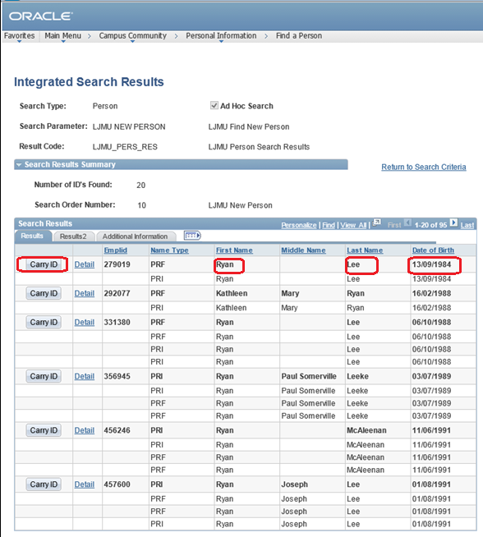

Additional information fields such as currents addresses, affiliations and admissions activity are also available to inform your search by clicking on the remaining **Results 2** and **Additional Information** Tabs or **‘Show More Columns’** icon next to them. You can also click on the ‘Details’ hyperlink for additional information on either an existing SIS record or potential import record to help you assess the record further.

## Importing a record from CRM

If having looked through the list of possible matches, you are confident that no existing SIS record exists, then you need to review any potential matches that are ready to import from CRM. Any potential CRM records will appear at the end of your results list and will have an **Import button** next to their name. This means that the person is present on CRM and the data set we have for them meets our minimum data criteria. The record can be published into SIS by clicking the Import button, which will in turn change to display as ‘Carry ID’ with an Emplid generated next to it.

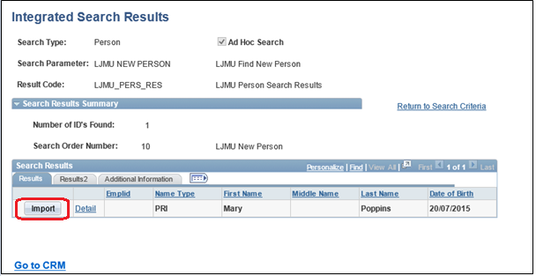

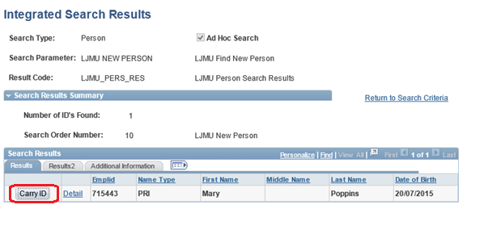

# Searching for a Person in CRM

To check CRM for any existing records navigate to the **Go to CRM** link at the bottom of the SIS search page:

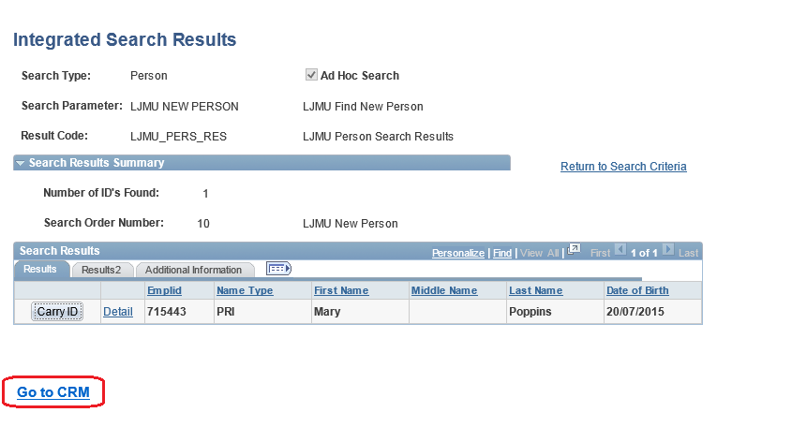

This will directly take you to the **CRM Contact** Page

Ensure you have **All Contacts** selected and then search within the **Search Bar:**

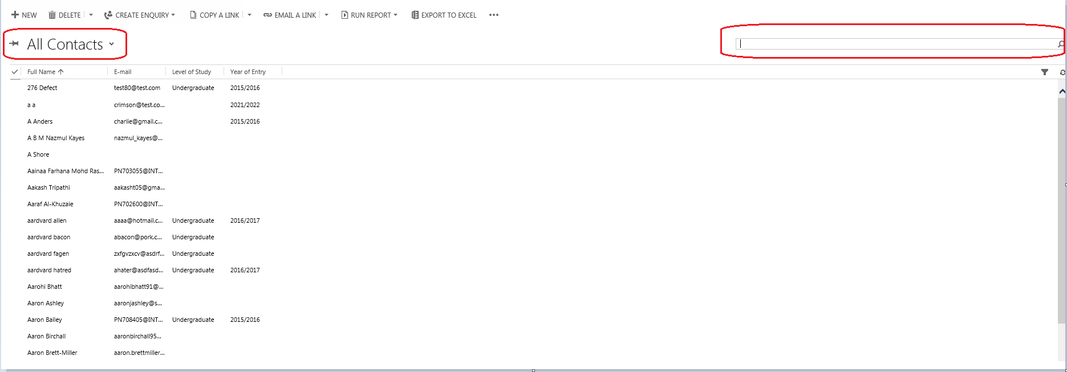

You can search using the **First Name, Surname & Email address (as well as other elements of the record such as partial address, known as etc).**

It is recommended that you use the **Wildcard \*** around and within any searches.

## Reviewing CRM Search Results

A list of contacts meeting your search criteria will display, this includes **Student Number. If the person you are looking for has a student number populated, then the person record does already exist on SIS** and this is the record that should be progressed. Please return to SIS to do so.

If you see the record that you require and this did not appear for import then this means that at least one element of required minimum data set is currently missing from the record. If this is the case, you can select the contact record and add the missing data (please ensure that your Contact View is set to Student described in 3.2 below). Once the missing data has been entered and saved, this should appear as an option for import.

## Creating a New Contact Record

Click +New from the All contacts page too bar to generate a new contact.

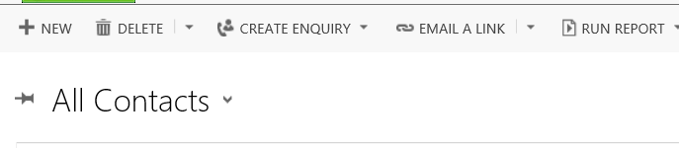

A new contact form will be displayed. Ensure that you are on the Student view as below. If not, select this from the drop down list of options.

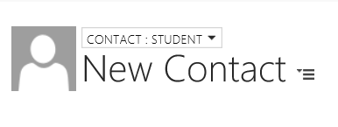

In order for the CRM contact to publish through to SIS for import the below fields **must be populated**:

* First Name
* Surname
* Primary Personal Email
* Country of Residence (country corresponding to the supplied address)
* Address
* Date of Birth

Optionally, it is recommended that the following fields are populated but are not mandatory:

* **Either** Home Phone or Mobile Phone (enter 1 only)
* Title
* Gender

Enter all the required data items and save.

Repeat the process as per section 2.

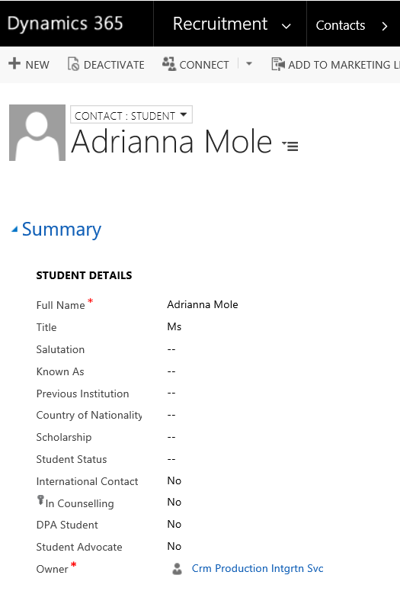

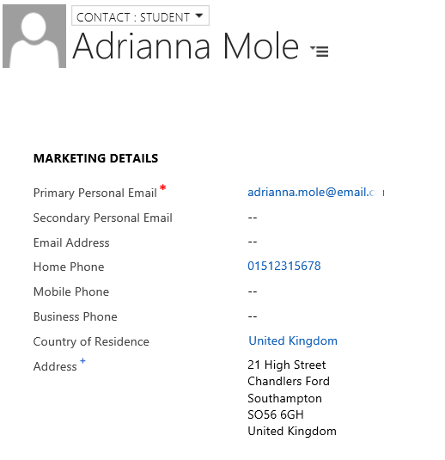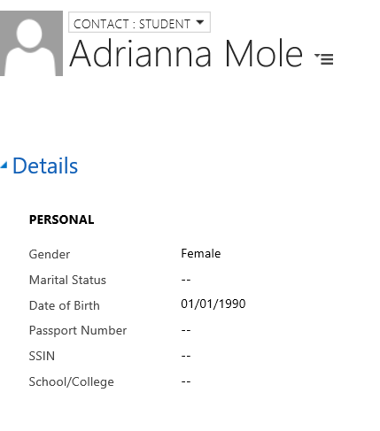

**End of Process**