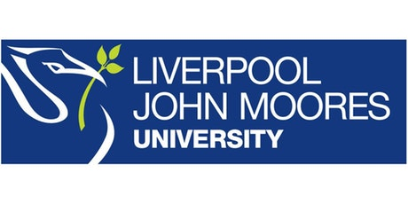
Process Document

CRM – Interview Booking
Liverpool John Moores University

Faculty Admissions: Interview Booking on CRM

Version 0.2 October 2019
Author: Diane Taggart Business Support Team

Version Control
Version 0.1 | October 2019 | Original Version | Page Change
Version 0.2 | October 2019 | - Addition of Creating a Primary Event Venue  - New Event Register (Student Numbers) | 12  21
Version 0.3 | November 2019 | - Addition of Interview cancellation feedback dashboard (applicant)  - Addition of process for managing venue change/cancellation (LJMU)  - Update of Workflow & SMS to incorporate cancellation & change of venue changes  - Addition of Appendix A & B with changes to communications in Appendix A | 5  19 & 20  22

Contents
1
1. Business Context 4
2. Interview Management Dashboards in CRM 5
3. Creating a Bookable Interview Event 6
Interview Event Set Up 8
Adding an Event Venue 11
Registration Management 13
Publishing the Event 13
4. Booking & Booking Management 16
Booking the Interview Slot 16
Reviewing Booking Registration in CRM 17
Applicant Cancellation & Reschedulling 18
LJMU Change of Interview Venue 18
LJMU Cancellation of Interview 19
5. Generating an Interview Register 20
6. Post Interview Processing 21
Logging Attendance/Non Attendance 21
7. Workflow Emails/SMS 22
Appendix A: Communications 23
Appendix B: SIS Cancellation Trigger Status 29

Business Context
When an application is being considered by faculty admissions, it may be a requirement of the consideration process to invite an applicant to attend an interview. The interviews are based either at an LJMU site or a designated location in Northern Ireland.
The process of inviting an applicant to interview will be triggered by the following applicant status in SIS:
- Program action DDEF (Defer Decision)
- Program action reason 2005 (JMU Interview)
Once this has been published across to CRM, an email notification will be sent to the applicant to invite them to book an interview slot via the LJMU Applicant Portal (See Appendix).
***Once the applicant status is changed from the combination above in SIS, the applicant will no longer be able to book an interview slot in the applicant portal. If they have already booked an interview slot and this status changes (See Appendix for trigger status’) then their booking will automatically be cancelled***

Interview Management Dashboards in CRM

Each Admissions team that conducts interviews has their own Interview Management Dashboard in CRM. They can be found under ‘My Dashboards’ in the drop down dashboard list:
- Education Interview Management
- APS Interview Management
- Health Interview Management

The Interview Management Dashboard has 4 views:

Upcoming Interviews: Displays a list and details of all upcoming interview events
Interviews Booked in the Next 7 Days: Displays all booked interviews taking place in the next week
Not Booked Interviews: A list of Applicants that have been invited for interview but have not yet booked a slot
Cancelled Booking Feedback: A list of all cancelled registrations and reasons where provided

You can click into the Events from the dashboard, and can pop any view out by clicking on
You can filter on any of the headings.
*Remember you can pin dashboards by clicking on Set as Default at the top of the page*

Creating a Bookable Interview Event

All Interview slots are setup as Events within CRM, regardless of the length of interview or the number of attendees.
***You will need to set up an individual interview event for each bookable time slot you want to make available on the LJMU Applicant Portal before you invite the applicant to interview***
To create an Interview Event, you first need to select the Events entity from your main menu ribbon:

- Next to Dynamics 365, there will be an Entity Name. e.g. My Work/ Recruitment

- Click on the downward arrow next to the Entity Name.

- Select Events Management

- Select Events

A page will appear called ‘My Campaigns’ (Events that you have personally created) You can change this to a more meaningful view if you wish. There is now a view for each faculty available which shows

If you change the view, then you can pin it by clicking on Set as Default.
To create a new event, in the top left hand corner, you will see 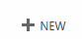

- Click here and a New Campaign page will open up.

- Check the form name located above the Campaign Name (at this stage it will say New Campaign) it should state ‘Campaign: Faculty Event’

- If it doesn’t, you can change this by clicking on the downward arrow and selecting the Faculty Event form view

Interview Event Set Up

In the Event Details region of the form, you will need to complete the following:
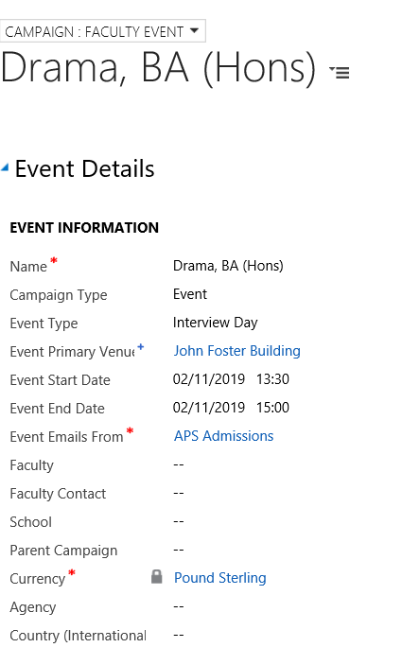

Name: Enter the Name of the Event – This will be the title of the course e.g. Drama and Creative Writing, BA (Hons)

Campaign Type: Select Event

Event Type: Select Interview Day or Interview Day (Northern Ireland)*

*Applicants with a Northern Ireland postcode will be offered interview slots to select for venues both in Liverpool and Northern Ireland where available

Event Primary Venue: Select the Building where the interview is taking place e.g. John Foster Building
If the interview is a telephone interview leave blank.

*** Please ensure that the building you select has an address as this will appear on the applicants booking***

Further details on the specifc meeting point or room can be entered later.
To Look Up the Venue: Click on the magnifying glass icon.

- A few venue options will pop up, but if you scroll down to ‘Look up more records’ a more detailed pop up box will appear to select the correct venue.

- You can check if the venue has a valid address by clicking on it to view its details and update them if missing

If the Venue is not set up, then please see section below called : Adding an Event Venue and follow the process through.

Event Start Date: Enter the Date and Start Time of the interview slot

Event End Date: Enter the Date and End Time of the interview slot

Event Emails From: This needs to be the email queue you want the Interview booking, reminder, and cancellation to go from e.g. APS Admissions
Scroll down to the Web/Facebook region of the page
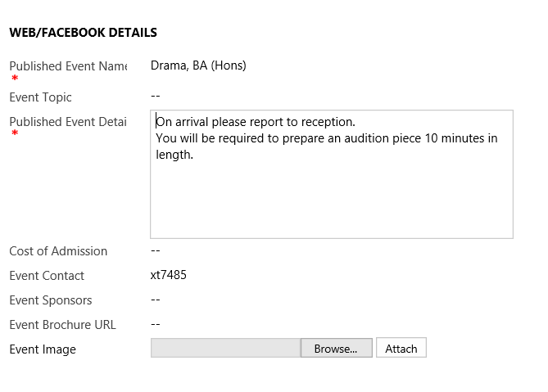

Published Event Name: The name of the program Drama and Creative Writing, BA (Hons)
Published Event Detail: This is a freetext box in which its recommended that you put any additional information. This should include the designated reception point or room but can also include any other information you want to communicate to the applicant from the point of booking the interview.
If the interview is a telephone interview format, please indicate this here.
Event Contact: The contact phone number for the interview day

- Navigate to the Delegate Management section of the screen (either by scrolling or clicking on the burger menu next to the event title). Here you can manage the numbers of applicants allowed to book on that slot. Note that there is no waitlist functionality available here.
You will need to complete the following fields:
Manage Registration: Yes
Maximum Event Capacity: Enter the number of applicants that can book that slot (the system will automatically calculate the remaining places as applicants book on or cancel).

Adding an Event Venue

If your Event Venue is not available in the list, then you can add this yourself.

If the Venue you require is not in the drop down list, you can add a new Venue

Click on the look up (magnifying glass icon)

Scroll down to the bottom of the list.

Click on Look Up More Records
- Click on New
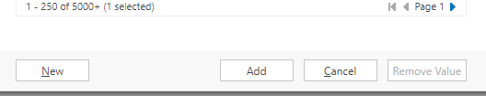
A new window will pop up.

Ensure that above the words ‘New Organisation’ it says ‘Organisation :Venue’.

You can change this by clicking on the downward arrow.
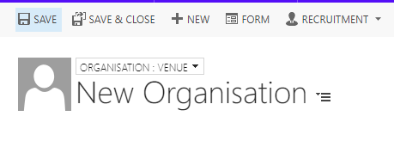

- Enter the Organisation Name – this will be the building name

- Set Is a Venue to Yes
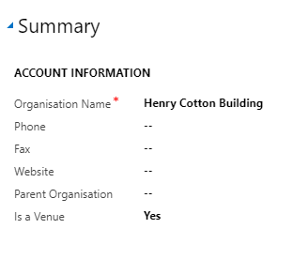
- Scroll down to Address fields and enter the Country and address of the building
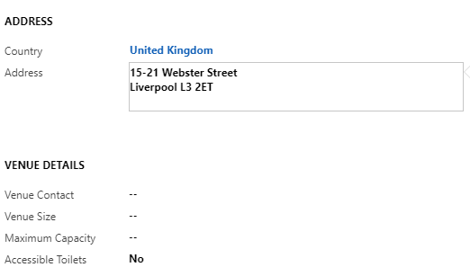

- Click Save.

You should now be able to select your building from the list

Registration Management

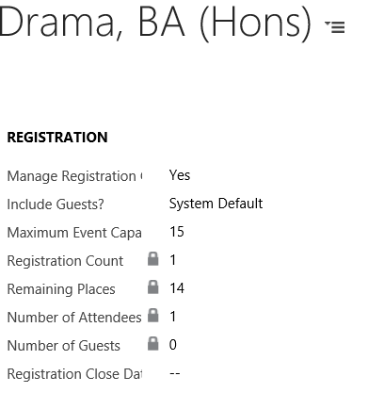
Click Save

Publishing the Event

All interview slots must be linked to one or more courses in order for them to appear in the applicant portal.
- To do this, navigate to the Course/Subject Area on the right hand side of the form and click on the +
A search Box will display
- Click on the Magnifying glass icon and scroll to Look Up More Records
- If the program is UG, select Marketable Courses (UG) from the drop down Look In list. This will help to filter the list more easily. If it is a PGT program you can select Marketable Courses to restrict the picklist.

- You can also use the * wildcard to continue your search

- Select the program that corresponds to the interview slot

Navigate to the Marketing Section of the form

- Set Publish to Web to Publish

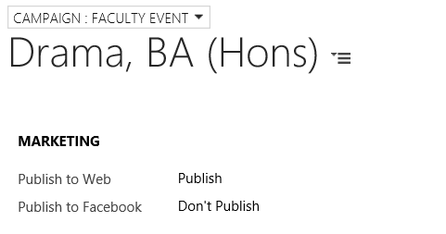
- Update the Status Details (top right hand corner) of the Event to Registration Open

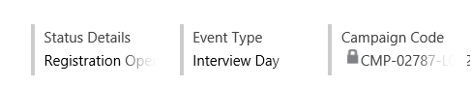

- Save
The interview is now live and bookable on the website!
When an event reaches either full capacity or its end date its status is automatically completed, however, it needs to remains visible for a further 2 days to continue to display on the applicant portal during this period.

Booking & Booking Management

Booking the Interview Slot

Applicants can book and manage their interview slot by either logging on to the applicant portal themselves or having a member of staff log on to the applicant portal on their behalf and booking them on. This should be possible as all applicants should have a SIS/UCAS ID and should have provided a personal email address as part of the application process.

***Note that staff cannot manage interview bookings via CRM they MUST be booked and managed via the portal***

Once logged into the portal the applicant will be presented with application(s) that are at Invited to Interview status, they will need to select the appropriate program.

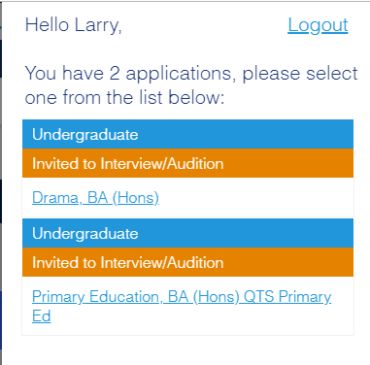

From there they can book on to any available interview slots, and once booked will receive an email confirmation of their booking. (See Appendix) They will also receive a QR code which can be used for logging attendance.

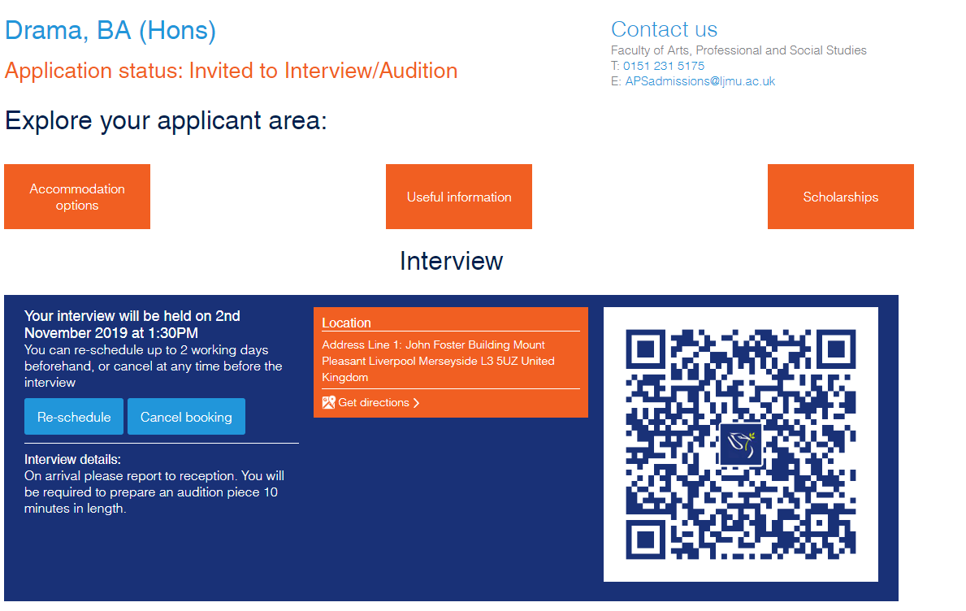

Reviewing Booking Registration in CRM

Back in CRM, on the Event Page, you are able to review who has booked on to an Event, within the ‘Bookings’ section.

All Bookings will appear under Event Booking. This includes any Bookings that have been cancelled. All Active Bookings will appear under Event Registrations.
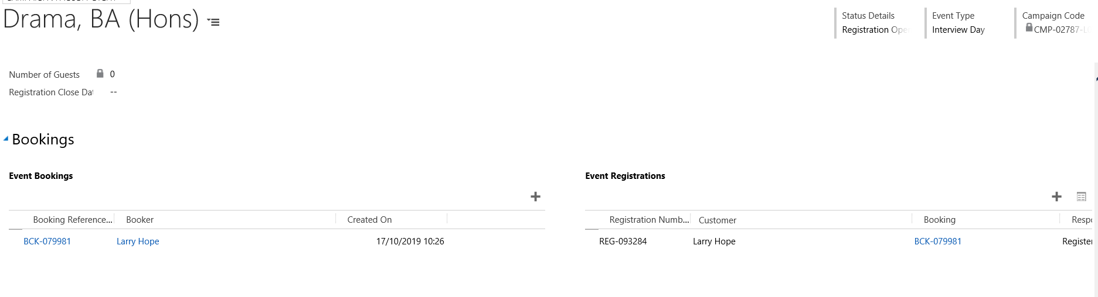

Applicant Cancellation & Reschedulling

Reschedulling and Cancellations requested by the applicant need to managed via the portal. Upon cancelling the applicant will be prompted to provide a reason, and advised that they can re-book if there is availibilty up until 2 days before the interview. Cancelling re-adjusts the delegate figures and the Campaign response remains but is set to cancelled.

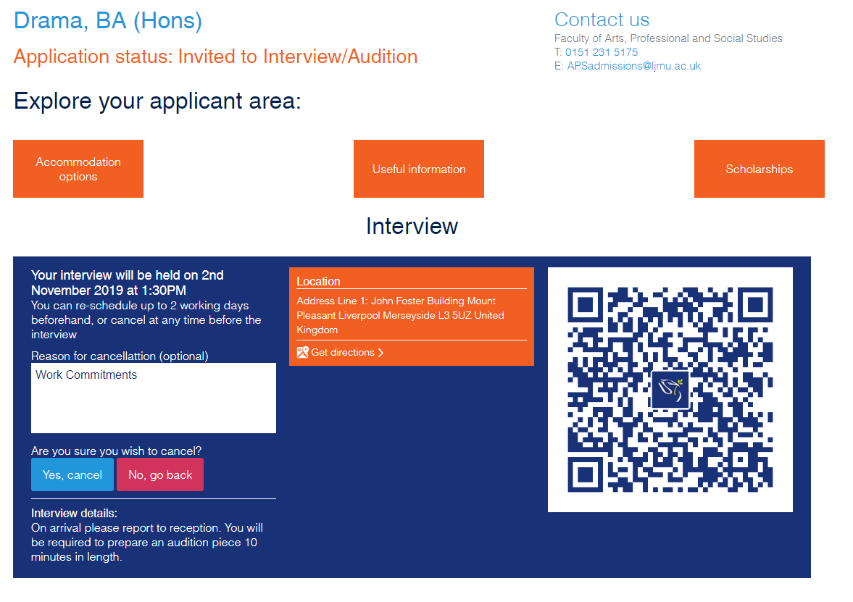

LJMU Change of Interview Venue

If there are circumstances that cause us to have to change the venue at which scheduled interviews are taking place then this can be done by locating the interview event and updating the Primary Event Venue. However, you should always attempt to contact applicants personally wherever possible to notify them first.
***You will also need to check the Published Event detail and update this to ensure that they display any additional room changes etc***
The applicant will also receive an email and SMS to alert them to the change.

LJMU Cancellation of Interview

If it is necessary to cancel a scheduled interview event then you should always attempt to contact applicants personally wherever possible to notify them first as they will receive an email and SMS as soon as the cancellation is processed.
You will need to cancel them on an individual basis from the interview event (otherwise they won’t be able to reschedule to an alternative date).
To do this you will need to:
- Navigate to Event Registrations

- Pop out the full registrant list by clicking within the Event Registrations section

- Select the applicant you want to cancel by clicking on the Subject (this is their name and status hyperlinked)
The Campaign Response page will open
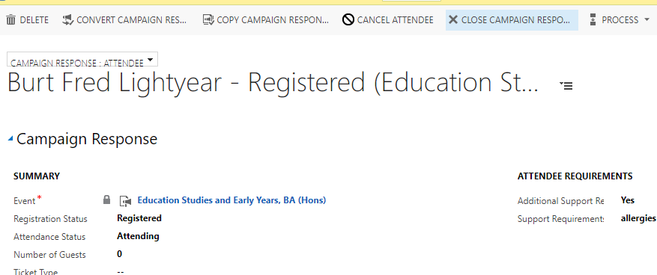

- Click the Cancel Attendee button on the grey toolbar

- Set Refund Event fees to No

- Click Next and Finish

- The applicants status will now be displayed as Registration Cancelled

- Repeat for all registered attendees

Generating an Interview Register

You can generate an interview registers to assist with monitoring attendance on the interview days from within the interview event.

There are now 2 event registers available to be generated:

Interview Register – A list of students registered for the interview with their contact numbers
Interview Register with student numbers – This will allow you to copy and paste all student numbers into the Interview sheet report held in SIS and allows you to view the statements and references for running your interviews.

- Locate the interview event

- Click on the ellipsis (three dots) on the event task bar

- Click on Run Report

- Click on Interview Register/Interview Register with Student Numbers

Post Interview Processing

Logging Attendance/Non Attendance

Attendance can be captured using QR codes, displayed on the applicant portal site and sent via Dotmailer in the Interview reminder email sent 48 hours before the start of the interview event. However, if the QR code isn’t available, you can manually log an applicant’s attendance or non-attendance via CRM.
***This is important because the status displays in the applicant portal***
To do this you need to:
- Locate the Interview Event

- Navigate to the Bookings area of the Event form
- Pop out the full registrant list by clicking within the Event Registrations section

- From here you can record (individually or in bulk) the applicants that attended and those that didn’t by clicking on the left hand side of the name (a marker tick will appear) to select the applicant(s)

- Click the status of either Attended or No Show as appropriate
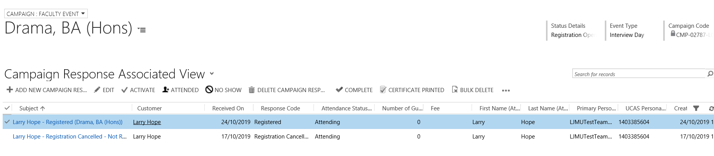

Workflow Emails/SMS

A number of Workflows have been created within CRM to send emails automatically at different stages of the booking process. Emails will be sent to the applicants Primary Personal Email address only. More details on email content can be found in the appendix.
Emails will be sent in the following circumstances:

- To invite the applicant to book an interview
- Booking Confirmation from the Queue specified in the event to the applicant (Face to Face & Telephone Interviews)
- Failing to book an interview within 72 hours of being JMU Interview status. This sent from a generic email address
- Booking reminder from the Queue specified in the event to the applicant 48 hours prior to the Interview start date/time
- Booking Cancellation from the Queue specified in the event to the applicant when the applicant cancels
- Notification of change of interview venue if we change it
- Booking Cancellation from the Queue specified in the event to the applicant if we cancel
SMS will be sent in the following circumstances:
- Booking reminder from the Queue specified in the event to the applicant 48 hours prior to the Interview start date/time / if requested during booking
- Failing to book an interview within 72 hours of being JMU Interview. This accompanies the email described above
- Notification of change of interview venue if we change it
- Booking Cancellation from the Queue specified in the event to the applicant if we cancel

Appendix A: Communications

- Invitation to book interview (CRM email)
Dear <<First_Name>>

RE: <<course>>

We would like to invite you to attend an interview for <<course>>.

Using the self-service booking tool you can now book an interview date and time that is suitable to you via the Applicant site https://www.ljmu.ac.uk/applicant-login.

What to expect

Once you have booked your interview, we will send you an email confirming the date and time.

You will be able to find out additional details, such as what to expect on the day, via the Applicant site: https://www.ljmu.ac.uk/applicant-login.

If you have any queries, please do not hesitate to contact the Faculty Admissions team <<Phone number of faculty – Email of faculty>>.

Yours sincerely

Faculty Admissions

- Confirmation of booking Email (CRM email)
  - Face to Face interview
Dear <<First_Name>>
Thanks for registering for your <<course>> interview. We are looking forward to seeing you on <<Date & time>>.
Your registration point is <<Venue address>>. You can find directions to this building on the LJMU find us page.
<<Interview details>>
If you would like further information about this interview or have any individual requirements, please reply to this email or call <<Phone number of faculty - Event contact from Parent Campaign>>.
Unable to attend?
If you find that you are no longer able to attend you can amend your interview through the Applicant site and select an alternative date or time.
We look forward to meeting you.
Kind regards,
Liverpool John Moores University.
  - Telephone interview
Dear <<First_Name>>

Thanks for registering for your <<course>> telephone interview. Your interview will take place between <<Event Start Date>> and <<Event End Date>>.

<<Interview details>>.

We will call on the following number(s):
<<Home Phone>>
<<Mobile Phone>>

If your contact number is not up to date, please amend your number on UCAS track and contact the Faculty admissions team to confirm the change <<Phone number of faculty - Event contact from Parent Campaign>>.

If you would like further information about this interview or have any individual requirements, please reply to this email or call <<Phone number of faculty - Event contact from Parent Campaign>>.

No longer available?
If you find that you are no longer available, you can amend your interview through the Applicant site and select an alternative date or time.

We look forward to speaking with you.

Kind regards,

Liverpool John Moores University.

- Reminder, not booked, 72 Hours Email
Dear <<First_Name>>,
Thank you for choosing to apply to Liverpool John Moores University. You have taken the first step on an incredible journey. So what next?
To be offered a place on <<course>>, you will need to have an interview. You can book your interview by logging in to the Applicant site, using your LJMU Student ID <LJMU Student Number>>), and selecting a date that suits you. Places are on a first come, first served basis so book early to avoid disappointment.
LJMU Student ID: <<LJMU Student Number>>
We look forward to meeting you.
Kind regards
Liverpool John Moores University
- Reminder, not booked, 72 Hours SMS
Hello <<First_Name>>, you have not yet booked your interview for <<course>> at LJMU. You can book your interview through your Applicant site (https://www.ljmu.ac.uk/applicant-login). If you need any assistance, please call 0151 231 5090 Kind regards, LJMU.
- Reminder, to attend, 48 hours before SMS
  - Face to Face Interview
Hello <<First_Name>>, your <<course>> interview is on <<Date & Time>> at <<address>>. Information on what to expect can be found at https://www.ljmu.ac.uk/applicant-login. If you need any assistance, please call <<Phone number of faculty - Event contact from Parent Campaign>>. Kind regards, LJMU.
  - Telephone interview
Hello <<First_Name>>, your <<course>> telephone interview will take place between <<event start date>> and <<event end date>>. Information on what to expect can be found at https://www.ljmu.ac.uk/applicant-login. If you need any assistance, please call <<Phone number of faculty - Event contact from Parent Campaign>>. Kind regards, LJMU.

- Dot digital reminder 48 hours before
  - The email in Dot Digital is called ‘UG Interview QR Reminder (48 Hours before)’ or ‘UG Interview QR Reminder (48 Hours before) Telephone’ for telephone interviews’.
  - The information you will need to push into Dot Digital is
Dot Digital Field name | CRM Field name
Event_Date | Event Start Date (Parent Campaign)
Event_Primary_Venue | Venue (Parent Campaign)
Event_QRCODE | QR Code URL (Campaign Response)
Event_Contact | Event Contact (Parent Campaign)
Firstname | First Name (attendee)
Event_End_ Date | Event End Date (Parent Campaign)

‘UG Interview QR Reminder (48 Hours before)’
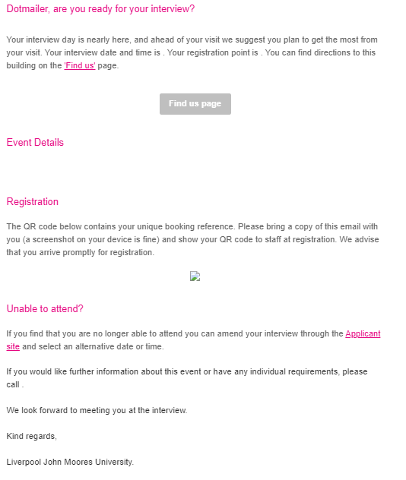

‘UG Interview QR Reminder (48 Hours before) telephone’
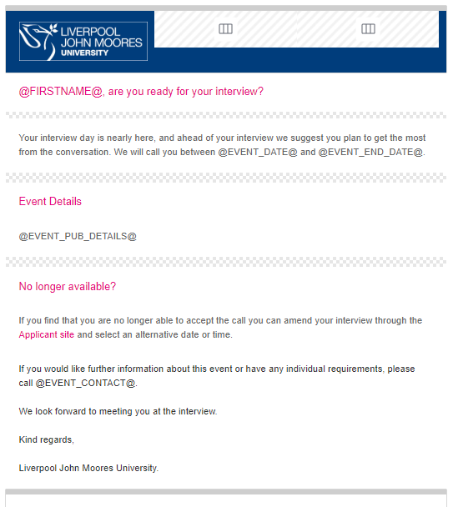
- Cancellation Email

Subject: *Please read carefully – important information regarding your interview*
Dear <<First Name>>,
Your interview for <<Course>> on <<date>> has been cancelled.
If you have any queries about the cancellation of your interview or you would like to discuss your application please email <<email queue>> or call <<EVENT CONTACT>>.
Best Wishes,
Liverpool John Moores University

- Change of Venue Email
Subject: *Please read carefully – your interview venue has changed*
Dear <<First name>>,
Your interview for <<course>> on <<Date>> will now take place in <<new venue>>. The address of the venue is:
<<Organisation name>>, <<Street 1>>, <<Street 2>>, <<City>>, <<Post Code>>.
You can find directions and more information here (https://www.ljmu.ac.uk/contact-us/find-us).
If you have any queries about the change of venue or you would like to discuss your application please email <<email queue>> or call <<EVENT CONTACT>>.
Best wishes,
Liverpool John Moores University

Appendix B: SIS Cancellation Trigger Status

Prog Action | Action Reason | Descr | Short Descr | code
DENY | 20 | Rejected | Rejected | DENY-0020
DENY | 21 | Rejected by Default | RBD | DENY-0021
DENY | 22 | Failed Conditions | Rej CI/CF | DENY-0022
DENY | 60 | No reply to RFI | No FurInfo | DENY-0060
WADM | 23 | Course Closed | Closed | WADM-0023
WADM | 34 | Withdrawal | Withdrawal | WADM-0034
WADM | 35 | UF Withdrawal | Wdraw (UF) | WADM-0035
WADM | 52 | Duplicate Application | Duplicate | WADM-0052
WADM | 55 | Other Offer Accepted | OthOffAcc | WADM-0055
WADM | 59 | Applicant Sent to UCAS via RPA | UCAS RPA | WADM-0059
WADM | 63 | Program Number 0 Matriculated | Prog 0 Mat | WADM-0063
WADM | 67 | UKBA Withdrawal | UKBA | WADM-0067
WADM | 1001 | SR- Cancel for re-admit | SR- Cancel | WADM-1001
WADM | 1002 | SR- Cancel for Admin Reasons | SR- Cancel | WADM-1002
WADM | 1003 | SG Process (NC) | SG Process | WADM-1003
WADM | 1004 | SG Process (panel) | SG Process | WADM-1004
WADM | 1005 | JMU CI Expiry | CI EXP | WADM-1005
WADM | DEAT | Deceased | Deceased | WADM-DEAT
WAPP | 24 | UF WIthdrawal | Wdrwl (UF) | WADM-0035
WAPP | 25 | Conditional Decline | CD | WAPP-0025
WAPP | 26 | Unconditional Decline | UD | WAPP-0026
WAPP | 27 | Choice Cancelled | ChoiceCanc | WAPP-0027
WAPP | 31 | Withdrawal | Withdrawal | WADM-0034
WAPP | 33 | Decline by Default | DBD | WAPP-0033
WAPP | 39 | Applicant UF Elsewhere | UF Else | WAPP-0039
WAPP | 40 | CLA Elsewhere | CLA Else | WAPP-0040
WAPP | 41 | Accepted Elsewhere (Adjusted) | Adjust Out | WAPP-0041
WAPP | 42 | Released into Clearing | Released | WAPP-0042

