CRM – International Admissions
Liverpool John Moores University

International Admissions
Contacts, Emails & Enquiries

Version 1.2. November 2018
Author: DS Business Support Team

Contents
- Dashboards

  - Locating your Dashboard
  - Pinning your Dashboard
  - Understanding ‘Emails’ and ‘Enquiries’
  - What’s on your Dashboard
  - Searching with a Wildcard.

- Processing Emails

- Enquiries

  - Searching for a Contact in Search Bar
  - Set Regarding
  - Convert Email to Enquiry
  - Convert Email to Enquiry for another Team
  - Convert Email to Enquiry when it has been forwarded internally
  - Progressing an Enquiry
  - Stages of an Enquiry
  - Sending Emails
  - Inserting Email Templates
  - Adding Phone Calls
  - Adding a Note
  - Resolving an Enquiry

- Enquiries: From Other Sources

  - Directly from a Contact
  - My Teams Enquiry Dashboard

1. Dashboards

1.1 Locating your Dashboard
- Each team within CRM will have their own dashboard, which acts as a sort of ‘home’ page.

- Each Dashboard is built up of different ‘views’ to show different information.

- The Dashboard for International Admissions is:

- International Admissions

    - Ensure you are in Recruitment area.

    - You can select Recruitment by clicking in the box to the right of ‘Dynamics 365’.
    - Select Dashboards
    - The top dashboard in the list will display, but this is not likely to be your dashboard.

    - Click on the arrow to the right to bring up a list to select your dashboard.
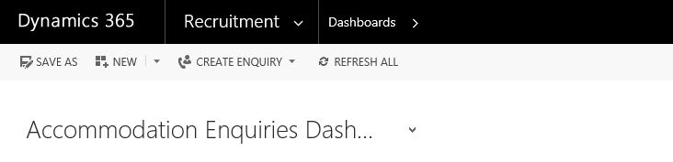
  - Pinning your Dashboard
You can then ‘pin’ your dashboard so that the correct dashboard displays each time you log in to CRM.
- Click on ‘Set as Default’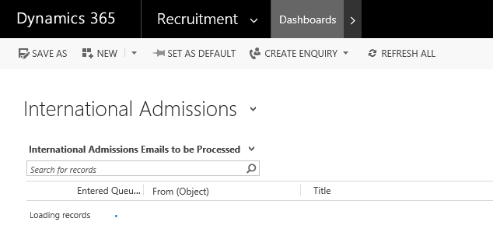
  - Understanding Emails and Enquiries

- You will already know about Emails but Enquiries are a CRM Dynamics Concept.
- Before replying to an email, you must first convert the email to an Enquiry and then respond as normal to the email and close off the Enquiry.
- Enquiries are used in CRM as they allow a picture to form of types of queries LJMU receive and with whom. This information can easily be reported on if in an Enquiry format and allows the University to better understand their enquirers.

1.4. What’s on the Dashboard
The dashboard displays all your team’s incoming emails and open enquiries:
1.4.1. Emails to be Processed
Incoming emails to your team mailbox are displayed here.
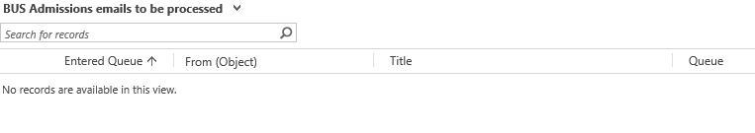

1.4.2. My Teams Enquiries (Unassigned)
Any email you convert into an enquiry will be removed from the ‘Emails to be processed’ queue, but will be added to the ‘My Team’s Enquiries (Unassigned)’ list with the status ‘New Enquiry’.

Any emails which come in relating to an open enquiry will bypass the top grid and go directly to ‘My Team’s Enquiries (Unassigned)’ with a status of ‘Contacted’ (3).

1.4.3. My Teams Enquiries (Assigned)
If you assign the email to yourself or someone else specifically in your team then they will be added to My Team Members Enquiries (Assigned) view
1.4.4. My Queues Pending Emails
These are emails which have been sent from someone in your team, which for whatever reason have become stuck and will not be sent by the system. Please keep an eye on this view and contact Helpdesk /BST if you need help fixing this.
1.4.5. Int Admissions emails by sender

You can expand either of these entities by clicking on the grid to the right of the dropdown:
This will create a pop out box showing all the emails or enquiries in much greater detail, making it much easier to search:

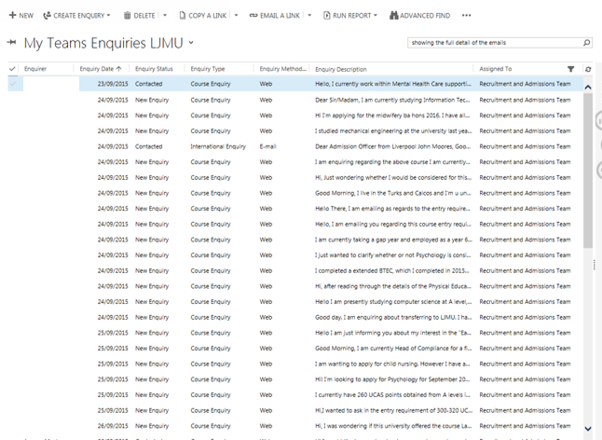
You can sort any of the columns by clicking at the top of the column (ascending or descending, numerical or alphabetical dependant on contents), or you can use the search function at top right to search for a student by name for example.

1.5. Searching with the Wildcard ‘*’
- An important tip to remember when searching is to use the wildcard function ‘*’.
- It is important that you use the wildcard in place of a Middle Name (as CRM will search for full names including Middle Name) or if you are unsure of the contacts full name.

Processing Emails
Click on the Email Title to open it and read the contents. If you click on the senders Email address then you will be taken to the Contact record.
Options available are:
- Delete – Only for Spam/Trash Emails.
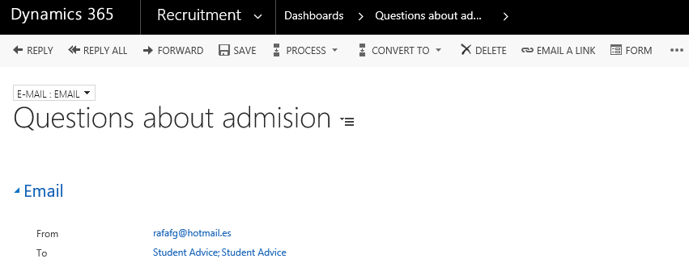

- Click Delete on the ‘Confirm Deletion’ box which appears, and the email deletes, and you are taken back to the dashboard.
- Forward – only forward an email where you need to pass it to someone else within LJMU, but they are not a CRM user:
- Examples of this are Awards Queries or Registry Services Queries.
- Click ‘Forward’, type the full email address into the ‘To’ field, then click ‘Send’. You can then delete the original email, or (to keep it on the contact’s activities), remove it from the queue.

Enquiries
  - International Admissions Enquiry Types

International Admissions Team have three Enquiry Types:

- International Admissions Enquiry
- International Admissions Decisions Enquiry
- International Admissions Agent Enquiry
The first two work the same way, but are designed so that you can (when going through the inbox and converting emails) convert urgent mail regarding a decision into a Decision Enquiry, and then those enquiries can be worked on first
Agent Enquiries work slightly differently, when you read the email and work out it is from an agent (not a student) and decide to convert the email to an International Admissions Agent Enquiry, the ‘Enquirer’ field is blanked out – this means that you can then click into the field and search for the student the enquiry refers to, rather than the ‘Enquirer’ field being automatically completed with the details of the person emailing in as for other enquiry types

Search for the Contact in the Search bar.
Before you convert the email to enquiry check whether the contact already exists in CRM and if the email should be related to an existing enquiry.
3.2.1. Search for the Contact first to see if person exists in CRM.
3.2.2. Click on ‘Recruitment’
3.2.3. Click on ‘Contacts’

- If they appear as a contact already then add the new email address to the contact and arrange for the contacts to be merged by raising a Helpdesk Job. BST will pick this up and carry out the merge.

- If the contact is brand new then update the contact record with the correct name if available and any further information that can be gathered such as level of entry, course of interest and year of entry.

  - Set Regarding

- If the email is related to an existing enquiry then you can connect it up to the existing enquiry. This is called ‘set regarding’.

    - Open up the Email and scroll down to the bottom of the window.

    - Click into the Regarding field.
    - Click on the look up

    - Scroll down to ‘look for more records’.

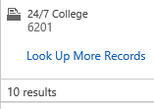
    - Change the Look for and Look In as below:
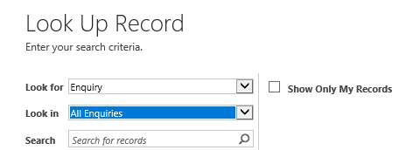
    - Search for the contacts name with ‘* ‘prior to and after their name.

    - Highlight and click on ‘Add’ when you have identified the appropriate enquiry.

    - Click on Save.

    - Double click on the email title to open it and read the contents.

  - Converting an Email to an Enquiry
- If the Email relates to a brand new query from a brand new contact then convert the email to an Enquiry
3.3.1. Open up the Email.
3.3.2. Click on the three dots at the top of the window.
3.3.3. Scroll to ‘Convert to Enquiry’ and then select the relevant enquiry type
- Each Faculty has their own enquiry type, which then feeds into their queue and dashboard.

- Once converted, the email will disappear from ‘<team> emails to be processed’ and appear below on your team’s ‘My Team’s Enquiries LJMU’.

3.5. Converting an email into an enquiry for another team
- If an email comes into your dashboard (e.g. int-admissions@ljmu.ac.uk), but it is apparent that the query needs to be answered by Engineering, then, select the Engineering and Technology Enquiry. This will then disappear from ‘Science Admission’s emails to be processed’ dashboard, and appears on Engineering & Technology’s ‘My Team’s Enquiries LJMU’ with a status of ‘New Enquiry’.

- The following requests should all be set up as a Course Enquiry Type:

- Undergraduate Prospectus
- Postgraduate Brochure
- Open Day Registration
Other Enquiries:
Enquiry | Team it goes to: | Additional Notes
Accommodation Enquiry | Accommodation Team
Advocate Enquiry | Outreach Team
APS Admissions Enquiry | APS Admissions
Awards Enquiry | Your Dashboard | This is used, it is auto routed to remain on the user’s dashboard if they created this enquiry type. And then the email should be forwarded on to awards@ljmu.ac.uk
BUS Admissions Enquiry | Bus Admissions Team
Careers/Placement Enquiry | Your Dashboard | This is used, it is auto routed to remain on the user’s dashboard if they created this enquiry type. And then the email is forwarded on to employerengagement@ljmu.ac.uk or careers@ljmu.ac.uk
China Recruitment Enquiry | International Recruitment Team
Clearing Enquiry |  | This is not to be selected as it is only relevant to the enquiries that are brought over from the SIS integration
Complaint | Your Dashboard | This Enquiry type is also routed to remain on the user’s dashboard as they are not always associated with recruitment only.
Course Enquiry | Course Enquiries
Engineering & Technology Admissions Enquiry | Engineering & Technology Team
Event Enquiry | Your Dashboard | This auto routes to remain on the user’s dashboard if they created this enquiry type, as many other users are involved with events not just recruitment
Funding Enquiry | SAW Finance Team
General Accommodation Enquiry | Accommodation Team
Health Admissions Enquiry | Health Admissions Team
Int Fee Status Enquiry | International Admissions Team
Int Admissions Agent Enquiry | International Admissions Team
Int Admissions Counsellor | International Admissions Counsellor
Int Admissions Decision Enquiry | International Admissions Team
Int Admissions Enquiry | International Admissions Team
Int CAS Enquiry | International Admissions Team
Int pre-application Enquiry | International Admissions Team
Int pre-sessional Enquiry | International Admissions Team
Int supporting documents | International Admissions Team
Int Third Party | International Admissions Team
Marsh Admissions Enquiry | Marsh Admissions Team
Middle East & Africa Recruitment Enquiry | International Relations Team | Not used/monitored so please beware if wishing to use.
Postgraduate Brochure | Course Enquiries
Scholarship Enquiry | SAW Finance Team
School Enquiry | Outreach Team
Science Admissions Enquiry | Science Admissions Team
South Asia Recruitment Enquiry | International Relations Team | Not used/monitored so please beware if wishing to use.
South East Asia Recruitment Enquiry | International Relations Team | Not used/monitored so please beware if wishing to use.
Student Admin Enquiry | Your Dashboard | This is used, it is auto routed to remain on the user’s dashboard. Please email to RegistryServices@ljmu.ac.uk
Summer University Enquiry | Outreach Team
Undergraduate Prospectus | Course Enquiries

3.6. Converting an email into an enquiry when it has been forwarded internally
- If an email comes into your dashboard (e.g. int-admissions@ljmu.ac.uk) and it has been forwarded from another LJMU email address (not a CRM user), when you convert it to an enquiry, the ‘Enquirer’ field will be blanked out by CRM automatically:

- This is so that you can then click into the ‘Enquirer’ field and locate the student that the enquiry refers to. Once this field has been completed, save and continue to progress the enquiry as usual.

3.7. Progressing an enquiry
- All Faculty Admissions enquiries appear with the same process bar once converted:
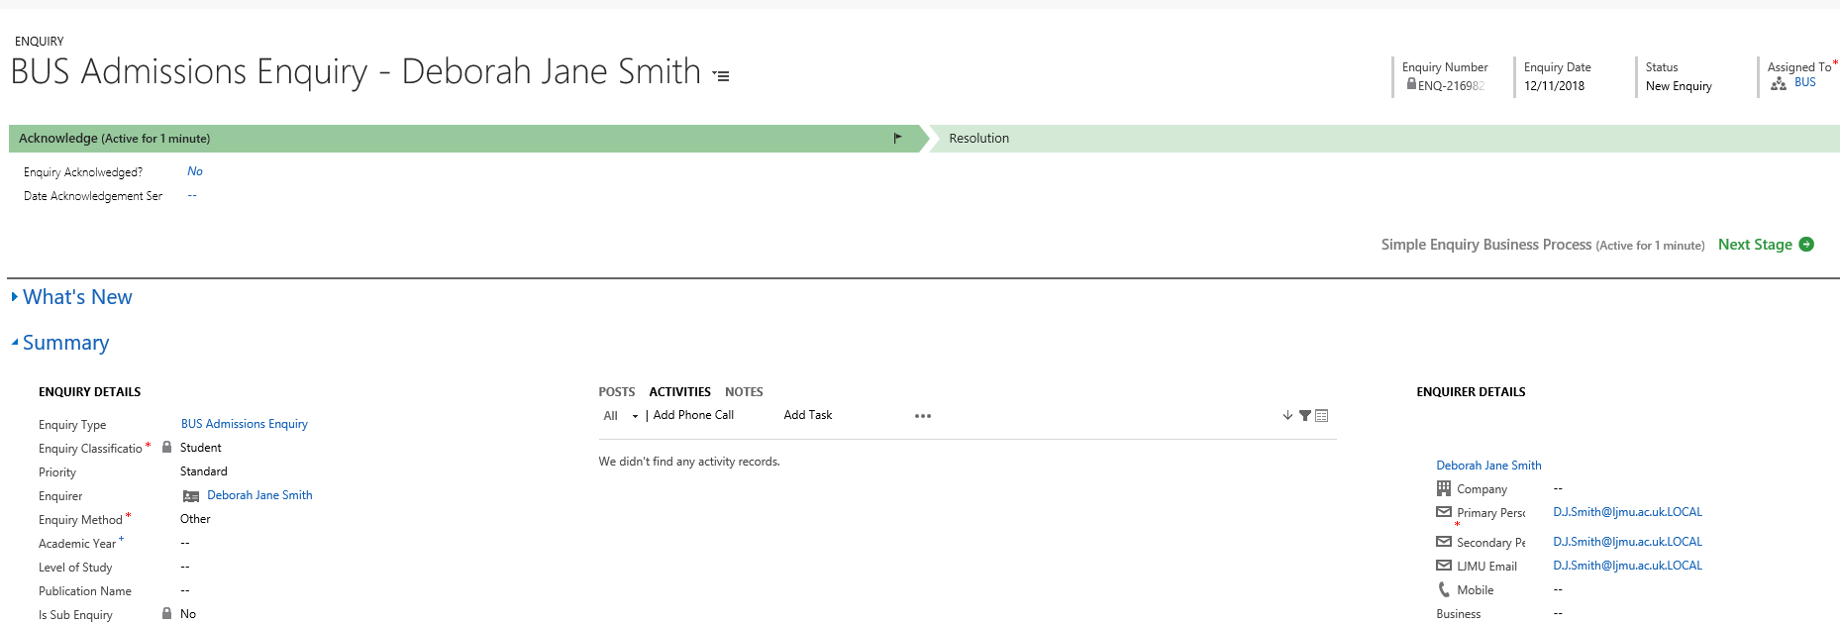
- The Enquiry Type, Enquiry Classification, Enquirer and Enquiry Method will already be filled in for you, as you have already chosen the enquiry type and it was created through an email.

- CRM has recognised the email address and thus sets the enquirer to the correct student.
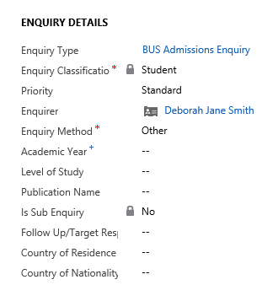
3.8. Stages of an Enquiry
- There are two stages, Acknowledge and Resolution.

- The flag in the process bar shows where you are up to - it will not let you click ‘Next Stage’ and move on until all the mandatory fields are complete.
3.8.1. Acknowledge Stage
- Click ‘Yes’ in the ‘Enquiry Acknowledged’ field, and the date will auto-fill.

- Click ‘Next Stage’ on the process bar and you will move into the ‘Resolution’ stage, and the blue flag will move across.
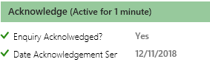
- At this point you may want to add an activity, such as an email or phone call.

- Click on Activities in the centre pane:
- If the Enquiry was the result of an Email received, you will see it here and the Email will also form the text of the enquiry below.

- Click on the email symbol to open the original email, then once opened, click ‘Reply’ (top right) to type a reply, then ‘Send’ (top right).

3.9. Sending emails
- Apart from replying to an email as part of the enquiry process as above, you can send an email at any point via the ‘Activities’ pane:
- A new email will open, complete as you normally would for Outlook. There is no need to make a note of emails, as they are all saved to activities in date order (newest first).

3.10. Inserting email templates
- Dynamics does not replicate the full functionality of Outlook, for example, there is no equivalent of an out of office or Auto Signature.

- To use a signature, you must use a template and insert it into the email each time used.
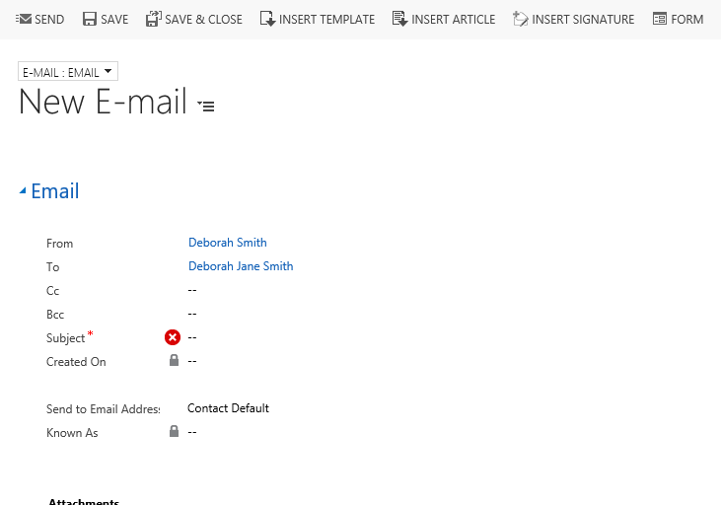
- Click onto ‘Insert Template’

- Click on ‘To Recipients’

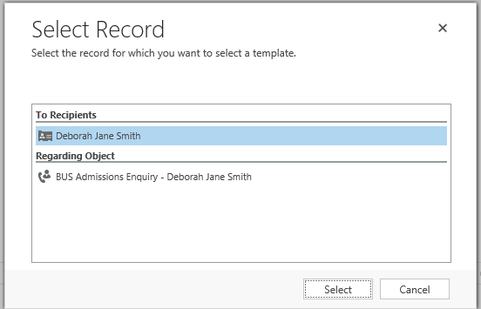
- Select the correct Template.
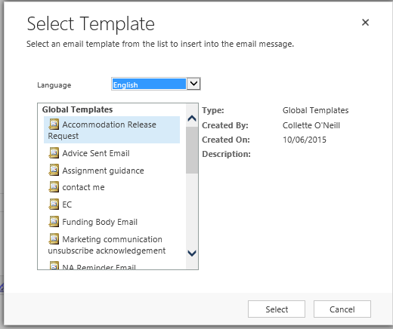
- Click onto the selected template and then ‘Select’.

- If you need a Template setting up then please contact Helpdesk.

3.11. Adding Phone calls
- To add the detail of a phone call, click on the Activities pane, and ‘Add Phone Call’:
- In the free text field, type the detail of the call.

- Click into the ‘Direction’ field to change the default ‘Outgoing’ to ‘Incoming’ if necessary, then click ‘OK’ to Save.

3.12. Adding a Note
- If you are waiting for more information such as from an academic before you can complete the enquiry, ensure you have saved (bottom right), and add a note.

- Again, this is in the centre of the screen:
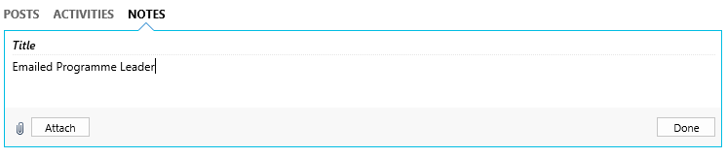
- Click ‘Done’ to save, and then, amend the status of the enquiry to Acknowledged:
- Click Save (bottom right)

3.13. Resolving an enquiry
- When you are able to resolve the enquiry, click ‘Yes’ in the ‘Resolution’ field,
‘Date Enquiry was Resolved’ and ‘Resolved By’ will autofill:

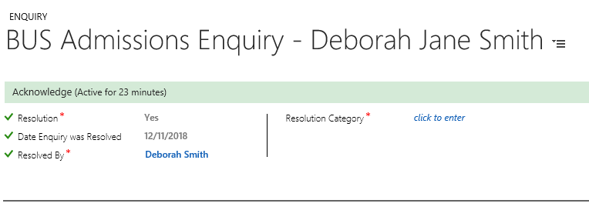
- Click into ‘Resolution Category’

- Select the correct Category from the options given in the drop down.
- Click Save.

- The status will change to ‘Resolved’

- The enquiry is complete; and will disappear from the dashboard.

- If a further email is received from the enquirer as part of the same chain (e.g. a reply to your email resolving the enquiry), the enquiry will re-open, and it will sit in the dashboard with the status ‘Contacted’.

- If a further email is received from the enquirer but they have sent a new email (i.e. not a ‘reply’ but a new email), this will go into the dashboard as new email, and require a new enquiry creating.

4. Enquiries – from other sources

4.1. Directly from a contact
- If an enquirer calls and you need to create an enquiry directly for example, navigate to Contacts:
- Using the search bar, search for the contact you wish to create the enquiry for:
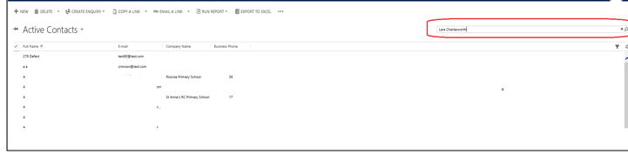
- In the list displayed, locate the correct enquirer, and click on the name to open

- If the contact does not exist then click on ‘New’ to create one.

- If creating a New Contact, you must complete certain mandatory criteria, these include:
    - Full Name
    - Primary Personal Email Address

- Once created, you can create your enquiry.

- From the contact record, click on the 3 dots and select ‘Create Enquiry’ and the correct enquiry type:

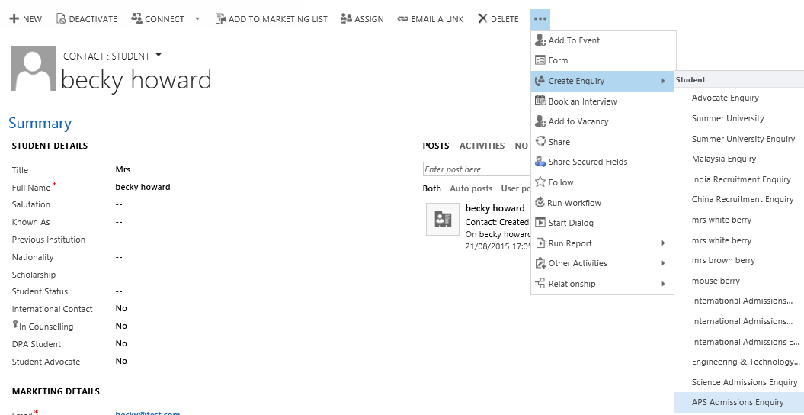

- Once you have created the enquiry, ensure that the correct ‘Enquiry Method’ is selected:
- Save
- Complete the enquiry as before.

‘My Teams Enquiries’ from dashboard

- All columns can be sorted by clicking on the column title, and selecting either the up or down arrow. You can create a new enquiry from here by clicking on the + (1). You can expand the view (to make searching easier for example) by clicking on the icon top right (2), which causes the view to ‘pop out’ into a new box.

- Any enquiries with the status ‘New Enquiry’ and the method ‘E-mail’ are those that have just been converted from an email.

- Any enquiries with the status ‘New Enquiry’ and the method ‘Web’ are those that have originated from the web enquiry form on the LJMU website, and have been redirected by the Course Enquiries Team.

- CRM will automatically create an ‘outgoing’ email. This outgoing email will be from the queue that is associated to the enquiry type. The email will be pre-populated with:
Hi <Enquirer>,
<type your response>
Kind regards
<text of original web enquiry>
Complete the missing details and click ‘Send’.
- Any enquiries with the status ‘Contacted’ and the method ‘E-mail’ are those that have just been converted from an email, answered and resolved, and the enquirer has sent another email in regarding the same matter. When you have read and decided on an appropriate response (e.g. phone call, another email, no response required), you will need to manually change the status from ‘Contacted’ to ‘Resolved’ – this does not happen automatically. If you don’t do this, the enquiry will sit in the bottom pane and not disappear:

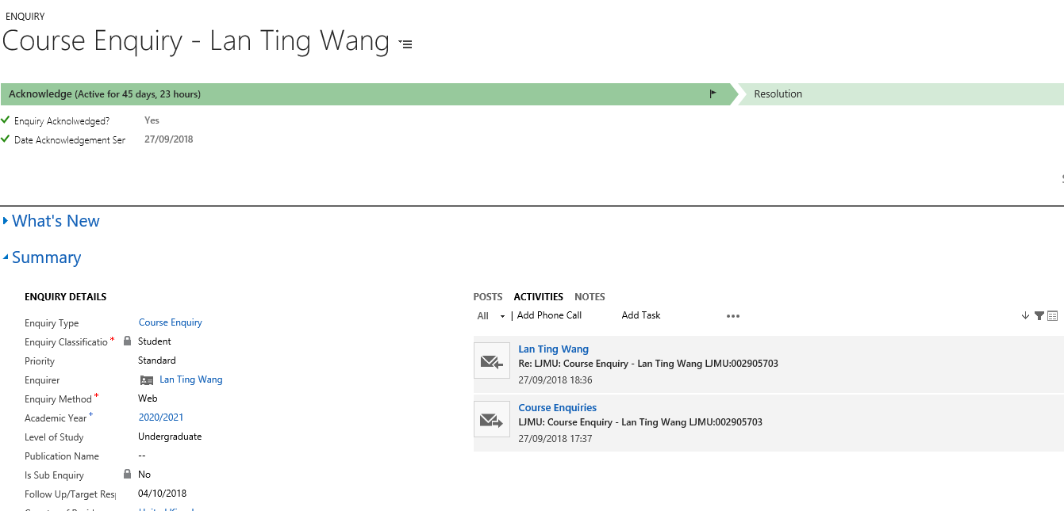

You now need to answer the email, and manually change the status to ‘Resolved’, then save:

This will remove the enquiry from the ‘My Teams Enquiries’ grid on the dashboard.

Version Control
Date | Version | Author | Change from last version
27.10.15 | v0.1 | SG | Draft
28.10.15 | v1 | SG | Baseline
29.10.15 | v1.1 | SG | Addition to 1.3.1. & 4.2
14/11/2018 | V1.2 | DS | Refreshed screenshots and layout. CRM Upgrade 2016.

