CRM – International Recruitment
Liverpool John Moores University

International Recruitment

Version 1.2. November 2018
Author: DS Business Support Team

1. Dashboards 3
1.1 Locating your Dashboard 3
2. Enquiry Reports 4
3. Version Control 5

1. Dashboards

1.1 Locating your Dashboard
Each region that has been defined within International Recruitment will have their own dashboard, which acts as a ‘home’ page – These will all start with the words International Recruitment.
- International Recruitment Africa
- International Recruitment Americas
- International Recruitment Central Asia
- International Recruitment China
- International Recruitment Europe EU
- International Recruitment Europe Non EU
- International Recruitment Middle East
- International Recruitment North Eastern Asia
- International Recruitment Oceania
- International Recruitment South East Asia
- International Recruitment Southern Asia

- Navigate to Recruitment
- Then click Dashboards
- From here you will be able to select the dashboard as listed above.

- Once selected you will see two charts which show the number of enquiries received.

- The third section of the dashboard shows you a summary of the enquiries that have been made to LJMU. The enquiries are ordered by the enquiry date and you will see the status in the end column. By clicking on the Enquirer name it will open the Contact record.

2. Enquiry Reports
There are two main reports created for you which will allow you to delve deeper in to your data.
- International Enquirers Report
- International Enquiries Report

- The small difference in the reports is between an Enquirer (as a single person) and an Enquiry (one person may make multiple enquiries)

- To locate the reports, click on the button next to Dynamics 365 button as per the picture below:
- Click on ‘My Work’
- Click on ‘Reports’

You will now find your Reports in the list.
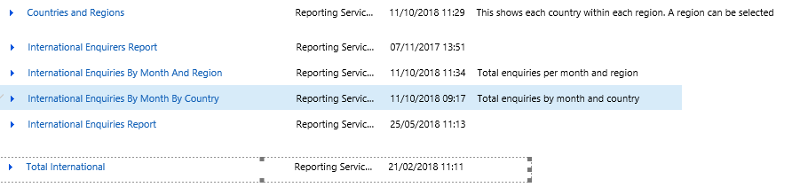
- Click the relevant report to view which will open a new window.

- Select an academic year

- Select Region

- Select Country

- Click View Report

3. Version Control

Date | Version | Author | Change from last version
16.10.17 | v1 | AGP | Baseline
16.11.18 | V2 | DS | CRM 2016 Upgrade – screens update

