Process Document

CRM – Outreach
Liverpool John Moores University

Outreach: Adding New Organisations

Version 0.1. November 2018
Author: Debbie Smith Business Support Team

Adding New Organisations on Dynamics
Set-Up
- All non-school/college organisations who we deal with should be recorded in Dynamics.
- Contact information should also be recorded against the relevant Organisation.
Procedure
- Microsoft Dynamics CRM > School Liaison > Organisations
- Click ‘+New’
- Complete as much detail as possible in the below form
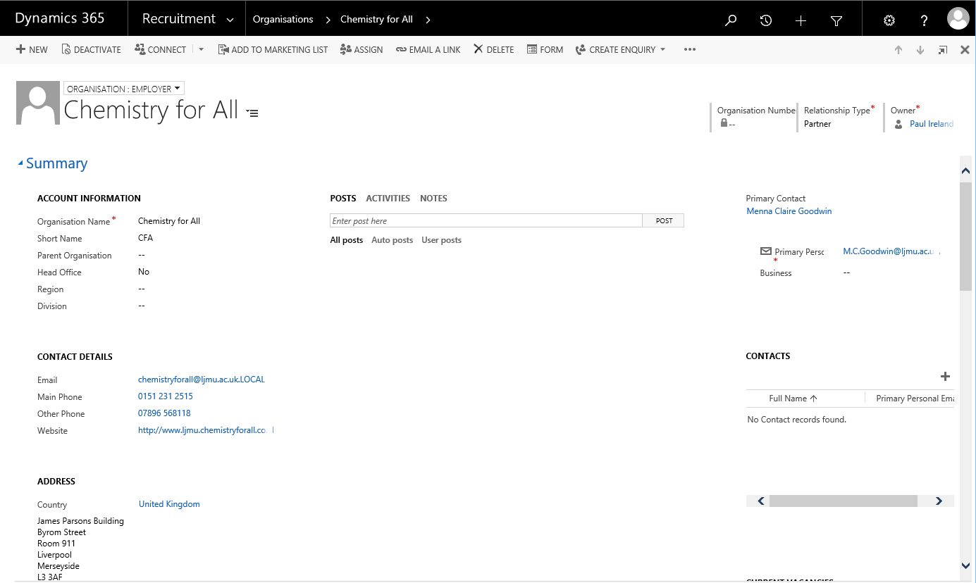
- You can then assign any Appointments/School Interactions which take place directly to this Organisation, using the ‘Activities’ tab (see below)

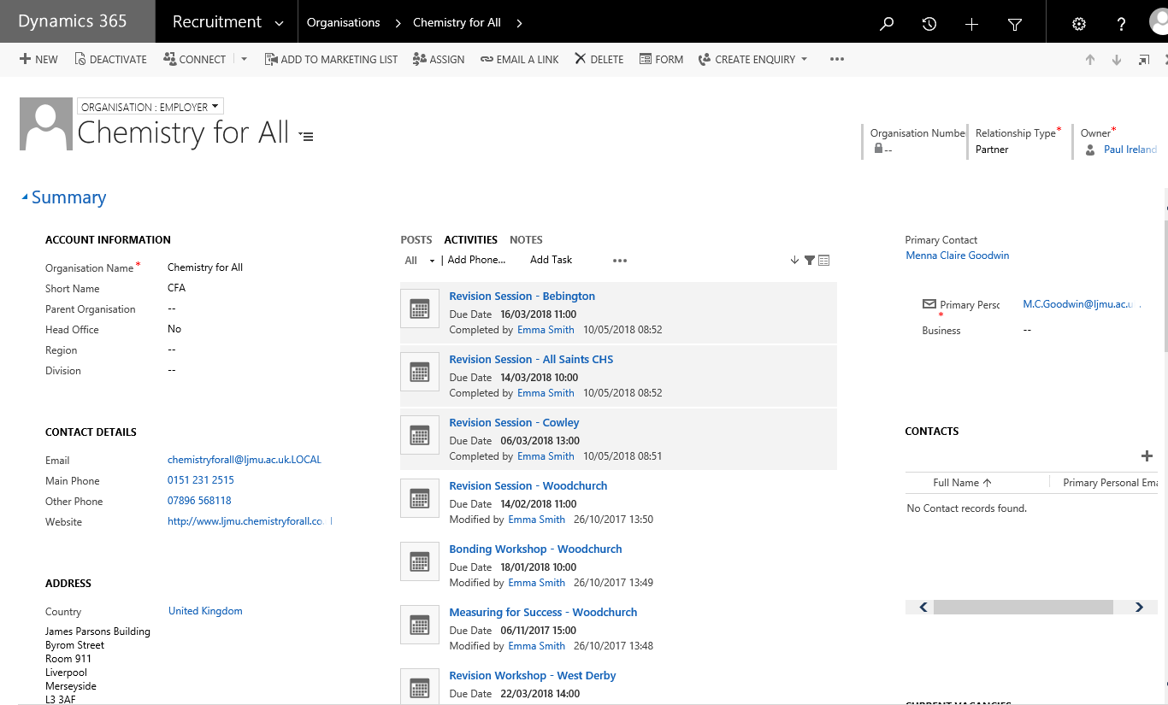
- To ensure that activities is displayed on the Organisation page, use the Organisation name in the ‘Regarding’ field.
- If you want the appointment to display on the School/Organisation page, then when setting up appointments make sure you list the School(s) involved under the ‘Optional’ section, which can hold multiple schools (see below).

