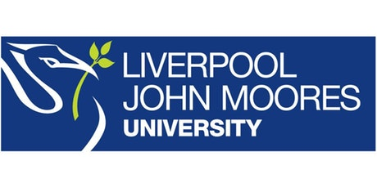

Process Document

CRM – Outreach
Liverpool John Moores University

Outreach: Marketing Lists

Version 0.1. November 2018
Author: Debbie Smith Business Support Team

Marketing > Marketing Lists

- New
- Name: Something Unique (and relevant!)
- Targeted At:
- Account – if you want to contact an Organisation via a hard copy mail out
- Contact – if you want to contact an individual via an email campaign
- Click Save
- In the Members panel (which should now have appeared) click +
- Decide how you want to add your members (ideally set up an Advanced Find beforehand)
- Select Email Marketing
- Change – Activated for Email
- Click synchronise

