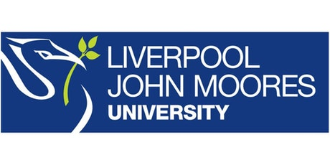

Process Document

CRM – Outreach
Liverpool John Moores University

Outreach: Setting up UCAS Fairs

Version 0.1. November 2018
Author: Debbie Smith Business Support Team

Setting up a UCAS Fair

Events Management > Events > New
Set up as below:
Name: Must be EXACTLY as named on UCAS. If in doubt, use the UCAS Poster behind Peter’s desk. i.e Kent & Medway then UCAS 2016
This is vital for the UCAS scanner data to match up to the correct event when it is uploaded
- Current Status: Registration Open
- Campaign Code – automatically generated once event has been saved
- Campaign Type – Event
- Event Type – Fair
- Event Start Date – as advertised via UCAS
- Event End Date – as advertised via UCAS (don’t worry about start and end times)
- Faculty Contact – insert the name of one member of the team who will be in attendance
