Process Document

CRM – Student Advice & Wellbeing
Liverpool John Moores University

CRM Activities: Add Task/Reminder

Version 0.2, October 2018
Author: DS Business Support Team
You may wish to add a Task to include any actions taken on the case, off line. You are also able to set a due date and time on a Task so that the system will prompt you and the Task will act as a Reminder.

- Navigate to the Case you wish to add a Task to.

- Click on ‘Activities’

- Click on the small square box

- Click on the small arrow to the right of the case name at the top of the screen, this will drop down to display a menu below, click on Activities.

The Open Activity Associated View will open.
- Click on to ‘Add New Activity’.
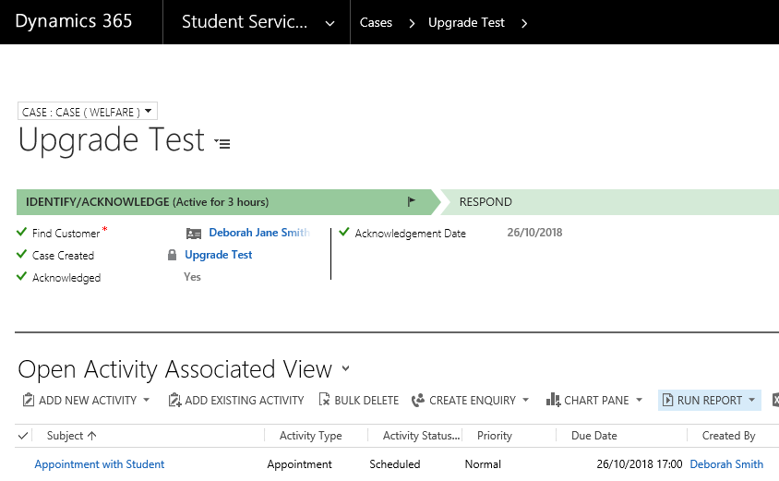

- Next, select ‘Task’ from the drop down menu which appears.

- The ‘New Task’ window will pop up.
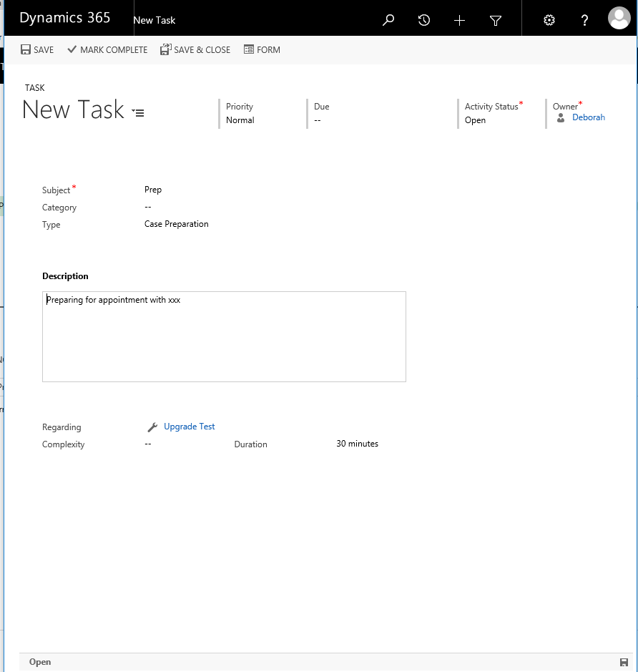

- The ‘Subject’ field is a Mandatory, and Free Text field.
- The ‘Type’ will default to ‘Case Preparation’. You can also select ‘Case Administration’.

- You may also wish to add a Description of the Task.

- Next, you need to record the Duration.

- Click into the Duration field and delete the time in the box, which will have defaulted to 30 minutes.

.
- Next, entered the desired amount of time
- Click Save in the top left corner.

- To go back to the Case view, click on the blue link where it says ‘Regarding’ A case will always have a ‘spanner icon’ prefixing it.

- You will return to the Case view.

- You can see the Task has been entered in the middle column.

Please Note: ALL Activities, including Tasks must be marked ‘Complete’ before a case can be resolved.

