Process Document:

CRM – Student Advice & Wellbeing
Liverpool John Moores University

CRM Activities: Appointments.

Version 0.2. October 2018
Author: DS Business Support Team

Adding an Appointment to a case in CRM
Appointments should be sent via Outlook first and then the appointment added to CRM. CRM does not link to Outlook calendars or vice versa.You can add an appointment at any stage of the case.

- In order to add an Appointment you must first ensure you are in a Case and not a Contact record. Check you are in a case by looking for the ‘chevrons’ which will appear along the top of the screen, as shown below.
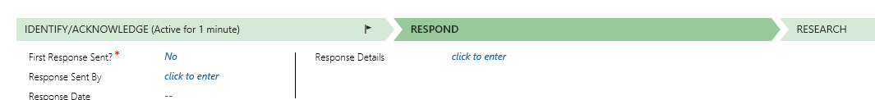

- To book an Appointment, navigate to the Activities section which can be found in the middle of the screen and click on the three dots (ellipsis) to reveal the menu:
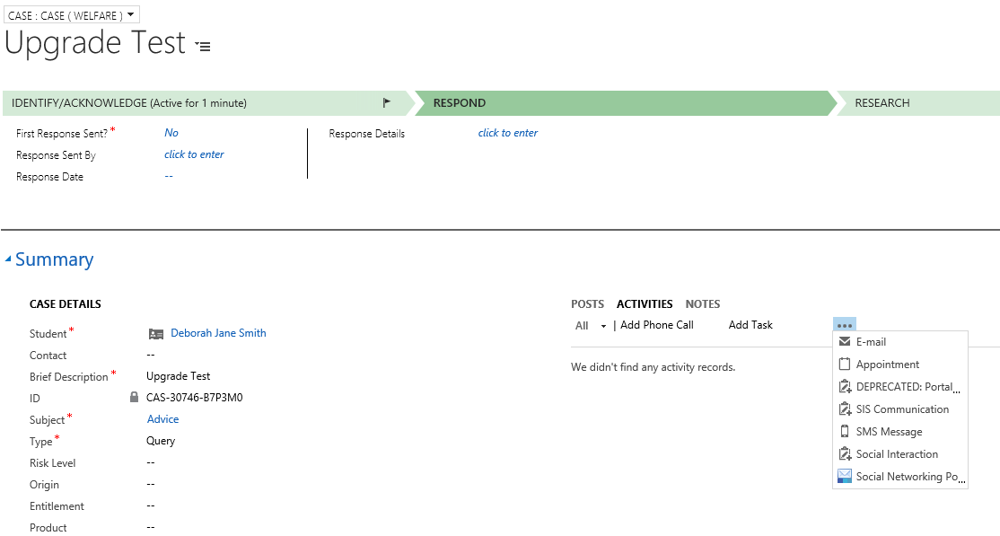
- Click on Appointment.
This will open up the Appointment form:
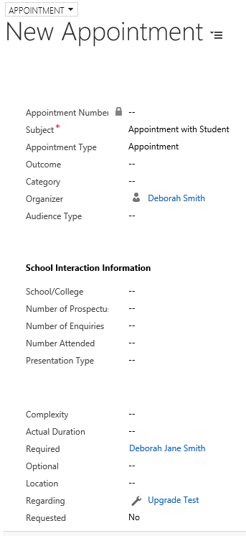
- You will need to fill out the following fields:

- Subject: For Counselling this will be the name of the student.
- Start Time
- End Time
- Duration Ensure the duration is accurate, as this will feed into Reporting.
- You may find Outcome useful to record whether the student Attended, was a No Show, or Rescheduled.
- You may also find it useful to record Complexity.
- There is also an option to add a Description of what was discussed if required.

- Click Save icon (found at the top of the Appointment form)
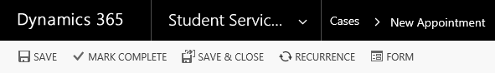

- The appointment will now show within the Activities section of the case in the centre of the screen, along with any other activities you create.

- Remember that before Resolving the case, you will need to ‘Complete’ all activities, including appointments.

- You can do this by clicking on to the activity, and clicking on the word ‘Complete’.

