Process Document

CRM – Student Advice & Wellbeing
Liverpool John Moores University

Student Advice and Wellbeing
Assigning an Email or a Case to a Colleague/Yourself

Version 0.3, November 2018
Author: DS Business Support
This process will ensure that an email can not be selected by another user. You can also ‘assign’ an email to a member of your team.

These instructions should assist in the management and organisation of incoming emails.
- From your Dashboard, select the E-mail from the Queue
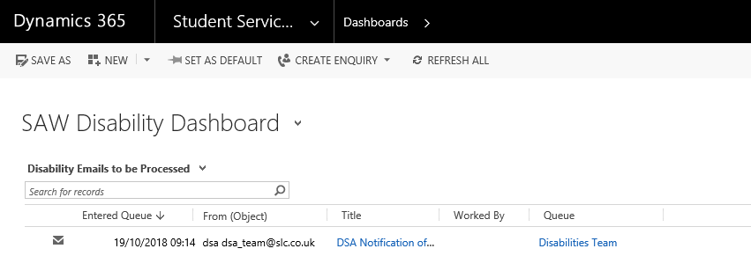
- Once the E-mail opens up, click on to the ellipsis (3 dots):
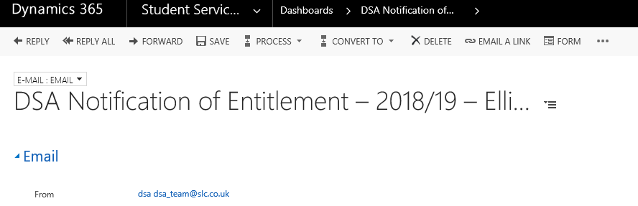
- From the drop down menu, click on to Queue Item Details.

- Click into the Worked By field
Type the first few letters of your colleagues name (or your name) and click on
the look up button.
Select the correct Name from the list.
Note: The name should appear so that it can be selected. If the name doesn’t
appear, then you may need to use the wildcard (*)
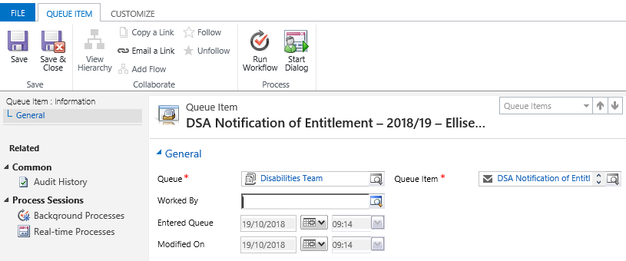

- Your name (or colleagues name) will now display in the Worked by column.

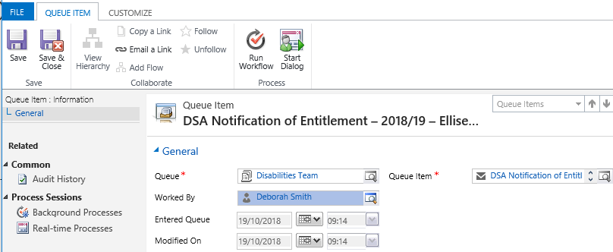

- Finally, click on the Save and Close button.

- If you navigate back to your dashboard, you will now see that the ‘Worked By’ column now displays the selected name.
