Process Document:

CRM – Student Advice & Wellbeing
Liverpool John Moores University

CRM Activities: Adding Connections

Version 0.2, November 2018
Author: DT Business Support Team

Adding Connections to Existing Contacts in CRM
Connections can be recorded between contacts on CRM to illustrate that there is an existing relationship. This could be a parent of a student or prospective student contacting the service or someone in a professional capacity such as a tutor or medical personnel.

- To add a connection, first ensure that you are in a contact record. You may have to create the contact record first based on the method by which they have contacted you. In this example, a parent has phoned the service.
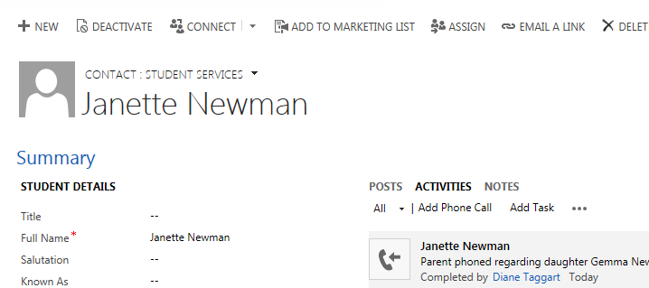

- Navigate to the Connections region of the contact record. Any existing connections will also appear here and can be filtered/sorted by clicking on the column heads.
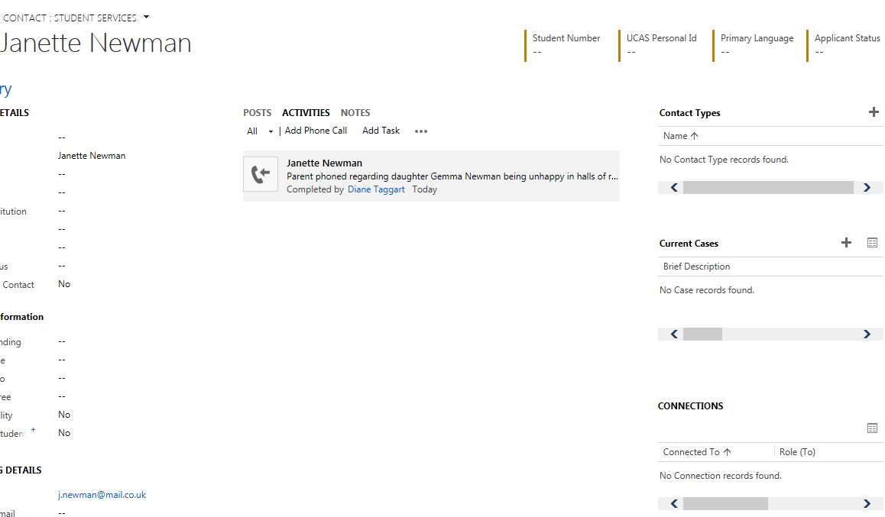

- To record a new connection click on the associated records view.
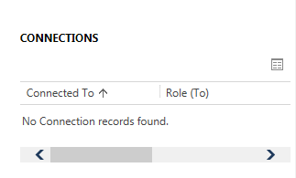

- The Active Connection Associated View will open. Click 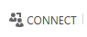.

- The New Connection view will display to enable you to search for and select the existing contact that you want to connect to. Click the Maginifer icon next to the Name field.

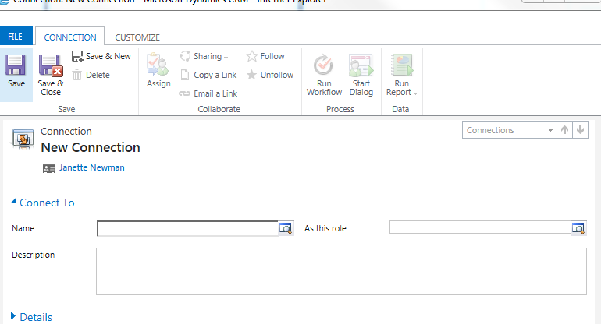

- Scroll to the bottom of the list and click on Look Up More Records to generate the search view.

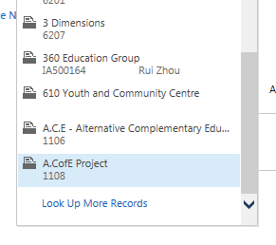

- In the Search field enter the details of the contact name you want to search for using the * wildcard to return the most possible matches, displayed as a list. (You can scroll right to view further data fields to verify your selection) and click Add.

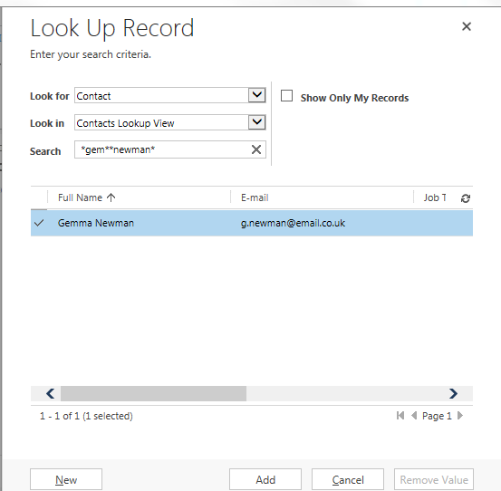

- Once added, repeat the process to select the best descriptor for the relationship between the two contacts by clicking on the role magnifier (this is bi-directional and will pre-populate the connecting record). Relationships can also be effective dated as per the below. Note that you will default as the owner.
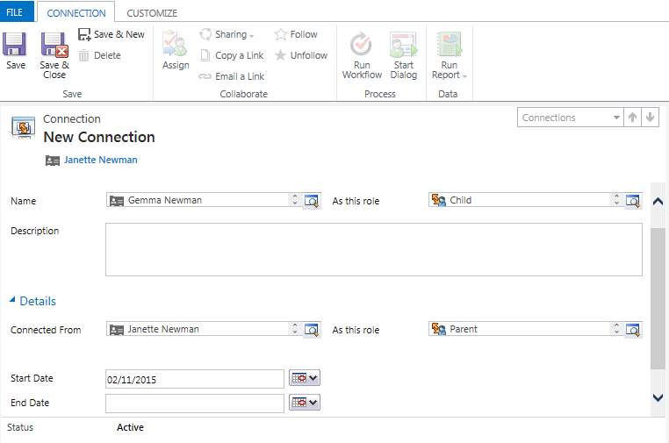

- Click the Save & Close icon to save the relatinship details and go back to the original contact screen.

