Process Document

CRM – Student Advice & Wellbeing
Liverpool John Moores University

Counselling: Processing a Counselling Case

Version 0.5 November 2018
Author: Business Support Team

Contents:

- Counselling Process in CRM: Overview

- Checking the Contact Record

- Activities

- Processing the Case: Initial Contact

- Processing the Case: Booking

5.1. Automatic Status Change

- Initial Meeting

- Processing the Case: Opt-In

- Processing the Case: Allocation

- Processing the Case: Resolve

- Counselling Process in CRM: Overview

Once you have created a case (details available in separate guide: ‘Creating a Case’), you will notice the chevrons along the top of the screen. These chevrons effectively make up the Case Management Flow for the case you have created. This flow will take you through the life of the case from beginning to resolution. The Case Management Flow changes depending upon the Subject selected on Case creation. For Counselling cases the correct Case Management Flow is the ‘Initial Contact to Allocation’ process.
For all Counselling queries, the Subject selected will be ‘Counselling’ or a sub –subject of Counsellling, (if presenting problem is known). This will ensure that the correct process is used.
The Initial Contact to Allocation Process is only used for Counselling cases and currently has five stages.
Stages of a Counselling Case:
- Initial Contact
- Booking
- Opt- In
- Allocation
- Resolve
The 5 stages will show as a flow along the top of the case. The current stage will be highlighted in green and have the word ‘Active’ displayed.
To work through each stage, the user will need to complete mandatory information which is displayed below each stage.
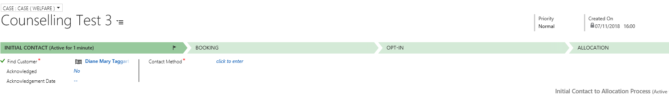
- Checking the Contact Record

The Counselling Service’s customers will be students.
All current students (and staff) will already be set up as a Contact in CRM. Users need to set up external contacts manually, for example parents of students/external agencies.

  - Checking the Welfare Information on a Contact

To navigate to the Contact:
- Select Student Services.
- Then select Contacts
- Search for the correct Contact.
- Navigate to Welfare section.
Or if the case is open, click on the contacts name to bring up the record.
Within the Welfare section, you can mark the student as being ‘In Counselling’.
- Activities

There are separate guides for:

- Adding Phone Calls
- Adding an Appointment
- Uploading Documents
- Sending Emails
- Adding Notes

You can complete any of the above at any point throughout the life of the case.

- Processing the Case: Initial Contact

- Find Customer: Mandatory Field. This should already be
- Acknowledged “Yes” or “No”. If Yes is selected, the status of the Case will update to Acknowledged.
- Acknowledge Date
- Contact Method- Mandatory Field. Drop down Menu options
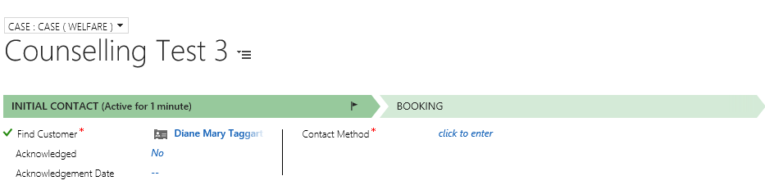

- Processing the Case: Booking
This stage will record the Initial Meeting.

- First Response Sent: Mandatory Field. Select Yes/No. If Yes is selected, the Status will update to Awaiting Initial Assessment.
- Response Sent By: Look up Counselling Staff Member Name.
- Response Date: Select Date.
- Response Details: FreeText – Optional field. Note: If an Email is sent, then details can be viewed.
- Allocate Appointment: Select Yes/No.
- Counseller for Booking: Mandatory Field. Look up Counselling Staff Member Name.
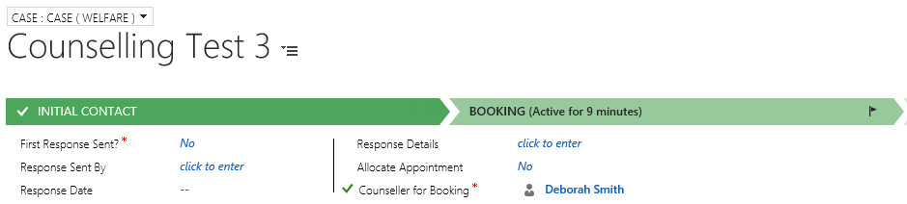
- At this point you may need to Add an Activity (Note/Task etc). Please see separate guide on how to do this.

- If you have selected Allocate Appointment – Yes you will also need to book an appointment. Currently, appointments are being organised via Outlook and then added on to CRM. Please see separate guide on Adding Appointments.
The appointment will now show within the Activities section, along with any other activities you create. Remember the duration of all activities will be added up when you resolve the Case.
It is important to note that before a case can be ‘Resolved’, all appointments must be marked as ‘Complete’.

  - Automatic Case Status Change.
The Case Status will change automatically at certain stages in the process, when a particular field changes. The table below indicates at what point the status of the case will change.
Stage | Action | Status
Initial Contact | ‘Acknowledged’ field updated to Yes | Acknowledged
Booking | ‘First Response Sent’ updated to Yes | Awaiting Initial Assessment
Opt In | ‘Opted In’ updated to Yes | Opted-In
Allocation |  | Waiting List

You can also manually update the status accordingly at any point if necessary.
- Initial Meeting

At the Initial Meeting, a counsellor will gather key information using a paper form. This has been re-designed to be much more streamlined than it was pre CRM. This information will then be uploaded via the Documents function (and sharepoint) to be held securely against the students case.

Please refer to the Uploading Documents guide for details.

- Processing the Case: Opt In

Once a Customer has chosen to Opt In to the Counselling Service they will be added to a Waiting List for the next available Counselling Slot. The Waiting List will be monitored daily by Counselling Team, using a Custom view on the Counselling Dashboard.
Opt In Stage
- Opted in: Yes/No. Once Yes is selected the Status of the Case will update to Opted In.
- Date of Opt In: Date of Initial Meeting.
- Subject: Mandatory - Counselling
- Escalated
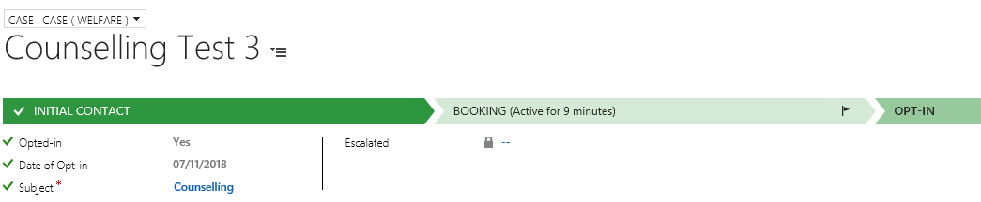

- Processing the Case: Allocation
At this stage, the customer is allocated a Counsellor, and Appointments will be set up.
The following fields to be completed at this stage:
- Assign Counsellor
- Create Tasks
- Date Added to Waitlist – Once Yes is selected, the status will update to Waiting List.
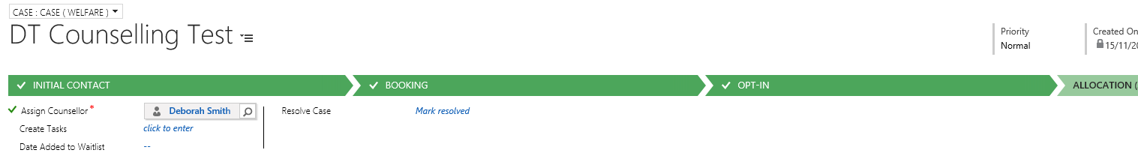
After each Appointment, Notes and documents can be uploaded to the case.
- Processing the Case: Resolve
Once the Counselling sessions have concluded, the case can be closed.
- Within the ‘Allocation’ chevron, click into the field for ‘Resolve Case’
- Click Mark Resolved.
- A Resolve Case window will appear.
Here you need to fill in the below fields:
- Resolution Type – Mandatory Field. Drop Down Menu.
- Resolution – Mandatory Field. Enter a brief description of how you Resolved the Case.
- Total Time - This will be a read only field, as it has added up all of the time spent on the Activities created against this Case.
- Billable Time – This is a new field. It is NOT Mandatory. Do not complete.
- Remarks - Here you can add in any remarks with regards to how you resolved the Case.
- Click Resolve button
By clicking on Resolve, you will make the case read-only.

