Process Document:

CRM – Student Advice & Wellbeing
Liverpool John Moores University

Student Advice Wellbeing:
Creating a Case

Version 0.1, October 2018
Author: DS Business Support Team

Contents:

- Setting up the Case from ‘Cases’

- Setting up the Case from ‘Contacts’

- Converting an Email to a Case

Creating a Case

Following any kind of initial contact/communication e.g. drop in/email/phone call with a student, or third party, you should set up a case for each issue so that all of the information is held in one place, securely. The overarching aim is to a build up a ‘story’ of the student.
There are a number of ways in which a Case can be created in CRM. The recommended way would be to create cases from ‘Contact’s (No.2). This enables you to see the Contacts history, e.g. any other cases/interactions they have had with other SAW teams. However, there is not necessarily an ‘incorrect’ way.
There are quick create ‘+’ buttons at the top of the screen which you may wish to use.
However, in this guide we will outline a few ways which we recommend you follow depending on the circumstance:

- Setting up the Case from ‘Cases’.
- Setting up the Case from ‘Contacts’.
- Converting an Email to a Case.

- Setting up the case from ‘Cases’
If you are using this method, then usually the client will be a student, and has contacted you via phone/referral/drop in and you will already have their student ID to hand.

  - You will start off at your default Dashboard. The table below will indicate your default Dashboard.

Advice | SAW Advice Welfare Dashboard
Funding | SAW Finance Welfare Dashboard
Counselling | SAW Counselling Dashboard
Disability | SAW Disability Dashboard
Student Engagement | SAW Student Engagement Dashboard

*You may also have your own Personalised Dashboards*
  - Click on to the arrow next to Student Services
  - Beneath the row of boxes, you will see a menu called ‘Services’.
  - Select ‘Cases’.

  - The ‘Cases’ window will open up. You will note it will default to showing a particular view, e.g. My Active Cases.
  - You can pin any Cases view if you like so that it shows this view each time you log in. You can do this by clicking on the push pin: 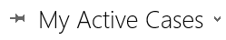

  - In the left hand corner click on to the plus sign for ‘New Case’.

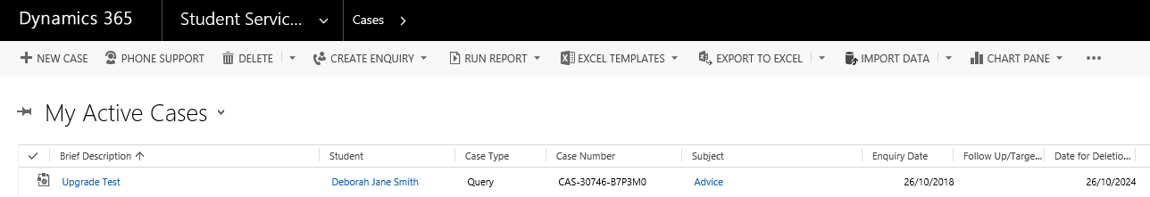

  - Another window will open up,

Note: You will notice the workflow chevrons across the top of the screen. Please do not be concerned if these are incorrect, they are driven by the Subject, and may change once the Subject is selected.
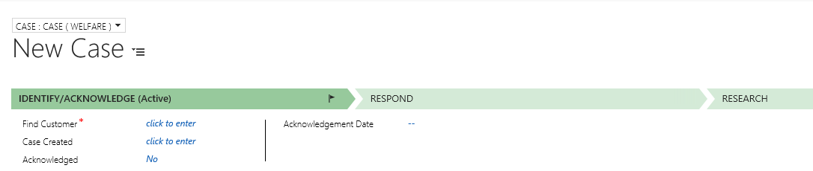

  - Click into the Student field and type in the Student ID. The system will bring back the correct student.
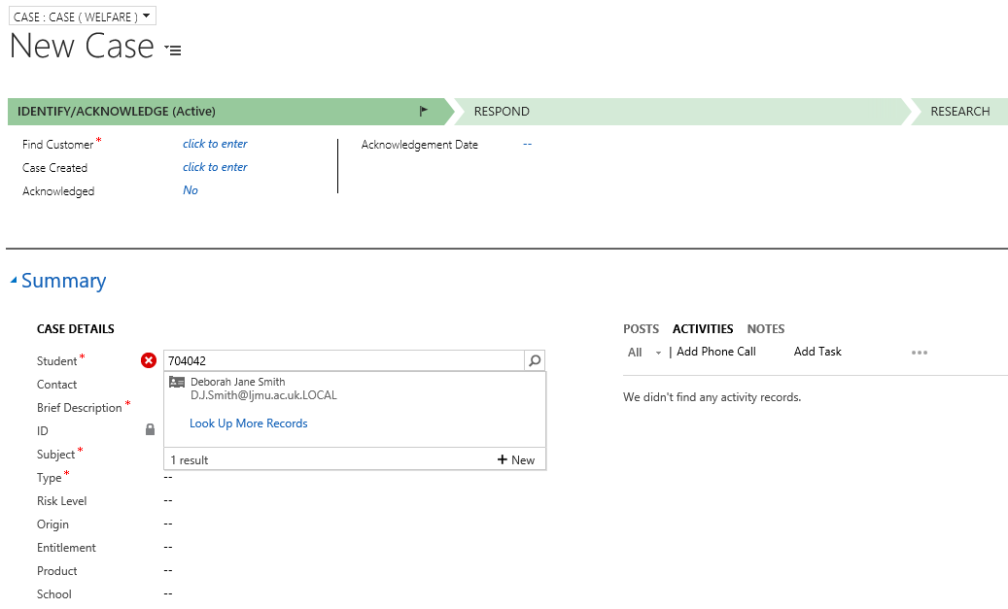
  - Next enter a Brief Description. This will form the name of the case.

We recommend for clarity and consistency, use the format:

For Counselling Cases:
Student Name

For all other Cases:
Student ID/Student Name/Type of Case (optional) to name your cases.

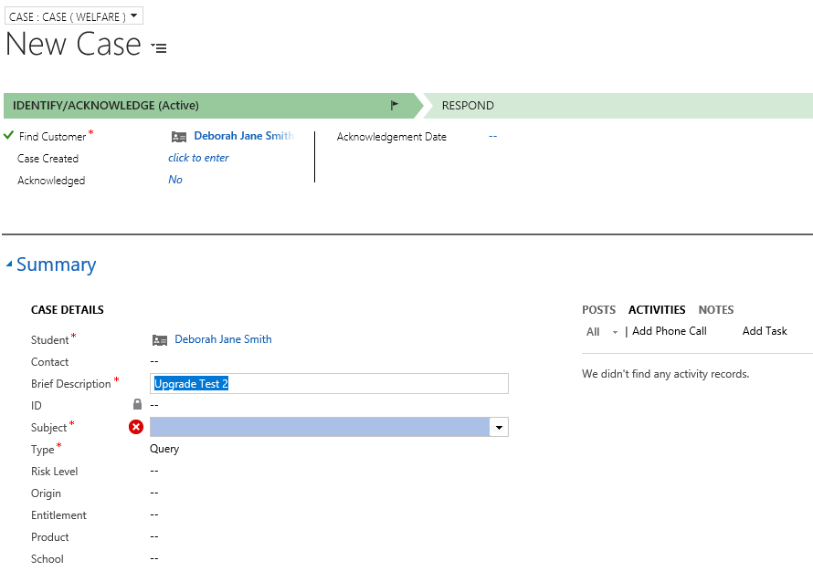

  - Next, select a Subject from the drop down list.
Please Note: Selecting a Subject from the top line Subject List (shown below) drives the correct process. For reporting purposes you should change this to a sub-subject before closing the case (Please refer to Changing the Subject of a Case document).

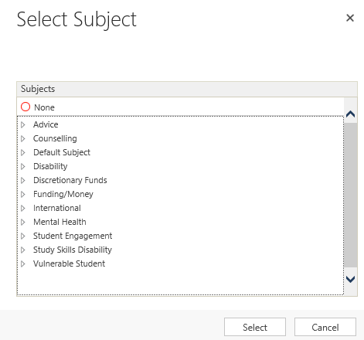

  - You will need to complete the Type box. Select any of the options. This field is due to be removed in the future.

  - Finally, click on the Save Icon.
You will note that the name you entered into the Brief Description field will populate at the top of the case, and the status will show ‘New Case’.

Case has been created!

- Setting up a Case from Contacts

If you do not know the Student ID or if the client is not a student, you can set up a Case via ‘Contacts’.

2.1. First you will need to navigate to Contacts, and check if the ‘Contact’ is set up on CRM already.

The ‘view’ may default to ‘My Active Contact’
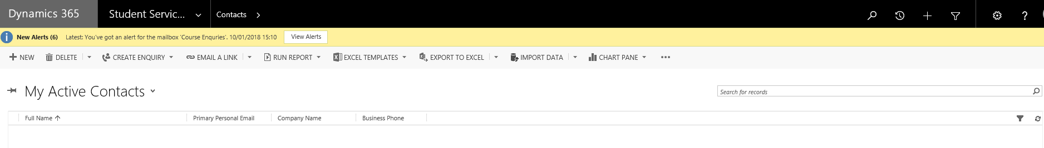
2.2. You can change the view, by clicking on the downward arrow.
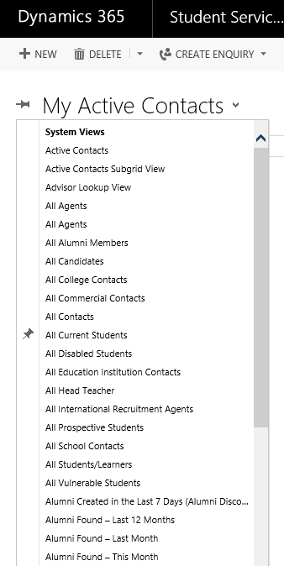

2.3. There are a number of views, you could select to narrow down your search. If you know the contact is definetely a student, then select ‘All Current Students’.

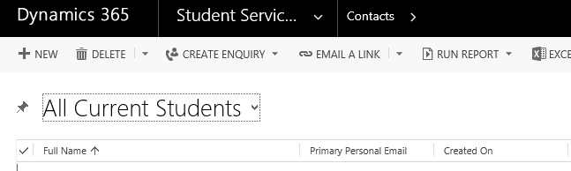

Then, click into the search field and search for the student.
Note: You can search using the wildcard function ‘*’ if you are not sure of the student’s full name.

  - Select the correct Contact from the results displayed to bring up the Contact Record.

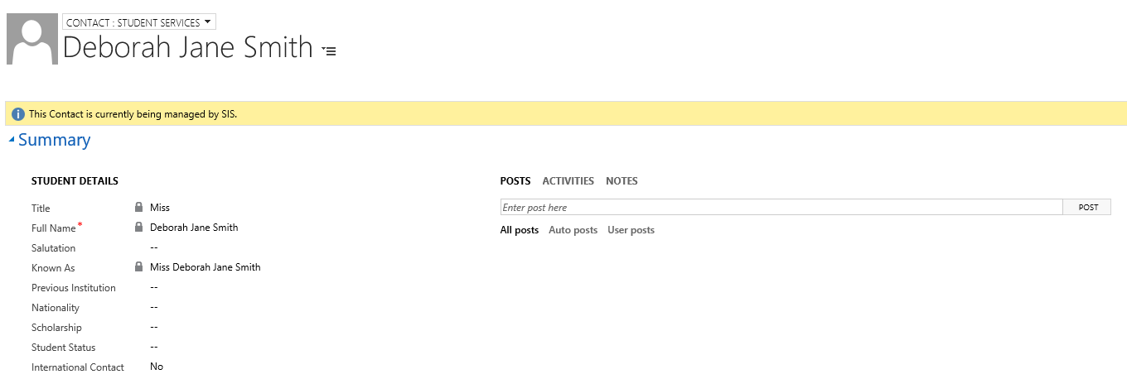

  - Ensure that the Contact view is ‘Student Services’. You can change this by clicking on the ‘Contact’ arrow above the Contacts Name.
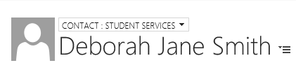

  - Scroll down and look for ‘Current Cases’ on the right hand side.

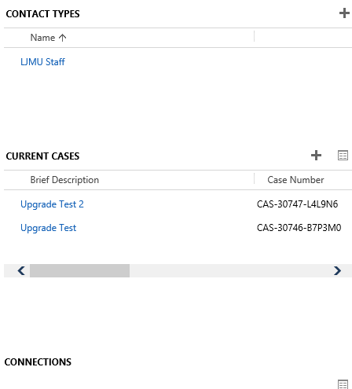

  - Click on the ‘plus +’ icon next to Current Cases section

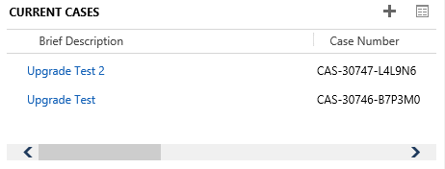

  - This will bring up a New Cases window at the top of the screen.

  - You will note that the Student is already selected. Complete the Brief Description, Subject, and Case Type.

  - Click Save

  - If you look back over at ‘Current Cases’ you will note that the Case now appears at the top of the list of Cases.

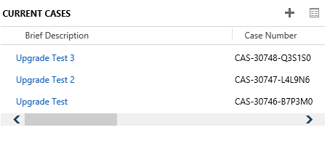
  - Click on the link in blue to open up the case.

- Setting up a Case from an Email

  - Click into the Email you want to Convert.

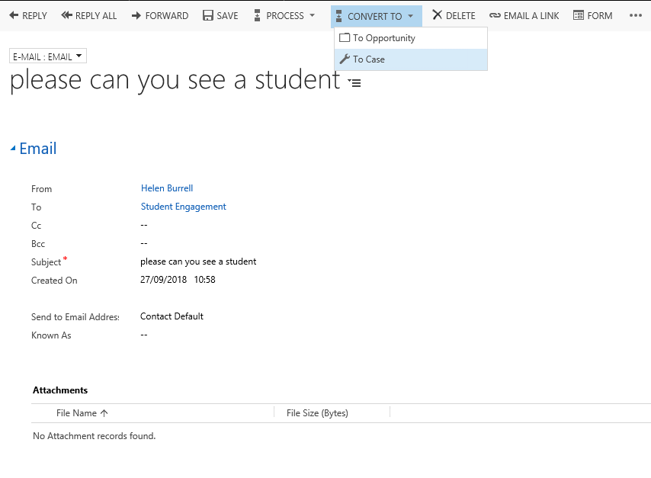

  - Select the Convert to option.

  - Select ‘Case’. Do not use Opportunity.

  - This will bring up a dialog box asking which student it is for (‘Customer’ field) and also the Subject, which you will select from the list.

  - It is important that the correct Subject is selected as this will drive the process flow across the top of the screen.

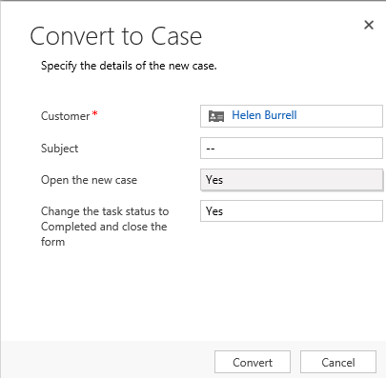

  - Ensure both ‘Open the New Case’ and ‘Change the task status to Completed and close the form’ are both set to Yes

  - Click the Convert button:

  - This will open up a new Case.

  - You will still need to complete the ‘Type’ field (this will hopefully soon be removed) before saving.

